St. Timothy Lutheran Church
Sunday, December 14th
3rd Sunday of Advent

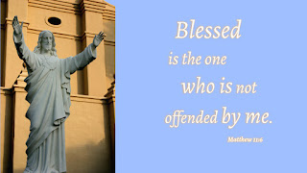

A note of joyful expectation marks today’s worship. Isaiah announces that the desert shall rejoice and blossom, and Jesus points to the unexpected and transforming signs of God’s reign. We wait with patience for the coming of the Lord, even as we rejoice at his presence among us this day: in word and holy supper, in church and in our homes, in silent reflection and in works of justice and love. We pray that God would open our eyes and ears to the wonders of Christ’s advent among us.

St Timothy Worship Planning Team
S.A.M. Bob Bonomo
Deacon, Frank Hofstetter
Director of Music, Sally Hennessey
Saturday Pianist, Bill Robinson

Pre-Service Music: O Come, O Come, Emmanuel ELW 257

Welcome and Sharing of Congregational News

Prelude

Confession and Forgiveness
Blessed be the holy Trinity, ☩ one God,
who forgives all our sin,
whose mercy endures forever.
Amen.
Let us confess our sin in the presence of God
and of one another.
Silence is kept for reflection.
Faithful God,
you have shown us the ways of your heart,
yet we stray from your paths.
We are stuck in sinful systems of oppression
and do not embrace the freedom
of your faithful promises.
We ignore our neighbors.
We exploit the earth.
We reject your abundance,
trusting our impulses instead of your steadfast love.
Repair our relationships,
restore what we have broken,
renew our hearts,
and bring us to new life.
Amen.

Hear the good news:
God the Faithful One loves you,
☩ in Christ Jesus your sins are forgiven,
and by the power of the Holy Spirit you are set free.
Amen.
Greeting
S.A.M. Bob: The joy of our Lord Jesus Christ, the compassion of God, and the creative power of the Holy Spirit be with you all.
C: And also with you.

(Lighting of the Advent candle. Week 3)

Gathering Hymn: Awake! Awake, and Greet the New Morn ELW 242

- Awake! Awake, and greet the new morn, for
angels herald its dawning. Sing out your joy, for
soon he is born, behold! the Child of our longing.
Come as a baby weak and poor, to bring all hearts together,
he opens wide the heav'nly door and
lives now inside us forever.

- To us, to all in sorrow and fear, Emmanuel
comes a-singing, his humble song is
quiet and near, yet fills the earth with its ringing;
music to heal the broken soul and hymns of lovingkindness,
the thunder of his anthems roll to
shatter all hatred and blindness.

- In darkest night his coming shall be, when
all the world is despairing, as morning light so
quiet and free, so warm and gentle and caring.
Then shall the mute break forth in song, the lame shall leap in wonder, the weak be raised above the strong, and
weapons be broken asunder.

- Rejoice, rejoice, take heart in the night, though
dark the winter and cheerless, the rising sun shall
crown you with light, be strong and loving and fearless.
Love be our song and love our prayer and love our endless
story; may God fill ev'ry day we share and
bring us at last into glory.
Text: Marty Haugen, b. 1950

Text © 1983 GIA Publications, Inc., 7404 S. Mason Ave., Chicago, IL 60638. www.giamusic.com. 800.442.3358. All rights reserved. Used by permission.

S.A.M. Bob - The Lord be with you.
C – And also with you.

Prayer of the Day
Stir up the wills of all who look to you, Lord God, and strengthen our faith in your coming, that, transformed by grace, we may walk in your way; through Jesus Christ, our Savior and Lord, who lives and reigns with you and the Holy Spirit, one God, now and forever.
Amen.

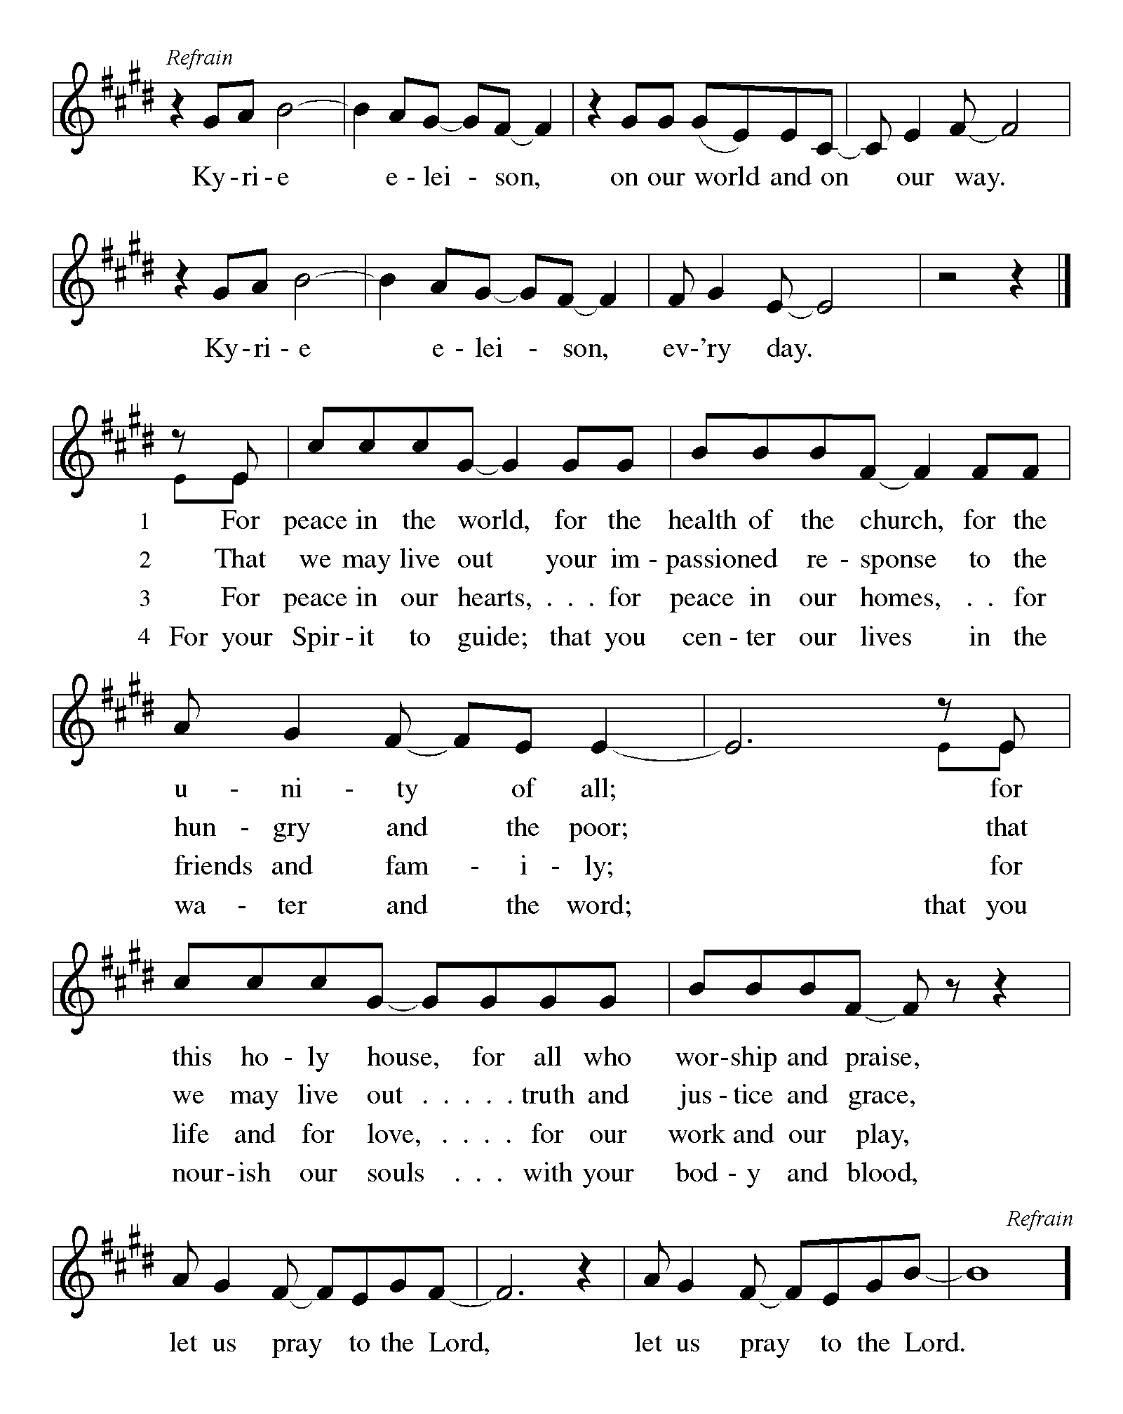

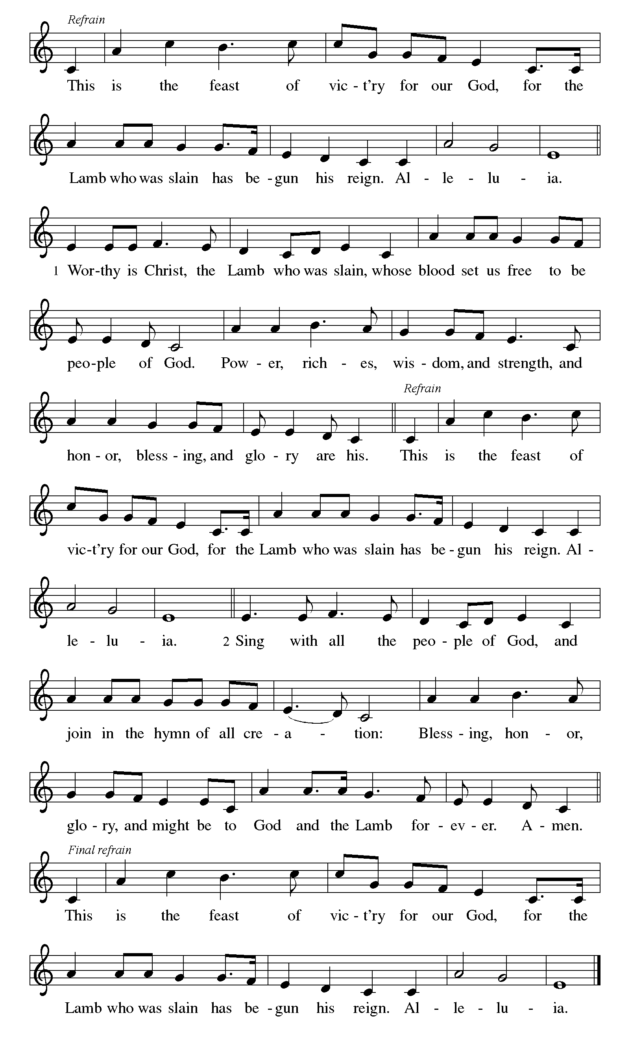

First Lesson: Isaiah 35:1-10
The prophet describes the return from the Babylonian captivity as a joyous procession to Zion. God’s coming reign will bring a renewal of creation in which health and wholeness will be restored. There is no need for fear, for God is coming to save.
¹ The wilderness and the dry land shall be glad;
the desert shall rejoice and blossom;
like the crocus ² it shall blossom abundantly
and rejoice with joy and shouting.
The glory of Lebanon shall be given to it,
the majesty of Carmel and Sharon.
They shall see the glory of the Lord,
the majesty of our God.]]
³ Strengthen the weak hands
and make firm the feeble knees.
⁴ Say to those who are of a fearful heart,
“Be strong, do not fear!
Here is your God.
He will come with vengeance,
with terrible recompense.
He will come and save you.”
⁵ Then the eyes of the blind shall be opened,
and the ears of the deaf shall be opened;
⁶ then the lame shall leap like a deer,
and the tongue of the speechless sing for joy.
For waters shall break forth in the wilderness
and streams in the desert;
⁷ the burning sand shall become a pool
and the thirsty ground springs of water;
the haunt of jackals shall become a swamp;
the grass shall become reeds and rushes.
⁸ A highway shall be there,
and it shall be called the Holy Way;
the unclean shall not travel on it,
but it shall be for God’s people;
no traveler, not even fools, shall go astray.
⁹ No lion shall be there,
nor shall any ravenous beast come up on it;
they shall not be found there,
but the redeemed shall walk there.
¹⁰ And the ransomed of the Lord shall return
and come to Zion with singing;
everlasting joy shall be upon their heads;
they shall obtain joy and gladness,
and sorrow and sighing shall flee away.

A – Word of God!

C – Words of Life!

Psalm 146:5-10
⁵ Happy are they who have the God of Jacob for their help,
whose hope is in the Lord their God;
⁶ who made heaven and earth, the seas, and all that is in them;
who keeps promises forever;
⁷ who gives justice to those who are oppressed, and food to those who hunger.
The Lord sets the captive free.
⁸ The Lord opens the eyes of the blind; the Lord lifts up those who are bowed down;
the Lord loves the righteous.
⁹ The Lord cares for the stranger;
the Lord sustains the orphan and widow, but frustrates the way of the wicked.
¹⁰ The Lord shall reign forever,
your God, O Zion, throughout all generations. Hallelujah!

Second Lesson: James 5:7-10
In anticipation of the Lord’s coming, Christians are called upon to cultivate patience rather than discontent.
⁷ Be patient, therefore, brothers and sisters, until the coming of the Lord. The farmer waits for the precious crop from the earth, being patient with it until it receives the early and the late rains. ⁸ You also must be patient. Strengthen your hearts, for the coming of the Lord is near. ⁹ Brothers and sisters, do not grumble against one another, so that you may not be judged. See, the Judge is standing at the doors! ¹⁰ As an example of suffering and patience, brothers and sisters, take the prophets who spoke in the name of the Lord.

A – Word of God!

C – Words of Life!

Gospel Acclamation
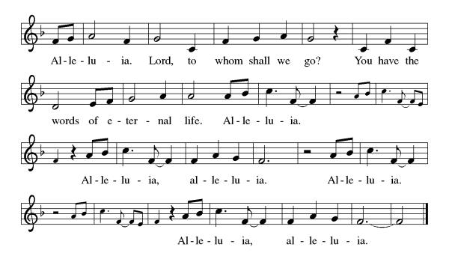

S.A.M. Bob: The Holy Gospel according to Matthew, the 11th Chapter
C- Glory to you, O Lord.

Gospel: Matthew 11:2-11
John the Baptist expects the Messiah to bring God’s judgment upon the earth (Matt. 3:11-12). From a prison cell, he wonders whether Jesus is the one who will do this. Jesus’ response indicates that God’s reign is indeed being fulfilled already through healing and restoration.
² When John heard in prison what the Messiah was doing, he sent word by his disciples ³ and said to him, “Are you the one who is to come, or are we to wait for another?” ⁴ Jesus answered them, “Go and tell John what you hear and see: ⁵ the blind receive their sight, the lame walk, those with a skin disease are cleansed, the deaf hear, the dead are raised, and the poor have good news brought to them. ⁶ And blessed is anyone who takes no offense at me.”
⁷ As they went away, Jesus began to speak to the crowds about John: “What did you go out into the wilderness to look at? A reed shaken by the wind? ⁸ What, then, did you go out to see? Someone dressed in soft robes? Look, those who wear soft robes are in royal palaces. ⁹ What, then, did you go out to see? A prophet? Yes, I tell you, and more than a prophet. ¹⁰ This is the one about whom it is written,
‘See, I am sending my messenger ahead of you,
who will prepare your way before you.’
¹¹ “Truly I tell you, among those born of women no one has arisen greater than John the Baptist, yet the least in the kingdom of heaven is greater than he.”

S.A.M. Bob- The Gospel of the Lord.
C - Praise to you, O Christ.
Sermon by S.A.M. Bob

Hymn of the Day: Prepare the Royal Highway ELW 264
1 Prepare the royal highway; the King of kings is near!
Let ev'ry hill and valley a level road appear!
Then greet the King of glory, foretold in sacred story:

Refrain
Hosanna to the Lord, for he fulfills God's word!

2 God's people, see him coming: your own eternal king!
Palm branches strew before him! Spread garments! Shout and sing!
God's promise will not fail you! No more shall doubt assail you! Refrain

3 Then fling the gates wide open to greet your promised king!
Your king, yet ev'ry nation its tribute too may bring.
All lands will bow before him; their voices join your singing: Refrain

4 His is no earthly kingdom; it comes from heav'n above.
His rule is peace and freedom and justice, truth, and love.
So let your praise be sounding for kindness so abounding: Refrain

Text: Frans Mikael Franzén, 1772-1847; tr. Lutheran Book of Worship
Text © 1978 Lutheran Book of Worship, admin. Augsburg Fortress.

Apostles’ Creed
I believe in God, the Father almighty,
creator of heaven and earth.
I believe in Jesus Christ, God’s only Son, our Lord,
who was conceived by the Holy Spirit,
born of the virgin Mary,
suffered under Pontius Pilate,
was crucified, died, and was buried;
he descended to the dead.
On the third day he rose again;
he ascended into heaven,
he is seated at the right hand of the Father,
and he will come to judge the living and the dead.
I believe in the Holy Spirit,
the holy catholic church,
the communion of saints,
the forgiveness of sins,
the resurrection of the body,
and the life everlasting. Amen.

Lord, listen to your children praying,
Lord, send your Spirit in this place;
Lord, listen to your children praying,
send us love, send us pow'r, send us grace.

Prayers of the People
In our waiting and watching, we come to you in prayer, O God, trusting your promise to renew the church, the nations, and the whole creation.
A brief silence.
God of power and mercy, we praise you for Jesus and his acts of healing and liberation. Lead us to proclaim the good news from generation to generation, that all may place their hope in you. God of grace,
We wait for You

When lands are parched and dry, bring rain and snow; where wilderness is barren, sow seeds of life. Fill the lands with trees that grow, plants that flower, and creatures that thrive, as nature proclaims the wonder of your works. God of grace,
We wait for You.

Lord, there is injustice and corruption among nations and its leaders. As John the Baptizer called the Pharisees a ‘brood of Vipers” The axe is ready at the root of the trees that cannot produce good fruit. Turn their attention to injustice and the cries of the poor. Instill a deeper sense of compassion and care in all who govern. God of grace,
We wait for You.

When our minds and bodies weaken, and our hearts grow fearful, speak your blessing. (We pray especially for . . .)
In uncertain times, remind us of the promise spoken to our ancestors in faith. God of grace,
We wait for You.

When people are imprisoned or held captive, break the chains and offer release. Strengthen the work of the church in healing justice, breaking cycles of poverty, and welcoming the immigrant, (especially we pray for Global Refuge and Lutheran Social Services). God of grace,
We wait for You

Bless all our men and women in the armed forces who might be very far from home. Bless them Lord with Your comfort as we pray for them and their families at home. God of Grace,
We wait for You.

Bless our Jewish neighbors as they celebrate Channukah, we wish them Shalom. God of Grace,
We wait for You

Lord, as we wait for Your coming, we give thanks for all the faithful who have gone before us who now live in Peace in Your Kingdom of Heaven. May their boldness of faith inspire our witness and work. God of grace,
We wait for You.

Draw near to us, O God, as we commend all for whom we pray, trusting in your mercy through Jesus Christ, Emmanuel.
Amen.

S.A.M.: May the peace of our Lord Jesus Christ be with you all.
C: And also with you.
S.A.M.: Let us now share this peace.

Offering is Brought to the Altar

Offering Prayer

We lift our voices, we lift our hands, we lift our lives up to you; we are an Offering. Lord, use our voices, Lord, use our hands, Lord, use our lives, they are yours: we are an offering. All that we have, all that we are, all that we hope to be, we give to you, we give to you. We lift our voices, we lift our hands, we lift our lives up to you; we are an offering, we are an offering.
S.A.M. Bob: The Lord be with you.
C: And also with you.

S.A.M. Bob: Lift up your hearts.
C: We lift them up to the Lord.

S.A.M. Bob: Let us give thanks to the Lord our God.
C: It is right to give our thanks and praise.

Preface
It is indeed right, our duty and our joy,
that we should at all times and in all places
give thanks and praise to you, almighty and merciful God, through our Savior Jesus Christ; who on this day overcame death and the grave, and by his glorious resurrection opened to us the way of everlasting life. And so, with all the choirs of angels,
with the church on earth and the hosts of heaven,
we praise your name and join their unending hymn:

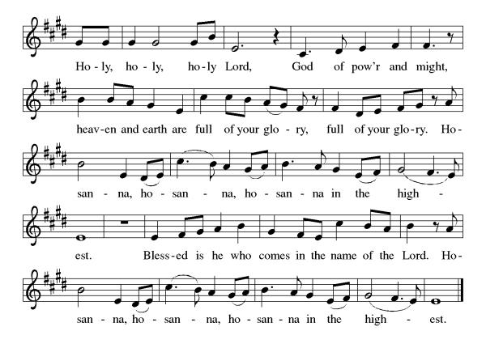

Eucharistic Prayer
Blessed are you, O God of the universe. Your mercy is everlasting, and your faithfulness endures from age to age.
Praise to you for creating the heavens and the earth. Praise to you for saving the earth from the waters of the flood. Praise to you for bringing the Israelites safely through the sea. Praise to you for leading your people through the wilderness to the land of milk and honey. Praise to you for the death and resurrection of Christ. Praise to you for your Spirit poured out on all nations.
In the night he was betrayed, our Lord Jesus took bread and gave thanks; broke it, and gave it to his disciples saying: Take and eat; this is my body given for you. Do this for the remembrance of me.
After supper he took the cup, gave thanks and gave it for all to drink saying: This cup is the new covenant in my blood, shed for you and for all people for the forgiveness of sin, Do this for the remembrance of me.
For as often as we eat of this bread and drink from this cup we proclaim the Lord’s death until He comes.

Christ has died
Christ is risen.
Christ will come again.
Gathered into one, by the Holy Spirit let us listen to the words that Jesus taught us.

The Lord’s Prayer
Our Father, who art in heaven, hallowed be thy name, thy kingdom come, thy will be done, on earth as it is in heaven. Give us this day our daily bread; and forgive us our trespasses, as we forgive those who trespass against us; and lead us not into temptation but deliver us from evil. For thine is the kingdom, and the power, and the glory, forever and ever. Amen.

Invitation to Communion
S.A.M. Bob: There is a place for you at the table of God. Come, receive the food that does not perish, a test of life eternal. Come and taste on your lips a Love we cannot comprehend.
C: Amen
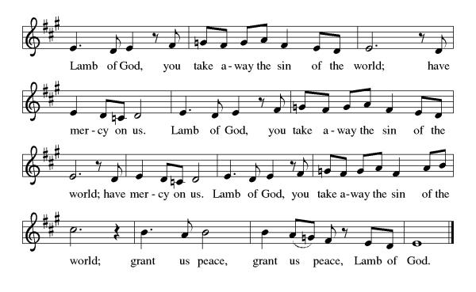

Please come forward to receive

Communion Anthem: Each Winter as the Year Grows Older ELW 252
S.A.M. Bob: We are now a tabernacle with Christ inside of us. Let us rejoice and be glad at the Lord’s table.
C: Amen
Prayer after Communion
O God, through this meal you have strengthened us and appointed us to be your servants. Send us to do good and to share our possessions with all in need. We ask this in Jesus’ name. Amen
Blessing
S.A.M. Bob: The God of righteousness, who gives justice to the oppressed, who gives food to the hungry, who sets the prisoners free, ☩ bless you now and forever.
C: Amen.

Sending Hymn: People, Look East ELW 248
1 People, look east. The time is near of the crowning
of the year. Make your house fair as you are able,
trim the hearth and set the table. People, look
east, and sing today—Love, the Guest, is on the way.

2 Furrows, be glad. Though earth is bare, one more seed is
planted there. Give up your strength the seed to nourish,
that in course the flow'r may flourish. People, look
east, and sing today—Love, the Rose, is on the way.

3 Stars, keep the watch. When night is dim, one more light the
bowl shall brim, shining beyond the frosty weather,
bright as sun and moon together. People, look
east, and sing today—Love, the Star, is on the way.

4 Angels announce with shouts of mirth him who brings new
life to earth. Set ev'ry peak and valley humming
with the word, the Lord is coming. People, look
east, and sing today—Love, the Lord, is on the way.
Text: Eleanor E. Farjeon, 1881-1965

Text © Miss E. Farjeon Will Trust, by permission of David Higham Associates.

Dismissal
S.A.M Bob: Go in peace. Keep awake.
C: Thanks be to God.
Postlude: instrumental
Unless otherwise noted, materials used in this bulletin are:
From Sundays and Seasons.com. Copyright 2015 Augsburg Fortress. All rights reserved. Reprinted by permission under Augsburg Fortress Liturgies Annual License #SAS028635. Music is reprinted under OneLicense.Net #A712074 and/or Augsburg Fortress #SBL12176H. Scripture, unless otherwise noted, is from the New Revised Standard Version Bible, Copyright © 1989, Division of Christian Education of the National Council of the Churches of Christ in the United States of America. Used by permission. All rights reserved.

Announcements for December 13th and 14th

ATTENDANCE
Saturday, December 6th, 4pm 20
Sunday, December 7th, 9am 44
Drive-Up Communion 0
64

The Altar Flowers are given this week by Jake and Marcia Jacobek in honor of Marcia’s birthday and to the glory of God!

This Week at St. Timothy's
Monday, December 15th
Tuesday, December 16th
Wednesday, December 17th 4pm – “A Time for Waiting” Advent Soup Supper
Thursday, December 18th 9:30am – Prayer Group, 3:30pm – Chimes, 4:30pm - Choir
Friday, December 19th
Saturday, December 20th 4pm - Worship
Sunday, December 21st 9am – Worship, 10:15-10:45 – Drive Up Communion, 10:30 – Adult SS, Coffee Fellowship



CHRISTMAS POINSETTIAS
If you wish to purchase a poinsettia for our Christmas services, there is a sign-up sheet on the bulletin board in the Narthex area. The cost per 6” plant is $15.00 which includes a $3.00 donation for the food pantry. Please put your payment in the church offering and designate it “Poinsettia”.

Advent/Christmas Schedule
Mid-week Advent “A Time for Waiting” Soup Supper, 4pm Wednesday, December 3rd, 10th, and 17th
Christmas Eve – Pre-service Music 4:30pm, Service at 5pm
Christmas Day –Service at 10am.

