St. Timothy Lutheran Church
Sunday, November 30th
1st Weekend of Advent
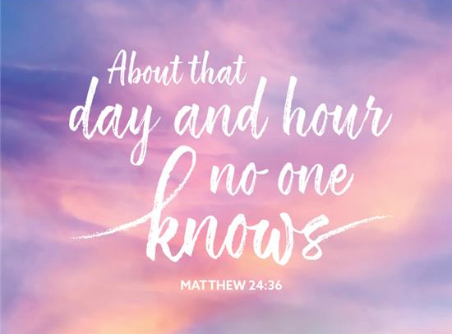

The new church year begins with a wake-up call: Christ is coming soon! In today’s readings both Paul and Jesus challenge us to wake from sleep, for we know neither the day nor hour of the Lord’s coming. Isaiah proclaims the day when God will gather all people on the holy mountain and there will be no more war or suffering. Though we vigilantly watch for the promised day of salvation, we wait for what we already have: Christ comes among us this day as the word and meal that strengthens our faith in the promises of God.

St Timothy Worship Planning Team
S.A.M. Bob Bonomo
Deacon, Frank Hofstetter
Director of Music, Sally Hennessey
Saturday Pianist, Bill Robinson

Pre-Service Music: The King of Glory W&P 136

Welcome and Sharing of Congregational News

Prelude

Confession and Forgiveness
Blessed be the holy Trinity, ☩ one God,
who forgives all our sin,
whose mercy endures forever.
Amen.
Let us confess our sin in the presence of God
and of one another.
Silence is kept for reflection.
Faithful God,
you have shown us the ways of your heart,
yet we stray from your paths.
We are stuck in sinful systems of oppression
and do not embrace the freedom
of your faithful promises.
We ignore our neighbors.
We exploit the earth.
We reject your abundance,
trusting our impulses instead of your steadfast love.
Repair our relationships,
restore what we have broken,
renew our hearts,
and bring us to new life.
Amen.

Hear the good news:
God the Faithful One loves you,
☩ in Christ Jesus your sins are forgiven,
and by the power of the Holy Spirit you are set free.
Amen.
Greeting
S.A.M. Bob: The joy of our Lord Jesus Christ, the compassion of God, and the creative power of the Holy Spirit be with you all.
C: And also with you.

Gathering Hymn: The King Shall Come ELW 260

1 The King shall come when morning dawns and light triumphant breaks,
when beauty gilds the eastern hills and life to joy awakes.
2 Not as of old a little child, to bear and fight and die,
but crowned with glory like the sun that lights the morning sky.
3 Oh, brighter than the rising morn when Christ, victorious, rose
and left the lonesome place of death, despite the rage of foes.
4 Oh, brighter than that glorious morn shall dawn upon our race
the day when Christ in splendor comes, and we shall see his face.
5 The King shall come when morning dawns and light and beauty brings.
Hail, Christ the Lord! Your people pray: come quickly, King of kings. Text: John Brownlie, 1859-1925

S.A.M. Bob - The Lord be with you.
C – And also with you.

Prayer of the Day
Stir up your power, Lord Christ, and come. By your merciful protection save us from the threatening dangers of our sins, and enlighten our walk in the way of your salvation, for you live and reign with the Father and the Holy Spirit, one God, now and forever.
Amen.
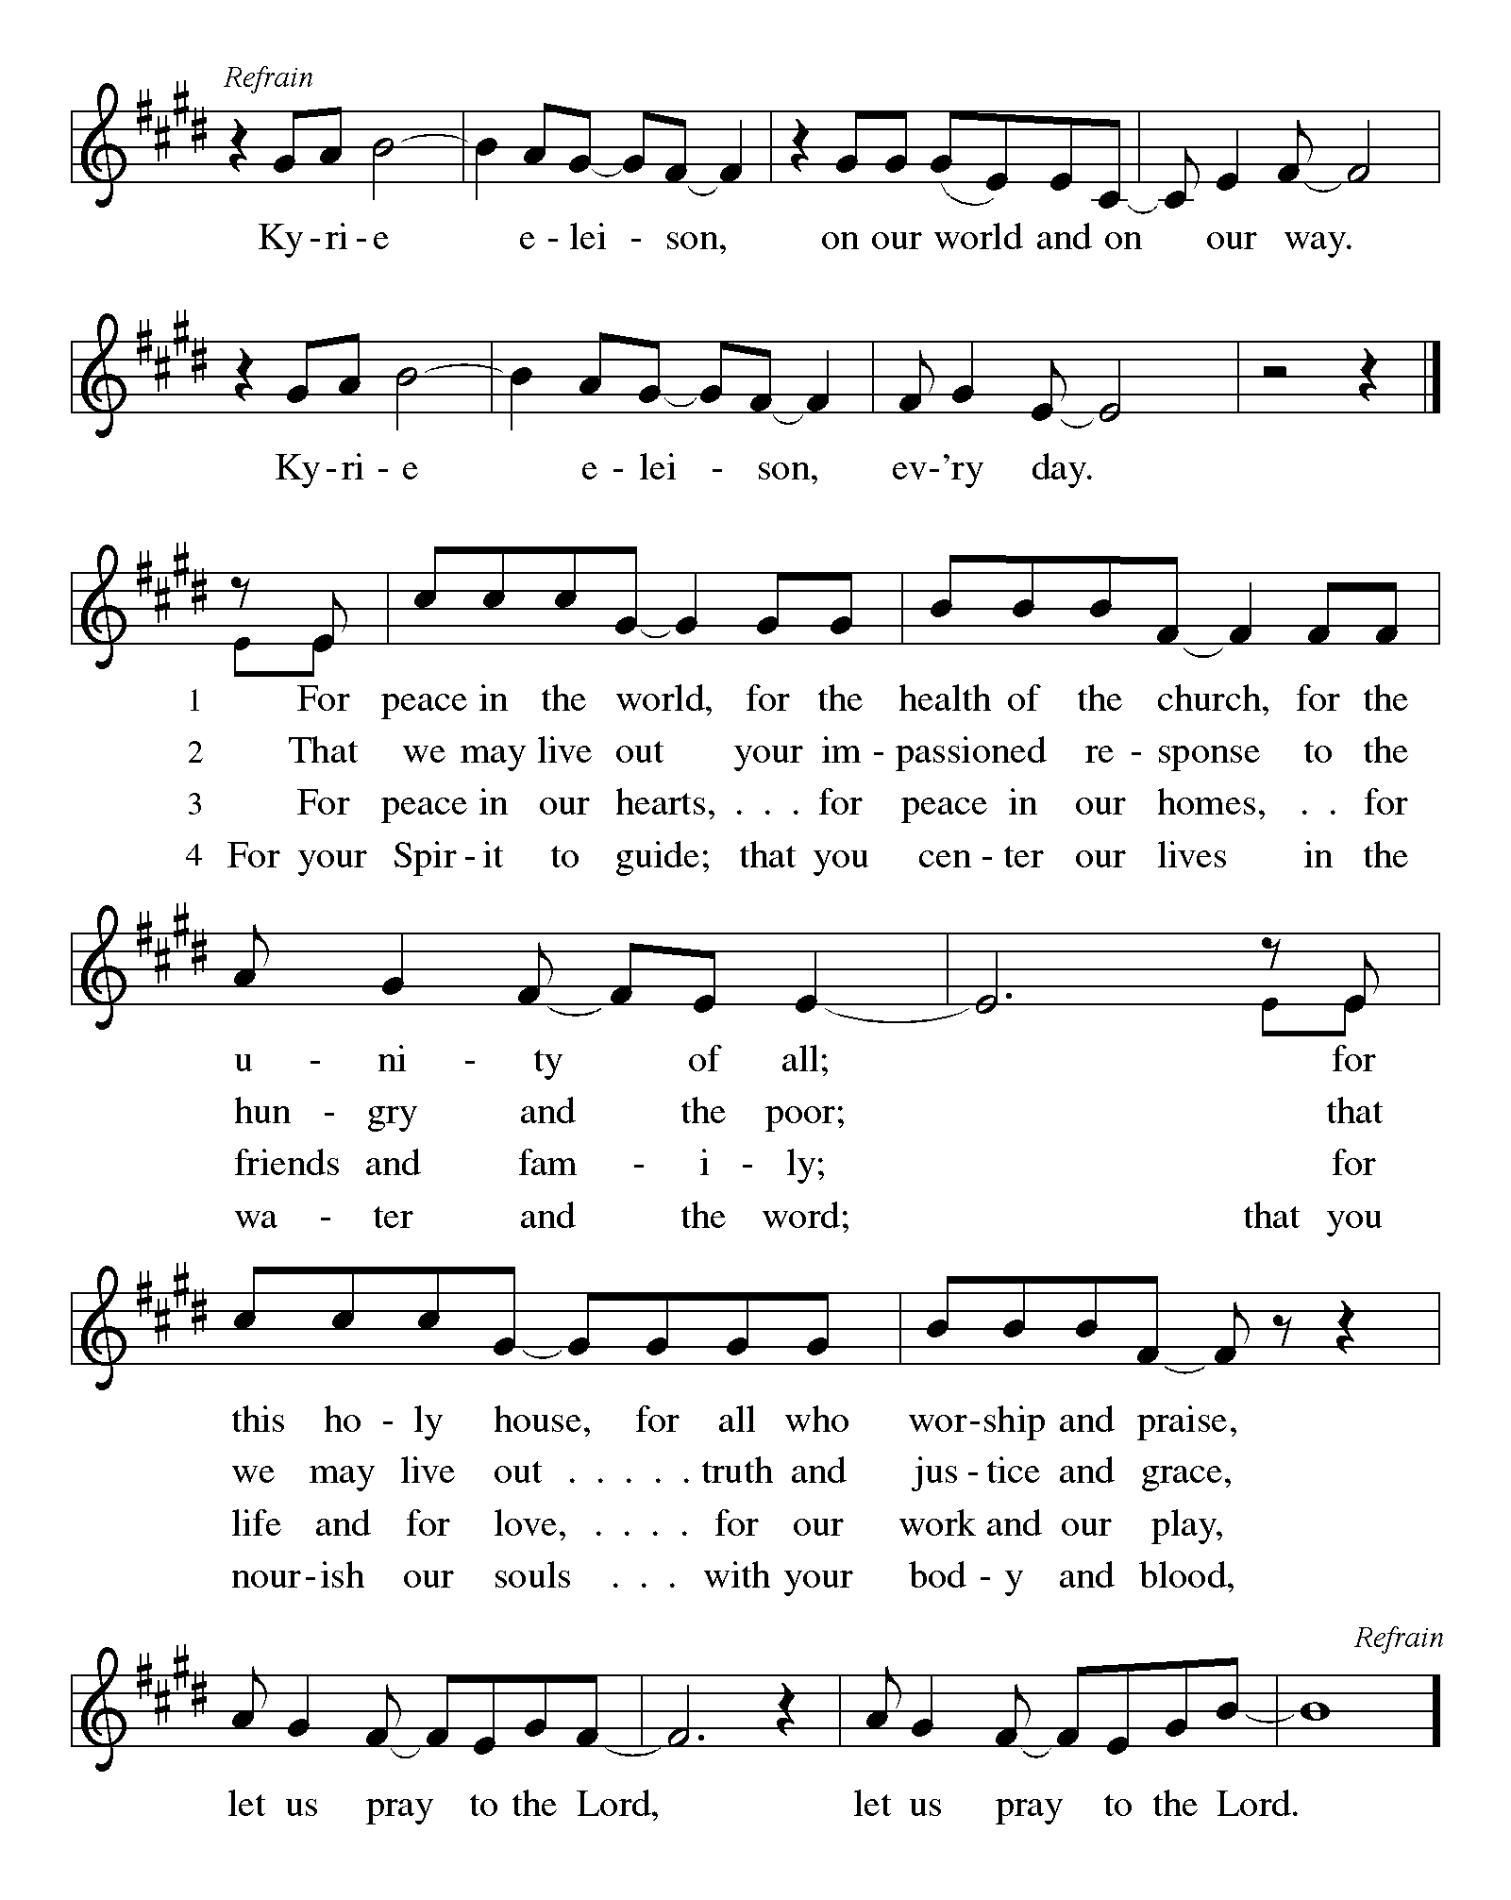
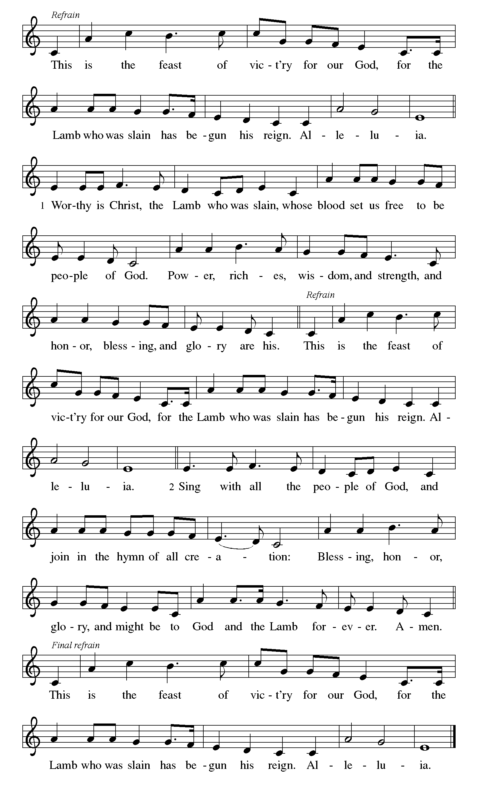

First Lesson: Isaiah 2:1-5
The visionary message presented in this reading focuses on a future day when God establishes a universal reign of peace. Divine decisions will make war obsolete, and the worshiping community responds: “Let us walk in the light of that Lord now!”
¹ The word that Isaiah son of Amoz saw concerning Judah and Jerusalem.
² In days to come
the mountain of the Lord’s house
shall be established as the highest of the mountains
and shall be raised above the hills;
all the nations shall stream to it.
³ Many peoples shall come and say,
“Come, let us go up to the mountain of the Lord,
to the house of the God of Jacob,
that he may teach us his ways
and that we may walk in his paths.”
For out of Zion shall go forth instruction
and the word of the Lord from Jerusalem.
⁴ He shall judge between the nations
and shall arbitrate for many peoples;
they shall beat their swords into plowshares
and their spears into pruning hooks;
nation shall not lift up sword against nation;
neither shall they learn war any more.
⁵ O house of Jacob,
come, let us walk
in the light of the Lord!

A – Word of God!

C – Words of Life!

Psalm 122
¹ I was glad when they said to me,
“Let us go to the house of the Lord.”
² Now our feet are standing
within your gates, O Jerusalem.
³ Jerusalem is built as a city
that is at unity with itself;
⁴ to which the tribes go up, the tribes of the Lord,
the assembly of Israel, to praise the name of the Lord.
⁵ For there are the thrones of judgment,
the thrones of the house of David.
⁶ Pray for the peace of Jerusalem:
“May they prosper who love you.
⁷ Peace be with in your walls
and quietness within your towers.
⁸ For the sake of my kindred and companions,
I pray for your prosperity.
⁹ Because of the house of the Lord our God,
I will seek to do you good.”

Second Lesson: Romans 13:11-14
Paul compares the advent of Christ to the coming of dawn. We live our lives today in light of Christ’s coming in the future.
¹¹ Besides this, you know what time it is, how it is already the moment for you to wake from sleep. For salvation is nearer to us now than when we became believers; ¹² the night is far gone; the day is near. Let us then throw off the works of darkness and put on the armor of light; ¹³ let us walk decently as in the day, not in reveling and drunkenness, not in illicit sex and licentiousness, not in quarreling and jealousy. ¹⁴ Instead, put on the Lord Jesus Christ, and make no provision for the flesh, to gratify its desires.

A – Word of God!

C – Words of Life!
Gospel Acclamation
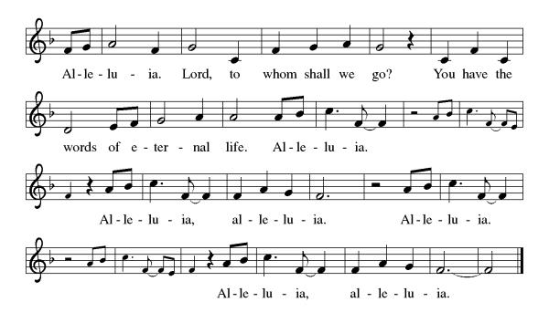

S.A.M. Bob: The Holy Gospel according to Luke, the 24th Chapter
C- Glory to you, O Lord.

Gospel: Matthew 24:36-44
Jesus describes his second coming as a sudden, turbulent event that will bring about deep change to our normal, day-to-day lives. Therefore, he urges people to stay awake, be aware, and wait expectantly, because the Son of Man will come unannounced.
[Jesus said to the disciples,] ³⁶ “About that day and hour no one knows, neither the angels of heaven, nor the Son, but only the Father. ³⁷ For as the days of Noah were, so will be the coming of the Son of Man. ³⁸ For as in the days before the flood they were eating and drinking, marrying and giving in marriage, until the day Noah entered the ark, ³⁹ and they knew nothing until the flood came and swept them all away, so, too, will be the coming of the Son of Man. ⁴⁰ Then two will be in the field; one will be taken, and one will be left. ⁴¹ Two women will be grinding meal together; one will be taken, and one will be left. ⁴² Keep awake, therefore, for you do not know on what day your Lord is coming. ⁴³ But understand this: if the owner of the house had known in what part of the night the thief was coming, he would have stayed awake and would not have let his house be broken into. ⁴⁴ Therefore you also must be ready, for the Son of Man is coming at an hour you do not expect.”

S.A.M. Bob- The Gospel of the Lord.
C - Praise to you, O Christ.
Sermon by S.A.M. Bob

Hymn of the Day: Wake, Awake, for Night Is Flying ELW 436
1 Wake, awake, for night is flying, the watchmen
on the heights are crying; awake, Jerusalem, at last.
Midnight hears the welcome voices, and at the
thrilling cry rejoices: "Come forth, you maidens! Night is past.
The bridegroom comes! Awake; your lamps with gladness take!"
Alleluia! Rise and prepare the feast to share;
go, meet the bridegroom, who draws near.
2 Zion hears the watchmen singing, and all her
heart with joy is springing. She wakes, she rises from her gloom.
Her dear friend comes down, all glorious, the strong in
grace, in truth victorious: her star is ris'n; her light is come.
Now come, O Blessed One, Lord Jesus, God's own Son.
Sing hosanna! Oh, hear the call! Come one, come all,
and follow to the banquet hall.
3 Gloria! Let heav'n adore you! Let saints and
angels sing before you, with harp and cymbal's clearest tone.
Gates of pearl, twelve portals gleaming, lead us to
bliss beyond all dreaming, with angel choirs around your throne.
No eye has caught the light, no ear the thund'ring might
of such glory. There we will go: what joy we'll know!
There sweet delight will ever flow.
Text: Philipp Nicolai, 1556-1608; tr. composite
Text © 1999 Augsburg Fortress.

Apostles’ Creed
I believe in God, the Father almighty,
creator of heaven and earth.
I believe in Jesus Christ, God’s only Son, our Lord,
who was conceived by the Holy Spirit,
born of the virgin Mary,
suffered under Pontius Pilate,
was crucified, died, and was buried;
he descended to the dead.
On the third day he rose again;
he ascended into heaven,
he is seated at the right hand of the Father,
and he will come to judge the living and the dead.
I believe in the Holy Spirit,
the holy catholic church,
the communion of saints,
the forgiveness of sins,
the resurrection of the body,
and the life everlasting. Amen.

Lord, listen to your children praying,
Lord, send your Spirit in this place;
Lord, listen to your children praying,
send us love, send us pow'r, send us grace.

Prayers of the People
In our waiting and watching, we come to you in prayer, O God, trusting your promise to renew the church, the nations, and the whole creation.
A brief silence.
God of the people, we come seeking wisdom and instruction. Uphold and strengthen lay leaders, teachers, deacons, pastors, and bishops. Teach us your ways and lead us in your paths.
God of grace,
We wait for You to come.
God of the earth, we seek your goodness in the grandeur of creation. Empower us to care for forests and oceans, as we see you in the world around us.
God of grace,
We wait for You to come.
God of the nations, grant wisdom to leaders, judges, and mediators. Cast out words of hate and transform them into words for building up community. Remake implements of war to sow peace.
God of grace,
We wait for You to come.
God of healing, bring comfort and strength. We pray for our kindred and companions who are ill or despairing (especially . . . and those affected by HIV and AIDS as we remember World AIDS Day). Surround all with care and consolation.
God of grace,
We wait for You to come.
God of new possibilities, when addiction wounds, jealousy tears down, and relationships fray, show us how to journey with one another. Nurture therapists, counselors, and sponsors in their care for others.
God of grace,
We wait for You to come.
God of all time, build up our lives that we would reflect your grace. At the last, bring us with all the saints (especially) to your holy city where peace and goodness make a home.
God of grace,
We wait for You to come.
Draw near to us, O God, as we commend all for whom we pray, as we wait for your coming and trusting in your mercy through Jesus Christ, Emmanuel.
Amen.

S.A.M.: May the peace of our Lord Jesus Christ be with you all.
C: And also with you.
S.A.M.: Let us now share this peace.
Offering is Brought to the Altar
Offering Prayer

We lift our voices, we lift our hands, we lift our lives up to you; we are an Offering. Lord, use our voices, Lord, use our hands, Lord, use our lives, they are yours: we are an offering. All that we have, all that we are, all that we hope to be, we give to you, we give to you. We lift our voices, we lift our hands, we lift our lives up to you; we are an offering, we are an offering.
S.A.M. Bob: The Lord be with you.
C: And also with you.

S.A.M. Bob: Lift up your hearts.
C: We lift them up to the Lord.

S.A.M. Bob: Let us give thanks to the Lord our God.
C: It is right to give our thanks and praise.
Preface
It is indeed right, our duty and our joy,
that we should at all times and in all places
give thanks and praise to you, almighty and merciful God, through our Savior Jesus Christ; who on this day overcame death and the grave, and by his glorious resurrection opened to us the way of everlasting life. And so, with all the choirs of angels,
with the church on earth and the hosts of heaven,
we praise your name and join their unending hymn:

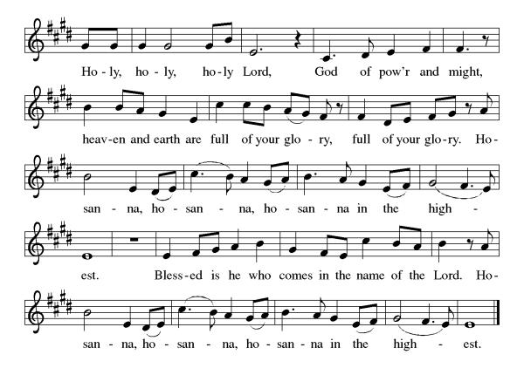
Eucharistic Prayer
Blessed are you, O God of the universe. Your mercy is everlasting, and your faithfulness endures from age to age.
Praise to you for creating the heavens and the earth. Praise to you for saving the earth from the waters of the flood. Praise to you for bringing the Israelites safely through the sea. Praise to you for leading your people through the wilderness to the land of milk and honey. Praise to you for the death and resurrection of Christ. Praise to you for your Spirit poured out on all nations.
In the night he was betrayed, our Lord Jesus took bread and gave thanks; broke it, and gave it to his disciples saying: Take and eat; this is my body given for you. Do this for the remembrance of me.
After supper he took the cup, gave thanks and gave it for all to drink saying: This cup is the new covenant in my blood, shed for you and for all people for the forgiveness of sin, Do this for the remembrance of me.
For as often as we eat of this bread and drink from this cup we proclaim the Lord’s death until He comes.

Christ has died
Christ is risen.
Christ will come again.
Gathered into one, by the Holy Spirit let us listen to the words that Jesus taught us.
The Lord’s Prayer
Our Father, who art in heaven, hallowed be thy name, thy kingdom come, thy will be done, on earth as it is in heaven. Give us this day our daily bread; and forgive us our trespasses, as we forgive those who trespass against us; and lead us not into temptation but deliver us from evil. For thine is the kingdom, and the power, and the glory, forever and ever. Amen.

Invitation to Communion
S.A.M. Bob: There is a place for you at the table of God. Come, receive the food that does not perish, a test of life eternal. Come and taste on your lips a Love we cannot comprehend.
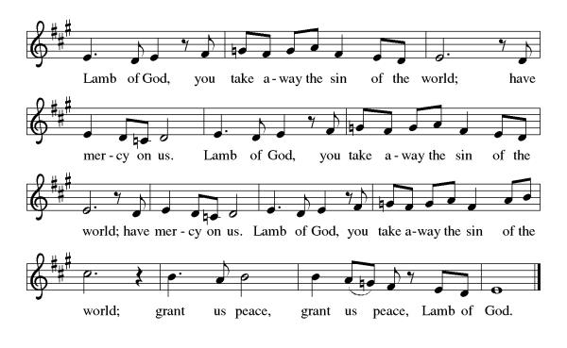
C: Amen

Please come forward to receive

Communion Anthem: Lo! He Comes With Clouds Descending ELW 435
S.A.M. Bob: We are now a tabernacle with Christ inside of us. Let us rejoice and be glad at the Lord’s table.
C: Amen
Prayer after Communion
O God, through this meal you have strengthened us and appointed us to be your servants. Send us to do good and to share our possessions with all in need. We ask this in Jesus’ name. Amen
Blessing
S.A.M. Bob: The God of righteousness, who gives justice to the oppressed, who gives food to the hungry, who sets the prisoners free, ☩ bless you now and forever.
C: Amen.

Sending Hymn: Fling Wide the Door ELW 259
- Fling wide the door, unbar the gate; the King of glory
comes in state; the Lord of lords and King of kings, the
Savior of the world who brings his great salvation
to the earth. So raise a shout of holy mirth and
praise our God and Lord, Creator, Spirit, Word.

2 He is the rock of our belief, the heart of mercy's
gentle self. His kingly crown is holiness; his
scepter is his loveliness; he brings our sorrows
to an end. Now gladly praise our king and friend, and
worship him with song for saving us from wrong.

3 Oh, happy towns and blessed lands that live by their true
king's commands. And blessed be the hearts he rules, the humble places where he dwells. He is the rightful
Son of bliss who fills our lives and makes us his, creator
of the world, our only strength for good.

4 Come, Lord, our Savior, Jesus Christ; our hearts are open
wide in trust. Oh, show us now your lovely grace, upon
our sorrows shine your face, and let your Holy
Spirit guide our journey in your grace so wide. We
praise your holy name, from age to age the same!
Text: Georg Weissel, 1590-1635; tr. Gracia Grindal, b. 1943
Text © 1978 Lutheran Book of Worship, admin. Augsburg Fortress.
Duplication in any form prohibited without permission or valid license from copyright administrator.

Dismissal
S.A.M Bob: Go in peace to love and serve our Lord.
C: Thanks be to God.
Postlude: instrumental
Unless otherwise noted, materials used in this bulletin are:
From Sundays and Seasons.com. Copyright 2015 Augsburg Fortress. All rights reserved. Reprinted by permission under Augsburg Fortress Liturgies Annual License #SAS028635. Music is reprinted under OneLicense.Net #A712074 and/or Augsburg Fortress #SBL12176H. Scripture, unless otherwise noted, is from the New Revised Standard Version Bible, Copyright © 1989, Division of Christian Education of the National Council of the Churches of Christ in the United States of America. Used by permission. All rights reserved.
Announcements for November 29th and 30th
ATTENDANCE
Dorth Rainear Svc, Friday, November 21 47
Saturday, November 22nd, 4pm 38
Sunday, November 23rd, 9am 48
Drive-Up Communion 2
135

The Altar Flowers are given this week by Bob and Mary Schlumberger, in honor of their anniversary!

This Week at St. Timothy's
Monday, December 1st 11am – Healthy Start
Tuesday, December 2nd
Wednesday, December 3rd 1pm – Card Makers, 2pm – Prayer Time, 4pm – “A Time for Waiting” Soup Supper
Thursday, December 4th 9:30am – Prayer Group, 11am – Miniatures, 3:30pm – Chimes, 4:30pm - Choir
Friday, December 5th 9:30am – Prayer Group
Saturday, December 6th 4pm - Worship
Sunday, December 7th 9am – Worship, 10:15-10:45 – Drive Up Communion, 10:30 – Adult SS, Coffee Fellowship


CHRISTMAS POINSETTIAS
If you wish to purchase a poinsettia for our Christmas services, there is a sign-up sheet on the bulletin board in the Narthex area. The cost per 6” plant is $15.00 which includes a $3.00 donation for the food pantry. Please put your payment in the church offering and designate it “Poinsettia”.

Advent/Christmas Schedule
Mid-week Advent “A Time for Waiting” Soup Supper, 4pm Wednesday, December 3rd, 10th, and 17th
Christmas Eve – Pre-service Music 4:30pm, Service at 5pm
Christmas Day – Pre-service Music 9:30am, Service at 10am.

