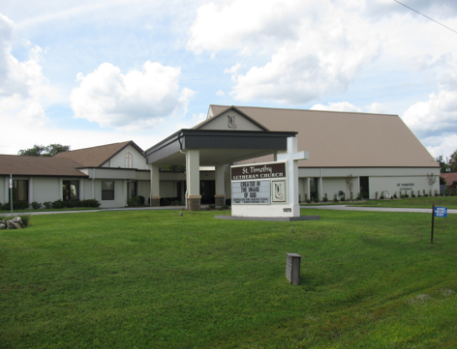

ST. TIMOTHY EVANGELICAL
LUTHERAN CHURCH
Vineyard Views
January 2026

S.A.M.’s Corner
S.A.M. BOB BONOMO
January 2026
Greetings from Our Lord and Savior Jesus Christ.
God is good. He has given us a new year with blessings and many wonderful opportunities to continue His work through us. Frank Hofstetter and I have reviewed the Time and Talent sheets that were returned, and I am joyfully impressed that many folks were touched by the Holy Spirit to commit to the talent they are comfortable with. Making this commitment, represents the love, trust and hope we share in Our Lord and our dedication to our community.
We are working on a format for those who will be involved in Worship for Saturdays and Sundays. Ushers, Readers, Assisting Ministers, Communion Assistants, Altar Guild (men or women), site and sound booth, so all can plan ahead.
Bible Study for Beginners will commence on January 15, 2026, at 11:00 am to 12:00 pm. In our fellowship hall. Please bring your bibles.
Wow, Advent and Christmas Season is behind us, but up and coming quickly is Lenten Season.
Ash Wednesday: February 18, 2026
For the next five Wednesday’s during Lent, there will be a soup/bread and butter supper, followed by attendance in the Sanctuary as we read Two Stations of the Cross, each week in prayer. A discussion will follow.
The calendar for Holy Week will be announced as we get closer.
My heartfelt thank you goes out to all of St. Timothy volunteers, who continue to do God’s Work.
Paul’s Letter to the Philippians:
“I thank my God every time I remember you, constantly praying with joy in every one of my prayers for all of you, because of your sharing in the Gospel from the first day until now.”
Blessings and Peace be with all of you,
S.A.M. Robert (Bob) Bonomo

“Like good stewards of the manifold grace of God, serve one another with whatever gift each of you has received.”
1 Peter 4:10

REMINDER – ANNUAL CONGREGATIONAL MEETING IS SUNDAY, JANUARY 18TH AFTER SERVICE. PLEASE READ YOUR COPY AND WRITE YOUR QUESTIONS AND CONCERNS ON THE BLANK PAGES PROVIDED IN THE BACK.
THE POWER OF PRAYER IN ACTION AND INSPIRATION

“THANKS-LIVING”
By Barbara Carson

Now that Thanksgiving is behind us and the holidays are in full swing, we got a little taste of excitement and joy and a different mindset of this season of giving. For some it could probably be the only time when people really truly think about giving to others. Maybe it feels like a formality for some because it is the right thing to do or they are expected to think of giving to others, but we can become more mindful of our surroundings and what we can do for others.

With this mindfulness we can go a little further and think about “Thanks-living”. I first heard that word in our devotional book. I thought about the “living” part and what it truly can bring to our lives. It can bring to our everyday lives a new way of living through having gratitude in everything we do. Psalm 107:8 – “Let them give thanks to the Lord for His love and the miracles he does for the people.” If we have and show the love of God in ourselves, it shows through us and attracts those around us leaving a glow of God’s love. It is like a “Christ-light” for others. The Holy Spirit spreads to everyone through our “thanks-living”. Living a life always of gratitude and praise for everything regardless of what it is. God knows you inside and out and what direction his will is for you. By “thanks-living” we are “God-serving”. I Corinthians 5:20 “Always give thanks to God the Father for everything, in the name of our Lord Jesus Christ.”

Consistent living with gratitude is a lifelong journey and can lead to daily blessings. Blessings we sometimes don’t even know we have but if we live our life with “thanks-living of continued gratitude, praise and even prayer our journey is so much better. These three things are what gets us to the “thanks-living” in our life. Our whole being is filled with the love of the Holy Spirit of Christ who leads us to the joy of living for and with Christ.

Psalm 9:1 – “I will give thanks to the Lord with my whole heart, I recount all of your wonderful deeds.” Colossians 4:2 “Devote yourself to prayer. Be watchful and thankful.”

So, turn on that Christ- light and let Christ shine through to reveal a life of “Thanks-living”.
HAPPY HOLIDAYS, AMEN!

Benevolence for January - Lutheran Social Services of Florida
The mission of this organization is to improve the quality of life for people in need. They are involved in programs such as Head Start, providing access to health care, Substance Abuse Treatment Programs, Family Counseling, Housing Assistance, and Shelters.
WELCA Update – updated 1/8
Dear Sisters in Christ,
On Tuesday, January 20, 2026 at 1:00pm, we will have our next WELCA membership meeting. We have a special guest speaker, Nancy Kennedy, Author & Speaker. Refreshments will be served. Let’s all welcome Nancy back to St. Timothy, as she was here during our 50th celebration. She commented on how warm and friendly our church family was to her. I have missed all of you and I am grateful for all of your love & prayers during my illness.

Blessings, Mary Schlumberger - President


2026 MINI GRANNY’S ATTIC
Where: ST. TIMOTHY LUTHERAN CHURCH
1070 N. SUNCOAST BLVD.
CRYSTAL RIVER, FL 34429
(352) 795-5325

When: FRIDAY, FEBRUARY 13, 2026
8:00 am to 2:00 pm

What: Delicious homemade goodies in the Bake Shop
Ever-popular men’s outdoor treasures
Terrific Buys Throughout Granny’s Attic

Save the date. Come join in the fun!


We kick off the Souper Bowl of Caring on January 17, 2026, and it will last until the Super Bowl is played on February 08, 2026. We are collecting soup along with canned fruit and canned vegetables. On February 8th, me, Randy, and whoever else wants to join us will tabulate the cans and come up with the winner. We will compare our “score” to the actual score and see how well we predicted the winner. All cans collected will then be brought to the Life Tree Church Food Pantry on Tuesday, February 10th, who is the real winner of this event.
Thanks so much
Barbara, "The Coach"

Please check for the following sign-up sheets
Worship Helpers – bulletin board

DEADLINES
Announcements
Please be aware that if you have entries for the weekend worship announcements you need to have them in on Tuesday prior, as we are preparing and printing them no later than Thursday.

Vineyard Views
If you have submissions for the February Vineyard Views, please have them in the office no later than the end of day on Tuesday, January 23rd.

NEW ZOOM LINK FOR ADULT SUNDAY SCHOOL – 9/18
Topic: Adult Sunday School Class
Time: Sep 21, 2025 10:30 AM Eastern Time (US and Canada)
Every week on Sun, 97 occurrence(s)
Please download and import the following iCalendar (.ics) files to your calendar system.
Weekly: https://us02web.zoom.us/meeting/tZwrc-mprDMoH9YRklu1WcmVIop862c72xVO/ics?icsToken=DBOIHJoC7iVwo_7kCQAALAAAABAB_uGypwq2ymkMO9EqrhDMoZY3vO7cudxQ3PHNM4LxWE7vm8v6Hf2LmVyJEkPyvcQ1Vmg_NR4W6BglNTAwMDAwMQ&meetingMasterEventId=3pLv0et_SMuCQYJkMknIyQ
Join Zoom Meeting
https://us02web.zoom.us/j/88640128252?pwd=asNJ6OiNGFFTNzwNA5yhkvPpmt6VCT.1
Meeting ID: 886 4012 8252
Passcode: 898938

CALLING ALL RINGERS OR POTENTIAL RINGERS!!
We’d like to expand the chimes choir (and have enough ringers for when people are out of town). Contact Sally Hennessey or Barbara Johnson.



INFORMATION FROM THE FINANCE COMMITTEE
AND YOUR TREASURERS
In the hope of getting ahead of our property, liability and flood insurance costs for next year, we have been trying to save toward those expenses. (Property and liability premiums are due by June 1st of each year, and flood is due November 1st.) We would appreciate any additional donation you could make. Please include that amount with your regular offering and designate it as “Insurance” on the offering envelope.
The lighting updates and replacements in the Sanctuary and throughout St. Timothy have been completed. What a wonderful improvement it is! The cost of this project was $9,500.00. As of December 14th we have received $5,508.38 in designated offerings to help with this expense. If you would like to help defray the cost, please note your donation as “Lighting Expense” on your offering envelope.

If you have not completed and returned your Time and Talent Sheets and Giving Card for 2026, please do so as soon as possible. This helps us plan for the current year.

A weekly offering update is given with the email announcements. We are most grateful to all of you who support our programs through your prayers, offerings, time and talents.

PLEASE PLAN TO ATTEND THE ANNUAL CONGREGATIONAL MEETING ON JANUARY 18, 2026 FOLLOWING THE SERVICE. IT WILL BE HELD IN THE FELLOWSHIP HALL.



THRIVENT FINANCIAL NEWS FOR JANUARY 2026
$$$THRIVENT CHOICE DOLLARS®$$$
Thanks so much to our Thrivent Financial members and friends who direct their Thrivent Choice Dollars® to available for activities and projects for our mission and ministry here at St. Timothy. If you are an eligible Thrivent Financial member and have Choice Dollars® available, please call Thrivent (800-847-4836) and say “Thrivent Choice®” or go online to ww.thrivent.com/thriventchoice and direct your dollars…hopefully to St. Timothy Lutheran Church in Crystal River. For 2025 our church has received $2085.00 through this program. Many thanks to our members who recently designated their dollars:

Bill Dively Lynn Dively

THRIVENT ACTION TEAMS
Thrivent Action Teams make it easy for you to bring people together to make a positive change in your community! When you see a need, apply to lead a volunteer team. Once your idea is approved, a Thrivent Action Kit is delivered to your door. It’s packed with everything you need to help make your project a success. It even includes $250.00 in seed money to help get your project started. After you finish the project, you report the results on-line to Thrivent. This program is brought to you by Thrivent Financial because they believe that being wise with money and living generously go hand in hand. All your questions and requests for this funding program will be answered by going to Thrivent.com/actionteam.***Please note that Thrivent Financial funds accessed for all programs and activities involving St. Timothy Lutheran Church need to be approved by a Committee and the Congregational Council. 2025 Thrivent Action Teams that were approved: World’s Greatest Baby Shower (Bump2Baby), Easter Food Boxes, Life Tree Food Pantry, God’s Work Our Hands, Thanksgiving Food Boxes, Ruth Circle’s December Project and PB&J Ministry.

THE $250 IN SEED MONEY IS A GIFT FROM THRIVENT THAT WE CAN USE TO HELP WITH COMMUNITY OUTREACH AND PROJECTS INVOLVING OUR CONGREGATION. THESE FUNDS ARE IN ADDITION TO OUR BUDGETED AMOUNTS AND OFFERINGS AND DONATIONS MADE BY OUR MEMBERS AND FRIENDS.

Financial Representatives for answering questions and offering advice on Thrivent investments and products are:

Katherine Gross Kevin Braunschweiger
in Gainesville, FL in Ocala, FL
352-505-8905 352-440-6784
Katherine.gross@thrivent.com

Virtual Advice Team – 855-303-7402

HAVE A BLESSED, HAPPY AND HEALTHY 2026!
Food Pantry – updated 12/18
The food pantry continues to operate on the 2nd and 4th week of every month from 9AM- noon. We continue to inform the congregation as to the needs of the pantry via the weekly announcements. The current needs are chili, mac-n-cheese, fruit and tuna. Thanks to all who contribute food. You can also contribute monetarily by writing out a check made out to Life Tree Church with Food Pantry in the memo line or writing out a check to Barbara Johnson and putting food pantry in the memo line, and placing it in my mailbox, #210. We will also accept cash donations. Please put it in an envelope in my mailbox, #210 and put your name on it so I know who you are. If you would like a receipt, please let me know.
On December 9, 2025, the food pantry had 61 individual people come in which consisted of 128 adults and 16 children for a total of 144 people. We had 8 new families consisting of 12 adults and 8 children for a total of 20 people.

The next food pantry will be Tuesday, January 13th. Barbara

Healthy Start – updated 1/8
Nothing is needed for February. Please help us stock up for March.
Baby bibs, baby blankets, baby lotion, baby oil, baby shampoo, baby wipes, booties or socks, diaper cream, gentle soap (like ivory), toy or teething ring, wash cloths, and Vaseline.

Carolyn Fialkowski

PB&J MINISTRY UPDATE – 12/30
There is a sign-up sheet on the board next to the kitchen. We will be packing on the first Monday of the month at 10am. We need about 6 people so we are done by 11. Please let me know if you can help. Barbara Carson


MESSAGE FROM REGINA
Please, if you are at a church function, think about snapping a few photos for everyone to enjoy. Thank you in advance.

SERVING HANDS
Serving Hands is a program created to help members of our own congregation. Serving Hands is there for you if you need some help in the following areas: a meal brought to you, driving you to an appointment, a friendly visit, doing a household chore, communion brought to you, walking your dog, or picking up food for your pet, etc. These are one-time opportunities, not forever experiences. Please contact Carolyn Fialkowski at 814-392-4281, or Jean Fowler at 586-322-8337 if you need help.
Please don’t hesitate to call. We want to serve you! Also, if you are willing to help with any of these services, there is a sign-up chart on the kiosk in the entrance way of the church or call one of these ladies.

AED /Medical response :
We have a poster that is behind the kiosk across from our AED in the narthex. An emergency incident can happen at any time, and it is good to be prepared. The poster explains a “hands only “ CPR protocol as the first line of an emergency of that kind and is very easy for anyone. Please take a look and refresh yourself on the protocol. Our AED is valuable for saving lives but initiating CPR is essential. We do have several people in our congregation that have more detailed experience to assist as needed. For any questions, please ask Barbara Carson.
Instructional video on how to use the Philips AED.
https://youtu.be/t6GV9PAbgM4?si=dZuGq8aLjfvpFiM-

ST TIMOTHY’S WEBSITE
Here is the St. Timothy website address: https://www.sttimlutherancrystalriver.com/

There are links for the weekend’s services on the homepage. Please note that the links will change every week, since this is a YouTube file address; every service has its own link. Watch for an email with the updated links when they are ready. The video links for previous weekends will still be available at the bottom of the webpage, as the links are updated each week. Please contact us if you would like a CD of any of the services to listen to. Be sure to check out our children’s artwork at the bottom of the home page. We hope to add more as they send it to us.

Here is a link to St Timothy's YouTube:


https://www.youtube.com/channel/UC5xrMj8-8_6iyR_KxjFAwRQ/videos

Facebook
See our Facebook page for information about upcoming events and Please feel free to message us with suggestions about content. - Regina


St. Timothy Evangelical Lutheran Church | Facebook


The Sunshine Card Makers
The Card Makers meet the first Wednesday of the month at 1pm, in the Fellowship Hall.
-Kathy G

Senior Care Resources
Caring.com is a free resource that provides comprehensive information on topics like financial support, and care options to family caregivers seeking information as they care for aging parents by AARP, The Administration for Community Living, The National Legal Resource Center, and Forbes, as well as referenced by many governmental agencies and organizations across the internet.
https://www.caring.com/senior-living/memory-care-facilities/
https://www.caring.com/senior-living/memory-care-facilities/florida
https://www.caring.com/caregivers/alzheimers/
https://www.caring.com/caregivers/dementia/

WE HAVE SEVERAL HANDBOOKS ON DEMENTIA IN THE CHURCH LIBRARY, IF ANYONE WOULD LIKE INFORMATION

We have the January, February, and March 2026 Christ in Our Home booklets. There are some on the table by the mailboxes or you may request one to be put in your box.

HERE AND THERE WITH THE FOLKS OF ST TIMOTHY

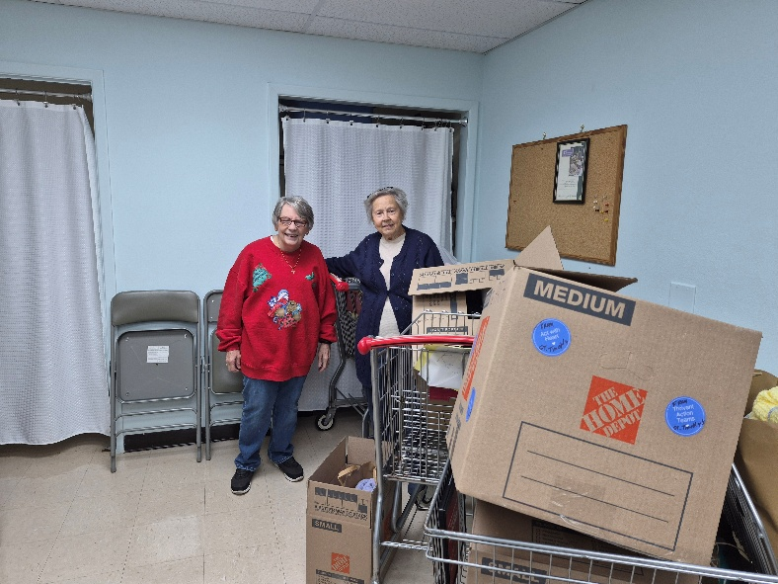
Ruth Circle Christmas Project Packing
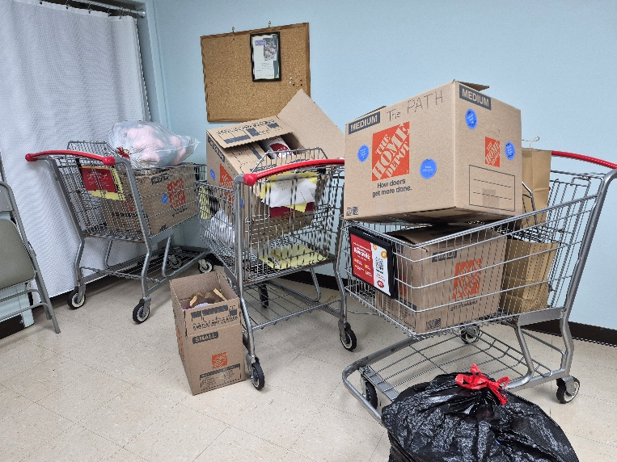

PB&J Packing
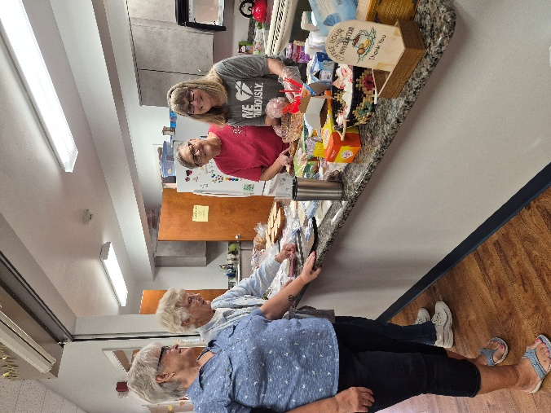
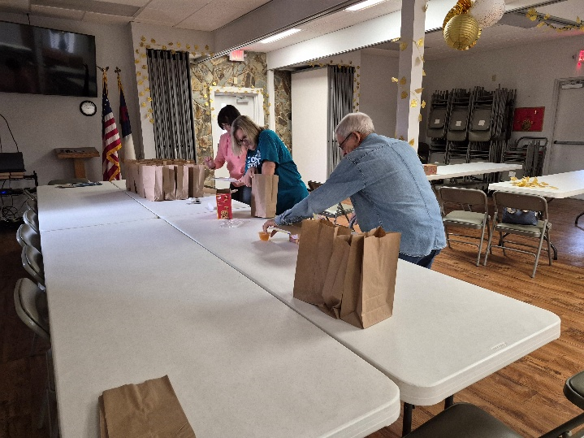



Lloyd DeBusk 01/02
Beverly Williams 01/02
Patricia Pule 01/03
Deb Miller 01/04
Eric Colfer 01/06
Barbara Johnson 01/12
Diana Mazzuchi 01/13
Helmutas “Tom” Ambrozaitis 01/15
Fred Steckert 01/17
Carol Johnson 01/20
Bob Harkness 01/26
Susan Gable 01/30

Birthday Blessings!
SUNDAY | MONDAY | TUESDAY | WEDNESDAY | THURSDAY | FRIDAY | SATURDAY
January 2026 |  |  |  | 1  Bob on vacation  9:30am Prayer Group  11:00 Miniatures  4:30 Choir | 2  Bob on vacation | 3  Bob on vacation  4pm Worship
4  Bob on vacation  9am Worship  10:15-10:45 Drive-Up Communion  10:30 Coffee Fellowship, Adult SS | 5  Bob on vacation  10am – PB&J Ministry  11am – Healthy Start | 6  Bob returns | 7  11am Citrus Blessings  1pm Card Makers | 8  9:30am Prayer Group  11:00 Miniatures  4:30 Choir | 9 | 10  4pm Worship
11  9am Worship  10:15-10:45 Drive-Up Communion  10:30 Coffee Fellowship, Adult SS | 12  10:30 – Ruth Circle@ Barb C’s house | 13  9-12 Food Pantry | 14 | 15  9:30 – Prayer Group  11am - Miniatures  11am – Bible Study for Beginners  4:30 Choir | 16  1pm Royal Dalton Memory Care Svc | 17  4pm Worship
18  9am Worship  10:15-10:45 Drive-Up Communion  Annual Congregational Meeting | 19 | 20  1pm WELCA  Guest speaker, Nancy Kennedy from the Chronicle | 21  1pm Worship & Music | 22  9:30am Prayer Group  11:00 Miniatures  4:30 Choir | 23 | 24  4pm Worship
25  9am Worship  10:15-10:45 Drive-Up Communion  10:30 Coffee Fellowship, Adult SS | 26 | 27  9-12 Food Pantry | 28 | 29  9:30am Prayer Group  11:00 Miniatures  4:30 Choir | 30 | 31  4pm Worship

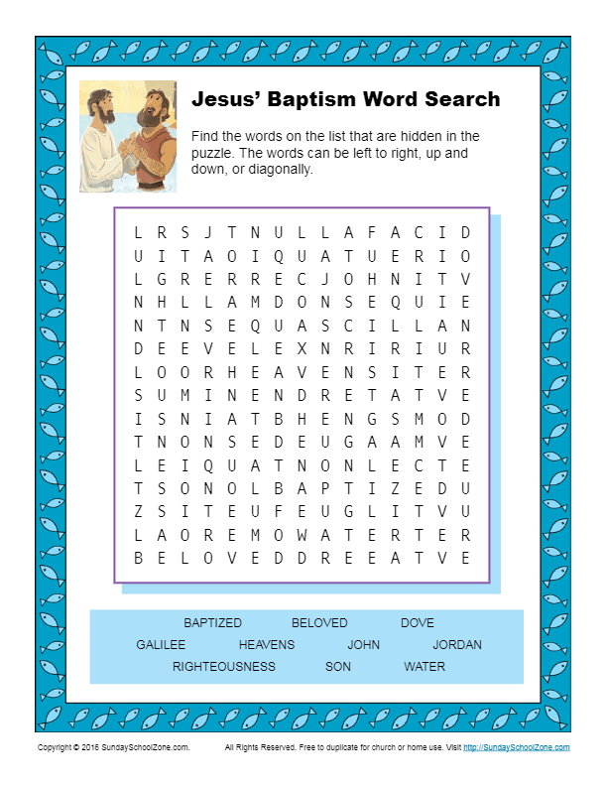
St. Timothy Lutheran Church
S.A.M. Robert “Bob” Bonomo
1070 N. Suncoast Blvd.
Crystal River, FL 34429
Phone: 352-795-5325

Church email: crsttimothy@tampabay.rr.com
Website: www.sttimlutherancrystalriver.com

Lay Minister: Frank Hofstetter
Director of Music: Sally Hennessey
Saturday Pianist: Bill Robinson
Church Secretary: Regina Mendicino
Sexton: William “Bill” Dexter

2025 Congregational Council
President: Ron Roecker
Vice-President: Barbara Johnson
Secretary: Jean Fowler
Treasurers: Lynn Dively & Cheryl VanHorn
Financial Secretary: Randy Holden & Dick Kleinsmith
Council Members: Carolyn Fialkowski, Andrea Mitchell, Fola Long, and Marsha Gibson

Weekly Worship
Saturdays 4pm
Sundays 9am
Communion available at both services
Children’s Sunday School - 9am
Adult Sunday School - 10:30am
Drive-Up Communion – 10:15-10:45
Saturday and Sunday Services - links ONLINE

