St. Timothy Lutheran Church
Sunday, November 9th
The 22nd Sunday after Pentecost

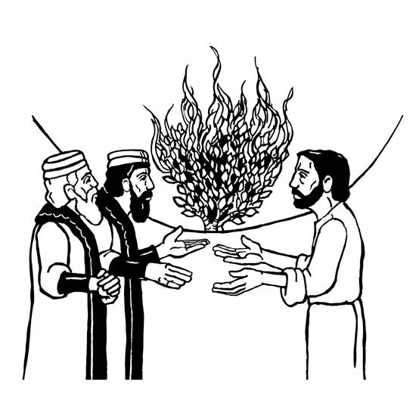

We worship on the first day of the week because Jesus was raised on that day. Every Sunday is a little Easter. This Sunday feels more like Easter than many as the appointed texts celebrate the reality of the resurrection. Live it up this Lord’s day. Our God is the God of the living.

St Timothy Worship Planning Team
S.A.M. Bob Bonomo
Deacon, Frank Hofstetter
Director of Music, Sally Hennessey
Saturday Pianist, Bill Robinson

Pre-Service Music: Deep River ACS 951

Welcome and Sharing of Congregational News

Prelude

Confessions and Forgiveness
Blessed be the holy Trinity, ☩ one God,
who forgives all our sin,
whose mercy endures forever.
Amen.
Let us confess our sin in the presence of God
and of one another.
Silence is kept for reflection.
Faithful God,
you have shown us the ways of your heart,
yet we stray from your paths.
We are stuck in sinful systems of oppression
and do not embrace the freedom
of your faithful promises.
We ignore our neighbors.
We exploit the earth.
We reject your abundance,
trusting our impulses instead of your steadfast love.
Repair our relationships,
restore what we have broken,
renew our hearts,
and bring us to new life.
Amen.
Hear the good news:
God the Faithful One loves you,
☩ in Christ Jesus your sins are forgiven,
and by the power of the Holy Spirit you are set free.
Amen.

Gathering Hymn: Jerusalem, My Happy Home ELW 628

1 Jerusalem, my happy home, when shall I come to thee?
When shall my sorrows have an end? Thy joys when shall I see?

2 O happy harbor of the saints, O sweet and pleasant soil!
In thee no sorrow may be found, no grief, no care, no toil.

3 Thy gardens and thy gallant walks continually are green;
there grow such sweet and pleasant flow'rs as nowhere else are seen.

4 There trees forevermore bear fruit and evermore do spring;
there evermore the angels sit and evermore do sing.

5 Jerusalem, Jerusalem, God grant that I may see
thine endless joy, and of the same partaker ever be!

Text: F.B.P., 16th cent.

S.A.M. Bob - The Lord be with you.
C – And also with you.

Prayer of the Day
O God, our eternal redeemer, by the presence of your Spirit you renew and direct our hearts. Keep always in our mind the end of all things and the day of judgment. Inspire us for a holy life here, and bring us to the joy of the resurrection, through Jesus Christ, our Savior and Lord. Amen.
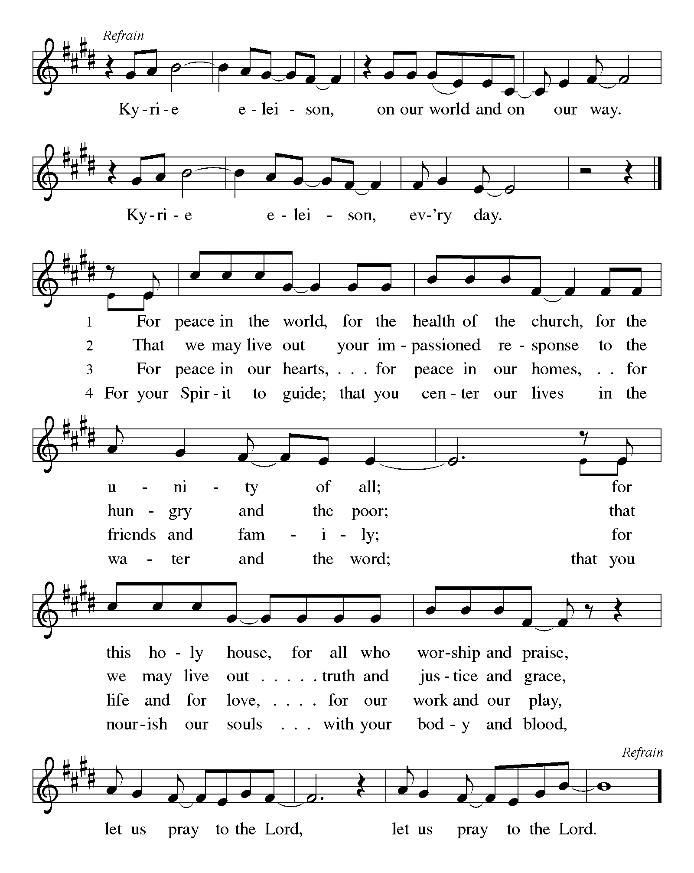
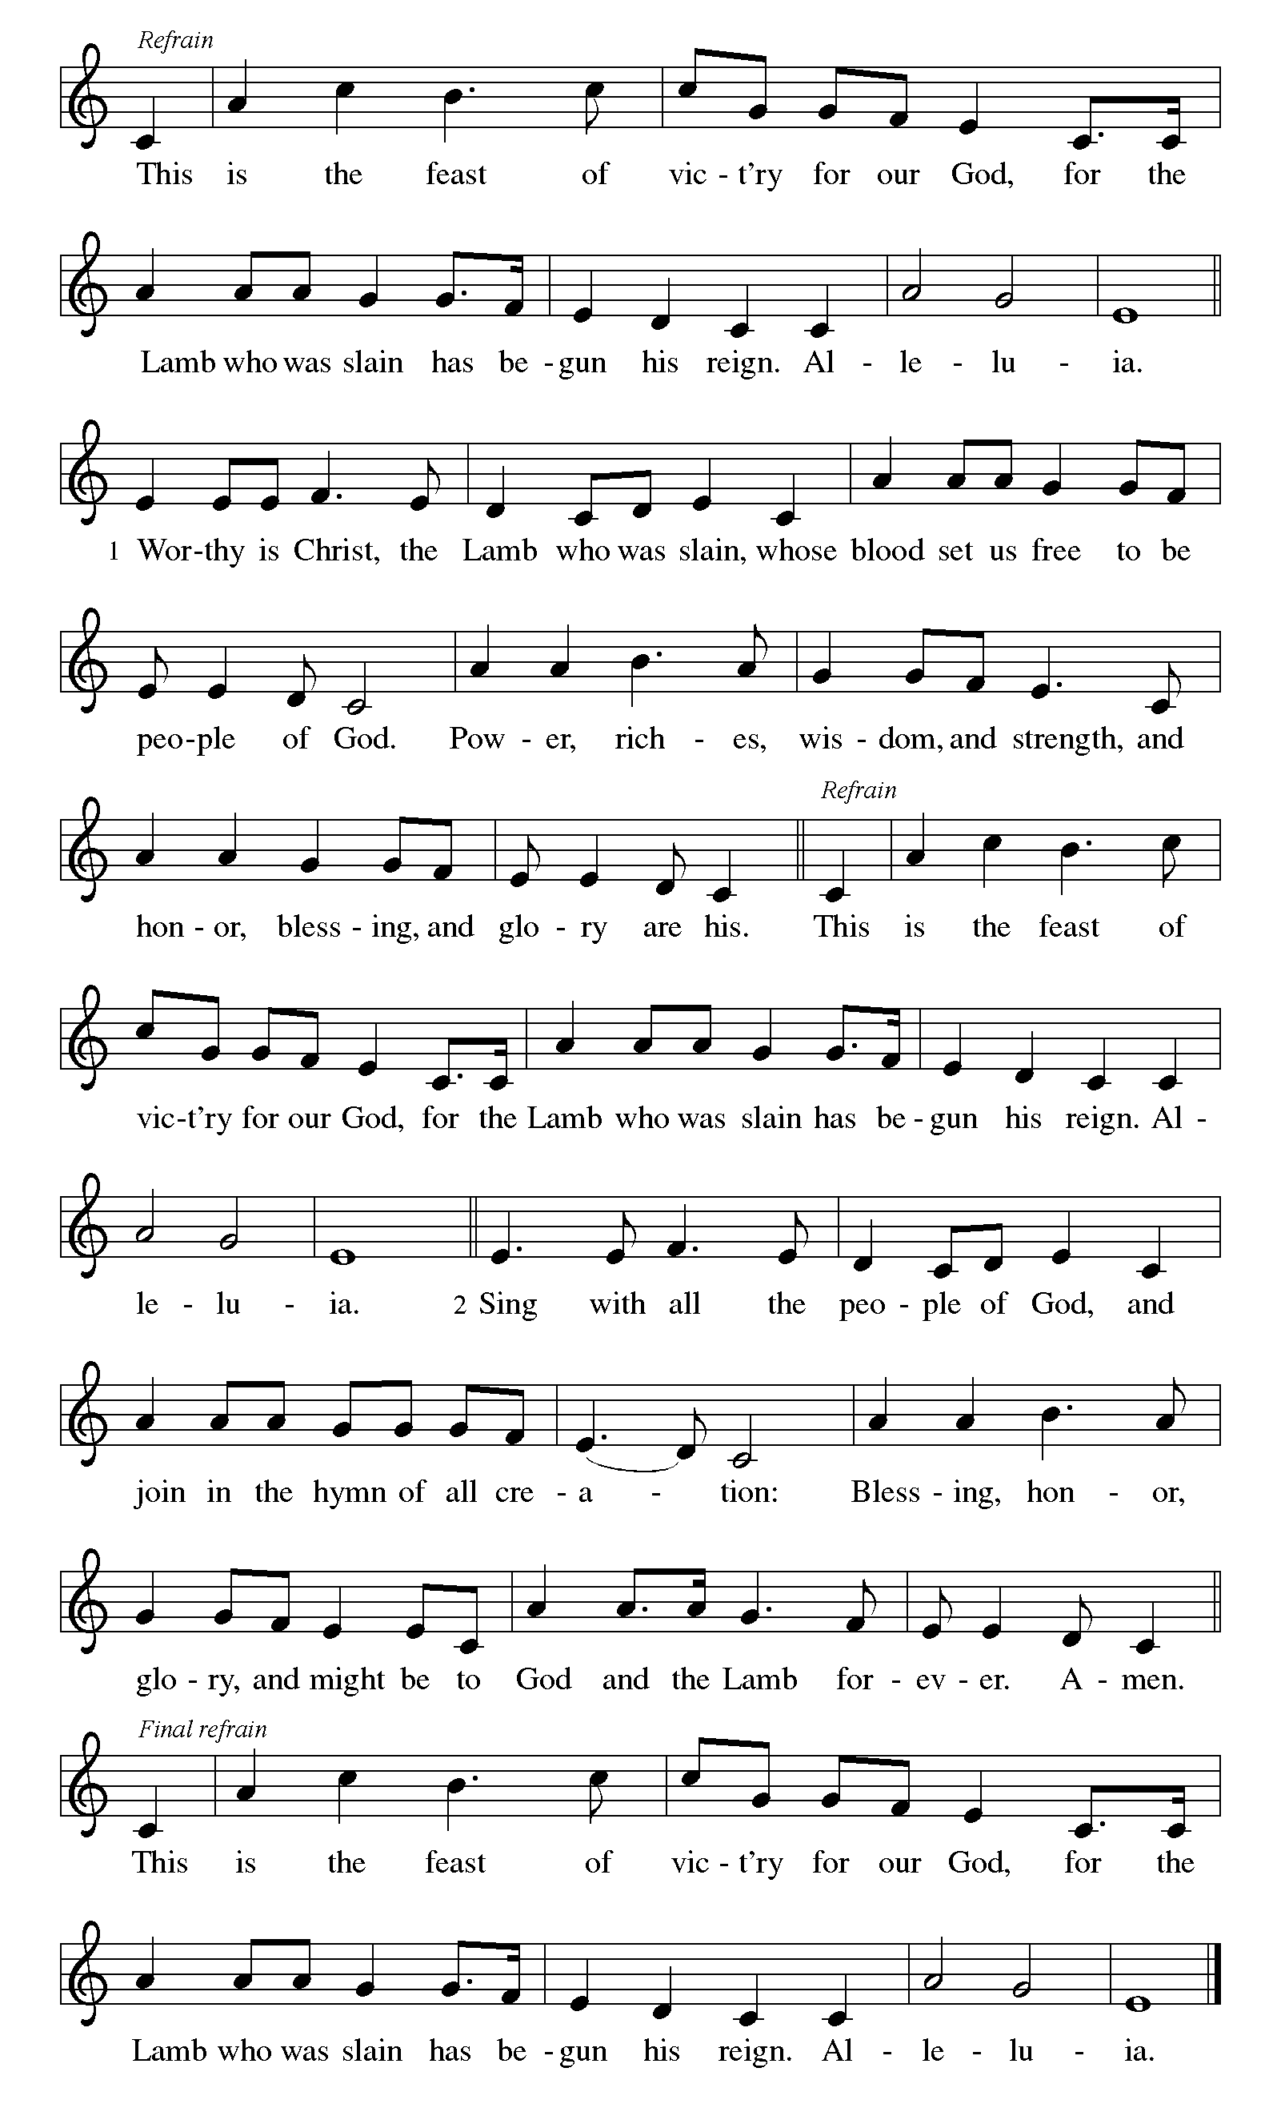

First Lesson: Job 19:23-27a
Job suffers the loss of children, wealth, and health. Accused by his companions of wrongdoing, he knows himself to be innocent. Here, in the midst of his suffering, Job clings to the radical hope that his vindicator, his redeemer, lives; and that one day he himself will see God.
²³ “O that my words were written down!
O that they were inscribed in a book!
²⁴ O that with an iron pen and with lead
they were engraved on a rock forever!
²⁵ For I know that my vindicator lives
and that in the end he will stand upon the earth;
²⁶ and after my skin has been destroyed,
then in my flesh I shall see God,
^{27a} whom I shall see on my side,
and my eyes shall behold, and not another.”

A – Word of God!

C – Words of Life!

Psalm 17:1-9

¹ Hear a just cause, O Lord; give heed to my cry;
listen to my prayer, which does not come from lying lips.
² Let my vindication come forth from your presence;
let your eyes be fixed on justice.
³ Examine my heart, visit me by night,
melt me down; you will find no impurity in me.
⁴ I have not regarded what others do;
at the word of your lips I have avoided the ways of the violent.
⁵ My footsteps hold fast to your well-worn path;
and my feet do not slip.
⁶ I call upon you, O God, for you will answer me;
incline your ear to me and hear my words.
⁷ Show me your marvelous lovingkindness,
O Savior of those who take refuge at your right hand from those who rise against them.
⁸ Keep me as the apple of your eye;
hide me under the shadow of your wings,
⁹ from the wicked who assault me,
from my deadly enemies who surround me

Second Lesson: 2 Thessalonians 2:1-5, 13-17
This portion of the letter provides encouragement for the church at Thessalonica during a time of confusion and opposition, as some allowed their concern over Jesus’ imminent return to divert them from the central teachings of the gospel.
¹ As to the coming of our Lord Jesus Christ and our being gathered together to him, we beg you, brothers and sisters, ² not to be quickly shaken in mind or alarmed, either by spirit or by word or by letter, as though from us, to the effect that the day of the Lord is already here. ³ Let no one deceive you in any way, for that day will not come unless the rebellion comes first and the lawless one is revealed, the one destined for destruction. ⁴ He opposes and exalts himself above every so-called god or object of worship, so that he takes his seat in the temple of God, declaring himself to be God. ⁵ Do you not remember that I told you these things when I was still with you?
¹³ But we must always give thanks to God for you, brothers and sisters beloved by the Lord, because God chose you as the first fruits for salvation through sanctification by the Spirit and through belief in the truth. ¹⁴ For this purpose he called you through our gospel, so that you may obtain the glory of our Lord Jesus Christ. ¹⁵ So then, brothers and sisters, stand firm and hold fast to the traditions that you were taught by us, either by word of mouth or by our letter.
¹⁶ Now may our Lord Jesus Christ himself and God our Father, who loved us and through grace gave us eternal comfort and good hope, ¹⁷ comfort your hearts and strengthen them in every good work and word.

A – Word of God! C – Words of Life!

Gospel Acclamation

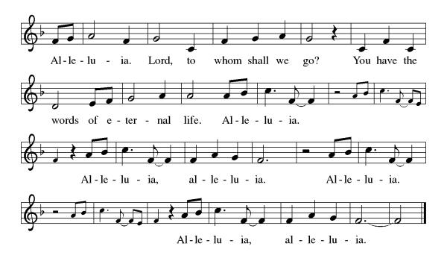
S.A.M. Bob: The Holy Gospel according to Luke, the 20th Chapter
C- Glory to you, O Lord.

Gospel: Luke 20:27-38
Some Sadducees, who do not believe in the resurrection of the dead, try to trap Jesus. They formulate the convoluted case of a serial widow who marries a succession of seven brothers. Jesus responds by teaching about God to whom all are alive and in whom all relationships are fulfilled.
²⁷ Some Sadducees, those who say there is no resurrection, came to [Jesus] ²⁸ and asked him a question: “Teacher, Moses wrote for us that if a man’s brother dies leaving a wife but no children, the man shall marry the widow and raise up children for his brother. ²⁹ Now there were seven brothers; the first married a woman and died childless; ³⁰ then the second ³¹ and the third married her, and so in the same way all seven died childless. ³² Finally the woman also died. ³³ In the resurrection, therefore, whose wife will the woman be? For the seven had married her.”
³⁴ Jesus said to them, “Those who belong to this age marry and are given in marriage, ³⁵ but those who are considered worthy of a place in that age and in the resurrection from the dead neither marry nor are given in marriage. ³⁶ Indeed, they cannot die anymore, because they are like angels and are children of God, being children of the resurrection. ³⁷ And the fact that the dead are raised Moses himself showed, in the story about the bush, where he speaks of the Lord as the God of Abraham, the God of Isaac, and the God of Jacob. ³⁸ Now he is God not of the dead but of the living, for to him all of them are alive.”

S.A.M. Bob- The Gospel of the Lord.
C - Praise to you, O Christ.
Sermon by S.A.M. Bob

Hymn of the Day: I Know That My Redeemer Lives! ELW 619 (v1-4 & 8)

- I know that my Redeemer lives! What comfort
this sweet sentence gives! He lives, he lives, who
once was dead; he lives, my ever-living head!

- He lives triumphant from the grave; he lives eternally
to save; he lives exalted,
throned above; he lives to rule his church in love.

- He lives to grant me rich supply; he lives to
guide me with his eye; he lives to comfort
me when faint; he lives to hear my soul's complaint.

- He lives to silence all my fears; he lives to
wipe away my tears; he lives to calm my
troubled heart; he lives all blessings to impart.

8 He lives, all glory to his name!
He lives, my Savior, still the same;
what joy this blest assurance gives:
I know that my Redeemer lives!
Text: Samuel Medley, 1738-1799, alt.

The Apostles’ Creed
I believe in God, the Father almighty,
creator of heaven and earth.
I believe in Jesus Christ, God’s only Son, our Lord,
who was conceived by the Holy Spirit,
born of the virgin Mary,
suffered under Pontius Pilate,
was crucified, died, and was buried;
he descended to the dead.
On the third day he rose again;
he ascended into heaven,
he is seated at the right hand of the Father,
and he will come to judge the living and the dead.
I believe in the Holy Spirit,
the holy catholic church,
the communion of saints,
the forgiveness of sins,
the resurrection of the body,
and the life everlasting. Amen.

Lord, listen to your children praying,
Lord, send your Spirit in this place;
Lord, listen to your children praying,
send us love, send us pow'r, send us grace.

Prayers of the People
Gathered with one voice, we offer our prayers for the church, the world, and all who are in need.
A brief silence.
God our Redeemer, bless your church universal and its leaders. Set all hearts on you from generation to generation in anticipation of Christ’s return.
Hear us, O God.
Your mercy is great.

God of life, we give thanks for the fruits and grains of harvest, for rivers and streams, for all that is made of rock and iron. Renew the earth’s natural resources and the lands from which they come.
Hear us, O God.
Your mercy is great.

God of justice, we give thanks for the service of our veterans and pray for those needing support for wounds of any kind. Strengthen those charged with the governance and protection of vulnerable populations. Bring an end to war throughout the world.
Hear us, O God.
Your mercy is great.

God who leads us to belief and truth, we give thanks that you are always and already here. Nurture and support those who are unsteady in mind, unsafe in spirit, or unwell in body (especially). Comfort those who suffer from trauma and exposure to traumatic events.
Hear us, O God.
Your mercy is great.

God who gathers us together, we give thanks for our pastors and deacons, teachers and musicians, administrators, and building caretakers. May they find joy in leadership as we grow in faith together. Hear us, O God.
Your mercy is great.

God of the saints, we give thanks for all who have died in faith. Uplift us as we honor their memory and await your coming in glory.
Hear us, O God.
Your mercy is great.

We offer these and all our prayers to you, O God, trusting in your grace and unyielding love, through Jesus Christ, our Lord.
Amen.

S.A.M.: May the peace of our Lord Jesus Christ be with you all.
C: And also with you.
S.A.M.: Let us now share this peace.
Offering is Brought to the Altar

Offering Prayer

We lift our voices, we lift our hands, we lift our lives up to you; we are an Offering. Lord, use our voices, Lord, use our hands, Lord, use our lives, they are yours: we are an offering. All that we have, all that we are, all that we hope to be, we give to you, we give to you. We lift our voices, we lift our hands, we lift our lives up to you; we are an offering, we are an offering.
S.A.M. Bob: The Lord be with you.
C: And also with you.

S.A.M. Bob: Lift up your hearts.
C: We lift them up to the Lord.

S.A.M. Bob: Let us give thanks to the Lord our God.
C: It is right to give our thanks and praise.

Preface
It is indeed right, our duty and our joy,
that we should at all times and in all places
give thanks and praise to you, almighty and merciful God, through our Savior Jesus Christ;
who on this day overcame death and the grave,
and by his glorious resurrection opened to us the way of everlasting life.
And so, with all the choirs of angels,
with the church on earth and the hosts of heaven,
we praise your name and join their unending hymn:

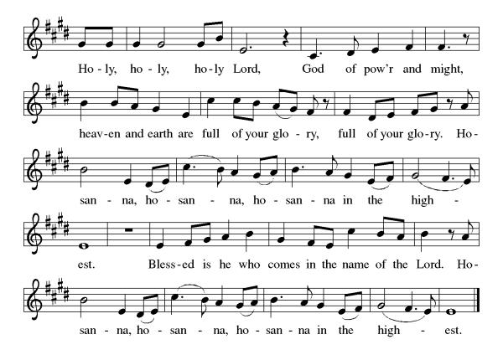
Eucharistic Prayer
Blessed are you, O God of the universe. Your mercy is everlasting, and your faithfulness endures from age to age.
Praise to you for creating the heavens and the earth. Praise to you for saving the earth from the waters of the flood. Praise to you for bringing the Israelites safely through the sea. Praise to you for leading your people through the wilderness to the land of milk and honey. Praise to you for the death and resurrection of Christ. Praise to you for your Spirit poured out on all nations.
In the night he was betrayed, our Lord Jesus took bread and gave thanks; broke it, and gave it to his disciples saying: Take and eat; this is my body given for you. Do this for the remembrance of me.
After supper he took the cup, gave thanks and gave it for all to drink saying: This cup is the new covenant in my blood, shed for you and for all people for the forgiveness of sin, Do this for the remembrance of me.
For as often as we eat of this bread and drink from this cup we proclaim the Lord’s death until He comes.

Christ has died
Christ is risen.
Christ will come again.

Gathered into one, by the Holy Spirit let us listen to the words that Jesus taught us.
The Lord’s Prayer
Our Father, who art in heaven, hallowed be thy name, thy kingdom come, thy will be done, on earth as it is in heaven. Give us this day our daily bread; and forgive us our trespasses, as we forgive those who trespass against us; and lead us not into temptation but deliver us from evil. For thine is the kingdom, and the power, and the glory, forever and ever. Amen.

Invitation to Communion
S.A.M. Bob: This is the Lamb of God who takes away the sins of the world. Happy are those who are called to His supper. Come and taste on your lips a Love we cannot comprehend.
C: Amen
Please come forward to receive

Communion Anthem: In Heaven Above ELW 630

S.A.M. Bob: We are now a tabernacle with Christ inside of us. Let us rejoice and be glad at the Lord’s table.
C: Amen

Prayer after Communion
O God, through this meal you have strengthened us and appointed us to be your servants. Send us to do good and to share our possessions with all in need. We ask this in Jesus’ name.
Amen

Blessing
S.A.M. Bob: The God of righteousness, who gives justice to the oppressed, who gives food to the hungry, who sets the prisoners free, ☩ bless you now and forever.
C: Amen.

Sending Hymn: Soon and Very Soon ELW 439

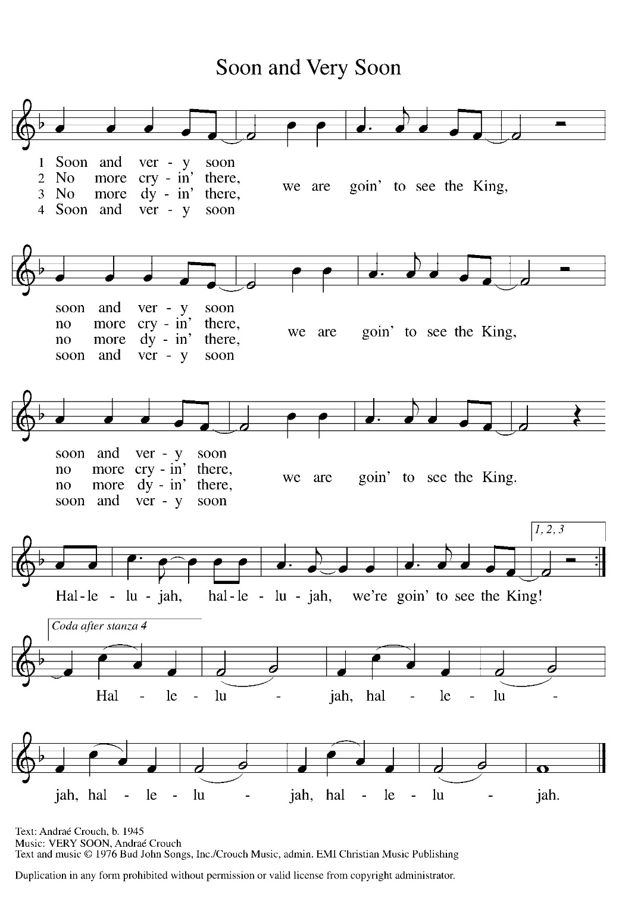

Dismissal
S.A.M Bob: Go in peace to love and serve our Lord.
C: Thanks be to God.
Postlude: instrumental
Unless otherwise noted, materials used in this bulletin are:
From Sundays and Seasons.com. Copyright 2015 Augsburg Fortress. All rights reserved. Reprinted by permission under Augsburg Fortress Liturgies Annual License #SAS028635. Music is reprinted under OneLicense.Net #A712074 and/or Augsburg Fortress #SBL12176H. Scripture, unless otherwise noted, is from the New Revised Standard Version Bible, Copyright © 1989, Division of Christian Education of the National Council of the Churches of Christ in the United States of America. Used by permission. All rights reserved.
Announcements for November 8th and 9th

ATTENDANCE
Saturday, November 1st, 4pm 22
Sunday, November 2nd, 9am 43
Drive-Up Communion 0
65

The Altar Flowers are given this week by Diane and Eddie Mason, to the glory of God!

This Week at St. Timothy's
Monday, November 10th 10:30am – Ruth Circle, 1pm – Garden Club (Fun with flowers)
Tuesday, November 11th VETERANS DAY, 9-12 Food Pantry
Wednesday, November 12th
Thursday, November 13th 9:30am – Prayer Group, 11am - Miniatures, 3:30 – Chimes, 4:30pm - Choir
Friday, November 14th
Saturday, November 15th 4pm - Worship
Sunday, November 16th 9am – Worship Installation of New Members, 10:15-10:45 – Drive Up Communion, 10:30 – Adult SS, Coffee Fellowship, Council

New members will be installed on Sunday, November 16th.

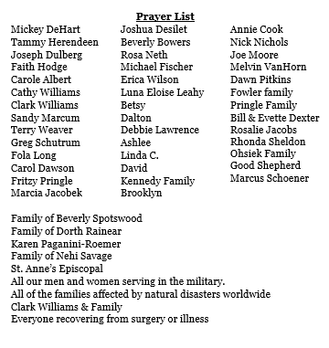
There will be a memorial service for Dorth Rainear at St. Timothy on Friday, November 21st at 1pm.

