A Service of Worship, Praise and Hope
Welcome to St. Timothy Saturday Evening Worship!
Lessons and Carols for Christmas
December 27th & 28th
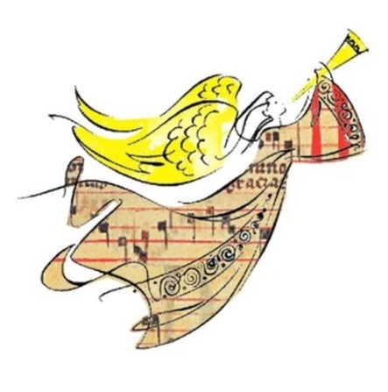

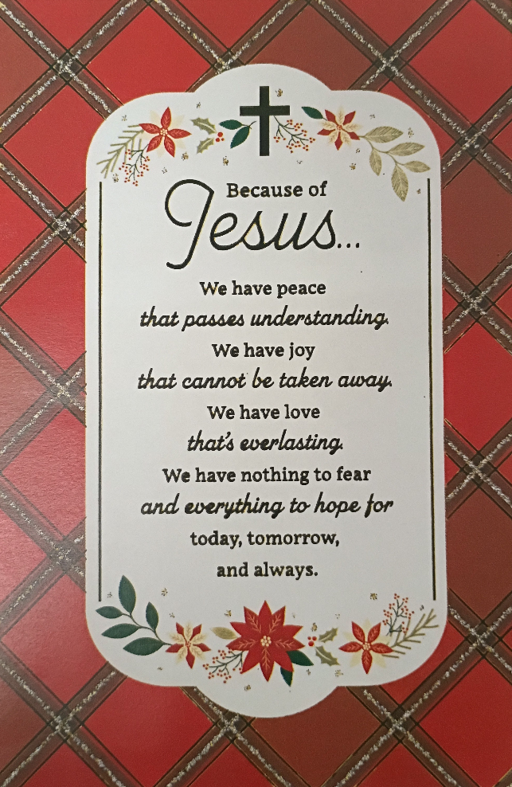
St Timothy Worship Planning Team
S.A.M. Bob Bonomo
Deacon, Frank Hofstetter
Director of Music, Sally Hennessey
Saturday Pianist, Bill Robinson

Pre-Service Music: The Bells of Christmas ELW 298
Welcome and Sharing of Congregational News
Prelude

Confession and Forgiveness
All may make the sign of the cross, the sign that is marked at baptism, as the presiding minister begins.
Blessed be the holy Trinity, ☩ one God,
Wonderful Counselor,
Mighty Savior,
Prince of Peace.
Amen.
Trusting in God’s steadfast love and faithfulness,
let us confess our sin.
Silence is kept for reflection.
Reconciling God,
we yearn for your presence to transform
our grief, pain, and despair.
We confess that we have not always prepared
room in our hearts for your love;
we have not always recognized
your presence among us;
we have not always embraced your message of peace.
We cry out, weary with the burden of violence,
oppression, and fear.
We confess our failure to make room
for those seeking refuge;
our participation in violent systems
that harm your innocent ones;
our reluctance to embody your good news.
Be born in us today
and teach us to sing the joyful song of your salvation.
Amen.
God’s grace upon grace flows over you.
☩ Christ’s presence redeems the whole creation.
Your sins are forgiven. Let the earth rejoice and be glad!
Amen.
Greeting
S.A.M. Bob: The joy of our Lord Jesus Christ, the compassion of God, and the creative power of the Holy Spirit be with you all.
C: And also with you.

Gathering Hymn: Angels We Have Heard on High ELW 289
1 Angels we have heard on high, sweetly singing o'er the plains,
and the mountains in reply, echoing their joyous strains.

Refrain
Gloria in excelsis Deo; gloria in excelsis Deo.
2 Shepherds, why this jubilee? Why your joyous strains prolong?
What the gladsome tidings be which inspire your heav'nly song? Refrain
3 Come to Bethlehem and see him whose birth the angels sing;
come, adore on bended knee Christ the Lord, the newborn king. Refrain
Text: French carol; tr. H. F. Hemy, The Crown of Jesus Music, 1864
S.A.M. Bob: The Lord be with you.
C: And also with you.

S.A.M. Bob: Let us pray.

First Reading: Genesis 1:1-5, 14-18

¹ When God began to create the heavens and the earth, ² the earth was complete chaos, and darkness covered the face of the deep, while a wind from God swept over the face of the waters. ³ Then God said, “Let there be light,” and there was light. ⁴ And God saw that the light was good, and God separated the light from the darkness. ⁵ God called the light Day, and the darkness he called Night. And there was evening and there was morning, the first day.
¹⁴ And God said, “Let there be lights in the dome of the sky to separate the day from the night, and let them be for signs and for seasons and for days and years, ¹⁵ and let them be lights in the dome of the sky to give light upon the earth.” And it was so. ¹⁶ God made the two great lights—the greater light to rule the day and the lesser light to rule the night—and the stars. ¹⁷ God set them in the dome of the sky to give light upon the earth, ¹⁸ to rule over the day and over the night, and to separate the light from the darkness. And God saw that it was good.

I Wonder as I Wander WOV 642
1. I wonder as I wander out under the sky,
How Jesus the Savior did come for to die.
For poor on'ry people like you and like I...
I wonder as I wander out under the sky.
2. When Mary birthed Jesus 'twas in a cow's stall,
With wise men and farmers and shepherds and all.
But high from God's heaven a star's light did fall,
And the promise of ages it then did recall.
3. If Jesus had wanted for any wee thing,
A star in the sky, or a bird on the wing,
Or all of God's angels in heav'n for to sing,
He surely could have it, 'cause he was the King.

Second Reading: Micah 5:2-5a
² But you, O Bethlehem of Ephrathah,
who are one of the little clans of Judah,
from you shall come forth for me
one who is to rule in Israel,
whose origin is from of old,
from ancient days.
³ Therefore he shall give them up until the time
when she who is in labor has brought forth;
then the rest of his kindred shall return
to the people of Israel.
⁴ And he shall stand and feed his flock in the strength of the Lord,
in the majesty of the name of the Lord his God.
And they shall live secure, for now he shall be great
to the ends of the earth,
⁵ and he shall be the one of peace.
If the Assyrians come into our land
and tread upon our soil,
we will raise against them seven shepherds
and eight rulers.

Once in Royal David's City ELW 269
1 Once in royal David's city stood a lowly cattle shed,
where a mother laid her baby in a manger for his bed:
Mary was that mother mild, Jesus Christ, her little child.

2 He came down to earth from heaven who is God and Lord of all,
and his shelter was a stable, and his cradle was a stall;
with the poor and meek and lowly, lived on earth our Savior holy.

3 And our eyes at last shall see him, through his own redeeming love;
for that child so dear and gentle is our Lord in heav'n above;
and he leads his children on to the place where he is gone.

4 Not in that poor lowly stable, with the oxen standing by,
we shall see him; but in heaven, set at God's right hand on high;
there his children gather round, bright like stars, with glory crowned.
Text: Cecil Frances Alexander, 1818-1895

Third Reading: Luke 1:26-35, 38
²⁶ In the sixth month the angel Gabriel was sent by God to a town in Galilee called Nazareth, ²⁷ to a virgin engaged to a man whose name was Joseph, of the house of David. The virgin’s name was Mary. ²⁸ And he came to her and said, “Greetings, favored one! The Lord is with you.” ²⁹ But she was much perplexed by his words and pondered what sort of greeting this might be. ³⁰ The angel said to her, “Do not be afraid, Mary, for you have found favor with God. ³¹ And now, you will conceive in your womb and bear a son, and you will name him Jesus. ³² He will be great and will be called the Son of the Most High, and the Lord God will give to him the throne of his ancestor David. ³³ He will reign over the house of Jacob forever, and of his kingdom there will be no end.” ³⁴ Mary said to the angel, “How can this be, since I am a virgin?” ³⁵ The angel said to her, “The Holy Spirit will come upon you, and the power of the Most High will overshadow you; therefore the child to be born will be holy; he will be called Son of God. ³⁸ Then Mary said, “Here am I, the servant of the Lord; let it be with me according to your word.” Then the angel departed from her.

The Angel Gabriel from Heaven Came ELW 265
1 The angel Gabriel from heaven came,
with wings as drifted snow, with eyes as flame:
"All hail to thee, O lowly maiden Mary,
most highly favored lady." Gloria!
2 "For know a blessed mother thou shalt be,
all generations laud and honor thee;
thy son shall be Emmanuel, by seers foretold,
most highly favored lady." Gloria!
3 Then gentle Mary meekly bowed her head;
"To me be as it pleaseth God," she said.
"My soul shall laud and magnify God's holy name."
Most highly favored lady, Gloria!
4 Of her, Emmanuel, the Christ, was born
in Bethlehem all on a Christmas morn,
and Christian folk throughout the world will ever say:
"Most highly favored lady." Gloria!
Text: Basque carol; para. Sabine Baring-Gould, 1834-1924

Fourth Reading: Matthew 1:18-25
¹⁸ Now the birth of Jesus the Messiah took place in this way. When his mother Mary had been engaged to Joseph, but before they lived together, she was found to be pregnant from the Holy Spirit. ¹⁹ Her husband Joseph, being a righteous man and unwilling to expose her to public disgrace, planned to divorce her quietly. ²⁰ But just when he had resolved to do this, an angel of the Lord appeared to him in a dream and said, “Joseph, son of David, do not be afraid to take Mary as your wife, for the child conceived in her is from the Holy Spirit. ²¹ She will bear a son, and you are to name him Jesus, for he will save his people from their sins.” ²² All this took place to fulfill what had been spoken by the Lord through the prophet:
²³ “Look, the virgin shall become pregnant and give birth to a son,
and they shall name him Emmanuel,”
which means, “God is with us.” ²⁴ When Joseph awoke from sleep, he did as the angel of the Lord commanded him; he took her as his wife ²⁵ but had no marital relations with her until she had given birth to a son, and he named him Jesus.

That Boy-Child of Mary ELW 293
Refrain
That boy-child of Mary was born in a stable,
a manger his cradle in Bethlehem.
1 What shall we call him, child of the manger?
What name is given in Bethlehem? Refrain
2 His name is Jesus, God ever with us,
God given for us in Bethlehem. Refrain
3 How can he save us, how can he help us,
born here among us in Bethlehem? Refrain
4 Gift of the Father, to human mother,
makes him our brother in Bethlehem. Refrain
5 One with the Father, he is our Savior,
heaven-sent helper in Bethlehem. Refrain
6 Gladly we praise him, love and adore him,
give ourselves to him in Bethlehem. Refrain
Text: Tom Colvin, 1925-2000
Text © 1969 Hope Publishing Company, Carol Stream, IL 60188. All rights reserved. Used by permission.

Fifth Reading: Luke 2:8-20
⁸ Now in that same region there were shepherds living in the fields, keeping watch over their flock by night. ⁹ Then an angel of the Lord stood before them, and the glory of the Lord shone around them, and they were terrified. ¹⁰ But the angel said to them, “Do not be afraid, for see, I am bringing you good news of great joy for all the people: ¹¹ to you is born this day in the city of David a Savior, who is the Messiah, the Lord. ¹² This will be a sign for you: you will find a child wrapped in bands of cloth and lying in a manger.” ¹³ And suddenly there was with the angel a multitude of the heavenly host, praising God and saying,
¹⁴ “Glory to God in the highest heaven,
and on earth peace among those whom he favors!”
¹⁵ When the angels had left them and gone into heaven, the shepherds said to one another, “Let us go now to Bethlehem and see this thing that has taken place, which the Lord has made known to us.” ¹⁶ So they went with haste and found Mary and Joseph and the child lying in the manger. ¹⁷ When they saw this, they made known what had been told them about this child, ¹⁸ and all who heard it were amazed at what the shepherds told them, ¹⁹ and Mary treasured all these words and pondered them in her heart. ²⁰ The shepherds returned, glorifying and praising God for all they had heard and seen, just as it had been told them.

On Christmas Night ELW 274
1 On Christmas night all Christians sing
to hear the news the angels bring.
On Christmas night all Christians sing
to hear the news the angels bring:
news of great joy, news of great mirth,
news of our merciful king's birth.

2 Then why should we on earth be sad,
since our redeemer made us glad?
Then why should we on earth be sad,
since our redeemer made us glad,
when from our sin he set us free,
all for to gain our liberty?

3 When sin departs before his face,
then life and health come in its place.
When sin departs before his face,
then life and health come in its place.
Angels rejoice with us and sing,
all for to see the newborn king.

4 All out of darkness we have light,
which made the angels sing this night.
All out of darkness we have light,
which made the angels sing this night:
"Glory to God in highest heav'n;
peace on earth, and goodwill. Amen."
Text: Luke Wadding, d. 1686, alt.

Sixth Reading: Matthew 2:1-11
¹ In the time of King Herod, after Jesus was born in Bethlehem of Judea, magi from the east came to Jerusalem, ² asking, “Where is the child who has been born king of the Jews? For we observed his star in the east and have come to pay him homage.” ³ When King Herod heard this, he was frightened, and all Jerusalem with him, ⁴ and calling together all the chief priests and scribes of the people, he inquired of them where the Messiah was to be born. ⁵ They told him, “In Bethlehem of Judea, for so it has been written by the prophet:
⁶ ‘And you, Bethlehem, in the land of Judah,
are by no means least among the rulers of Judah,
for from you shall come a ruler
who is to shepherd my people Israel.’ ”
⁷ Then Herod secretly called for the magi and learned from them the exact time when the star had appeared. ⁸ Then he sent them to Bethlehem, saying, “Go and search diligently for the child, and when you have found him, bring me word so that I may also go and pay him homage.” ⁹ When they had heard the king, they set out, and there, ahead of them, went the star that they had seen in the east, until it stopped over the place where the child was. ¹⁰ When they saw that the star had stopped, they were overwhelmed with joy. ¹¹ On entering the house, they saw the child with Mary his mother, and they knelt down and paid him homage. Then, opening their treasure chests, they offered him gifts of gold, frankincense, and myrrh.

What Child Is This ELW 296
1 What child is this, who, laid to rest,
on Mary's lap is sleeping?
Whom angels greet with anthems sweet
while shepherds watch are keeping?
This, this is Christ the king,
whom shepherds guard and angels sing;
haste, haste to bring him laud,
the babe, the son of Mary!

2 Why lies he in such mean estate
where ox and ass are feeding?
Good Christian, fear; for sinners here
the silent Word is pleading.
Nails, spear shall pierce him through,
the cross be borne for me, for you;
hail, hail the Word made flesh,
the babe, the son of Mary!

3 So bring him incense, gold, and myrrh;
come, peasant, king, to own him.
The King of kings salvation brings;
let loving hearts enthrone him.
Raise, raise the song on high,
the virgin sings her lullaby;
joy, joy, for Christ is born,
the babe, the son of Mary!
Text: William C. Dix, 1837-1898

Seventh Reading: John 1:1-14
¹ In the beginning was the Word, and the Word was with God, and the Word was God. ² He was in the beginning with God. ³ All things came into being through him, and without him not one thing came into being. What has come into being ⁴ in him was life, and the life was the light of all people. ⁵ The light shines in the darkness, and the darkness did not overtake it.
⁶ There was a man sent from God whose name was John. ⁷ He came as a witness to testify to the light, so that all might believe through him. ⁸ He himself was not the light, but he came to testify to the light. ⁹ The true light, which enlightens everyone, was coming into the world.
¹⁰ He was in the world, and the world came into being through him, yet the world did not know him. ¹¹ He came to what was his own, and his own people did not accept him. ¹² But to all who received him, who believed in his name, he gave power to become children of God, ¹³ who were born, not of blood or of the will of the flesh or of the will of man, but of God.
¹⁴ And the Word became flesh and lived among us, and we have seen his glory, the glory as of a father’s only son, full of grace and truth.
Love Has Come ELW 292
1 Love has come—a light in the darkness!
Love shines forth in the Bethlehem skies.
See, all heaven has come to proclaim it;
hear how their song of joy arises:
Love! Love! Born unto you, a Savior!
Love! Love! Glory to God on high.
2 Love is born! Come, share in the wonder.
Love is God now asleep in the hay.
See the glow in the eyes of his mother;
what is the name her heart is saying?
Love! Love! Love is the name she whispers;
Love! Love! Jesus, Immanuel.
3 Love has come and never will leave us!
Love is life everlasting and free.
Love is Jesus within and among us.
Love is the peace our hearts are seeking.
Love! Love! Love is the gift of Christmas;
Love! Love! Praise to you, God on high!
Text: Ken Bible, b. 1950
Text © 1996 Integrity's Hosanna! Music (ASCAP) c/o Integrity Media, Inc., 1000 Cody Road, Mobile, AL 36695

Apostles’ Creed
I believe in God, the Father almighty,
creator of heaven and earth.
I believe in Jesus Christ, God’s only Son, our Lord,
who was conceived by the Holy Spirit,
born of the virgin Mary,
suffered under Pontius Pilate,
was crucified, died, and was buried;
he descended to the dead.
On the third day he rose again;
he ascended into heaven,
he is seated at the right hand of the Father,
and he will come to judge the living and the dead.
I believe in the Holy Spirit,
the holy catholic church,
the communion of saints,
the forgiveness of sins,
the resurrection of the body,
and the life everlasting. Amen.

The Peace
S.A.M. Bob: May the peace of our Lord Jesus Christ be with you all.
C: And also with you.
S.A.M. Bob: Let us now share this peace.
Offering is Brought to the Altar
Offering Prayer

We lift our voices, we lift our hands, we lift our lives up to you; we are an Offering. Lord, use our voices, Lord, use our hands, Lord, use our lives, they are yours: we are an offering. All that we have, all that we are, all that we hope to be, we give to you, we give to you. We lift our voices, we lift our hands, we lift our lives up to you; we are an offering, we are an offering.
S.A.M. Bob: The Lord be with you.
C: And also with you.

S.A.M. Bob: Lift up your hearts.
C: Lift them to the Lord.

S.A.M. Bob: Let us give thanks to the Lord our God.
C: It is right to give our thanks and praise.

Preface
It is indeed right, our duty and our joy, that we should at all times and in all places give thanks and praise to you, almighty and merciful God, through our Savior Jesus Christ. In the wonder and mystery of the Word made flesh you have opened the eyes of faith to a new and radiant vision of your glory, that beholding the God made visible, we may be drawn to love the God whom we cannot see. And so, with all the choirs of angels, with the church on earth and the hosts of heaven, we praise your name and join their unending hymn:

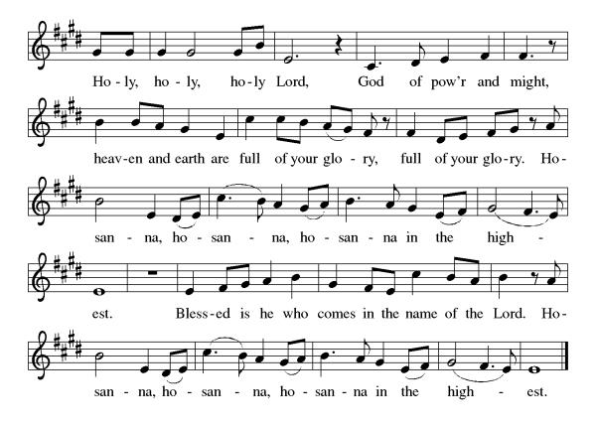

Eucharistic Prayer
Blessed are you, O God of the universe. Your mercy is everlasting, and your faithfulness endures from age to age.
Praise to you for creating the heavens and the earth. Praise to you for saving the earth from the waters of the flood. Praise to you for bringing the Israelites safely through the sea. Praise to you for leading your people through the wilderness to the land of milk and honey. Praise to you for the death and resurrection of Christ. Praise to you for your Spirit poured out on all nations.
In the night he was betrayed, our Lord Jesus took bread and gave thanks; broke it, and gave it to his disciples saying: Take and eat; this is my body given for you. Do this for the remembrance of me.
After supper he took the cup, gave thanks and gave it for all to drink saying: This cup is the new covenant in my blood, shed for you and for all people for the forgiveness of sin, Do this for the remembrance of me.
For as often as we eat of this bread and drink from this cup we proclaim the Lord’s death until He comes.
Christ has died
Christ is risen.
Christ will come again.
Gathered into one, by the Holy Spirit let us listen to the words that Jesus taught us.

The Lord’s Prayer
Our Father, who art in heaven, hallowed be thy name, thy kingdom come, thy will be done, on earth as it is in heaven. Give us this day our daily bread; and forgive us our trespasses, as we forgive those who trespass against us; and lead us not into temptation but deliver us from evil. For thine is the kingdom, and the power, and the glory, forever and ever. Amen.

Invitation to Communion
S.A.M. Bob: There is a place for you at the table of God. Come, receive the food that does not perish, a test of life eternal. Come and taste on your lips a Love we cannot comprehend.
C: Amen
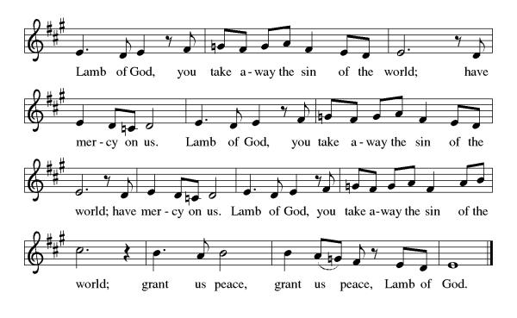
Please come forward to receive
Prayer After Communion
Life-giving God, through this meal you have bandaged our wounds and fed us with your mercy. Now send us forth to live for others, both friend and stranger, that all may come to know your love. This we pray in the name of Jesus. Amen.
Sending
Blessing
S.A.M. Bob: Praise God, from whom all blessings flow!
C: Praise God, all creatures here below!
S.A.M. Bob: You are the shepherds telling the story.
C: We tell it in the streets and across the land.
S.A.M. Bob: You are the wise ones worshiping with thanksgiving.
C: We worship with gifts of song and service, talents and treasures.
S.A.M. Bob: You are the angels announcing peace.
C: We live with joy and go now in peace.
S.A.M. Bob: Almighty God, Father, ☩ Son, and Holy Spirit,
bless you now and forever.
C: Amen.

Sending Hymn: Good Christian Friends, Rejoice ELW 288
1 Good Christian friends, rejoice with heart and soul and voice;
give ye heed to what we say: Jesus Christ is born today;
ox and ass before him bow, and he is in the manger now.
Christ is born today! Christ is born today!

2 Good Christian friends, rejoice with heart and soul and voice;
now ye hear of endless bliss: Jesus Christ was born for this!
He has opened heaven's door, and we are blest forevermore.
Christ was born for this! Christ was born for this!

3 Good Christian friends, rejoice with heart and soul and voice;
now ye need not fear the grave; Jesus Christ was born to save!
Calls you one and calls you all to gain the everlasting hall.
Christ was born to save! Christ was born to save!
Text: Medieval Latin carol; tr. John Mason Neale, 1818-1866

Dismissal
S.A.M. Bob: Go in peace. Christ was born to save!
C: Thanks be to God.
Postlude: instrumental
Unless otherwise noted, materials used in this bulletin are:
From Sundays and Seasons.com. Copyright 2015 Augsburg Fortress. All rights reserved. Reprinted by permission under Augsburg Fortress Liturgies Annual License #SAS028635. Music is reprinted under OneLicense.Net #A712074 and/or Augsburg Fortress #SBL12176H. Scripture, unless otherwise noted, is from the New Revised Standard Version Bible, Copyright © 1989, Division of Christian Education of the National Council of the Churches of Christ in the United States of America. Used by permission. All rights reserved.

Announcements for December 27th and 28th

ATTENDANCE
Saturday, December 20th, 4pm 31
Sunday, December 21st, 9am 50
Drive-Up Communion 0
81

The Altar Flowers are given this week by Frank and Eileen Hofstetter, to the glory of God!

This Week at St. Timothy's
Monday, December 29th Bob on Vacation
Tuesday, December 30th Bob on Vacation
Wednesday, December 31st Bob on Vacation
Thursday, January 1st Bob on Vacation - 9:30am – Prayer Group, 3:30pm – Chimes, 4:30pm - Choir
Friday, January 2nd Bob on Vacation
Saturday, January 3rd Bob on Vacation -Pr. Steve Brisson Presiding - 4pm - Worship
Sunday, January 4th Pr. Steve Brisson Presiding - Bob on Vacation - 9am – Worship, 10:15-10:45 – Drive Up Communion, 10:30 – Adult SS, Coffee Fellowship

