St Timothy Lutheran Church
Saturday, May 16th, 2026
Seventh Saturday of Easter

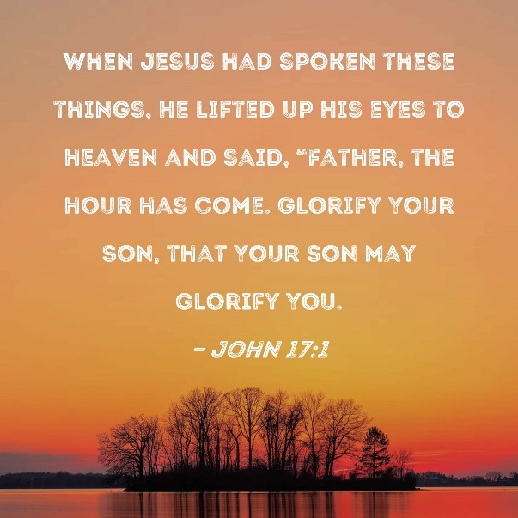

In these days between Ascension and Pentecost, we gather with the disciples in the upper room, waiting for the Spirit to transform the church around the world. In today’s gospel Jesus prays for his followers and for their mission in his name. Amid religious, social, and economic divisions, we seek the unity that Jesus had with his Father. Made one in baptism, we go forth to live our faith in the world, eager for the unity that God intends for the whole human family.

Preservice: Bind Us Together W&P 18
Welcome!
Prelude
P – Preparing our hearts for Worship

Thanksgiving for Baptism
All may make the sign of the cross, the sign that is marked at baptism, as the presiding minister begins.
Alleluia! Christ is risen.
Christ is risen indeed. Alleluia!
Salvation belongs to our God who is seated on the throne
and to the Lamb!
Amen.
Let us give thanks for the gifts of baptism.
P - Merciful God,
you are the one who was, who is, and who is to come.
You lead us beside still waters.
We thank you for the waters of creation:
morning dew, gentle rain, roaring waves.
We thank you for the waters that nourish us.
Blessed are you.
You guide us to springs of the water of life.
Jesus Christ, you are the faithful witness
who accompanies us on our journeys.
We give you thanks for your life-giving death and resurrection.
We praise you for joining us in joy and sorrow.
Blessed are you.
You guide us to springs of the water of life.

Holy Spirit, you anoint our head with oil and our cup overflows.
Break down barriers that divide us.
Fill us with the breath of peace.
Blessed are you.
You guide us to springs of the water of life.
Holy One, we thank you for the gifts and grace of baptism,
and for making us a new creation.
We join with saints and angels, giving you honor and praise,
now and forever.
Amen.

Gathering Hymn: As We Gather at Your Table ELW 522
1 As we gather at your table, as we listen to your word,
help us know, O God, your presence; let our hearts and minds be stirred.
Nourish us with sacred story till we claim it as our own;
teach us through this holy banquet how to make Love's vict'ry known.

2 Turn our worship into witness in the sacrament of life;
send us forth to love and serve you, bringing peace where there is strife.
Give us, Christ, your great compassion to forgive as you forgave;
may we still behold your image in the world you died to save.

3 Gracious Spirit, help us summon other guests to share that feast
where triumphant Love will welcome those who had been last and least.
There no more will envy blind us nor will pride our peace destroy,
as we join with saints and angels to repeat the sounding joy.

Text: Carl P. Daw Jr., b. 1944
Text © 1989 Hope Publishing Company, Carol Stream, IL 60188. All rights reserved. Used by permission.
Duplication in any form prohibited without permission or valid license from copyright administrator.

P - The grace of our Lord Jesus Christ, the love of God and the communion of the Holy Spirit be with you all.
C - And also with you.

Prayer of the Day
O God of glory, your Son Jesus Christ suffered for us and ascended to your right hand. Unite us with Christ and each other in suffering and in joy, that all the world may be drawn into your bountiful presence, through Jesus Christ, our Savior and Lord, who lives and reigns with you and the Holy Spirit, one God, now and forever.
Amen.

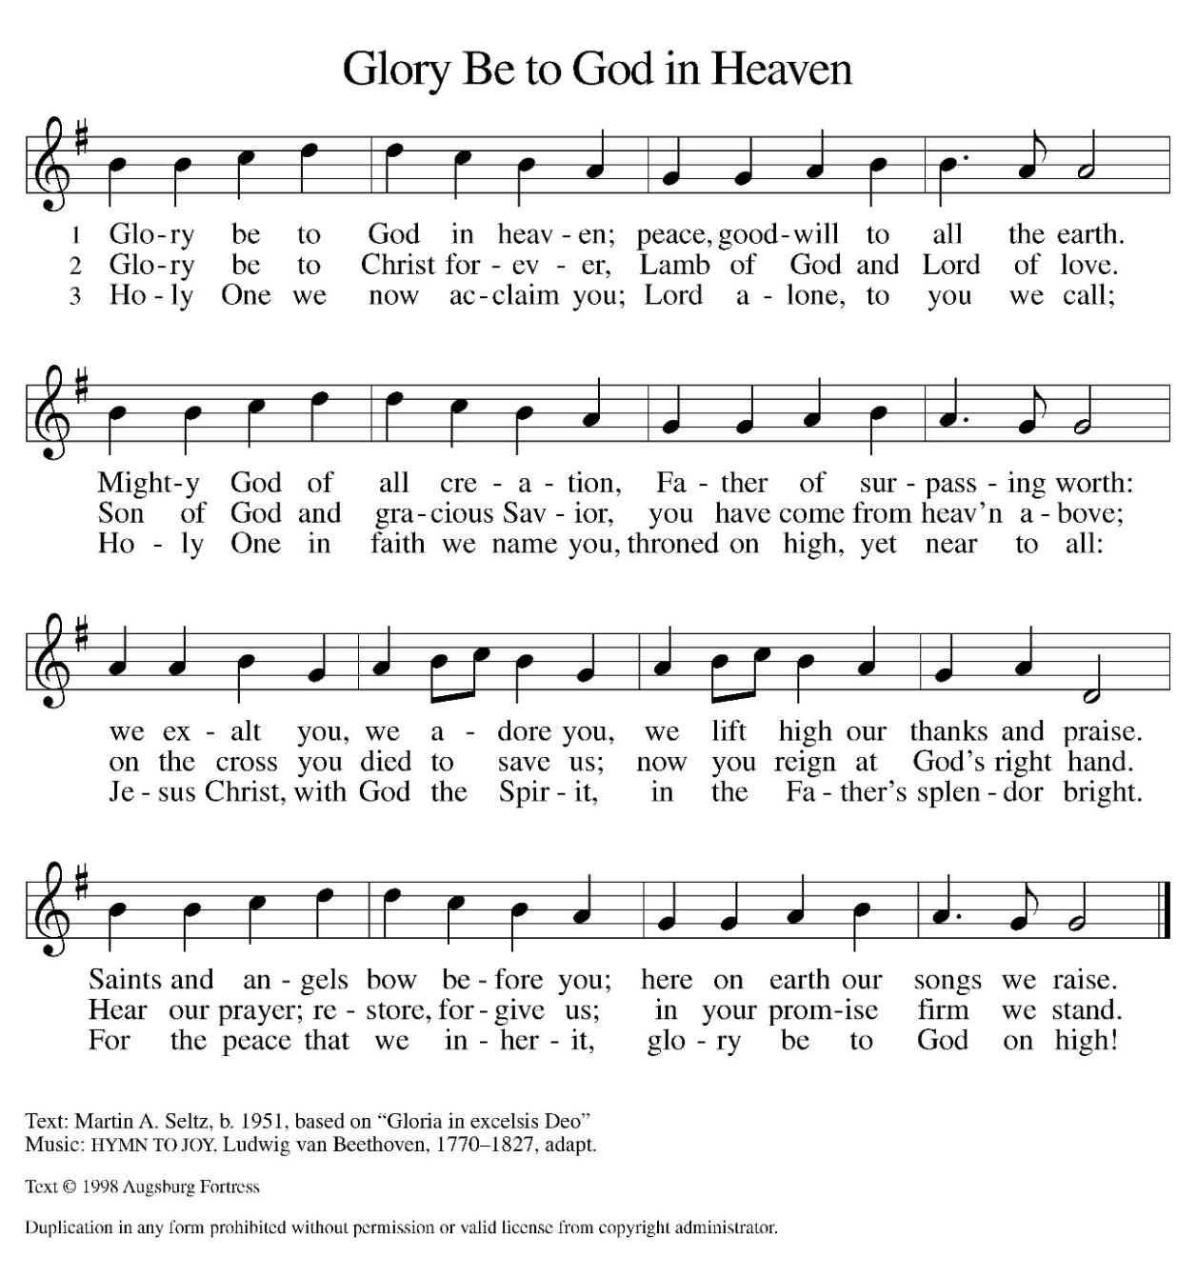
Hymn of Praise:

Please be seated.

Reading: Acts 1:6-14
Today’s reading is part of the introduction to the narrative of the outpouring of the Spirit on Pentecost. These verses tell of the risen Lord’s conversation with his disciples on the eve of his ascension, in which he promises that they will receive the power of the Holy Spirit.
⁶ When [the apostles] had come together, they asked [Jesus], “Lord, is this the time when you will restore the kingdom to Israel?” ⁷ He replied, “It is not for you to know the times or periods that the Father has set by his own authority. ⁸ But you will receive power when the Holy Spirit has come upon you, and you will be my witnesses in Jerusalem, in all Judea and Samaria, and to the ends of the earth.” ⁹ When he had said this, as they were watching, he was lifted up, and a cloud took him out of their sight. ¹⁰ While he was going and they were gazing up toward heaven, suddenly two men in white robes stood by them. ¹¹ They said, “Men of Galilee, why do you stand looking up toward heaven? This Jesus, who has been taken up from you into heaven, will come in the same way as you saw him go into heaven.”
¹² Then they returned to Jerusalem from the mount called Olivet, which is near Jerusalem, a Sabbath day’s journey away. ¹³ When they had entered the city, they went to the room upstairs where they were staying: Peter, and John, and James, and Andrew, Philip and Thomas, Bartholomew and Matthew, James son of Alphaeus, and Simon the Zealot, and Judas son of James. ¹⁴ All these were constantly devoting themselves to prayer, together with certain women, including Mary the mother of Jesus, as well as his brothers.
A – Here ends the reading!
C – Thanks be to God!

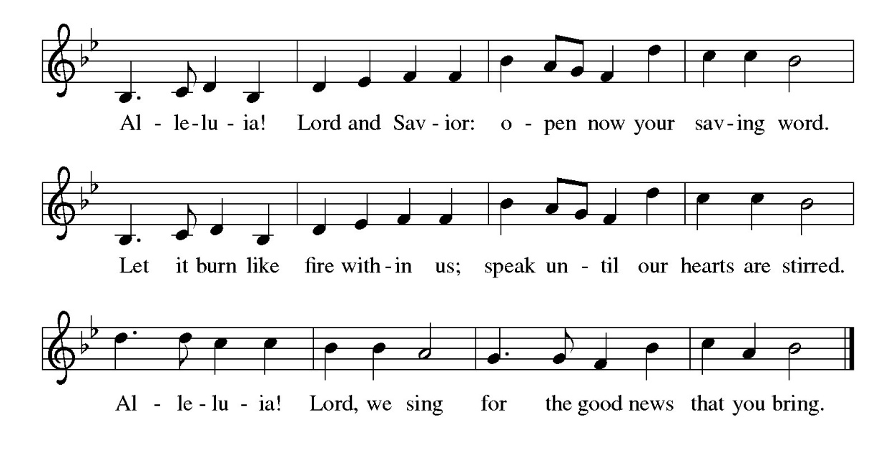
Gospel Acclamation

P - The Holy Gospel according to John, the 17th Chapter
C - Glory to You O Lord!

Gospel: John 17:1-11
On the night before his crucifixion, Jesus prays to his heavenly Father, asking that those who continue his work in this world will live in unity.
¹ After Jesus had spoken these words [to his disciples,] he looked up to heaven and said, “Father, the hour has come; glorify your Son so that the Son may glorify you, ² since you have given him authority over all people, to give eternal life to all whom you have given him. ³ And this is eternal life, that they may know you, the only true God, and Jesus Christ, whom you have sent. ⁴ I glorified you on earth by finishing the work that you gave me to do. ⁵ So now, Father, glorify me in your own presence with the glory that I had in your presence before the world existed.
⁶ “I have made your name known to those whom you gave me from the world. They were yours, and you gave them to me, and they have kept your word. ⁷ Now they know that everything you have given me is from you, ⁸ for the words that you gave to me I have given to them, and they have received them and know in truth that I came from you, and they have believed that you sent me. ⁹ I am asking on their behalf; I am not asking on behalf of the world but on behalf of those whom you gave me, because they are yours. ¹⁰ All mine are yours, and yours are mine, and I have been glorified in them. ¹¹ And now I am no longer in the world, but they are in the world, and I am coming to you. Holy Father, protect them in your name that you have given me, so that they may be one, as we are one.”
P - The Gospel of the Lord.
C – Praise to you, O Christ!

Sermon

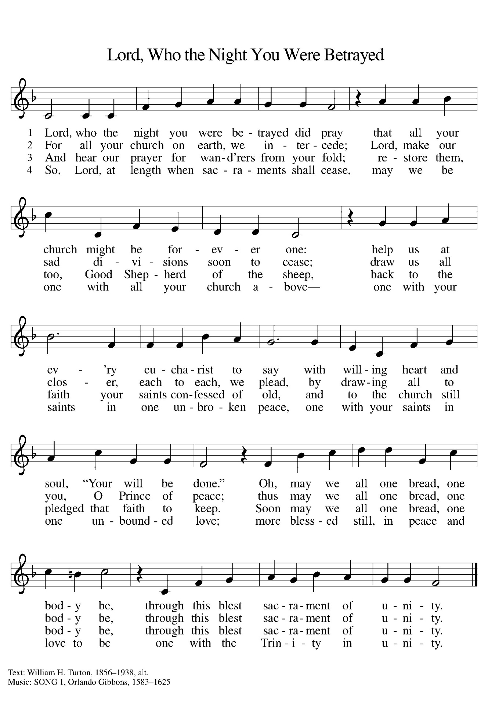
Hymn of the Day: ELW463

The Apostle’s Creed
I believe in God, the Father almighty,
creator of heaven and earth.
I believe in Jesus Christ, God’s only Son, our Lord,
who was conceived by the Holy Spirit,
born of the virgin Mary,
suffered under Pontius Pilate,
was crucified, died, and was buried;
he descended to the dead.*
On the third day he rose again;
he ascended into heaven,
he is seated at the right hand of the Father,
and he will come to judge the living and the dead.
I believe in the Holy Spirit,
the holy catholic church,
the communion of saints,
the forgiveness of sins,
the resurrection of the body,
and the life everlasting. Amen.
From sundaysandseasons.com.
Copyright © 2026 Augsburg Fortress. All rights reserved.

Prayers of the People
Trusting in the power of Christ’s resurrection to heal and redeem our broken world, let us pray for the needs of all creation.
O God, your people sing praises throughout the church. By your Holy Spirit, inspire musicians, deacons, pastors, and bishops to proclaim the gospel of Jesus.
Merciful God,
receive our prayer.
Your creative power fills the universe. Bring favorable weather, nurture plants and animals, protect us from natural disasters, and guide us to care for all you have made.
Merciful God,
receive our prayer.
Your justice is exercised in society by those in authority. Instill in political leaders, business leaders, school administrators, and all who care for others a desire for peace and equity.
Merciful God,
receive our prayer.
Your compassion and care come through the gifts of medicine and relationships. Soothe the anxious, protect widows and orphans, comfort those living with memory loss and their families, and heal the sick (especially).
Merciful God,
receive our prayer.
Your love radiates from communities gathered in your name. Bless those experiencing significant transitions in life such as graduation, retirement, new employment and accompany us in our prayers during these times. Merciful God,
receive our prayer.
O God, your promise of eternal life is certain and sure. Inspire us by the steadfast faith of those who have gone before us, so that we may be confident in the assurances you give.
Merciful God,
receive our prayer.
God of resurrection power, use us and these prayers to proclaim the good news of new life to all the world, through Jesus Christ, our risen Savior.
Amen.

P – The Peace of the Lord be with you always.
C – And also with you.

The Offering is Brought to the Altar
Offertory Prayer
Merciful God,
accept the fruits of our labor, gathered to give you glory.
You have set a table before us, a glimpse of that great day
when we will hunger and thirst no more.
Nourish us with the body and blood of Jesus,
that goodness and mercy may follow us
and bless the world you love.
In the name of Jesus,
Amen.

P – The Lord be with You
C – And also with you.
P – Lift up your hearts
C – We lift them to the Lord.
P – Let us give thanks to the Lord, our God
C – It is right to give Him our thanks and praise.

Preface
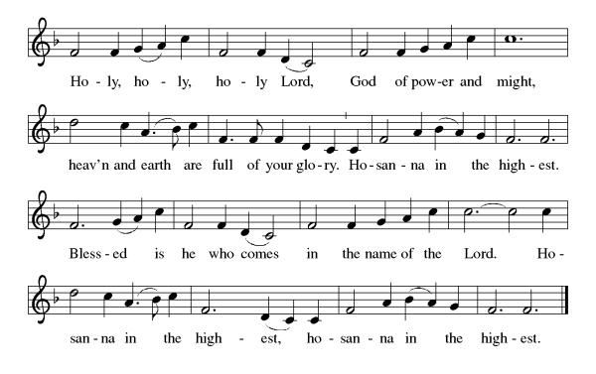
And so, with Mary Magdalene and Peter and all the witnesses of the resurrection, with earth and sea and all their creatures, and with angels and archangels, cherubim and seraphim, we praise your name and join their unending hymn:

Eucharistic Prayer
(Words of Institution)
For as often as we eat of this bread and drink from this cup we proclaim the Lord’s death until He comes.
Christ has died
Christ is risen.
Christ will come again.
Remembering, therefore, his salutary command,
his life-giving passion and death, his glorious resurrection and ascension, and the promise of his coming again,
we give thanks to you, O Lord God Almighty,
not as we ought but as we are able;
we ask you mercifully to accept our praise and thanksgiving and with your Word and Holy Spirit to bless us, your servants, and these your own gifts of bread and wine, so that we and all who share in the body and blood of Christ may be filled with heavenly blessing and grace, and, receiving the forgiveness of sin,
may be formed to live as your holy people
and be given our inheritance with all your saints.
To you, O God, Father, Son, and Holy Spirit,
be all honor and glory in your holy church, now and forever. Amen.

Gathered into one, by the Holy Spirit let us listen to the words that Jesus taught us.
The Lord’s Prayer
Our Father, who art in heaven, hallowed be thy name, thy kingdom come, thy will be done, on earth as it is in heaven. Give us this day our daily bread; and forgive us our trespasses, as we forgive those who trespass against us; and lead us not into temptation but deliver us from evil. For thine is the kingdom, and the power, and the glory, forever and ever. Amen.
P: God feeds those who hunger, Come! Be fed and be healed!
C: Thanks be to God.

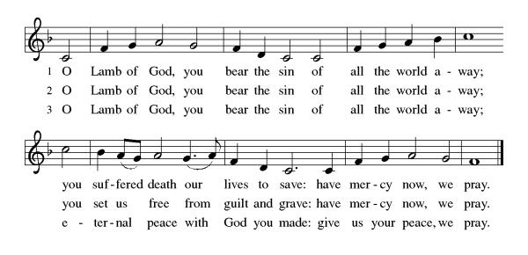
Invitation to Communion

Distribution of Communion – Come Forward to Receive
Communion Hymn: Around You, O Lord Jesus ELW 468, I Come with Joy ELW 482

P – Now may the body and blood of our Lord and Savior Jesus Christ strengthen you and keep you in His grace!
C – Thank You Jesus!

Prayer after Communion
Holy One,
through this meal you have made your home among us
and are making all things new.
Send us now to speak peace to anxious hearts,
to love our enemies,
and to bring your healing to the nations.
In the name of Jesus,
Amen.

Benediction
Psalm 29:11
“The Lord gives strength to His people; the Lord blesses His people with peace. Lord, as we close this time of worship, we ask for Your peace to rest upon every heart present. Let every burden be lifted, and every anxious thought be silenced by Your presence. May Your blessing and strength go with us as we return to our daily lives.
May almighty God bless you Father, Son, and Holy Spirit. Amen

Sending Hymn: The Spirit Sends Us Forth to Serve ELW 551

- The Spirit sends us forth to serve; we go in
Jesus' name to bring glad tidings
to the poor, God's favor to proclaim.

- We go to comfort those who mourn and set the
burdened free; where hope is dim, to
share a dream and help the blind to see.

- We go to be the hands of Christ, to scatter
joy like seed and, all our days, to
cherish life, to do the loving deed.

- Then let us go to serve in peace, the gospel
to proclaim. God's Spirit has empowered
us; we go in Jesus' name.

Text: Delores Dufner, OSB, b. 1939
Text © 1993 Delores Dufner, OSB. Published by OCP Publications, 5536 NE Hassalo, Portland OR 97213. All rights reserved. Used by permission.
Duplication in any form prohibited without permission or valid license from copyright administrator.

Dismissal
P – Look and listen to S.A.M. Bob
C- Thanks be to God. Alleluia!

Postlude:
Unless otherwise noted, service materials used in this bulletin are:
"Reprinted from the 1995 Moravian Book of Worship with permission of the Interprovincial Board of Communication, Moravian Church in North America."
Music is reprinted under OneLicense.Net #A712074 and/or Augsburg Fortress #SBL12176H. Scripture, unless otherwise noted, is from the New Revised Standard Version Bible, Copyright © 1989, Division of Christian Education of the National Council of the Churches of Christ in the United States of America. Used by permission. All rights reserved.

St Timothy’s is served by S.A.M. Robert Bonomo
Lay Minister Frank Hofstetter
Director of Music Sally Hennessey
Saturday Pianist Bill Robinson
Announcements for May 16th and 17th
ATTENDANCE
Saturday, May 9th, 4pm 23
Sunday, May 10th, 9am 51
Drive-Up Communion 2
76

The altar flowers are given, this week, by Greg and Judi Schutrum, in honor of their 45th anniversary!

Serving our Lord this weekend:
Saturday, May 16th
Reader – Jean Fowler
Communion Assistant – Carolyn Fialkowski
Sunday, May 17th
Assisting Minister - Frank Hofstetter
Reader - Dick Kleinsmith
Communion Assistant – Patie Pule

This Week at St. Timothy's
Monday, May 18th
Tuesday, May 19th 12pm Indoor Picnic/Potluck, 7pm ZOOM Pre-assembly Bible Study
Wednesday, May 20th
Thursday, May 21st 11am Bible Study for Beginners, 11am – Miniatures, 3:30 – Chimes, 4:30pm - Choir
Friday, May 22nd
Saturday, May 23rd 4pm Worship, No Fellowship
Sunday, May 24th 9am Worship 10:30am – Adult SS, Coffee Fellowship

Prayer List
Steve Cook
Family of Karen Adyniec
Vicky Quigley
Greg Schutrum
Debbie Lawrence
Carole Albert
Linda C.
Ashlee

