St Timothy Lutheran Church
Sunday, October 25th, 2026
Reformation Sunday

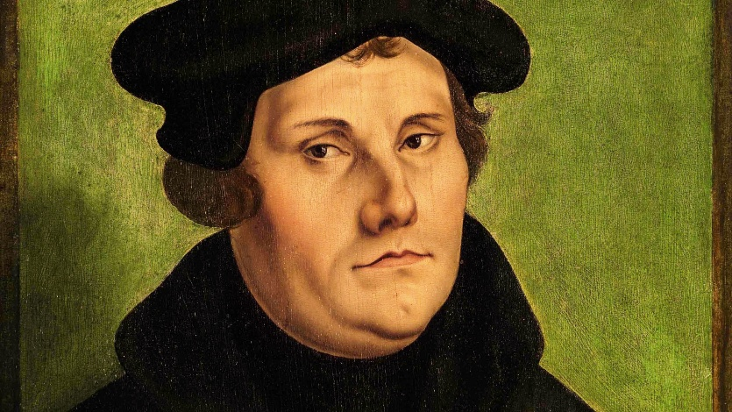

Reformation Day isn't about celebrating how much better Lutherans are at getting Christianity right; it's about hearing the promise that sets sinners free.

Jesus says that even those who believe in him are slaves to sin, and that freedom comes not from our ability to remain faithful, but from the Son who gives us a permanent place in God's household.

Preservice: Chimes
ringing of the bell 7x
Frank announces Rev. Martin Luther as leader of worship today.
Bob (“Martin Luther”) bangs the hammer on the 95 Theses on the board in the back
P – Preparing our hearts for Worship

Confession and Forgiveness
All may make the sign of the cross, the sign that is marked at baptism, as the presiding minister begins.
P – In the name of the Father, and of the Son, and of the Holy Spirit.
C – Amen.

P – Almighty God, to whom all hearts are open, all desires known, and from whom no secrets are hid: Cleanse the thoughts of our hearts by the inspiration of your Holy Spirit, that we may perfectly love you and worthily magnify your holy name, through Jesus Christ our Lord.
C – Amen

P – If we say we have no sin, we deceive ourselves, and the truth is not in us. But if we confess our sins, God who is faithful and just will forgive our sins and cleanse us from all unrighteousness.

Brief silence

P – Most merciful God,
C – We confess that we are in bondage to sin and cannot free ourselves. We have sinned against you in thought, word, and deed, by what we have done and by what we have left undone. We have not loved you with our whole heart; we have not loved our neighbors as ourselves. For the sake of your Son, Jesus Christ, have mercy on us. Forgive us, renew us, and lead us, so that we may delight in your will and walk in your ways, to the glory of your holy name. Amen.

P – Almighty God, in his mercy, has given his Son to die for us and, for his sake, forgives us all our sins. In the name of our Father, and of the Son, and of the Holy Spirit. Receive freely this healing gift of grace.

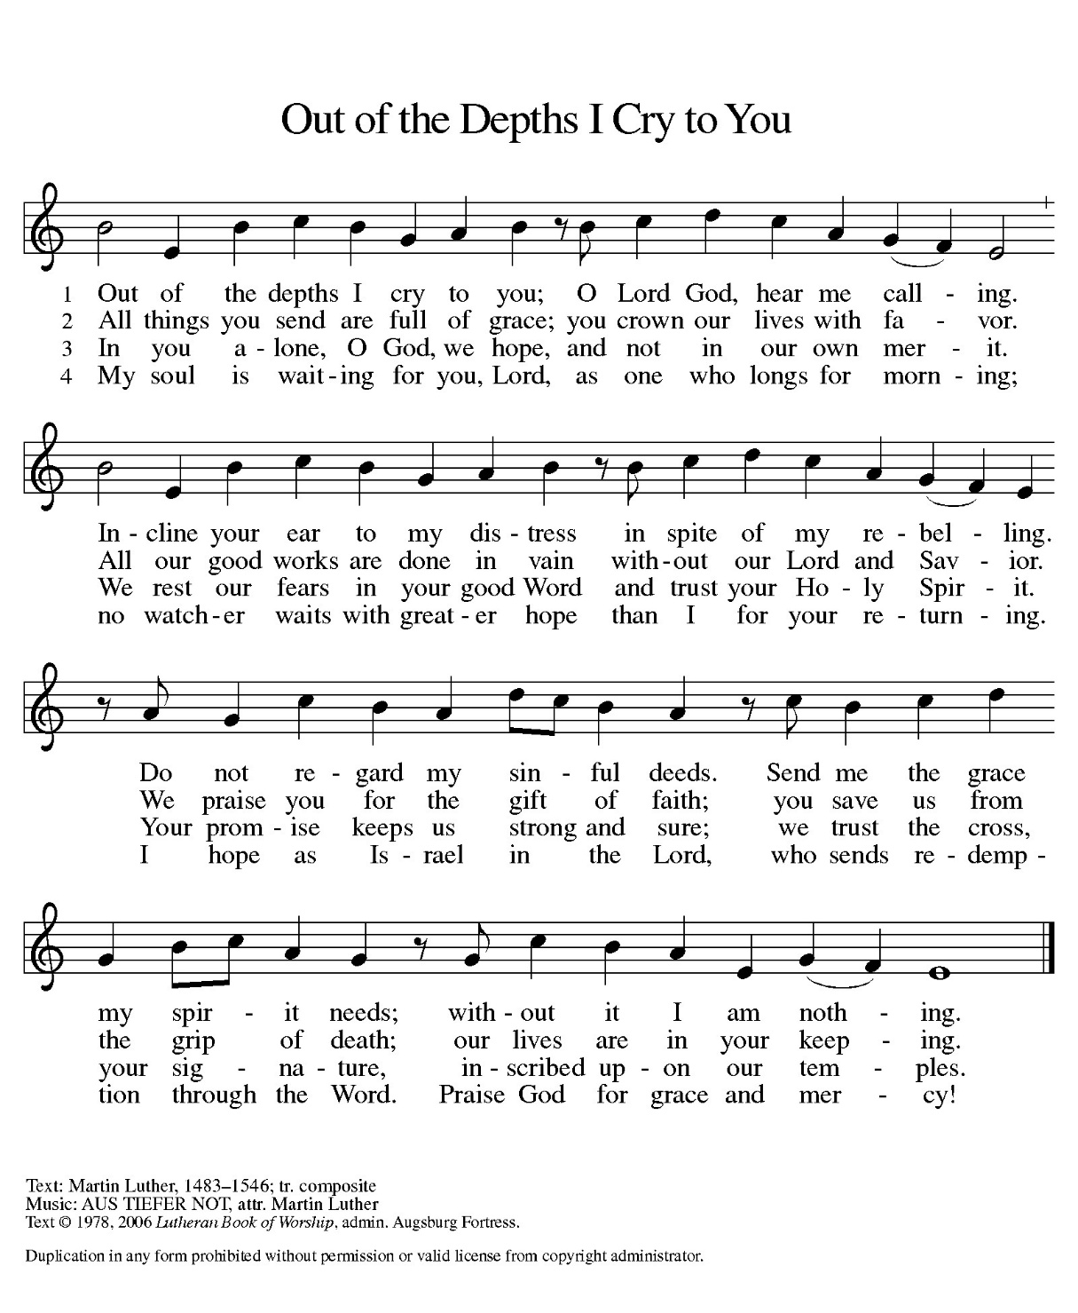
C – Amen.

ELW 600

P - The grace of our Lord Jesus Christ, the love of God and the communion of the Holy Spirit be with you all.
C - And also with you.

Prayer of the Day
Almighty God, gracious Lord, we thank you that your Holy Spirit renews the church in every age. Pour out your Holy Spirit on your faithful people. Keep them steadfast in your word, protect and comfort them in times of trial, defend them against all enemies of the gospel, and bestow on the church your saving peace, through Jesus Christ, our Savior and Lord, who lives and reigns with you and the Holy Spirit, one God, now and forever.
Amen.
Please be seated.

First Reading: Jeremiah 31:31-34
The renewed covenant will not be breakable, but like the old covenant it will expect the people to live upright lives. To know the Lord means that one will defend the cause of the poor and needy (Jer. 22:16). The renewed covenant is possible only because the Lord will forgive iniquity and not remember sin. Our hope lies in a God who forgets.
³¹ The days are surely coming, says the Lord, when I will make a new covenant with the house of Israel and the house of Judah. ³² It will not be like the covenant that I made with their ancestors when I took them by the hand to bring them out of the land of Egypt—a covenant that they broke, though I was their husband, says the Lord. ³³ But this is the covenant that I will make with the house of Israel after those days, says the Lord: I will put my law within them, and I will write it on their hearts, and I will be their God, and they shall be my people. ³⁴ No longer shall they teach one another or say to each other, “Know the Lord,” for they shall all know me, from the least of them to the greatest, says the Lord, for I will forgive their iniquity and remember their sin no more.

A – Here ends the first reading!

C – Thanks be to God!

Psalm 46
¹ God is our refuge and strength,
a very present help in trouble.
² Therefore we will not fear, though the earth be moved,
and though the mountains shake in the depths of the sea;
³ though its waters rage and foam,
and though the mountains tremble with its tumult.
⁴ There is a river whose streams make glad the city of God,
the holy habitation of the Most High.
⁵ God is in the midst of the city; it shall not be shaken;
God shall help it at the break of day.
⁶ The nations rage, and the kingdoms shake;
God speaks, and the earth melts away.
⁷ The Lord of hosts is with us;
the God of Jacob is our stronghold.
⁸ Come now, regard the works of the Lord,
what desolations God has brought upon the earth;
⁹ behold the one who makes war to cease in all the world;
who breaks the bow, and shatters the spear, and burns the shields with fire.
¹⁰ “Be still, then, and know that I am God;
I will be exalted among the nations; I will be exalted in the earth.”
¹¹ The Lord of hosts is with us;
the God of Jacob is our stronghold.

Second Reading: Romans 3:19-28
Paul’s words stand at the heart of the preaching of Martin Luther and other Reformation leaders. No human beings make themselves right with God through works of the law. We are brought into a right relationship with God through the divine activity centered in Christ’s death. This act is a gift of grace that liberates us from sin and empowers our faith in Jesus Christ.
¹⁹ Now we know that, whatever the law says, it speaks to those who are under the law, so that every mouth may be silenced and the whole world may be held accountable to God. ²⁰ For no human will be justified before him by deeds prescribed by the law, for through the law comes the knowledge of sin.
²¹ But now, apart from the law, the righteousness of God has been disclosed and is attested by the Law and the Prophets, ²² the righteousness of God through the faith of Jesus Christ for all who believe. For there is no distinction, ²³ since all have sinned and fall short of the glory of God; ²⁴ they are now justified by his grace as a gift, through the redemption that is in Christ Jesus, ²⁵ whom God put forward as a sacrifice of atonement by his blood, effective through faith. He did this to demonstrate his righteousness, because in his divine forbearance he had passed over the sins previously committed; ²⁶ it was to demonstrate at the present time his own righteousness, so that he is righteous and he justifies the one who has the faith of Jesus.
²⁷ Then what becomes of boasting? It is excluded. Through what kind of law? That of works? No, rather through the law of faith. ²⁸ For we hold that a person is justified by faith apart from works prescribed by the law.

A – Here ends the second reading!
C – Thanks be to God!

Gospel Acclamation
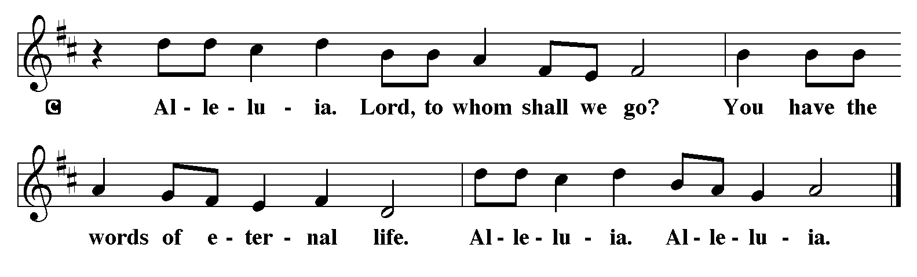
P - The Holy Gospel according to John, the 8th Chapter
C - Glory to You O Lord!

Gospel: John 8:31-36
Jesus speaks of truth and freedom as spiritual realities known through his word. He reveals the truth that sets people free from sin.
³¹ Jesus said to the Jews who had believed in him, “If you continue in my word, you are truly my disciples, ³² and you will know the truth, and the truth will make you free.” ³³ They answered him, “We are descendants of Abraham and have never been slaves to anyone. What do you mean by saying, ‘You will be made free’?”
³⁴ Jesus answered them, “Very truly, I tell you, everyone who commits sin is a slave to sin. ³⁵ The slave does not have a permanent place in the household; the son has a place there forever. ³⁶ So if the Son makes you free, you will be free indeed.”

P - The Gospel of the Lord.
C – Praise to you, O Christ!
Sermon by Martin Luther

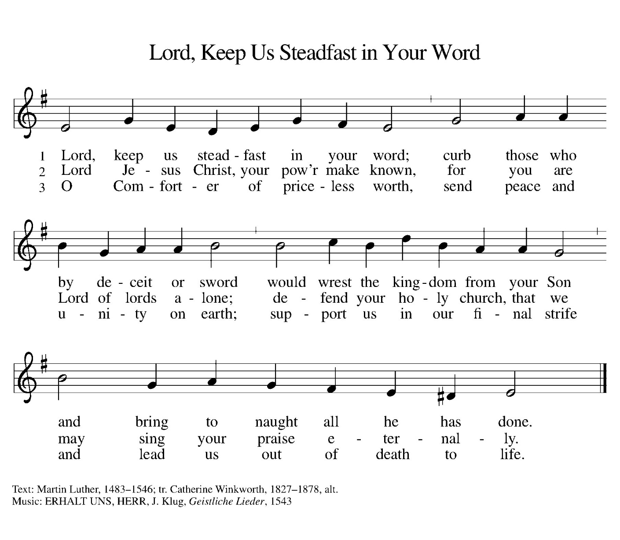
Hymn of the Day: ELW 517

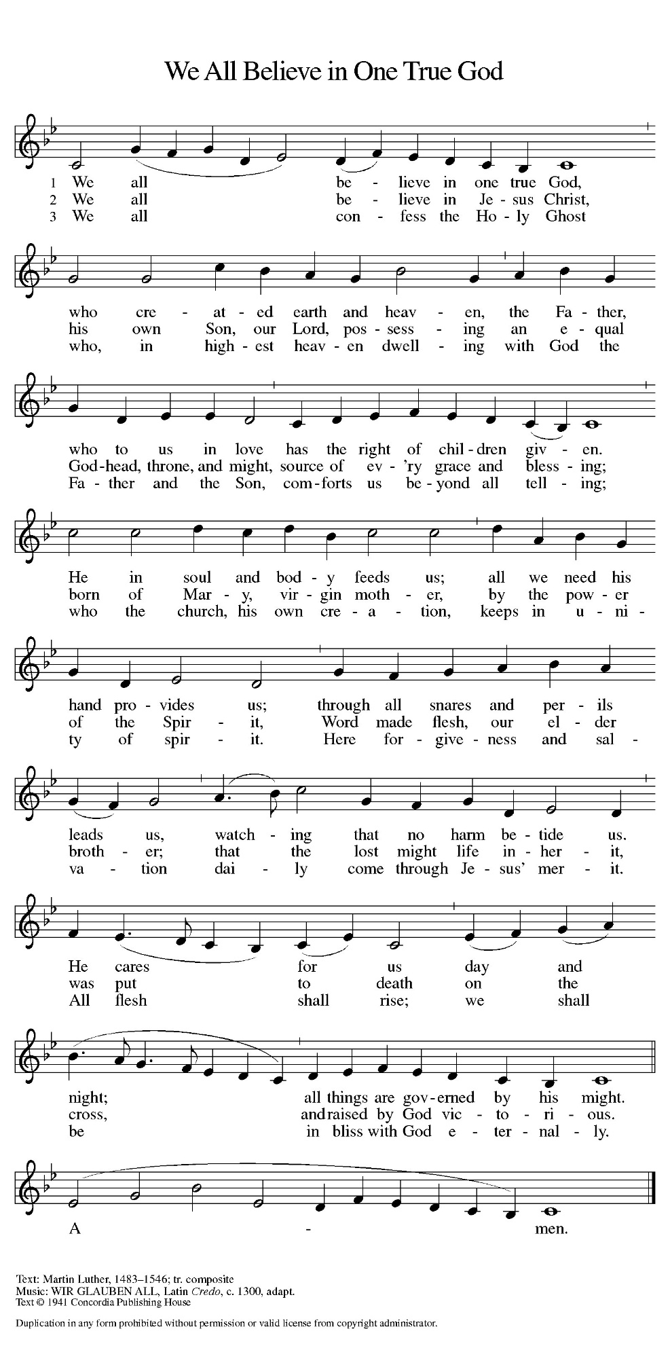
ELW 411

Prayers of Intercession for Reformation Sunday 2026
Challenged by God’s Word in Christ, and inspired by the witness of the Reformers, let us pray for the church, the world, and all God’s creation.
A brief silence
Gracious God,
We give thanks for the courage and faith of Martin Luther and all reformers throughout history who sought to renew your church.
Empower us today to be faithful stewards of your Word, proclaiming the gospel with clarity, compassion, and conviction.
May your Spirit guide our leaders, pastors, and teachers, so that the church remains rooted in truth and open to transformation.
Lord, in your mercy,
Hear our prayer.

God of justice and peace,
We pray for nations and leaders, that they may govern with wisdom, humility, and integrity.
Break down walls of division and bring reconciliation where there is conflict.
Inspire us to be peacemakers in our communities, and to stand against injustice wherever it is found.
Lord, in your mercy,
Hear our prayer.

Creator God,
We thank you for the beauty and abundance of the earth.
Teach us to care for your creation as a sacred trust, resisting exploitation and waste.
Bless those who work to protect natural resources and guide us toward sustainable living.
Lord, in your mercy,
Hear our prayer.

Merciful God,
We lift up all who are burdened by illness, grief, loneliness, or despair.
Bring healing to the sick, comfort to the grieving, and hope to the hopeless.

Lord, in your mercy,
Hear our prayer.

Spirit of the Living God,
Just as you moved in the days of the Reformation, move among us now.
Renew our hearts, reform our minds, and revive our witness.
Help us to live boldly in faith, joyfully in service, and humbly in love. Give us the courage and faith to remember not only the days gone by, but to get excited to new ways as we look ahead for the future of Your church.
Lord, in your mercy,
Hear our prayer.

Into your hands, O Lord, we commend all for whom we pray, trusting in your mercy, through Jesus Christ our Lord.
Amen.

P – The Peace of the Lord be with you always.
C – And also with you.

The Offering is Brought to the Altar
Offering Prayer

We lift our voices, we lift our hands, we lift our lives up to you; we are an Offering. Lord, use our voices, Lord, use our hands, Lord, use our lives, they are yours: we are an offering. All that we have, all that we are, all that we hope to be, we give to you, we give to you. We lift our voices, we lift our hands, we lift our lives up to you; we are an offering, we are an offering.
The Great Thanksgiving

P – The Lord be with You
C – And also with you.
P – Lift up your hearts
C – We lift them to the Lord.
P – Let us give thanks to the Lord, our God
C – It is right to give Him our thanks and praise.

Preface
And so, with all the choirs of angels, with the church on earth and the hosts of heaven, we praise your name and join their unending hymn:
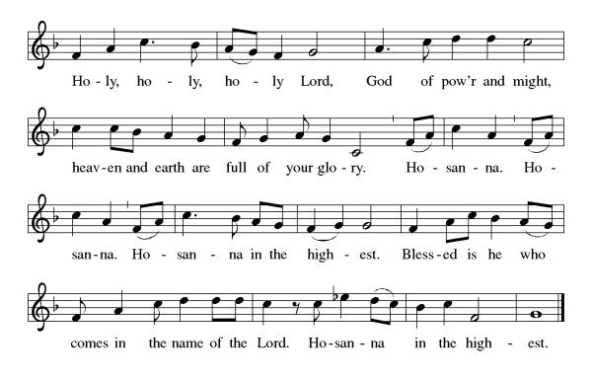

Eucharistic Prayer
(Words of Institution)
For as often as we eat of this bread and drink from this cup we proclaim the Lord’s death until He comes.
Christ has died
Christ is risen.
Christ will come again.
Remembering, therefore, his salutary command,
his life-giving passion and death, his glorious resurrection and ascension,
and the promise of his coming again,
we give thanks to you, O Lord God Almighty,
not as we ought but as we are able;
we ask you mercifully to accept our praise and thanksgiving and with your Word and Holy Spirit to bless us, your servants, and these your own gifts of bread and wine, so that we and all who share in the body and blood of Christ may be filled with heavenly blessing and grace,
and, receiving the forgiveness of sin,
may be formed to live as your holy people
and be given our inheritance with all your saints.
To you, O God, Father, Son, and Holy Spirit,
be all honor and glory in your holy church, now and forever. Amen.

Gathered into one, by the Holy Spirit let us listen to the words that Jesus taught us.

The Lord’s Prayer
Our Father, who art in heaven, hallowed be thy name, thy kingdom come, thy will be done, on earth as it is in heaven. Give us this day our daily bread; and forgive us our trespasses, as we forgive those who trespass against us; and lead us not into temptation but deliver us from evil. For thine is the kingdom, and the power, and the glory, forever and ever. Amen.
P: Taste and see that the Lord is good.
C: Thanks be to God.

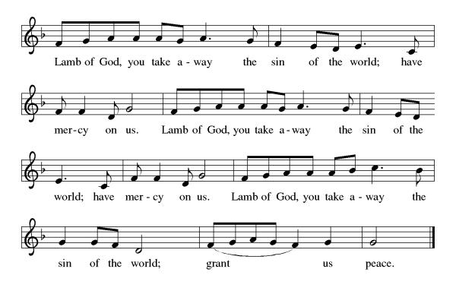
Invitation to Communion

P – Come, feast at His table. He is waiting for you.
C – Amen.
Distribution of Communion – Come Forward to Receive
Communion Hymn: Be Thou My Vision
P – Now may the body and blood of our Lord and Savior Jesus Christ strengthen you and keep you in His grace!
C – Thank You Jesus!

Prayer after Communion
Sustaining God,
with this bread and cup,
You nourish us with mercy and abundant life.
By Your Spirit, send us from this table to serve a needy world.
Make us living signs of Your liberation, healing, and love,
following the way of Jesus, in whose name we pray.
Amen.

Blessing
May the Lord open your eyes to see His vineyard in your life. May He guard your heart against rejecting His messengers, and may you walk in the fruitfulness that honors the cornerstone of Christ Jesus.
May you be a tenant who keeps the Owner's commands and may the Lord's peace and protection be with you always.
May almighty God bless you, The Father, The Son, and The Holy Spirit.
Amen

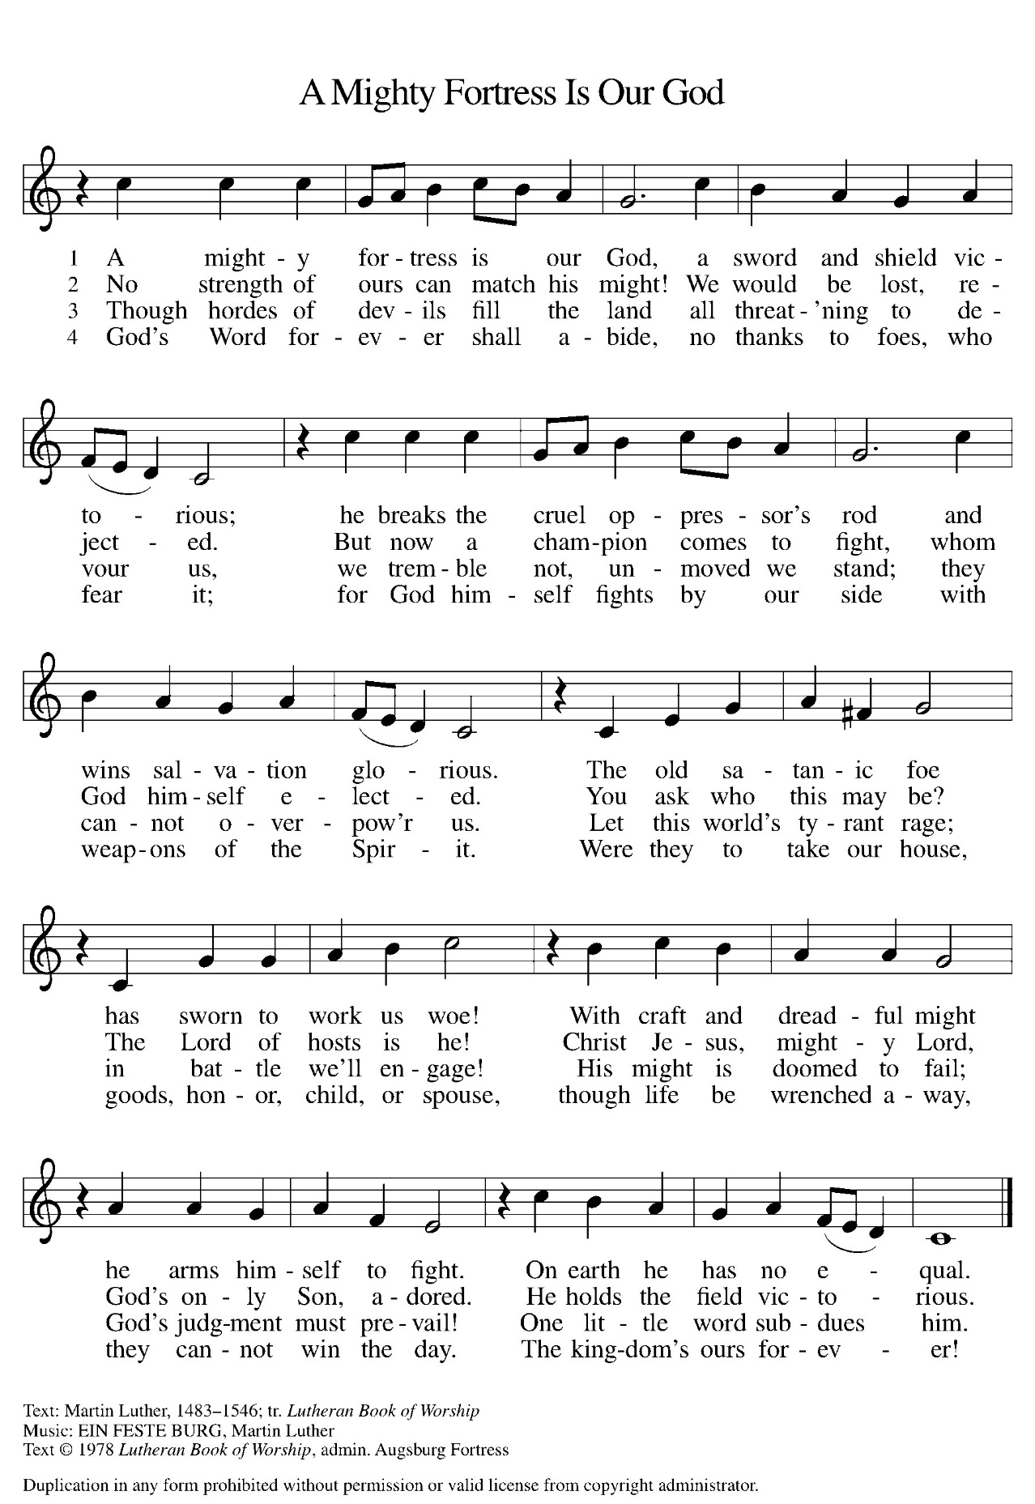
Sending Hymn: ELW 504

Dismissal
P - Go out in joy. Be led forth in peace.
C - Thanks be to God.

Postlude:
Unless otherwise noted, service materials used in this bulletin are:
Music is reprinted under OneLicense.Net #A712074 and/or Augsburg Fortress #SBL12176H. Scripture, unless otherwise noted, is from the New Revised Standard Version Bible, Copyright © 1989, Division of Christian Education of the National Council of the Churches of Christ in the United States of America. Used by permission. All rights reserved.

St. Timothy’s is served by S.A.M. Robert “Bob” Bonomo
Lay Minister Frank Hofstetter
Director of Music Sally Hennessey
Saturday Pianist Bill Robinson
Announcements for October 24th and 25th
ATTENDANCE
Saturday, October 17th , 4pm 31
Sunday, October 18th, 9am 54
Drive-Up Communion 2
Rickett’s Svc., Monday Oct. 19th 29
116

The altar flowers are given this week by Jake and Marcia Jacobek, to the Glory of God!

Serving our Lord this weekend:
Saturday, October 24th

Sunday, October 25th
Assisting Minister – Lay Minister Frank Hoffstetter
Reader – Judi Schutrum
Altar Guild – Frank & Eileen Hofstetter
Greeters – John & Jodie Gudorf

This Week at St. Timothy's
Monday, October 26th
Tuesday, October 27th Bob @ Joy for Pastor’s Conference
Wednesday, October 28th
Thursday, October 29th 11-12 Bible Study, 11am – Miniatures, 3:30 - Chimes, 4:30 - Choir
Friday, October 30th
Saturday, October 31st 4pm Worship, No Fellowship
Sunday, November 1st 9am Worship, 10:30 – Adult SS, Coffee Fellowship

PRAYER LIST

Bill Dively
Carlos
Jim & Rosa Neth
JoAnne Ollenborger
Judy Conaster
Family of Phil
Family of Sharon Ricketts
Marcia & Harry Treber
Erica
Beth Gardener
Ellie Padilla
Dixie
Tyler
Marsha Gibson
Thea
May
Ben
Sarah Brisson
Sheila
Sharon Grimes
Ginny
Cindy
Teresa York
Debbie Lawrence
Carole Albert
Linda C.
Ashlee
Frani Barnes
Melanie
Trish Bradley
Fowler Family
Marcus

