A Service of Worship, Praise and Hope
Welcome to St. Timothy Saturday Evening Worship!
November 22nd

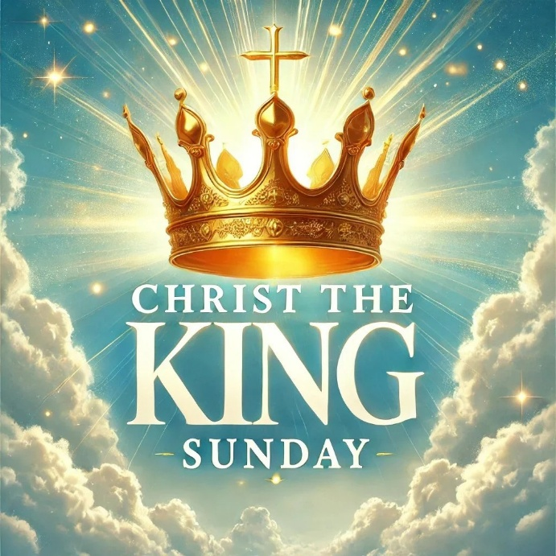

Jeremiah’s promise of the execution of “justice and righteousness in the land” finds ironic fulfillment in the execution of Jesus of Nazareth, the King of the Jews. It appears utterly contradictory that a king should be crucified with a criminal. This victory appears for all the world as humiliating defeat. Yet through the gate of death Jesus opens the door to paradise.
St Timothy Worship Planning Team
S.A.M. Bob Bonomo
Deacon, Frank Hofstetter
Director of Music, Sally Hennessey
Saturday Pianist, Bill Robinson

Pre-Service Music:
Welcome and Sharing of Congregational News
Prelude

Gathering Hymn: Jesus Shall Reign ElW 434
- Jesus shall reign where'er the sun does its successive
journeys run; his kingdom stretch from
shore to shore, till moons shall wax and wane no more.

- To him shall endless prayer be made, and praises
throng to crown his head; his name like sweet perfume
shall rise with ev'ry morning sacrifice.

- People and realms of ev'ry tongue dwell on his
love with sweetest song; and infant voices
shall proclaim their early blessings on his name.

- Blessings abound where'er he reigns: the pris'ners
leap to lose their chains, the weary find eternal
rest, and all who suffer want are blest.

- Let ev'ry creature rise and bring peculiar
honors to our king; angels descend with
songs again, and earth repeat the loud amen. Text: Isaac Watts, 1674-1748, alt.

Confession and Forgiveness
Blessed be the holy Trinity, ☩ one God,
who forgives all our sin,
whose mercy endures forever.
Amen.
Let us confess our sins in the presence of God
and of one another.
Silence is kept for reflection.
Faithful God,
you have shown us the ways of your heart,
yet we stray from your paths.
We are stuck in sinful systems of oppression
and do not embrace the freedom
of your faithful promises.
We ignore our neighbors.
We exploit the earth.
We reject your abundance,
trusting our impulses instead of your steadfast love.
Repair our relationships,
restore what we have broken,
renew our hearts,
and bring us to new life. Amen.
Hear the good news:
God the Faithful One loves you,
☩ in Christ Jesus your sins are forgiven,
and by the power of the Holy Spirit you are set free.
Amen.
Greeting
S.A.M. Bob: The joy of our Lord Jesus Christ, the compassion of God, and the creative power of the Holy Spirit be with you all.
C: And also with you.

Prayer of the Day
O God, our true life, to serve you is freedom, and to know you is unending joy. We worship you, we glorify you, we give thanks to you for your great glory. Abide with us, reign in us, and make this world into a fit habitation for your divine majesty, through Jesus Christ, our Savior and Lord, who lives and reigns with you and the Holy Spirit, one God, now and forever. Amen.

Lesson: Colossians 1:11-20
An early Christian hymn praises the mystery of the political, personal, and mystical Christ, the one who was present at creation and is eternally reigning with God.
¹¹ May you be made strong with all the strength that comes from his glorious power, so that you may have all endurance and patience, joyfully ¹² giving thanks to the Father, who has enabled you to share in the inheritance of the saints in the light. ¹³ He has rescued us from the power of darkness and transferred us into the kingdom of his beloved Son, ¹⁴ in whom we have redemption, the forgiveness of sins.
¹⁵ He is the image of the invisible God, the firstborn of all creation, ¹⁶ for in him all things in heaven and on earth were created, things visible and invisible, whether thrones or dominions or rulers or powers—all things have been created through him and for him. ¹⁷ He himself is before all things, and in him all things hold together. ¹⁸ He is the head of the body, the church; he is the beginning, the firstborn from the dead, so that he might come to have first place in everything. ¹⁹ For in him all the fullness of God was pleased to dwell, ²⁰ and through him God was pleased to reconcile to himself all things, whether on earth or in heaven, by making peace through the blood of his cross.

A: Word of God!
C: Words of Life!
S.A.M. Bob: The Holy Gospel according to Luke, Chapter 23
C: Glory to you O Lord.

Gospel: Luke 23:33-43
Amid scoffing and slander from those who sarcastically call him Messiah and king, Jesus reveals that to be Messiah and king is to give one’s life for others. Here he uses his power to welcome a despised sinner to paradise but puts his own death into God’s hands.
³³ When they came to the place that is called The Skull, they crucified Jesus there with the criminals, one on his right and one on his left. ³⁴ [[Then Jesus said, “Father, forgive them, for they do not know what they are doing.”]] And they cast lots to divide his clothing. ³⁵ And the people stood by watching, but the leaders scoffed at him, saying, “He saved others; let him save himself if he is the Messiah of God, his chosen one!” ³⁶ The soldiers also mocked him, coming up and offering him sour wine ³⁷ and saying, “If you are the King of the Jews, save yourself!” ³⁸ There was also an inscription over him, “This is the King of the Jews.”
³⁹ One of the criminals who were hanged there kept deriding him and saying, “Are you not the Messiah? Save yourself and us!” ⁴⁰ But the other rebuked him, saying, “Do you not fear God, since you are under the same sentence of condemnation? ⁴¹ And we indeed have been condemned justly, for we are getting what we deserve for our deeds, but this man has done nothing wrong.” ⁴² Then he said, “Jesus, remember me when you come in your kingdom.” ⁴³ He replied, “Truly I tell you, today you will be with me in paradise.”

S.A.M. Bob: The Gospel of Our Lord!
C: Praise to You O Christ!
Sermon by S.A.M. Bob

Hymn of the Day: O Christ, What Can It Mean for Us ELW 431

- O Christ, what can it mean for us to claim you as our
king? What royal face have you revealed whose
praise the church would sing? Aspiring not to
glory's height, to power, wealth, and fame, you
walked a diff'rent, lowly way, another's will your aim.

2 You came, the image of our God, to heal and to forgive,
to shed your blood for sinners' sake that
we might rise and live. To break the law of
death you came, the law of love to bring: a
diff'rent rule of righteousness, a diff'rent kind of king.

- Though some would make their greatness felt and lord it over
all, you said the first must be the last and
service be our call. O Christ in workplace,
church, and home, let none to power cling; for
still, through us, you come to serve, a diff'rent kind of king.

- You chose a humble human form and shunned the world's renown;
you died for us upon a cross with
thorns your only crown. But still, beyond the
span of years, our glad hosannas ring, for
now at God's right hand you reign, a diff'rent kind of king!

Text: Delores Dufner, OSB, b. 1939
Text © 2001, 2003 GIA Publications, Inc., 7404 S. Mason Ave., Chicago, IL 60638. www.giamusic.com. 800.442.3358. All rights reserved. Used by permission.

Apostles’ Creed
I believe in God, the Father almighty,
creator of heaven and earth.
I believe in Jesus Christ, God’s only Son, our Lord,
who was conceived by the Holy Spirit,
born of the virgin Mary,
suffered under Pontius Pilate,
was crucified, died, and was buried;
he descended to the dead.
On the third day he rose again;
he ascended into heaven,
he is seated at the right hand of the Father,
and he will come to judge the living and the dead.
I believe in the Holy Spirit,
the holy catholic church,
the communion of saints,
the forgiveness of sins,
the resurrection of the body,
and the life everlasting. Amen.

Lord, listen to your children praying,
Lord, send your Spirit in this place;
Lord, listen to your children praying,
send us love, send us pow'r, send us grace.

Prayers of the People
Gathered with one voice, we offer our prayers for the church, the world, and all who are in need.
A brief silence.
We pray for the church in the world, its leaders, and its mission to share the good news of healing and restoration. Inspire us to embody the beloved community in ways that faithfully witness to the Holy Spirit. Hear us, O God.
Your mercy is great.
We pray for the trembling mountains and glad streams of creation. Preserve and renew your coastlines, deep seas, forests, and grasslands. Guide all who tend flocks or care for creatures of all kinds. Hear us, O God.
Your mercy is great.
We pray for leaders and advocates in government, civic life, and public safety. Support equity across the globe, and heal division with accountability and truth. Hear us, O God.
Your mercy is great.
We pray for any who are hungry, living in poverty or desperation, weary in body or spirit, or sick (especially). Comfort all in need of your tender care. Hear us, O God.
Your mercy is great.
We pray for this part of the body of Christ gathered around word and sacrament. Bring us into authentic community where all ages are valued and experience God’s faithfulness together. Hear us, O God.
Your mercy is great.

We give thanks for all who have died in faith (especially). May we remember them faithfully until we are gathered with you in the paradise you promise. Hear us, O God. Your mercy is great.
We offer these and all our prayers to you, O God, trusting in your grace and unyielding love; through Jesus Christ, our Lord.
Amen.

S.A.M. Bob: May the peace of our Lord Jesus Christ be with you all.
C: And also with you.
S.A.M. Bob: Let us now share this peace.

Offering is Brought to the Altar

Offering Prayer

We lift our voices, we lift our hands, we lift our lives up to you; we are an Offering. Lord, use our voices, Lord, use our hands, Lord, use our lives, they are yours: we are an offering. All that we have, all that we are, all that we hope to be, we give to you, we give to you. We lift our voices, we lift our hands, we lift our lives up to you; we are an offering, we are an offering.
S.A.M. Bob: The Lord be with you.
C: And also with you.

S.A.M. Bob: Lift up your hearts.
C: Lift them to the Lord.

S.A.M. Bob: Let us give thanks to the Lord our God.
C: It is right to give our thanks and praise.

Preface
It is indeed right, our duty and our joy,
that we should at all times and in all places
give thanks and praise to you, almighty and merciful God, through our Savior Jesus Christ; who on this day overcame death and the grave, and by his glorious resurrection opened to us the way of everlasting life.
And so, with all the choirs of angels, with the church on earth and the hosts of heaven, we praise your name and join their unending hymn:
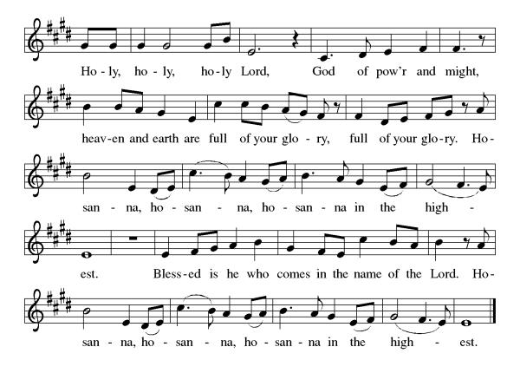

Eucharistic Prayer
Blessed are you, O God of the universe. Your mercy is everlasting, and your faithfulness endures from age to age.
Praise to you for creating the heavens and the earth. Praise to you for saving the earth from the waters of the flood. Praise to you for bringing the Israelites safely through the sea. Praise to you for leading your people through the wilderness to the land of milk and honey. Praise to you for the death and resurrection of Christ. Praise to you for your Spirit poured out on all nations.
In the night he was betrayed, our Lord Jesus took bread and gave thanks; broke it, and gave it to his disciples saying: Take and eat; this is my body given for you. Do this for the remembrance of me.
After supper he took the cup, gave thanks and gave it for all to drink saying: This cup is the new covenant in my blood, shed for you and for all people for the forgiveness of sin, Do this for the remembrance of me.
For as often as we eat of this bread and drink from this cup we proclaim the Lord’s death until He comes.
Christ has died
Christ is risen.
Christ will come again.
Gathered into one, by the Holy Spirit let us listen to the words that Jesus taught us.
The Lord’s Prayer
Our Father, who art in heaven, hallowed be thy name, thy kingdom come, thy will be done, on earth as it is in heaven. Give us this day our daily bread; and forgive us our trespasses, as we forgive those who trespass against us; and lead us not into temptation but deliver us from evil. For thine is the kingdom, and the power, and the glory, forever and ever. Amen.

Invitation to Communion
S.A.M. Bob: There is a place for you at the table of God. Come, receive the food that does not perish, a test of life eternal. Come and taste on your lips a Love we cannot comprehend.
C: Amen

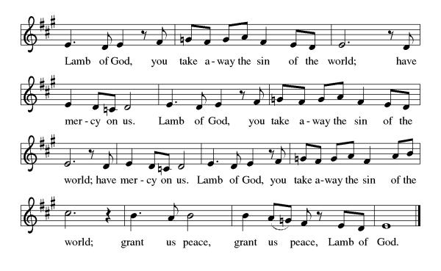Please come forward to receive
Communion Anthem: Beautiful Savior ELW 838
S.A.M. Bob: We are now a tabernacle with Christ inside of us. Let us rejoice and be glad at the Lord’s table.
C: Amen

Prayer After Communion
Life-giving God, through this meal you have bandaged our wounds and fed us with your mercy. Now send us forth to live for others, both friend and stranger, that all may come to know your love. This we pray in the name of Jesus. Amen.
Sending
Blessing
S.A.M. Bob: Lord, thank you for your abundant love and care for us. Thank you for forgiving our sins, even for the sins we do not realize we commit. Lord, please fill us with your wisdom and your compassion for others. May Almighty God Bless you "The Father, Son and Holy Spirit"
C: Amen

Sending Hymn: Crown Him with Many Crowns ELW 855
1 Crown him with many crowns, the Lamb upon his throne;
hark, how the heav'nly anthem drowns all music but its own.
Awake, my soul, and sing of him who died for thee,
and hail him as thy matchless king through all eternity.

2 Crown him the virgin's Son, the God incarnate born,
whose arm those crimson trophies won which now his brow adorn;
fruit of the mystic rose, yet of that rose the stem,
the root whence mercy ever flows, the babe of Bethlehem.

3 Crown him the Lord of love-- behold his hands and side,
rich wounds, yet visible above, in beauty glorified.
No angels in the sky can fully bear that sight,
but downward bend their burning eyes at mysteries so bright.

4 Crown him the Lord of life, who triumphed o'er the grave
and rose victorious in the strife for those he came to save.
His glories now we sing, who died and rose on high,
who died, eternal life to bring, and lives that death may die.

5 Crown him the Lord of years, the potentate of time,
creator of the rolling spheres, ineffably sublime.
All hail, Redeemer, hail! For thou hast died for me;
thy praise and glory shall not fail throughout eternity.

Text: Matthew Bridges, 1800-1894, sts. 1-3, 5; Godfrey Thring, 1823-1903, st. 4

Dismissal
S.A.M. Bob: Go in peace. Live by the Spirit.
C: Thanks be to God.
Postlude: instrumental
Unless otherwise noted, materials used in this bulletin are:
From Sundays and Seasons.com. Copyright 2015 Augsburg Fortress. All rights reserved. Reprinted by permission under Augsburg Fortress Liturgies Annual License #SAS028635. Music is reprinted under OneLicense.Net #A712074 and/or Augsburg Fortress #SBL12176H. Scripture, unless otherwise noted, is from the New Revised Standard Version Bible, Copyright © 1989, Division of Christian Education of the National Council of the Churches of Christ in the United States of America. Used by permission. All rights reserved.
Announcements for November 22nd and 23rd

ATTENDANCE
Saturday, November 15th, 4pm 28
Sunday, November 16th, 9am 50
Drive-Up Communion 0
78

The Altar Flowers are given this week by DuWayne and Jean Fowler, in honor of their wedding anniversary!

This Week at St. Timothy's
Monday, November 24th
Tuesday, November 25th
Wednesday, November 26th 2pm – Prayer Time
Thursday, November 27th 12pm- Thanksgiving Meal
Friday, November 28th
Saturday, November 29th 4pm - Worship
Sunday, November 30th 9am – Worship, 10:15-10:45 – Drive Up Communion, 10:30 – Adult SS, Coffee Fellowship

RUTH CIRCLE UPDATE- CHRISTMAS PROJECT 2025
Ruth Circle/WELCA will be starting their Christmas Project contributing items to three charities, The Path Rescue Mission, DayStar and the Family Resource Center. Thrivent will be helping us but there are some items that we can use help with if you're able. We will start collecting on November 17 and end on Dec. 7. There will be a basket in the fellowship Hall on the table which will be labeled Christmas Project. The Ruth Circle will be gathering and packing at their next meeting at the church on Dec. 8. There is a list of items below.
RUTH CIRCLE/WELCA CHRISTMAS PROJECT DONATIONS
Items will be donated to The Path Rescue Mission, DayStar Ministries and the Family Resource Center.
Men & women’s underwear and socks
Stocking caps, gloves, adult and children
First Aid Supplies
Children’s games and puzzles
Razors and shaving cream
Shampoo, Antiperspirant deodorant
Bars of soap (Irish Spring plus others)
Laundry detergent
Dish Washing soap, Bleach
Toilet paper, Paper Towels
Disinfectant wipes
Hand Sanitizer
Pine Sol
Trash bags 13 gal. or larger
Bottled water- small bottles
Crackers or Granola Bars
Ramen Noodles
Dry Cereal, all kinds
Ready to eat meals

Thank you for all you do at St. Timothy. Barbara Carson

