***A Service of Worship, Praise and Hope***

***Welcome to St. Timothy Saturday Evening Worship!***

***May 4, 2024, Sixth Week of Easter***



**"Equip people to grow as Disciples faithfully serving our community"**

**We are glad to have you worship with us. All are welcome at communion. If you need gluten-free – please tell Pastor Joanie when you go up for communion. If you have any questions – just ask the Welcomer at the back of the sanctuary.**

***Please note** if you use a pew envelope for your offering – please write your name on the envelope so that the financial secretaries can post it as a gift from you. Thank You!***

**St Timothy Worship Planning Team**

**The Reverend Joan E. Holden 850-774-7730**

**Eric Mortensen – Director of Music**

**Frank Hofstetter, Parish Deacon**

**The Altar Flowers are given by Parish Deacon Frank and Eileen Hofstetter, in honor of their wedding anniversary!**

**This Week at St. Timothy's**

**Monday, May 6th PJ OFF, 11am – Healthy Start**

**Tuesday, May 7th**

**Wednesday, May 8th 10am – OT BS**

**Thursday, May 9th 9:30am – Prayer Group, 11:00 am – Miniatures , 4:30pm - Choir**

**Friday, May 10th 10am – NT BS**

**Saturday, May 11th 4 pm – Worship**

**Sunday, May 12th 9 am – Worship – Childrens SS, 10:30 am – Adult Sunday School, 10:30 – Committees, 11-11:30 am – Drive Up Communion**

***Rooted in the past and growing into the future, the church must always be reformed in order to live out the love of Christ in an ever-changing world. We celebrate the good news of God’s grace, that Jesus Christ sets us free every day to do this life-transforming work. Trusting in the freedom given to us in baptism, we pray for the church, that Christians will unite more fully in worship and mission.***

***(from Sundays and Seasons for Reformation Weekend)***

***“Shout to the Lord” is the last pre-service hymn the choir sings, it is Hymn #821 and everyone is welcome to sing with the choir.***

**Welcome and Sharing of Congregational News**

## ***Preparation Anthem: Let There be Praise W&P 87***

***Gathering Hymn: Love Has Brought Us Here Together ACS 1040***

1. Love has brought us here together; love of fam'ly,

love of friends; love, our vow till death should part us; love, God's gift, that never ends. From our birth, throughout our lifetime,

love's insistence calls our name. Floods of waters

cannot drown it or put out its dancing flame.

1. Love is gentle, love is patient, soft in words and

kind in deeds. Love is strong and never pompous; love puts

first the other's needs. Not quick-tempered or resentful,

prone to take offense or brood, love excels in

grace and mercy, never jealous, never rude.

1. Love does not rejoice at evil; love rejoices

in the right. Keen in giving and forgiving, spreading

love is love's delight. When two people pledge their union,

all who witness are renewed, feasting at love's

earthly banquet, tasting heav'n's beatitude.

### P - The grace of our Lord Jesus Christ, the love of God and the communion of the Holy Spirit be with you all.

**C - And also with you.**

**Confession and Forgiveness**

P - Blessed be the Holy Trinity, + one God, whose name is majestic in all the earth, who rescues and heals in every time of trouble, who does all things well.

**C – Amen**

P - Let us come before God, seeking forgiveness and life.

*(Silence is kept for reflection and self-examination)*

P - Steadfast and saving God,

**C - Have mercy on us. We confess to you all our sins and that in these continuing times of uncertainty and fear, we have trouble trusting you and feeling your presence. Forgive us our sins, our doubts, our fears and lack of patience with others. Strengthen our faith and help us to let your hope and light shine through us in these challenging times. We ask for mercy, wisdom and guidance, through Jesus Christ, our Savior and Lord. Amen.**

P - In the name of + Jesus, the Son of God, receive mercy and find grace in your time of need. Your sins are forgiven; God's love is healing balm for your wounds. Rejoice, for God raises you up to new life in Christ.

**C - Amen**

**Greeting**

P - The joy of our Lord Jesus Christ, the compassion of God, and the creative power of the Holy Spirit be with you all.

**C - And also with you.**

### Prayer of the Day

**O God, you have prepared for those who love you joys beyond understanding. Pour into our hearts such love for you that, loving you above all things, we may obtain your promises, which exceed all we can desire; through Jesus Christ, your Son and our Lord, who lives and reigns with you and the Holy Spirit, one God, now and forever.**

**Amen.**

**Word**

### Lesson: Acts 10:44-48

While Peter shares the good news of Jesus with a Gentile soldier and his family, the Holy Spirit comes upon them. Recognizing that the Spirit works inclusively in the lives of both Jews and Gentiles, Peter commands that these Gentiles also be baptized in the name of Jesus Christ.

### 44While Peter was still speaking, the Holy Spirit fell upon all who heard the word. 45The circumcised believers who had come with Peter were astounded that the gift of the Holy Spirit had been poured out even on the Gentiles, 46for they heard them speaking in tongues and extolling God. Then Peter said, 47“Can anyone withhold the water for baptizing these people who have received the Holy Spirit just as we have?” 48So he ordered them to be baptized in the name of Jesus Christ. Then they invited him to stay for several days

### A: Words of God!

**C: Words of Life!**

### P – The Holy Gospel according to John, Chapter 15

### C – Glory to you O Lord.

### Gospel: John 15:9-17

On the night of his arrest, Jesus delivers a final testimony to his disciples to help them in the days ahead. Here, he repeats the most important of all his commands, that they love one another.

[Jesus said:] 9“As the Father has loved me, so I have loved you; abide in my love. 10If you keep my commandments, you will abide in my love, just as I have kept my Father’s commandments and abide in his love. 11I have said these things to you so that my joy may be in you, and that your joy may be complete.  
 12“This is my commandment, that you love one another as I have loved you. 13No one has greater love than this, to lay down one’s life for one’s friends. 14You are my friends if you do what I command you. 15I do not call you servants any longer, because the servant does not know what the master is doing; but I have called you friends, because I have made known to you everything that I have heard from my Father. 16You did not choose me but I chose you. And I appointed you to go and bear fruit, fruit that will last, so that the Father will give you whatever you ask him in my name. 17I am giving you these commands so that you may love one another.”

### P - The Gospel of Our Lord!

**C - Praise to You O Christ!**

***Message:***

***Hymn of the Day: Jesu, Jesu, Fill Us with Your Love ELW 708***

***Refrain***

***Jesu, Jesu, fill us with your love, show***

***us how to serve the neighbors we have from you.***

1 Kneels at the feet of his friends, silently washes their feet,

master who acts as a slave to them. ***Refrain***

2 Neighbors are wealthy and poor, varied in color and race,

neighbors are nearby and far away. ***Refrain***

3 These are the ones we will serve, these are the ones we will love;

all these are neighbors to us and you. ***Refrain***

4 Kneel at the feet of our friends, silently washing their feet:

this is the way we will live with you. ***Refrain***

**Apostles’ Creed**

**I believe in God, the Father almighty,**

**creator of heaven and earth.**

**I believe in Jesus Christ, God’s only Son, our Lord,**

**who was conceived by the Holy Spirit,**

**born of the virgin Mary,**

**suffered under Pontius Pilate,**

**was crucified, died, and was buried;**

**he descended to the dead.**

**On the third day he rose again;**

**he ascended into heaven,**

**he is seated at the right hand of the Father,**

**and he will come to judge the living and the dead.**

**I believe in the Holy Spirit,**

**the holy catholic church,**

**the communion of saints,**

**the forgiveness of sins,**

**the resurrection of the body,**

**and the life everlasting. Amen.**

**Lord, listen to your children praying,**

**Lord, send your Spirit in this place;**

**Lord, listen to your children praying,**

**send us love, send us pow'r, send us grace.**

### Prayers of the People *please stand, sit, or kneel as you are able*

Rejoicing that Jesus is risen and love has triumphed over fear, let us pray for the church, the world, and all those in need of good news. *A brief silence.*

Gathering Shepherd, we thank you for bringing new members to our church family. By your life-giving power, bind us to each other in you, strengthen us for service, support us all our days, and bring us at length to that day when all your children will be united as one with you. God of grace, **hear our prayer.**

Your Holy Spirit falls on all who hear the word. Fill your church with the gifts of your Spirit and give understanding hearts to those who strengthen our commitments with our ecumenical and interreligious partners. God of grace, **hear our prayer.**

You speak and the face of the earth is renewed. Renew your creation, that habitats and every kind of living thing will flourish. Protect endangered species and help us to care for all your creatures. God of grace, **hear our prayer.**

Your world is divided and the nations rage. Grant wisdom and vision to world leaders, that they will seek justice, peace, and the good of all. Strengthen international partnerships and cooperation. God of grace, **hear our prayer.**

Your children are in need. Comfort all those who suffer. Help us to be conduits of your love in our care for one another. We pray especially for everyone on our prayer list and everyone we name out loud or silently in our hearts at this time……. God of grace, **hear our prayer.**

Your work is done in this place with our hands. Bless the ministries of this congregation, that we will embody your love for the world. Inspire those who plan and lead worship, council members, committee members, and volunteers. God of grace, **hear our prayer.**

*At this time anyone may lift up prayers:*

*God of grace,* ***hear our prayer.***

Your blessed saints now rest in you. Give us thankful hearts for those who have gone before us. At the last, bring us all together around your heavenly banquet table. God of grace, **hear our prayer.**

Into your hands, most merciful God, we commend all for whom we pray, trusting in your abiding love; through Jesus Christ, our resurrected and living Lord.

**Amen.**

**Peace**

P- The Peace of the Lord be with you always.

**C – And also with you.**

**We Share Christ’s Peace**

**Offering is Brought to the Altar**

**Offering Prayer**

**We lift our voices, we lift our hands, we lift our lives up to you; we are an Offering. Lord, use our voices, Lord, use our hands, Lord, use our lives, they are yours: we are an offering. All that we have, all that we are, all that we hope to be, we give to you, we give to you. We lift our voices, we lift our hands, we lift our lives up to you; we are an offering, we are an offering.**

**Jesus’ Words of Promise and Gift of Life**

Dear Lord, Jesus Christ:

in the night in which you were betrayed,

You took bread, broke it and gave thanks,

then you gave it to your disciples saying:

take and eat, this is my body I am giving for you.

Do this in remembrance of me.

Again, after supper, Dear Lord Jesus,

You took the cup, gave thanks

and gave it for everyone to drink saying:

this cup is the new covenant in my blood,

I am shedding for you and for all people for the forgiveness of sin.

Do this for the remembrance of me. **Amen.**

**Our Lord's Prayer**

**Our Father in heaven, hallowed be your name, your kingdom come, your will be done, on earth as in heaven. Give us today our daily bread. Forgive us our sins as we forgive those who sin against us. Save us from the time of trial and deliver us from evil. For the kingdom, the power, and the glory are yours, now and forever. Amen.**

**Invitation to Communion**

P: Come to this Table where God really does come to us!

**C: Thank You Jesus!**

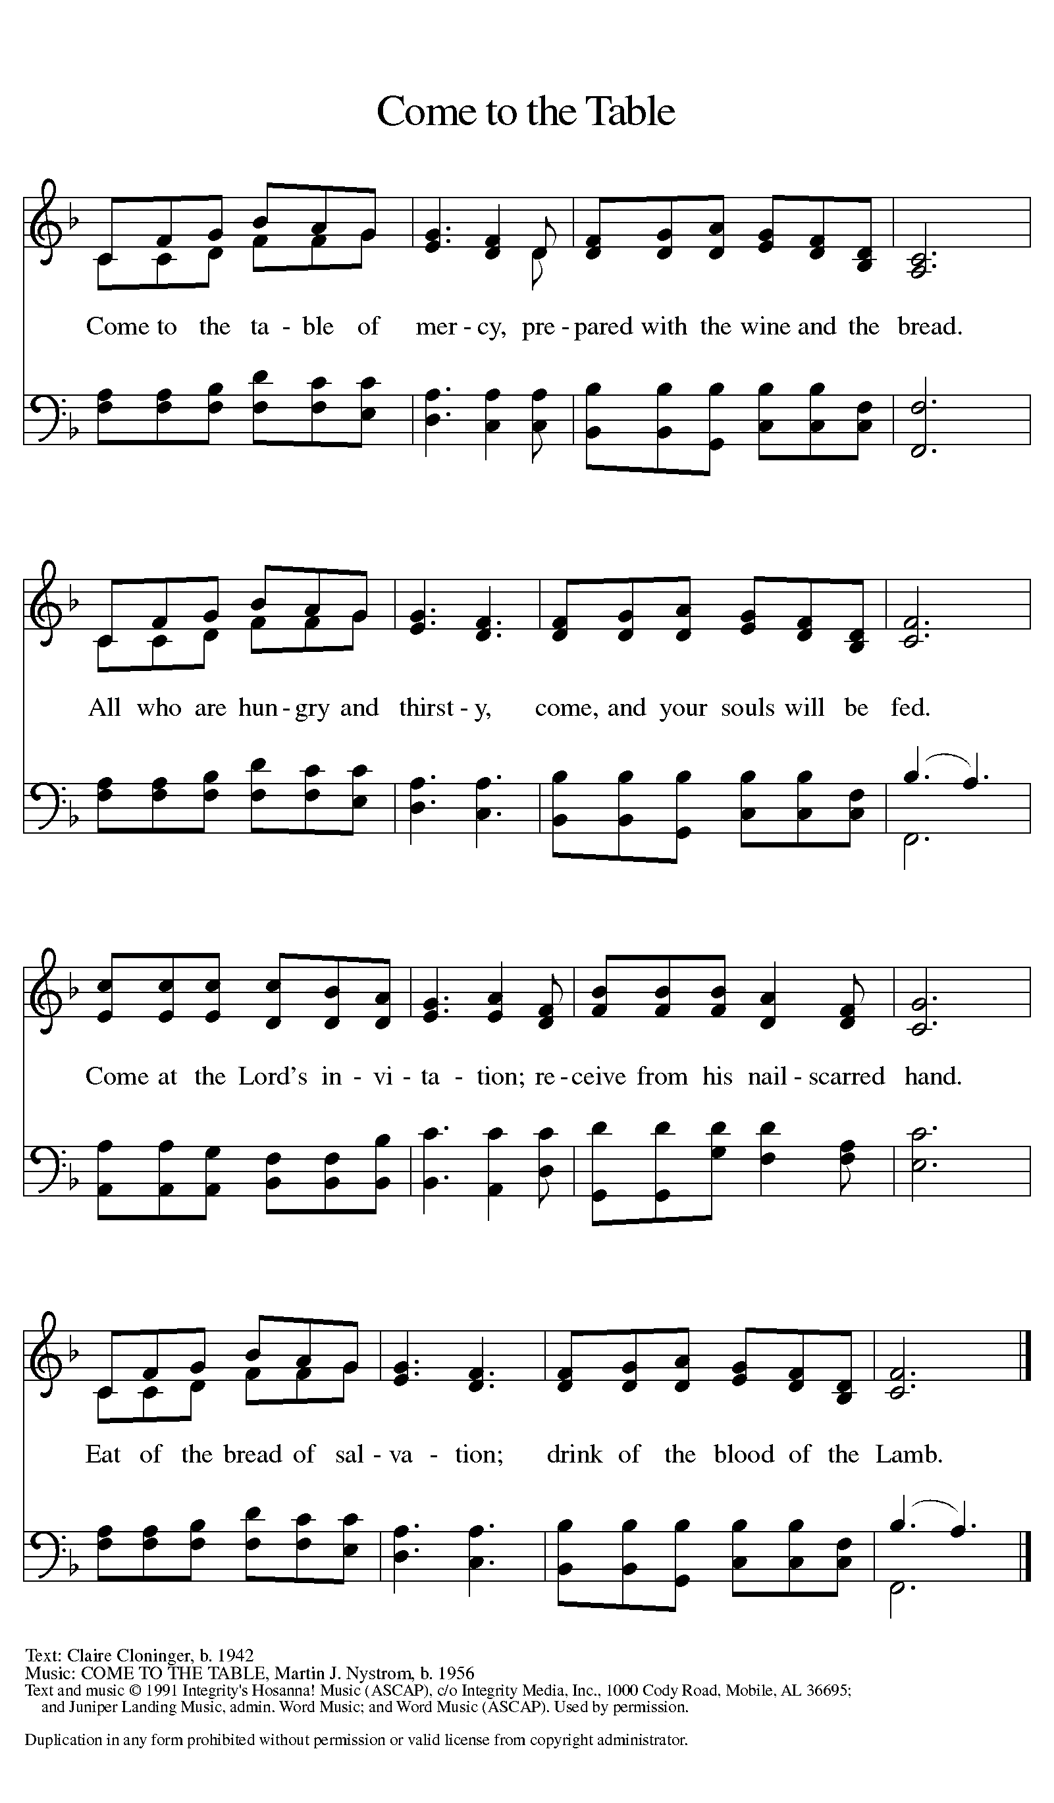

***Distribution - Please come forward to receive***

***Communion Anthem: We Walk by Faith ELW 635***

***United at the Table ELW 498***

P - Now may the body and blood of our Lord Jesus Christ strengthen you and keep you in his grace…. Jesus Loves You!

**C – Thank You Jesus!**

### Prayer after Communion

**Shepherding God, you have prepared a table before us and nourished us with your love. Send us forth from this banquet to proclaim your goodness and share the abundant mercy of Jesus, our redeemer and friend.** **Amen.**

**Sending**

**Blessing**

P - God Almighty send you light and truth to keep you all the days of your lives. The hand of God protect you; the holy angels accompany you; and the blessing of almighty God, the Father, the ☩ Son, and the Holy Spirit, be with you now and forever.

**C -Amen.**

## ***Sending Hymn: Joyful, Joyful We Adore Thee ELW 836***

1 Joyful, joyful we adore thee, God of glory, Lord of love!

Hearts unfold like flow'rs before thee, praising thee, their sun above.

Melt the clouds of sin and sadness, drive the gloom of doubt away.

Giver of immortal gladness, fill us with the light of day.

2 All thy works with joy surround thee, earth and heav'n reflect thy rays,

stars and angels sing around thee, center of unbroken praise.

Field and forest, vale and mountain, flow'ry meadow, flashing sea,

chanting bird, and flowing fountain call us to rejoice in thee.

3 Thou art giving and forgiving, ever blessing, ever blest,

wellspring of the joy of living, ocean-depth of happy rest!

Thou our Father, Christ our brother, all who live in love are thine;

teach us how to love each other, lift us to the joy divine!

### Dismissal

A: Alleluia! Go in peace. Rejoice and be glad.

**C: Thanks be to God. Alleluia!**

***Postlude Anthem: He is Exalted W&P 55***

From Sundays and Seasons.com. Copyright 2015 Augsburg Fortress. All rights reserved. Reprinted by permission under Augsburg Fortress Liturgies Annual License #SAS028635. Music is reprinted under OneLicense.Net #A712074 and/or Augsburg Fortress #SBL12176H. Scripture, unless otherwise noted, is from the New Revised Standard Version Bible, Copyright © 1989, Division of Christian Education of the National Council of the Churches of Christ in the United States of America. Used by permission. All rights reserved.

**REMEMBRANCE**

**Julian of Norwich, renewer of the church, died around 1416**

When she was about thirty years old, Julian (or Juliana) reported visions that she later compiled into a book, Sixteen Revelations of Divine Love, now a classic of medieval mysticism. The visions declared that love was the meaning of religious experience, provided by Christ who is love, for the purpose of love.

**Announcements for May 4th and 5th**

**ATTENDANCE**

**Saturday, April 27th 4pm 26**

**Sunday, April 28th , 9am 37**

**Drive-Up Communion 5**

**