A Service of Worship, Praise and Hope
Welcome to St. Timothy Saturday Easter Season Evening Worship!
May 24, 2025, Sixth Saturday of Easter



"Equip people to grow as Disciples faithfully serving our community"

We are glad to have you worship with us. All are welcome at communion. If you need gluten-free – please let us know when you go up for communion. If you have any questions – just ask the Welcomer at the back of the sanctuary.

Please note** if you use a pew envelope for your offering – please write your name on the envelope so that the financial secretaries can post it as a gift from you. Thank You!
Announcements
Let us prepare our hearts and minds for worship.
Preparation Hymn: Holy Ground W&P 59
Gathering Hymn: Good Christian Friends, Rejoice and Sing! ELW 385
- Good Christian friends, rejoice and sing! Now is the triumph
of our king! To all the world glad news we bring:
Alleluia, alleluia, alleluia!

- The Lord of life is ris'n this day; death's mighty stone is
rolled away; let all the world rejoice and say:
Alleluia, alleluia, alleluia!

- Praise we in songs of victory that love, that life, which
cannot die, and sing with hearts uplifted high:
Alleluia, alleluia, alleluia!

- Your name we bless, O risen Lord, and sing today with
one accord, the life laid down, the life restored:
Alleluia, alleluia, alleluia!

V- In the name of the Father and of the Son and of the Holy Spirit.
C - Amen

V - The grace of our Lord Jesus Christ, the love of God and the communion of the Holy Spirit be with you all.
C - And also with you.
V - Holy God,
we give you thanks for the waters of baptism,
waters that make a people your own,
that restore to wholeness,
and empower us to be witnesses in your name.
Baptized into you, O Living One,
C - make us one as you are one.
Let us confess our sins in front of God and one another.
(Silence is kept for reflection and self-examination)
Confession and Forgiveness
Most merciful God, We confess that we are captive to sin and cannot free ourselves. We have sinned against you in thought, word, and deed, by what we have done and by what we have left undone. We have not loved you with our whole heart; and we have not loved our neighbors as ourselves. For the sake of your Son, Jesus Christ, have mercy on us. Forgive us, renew us, and lead us, so that we may delight in your will and walk in your ways, to the glory of your holy name.

V - In the name of + Jesus, the Son of God, receive mercy and final grace in your time of need. Your sins are forgiven; God's love is healing balm for your wounds. Rejoice, for God raises you up to new life in Christ.
C – Amen
Greeting
V - The joy of our Lord Jesus Christ, the compassion of God, and the creative power of the Holy Spirit be with you all.
C - And also with you.

Prayer of the Day
Bountiful God, you gather your people into your realm, and you promise us food from your tree of life. Nourish us with your word, that empowered by your Spirit we may love one another and the world you have made, through Jesus Christ, our Savior and Lord, who lives and reigns with you and the Holy Spirit, one God, now and forever. Amen.
Please be seated

Lesson: Revelation 21:10, 22—22:5
John’s vision of a new Jerusalem coming out of heaven provides continuity with God’s past actions. Yet in this new city, God’s presence replaces the temple, and the glory of God and the Lamb supplants sun and moon.
¹⁰ And in the spirit [one of the angels] carried me away to a great, high mountain and showed me the holy city Jerusalem coming down out of heaven from God.
²² I saw no temple in the city, for its temple is the Lord God the Almighty and the Lamb. ²³ And the city has no need of sun or moon to shine on it, for the glory of God is its light, and its lamp is the Lamb. ²⁴ The nations will walk by its light, and the kings of the earth will bring their glory into it. ²⁵ Its gates will never be shut by day—and there will be no night there. ²⁶ People will bring into it the glory and the honor of the nations. ²⁷ But nothing unclean will enter it, nor anyone who practices abomination or falsehood, but only those who are written in the Lamb’s book of life.
^{22:1} Then the angel showed me the river of the water of life, bright as crystal, flowing from the throne of God and of the Lamb ² through the middle of the street of the city. On either side of the river is the tree of life with its twelve kinds of fruit, producing its fruit each month; and the leaves of the tree are for the healing of the nations. ³ Nothing accursed will be found there any more. But the throne of God and of the Lamb will be in it, and his servants will worship him; ⁴ they will see his face, and his name will be on their foreheads. ⁵ And there will be no more night; they need no light of lamp or sun, for the Lord God will be their light, and they will reign forever and ever.

A – Word of God!
C – Words of Life!
Please stand for the Gospel.

V – The Holy Gospel according to John, Chapter 14

C – Glory to you O Lord.

Gospel: John 14:23-29
As Jesus talks of returning to the Father, he promises to send the Advocate, the Holy Spirit, who will teach Jesus’ followers and remind them of all that Jesus taught. Even more, those in whom God makes a home will experience a peace that overcomes fear.
²³ Jesus answered [Judas (not Iscariot),] “Those who love me will keep my word, and my Father will love them, and we will come to them and make our home with them. ²⁴ Whoever does not love me does not keep my words; and the word that you hear is not mine, but is from the Father who sent me.
²⁵ “I have said these things to you while I am still with you. ²⁶ But the Advocate, the Holy Spirit, whom the Father will send in my name, will teach you everything, and remind you of all that I have said to you. ²⁷ Peace I leave with you; my peace I give to you. I do not give to you as the world gives. Do not let your hearts be troubled, and do not let them be afraid. ²⁸ You heard me say to you, ‘I am going away, and I am coming to you.’ If you loved me, you would rejoice that I am going to the Father, because the Father is greater than I. ²⁹ And now I have told you this before it occurs, so that when it does occur, you may believe.”
V - The Gospel of Our Lord!
C - Praise to You O Christ!
You may be seated.

Sermon by Vicar Bob

Hymn of the Day: Lead Me, Guide Me ELW 768

Refrain
Lead me, guide me, along the way;
For if you lead me, I cannot stray.
Lord, let me walk each day with thee.
Lead me, O Lord, lead me.

- I am weak and I need thy strength and pow’r
To help me over my weakest hour.
Help me through the darkness thy face to see.
Lead me, O Lord, lead me. Refrain

- Help me tread in the paths of righteousness,
Be my aid when Satan and sin oppress.
I am putting all my trust in thee.
Lead me, O Lord, lead me. Refrain

- I am lost if you take hour hand from me,
I am blind without thy light to see.
Lord, just always let me thy servant be.
Lead me, O Lord, lead me. Refrain

Apostles’ Creed
I believe in God, the Father almighty,
creator of heaven and earth.
I believe in Jesus Christ, God’s only Son, our Lord,
who was conceived by the Holy Spirit,
born of the virgin Mary,
suffered under Pontius Pilate,
was crucified, died, and was buried;
he descended to the dead.
On the third day he rose again;
he ascended into heaven,
he is seated at the right hand of the Father,
and he will come to judge the living and the dead.
I believe in the Holy Spirit,
the holy catholic church,
the communion of saints,
the forgiveness of sins,
the resurrection of the body,
and the life everlasting. Amen.

Lord, listen to your children praying,
Lord, send your Spirit in this place;
Lord, listen to your children praying,
send us love, send us pow'r, send us grace.

Prayers of The People

Response: Your mercy is great.

God of resurrection and new life, we come before you in prayer for the church, the world, and all who are in need.
A brief silence.
Loving God, you welcome all at your table of grace. Instill in your church a spirit of humility and curiosity, that we embrace all who seek you. We pray especially for all of St. Timothy’s Ministries and the volunteers who faithfully share the Gospel with everyone by their actions of giving. Hear us O God, Your mercy is great.
Unite your people with communities of faith throughout the world. Further cooperation between people of different faith traditions and bless our non-Christian neighbors that we learn and grow in deeper relationship. Hear us, O God. Your mercy is great.
Bless the earth with fresh water, clean air, and rich soil. Nurture growing crops and encourage communities developing sustainable farming practices. Help us to live in balance and harmony with your good creation.
Hear us, O God. Your mercy is great.
Reconcile nations (Israel/Gaza) so that all people can live in peace. Make all nations safe for both migrants and residents. Hear us, O God. Your mercy is great.
Sustain all who are in need, especially individuals and families struggling with trauma or addiction. Support caregivers, especially nurses, doctors, counselors, and social workers. Come alongside all who are ill or struggling (mention aloud or I your heart). Hear us, O God. Your mercy is great.
This Memorial Day weekend, we remember all who have died in military service. Soothe loved ones who mourn and strengthen support systems for veterans and their families. Bring peace among nations, that war and conflict around the world might cease. Hear us, O God. Your mercy is great.
We give you thanks for all your saints raised to new life in Christ, especially Margo Blum. Gather us, with them, into the peace only you can give. Hear us, O God. Your mercy is great.
We commend these and all our prayers to you, O God, trusting that you are always with us, in the name of Jesus Christ, our risen Savior.
Amen.

Peace
V - The Peace of the Lord be with you always.
C – And also with you.
We Share Christ’s Peace
Offering is Brought to the Altar

Offering Prayer

We lift our voices, we lift our hands, we lift our lives up to you; we are an Offering. Lord, use our voices, Lord, use our hands, Lord, use our lives, they are yours: we are an offering. All that we have, all that we are, all that we hope to be, we give to you, we give to you. We lift our voices, we lift our hands, we lift our lives up to you; we are an offering, we are an offering.

V : The Lord be with you.

C: And also with you.

V: We lift up your hearts.

C: We lift them to the Lord.

V: Let us give thanks to the Lord our God.

C: It is right to give our thanks and praise.

Words of Institution

Preface

It is indeed right, our duty and our joy, that we should at all times and in all places give thanks and praise to you, almighty and merciful God, through our Savior Jesus Christ.

You call your people to cleanse their hearts and prepare with joy for the paschal feast, that, renewed in the gift of baptism, we may come to the fullness of your grace. And so, with all the choirs of angels, with the church on earth and the hosts of heaven, we praise your name and join their unending hymn.

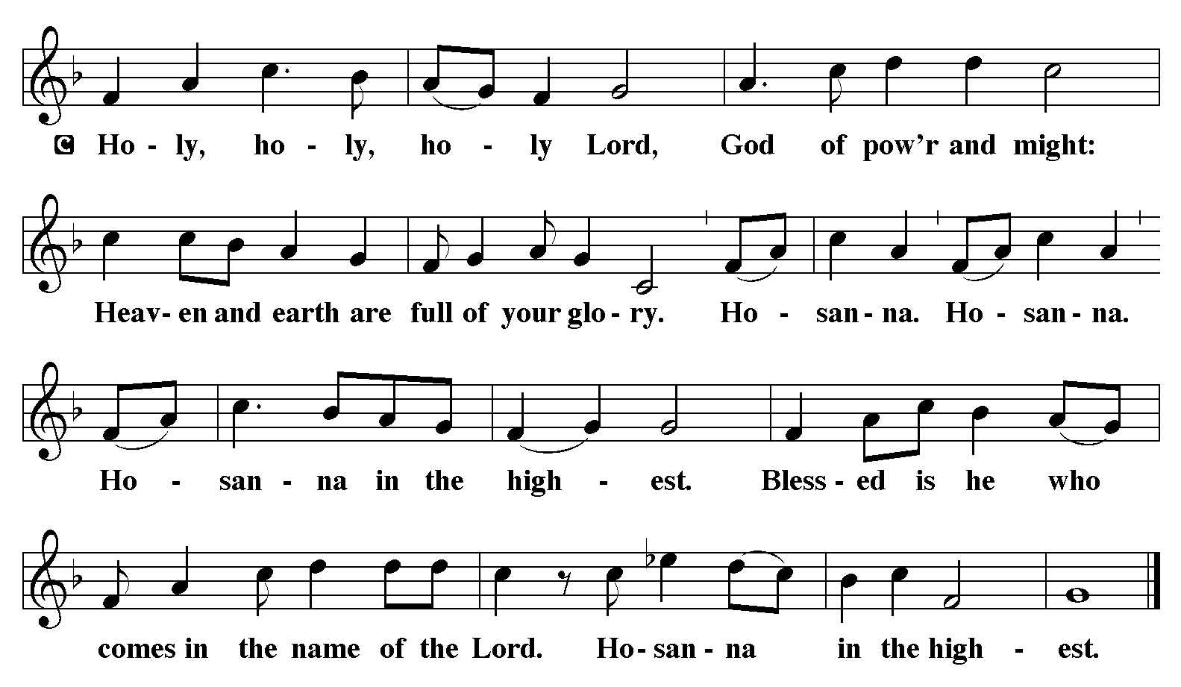

Eucharist Prayer
Blessed are you, O God of the universe. Your mercy is everlasting, and your faithfulness endures from age to age.

Praise to you for creating the heavens and the earth. Praise to you for saving the earth from the waters of the flood. Praise to you for bringing the Israelites safely through the sea. Praise to you for leading your people through the wilderness to the land of milk and honey. Praise to you for the death and resurrection of Christ. Praise to you for your Spirit poured out on all nations.

In the night he was betrayed, our Lord Jesus took bread and gave thanks; broke it, and gave it to his disciples saying: Take and eat; this is my body given for you. Do this for the remembrance of me.

After supper he took the cup, gave thanks and gave it for all to drink saying: This cup is the new covenant in my blood, shed for you and for all people for the forgiveness of sin, Do this for the remembrance of me.

With this bread and cup we remember our Lord’s Passover from death to life as we proclaim the mystery of faith:
Christ has died
Christ is risen.
Christ will come again.

The Lord’s Prayer
Our Father, who art in heaven, hallowed be thy name, thy kingdom come, thy will be done, on earth as it is in heaven. Give us this day our daily bread; and forgive us our trespasses, as we forgive those who trespass against us; and lead us not into temptation but deliver us from evil. For thine is the kingdom, and the power, and the glory, forever and ever. Amen.

Invitation to Communion
C: Lamb of God who takes away the sins of the world, have mercy on us. Lamb of God who takes away the sins of the world, have mercy on us. Lamb of God who takes away the sins of the world, grant us peace.

V: This is the Lamb of God who takes away the sin of the world. Happy are those who are called to his supper. Come and taste upon your lips a love we cannot comprehend.
C: Thank You Jesus!

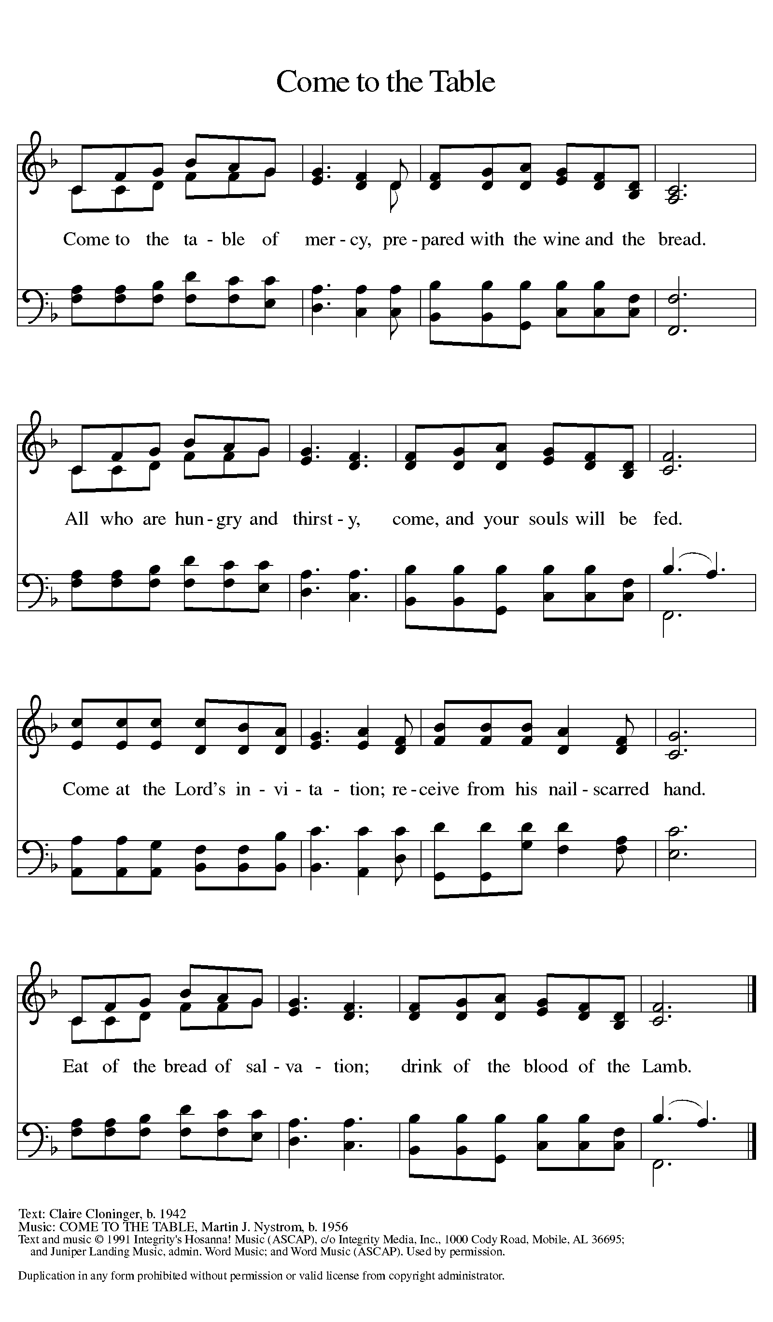

Communion Anthem: Here is Bread W&P 58

Prayer after Communion
Living One, in this feast you have made yourself known to us. Send us now to tell of your wonders, sing of your glory, and proclaim your risen life to a wounded and weary world.
Amen.

V - Now may the body and blood of our Lord and Savior Jesus Christ strengthen you and keep you in his grace…. Jesus Loves You!
C – Thank You Jesus!

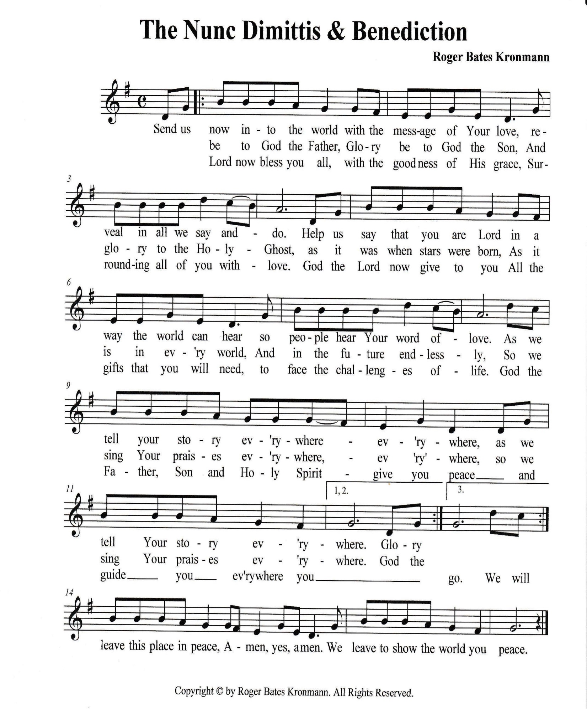

Sending
Blessing
V- The triune God, who was, who is, and who is to come, Sovereign, ☩ Savior, and Spirit, light your way with resurrection dawn, now and always.
C -Amen.

Sending Hymn: Oh, Sing to the Lord ELW 822
1 Oh, sing to the Lord, oh, sing God a new song.
Oh, sing to the Lord, oh, sing God a new song.
Oh, sing to the Lord, oh, sing God a new song.
Oh, sing to our God, oh, sing to our God.

2 For God is the Lord, and God has done wonders.
For God is the Lord, and God has done wonders.
For God is the Lord, and God has done wonders.
Oh, sing to our God, oh, sing to our God.

3 So dance for our God and blow all the trumpets.
So dance for our God and blow all the trumpets.
So dance for our God and blow all the trumpets,
Oh, sing to our God, oh, sing to our God.

4 Oh, shout to our God, who gave us the Spirit.
Oh, shout to our God, who gave us the Spirit.
Oh, shout to our God, who gave us the Spirit.
Oh, sing to our God, oh, sing to our God.

5 For Jesus is Lord! Amen! Alleluia!
For Jesus is Lord! Amen! Alleluia!
For Jesus is Lord! Amen! Alleluia!
Oh, sing to our God, oh, sing to our God.

Dismissal
V: Go in peace. Proclaim the Good News – Christ is Risen!
C: By the Grace of God we will – Alleluia!
Postlude: Go Ye Therefore W&P 49
Unless otherwise noted, materials used in this bulletin are:
From Sundays and Seasons.com. Copyright 2015 Augsburg Fortress. All rights reserved. Reprinted by permission under Augsburg Fortress Liturgies Annual License #SAS028635. Music is reprinted under OneLicense.Net #A712074 and/or Augsburg Fortress #SBL12176H. Scripture, unless otherwise noted, is from the New Revised Standard Version Bible, Copyright © 1989, Division of Christian Education of the National Council of the Churches of Christ in the United States of America. Used by permission. All rights reserved.

REMEMBRANCE
John Calvin, renewer of the church, died 1564
Gifted both as a systematic theologian and as an interpreter of scriptures, Calvin embraced the Reformation, and as a preacher in Geneva, Switzerland, brought a theocratic government to it. He is regarded as the father of the Reformed churches.
From sundaysandseasons.com.

_____________________________________________________________________________________________________________________________________

St. Timothy Worship Planning Team
Vicar Bob Bonomo
Director of Music, Eric Mortensen
Deacon, Frank Hofstetter

The Altar Flowers are given this week by Patie Pule, in memory of our fallen military!

ATTENDANCE
Saturday, May 17th , 4pm 28
Sunday, May 18^{th,} 9am 46
Drive-Up Communion 2
76

This Week at St. Timothy's
Monday, May 26th 10am – Memory Day Svc
Tuesday, May 27th 9-12 – Food Pantry
Wednesday, May 28th
Thursday, May 29th 9:30am – Prayer Group, 11:00am – Miniatures, 4:30pm – Choir
Friday, May 30th
Saturday, May 31st 4pm - Worship
Sunday, June 1st 9am – Worship, Children’s SS, 10:15-10:45
Drive-Up Communion, 10:30 – Coffee Fellowship, Adult SS

