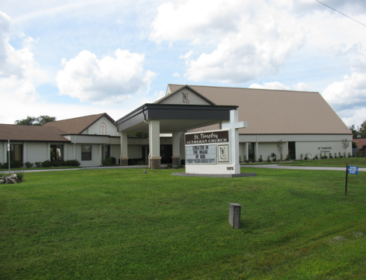

ST. TIMOTHY EVANGELICAL
LUTHERAN CHURCH
Vineyard Views
April 2026

Sam’s Corner
S.A.M. BOB BONOMO
April 2026

Greetings from Our Lord and Savior Jesus Christ,
The Lord is Risen!!!

Dear St. Timothy Family,
What a beautiful Easter celebration we shared together! My heart is overflowing with gratitude for each of you — for your prayers, your service, your worship, and your joy in proclaiming that Christ is risen indeed!
Easter is not just a day on the calendar; it’s the beginning of a renewed season of hope. The empty tomb reminds us that no darkness can overcome the light of Christ, and no burden is too heavy for His grace to lift.
As we move forward, let’s carry the spirit of Resurrection Sunday into our daily lives — speaking words of life, extending kindness to those in need, and living as witnesses of the power of the risen Savior.
Thank you to everyone who served, invited friends, decorated, sang, prayed, and welcomed guests. You have been the hands and feet of Jesus in such a touchable way.
Let’s keep the momentum going! I encourage you to stay connected in worship, small groups, and outreach opportunities in the weeks ahead. The story of Easter is still unfolding — and we are part of it.
May His peace be with you always,
Bob

EASTER FOOD BOXES
Thank you, everyone for all your help. We had approximately 27 members participate in the packing and pizza party. Many thanks to all those who helped provide the food items needed for the boxes, and also helping with monetary donations.
We filled 42 food boxes, with a total of 71 adults and 70 children. The good news is that any overage on an item was given to the food pantry.
Also, I need to give a big “THANK YOU” to Barbara Carson and her group of volunteers for taking on the Children’s easter bags. You took on this blessed task and did an outstanding job.
This outreach can’t be done without all the help from our church family.
Blessings and Thank you,
Patti Cyr

THE POWER OF PRAYER IN ACTION AND INSPIRATION

“FOLLOW MY LEAD”
By Barbara Carson

That title “Follow My Lead” sounds like something you hear on stage from actors or entertainers, but really you can take it out of that context, and it can mean, act in the same manner, copy some other actions and accept guidance or direction. So, let’s think of it as God saying, “Follow My Lead”! Isaiah 55:8-9 says “For my thoughts are not your thoughts, nor are your ways My ways,” says the Lord. For as the heavens are higher than your ways, And my thoughts than your thoughts.” So, knowing this why not follow God’s lead?

Our life has ups and downs and we would like to have a life of unity and more enrichment. If we respond to God’s Will it is much easier to know and carry out His plan for us. We may miss out on what life has to offer as our actions and voices lead us astray, not knowing that God has secret purposes for us. It is nice to know God has no limits on forgiveness and His unlimited Love and Grace are here for us as we Follow God’s Lead.

Facing difficulties and challenges is annoying and overtakes our life. God is our compass that points us in the right direction no matter what life brings us. Just Follow God’s Lead.
Those secret purposes God has for us will become more clearer when go in the right direction. My favorite song “Christ Be Our Light” starts out saying “Longing for light, we wait in the darkness, Longing for truth, we turn to you. Make us your own, your holy people light for the world to see.” Sounds comforting.

So, God says, “Follow My Lead” is not a bad idea as we strive to act in the same way as Him, copy His actions and accept guidance and directions to lead us to a more fulfilling life. As Psalm 119:105 is paraphrased, your guidance is like a lamp for my feet and gives direction for my path. God says to His people “FOLLOW ME” and have a richer, fuller life. AMEN!

Benevolence for April - The Path
Citrus County Homeless Shelter and resource center

From the desk of Minister Robert
If the holy spirit has touched you to even thinking about becoming a council member, feel free to call me or come and see me.
Having a discussion does not mean in any way that you must say yes.

Blessings

“If you have submissions for the April Vineyard Views, please have them in the office no later than the end of day on Tuesday, March 24th.”
This was in the March Vineyard views, and you will notice not much info to share except for those who had their articles in by March 24.
Please help us so our monthly newsletter can be completed timely.
Very much appreciated.
Bob


Pre-Assembly Bible Study

A 7-Week Journey through Acts
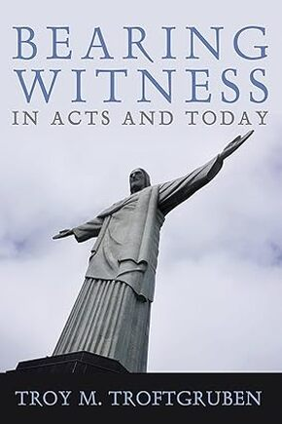
​We are inviting you to a 7-week pre-assembly Bible study looking at stories in Acts, beginning the week after Easter and wrapping up the week prior to the assembly. To facilitate this study, we are providing each congregation with a copy of Bearing Witness in Acts and Today, by Rev. Dr. Troy Troftgruben (ctrl + click to follow link), the William A. & John E. Wagner Professor in Biblical Theology at Wartburg seminary.
The book uses the stories in Acts to wrestle with practices of evangelism and provides a grounding for the ways we are called to bear witness in the world. Each chapter includes discussion questions, resources for further exploration, and action steps for further consideration.
Our “Do you Understand?” theme for the 2026 synod assembly comes from the story of Philip’s encounter with the Ethiopian eunuch in the 8th chapter of Acts. Our keynote presentations will focus on Fresh Expressions, a movement meant to “unleash new forms of Christian community in the wild and wonderful spaces of everyday life.”
​This movement entails bearing witness in new ways to our neighbors. Our keynote speaker will be the Rev. Shannon Kiser, the Senior Director of Fresh Expressions North America and author of Opening Space: A Vision for Fresh Expressions of Church and Creative Mission (ctrl + click to follow link).

How You Can Participate
You can engage with this material in several ways:
- As a congregational study
- As a study with your synod assembly voting members
- In collaboration with other conference congregations (e.g. as rostered leader colleagues or with synod assembly voting members)
Weekly Zoom Conversation
We will also be hosting a weekly conversation on Tuesday nights, starting April 14, at 7:00 p.m. on Zoom.
JOIN VIA ZOOM
(ctrl + click to follow link)
Meeting ID: 854 9042 0373 | ​Passcode: 819327
Weekly Discussion Guides
APRIL 14  Introduction and Chapter 1: Embracing the Story  ​(Acts 1:1-11; Luke 24:48)  APRIL 14 DISCUSSION GUIDE  APRIL 28:  Chapter 3: Embodying the Story  (Acts 2:42-47 and 4:32-37)  APRIL 28 DISCUSSION GUIDE  MAY 12  Chapter 5: Conversing About the Story  (Acts 8:26-40)  MAY 12 DISCUSSION GUIDE | ​APRIL 21  Chapter 2: Telling the Story  (Acts 2:1-41)  APRIL 21 DISCUSSION GUIDE  ​MAY 5:  Chapter 4: Making the Story Public  ​(Acts 3-4)  MAY 5 DISCUSSION GUIDE  ​​​MAY 19  Chapter 6: Taking the Story to New Places  (Acts 10:1-11:18)  may 19 discussion guide

MAY 26
Chapter 7: Sharing the Story as a Way of Life and Conclusion
​(Acts 17:16-34; Acts 28:16-31)

Bump2Baby (Formerly “World's Greatest Baby Shower”)
Bump2Baby is going to be held April 30 from 5-7pm. Again St. Timothy is going to sponsor this event. Lynn Dively has agreed again to help me.
We will be needing some volunteers to help pack bags on the day of the event (2ish on day of event). A few to help deliver prizes to winners. And some to help pack our contributions. Leave me a name and contact info in box 72 if you wish to help. If you just tell me, I will forget.
We need things to put in the bags. They are making 60 of them. Things from Dollar Tree are very acceptable. Not all our bags have to be alike. Last year they contained: a hat, booties or socks, sippy cup, washcloth, one piece suit, and bib. All wrapped up in a receiving blanket. But this is not all we can use. Anything on the Healthy Start list will do. If we get too many of an item, we will pass on to Healthy Start. Use your imagination. We do not want big items. The bags are not very big. The Bump2Baby committee has asked that the one-piece suit be size 6 months or larger. But we will not turn down smaller sizes. Walmart in Lecanto had a lot of these on sale. PJ'S are fine too. I will be putting out the booties for you to pick up soon. Any questions please ask Lynn or me. Oh , we will take cash or check.

Thanks for supporting this wonderful program again,

Sallie Haley

DEADLINES
Announcements
Please be aware that if you have entries for the weekend worship announcements you need to have them in on Tuesday prior, as we are preparing and printing them no later than Thursday.

Vineyard Views
If you have submissions for the May Vineyard Views, please have them in the office no later than the end of day on Tuesday, April 28th

Please check for the following sign-up sheets
Serving Our Lord (Worship Helpers) – bulletin board by kitchen
Flower chart – bulletin board across from nursery
Healthy Start –bulletin board by kitchen
PB&J Ministry – bulletin board by kitchen
Coffee Hour – in kitchen

NEW ZOOM LINK FOR ADULT SUNDAY SCHOOL – 9/18
Topic: Adult Sunday School Class
Time: Sep 21, 2025 10:30 AM Eastern Time (US and Canada)
Every week on Sun, 97 occurrence(s)
Please download and import the following iCalendar (.ics) files to your calendar system.
Weekly: https://us02web.zoom.us/meeting/tZwrc-mprDMoH9YRklu1WcmVIop862c72xVO/ics?icsToken=DBOIHJoC7iVwo_7kCQAALAAAABAB_uGypwq2ymkMO9EqrhDMoZY3vO7cudxQ3PHNM4LxWE7vm8v6Hf2LmVyJEkPyvcQ1Vmg_NR4W6BglNTAwMDAwMQ&meetingMasterEventId=3pLv0et_SMuCQYJkMknIyQ
Join Zoom Meeting
https://us02web.zoom.us/j/88640128252?pwd=asNJ6OiNGFFTNzwNA5yhkvPpmt6VCT.1
Meeting ID: 886 4012 8252
Passcode: 898938



INFORMATION FROM THE FINANCE COMMITTEE
AND YOUR TREASURERS
In the hope of getting ahead of our property, liability and flood insurance costs for next year, we have been trying to save toward those expenses. (Property and liability premiums are due by June 1st of each year, and flood is due November 1st.) We would appreciate any additional donation you could make. Please include that amount with your regular offering and designate it as “Insurance” on the offering envelope.
A security camera system to monitor the outside areas of our campus has been installed. The cost is $3,852.00. If you would like to donate to this purchase for the welfare of our safety and security, please designate “Security Expense” on your offering.
Duke Energy will also be updating the lighting in the parking lot. There will be no additional charge for this service.
A weekly offering update is given with the email announcements. We are most grateful to all of you who support our programs through your prayers, offerings, time and talents.
- Lynn Dively



THRIVENT FINANCIAL NEWS FOR APRIL 2026

$$$THRIVENT CHOICE DOLLARS®$$$
Thanks so much to our Thrivent Financial members and friends who direct their Thrivent Choice Dollars® to
available for activities and projects for our mission and ministry here at St. Timothy. If you are an eligible
Thrivent Financial member and have Choice Dollars® available, please call Thrivent (800-847-4836) and say “Thrivent Choice®” or go online to www.thrivent.com/thriventchoice and direct your dollars…hopefully to St. Timothy Lutheran Church in Crystal River. To date for 2026 our church has received $870.00 through this program.

Thanks to the following members and friend who recently directed their $$ to St. Timothy:

Lloyd DeBusk JoAn DeBusk Martha Hoagland Barbara Johnson

THRIVENT ACTION TEAMS
Thrivent Action Teams make it easy for you to bring people together to make a positive change in your community! When you see a need, apply to lead a volunteer team. Once your idea is approved, a Thrivent Action Kit is delivered to your door. It’s packed with everything you need to help make your project a success. It even includes $250.00 in seed money to help get your project started. After you finish the project, you report the results on-line to Thrivent. This program is brought to you by Thrivent Financial because they believe that being wise with money and living generously go hand in hand. All your questions and requests for this funding program will be answered by going to Thrivent.com/actionteam.***Please note that Thrivent Financial funds accessed for all programs and activities involving St. Timothy Lutheran Church need to be approved by a Committee and the Congregational Council. 2026Thrivent Action Teams that have been approved: Easter Food Boxes, Bump2Baby Expo
THE $250 IN SEED MONEY IS A GIFT FROM THRIVENT THAT WE CAN USE TO HELP WITH COMMUNITY OUTREACH AND PROJECTS INVOLVING OUR CONGREGATION. THESE FUNDS ARE IN ADDITION TO OUR BUDGETED AMOUNTS AND OFFERINGS AND DONATIONS MADE BY OUR MEMBERS AND FRIENDS.

Financial Representatives for answering questions and offering advice on Thrivent investments and products are:
Katherine Gross Kevin Braunschweiger
in Gainesville, FL in Ocala, FL
352-505-8905 352-440-6784
Katherine.gross@thrivent.com
Virtual Advice Team – 855-303-7402

Food Pantry
The food pantry continues to operate on the 2nd and 4th week of every month from 9AM- noon. We continue to inform the congregation as to the needs of the pantry via the weekly announcements. The current needs are fruit, spaghetti- 16oz., peanut butter, chili which serves 2 people and laundry detergent (dollar store is fine), saltines. Thanks to all who contribute food. You can also contribute monetarily by writing out a check made out to Life Tree Church with Food Pantry in the memo line or writing out a check to St. Timothy Lutheran and putting food pantry in the memo line, and placing it in my mailbox, #210. We will also accept cash donations. Please put it in an envelope in mailbox, #210 and put your name on it so I know who you are. If you would like a receipt, please let me know. The next food pantry will be March 10, 2026.
The next food pantry will be on April 28th from 9-12.
Thank you. - Barbara J
Healthy Start – updated 4/16
Needs for May: 13 baby lotion
Carolyn Fialkowski

PB&J MINISTRY UPDATE
Our peanut butter lunch packing for DayStar is the first Monday of the month at 10:00. There is a sign-up sheet on the bulletin board in the hallway by the kitchen. We need about 6 people each time or let me know if you are interested. Thank you - Barbara Carson


MESSAGE FROM REGINA
Please, if you are at a church function, think about snapping a few photos for everyone to enjoy. Thank you in advance.

SERVING HANDS
Serving Hands is a program created to help members of our own congregation. Serving Hands is there for you if you need some help in the following areas: a meal brought to you, driving you to an appointment, a friendly visit, doing a household chore, communion brought to you, walking your dog, or picking up food for your pet, etc. These are one-time opportunities, not forever experiences. Please contact Carolyn Fialkowski at 814-392-4281, or Jean Fowler at 586-322-8337 if you need help.
Please don’t hesitate to call. We want to serve you! Also, if you are willing to help with any of these services, there is a sign-up chart on the kiosk in the entrance way of the church or call one of these ladies.

AED /Medical response :
We have a poster that is behind the kiosk across from our AED in the narthex. An emergency incident can happen at any time, and it is good to be prepared. The poster explains a “hands only “ CPR protocol as the first line of an emergency of that kind and is very easy for anyone. Please take a look and refresh yourself on the protocol. Our AED is valuable for saving lives but initiating CPR is essential. We do have several people in our congregation that have more detailed experience to assist as needed. For any questions, please ask Barbara Carson.
Instructional video on how to use the Philips AED.
https://youtu.be/t6GV9PAbgM4?si=dZuGq8aLjfvpFiM-
(ctrl + click to follow link)

ST TIMOTHY’S WEBSITE
Here is the St. Timothy website address: https://www.sttimlutherancrystalriver.com/
(ctrl + click to follow link)

There are links for the weekend’s services on the homepage. Please note that the links will change every week, since this is a YouTube file address; every service has its own link. Watch for an email with the updated links when they are ready. The video links for previous weekends will still be available at the bottom of the webpage, as the links are updated each week. Please contact us if you would like a CD of any of the services to listen to. Be sure to check out our children’s artwork at the bottom of the home page. We hope to add more as they send it to us.

Here is a link to St Timothy's YouTube:
https://www.youtube.com/channel/UC5xrMj8-8_6iyR_KxjFAwRQ/videos
(ctrl + click to follow link)

Facebook
See our Facebook page for information about upcoming events and Please feel free to message us with suggestions about content. - Regina

St. Timothy Evangelical Lutheran Church | Facebook
(ctrl + click to follow link)


The Sunshine Card Makers
The Card Makers meet the first Wednesday of the month at 1pm, in the Fellowship Hall.
-Kathy G

We have the April, May and June 2026 Christ in Our Home booklets. There are some on the table by the mailboxes or you may request one to be put in your box.

HERE AND THERE WITH THE FOLKS OF ST TIMOTHY
New member, Becca Tatun and her Trainee, Ollie
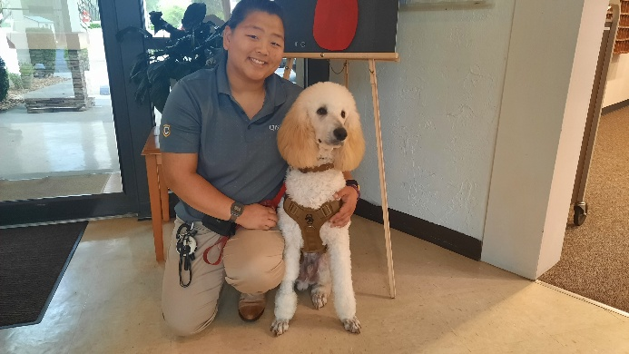

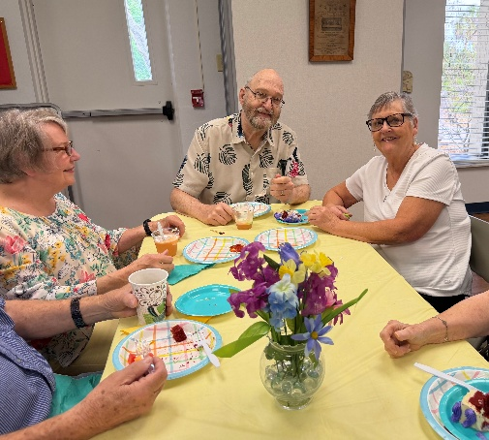
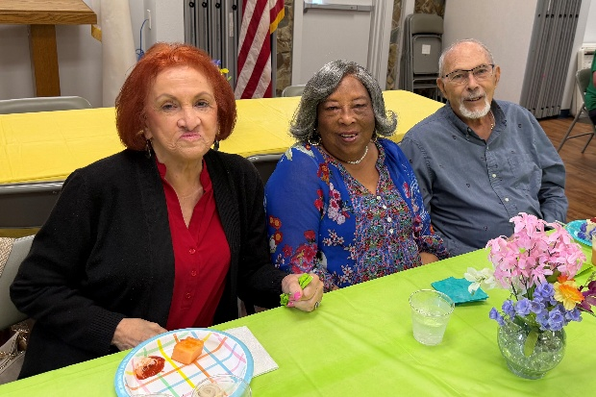
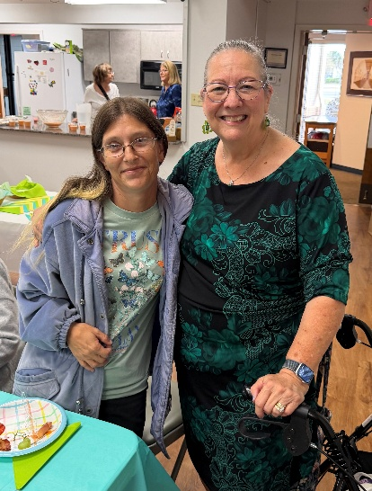
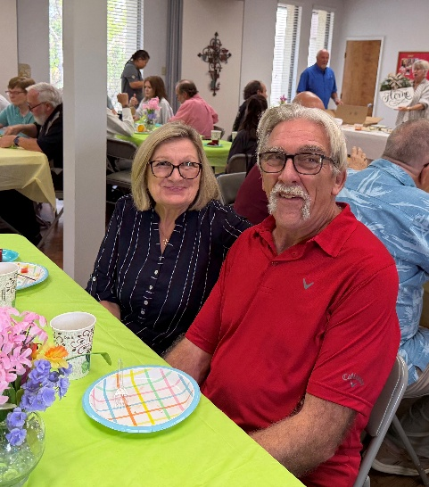
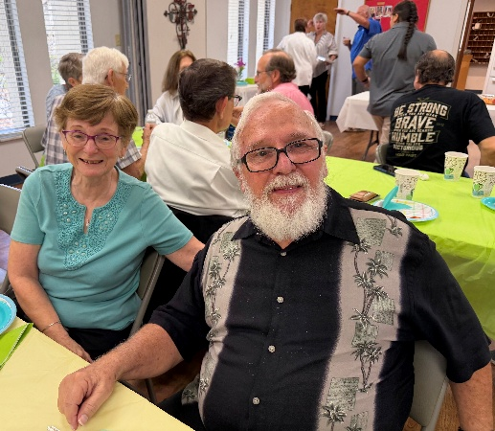
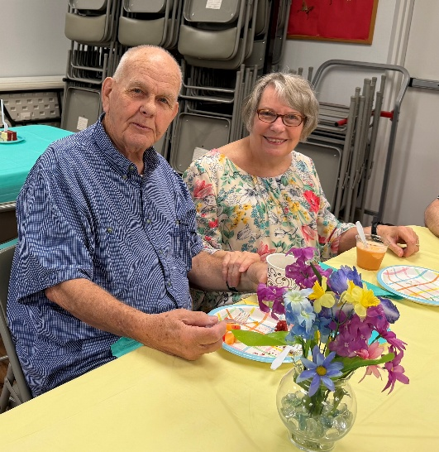
On Sunday, March 15th we said “thank you” and “farewell to Ron and Justine Roecker. We’re sure going to miss them.

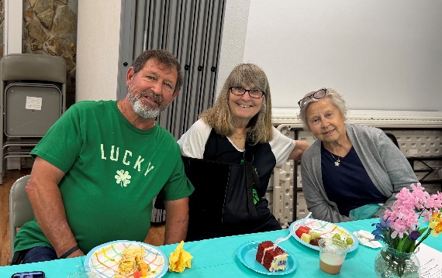
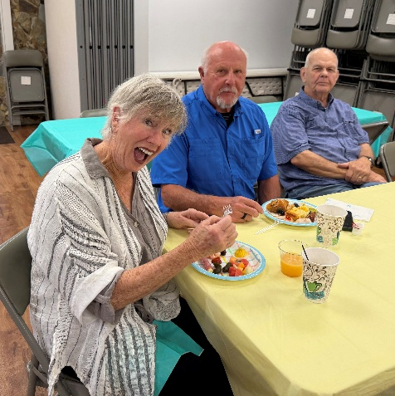

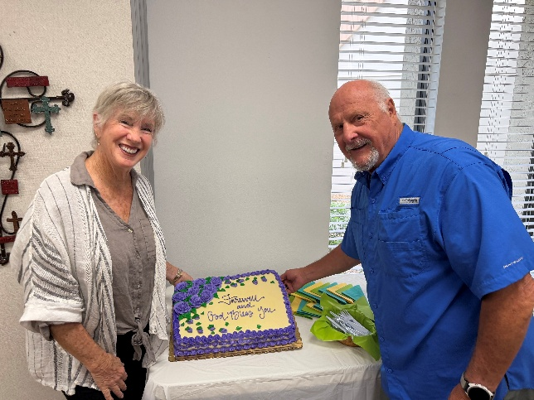

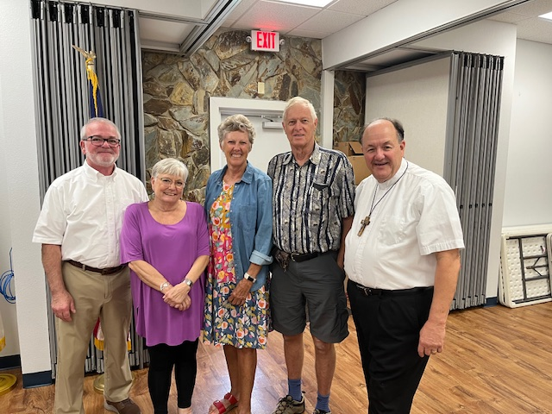
Palm Sunday

Carolyn & Peter Spanagel
Visiting from Australia
Easter Food Box Packing
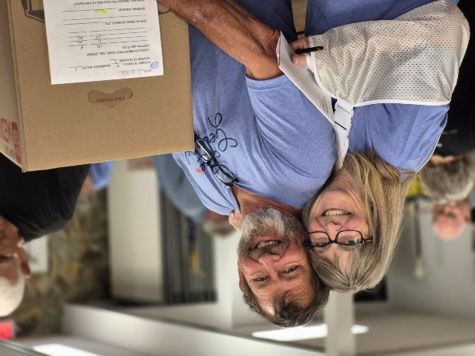
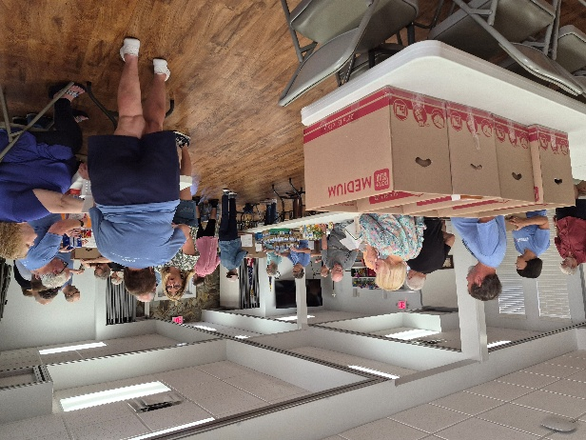

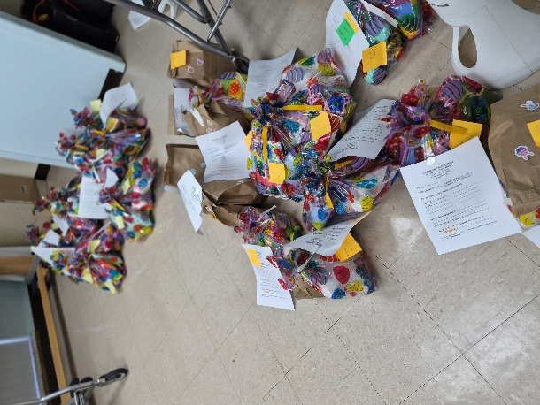
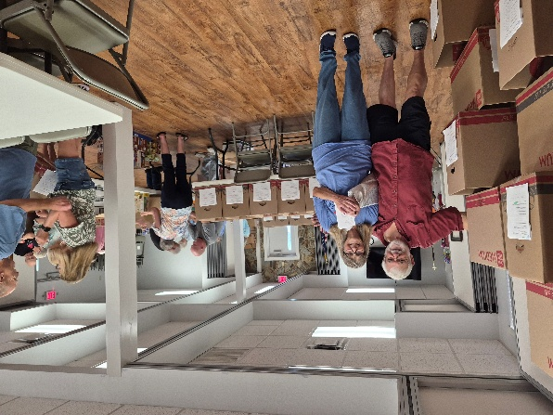
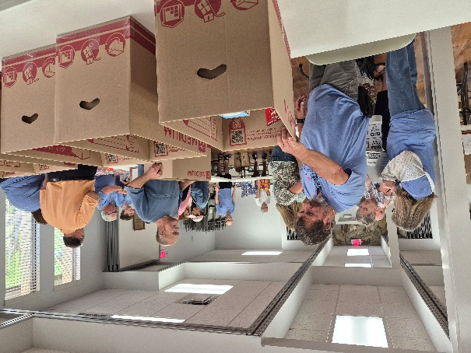
Easter Sunday
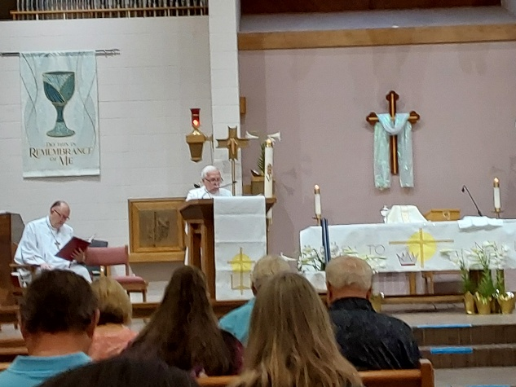
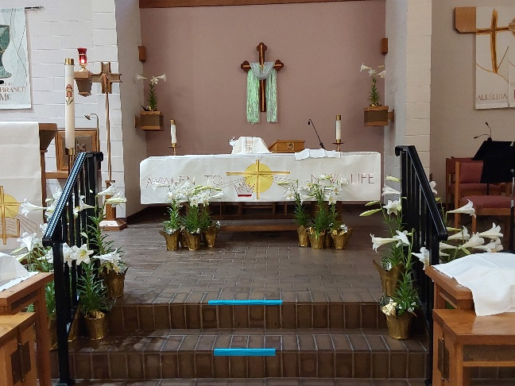

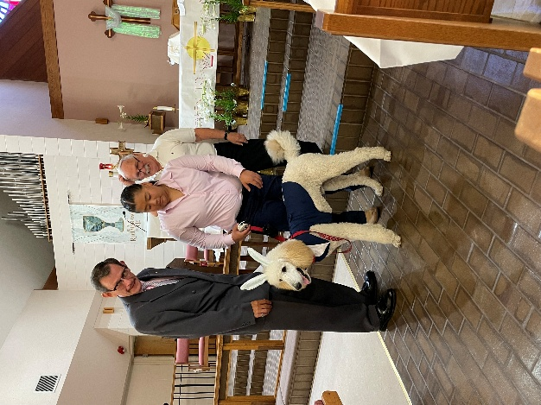
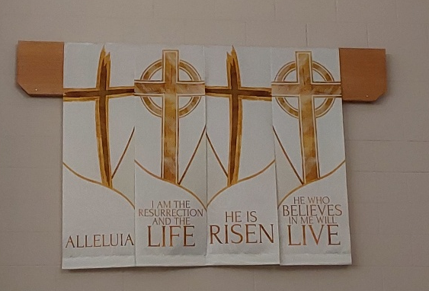
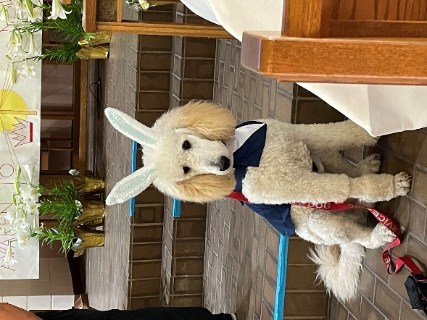
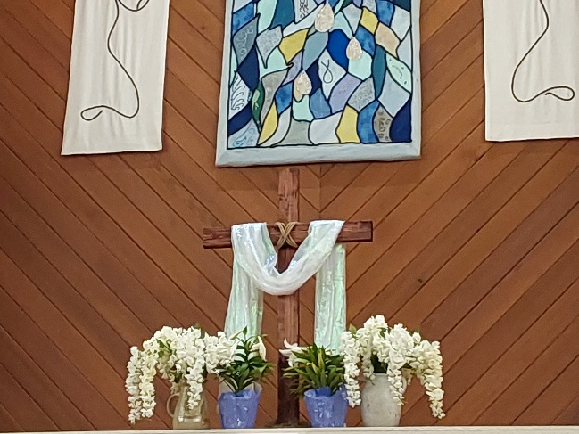
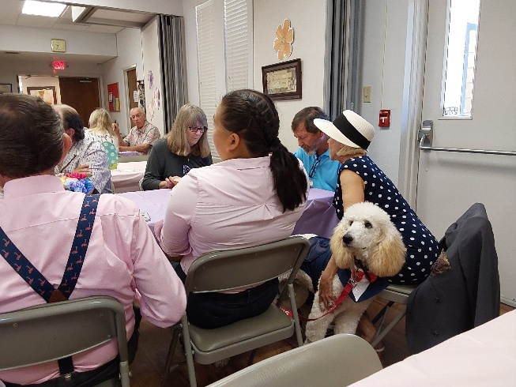

Ollie’s last visit to St. Timothy
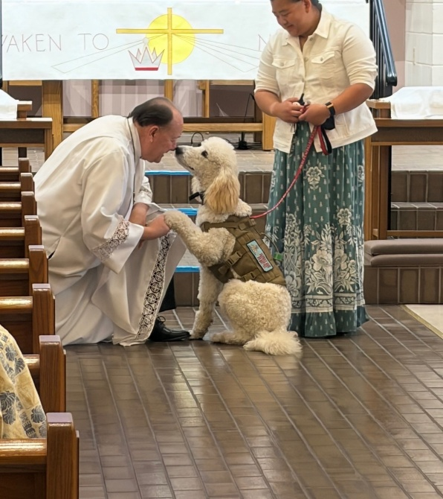
S.A.M. Bob called Ollie up for a blessing.

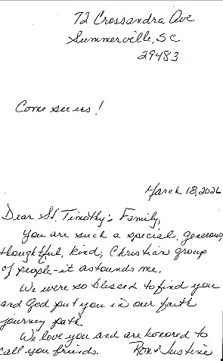



Harry Treber 4/01
Ed Fialkowski 4/03
Dan Cyr 4/04
Kris Harper 4/04
Kyle Messier 4/05
Sallie Haley 4/05
Eileen Ambrozaitis 4/05
Diane Mason 4/09
Dick Kleinsmith 4/09
JoAn DeBusk 4/16
Justine Roecker 4/18
Bill Dively 4/19
Barbara Pringle 4/21
Rosa Neth 4/21
Jim Neth 4/26
Jean Fowler 4/27
Frank Hofstetter 4/30

Birthday Blessings!
Directory Updates
Ron & Justine Roecker
72 Crossandra Ave.
Summerville, SC 29483

Santana, Frank
8326 N. Santos Drive
Citrus Springs, FL 34434
813-407-6129

Tatun, Rebecca “Becca”
9 Apple Ct.
Homosassa, FL 34446
rytatun@gmail.com
352-476-3204

Headrick, Ray Anthony
31 Pine Dr
Homosassa, FL 34446
Brooksp1957@gmail.com

Colón, Debbie
2057 N. Cedarhouse Ter
Crystal River, FL 34428
dsdcolon@gmail.com
813-389-4133

SUNDAY | MONDAY | TUESDAY | WEDNESDAY | THURSDAY | FRIDAY | SATURDAY
 |  |  | 1  11am Citrus Blessings  1pm Card Makers | 2  MAUNDY THURSDAY  11am Miniatures  4pm Worship | 3  GOOD FRIDAY  12pm Worship | 4  NO WORSHIP
5  EASTER SUNDAY  8am Worship  Breakfast  11am Worship w/Cantata | 6  10am PB&J  11am Healthy Start | 7 | 8 | 9  11-12 Bible Study for Beginners  11am Miniatures  4:30 Choir | 10 | 11  4pm Worship
12  9am Worship  10:30 Adult SS, Coffee Fellowship | 13  10:30 Ruth Circle @ Barb C’s house | 14  9-12 Food Pantry  7pm ZOOM Pre-Assembly Bible Study | 15 | 16  11-12 Bible Study for Beginners  11am Miniatures  4:30 Choir | 17 | 18  4pm Worship
19  9am Worship  10:15-10:45 D-UP Communion  10:30 Adult SS, Coffee Fellowship  Council | 20 | 21  1pm WELCA  7pm ZOOM Pre-Assembly Bible Study | 22 | 23  11-12 Bible Study for Beginners  11am Miniatures  4:30 Choir | 24 | 25  4pm Worship
26  9am Worship -New Member Installation  10:15-10:45 D-UP Communion  10:30 Adult SS, Coffee Fellowship | 27 | 28  9-12 Food Pantry  7pm ZOOM Pre-Assembly Bible Study | 29 | 30  11-12 Bible Study for Beginners  11am Miniatures  4:30 Choir
April 2026

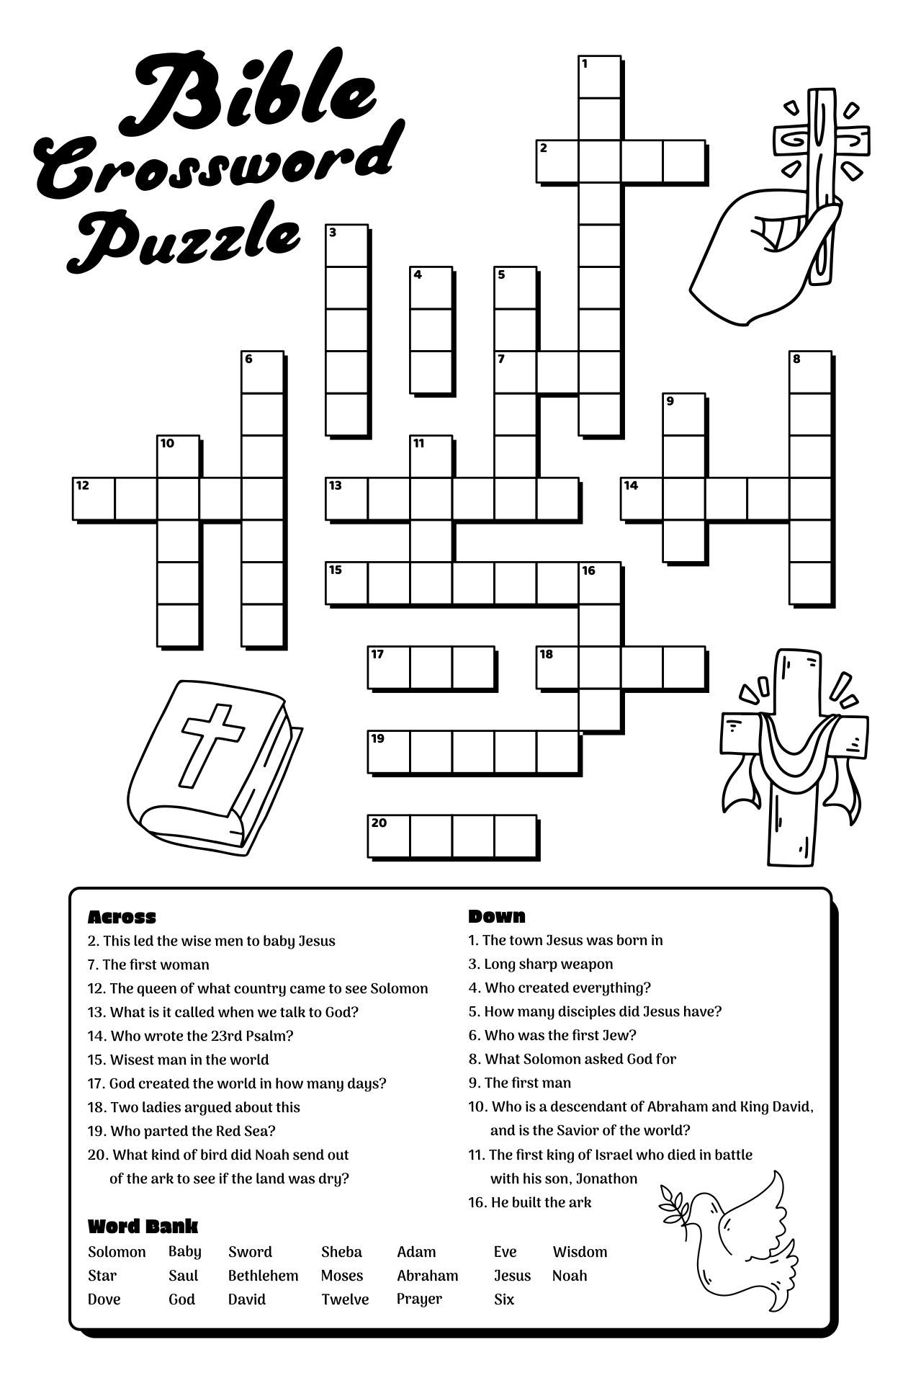

St. Timothy Lutheran Church
S.A.M. Robert “Bob” Bonomo
1070 N. Suncoast Blvd.
Crystal River, FL 34429
Phone: 352-795-5325

Church email: crsttimothy@tampabay.rr.com
Website: www.sttimlutherancrystalriver.com
(ctrl + click to follow link)

Lay Minister: Frank Hofstetter
Director of Music: Sally Hennessey
Saturday Pianist: Bill Robinson
Church Secretary: Regina Mendicino
Sexton: William “Bill” Dexter

2026 Congregational Council Members
President: Barbara Carson
Vice-President: Barbara Johnson
Secretary: Carolyn Fialkowski
Treasurer: Lynn Dively
Council Members: Marsha Gibson, Bob Bonomo

Weekly Worship
Saturdays 4pm
Sundays 9am
Holy Communion available at both services
Adult Sunday School - 10:30am
Sunday Services -YouTube links on website

