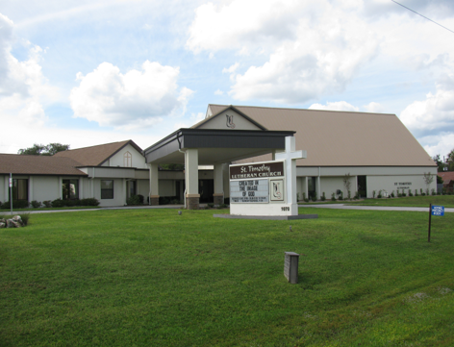

ST. TIMOTHY EVANGELICAL
LUTHERAN CHURCH
Vineyard Views
August 2026

July 24,2026

You would think that the hot, humid weather in Florida is something we can get used to, especially if you have lived here for a long time. As I write this article, I am in Douglaston, Queens, NY enjoying 80–85-degree weather: sunny with 25 % humidity. Let me tell all of you that this weather is so refreshing, that going inside to an air-conditioned home is my last thought. Facing the heat is not tempting.
As you hear me say on Sunday morning: “This is the day the Lord has made, let us rejoice and be glad in it.” This includes the hot scorching weather and the cold as well. I don’t think I have ever been cold in Florida, but it certainly can happen.
It includes the torrential rains and lack thereof. It includes hurricanes and tornadoes.
Yes, there is plenty of devastation in these situations and we wonder when it stops. We should not wonder when it stops because it is not our concern. This is God’s concern, not ours. It is the need to pray to get through these terrible storms. But: We continue to complain when it’s hot, we want cold: when its cold we want hot.
Do we really know what we want? No, we don’t!
But my dear church family, God knows what we need, and with prayer, faith and trust in Our Savior, we make it through every time, in His time.
Now, my question for everyone is: “Am I talking about the weather or am I talking about life itself.”

May the Peace of Christ be with every single one of you,
Robert (Bob) Bonomo
S.A.M. Interim

Article I found in a Christian Magazine

Finding Peace in a Scorching Environment
As we thrive through the heat, it’s essential for us to find peace despite our surroundings. Hot weather may cause stress and unease, but God wants us to find serenity in Him. We read about various instances in the Bible where peaceful spirits prevailed despite being surrounded by chaos. Seeking God in prayer during the hot weather allows us to cast our burdens onto Him. When we rest in His presence, we are filled with a peace that surpasses all understanding, giving us a renewed spirit even when outside conditions are harsh.

THE POWER OF PRAYER
IN ACTION AND INSPIRATION
“WE ARE A VESSEL”
By Barbara Carson

There are many definitions of vessel. A ship or boat, a container or holder of things. Whatever it is, they are functional and have a purpose. God made us to be a vessel. We are his children and uniquely made in his image. He fills us with his love, guidance and protection. We are a vessel of his knowledge and the embodiment and instruments of God’s work. Yes, we are flawed and fragile, but God picks us up and dusts us off and continues to make us his own. 1 Corinthians 6:19 says “You should know that your body is a temple for the Holy Spirit who is in you. You have received the Holy Spirit from God. So, you do not belong to yourselves because you were bought by God for a price. So, honor God with your bodies.”

Yes, God uses people through his Holy Spirit. He channels us to spread his kindness and pour out service to help and love others. He channels us to store energy for God’s work and shapes us for the missions of delivering his message of forgiveness and love. Through his power we can do all things through him that strengthens me. Ephesians 2:10 “God has made us what we are. In Christ Jesus, God made us to do good works which God planned in advance for us to live our lives doing”.

So be renewed each day knowing that we are the embodiment and vessel that God has made us into. God is filling our mind, body and soul for the missions ahead. LET’S KEEP MOVING! Amen

Benevolence for August - ELCA Fund for Leaders
Evangelical Lutheran Church in America (ELCA) fund to assist with seminary expenses for future pastors.

From the desk of Minister Robert
If the holy spirit has touched you to even thinking about becoming a council member, feel free to call me or come and see me.
Having a discussion does not mean in any way that you must say yes.

Blessings

DEADLINES
Announcements
Please be aware that if you have entries for the weekend worship announcements you need to have them in on Tuesday prior, as we are preparing and printing them no later than Thursday.

Vineyard Views
If you have submissions for the September Vineyard Views, please have them in the office no later than the end of day on Tuesday, August 25th.

GOD’S WORK, OUR HANDS 2026 – updated 8/4
St. Timothy’s will be participating in this outreach activity again this year to provide goody bags to our first responders. We are now collecting goody bags items. Place items on the designated table in the fellowship hall. Packing will take place on Sunday, September 13th at 12:00. Volunteer Sign-up sheet and t-shirt sign-up sheets on bulletin board by kitchen. T-shirts must be ordered by August 19th.

T-shirt prices as follows: Adult S, M, L, XL $14.95
2XL $16.95, 3XL $17.95, 4XL $18.45, 5XL $18.95

ITEMS NEEDED FOR GOODY BAGS
(All items must be individually packaged)

Peanuts
Chips
Crackers
Slim Jims
Granola bars
Cereal/fruit bars
Twizzlers
Sweet stripes peppermint candies
Trail mix
Tootsie pops
Peppermint patties
Water
Gatorade
Milk bones

Please check for the following sign-up sheets
GWOH volunteer and t-shirt sign-up sheets – bulletin board by kitchen.
Serving Our Lord (Worship Helpers) – bulletin board by kitchen
Flower chart – WELCA board
Healthy Start –bulletin board by kitchen
PB&J Ministry – bulletin board by kitchen
Serving Hands - bulletin board by kitchen
Coffee Hour – in kitchen

ZOOM LINK FOR ADULT SUNDAY SCHOOL – 9/18
Topic: Adult Sunday School Class
Time: Sundays at 10:30am
Join Zoom Meeting
https://us02web.zoom.us/j/88640128252?pwd=asNJ6OiNGFFTNzwNA5yhkvPpmt6VCT.1
Meeting ID: 886 4012 8252
Passcode: 898938
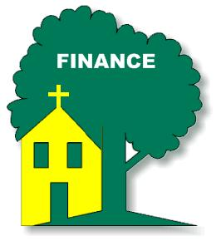

INFORMATION FROM THE FINANCE COMMITTEE
AND YOUR TREASURERS – updated 8/4
In the hope of getting ahead of our property, liability and flood insurance costs, we have been trying to save toward those expenses. We would appreciate any additional donation you could make. Please include that amount with your regular offering and designate it as “Insurance” on the offering envelope.
AIR CONDITIONING CHALLENGE
The two air conditioning units for the Sanctuary are in the process of being replaced. The cost of the 2 units is $48,628.00 which was approved at our Congregational Meeting on June 28, 2026. We are blessed to have St. Timothy Family Members who will match donations up to ½ of the cost of the 2 units. As of August 2nd we have received $18,562.00 in donations. An additional estimate of $10,300.00 is needed for the new electrical wiring and the enlargement of the openings and 2 new fire-rated doors in the mechanical rooms. HELP MATCH THE CHALLEGNE FOR THIS PROJECT. Please
add your donation to the offering basket and designate it for “AC Sanctuary”.
A weekly offering update is given with the email announcements. We are most grateful to all of you who support our projects and programs through your prayers, offerings, time and talents.

Lynn Dively, Treasurer





THRIVENT FINANCIAL NEWS FOR AUGUST 2026
$$$THRIVENT CHOICE DOLLARS®$$$
Thanks so much to our Thrivent Financial members and friends who direct their Thrivent Choice Dollars® to
available for activities and projects for our mission and ministry here at St. Timothy. If you are an eligible
Thrivent Financial member and have Choice Dollars® available, please call Thrivent (800-847-4836) and say “Thrivent Choice®” or go online to www.thrivent.com/thriventchoice and direct your dollars…hopefully to St. Timothy Lutheran Church in Crystal River. To date for 2026 our church has received $1970.00 through this program. Thanks to the following family and friends who recently directed their $$ to St. Timothy:

Daniel Cashman William Dively

THRIVENT ACTION TEAMS
Thrivent Action Teams make it easy for you to bring people together to make a positive change in your community! When you see a need, apply to lead a volunteer team. Once your idea is approved, a Thrivent Action Kit is delivered to your door. It’s packed with everything you need to help make your project a success. It even includes $250.00 in seed money to help get your project started. After you finish the project, you report the results on-line to Thrivent. This program is brought to you by Thrivent Financial because they believe that being wise with money and living generously go hand in hand. All your questions and requests for this funding program will be answered by going to Thrivent.com/actionteam.***Please note that Thrivent Financial funds accessed for all programs and activities involving St. Timothy Lutheran Church need to be approved by a Committee and the Congregational Council. 2026Thrivent Action Teams that have been approved: Easter Food Boxes, Bump2Baby Expo, PB&J Ministry, Food Pantry and God’s Work Our Hands.

THE $250 IN SEED MONEY IS A GIFT FROM THRIVENT THAT WE CAN USE TO HELP WITH COMMUNITY OUTREACH AND PROJECTS INVOLVING OUR CONGREGATION. THESE FUNDS ARE IN ADDITION TO OUR BUDGETED AMOUNTS AND OFFERINGS AND DONATIONS MADE BY OUR MEMBERS AND FRIENDS.

Financial Representatives for answering questions and offering advice on Thrivent investments and products are:

Katherine Gross Kevin Braunschweiger
in Gainesville, FL in Ocala, FL
352-505-8905 352-440-6784
Katherine.gross@thrivent.com
Virtual Advice Team – 855-303-7402

Submitted by Lynn Dively

Food Pantry
The food pantry continues to operate on the 2nd and 4th week of every month from 9AM- noon. We continue to inform the congregation as to the needs of the pantry via the weekly announcements. The current needs are fruit, spaghetti- 16oz., peanut butter, chili which serves 2 people and laundry detergent (dollar store is fine), saltines. Thanks to all who contribute food. You can also contribute monetarily by writing out a check made out to Life Tree Church with Food Pantry in the memo line or writing out a check to St. Timothy Lutheran and putting food pantry in the memo line, and placing it in my mailbox, #210. We will also accept cash donations. Please put it in an envelope in mailbox, #210 and put your name on it so I know who you are. If you would like a receipt, please let me know.
The next food pantry will be on August 11th from 9-12.
Thank you. - Barbara J

Healthy Start – updated 8/5
Needs for September: 8 baby oil, 13 baby shampoo, 13 baby wipes, 13 diaper cream, 6 wash cloths, 13 Vaseline
Carolyn Fialkowski

PB&J MINISTRY UPDATE
Our peanut butter lunch packing for DayStar is the first Monday of the month at 10:30. There is a sign-up sheet on the bulletin board in the hallway by the kitchen. We need about 6 people each time or let me know if you are interested. Thank you - Barbara Carson


MESSAGE FROM REGINA
Please, if you are at a church function, think about snapping a few photos for everyone to enjoy. Thank you in advance.

SERVING HANDS
Serving Hands is a program created to help members of our own congregation. Serving Hands is there for you if you need some help in the following areas: a meal brought to you, driving you to an appointment, a friendly visit, doing a household chore, communion brought to you, walking your dog, or picking up food for your pet, etc. These are one-time opportunities, not forever experiences. Please contact Carolyn Fialkowski at 814-392-4281, or Jean Fowler at 586-322-8337 if you need help.
Please don’t hesitate to call. We want to serve you! Also, if you are willing to help with any of these services, there is a sign-up chart on the kiosk in the entrance way of the church or call one of these ladies.

AED /Medical response :
We have a poster that is behind the kiosk across from our AED in the narthex. An emergency incident can happen at any time, and it is good to be prepared. The poster explains a “hands only “ CPR protocol as the first line of an emergency of that kind and is very easy for anyone. Please take a look and refresh yourself on the protocol. Our AED is valuable for saving lives but initiating CPR is essential. We do have several people in our congregation that have more detailed experience to assist as needed. For any questions, please ask Barbara Carson.
Instructional video on how to use the Philips AED.
https://youtu.be/t6GV9PAbgM4?si=dZuGq8aLjfvpFiM-
(ctrl + click to follow link)

ST TIMOTHY’S WEBSITE
Here is the St. Timothy website address: https://www.sttimlutherancrystalriver.com/
(ctrl + click to follow link)

There are links for the weekend’s services on the homepage. Please note that the links will change every week, since this is a YouTube file address; every service has its own link. Watch for an email with the updated links when they are ready. The video links for previous weekends will still be available at the bottom of the webpage, as the links are updated each week. Please contact us if you would like a CD of any of the services to listen to. Be sure to check out our children’s artwork at the bottom of the home page. We hope to add more as they send it to us.

Here is a link to St Timothy's YouTube:
https://www.youtube.com/channel/UC5xrMj8-8_6iyR_KxjFAwRQ/videos
(ctrl + click to follow link)

Facebook
See our Facebook page for information about upcoming events and Please feel free to message us with suggestions about content. - Regina

St. Timothy Evangelical Lutheran Church | Facebook
(ctrl + click to follow link)


The Sunshine Card Makers
The Card Makers meet the first Wednesday of the month at 1pm, in the Fellowship Hall.
-Kathy G

We have the July, August and September 2026 Christ in Our Home booklets. There are some on the table by the mailboxes or you may request one to be put in your box.

HERE AND THERE WITH THE FOLKS OF ST TIMOTHY
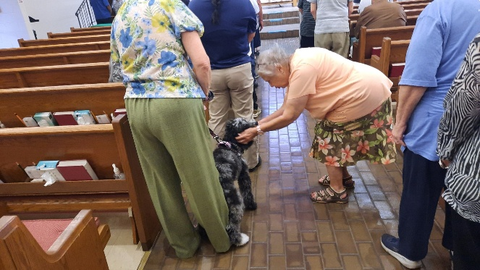

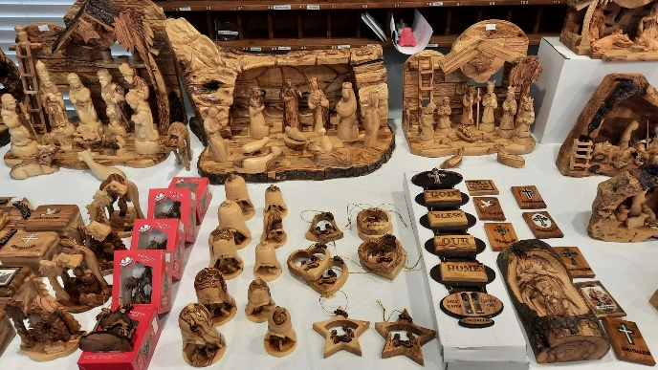





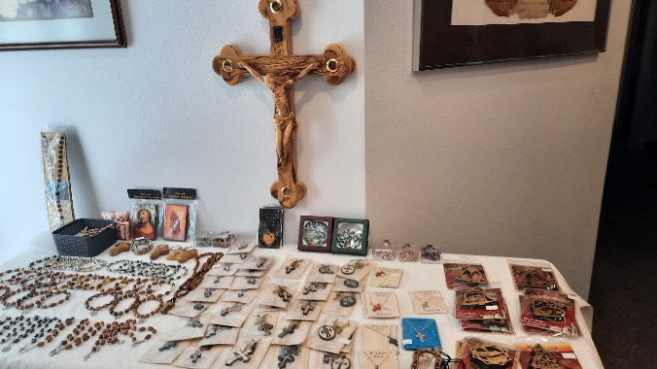
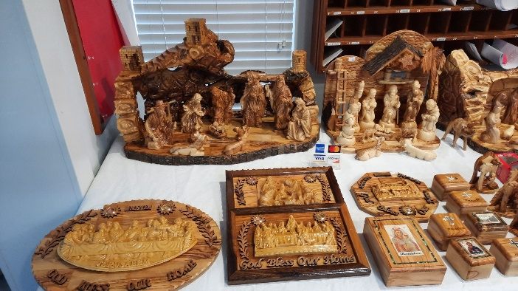



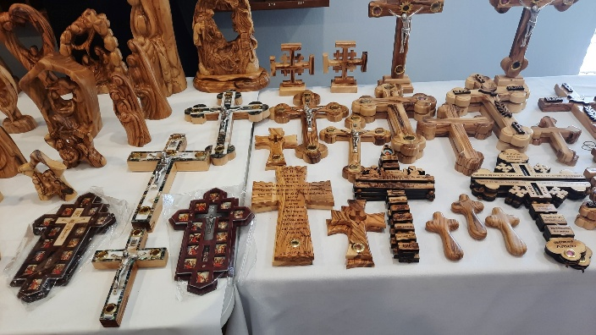
Missionaries from the Holy Land were invited to join us at St. Tim’s.
I have had the pleasure of meeting these folks at Joy Lutheran during my internship.
All of the items for sale are hand crafted from olive wood, made by family members.
Tourism is naught during these horrific times and the need for this is to offset their ministry in Jerusalem.
If interested, the contact name is Dr. George Ghanem
⁷⁰³⁻⁷⁴⁵⁻²⁶⁰⁴
or call me, Robert Bonomo, S.A.M.
³⁵²⁻²²⁰⁻⁴³⁰⁷

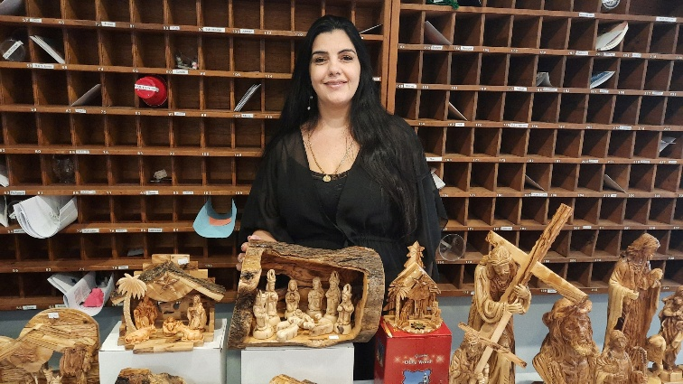



Patricia Rhoads 8/02
Nancy Meier 8/03
Sue Nawrocki 8/05
Marie Demastus 8/08
Paul Bradford 8/10
Eddie Meier 8/16
Charles Yeager 8/19
Sally Hennessey 8/23
John Seasholtz 8/28
Joe Moore, Jr. 8/28
Elin Perate 8/30
Patti Cyr 8/31
Nancy Schneider 8/31

Birthday Blessings!

August
SUNDAY | MONDAY | TUESDAY | WEDNESDAY | THURSDAY | FRIDAY | SATURDAY
1
4pm Worship
No Fellowship

2  9am Worship  10:30 Adult SS, Coffee Fellowship | 3  10:30am PB&J  11am – Healthy Start | 4 | 5  1pm Card Makers | 6  11-12 Bible Study for Beginners  11am Miniatures  4:30 Choir | 7 | 8  4pm Worship  No Fellowship
9  9am Worship  10:30 Adult SS, Coffee Fellowship | 10  NO RUTH CIRCLE | 11  9-12 Food Pantry | 12  Executive Board Meeting | 13  11-12 Bible Study for beginners  11am - Miniatures  4:30 Choir | 14 | 15  4pm Worship  No Fellowship
16  9am Worship  10:30 Adult SS, Coffee Fellowship  Council | 17 | 18  NO WELCA UNTIL SEPT 15  1pm Royal Dalton | 19  11am Council | 20  11-12 Bible Study for beginners  11am – Miniatures, 4:30 Choir | 21 | 22  4pm Worship  No Fellowship
23  9am Worship -  10:30 Adult SS, Coffee Fellowship | 24 | 25  9-12 Food Pantry  Vineyard Views Deadline | 26 | 27  11-12 Bible Study for beginners  11am – Miniatures, 4:30 Choir | 28 | 29  4pm Worship  No Fellowship
30  9am Worship  10:30 Adult SS, Coffee Fellowship  Council | 31

Lutheran Basics Vocabulary
L | S | A | N | C | T | I | F | I | C | A | T | I | O | N | Q | T | W | Z | B | K | M | F | W
M | S | H | D | G | G | K | B | T | F | T | D | P | B | U | R | T | J | M | G | J | M | X | V
Y | D | E | M | E | N | J | Q | J | N | K | D | O | L | I | G | I | Q | R | Z | C | P | Z | B
F | Y | X | G | Q | G | Q | H | R | P | E | D | D | N | P | O | O | A | O | T | F | S | G | I
P | A | M | D | G | E | A | B | Y | V | Q | M | I | Z | Q | D | C | S | C | C | S | C | O | W
P | G | U | Q | Z | L | B | T | V | Y | K | T | E | N | X | E | Q | E | P | F | R | B | F | C
L | A | K | H | U | P | M | H | X | M | Y | A | C | N | A | M | J | I | W | E | Q | Q | O | O
I | G | Y | V | G | I | P | K | Z | N | V | X | E | A | O | Z | T | F | E | D | L | I | A | N
T | J | T | U | P | C | H | G | V | O | G | H | Z | U | O | T | R | D | U | V | I | V | M | F
T | S | E | G | C | S | C | N | Y | I | R | M | V | Q | L | M | A | W | O | R | D | X | F | E
B | N | C | C | O | I | R | J | C | T | O | P | D | Y | C | U | Z | G | K | N | C | B | S | S
Y | W | N | M | P | D | U | J | H | A | C | L | I | W | Z | O | Q | Q | M | F | V | V | X | S
Y | H | A | I | T | E | H | D | T | C | H | J | L | H | V | T | I | F | I | B | M | S | N | I
T | P | T | W | U | W | C | R | S | I | I | K | E | G | S | X | P | K | I | D | I | Z | O | O
R | B | N | B | F | U | S | A | G | F | T | S | A | S | E | R | N | N | L | N | U | L | N | N
K | F | E | P | N | K | C | I | H | I | J | A | F | W | E | B | O | M | S | O | O | O | H | D
M | I | P | G | H | R | B | Q | Q | T | A | H | J | N | O | F | X | W | U | I | L | T | T | E
I | O | E | J | A | P | L | C | U | S | G | E | U | D | E | W | Z | P | D | T | I | U | A | L
X | W | R | M | N | L | M | J | P | U | F | P | Q | G | M | B | T | L | B | A | C | V | X | X
X | U | E | M | N | V | N | W | Z | J | N | N | N | B | R | L | U | M | F | V | P | U | S | Q
D | N | T | K | R | E | C | O | N | C | I | L | I | A | T | I | O | N | Z | L | B | W | X | X
T | L | G | A | I | E | I | N | J | K | F | F | J | D | B | I | Y | V | Y | A | M | H | F | N
K | B | A | B | S | O | L | U | T | I | O | N | A | A | C | Z | C | W | V | S | J | A | E | J
A | P | A | N | W | C | H | J | C | D | O | J | V | Q | K | B | G | O | I | A | G | C | W | K
worship word trinity sin sanctification salvation sacrament repentance reconciliation justification grace gospel faith disciple creed confession church atonement absolution

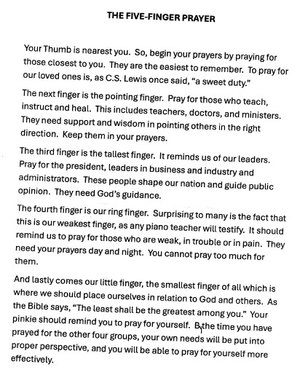

St. Timothy Lutheran Church
S.A.M. Robert “Bob” Bonomo
1070 N. Suncoast Blvd.
Crystal River, FL 34429
Phone: 352-795-5325

Church email: crsttimothy@tampabay.rr.com
Website: www.sttimlutherancrystalriver.com
(ctrl + click to follow link)

Lay Minister: Frank Hofstetter
Director of Music: Sally Hennessey
Saturday Pianist: Bill Robinson
Church Secretary: Regina Mendicino
Sexton: William “Bill” Dexter

2026 Congregational Council Members
President: Barbara Carson
Vice-President: Barbara Johnson
Secretary: Carolyn Fialkowski
Treasurer: Lynn Dively
Council Members: Patti Cyr, Jodie Gudorf, Bob Bonomo

Weekly Worship
Saturdays 4pm
Sundays 9am
Holy Communion available at both services
Adult Sunday School - 10:30am
Sunday Services -YouTube links on website

