A Service of Worship, Praise and Hope
Welcome to St. Timothy Saturday Evening Worship!
May 11th, Seventh Weekend after Easter
Mother’s Day Weekend

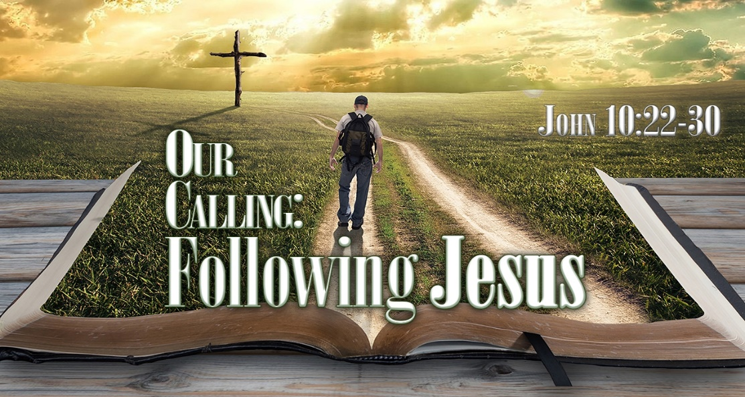
"Equip people to grow as Disciples faithfully serving our community"

We are glad to have you worship with us. All are welcome at communion. If you need gluten-free – please tell Pastor Joanie when you go up for communion. If you have any questions – just ask the Welcomer at the back of the sanctuary.

Please note** if you use a pew envelope for your offering – please write your name on the envelope so that the financial secretaries can post it as a gift from you. Thank You!

WELCA Worship Participants – Mother’s Day, May 11th and 12th
Ginny Owen
Marsha Gibson
Nancy Schneider
Wendy Mayger
Barbara Johnson
Sue Nawrocki
JoAnne Ollenborger
Barbara Carson
Jean Fowler
Mary Smorel
Carol Rulfs
Patty Cyr
Stephanie Yeager
Lynn Dively
Nancy Strange
Diane Mason
Jennifer Messier
Kris Harper
Eileen Hofstetter
Kathy Geer
Jackie Gregg
Mary Schlumberger
Debbie Col ón
Erica Wilson
Wendy White
Carolyn Fialkowski

St Timothy Worship Planning Team
The Reverend Joan E. Holden 352-423-2554
Parish Deacon, Frank Hofstetter
Eric Mortensen, Director of Music

The Altar Flowers are given by Diane Mason, in honor of Mother’s Day!

This Week at St. Timothy's
Monday, May 13th PJ OFF, 10:30 – Ruth Circle @ Barbara Carson’s house
Tuesday, May 14th 9-12am – Food Pantry
Wednesday, May 15th 10 am – OT BS
Thursday, May 16th 9:30am – Prayer Group, 11:00 am – Miniatures, 4:30 - Choir
Friday, May 17th 10 am – NT BS
Saturday, May 18th 4 pm – Worship
Sunday, May 19th 9 am – Worship, Children’s SS, 10:30 am – Sunday School, 10:30am - Aidan Graduation Celebration, 11-11:30 am – Drive Up Communion, Noon – Council Meeting

Rooted in the past and growing into the future, the church must always be reformed in order to live out the love of Christ in an ever-changing world. We celebrate the good news of God’s grace, that Jesus Christ sets us free every day to do this life-transforming work. Trusting in the freedom given to us in baptism, we pray for the church, that Christians will unite more fully in worship and mission.
(from Sundays and Seasons for Reformation Weekend)

Welcome and Sharing of Congregational News
Prelude: Sing a New Song W &P 125
Preparation Hymn: Shout to the Lord ELW 821
Gathering Hymn: Mothering God, You Gave Me Birth ELW 735
1 Mothering God, you gave me birth
in the bright morning of this world.
Creator, source of ev'ry breath,
you are my rain, my wind, my sun.
2 Mothering Christ, you took my form,
offering me your food of light,
grain of life, and grape of love,
your very body for my peace.
3 Mothering Spirit, nurt'ring one,
in arms of patience hold me close,
so that in faith I root and grow
until I flow'r, until I know.
Greeting
L – The joy of our risen Lord Jesus Christ, the compassion of God, and the creative power of th Holy Spirit be with you all.
C - And also with you.

Prayer of the Day
Gracious and glorious God, you have chosen us as your own, and by the powerful name of Christ you protect us from evil. By your Spirit transform us and your beloved world, that we may find our joy in your Son, Jesus Christ, our Savior and Lord, who lives and reigns with you and the Holy Spirit, one God, now and forever.
Amen.

Confession and Forgiveness
L - Blessed be the Holy Trinity, + one God, whose name is majestic in all the earth, who rescues and heals in every time of trouble, who does all things well.
C – Amen
L - Let us come before God, seeking forgiveness and life.
(Silence is kept for reflection and self-examination)
L - Steadfast and saving God,
C - Have mercy on us. We confess to you all our sins and that in these continuing times of uncertainty and fear, we have trouble trusting you and feeling your presence. Forgive us our sins, our doubts, our fears and lack of patience with others. Strengthen our faith and help us to let your hope and light shine through us in these dark times. We ask for mercy, wisdom and guidance, through Jesus Christ, our Savior and Lord. Amen.
L - In the name of + Jesus, the Son of God, receive mercy and find grace in your time of need. God forgives your sins; God's love is healing balm for your wounds. Rejoice, for God raises you up to new life in Christ.
C - Amen
Greeting
L - The joy of our Lord Jesus Christ, the compassion of God, and the creative power of the Holy Spirit be with you all.
C - And also with you.
Word

First Reading: Acts 1:15-17, 21-26
In the days between Jesus’ ascension and Pentecost, Peter oversees the process whereby one of the members of the community of believers is chosen to be the twelfth apostle, in order to fill the vacancy created by Judas’s treachery and death.
¹⁵In those days Peter stood up among the believers (together the crowd numbered about one hundred twenty persons) and said, ¹⁶“Friends, the scripture had to be fulfilled, which the Holy Spirit through David foretold concerning Judas, who became a guide for those who arrested Jesus—¹⁷for he was numbered among us and was allotted his share in this ministry.” ²¹So one of the men who have accompanied us during all the time that the Lord Jesus went in and out among us, ²²beginning from the baptism of John until the day when he was taken up from us—one of these must become a witness with us to his resurrection.” ²³So they proposed two, Joseph called Barsabbas, who was also known as Justus, and Matthias. ²⁴Then they prayed and said, “Lord, you know everyone’s heart. Show us which one of these two you have chosen ²⁵to take the place in this ministry and apostleship from which Judas turned aside to go to his own place.” ²⁶And they cast lots for them, and the lot fell on Matthias; and he was added to the eleven apostles.

A – Word of God!

C – Words of Life!

L – The Holy Gospel according to John, the 17th Chapter

C – Glory to you O Lord.

Gospel: John 17:6-19
In this reading the church hears Jesus’ words on the night before his death—his prayer for his disciples and for all who would believe in him through their words.
[Jesus prayed:] ⁶“I have made your name known to those whom you gave me from the world. They were yours, and you gave them to me, and they have kept your word. ⁷Now they know that everything you have given me is from you; ⁸for the words that you gave to me I have given to them, and they have received them and know in truth that I came from you; and they have believed that you sent me. ⁹I am asking on their behalf; I am not asking on behalf of the world, but on behalf of those whom you gave me, because they are yours. ¹⁰All mine are yours, and yours are mine; and I have been glorified in them. ¹¹And now I am no longer in the world, but they are in the world, and I am coming to you. Holy Father, protect them in your name that you have given me, so that they may be one, as we are one. ¹²While I was with them, I protected them in your name that you have given me. I guarded them, and not one of them was lost except the one destined to be lost, so that the scripture might be fulfilled. ¹³But now I am coming to you, and I speak these things in the world so that they may have my joy made complete in themselves. ¹⁴I have given them your word, and the world has hated them because they do not belong to the world, just as I do not belong to the world. ¹⁵I am not asking you to take them out of the world, but I ask you to protect them from the evil one. ¹⁶They do not belong to the world, just as I do not belong to the world. ¹⁷Sanctify them in the truth; your word is truth. ¹⁸As you have sent me into the world, so I have sent them into the world. ¹⁹And for their sakes I sanctify myself, so that they also may be sanctified in truth.”
L - The Gospel of Our Lord!
C - Praise to You O Christ!

Message

Hymn of the Day: I Come with Joy ELW 482
- I come with joy, a child of God, forgiven, loved, and
free, the life of Jesus to recall in
love laid down for me, in love laid down for me.
- I come with Christians far and near to find, as all are
fed, the new community of love in
Christ's communion bread, in Christ's communion bread.
- As Christ breaks bread and bids us share, each proud division
ends. The love that made us, makes us one, and
strangers now are friends, and strangers now are friends.
- The Spirit of the risen Christ, unseen, but ever
near, is in such friendship better known,
alive among us here, alive among us here.
- Together met, together bound by all that God has
done, we'll go with joy, to give the world the
love that makes us one, the love that makes us one.

Apostles’ Creed
I believe in God, the Father almighty,
creator of heaven and earth.
I believe in Jesus Christ, God’s only Son, our Lord,
who was conceived by the Holy Spirit,
born of the virgin Mary,
suffered under Pontius Pilate,
was crucified, died, and was buried;
he descended to the dead.
On the third day he rose again;
he ascended into heaven,
he is seated at the right hand of the Father,
and he will come to judge the living and the dead.
I believe in the Holy Spirit,
the holy catholic church,
the communion of saints,
the forgiveness of sins,
the resurrection of the body,
and the life everlasting. Amen.

Lord, listen to your children praying,
Lord, send your Spirit in this place;
Lord, listen to your children praying,
send us love, send us pow'r, send us grace.

Prayers of the People (please stand, sit or kneel as you are able)
Rejoicing that Jesus is risen and love has triumphed over fear, let us pray for the church, the world, and all those in need of good news.
A brief silence.
You sanctify us in your truth; your word is truth. Send your church out into the world to spread your love and joy. Embolden all bishops, pastors, and deacons (especially) to be faithful ministers of your word and sacraments. God of grace, hear our prayer.
Your creation groans under the strain of pollution. Preserve melting glaciers and dwindling forests. Bolster those who work for climate justice and help us all to be good and faithful stewards of your creation. God of grace, hear our prayer.
Your people seek wisdom, understanding, and peace. Guide all those who govern and inspire them to work on behalf of the most vulnerable in our midst. Keep safe first responders, those serving in the military, and those whose duty it is to protect others. God of grace, hear our prayer.
Your children need your loving care. Protect them from all harm. Comfort those in any affliction (especially). Support those who grieve and bring solace to those near death. God of grace, hear our prayer.
Your Spirit lives within us here. Inspire the work of this congregation and unite us as one. Bless all the mothers in our midst, console those for whom this day is difficult, and gather us all under the care of your loving wings. God of grace, hear our prayer.
Here other intercessions may be offered.
Your saints dwell with you in light. Keep us ever thankful for those who have gone before us in faith (especially). Inspire us by their witness. God of grace, hear our prayer.
Into your hands, most merciful God, we commend all for whom we pray, trusting in your abiding love; through Jesus Christ, our resurrected and living Lord. Amen.

Peace
L- The Peace of the Lord be with you always.
C – And also with you.
We Share Christ’s Peace
Offering is Brought to the Altar

Offering Prayer

We lift our voices, we lift our hands, we lift our lives up to you; we are an Offering. Lord, use our voices, Lord, use our hands, Lord, use our lives, they are yours: we are an offering. All that we have, all that we are, all that we hope to be, we give to you, we give to you. We lift our voices, we lift our hands, we lift our lives up to you; we are an offering, we are an offering.
Jesus’ Words of Promise and Gift of Life
Pastor:
Dear Lord, Jesus Christ:
in the night in which you were betrayed,
You took bread, broke it and gave thanks,
then you gave it to your disciples saying:
take and eat, this is my body I am giving for you.
Do this in remembrance of me.
Again, after supper, Dear Lord Jesus,
You took the cup, gave thanks
and gave it for everyone to drink saying:
this cup is the new covenant in my blood,
I am shedding for you and for all people for the forgiveness of sin.
Do this for the remembrance of me. Amen.

Our Lord's Prayer
Our Father in heaven, hallowed be your name, your kingdom come, your will be done, on earth as in heaven. Give us today our daily bread. Forgive us our sins as we forgive those who sin against us. Save us from the time of trial and deliver us from evil. For the kingdom, the power, and the glory are yours, now and forever. Amen.
Invitation to Communion
P: Come to this Table where God really does come to us!
C: Thank You Jesus!
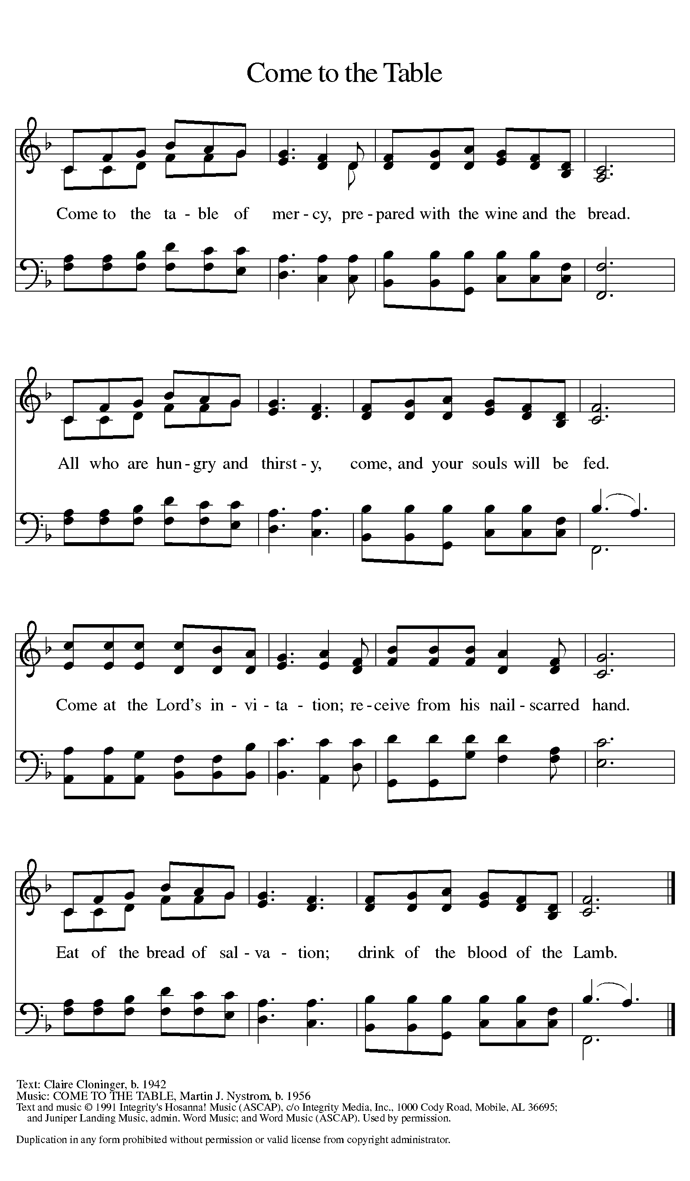

Distribution - Please come forward to receive

Communion Anthem – Shepherd Me, O God ELW 780 Morning has Broken W & P 98

Shepherd Me, O God ELW 780

Refrain
Shepherd me, O God, beyond my wants,
beyond my fears, from death into life.

1 God is my shepherd, so nothing shall I want,
I rest in the meadows of faithfulness and love,
I walk by the quiet waters of peace. Refrain
2 Gently you raise me and heal my weary soul,
you lead me by pathways of righteousness and truth,
my spirit shall sing the music of your name. Refrain
3 Though I should wander the valley of death,
I fear no evil, for you are at my side,
your rod and your staff, my comfort and my hope. Refrain
4 You have set me a banquet of love
in the face of hatred,
crowning me with love beyond my pow'r to hold. Refrain
5 Surely your kindness and mercy follow me
all the days of my life;
I will dwell in the house of my God forevermore. Refrain
L - Now may the body and blood of our Lord Jesus Christ strengthen you and keep you in his grace!
C – Thank You Jesus!

Prayer After Communion
God for whom we wait, you come to us in the broken bread and the cup we share. Make us ready always to welcome Christ into our hearts and send us forth to be your people in the world, announcing your coming among us in Jesus Christ our Lord. Amen.

Sending

Blessing
L - God Almighty send you light and truth to keep you all the days of your lives. The hand of God protect you; the holy angels accompany you; and the blessing of almighty God, the Father, the ☩ Son, and the Holy Spirit, be with you now and forever.
C -Amen.

Sending Hymn: Nunc Dimittis and Benediction
(See next page)

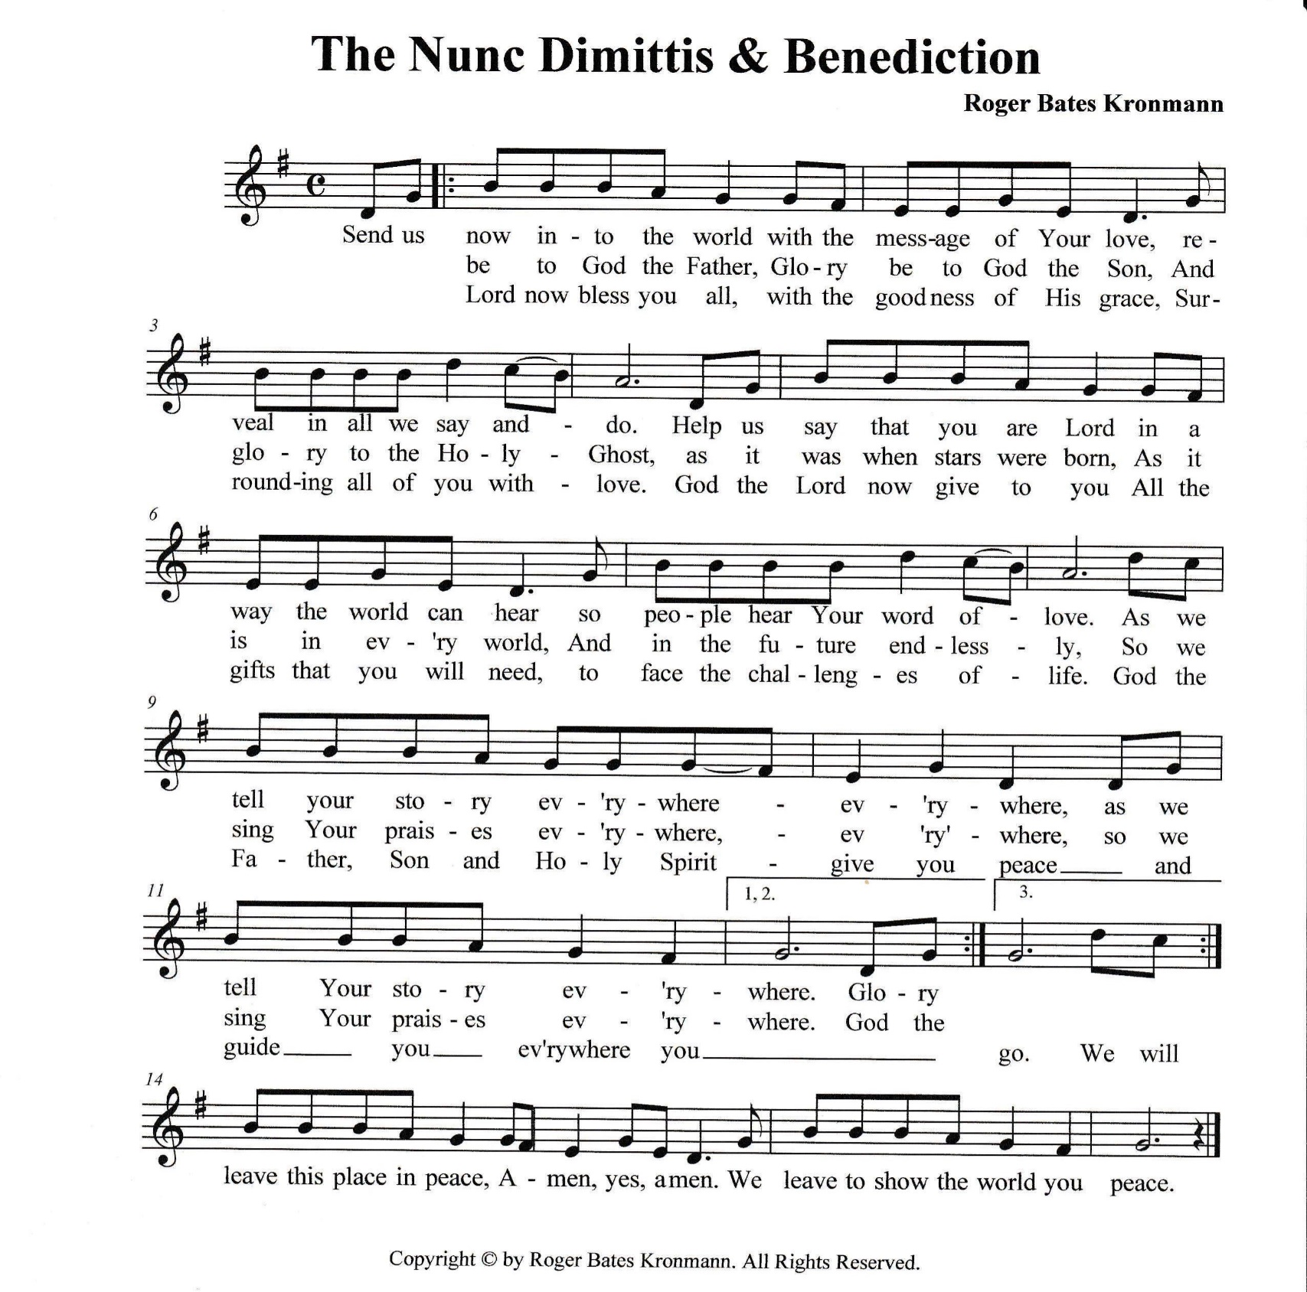
Dismissal
L: Go in peace. Proclaim the Good News – Christ is Risen!
C: By the Grace of God we will – Alleluia!
Postlude: Emmanuel W &P 36
Unless otherwise noted, materials used in this bulletin are: From Sundays and Seasons.com. Copyright 2015 Augsburg Fortress. All rights reserved. Reprinted by permission under Augsburg Fortress Liturgies Annual License #SAS028635. Music is reprinted under OneLicense.Net #A712074 and/or Augsburg Fortress #SBL12176H. Scripture, unless otherwise noted, is from the New Revised Standard Version Bible, Copyright © 1989, Division of Christian Education of the National Council of the Churches of Christ in the United States of America. Used by permission. All rights reserved.
Remembrance
Matthias, Apostle
Matthias was the apostle added to the Twelve after Jesus' resurrection, as a replacement for the dead Judas Iscariot. He had traveled among the followers of Jesus throughout the Lord's ministry. Formerly commemorated on February 24, Matthias's celebration is moved to May 14 in agreement with most Western calendars.

Announcements for May 11th and 12th
ATTENDANCE
Saturday, May 4th, 4pm 22
Sunday, May 5th, 9am 32
Drive-Up Communion 3
57

CELEBRATION
Please join our St. Timothy Family as we congratulate and celebrate the high school graduation of Aidan Sisneros during our Coffee Fellowship, following the service, on Sunday, May 19,2024.

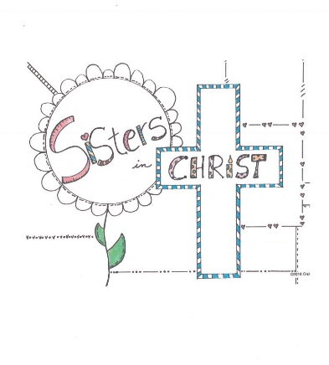

WELCA’S
SISTERS IN CHRIST LUNCHEON
Tuesday, May 21, 2024, at 12 noon
ATTENDANCE & DESSERT SIGN-UP SHEET on WELCA Board.

JOIN US FOR A MEMORIAL DAY SERVICE AT 10AM ON MONDAY, MAY 27TH
