St Timothy Lutheran Church
Sunday, April 5, 2026
Easter Sunday Cantata
11am

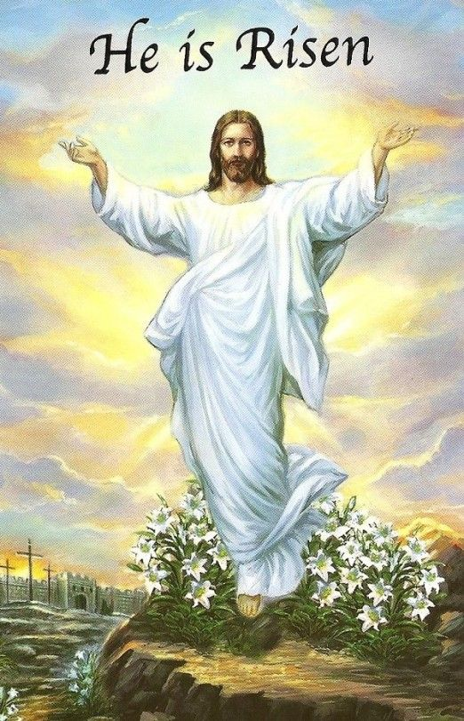

Alleluia, Christ is Risen Today!

This is the day the Lord has made! Christ is risen, and through him all creation is made new! Indeed, “God shows no partiality” (Acts 10:34): Christ’s resurrection truly brings life to everyone. We sing hymns of praise, gather around sacred words, and proclaim God’s faithfulness, power, and love in the feast of holy communion. With the women at the tomb, we are astonished, elated, and grateful. We depart with joy to proclaim the good news of God’s endless love.

St Timothy’s is served by S.A.M. Robert Bonomo
Lay Minister Frank Hofstetter
Director of Music Sally Hennessey
Saturday Pianist Bill Robinson

We begin worship this joyous Easter morning with Affirmation of Our Baptism into the Life, Death, and Resurrection of our Lord and Savior Jesus Christ. It is important for us to remember that in Christ we are made new every day and we are Joint Heirs in the Kingdom with Christ, God the Son.
Since this is Jesus’ House and Table and not ours – all are Welcome to Join With Christ at His Table. Both wheat and gluten-free wafers are served by the Pastor, just let us know at the Table if you need gluten-free. Also, grape juice and water are available for those who prefer one of these instead of the wine – just let the communion assistant know your preference.

Come to this Table Where God Comes to Us!

Unless otherwise noted, service materials used in this bulletin are:
"Reprinted from the 1995 Moravian Book of Worship with permission of the Interprovincial Board of Communication, Moravian Church in North America."
Music is reprinted under OneLicense.Net #A712074 and/or Augsburg Fortress #SBL12176H. Scripture, unless otherwise noted, is from the New Revised Standard Version Bible, Copyright © 1989, Division of Christian Education of the National Council of the Churches of Christ in the United States of America. Used by permission. All rights reserved.
Preservice Music: Come, You Faithful, Raise the Strain ELW 363
Welcome!
P – Preparing our hearts for Worship
Prelude: Jesus Lives! The Victory’s Won! by Jan Bender

Thanksgiving for Baptism
All may make the sign of the cross, the sign that is marked at Baptism, as the presiding minister begins.
Alleluia! Christ is risen.
Christ is risen indeed. Alleluia!
Salvation belongs to our God who is seated on the throne
and to the Lamb!
Amen.
Let us give thanks for the gifts of Baptism.
Frank - Water may be poured into the font as the presiding minister continues.
P - Merciful God,
you are the one who was, who is, and who is to come.
You lead us beside still waters.
We thank you for the waters of creation:
morning dew, gentle rain, roaring waves.
We thank you for the waters that nourish us.
Blessed are you.
You guide us to springs of the water of life.
Jesus Christ, you are the faithful witness
who accompanies us on our journeys.
We give you thanks for your life-giving death and resurrection.
We praise you for joining us in joy and sorrow.
Blessed are you.
You guide us to springs of the water of life.
Holy Spirit, you anoint our head with oil and our cup overflows.
Break down barriers that divide us.
Fill us with the breath of peace.
Blessed are you.
You guide us to springs of the water of life.
Holy One, we thank you for the gifts and grace of Baptism,
and for making us a new creation.
We join with saints and angels, giving you honor and praise,
now and forever.
Amen.
Affirmation of Baptism
P - Dear friends, we give thanks for the gift of Baptism as we come before God to make public affirmation of Baptism into Christ.
P - Let us pray.
Merciful God, we thank for these sisters and brothers, who you have made us your own by water and the Word in Baptism. You have called them to yourself, enlightened them with the gifts of your Spirit, and nourished them in the community of faith. Uphold your servants in the gifts and promises of Baptism, and unite the hearts of all whom you have brought to new birth. We ask this in the name of Christ.
C - Amen.
Profession of Faith by The Congregation
P - I ask you to profess your faith in Christ Jesus, reject sin, and confess the faith of the church.
Do you renounce the devil and all the forces that defy God?
C - I renounce them.
P – Do you renounce the powers of this world that rebel against God?
C - I renounce them.
P – Do you renounce the ways of sin that draw you from God?
C - I renounce them.
P - Do you believe in God the Father?
C - I believe in God, the Father almighty,
creator of heaven and earth.
P - Do you believe in Jesus Christ, the Son of God?
C - I believe in Jesus Christ, God’s only Son, our Lord,
who was conceived by the Holy Spirit,
born of the virgin Mary,
suffered under Pontius Pilate,
was crucified, died, and was buried;
he descended to the dead.*
On the third day he rose again;
he ascended into heaven,
he is seated at the right hand of the Father,
and he will come to judge the living and the dead.
P - Do you believe in God the Holy Spirit?
I believe in the Holy Spirit,
the holy catholic church,
the communion of saints,
the forgiveness of sins,
the resurrection of the body,
and the life everlasting.
Affirmation in the Presence of the Assembly
P - You have made public profession of your faith. Do you intend to continue in the covenant God made with you in holy Baptism?:
to live among God’s faithful people,
to hear the word of God and share in the Lord’s supper,
to proclaim the good news of God in Christ through word and deed,
to serve all people, following the example of Jesus,
and to strive for justice and peace in all the earth?
C- I do, and I ask God to help and guide me.
P - People of God, do you promise to support and pray for one another in your life in Christ?
C - We do, and we ask God to help and guide us.
P - We give you thanks, O God, that through water and the Holy Spirit you give us new birth, cleanse us from sin, and raise us to eternal life. Stir up in your people the gift of your Holy Spirit: the spirit of wisdom and understanding, the spirit of counsel and might, the spirit of knowledge and the fear of the Lord, the spirit of joy in your presence both now and forever.
C - Amen.

Processional Hymn: Jesus Christ is Risen Today ELW 365
1 Jesus Christ is ris'n today, Alleluia!
our triumphant holy day, Alleluia!
who did once upon the cross, Alleluia!
suffer to redeem our loss. Alleluia!
2 Hymns of praise then let us sing, Alleluia!
unto Christ, our heav'nly king, Alleluia!
who endured the cross and grave, Alleluia!
sinners to redeem and save. Alleluia!
3 But the pains which he endured, Alleluia!
our salvation have procured; Alleluia!
now above the sky he's king, Alleluia!
where the angels ever sing. Alleluia!
4 Sing we to our God above, Alleluia!
praise eternal as his love; Alleluia!
praise him, all you heav'nly host, Alleluia!
Father, Son, and Holy Ghost. Alleluia!
P - The grace of our Lord Jesus Christ, the love of God and the communion of the Holy Spirit be with you all.
C - And also with you.

Prayer of the Day
O God, you gave your only Son to suffer death on the cross for our redemption, and by his glorious resurrection you delivered us from the power of death. Make us die every day to sin, that we may live with him forever in the joy of the resurrection, through your Son, Jesus Christ our Lord, who lives and reigns with you and the Holy Spirit, one God, now and forever.
Amen.
P – The Lord be with you!
C - And also with you!
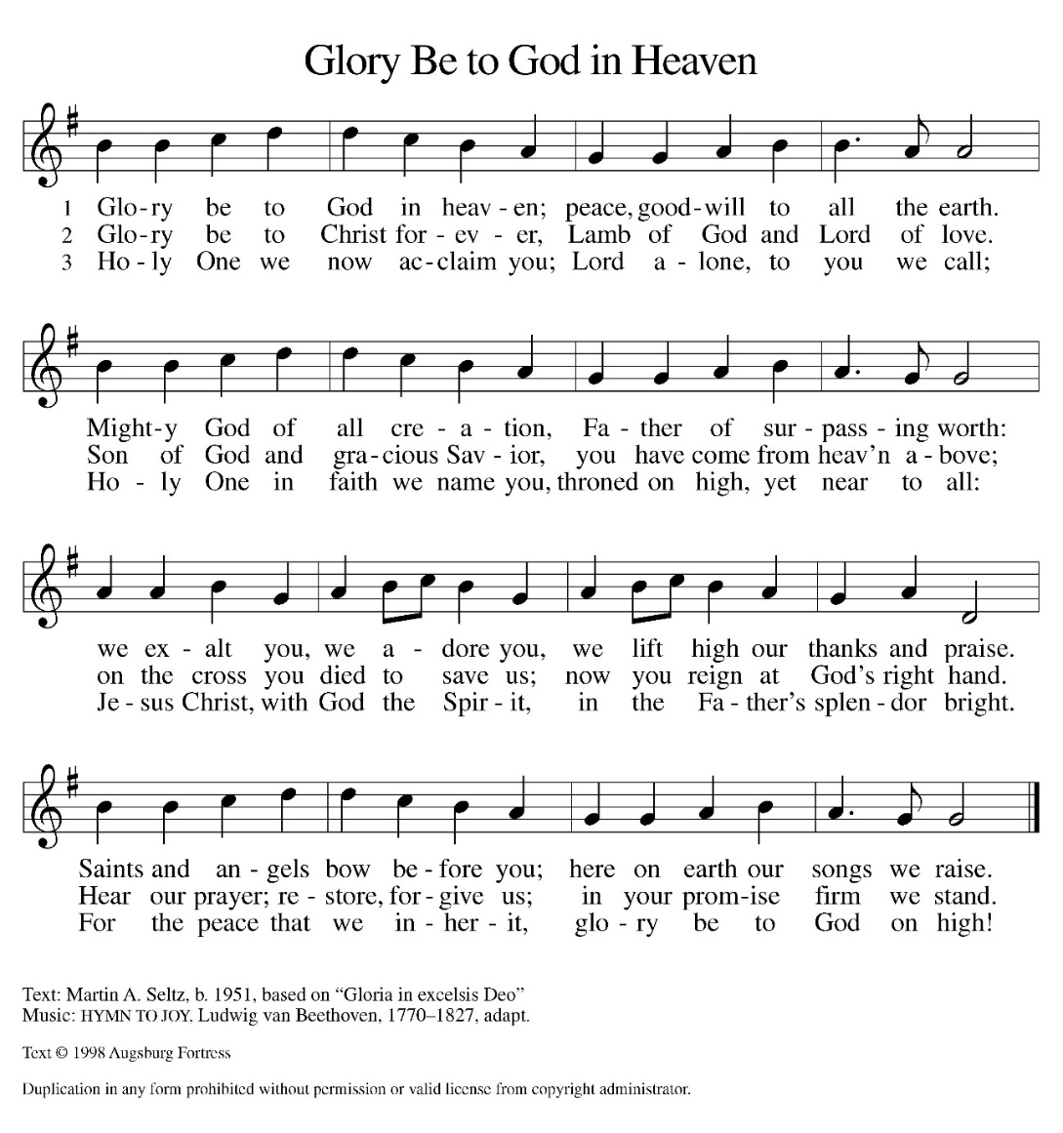
(Please be seated)
Hymn of Praise:

First Reading: Acts 10:34-43
Peter’s sermon, delivered at the home of Cornelius, a Roman army officer, is a summary of the essential message of Christianity: Everyone who believes in Jesus, whose life, death, and resurrection fulfilled the words of the prophets, “receives forgiveness of sins through his name.”
³⁴ Peter began to speak to [Cornelius and his household]: “I truly understand that God shows no partiality, ³⁵ but in every people anyone who fears him and practices righteousness is acceptable to him. ³⁶ You know the message he sent to the people of Israel, preaching peace by Jesus Christ—he is Lord of all. ³⁷ That message spread throughout Judea, beginning in Galilee after the Baptism that John announced: ³⁸ how God anointed Jesus of Nazareth with the Holy Spirit and with power; how he went about doing good and healing all who were oppressed by the devil, for God was with him. ³⁹ We are witnesses to all that he did both in Judea and in Jerusalem. They put him to death by hanging him on a tree, ⁴⁰ but God raised him on the third day and allowed him to appear, ⁴¹ not to all the people but to us who were chosen by God as witnesses and who ate and drank with him after he rose from the dead. ⁴² He commanded us to preach to the people and to testify that he is the one ordained by God as judge of the living and the dead. ⁴³ All the prophets testify about him that everyone who believes in him receives forgiveness of sins through his name.”

A – Here ends the first reading!

C – Thanks be to God!

Psalm 118:1-2, 14-24
¹Give thanks to the Lord, for the Lord is good;
God’s mercy endures forever.
²Let Israel now declare,
“God’s mercy endures forever.”
¹⁴The Lord is my strength and my song,
and has become my salvation.
¹⁵Shouts of rejoicing and salvation echo in the tents of the righteous:
“The right hand of the Lord acts valiantly!
¹⁶The right hand of the Lord is exalted!
The right hand of the Lord acts valiantly!”
¹⁷I shall not die, but live,
and declare the works of the Lord.
¹⁸The Lord indeed punished me sorely,
but did not hand me over to death.
¹⁹Open for me the gates of righteousness;
I will enter them and give thanks to the Lord.
²⁰“This is the gate of the Lord;
here the righteous may enter.”
²¹I give thanks to you, for you have answered me
and you have become my salvation.
²²The stone that the builders rejected
has become the chief cornerstone.
²³By the Lord has this been done;
it is marvelous in our eyes.
²⁴This is the day that the Lord has made;
let us rejoice and be glad in it.

Second Reading: Colossians 3:1-4
Easter means new life for us as it first meant new life for Christ. His resurrection reshapes the entire focus and motivation for our lives since we are now hidden with the risen Christ in God.
¹ If you have been raised with Christ, seek the things that are above, where Christ is, seated at the right hand of God. ² Set your minds on the things that are above, not on the things that are on earth, ³ for you have died, and your life is hidden with Christ in God. ⁴ When Christ who is your life is revealed, then you also will be revealed with him in glory.
A – Here ends the second reading! C – Thanks be to God!

Easter Cantata
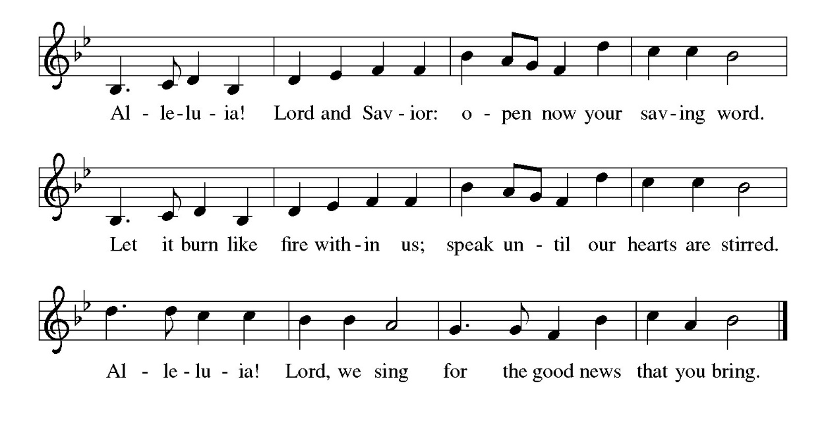
Gospel Acclamation

Please stand.
P - The Holy Gospel according to Matthew, the 28th Chapter
C - Glory to You O Lord!

Gospel: Matthew 28:1-10
Sorrow gives way to “fear and great joy” when two women are sent by an angel to proclaim the good news: Jesus is risen!
¹ After the Sabbath, as the first day of the week was dawning, Mary Magdalene and the other Mary went to see the tomb. ² And suddenly there was a great earthquake, for an angel of the Lord, descending from heaven, came and rolled back the stone and sat on it. ³ His appearance was like lightning and his clothing white as snow. ⁴ For fear of him the guards shook and became like dead men. ⁵ But the angel said to the women, “Do not be afraid, for I know that you are looking for Jesus who was crucified. ⁶ He is not here, for he has been raised, as he said. Come, see the place where he lay. ⁷ Then go quickly and tell his disciples, ‘He has been raised from the dead, and indeed he is going ahead of you to Galilee; there you will see him.’ This is my message for you.” ⁸ So they left the tomb quickly with fear and great joy and ran to tell his disciples. ⁹ Suddenly Jesus met them and said, “Greetings!” And they came to him, took hold of his feet, and worshiped him. ¹⁰ Then Jesus said to them, “Do not be afraid; go and tell my brothers and sisters to go to Galilee; there they will see me.”
P - The Gospel of the Lord.
C – Praise to you, O Christ!
Choir and congregation: Up from the Grave He arose (TFF94)

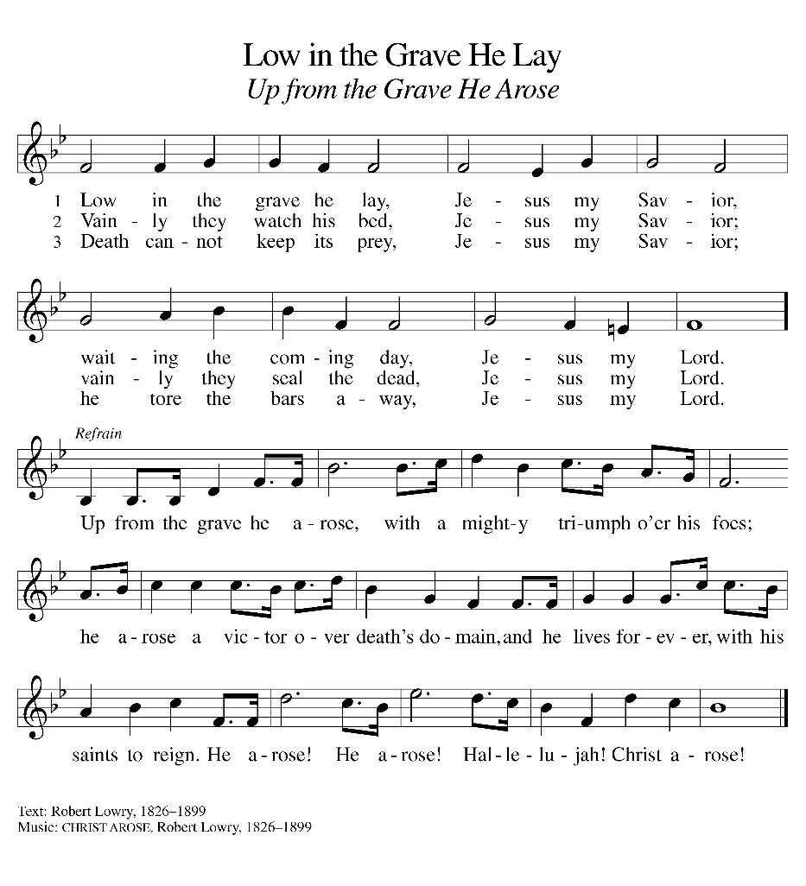

The Cantata is concluded.
Please be seated

Sermon

Hymn of the Day: Christ Is Risen! Alleluia! ELW 382
1 Christ is risen! Alleluia! Risen our victorious head!
Sing his praises! Alleluia! Christ is risen from the dead!
Gratefully our hearts adore him as his light once more appears;
bowing down in joy before him, rising up from griefs and tears.

Refrain
Christ is risen! Alleluia! Risen our victorious head!
Sing his praises! Alleluia! Christ is risen from the dead!

2 Christ is risen! All the sadness of our Lenten fast is o'er;
through the open gates of gladness he returns to life once more;
death and hell before him bending see him rise, the victor now,
angels on his steps attending, glory round his wounded brow. Refrain

3 Christ is risen! All the sorrow that last evening round him lay
now has found a glorious morrow in the rising of today.
See the grave its firstfruits giving, springing up from holy ground;
Christ was dead, but now is living; he was lost, but he is found. Refrain

4 Christ is risen! Henceforth never death or hell shall us enthrall.
We are Christ's, in him forever we have triumphed over all.
All the doubting and dejection of our trembling hearts have ceased;
hail the day of resurrection! Let us rise and keep the feast. Refrain

Text: John S. B. Monsell, 1811-1875, alt.

Prayers of the People
Knowing that in the power of Christ’s resurrection to heal and redeem our broken world, let us pray for the needs of all creation.
A brief silence.
Dear Heavenly Father, on this Easter Sunday, our hearts are filled with gratitude for the gift of Your Son’s resurrection. We thank You for the hope and joy that this day brings. May our prayers be a symphony of gratitude, echoing the triumph of life over death.
Resurrected Jesus,
We honor and praise You.

Risen Savior, you have conquered death and opened the gates of everlasting life. Drive out our doubts and fears and renew our faith and hope in You. Let us pray for those who do not know Jesus and pray for those who do not want to know Jesus.

Resurrected Jesus,
We honor and praise You.

Life-giving God, the created world rejoices in Christ’s victory over death. May all the earth be renewed by the light of Jesus’ resurrection, and may we be faithful stewards of all You have made.

Resurrected Jesus
We honor and praise You.

Sovereign God, let the nations acknowledge your reign of justice and truth. Where violence, oppression, and corruption hold authority, pour out Your holy and life-giving Spirit to transform and redeem.

Resurrected Jesus,
We honor and praise You

Gentle Shepherd, like the women at the empty tomb, many grieve or feel lost and afraid. Draw near to those who are ill or in pain (especially). Reveal Yourself to them as the Risen One.

Resurrected Jesus,
We honor and praise You

Faithful God, we thank you for the living hope You give us through Christ’s resurrection. Bless St. Timothy’s community, and all church communities to boldly proclaim Christ’s victory over death in Word and deed.

Resurrected Jesus,
We honor and praise You

Eternal One, we give thanks for all who have died and now share in the joy of Your resurrection. Bring us, with them, to the unending feast of Your victory.

Resurrected Jesus,
We honor and praise You

God of resurrection power, use us and these prayers to proclaim the good news of new life to all the world, through Jesus Christ, our risen Savior.
Amen

P – The Peace of the Lord be with you always.
C – And also with you.

Please remain in your pew for the sharing of Peace.

The Offering is Brought to the Altar
Offertory Prayer
Merciful God,
accept the fruits of our labor, gathered to give you glory.
You have set a table before us, a glimpse of that great day
when we will hunger and thirst no more.
Nourish us with the body and blood of Jesus,
that goodness and mercy may follow us
and bless the world you love.
In the name of Jesus,
Amen.

P – The Lord be with You
C – And also with you.
P – Lift up your hearts
C – We lift them to the Lord.
P – Let us give thanks to the Lord, our God
C – It is right to give Him our thanks and praise.

Preface
And so, with Mary Magdalene and Peter and all the witnesses of the resurrection, with earth and sea and all their creatures, and with angels and archangels, cherubim and seraphim, we praise your name and join their unending hymn:

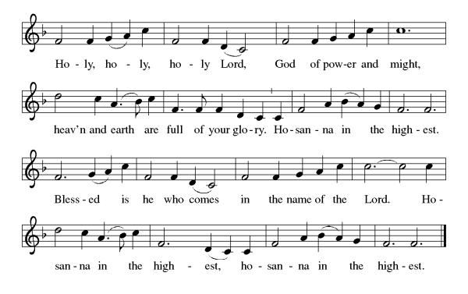

Eucharistic Prayer
(Words of Institution)

For as often as we eat of this bread and drink from this cup we proclaim the Lord’s death until He comes.
Christ has died
Christ is risen.
Christ will come again.
Remembering, therefore, his salutary command,
his life-giving passion and death, his glorious resurrection and ascension,
and the promise of his coming again,
we give thanks to you, O Lord God Almighty,
not as we ought but as we are able;
we ask you mercifully to accept our praise and thanksgiving and with your Word and Holy Spirit to bless us, your servants, and these your own gifts of bread and wine, so that we and all who share in the body and blood of Christ may be filled with heavenly blessing and grace,
and, receiving the forgiveness of sin,
may be formed to live as your holy people
and be given our inheritance with all your saints.
To you, O God, Father, Son, and Holy Spirit,
be all honor and glory in your holy church, now and forever. Amen.

Gathered into one, by the Holy Spirit let us listen to the words that Jesus taught us.

The Lord’s Prayer
Our Father, who art in heaven, hallowed be thy name, thy kingdom come, thy will be done, on earth as it is in heaven. Give us this day our daily bread; and forgive us our trespasses, as we forgive those who trespass against us; and lead us not into temptation but deliver us from evil. For thine is the kingdom, and the power, and the glory, forever and ever. Amen.
P: God feeds those who hunger, Come! Be fed and be healed!
C: Thanks be to God.
Invitation to Communion
P – This is the Lamb of God who takes away the sins of the world. Happy are those that are called to His supper.
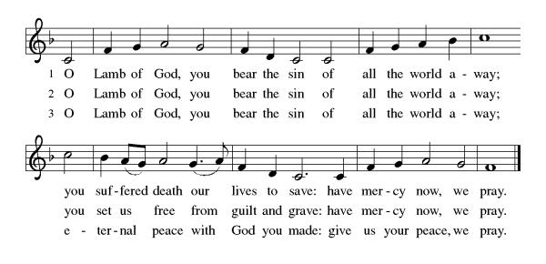
Distribution of Communion – Come Forward to Receive

Communion Anthem: A Day of Delight and Beauty Unbounded ACS 933, Woman, Weeping in the Garden ACS 935
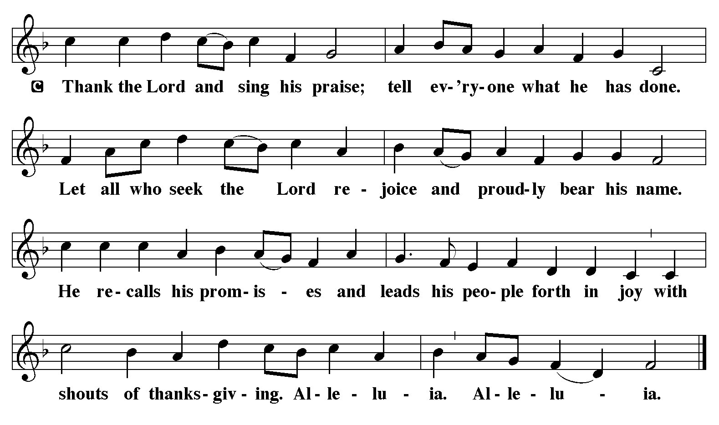

P – Now may the body and blood of our Lord and Savior Jesus Christ strengthen you and keep you in His grace!
C – Thank You Jesus!

Prayer after Communion
Holy One,
through this meal you have made your home among us
and are making all things new.
Send us now to speak peace to anxious hearts,
to love our enemies,
and to bring your healing to the nations.
In the name of Jesus,
Amen.

Blessing
God Almighty, who is the beginning and the end,
Jesus Christ, the firstborn of the dead,
and the Spirit, our advocate and peace,
☩ bless you now and forever.
Amen.

Sending Hymn: Thine Is the Glory ELW 376
- Thine is the glory, risen, conqu'ring Son; endless is the
vict'ry thou o'er death hast won! Angels in bright raiment
rolled the stone away, kept the folded grave-clothes
where thy body lay.
Refrain
Thine is the glory, risen, conqu'ring Son;
endless is the vict'ry thou o'er death hast won!
- Lo, Jesus meets thee, risen from the tomb! Lovingly he
greets thee, scatters fear and gloom; let his church with gladness
hymns of triumph sing, for the Lord now liveth;
death hath lost its sting! Refrain
3 No more we doubt thee, glorious Prince of life; life is naught without thee; aid us in our strife; make us more than conqu'rors,
through thy deathless love; bring us safe through Jordan
to thy home above. Refrain
Text: Edmond Budry, 1854-1932; tr. R. Birch Hoyle, 1875-1939

Dismissal
P - Go in peace. Praise the Lord. Alleluia!
C - Thanks be to God. Alleluia!

Postlude: Christ Jesus Lay in Death’s Strong Bands ELW 370 by J.S. Bach

