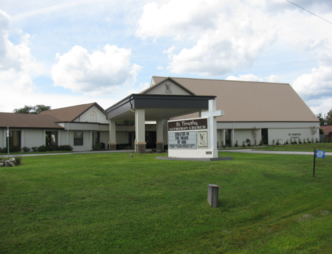

ST. TIMOTHY EVANGELICAL
LUTHERAN CHURCH
Vineyard Views
March 2026

Sam’s Corner

S.A.M. BOB BONOMO

MARCH 2026

Greetings from Our Lord and Savior Jesus Christ.
Words of Peace for the Lenten Journey to Easter
As we walk through the quiet, reflective days of Lent toward the radiant joy of Easter, peace becomes both our prayer and our promise.
1. A Gentle Benediction
*May the stillness of Christ calm your restless heart.
May His mercy wash over your weary soul.
And may His peace, deeper than the grave,
carry you from the shadows of Lent
into the dawn of Resurrection.
2. A Reflection of Hope
Lent teaches us that peace is not the absence of struggle,
but the presence of God in the midst of it.
Every step toward the cross is also a step toward the empty tomb.
Hold fast to the promise:
“Peace, I leave with you; my peace I give you.”
3. A Prayer for the Season
Lord of life,
in this season of repentance and renewal,
quiet the storms within us.
Teach us to forgive as You forgive,
to love as You love,
and to walk in the peace that Easter morning will proclaim to the world.

Luther’s Small Catechism and Lent:
https://steadfastlutherans.org/blog/2014/03/luthers-small-catechism-and-lent/

Keeping a Holy Lent – The Lutheran Witness

Good people of St. Timothy’s:
This is who we are as His people, and what we believe through faith. Without Him we have nothing here on earth or for eternity.
BELIEVE!!!!!

Blessings and His Peace be with you always.
S.AM. Bob

Message from new Council President
The Church Council is starting a new year, and we still could use more members. It is still time to join. It would be nice if we had a variety of men and women which will give us new ideas and insight. The more people we have the more constructive work we can do to meet all the needs of our congregation. Everyone has a voice which can make our church a fellowship of meeting their needs spiritually and physically. Please pray for discernment on the direction God wants you to go.

I am listing some responsibilities for a council member if anyone if wondering what the office entails. It not hard!
- Attend monthly meetings - 3rd Sunday of the month at 11:30 for approximately 1-1/2 hours.
- Report on one of our church committees. You will be given a designated person to contact.
- Take part in decision making and voting.
- Take part in discussion of new and old ideas pertaining to the congregation and church
- Attend Emergency meetings if needed.
If you have any questions let me know.

Barbara Carson, Council President

WELCA ANNOUNCEMENT FOR MARCH VINEYARD VIEWS
"Sisters in Christ, are sisters for life!"

Dear Sisters In Christ,
Did you know that if you are a woman, and you attend St. Timothy Lutheran, you are a member of WELCA (Women of the ELCA). We either have a membership meeting at 1:00 P.M. in the Bradford Fellowship Hall, or a luncheon at 12:00 P.M. either in the Bradford Fellowship Hall or a local restaurant, each month on the third Tuesday. Twice a year, we get to see our other sisters in Christ at the Pinelands Conference Spring Gathering at one of our sister churches in March on a Saturday, and Florida Bahamas Synod WELCA Fall Gathering from a Friday -Sunday usually around the second weekend in November at Warren Willis Retreat Center in Fruitland Park, FL.
On Friday, February 12, 2026, from 8:00am to 2:00pm we had our Mini Granny's Attic sale. This event is our only fundraiser for the year. The funds that WELCA & MOST take in are combined, then portioned out as 1/3 to be used for a voted on charity(ies), then 1/3 is given to MOST, & finally the remaining 1/3 will be kept in our WELCA account to pay for the Synodical Women’s organization donations, and costs incurred by WELCA, sometimes for a church need as well as supporting several WELCA ministries. The total monies rec'd from Granny's Attic was $1605.00, which consisted of Bakery monies of $286.00, WELCA inside $637.41, & MOST outside $681.59. Many thanks to all who volunteered to help with set up, sale day, & pack up, donated items to sell, baked something to sell and those who purchased. It takes a village and all of you made it a fun time. God Bless You.
On Tuesday, February 17, 2026, at 1:00pm in Bradford Fellowship Hall, we had a regular WELCA Meeting and a great attendance of sisters. We welcomed a new sister & welcomed back three sisters. We voted to donate the 1/3 of the Granny's Attic funds to CASA. $535.00 will be given to CASA, then $535.00 will be given to MOST, then the remaining $535.00 will be kept in the WELCA account to help pay Scholarship & Love funds to the Florida Bahamas Synodical Women’s Organization as well as bills that WELCA is required to pay for the Prayer Garden Maintenance & expenses for some of our luncheons, and activities.
On Tuesday, February 24, 2026, at 1:00pm, we gathered to prepare the favors for the Spring Gathering. Fun was had by all in attendance. The Spring Gathering Theme of Don't Worry is from Matthew 6:26-34. We made little bird's nests with a bird, a flower, & a cross. In addition, we made laminated Scripture cards to go with the little nests.
On Saturday, March 7, 2026, we had the PINELANDS CONFERENCE SPRING GATHERING AT HOPE LUTHERAN CHURCH IN THE VILLAGES.
On Tuesday, March 17, 2026, we will have our St. Patrick's Day Tea Party at 12:00pm in Bradford Fellowship Hall. Look for the sign-up sheets on the Bulletin Board.

Blessings,
Mary C. Schlumberger - President

Call Committee Corner

Dear Church Family,
The Call Committee is diligently working on the Ministry Site Profile and we are nearing completion on this important form that will help to give Synod and our prospective Pastoral Candidate(s) an overall view of what our church family considers most important and helpful ministry skills & tasks for the prospective Pastor to have as well as what the Call Committee has discerned through prayer and the Holy Spirit to be the most important attributes & talents for our new shepherd to have.
We are prayerful to have this form finished very soon to present to Council and upon their approval, then to submit a copy to Synod. The next step is to be patient, pray, & wait for God's timing.
We appreciate your trust, patience, & prayers as we move forward. May God continue to guide St. Timothy's in the path ahead. In the Name of Jesus Christ, our Lord & Savior, we ask this. Amen.
Respectfully Submitted,
Mary Schlumberger & The Call Committee

POWER OF PRAYER IN ACTION AND INSPIRATION

“JOY”
By Barbara Carson

Always be full of Joy in the Lord. (Philippians 4:4) That says “always,” but how can we do that? Boy, that is asking a lot of us, isn’t it? Is Joy something we have to work on, or does it just come? The answer may be what I read a few weeks ago: “Only in God there is the fullness of Joy.” I started each day praying “God give me joy today” and went on my way. So, my weeks had been pretty good, and I realized God did give me that daily Joy. I really felt good about myself at the end of those days. I know I wanted to write something for The Vineyard Views, so I had been thinking about what to write. I finally realized after a few days when I didn’t know what to write, that it dawned on me that God was saying “Joy”. So today was the day I was starting this topic.
Well, I fell flat when I got up and had frustration after frustration. Where did that joy go, I thought I had each morning with? My Joy was blocked out just when I needed it the most.

Joy is a mind and heart activity I think produced by our faith in God. Joy gives us energy; it can be our “Guiding Star” to keep it coming through the morning and all the way to our bedtime. “For the Joy of the Lord is your strength.” Nehemiah 8:10. God who is with us all day provides us a compass to point us through Joy, day in and day out. God’s plan is better than ours, for he says, “My thoughts are not your thoughts, and my ways are higher than your ways.” So, with that we should have no choice but to follow his Guiding Star.

Going back to my frustration and inability to even appreciate my topic, I had a dent in the road, and I needed God to set me straight again. It was obvious that Satan had pushed me to that frustration. We know that Satan works best on the little things first and brings those outside interferences to the forefront. My mistake was not bringing it to God right away. You know, we want to lead. His power is so strong that it does not take much from us to let him in. Don’t let Satan run the show. Push that pedal to the floor and let God do the work. Remember Joy is a mind and heart activity produced by the Holy Spirit. He is just waiting for us. Philippians 4:4 – “Always be full of the Joy in the Lord” and he will be our Guiding Star from morning to bedtime. I found that star and then I started writing. It will continue to be a Joyful today because I turned to God to reverse my course for the day. Let God be your Joy today. Amen

Benevolence for March: E-Nini-Hassee (Outdoor Therapeutic School for girls)
The first outdoor therapeutic program for troubled girls ages 12-18 in the southeast.

Shepard Program March 2026
I am taking the lead in our existing Shepard Program. This program started many years ago before we were sending e-mail and computer messages. We revised it as we grew into a better information tree for our congregation. Now it has only been passing on information to those who do not use e-mail/computer for their information. There is only a small percentage of people we have on the program. I would like to revise it once again to include people that still do not use the computer or e-mail but to people in our congregation that may have special needs whatever they are and our shut-ins or those that may need to be checked on periodically. This may take a little more time from our Shepherd members but it will keep our congregation closer as a church family. We have about 4 Shepherds now that make calls when needed.
I am asking from anyone any new ideas that can help us improve a new shepherd group that can make it a more useful program to help people stay in close contact with the church family with frequent communication or any resources they may need. Our church members deserve to be heard and know that they are cared for and remembered in any instance. Any ideas will be appreciated or interested in helping. Place your ideas in my box #90 or see me or call. 352-422-8248. Thank you Barbara Carson Council President
From the desk of Minister Robert
If the holy spirit has touched you to even thinking about becoming a council member, feel free to call me or come and see me.
Having a discussion does not mean, in any way that you must say yes.

Blessings

Message from Patti Cyr – Food boxes
Food box tubs are set up in the fellowship hall, under the table on the left, to start collecting for Easter Food Boxes. Lots of BOGOs going on if you would like to help. Also, the food box request forms are on the table if you know anyone in need. Please fill out and place it in my mailbox.

Blessings & Thanks,
Patti

Lenten/Easter Worship
Lenten Studies – “Stations of the Cross”, followed by Soup Supper at 4pm on 2/25, 3/4, 3/11, 3/18, 3/25, and 4/1
Maundy Thursday, April 2nd – Worship with Holy Communion on 4/2/26 at 4pm
Good Friday, April 3rd – Worship at 12 Noon
NO SATURDAY WORSHIP
Easter Sunday, April 5th – Worship at 8am
Easter Breakfast
Worship at 11am with Cantata

Easter Lilies
We will have Easter Lilies available again this year for $20. If you will be writing a check, please be sure to note that it’s for the purchase of a Lily in order to ensure that the funds are distributed correctly.
We have 25 plants ordered so please sign up now so as not to miss out on getting a plant for yourself. Sign-up sheet next to flower chart on the board across from the nursery. Plants can be picked up after the Easter service on April 5th.

Bump2Baby (Formerly “World's Greatest Baby Shower”)
Bump2Baby is going to be held April 30 from 5-7pm. Again St. Timothy is going to sponsor this event. Lynn Dively has agreed again to help me.
We will be needing some volunteers to help pack bags on the day of the event (2ish on day of event). A few to help deliver prizes to winners. And some to help pack our contributions. Leave me a name and contact info in box 72 if you wish to help. If you just tell me, I will forget.
We need things to put in the bags. They are making 60 of them. Things from Dollar Tree are very acceptable. Not all our bags have to be alike. Last year they contained: a hat, booties or socks, sippy cup, washcloth, one piece suit, and bib. All wrapped up in a receiving blanket. But this is not all we can use. Anything on the Healthy Start list will do. If we get too many of an item, we will pass on to Healthy Start. Use your imagination. We do not want big items. The bags are not very big. The Bump2Baby committee has asked that the one-piece suit be size 6 months or larger. But we will not turn down smaller sizes. Walmart in Lecanto had a lot of these on sale. PJ'S are fine too. I will be putting out the booties for you to pick up soon. Any questions please ask Lynn or me. Oh , we will take cash or check.

Thanks for supporting this wonderful program again,

Sallie Haley



2026 Easter Food Box Supply List
Wow! Time sure goes by fast. Seems like we just got done with Thanksgiving Food Boxes and we need to start collecting for Easter Boxes. We will continue to provide 40 food boxes and Easter bags for their children for families in our community and will begin March 1, 2026. If you would like to request a box for a family member or friend, forms will be available on the table in the fellowship hall and need to be turned in to Patti Cyr (Box #139) no later than March 14th.
Please purchase only these items (CHECK EXPIRATION DATES):
Canned Fruit
Canned Chicken Canned Vegetables (corn/green beans)
Canned Ham Pasta
Tuna Spaghetti Sauce (preferred – canned)
Soup Instant Potatoes
Peanut Butter White Rice
Jelly Gravy (prefer brown)
Saltine crackers Jello and Pudding
Macaroni & Cheese Canned chili
Baked Beans (Canned)
Oatmeal (prefer box with individual packets)

Place food in designated bins under the table in the fellowship hall no later than Sunday March 22, 2026. Thanks so very much for the food, funds and help you, so willingly, donate for this activity.

Packing of the food boxes will be March 26, 2026. A light lunch will be at Noon and packing will be done afterwards.

Much thanks and blessing
~Patti Cyr Cell # 352-422-7313. Leave a message and I will return your call.
Message from Barbara Carson – Teddy Bears
We are making teddy bears once again for our Easter baskets. We need help sewing, stuffing and stitching the bottoms closed. We have the supplies; just need the volunteers. Contact Jean Fowler or Regina if interested.

DEADLINES
Announcements
Please be aware that if you have entries for the weekend worship announcements you need to have them in on Tuesday prior, as we are preparing and printing them no later than Thursday.

Vineyard Views
If you have submissions for the April Vineyard Views, please have them in the office no later than the end of day on Tuesday, March 24th.

Please check for the following sign-up sheets
Lenten Soup Suppers – bulletin board by kitchen
Serving Our Lord (Worship Helpers) – bulletin board by music room
Flower chart – bulletin board across from nursery (no flowers during Lent)
Easter Lilies – next to flower chart (across from nursery)
Healthy Start – WELCA bulletin board
PB&J Ministry – WELCA board
Coffee Hour – in kitchen
St. Patrick’s Day/Spring Tea WELCA board
Easter Breakfast -Bulletin board by kitchen

NEW ZOOM LINK FOR ADULT SUNDAY SCHOOL – 9/18
Topic: Adult Sunday School Class
Time: Sep 21, 2025 10:30 AM Eastern Time (US and Canada)
Every week on Sun, 97 occurrence(s)
Please download and import the following iCalendar (.ics) files to your calendar system.
Weekly: https://us02web.zoom.us/meeting/tZwrc-mprDMoH9YRklu1WcmVIop862c72xVO/ics?icsToken=DBOIHJoC7iVwo_7kCQAALAAAABAB_uGypwq2ymkMO9EqrhDMoZY3vO7cudxQ3PHNM4LxWE7vm8v6Hf2LmVyJEkPyvcQ1Vmg_NR4W6BglNTAwMDAwMQ&meetingMasterEventId=3pLv0et_SMuCQYJkMknIyQ
Join Zoom Meeting
https://us02web.zoom.us/j/88640128252?pwd=asNJ6OiNGFFTNzwNA5yhkvPpmt6VCT.1
Meeting ID: 886 4012 8252
Passcode: 898938

CALLING ALL RINGERS OR POTENTIAL RINGERS!!
We’d like to expand the chimes choir (and have enough ringers for when people are out of town). Rehearsal is every Thursday at 3:30. Contact Sally Hennessey or Barbara Johnson.



INFORMATION FROM THE FINANCE COMMITTEE
AND YOUR TREASURERS
In the hope of getting ahead of our property, liability and flood insurance costs for next year, we have been trying to save toward those expenses. (Property and liability premiums are due by June 1st of each year, and flood is due November 1st.) We would appreciate any additional donation you could make. Please include that amount with your regular offering and designate it as “Insurance” on the offering envelope.
The cost of lighting updates and replacements was $9,500.00. Through February 15, 2026 we have received $5,958.38 in designated offerings to help with this expense. If you would like to help defray the cost, please note your donation as “Lighting Expense” on your offering envelope.
A weekly offering update is given with the email announcements. We are most grateful to all of you who support our programs through your prayers, offerings, time and talents.



THRIVENT FINANCIAL NEWS FOR MARCH 2026

$$$THRIVENT CHOICE DOLLARS®$$$
Thanks so much to our Thrivent Financial members and friends who direct their Thrivent Choice Dollars® to
available for activities and projects for our mission and ministry here at St. Timothy. If you are an eligible
Thrivent Financial member and have Choice Dollars® available, please call Thrivent (800-847-4836) and say “Thrivent Choice®” or go online to www.thrivent.com/thriventchoice and direct your dollars…hopefully to St. Timothy Lutheran Church in Crystal River. To date for 2026 our church has received $374.00 through this program. Thanks to the following members and friend who recently directed their $$ to St. Timothy:

Patti Cyr Martha Hoagland Gwen Pringle

PLEASE NOTE: If you have Choice Dollars remaining for 2025 that you haven’t designated, please do so before March 31, 2026.
THRIVENT ACTION TEAMS
Thrivent Action Teams make it easy for you to bring people together to make a positive change in your community! When you see a need, apply to lead a volunteer team. Once your idea is approved, a Thrivent Action Kit is delivered to your door. It’s packed with everything you need to help make your project a success. It even includes $250.00 in seed money to help get your project started. After you finish the project, you report the results on-line to Thrivent. This program is brought to you by Thrivent Financial because they believe that being wise with money and living generously go hand in hand. All your questions and requests for this funding program will be answered by going to Thrivent.com/actionteam.***Please note that Thrivent Financial funds accessed for all programs and activities involving St. Timothy Lutheran Church need to be approved by a Committee and the Congregational Council. 2026Thrivent Action Teams that have been approved: Easter Food Boxes, Bump2Baby Expo
THE $250 IN SEED MONEY IS A GIFT FROM THRIVENT THAT WE CAN USE TO HELP WITH COMMUNITY OUTREACH AND PROJECTS INVOLVING OUR CONGREGATION. THESE FUNDS ARE IN ADDITION TO OUR BUDGETED AMOUNTS AND OFFERINGS AND DONATIONS MADE BY OUR MEMBERS AND FRIENDS.

Financial Representatives for answering questions and offering advice on Thrivent investments and products are:
Katherine Gross Kevin Braunschweiger
in Gainesville, FL in Ocala, FL
352-505-8905 352-440-6784
Katherine.gross@thrivent.com
Virtual Advice Team – 855-303-7402

Food Pantry- updated 2/26
The food pantry continues to operate on the 2nd and 4th week of every month from 9AM- noon. We continue to inform the congregation as to the needs of the pantry via the weekly announcements. The current needs are fruit, spaghetti- 16oz., peanut butter, chili which serves 2 people and laundry detergent (dollar store is fine). Thanks to all who contribute food. You can also contribute monetarily by writing out a check made out to Life Tree Church with Food Pantry in the memo line or writing out a check to Barbara Johnson and putting food pantry in the memo line, and placing it in my mailbox, #210. We will also accept cash donations. Please put it in an envelope in my mailbox, #210 and put your name on it so I know who you are. If you would like a receipt, please let me know. The next food pantry will be March 10, 2026.
On February 24, 2026, the food pantry had 56 individual people come in which consisted of 114 adults and 18 children for a total of 132 people. We had 3 new families consisting of 7 adults and 1 child for a total of 8 people.

Thank you.
Barbara J
Healthy Start – updated 3/6
Needs for April: 13 baby lotion, 12 baby shampoo, 13 baby wipes, 8 toys or teething rings.
Carolyn Fialkowski

PB&J MINISTRY UPDATE – updated 1/22
Our peanut butter lunch packing for DayStar is the first Monday of the month at 10:00. There is a sign-up sheet on the bulletin board in the hallway. We need about 6 people each time or let me know if you are interested. Thank you - Barbara Carson


MESSAGE FROM REGINA
Please, if you are at a church function, think about snapping a few photos for everyone to enjoy. Thank you in advance.

SERVING HANDS
Serving Hands is a program created to help members of our own congregation. Serving Hands is there for you if you need some help in the following areas: a meal brought to you, driving you to an appointment, a friendly visit, doing a household chore, communion brought to you, walking your dog, or picking up food for your pet, etc. These are one-time opportunities, not forever experiences. Please contact Carolyn Fialkowski at 814-392-4281, or Jean Fowler at 586-322-8337 if you need help.
Please don’t hesitate to call. We want to serve you! Also, if you are willing to help with any of these services, there is a sign-up chart on the kiosk in the entrance way of the church or call one of these ladies.

AED /Medical response :
We have a poster that is behind the kiosk across from our AED in the narthex. An emergency incident can happen at any time, and it is good to be prepared. The poster explains a “hands only “ CPR protocol as the first line of an emergency of that kind and is very easy for anyone. Please take a look and refresh yourself on the protocol. Our AED is valuable for saving lives but initiating CPR is essential. We do have several people in our congregation that have more detailed experience to assist as needed. For any questions, please ask Barbara Carson.
Instructional video on how to use the Philips AED.
https://youtu.be/t6GV9PAbgM4?si=dZuGq8aLjfvpFiM-

ST TIMOTHY’S WEBSITE
Here is the St. Timothy website address: https://www.sttimlutherancrystalriver.com/

There are links for the weekend’s services on the homepage. Please note that the links will change every week, since this is a YouTube file address; every service has its own link. Watch for an email with the updated links when they are ready. The video links for previous weekends will still be available at the bottom of the webpage, as the links are updated each week. Please contact us if you would like a CD of any of the services to listen to. Be sure to check out our children’s artwork at the bottom of the home page. We hope to add more as they send it to us.

Here is a link to St Timothy's YouTube:


https://www.youtube.com/channel/UC5xrMj8-8_6iyR_KxjFAwRQ/videos

Facebook
See our Facebook page for information about upcoming events and Please feel free to message us with suggestions about content. - Regina


St. Timothy Evangelical Lutheran Church | Facebook


The Sunshine Card Makers
The Card Makers meet the first Wednesday of the month at 1pm, in the Fellowship Hall.
-Kathy G

Senior Care Resources
Caring.com is a free resource that provides comprehensive information on topics like financial support, and care options to family caregivers seeking information as they care for aging parents by AARP, The Administration for Community Living, The National Legal Resource Center, and Forbes, as well as referenced by many governmental agencies and organizations across the internet.
https://www.caring.com/senior-living/memory-care-facilities/
https://www.caring.com/senior-living/memory-care-facilities/florida
https://www.caring.com/caregivers/alzheimers/
https://www.caring.com/caregivers/dementia/

WE HAVE SEVERAL HANDBOOKS ON DEMENTIA IN THE CHURCH LIBRARY, IF ANYONE WOULD LIKE INFORMATION

We have the January, February, and March 2026 Christ in Our Home booklets. There are some on the table by the mailboxes or you may request one to be put in your box.

Directory Update
Long, Fola #45 M
Home: 352-400-4082
Folasue1@gmail.com

HERE AND THERE WITH THE FOLKS OF ST TIMOTHY
Citrus Blessings
March 4, 2026
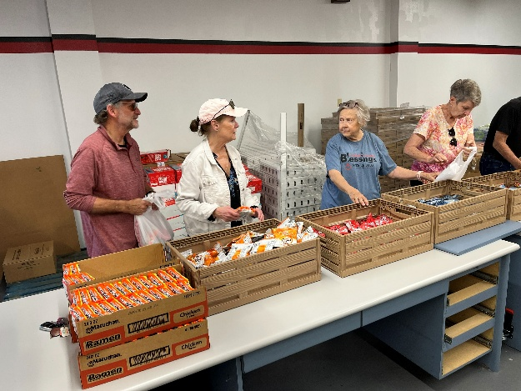
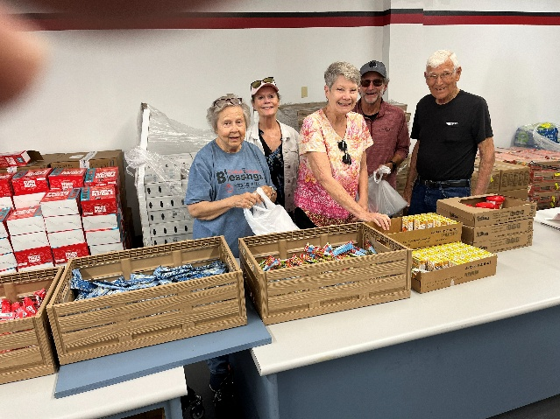


Brenda Kenney 3/5
Judith Lambert 3/6
Steve York 3/9
Carol Lawson 3/9
Willard Cunningham 3/12
Sharon Ricketts 3/13
Jane Estep 3/16
Pat Hennessey 3/17
John Kenney 3/18
Tammy Chainey 3/19
Leah Haussmann 3/25
Avery Messier 3/26
Bill Fullerton 3/31

Birthday Blessings!
SUNDAY | MONDAY | TUESDAY | WEDNESDAY | THURSDAY | FRIDAY | SATURDAY
1  9am Worship  10:15-10:45 D-UP Communion  10:30 Adult SS, Coffee Fellowship | 2  10am PB&J  11am Healthy Start | 3 | 4  11am Citrus Blessings  1pm Card Makers  4pm Lenten Studies followed by Soup Supper | 5  11-12 Bible Study for Beginners  11am Miniatures  3:30 Chimes  4:30 Choir | 6 | 7  4pm Worship
8  9am Worship  10:15-10:45 D-UP Communion  10:30 Adult SS, Coffee Fellowship,  Committees | 9  10:30 Ruth Circle @ Barb C’s house  1pm Garden Club | 10  9-12 Food Pantry | 11  1pm Worship & Music  4pm Lenten Studies followed by Soup Supper | 12  11-12 Bible Study for Beginners  11am Miniatures  3:30 Chimes  4:30 Choir | 13 | 14  4pm Worship
15  9am Worship  10:15-10:45 D-UP Communion  10:30 Adult SS, Special Coffee Fellowship  Council | 16 | 17  12pm WELCA Luncheon | 18  4pm Lenten Studies followed by Soup Supper | 19  11-12 Bible Study for Beginners  11am Miniatures  3:30 Chimes  4:30 Choir | 20 | 21  4pm Worship
22  9am Worship  10:15-10:45 D-UP Communion  10:30 Adult SS, Coffee Fellowship | 23 | 24  9-12 Food Pantry | 25  4pm Lenten Studies followed by Soup Supper | 26  11-12 Bible Study for Beginners  11am Miniatures  3:30 Chimes  4:30 Choir | 27 | 28  4pm Worship
29  PALM SUNDAY  9am Worship  10:15-10:45 D-UP Communion  10:30 Adult SS, Coffee Fellowship | 30 | 31
March 2026

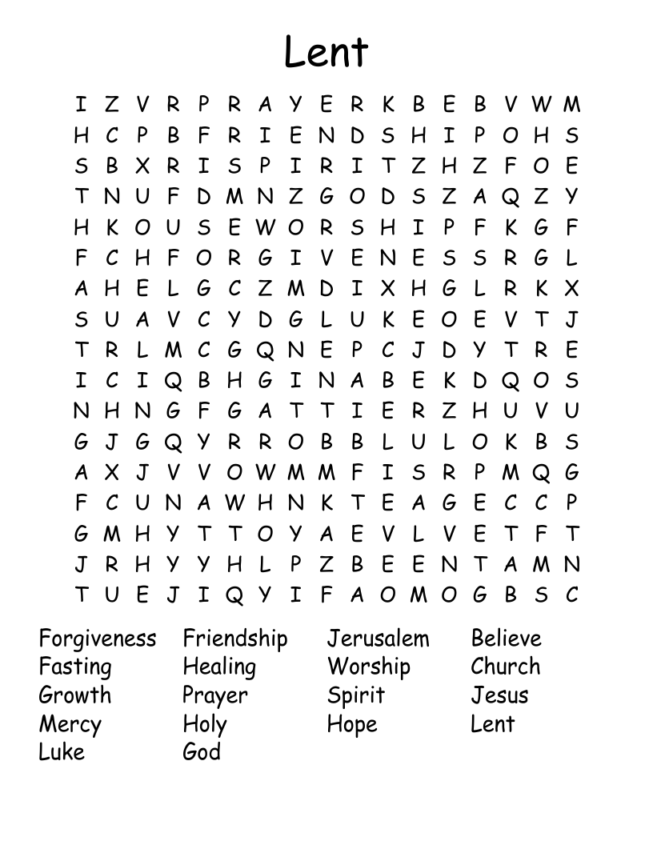

St. Timothy Lutheran Church
S.A.M. Robert “Bob” Bonomo
1070 N. Suncoast Blvd.
Crystal River, FL 34429
Phone: 352-795-5325

Church email: crsttimothy@tampabay.rr.com
Website: www.sttimlutherancrystalriver.com

Lay Minister: Frank Hofstetter
Director of Music: Sally Hennessey
Saturday Pianist: Bill Robinson
Church Secretary: Regina Mendicino
Sexton: William “Bill” Dexter

2026 Congregational Council Members
President: Barbara Carson
Vice-President: Barbara Johnson
Secretary: Carolyn Fialkowski
Treasurer: Lynn Dively
Council Members: Marsha Gibson, Bob Bonomo

Weekly Worship
Saturdays 4pm
Sundays 9am
Communion available at both services
Children’s Sunday School - 9am
Adult Sunday School - 10:30am
Drive-Up Communion – 10:15-10:45
Saturday and Sunday Services - links ONLINE

