Welcome to St. Timothy Evangelical Lutheran Church
March 21, 2026
Fifth Saturday in Lent
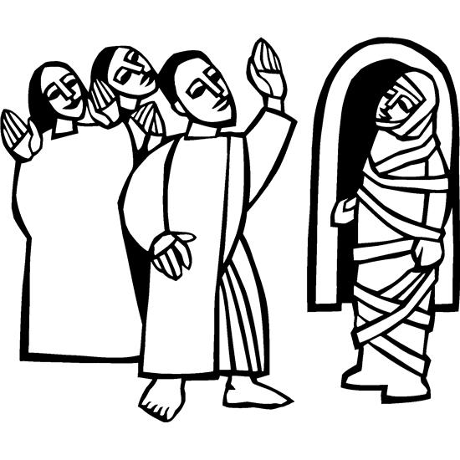

In today’s gospel Jesus reveals his power over death by raising Lazarus from the dead. The prophet Ezekiel prophesies God breathing new life into dry bones. To those in exile or living in the shadows of death, these stories proclaim God’s promise of resurrection. In baptism we die with Christ that we might also be raised with him to new life. At the Easter Vigil we will welcome the newly baptized as we remember God’s unfailing promise in our baptism.

Pre-Service: Jesus is a Rock in a Weary Land ELW 333
Welcome and Sharing of Congregational News
Prelude

Confession and Forgiveness
All may make the sign of the cross, the sign that is marked at baptism, as the presiding minister begins.
Blessed be the holy Trinity, ☩ one God, who forgives all our sin,
whose mercy endures forever.
Amen.
Let us confess our sin before God, who removes our guilt
and blots out all offenses.
Silence is kept for reflection.
Gracious God,
have mercy on us according to your steadfast love.
For seeking worldly delights that deceive us and dishonor you:
Gracious God,
have mercy on us according to your steadfast love.
For desiring self-reliance instead of hungering for your word:
Gracious God,
have mercy on us according to your steadfast love.
For failing to recognize your coming reign,
and for hindering the work of the Spirit: Gracious God,
have mercy on us according to your steadfast love.
For drawing from the well of self-serving ambition,
and for disdaining the living water Christ offers: Gracious God,
have mercy on us according to your steadfast love.
For disregarding voices from the margin,
and for distrusting signs of your healing and hope in the world:
Gracious God,
have mercy on us according to your steadfast love.
For dwelling in tombs of self-pity and discontent,
and for disregarding Christ’s call to come forth to life:
Gracious God,
have mercy on us according to your steadfast love.
God’s steadfast love, grace, and forgiveness abound.
Through faith, the free gift of God,
you have been clothed in the righteousness of Christ.
In the name of ☩ Jesus Christ, your sins are forgiven.
The Spirit of the One who raised Christ from the dead
dwells in you,
pours God’s love into your hearts,
and gives you life and peace.
Amen.
Greeting
P: The joy of our Lord Jesus Christ, the compassion of God, and the creative power of the Holy Spirit be with you all.
C: And also with you.

Gathering Hymn: Lord, Whose Love in Humble Service ELW 712
1 Lord, whose love in humble service
bore the weight of human need,
who upon the cross, forsaken,
worked your mercy's perfect deed:
we, your servants, bring the worship
not of voice alone, but heart;
consecrating to your purpose
ev'ry gift which you impart.
2 Still your children wander homeless;
still the hungry cry for bread;
still the captives long for freedom;
still in grief we mourn our dead.
As you, Lord, in deep compassion
healed the sick and freed the soul,
by your Spirit send your power
to our world to make it whole.
3 As we worship, grant us vision,
till your love's revealing light
in its height and depth and greatness
dawns upon our quickened sight,
making known the needs and burdens
your compassion bids us bear,
stirring us to ardent service,
your abundant life to share.
4 Called by worship to your service,
forth in your dear name we go,
to the child, the youth, the aged,
love in living deeds to show;
hope and health, good will and comfort,
counsel, aid and peace we give,
that your servants, Lord, in freedom
may your mercy know and live.
Text: Albert F. Bayly, 1901-1984. Text © 1961 Oxford University Press. Duplication in any form prohibited without permission or valid license from copyright administrator.

Prayer of the Day
Almighty God, your Son came into the world to free us all from sin and death. Breathe upon us the power of your Spirit, that we may be raised to new life in Christ and serve you in righteousness all our days, through Jesus Christ, our Savior and Lord, who lives and reigns with you and the Holy Spirit, one God, now and forever.
Amen.
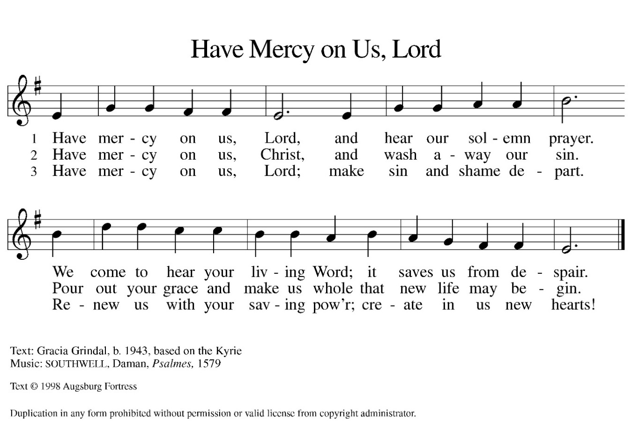

Reading: Ezekiel 37:1-14
Ezekiel’s vision of the valley of dry bones is a promise that Israel as a nation, though dead in exile, will live again in their land through God’s life-giving spirit. Three times Israel is assured that through this vision they will know that “I am the Lord.”
¹ The hand of the Lord came upon me, and he brought me out by the spirit of the Lord and set me down in the middle of a valley; it was full of bones. ² He led me all around them; there were very many lying in the valley, and they were very dry. ³ He said to me, “Mortal, can these bones live?” I answered, “O Lord God, you know.” ⁴ Then he said to me, “Prophesy to these bones and say to them: O dry bones, hear the word of the Lord. ⁵ Thus says the Lord God to these bones: I will cause breath to enter you, and you shall live. ⁶ I will lay sinews on you and will cause flesh to come upon you and cover you with skin and put breath in you, and you shall live, and you shall know that I am the Lord.”
⁷ So I prophesied as I had been commanded, and as I prophesied, suddenly there was a noise, a rattling, and the bones came together, bone to its bone. ⁸ I looked, and there were sinews on them, and flesh had come upon them, and skin had covered them, but there was no breath in them. ⁹ Then he said to me, “Prophesy to the breath, prophesy, mortal, and say to the breath: Thus says the Lord God: Come from the four winds, O breath, and breathe upon these slain, that they may live.” ¹⁰ I prophesied as he commanded me, and the breath came into them, and they lived and stood on their feet, a vast multitude.
¹¹ Then he said to me, “Mortal, these bones are the whole house of Israel. They say, ‘Our bones are dried up, and our hope is lost; we are cut off completely.’ ¹² Therefore prophesy and say to them: Thus says the Lord God: I am going to open your graves and bring you up from your graves, O my people, and I will bring you back to the land of Israel. ¹³ And you shall know that I am the Lord when I open your graves and bring you up from your graves, O my people. ¹⁴ I will put my spirit within you, and you shall live, and I will place you on your own soil; then you shall know that I, the Lord, have spoken and will act, says the Lord.”

P: The Word of the Lord.
C: Thanks be to God!
Gospel Acclamation
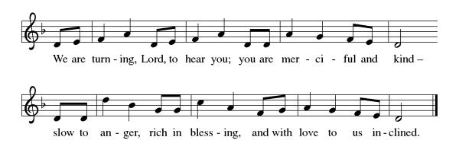

P: The Holy Gospel according to John 11: 1-45
C: Glory to you O Lord.

Gospel: John 11:1-45
Jesus is moved to sorrow when his friend Lazarus falls ill and dies. Then, in a dramatic scene, he calls his friend out of the tomb and restores him to life.
¹ Now a certain man was ill, Lazarus of Bethany, the village of Mary and her sister Martha. ² Mary was the one who anointed the Lord with perfume and wiped his feet with her hair; her brother Lazarus was ill. ³ So the sisters sent a message to Jesus, “Lord, he whom you love is ill.” ⁴ But when Jesus heard it, he said, “This illness does not lead to death; rather, it is for God’s glory, so that the Son of God may be glorified through it.” ⁵ Accordingly, though Jesus loved Martha and her sister and Lazarus, ⁶ after having heard that Lazarus was ill, he stayed two days longer in the place where he was.
⁷ Then after this he said to the disciples, “Let us go to Judea again.” ⁸ The disciples said to him, “Rabbi, the Jews were just now trying to stone you, and are you going there again?” ⁹ Jesus answered, “Are there not twelve hours of daylight? Those who walk during the day do not stumble because they see the light of this world. ¹⁰ But those who walk at night stumble because the light is not in them.” ¹¹ After saying this, he told them, “Our friend Lazarus has fallen asleep, but I am going there to awaken him.” ¹² The disciples said to him, “Lord, if he has fallen asleep, he will be all right.” ¹³ Jesus, however, had been speaking about his death, but they thought that he was referring merely to sleep. ¹⁴ Then Jesus told them plainly, “Lazarus is dead. ¹⁵ For your sake I am glad I was not there, so that you may believe. But let us go to him.” ¹⁶ Thomas, who was called the Twin, said to his fellow disciples, “Let us also go, that we may die with him.”
¹⁷ When Jesus arrived, he found that Lazarus had already been in the tomb four days. ¹⁸ Now Bethany was near Jerusalem, some two miles away, ¹⁹ and many of the Jews had come to Martha and Mary to console them about their brother. ²⁰ When Martha heard that Jesus was coming, she went and met him, while Mary stayed at home. ²¹ Martha said to Jesus, “Lord, if you had been here, my brother would not have died. ²² But even now I know that God will give you whatever you ask of him.” ²³ Jesus said to her, “Your brother will rise again.” ²⁴ Martha said to him, “I know that he will rise again in the resurrection on the last day.” ²⁵ Jesus said to her, “I am the resurrection and the life. Those who believe in me, even though they die, will live, ²⁶ and everyone who lives and believes in me will never die. Do you believe this?” ²⁷ She said to him, “Yes, Lord, I believe that you are the Messiah, the Son of God, the one coming into the world.”
²⁸ When she had said this, she went back and called her sister Mary and told her privately, “The Teacher is here and is calling for you.” ²⁹ And when she heard it, she got up quickly and went to him. ³⁰ Now Jesus had not yet come to the village but was still at the place where Martha had met him. ³¹ The Jews who were with her in the house consoling her saw Mary get up quickly and go out. They followed her because they thought that she was going to the tomb to weep there. ³² When Mary came where Jesus was and saw him, she knelt at his feet and said to him, “Lord, if you had been here, my brother would not have died.” ³³ When Jesus saw her weeping and the Jews who came with her also weeping, he was greatly disturbed in spirit and deeply moved. ³⁴ He said, “Where have you laid him?” They said to him, “Lord, come and see.” ³⁵ Jesus began to weep. ³⁶ So the Jews said, “See how he loved him!” ³⁷ But some of them said, “Could not he who opened the eyes of the blind man have kept this man from dying?”
³⁸ Then Jesus, again greatly disturbed, came to the tomb. It was a cave, and a stone was lying against it. ³⁹ Jesus said, “Take away the stone.” Martha, the sister of the dead man, said to him, “Lord, already there is a stench because he has been dead four days.” ⁴⁰ Jesus said to her, “Did I not tell you that if you believed you would see the glory of God?” ⁴¹ So they took away the stone. And Jesus looked upward and said, “Father, I thank you for having heard me. ⁴² I knew that you always hear me, but I have said this for the sake of the crowd standing here, so that they may believe that you sent me.” ⁴³ When he had said this, he cried with a loud voice, “Lazarus, come out!” ⁴⁴ The dead man came out, his hands and feet bound with strips of cloth and his face wrapped in a cloth. Jesus said to them, “Unbind him, and let him go.”
⁴⁵ Many of the Jews, therefore, who had come with Mary and had seen what Jesus did believed in him.

P: The Gospel of Our Lord!
C: Praise to You O Christ!
Sermon by Bob

Hymn of the Day: What Wondrous Love Is This ELW 666

1 What wondrous love is this, O my soul, O my soul! What wondrous love is this, O my soul! What wondrous love is this
that caused the Lord of bliss to bear the dreadful curse for my soul, for my soul, to bear the dreadful curse for my soul?

2 When I was sinking down, sinking down, sinking down, when
I was sinking down, sinking down, when I was sinking down
beneath God's righteous frown, Christ laid aside his crown for my soul, for my soul, Christ laid aside his crown for my soul.

3 To God and to the Lamb I will sing, I will sing; to
God and to the Lamb I will sing; to God and to the Lamb,
who is the great I AM, while millions join the theme, I will
sing, I will sing, while millions join the theme, I will sing.

4 And when from death I'm free, I'll sing on, I'll sing on; and
when from death I'm free, I'll sing on; and when from death I'm free,
I'll sing God's love for me, and through eternity I'll sing
on, I'll sing on; and through eternity I'll sing on.
Text: North American folk hymn, 19th cent., alt.

Nicene Creed
We believe in one God, the Father, the Almighty,
maker of heaven and earth,
of all that is, seen and unseen.
We believe in one Lord, Jesus Christ,
the only Son of God,
eternally begotten of the Father,
God from God, Light from Light,
true God from true God,
begotten, not made,
of one Being with the Father;
through him all things were made.
For us and for our salvation
he came down from heaven,
was incarnate of the Holy Spirit and the Virgin Mary
and became truly human.
For our sake he was crucified under Pontius Pilate;
he suffered death and was buried.
On the third day he rose again
in accordance with the Scriptures;
he ascended into heaven
and is seated at the right hand of the Father.
He will come again in glory to judge the living and the dead,
and his kingdom will have no end.
We believe in the Holy Spirit, the Lord, the giver of life,
who proceeds from the Father and the Son,
who with the Father and the Son is worshiped and glorified,
who has spoken through the prophets.
We believe in one holy catholic and apostolic church.
We acknowledge one baptism for the forgiveness of sins.
We look for the resurrection of the dead,
and the life of the world to come. Amen.
From sundaysandseasons.com.
Copyright © 2026 Augsburg Fortress. All rights reserved.

Prayers of the People

Response (after “Hear us, O God”): “Your mercy is great.”

Receive our prayers, O God, through Jesus Christ, our strength and salvation.
Amen.

P: May the peace of our Lord Jesus Christ be with you all.
C: And also with you.
P: Let us now share this peace.
Offering is Brought to the Altar

Offertory Prayer
O God, maker of heaven and earth,
your steadfast love embraces all creation.
You send rain and sunshine to nourish the earth
and bring forth its bounty.
Through these gifts of bread and wine,
draw us into the death and life of your Son,
who calls us to bear witness to his saving work.
We ask this in Jesus’ name. Amen.
P: The Lord be with you.
C: And also with you.

P: Lift up your hearts.
C: We Lift them to the Lord.

P: Let us give thanks to the Lord our God.
C: It is right to give our thanks and praise.

Preface
(Words spoken by Bob)
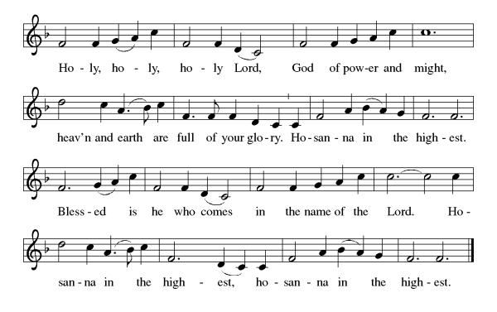
Eucharistic Prayer
(Words of Institution)

For as often as we eat of this bread and drink from this cup we proclaim the Lord’s death until He comes.
Christ has died
Christ is risen.
Christ will come again.
Remembering, therefore, his salutary command,
his life-giving passion and death, his glorious resurrection and ascension,
and the promise of his coming again,
we give thanks to you, O Lord God Almighty,
not as we ought but as we are able;
we ask you mercifully to accept our praise and thanksgiving and with your Word and Holy Spirit to bless us, your servants, and these your own gifts of bread and wine, so that we and all who share in the body and blood of Christ may be filled with heavenly blessing and grace,
and, receiving the forgiveness of sin,
may be formed to live as your holy people
and be given our inheritance with all your saints.
To you, O God, Father, Son, and Holy Spirit,
be all honor and glory in your holy church, now and forever. Amen.
Gathered into one, by the Holy Spirit let us listen to the words that Jesus taught us.

The Lord’s Prayer
Our Father, who art in heaven, hallowed be thy name, thy kingdom come, thy will be done, on earth as it is in heaven. Give us this day our daily bread; and forgive us our trespasses, as we forgive those who trespass against us; and lead us not into temptation but deliver us from evil. For thine is the kingdom, and the power, and the glory, forever and ever. Amen.

Invitation to Communion
P: All are welcomed at His table. Feast on God’s goodness and mercy.
C: Amen
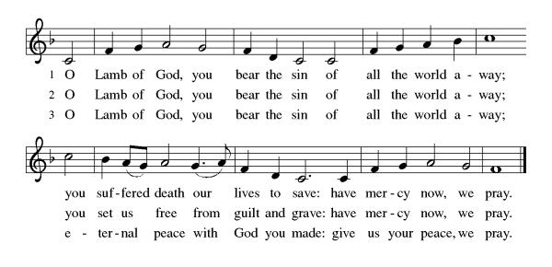
All may come.
Communion Anthem: I Am the Bread of Life ELW 485
P: Martin Luther's Post Communion Prayer German Mass 1526
We give You thanks, Almighty God, that You have refreshed us through this holy gift. We ask that, in Your mercy, You would strengthen us through it in faith toward You and in fervent love toward one another, through Jesus Christ, Your Son, our Lord.
C: Amen

Prayer after Communion
God of our salvation,
We give you thanks for this meal that restores our souls,
Reconciles us to you, and strengthens us for the journey.
Through the body and blood of your Son,
May we become Christ’s body in the world,
Bearing witness to your love for all creation,
Through Jesus Christ, our Savior and Lord.
Amen.

Blessing
Receive the blessing of the holy Trinity:
God, who calls all things into existence,
Jesus Christ, who redeems us,
And the Holy Spirit, whose breath sustains creation,
☩ bless you now and always.
Amen.

Sending Hymn: You Are the Way ELW 758
1 You are the way; to you alone from sin and death we flee;
all those who search for God, you find and by your grace set free.

2 You are the truth; your word alone true wisdom can impart;
you only can inform the mind and purify the heart.

3 You are the life; the rending tomb proclaims your conqu'ring arm;
and those who put their trust in you not death nor hell shall harm.

4 You are the way, the truth, the life; grant us that way to know,
that truth to keep, that life to win, whose joys eternal flow.
Text: George W. Doane, 1799-1859, alt.

Dismissal
P: Let Holy Week be your guide to who we are and what Jesus did for us.
C: Thanks be to God.
Postlude
Unless otherwise noted, materials used in this bulletin are:
From Sundays and Seasons.com. Copyright 2015 Augsburg Fortress. All rights reserved. Reprinted by permission under Augsburg Fortress Liturgies Annual License #SAS028635. Music is reprinted under OneLicense.Net #A712074 and/or Augsburg Fortress #SBL12176H. Scripture, unless otherwise noted, is from the New Revised Standard Version Bible, Copyright © 1989, Division of Christian Education of the National Council of the Churches of Christ in the United States of America. Used by permission. All rights reserved.

St. Timothy Evangelical Lutheran Church
1070 N. Suncoast Blvd.
Crystal River, FL 34429
Telephone number (Office): 352-795-5325
Office email address: crsttimothy@tampabay.rr.com

St Timothy Worship Team
S.A.M. Robert F. Bonomo
Lay Minister, Frank Hofstetter
Director of Music, Sally Hennessey
Saturday Pianist, Bill Robinson

Announcements for March 21st and 22nd

ATTENDANCE
Wednesday, March 11 (Lent SS) 25
Saturday, March 14th, 4pm 25
Sunday, March 15th, 9am 62
112

There will be no Altar Flowers during Lent.

Serving our Lord this weekend:
Saturday, March 21st
Assisting Minister: Carolyn Fialkowski
Reader: Jean Fowler
Sunday, March 22nd
Assisting Minister – Sarah Brisson
Reader –Kris Harper

This Week at St. Timothy's
Monday, March 23rd
Tuesday, March 24th 9-12 Food Pantry
Wednesday, March 25th 4pm Lenten Studies followed by Soup Supper
Thursday, March 26th 11am Bible Study for Beginners, 11am – Miniatures, 12pm Pizza/Food Box Packing Party, 3:30 Chimes, 4:30pm - Choir
Friday, March 27th
Saturday, March 28th 4pm - Worship
Sunday, March 29th 9am – Worship, 10:15-10:45 – Drive Up Communion, Adult SS, Coffee Fellowship

Message from Patti Cyr – Food boxes
Food box tubs are set up in the fellowship hall, under the table on the left, to start collecting for Easter Food Boxes. Lots of BOGOs going on if you would like to help. Also, the food box request forms are on the table if you know anyone in need. Please fill out and place it in my mailbox.

Blessings & Thanks,
Patti



2026 Easter Food Box Supply List
Wow! Time sure goes by fast. Seems like we just got done with Thanksgiving Food Boxes and we need to start collecting for Easter Boxes. We will continue to provide 40 food boxes and Easter bags for their children for families in our community and will begin March 1, 2026. If you would like to request a box for a family member or friend, forms will be available on the table in the fellowship hall and need to be turned in to Patti Cyr (Box #139) no later than March 14th.
Please purchase only these items (CHECK EXPIRATION DATES):
Canned Fruit
Canned Chicken Canned Vegetables (corn/green beans)
Canned Ham Pasta
Tuna Spaghetti Sauce (preferred – canned)
Soup Instant Potatoes
Peanut Butter White Rice
Jelly Gravy (prefer brown)
Saltine crackers Jello and Pudding
Macaroni & Cheese Canned chili
Baked Beans (Canned)
Oatmeal (prefer box with individual packets)

Place food in designated bins under the table in the fellowship hall no later than Sunday March 22, 2026. Thanks so very much for the food, funds and help you, so willingly, donate for this activity.

Packing of the food boxes will be March 26, 2026. A light lunch will be at Noon and packing will be done afterwards.

Much thanks and blessing
~Patti Cyr Cell # 352-422-7313. Leave a message and I will return your call.

