St Timothy Lutheran Church
Sunday, May 31st, 2026
The Holy Trinity



Though the word trinity is not found in the scriptures, today’s second reading includes the apostolic greeting that begins the liturgy: The grace of our Lord Jesus Christ, the love of God, and the communion of the Holy Spirit be with you all. In the gospel Jesus sends his disciples forth to baptize in the name of the Father, and the Son, and the Holy Spirit. More than a doctrine, the Trinity expresses the heart of our faith: we have experienced the God of creation made known in Jesus Christ and with us always through the Holy Spirit. We celebrate the mystery of the Holy Trinity in word and sacrament, as we profess the creed, and as we are sent into the world to bear witness to our faith.
Preservice: Chimes
Welcome!
Prelude
P – Preparing our hearts for Worship

Confession and Forgiveness
All may make the sign of the cross, the sign that is marked at baptism, as the presiding minister begins.
Blessed be the holy Trinity,☩ one God,
whose compassion endures forever.
Amen.
Let us confess our sin to God.
Silence is kept for reflection.
Compassionate God,
we confess to you all our sins.
Our burden is heavy, and we cannot free ourselves.
In your mercy, call us back to you.
Your yoke is easy and your burden is light.
Restore us to dwell in your peace.
In Christ’s name we pray,
Amen.
Jesus says, “Come to me,
all you who are weary
and are carrying heavy burdens,
and I will give you rest.”
In the name of God,
Father, ☩ Son, and Holy Spirit,
your sins are forgiven.
Rest in God’s love.
Amen.

Gathering Hymn: Holy God, We Praise Your Name ELW 414
- Holy God, we praise your name; Lord of all, we
bow before you. All on earth your scepter claim,
all in heav'n above adore you. Infinite your
vast domain, everlasting is your reign.

- Hark! The glad celestial hymn angel choirs above
are raising; cherubim and seraphim,
in unceasing chorus praising, fill the heav'ns with
sweet accord: "Holy, holy, holy Lord!"

- Lo, the apostolic train join your sacred
name to hallow; prophets swell the glad refrain,
and the white-robed martyrs follow; and from morn to
set of sun through the church the song goes on.

- Holy Father, holy Son, Holy Spirit,
three we name you, though in essence only one;
undivided God we claim you and, adoring,
bend the knee while we own the mystery.
Text: source unknown; tr. Clarence A. Walworth, 1820-1900

P - The grace of our Lord Jesus Christ, the love of God and the communion of the Holy Spirit be with you all.
C - And also with you.
Prayer of the Day
Almighty Creator and ever-living God: we worship your glory, eternal Three-in-One, and we praise your power, majestic One-in-Three. Keep us steadfast in this faith, defend us in all adversity, and bring us at last into your presence, where you live in endless joy and love, Father, Son, and Holy Spirit, one God, now and forever.
Amen.

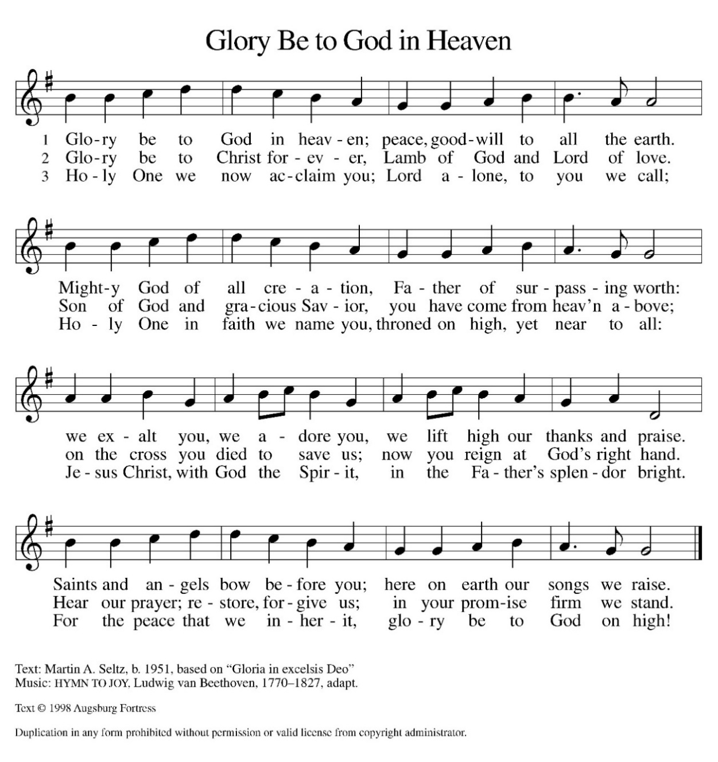
Hymn of Praise:

Please be seated.

First Reading: Genesis 1:1—2:4a
At the beginning of time, God the Creator, God the powerful Word, and God the life-giving Spirit form the earth and all its inhabitants. God sees that all this created work is good and then rests on the seventh day.
¹ When God began to create the heavens and the earth, ² the earth was complete chaos, and darkness covered the face of the deep, while a wind from God swept over the face of the waters. ³ Then God said, “Let there be light,” and there was light. ⁴ And God saw that the light was good, and God separated the light from the darkness. ⁵ God called the light Day, and the darkness he called Night. And there was evening and there was morning, the first day.
⁶ And God said, “Let there be a dome in the midst of the waters, and let it separate the waters from the waters.” ⁷ So God made the dome and separated the waters that were under the dome from the waters that were above the dome. And it was so. ⁸ God called the dome Sky. And there was evening and there was morning, the second day.
⁹ And God said, “Let the waters under the sky be gathered together into one place, and let the dry land appear.” And it was so. ¹⁰ God called the dry land Earth, and the waters that were gathered together he called Seas. And God saw that it was good. ¹¹ Then God said, “Let the earth put forth vegetation: plants yielding seed and fruit trees of every kind on earth that bear fruit with the seed in it.” And it was so. ¹² The earth brought forth vegetation: plants yielding seed of every kind and trees of every kind bearing fruit with the seed in it. And God saw that it was good. ¹³ And there was evening and there was morning, the third day.
¹⁴ And God said, “Let there be lights in the dome of the sky to separate the day from the night, and let them be for signs and for seasons and for days and years, ¹⁵ and let them be lights in the dome of the sky to give light upon the earth.” And it was so. ¹⁶ God made the two great lights—the greater light to rule the day and the lesser light to rule the night—and the stars. ¹⁷ God set them in the dome of the sky to give light upon the earth, ¹⁸ to rule over the day and over the night, and to separate the light from the darkness. And God saw that it was good. ¹⁹ And there was evening and there was morning, the fourth day.
²⁰ And God said, “Let the waters bring forth swarms of living creatures, and let birds fly above the earth across the dome of the sky.” ²¹ So God created the great sea monsters and every living creature that moves, of every kind, with which the waters swarm and every winged bird of every kind. And God saw that it was good. ²² God blessed them, saying, “Be fruitful and multiply and fill the waters in the seas, and let birds multiply on the earth.” ²³ And there was evening and there was morning, the fifth day.
²⁴ And God said, “Let the earth bring forth living creatures of every kind: cattle and creeping things and wild animals of the earth of every kind.” And it was so. ²⁵ God made the wild animals of the earth of every kind and the cattle of every kind and everything that creeps upon the ground of every kind. And God saw that it was good.
²⁶ Then God said, “Let us make humans in our image, according to our likeness, and let them have dominion over the fish of the sea and over the birds of the air and over the cattle and over all the wild animals of the earth and over every creeping thing that creeps upon the earth.”
²⁷ So God created humans in his image,
in the image of God he created them;
male and female he created them.
²⁸ God blessed them, and God said to them, “Be fruitful and multiply and fill the earth and subdue it and have dominion over the fish of the sea and over the birds of the air and over every living thing that moves upon the earth.” ²⁹ God said, “See, I have given you every plant yielding seed that is upon the face of all the earth and every tree with seed in its fruit; you shall have them for food. ³⁰ And to every beast of the earth and to every bird of the air and to everything that creeps on the earth, everything that has the breath of life, I have given every green plant for food.” And it was so. ³¹ God saw everything that he had made, and indeed, it was very good. And there was evening and there was morning, the sixth day.
^{2:1} Thus the heavens and the earth were finished and all their multitude. ² On the sixth day God finished the work that he had done, and he rested on the seventh day from all the work that he had done. ³ So God blessed the seventh day and hallowed it, because on it God rested from all the work that he had done in creation.
^{4a} These are the generations of the heavens and the earth when they were created.

A – Here ends the first reading!

C – Thanks be to God!

Psalm 8
¹ O Lord our Lord,
how majestic is your name in all the earth!—
² you whose glory is chanted above the heavens out of the mouths of infants and children;
you have set up a fortress against your enemies, to silence the foe and avenger.
³ When I consider your heavens, the work of your fingers,
the moon and the stars you have set in their courses,
⁴ what are mere mortals that you should be mindful of them,
human beings that you should care for them?
⁵ Yet you have made them little less than divine;
with glory and honor you crown them.
⁶ You have made them rule over the works of your hands;
you have put all things under their feet:
⁷ all flocks and cattle,
even the wild beasts of the field,
⁸ the birds of the air, the fish of the sea,
and whatever passes along the paths of the sea.
⁹ O Lord our Lord,
how majestic is your name in all the earth!

Second Reading: 2 Corinthians 13:11-13
Paul closes a challenging letter to the Corinthians with an appeal to Christian fellowship grounded in the triune harmony of Christ’s grace, God’s love, and the Spirit’s partnership.
[Paul writes:] ¹¹ Finally, brothers and sisters, farewell. Be restored; listen to my appeal; agree with one another; live in peace; and the God of love and peace will be with you. ¹² Greet one another with a holy kiss. All the saints greet you.
¹³ The grace of the Lord Jesus Christ, the love of God, and the communion of the Holy Spirit be with all of you.

A – Here ends the second reading!
C – Thanks be to God!

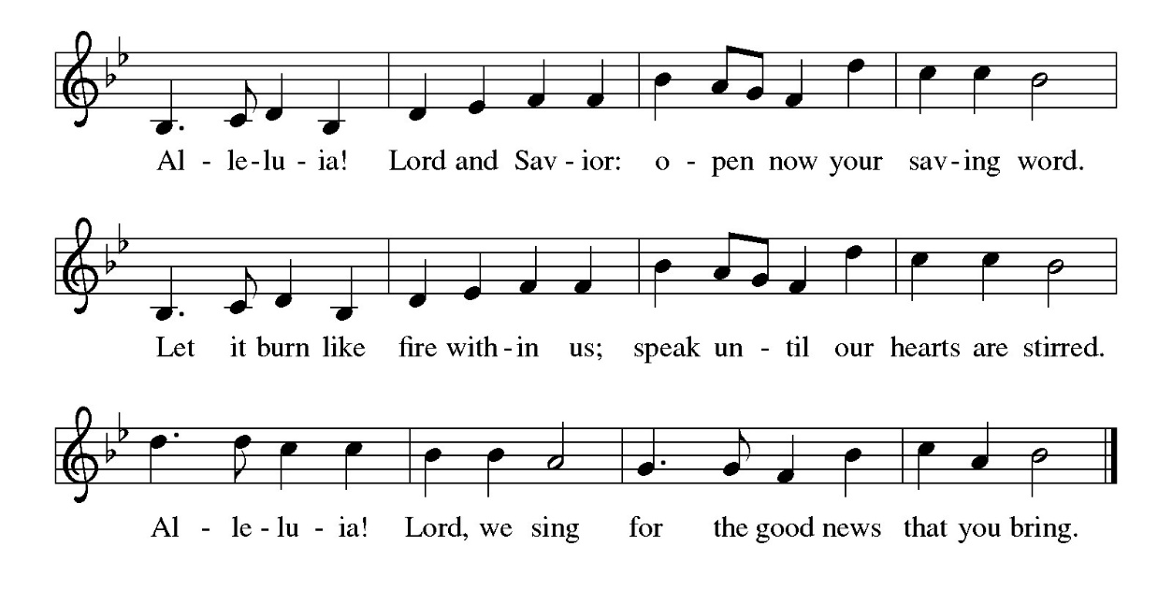
Gospel Acclamation

P - The Holy Gospel according to Matthew, the 28th Chapter
C - Glory to You O Lord!

Gospel: Matthew 28:16-20
After his resurrection, Jesus summons his remaining disciples and commissions them to baptize and teach all nations in the name of the Father, Son, and Holy Spirit.
¹⁶ Now the eleven disciples went to Galilee, to the mountain to which Jesus had directed them. ¹⁷ When they saw him, they worshiped him, but they doubted. ¹⁸ And Jesus came and said to them, “All authority in heaven and on earth has been given to me. ¹⁹ Go therefore and make disciples of all nations, baptizing them in the name of the Father and of the Son and of the Holy Spirit ²⁰ and teaching them to obey everything that I have commanded you. And remember, I am with you always, to the end of the age.”

P - The Gospel of the Lord.
C – Praise to you, O Christ!
Sermon
Hymn of the Day: Holy, Holy, Holy, Lord God Almighty ELW 413
1 Holy, holy, holy, Lord God Almighty!
Early in the morning our song shall rise to thee.
Holy, holy, holy, merciful and mighty!
God in three persons, blessed Trinity!

2 Holy, holy, holy! All the saints adore thee,
casting down their golden crowns around the glassy sea;
cherubim and seraphim falling down before thee,
which wert and art, and evermore shalt be.

3 Holy, holy, holy! Though the darkness hide thee,
though the eye of sinfulness thy glory may not see,
only thou art holy; there is none beside thee,
perfect in pow'r, in love and purity.

4 Holy, holy, holy! Lord God Almighty!
All thy works shall praise thy name in earth and sky and sea.
Holy, holy, holy, merciful and mighty!
God in three persons, blessed Trinity!

Text: Reginald Heber, 1783-1826, alt.

The Apostle’s Creed
I believe in God, the Father almighty,
creator of heaven and earth.
I believe in Jesus Christ, God’s only Son, our Lord,
who was conceived by the Holy Spirit,
born of the virgin Mary,
suffered under Pontius Pilate,
was crucified, died, and was buried;
he descended to the dead.*
On the third day he rose again;
he ascended into heaven,
he is seated at the right hand of the Father,
and he will come to judge the living and the dead.
I believe in the Holy Spirit,
the holy catholic church,
the communion of saints,
the forgiveness of sins,
the resurrection of the body,
and the life everlasting. Amen.
From sundaysandseasons.com.
Copyright © 2026 Augsburg Fortress. All rights reserved.

Prayers of the People
Trusting in the power of Christ’s Resurrection and Ascension to heal and redeem our broken world, let us pray for the needs of all creation.
A brief silence.
O God, you send the Holy Spirit to gather your church into one. Inspire all ministers of the gospel to speak prophetic and hope-filled words to all whom they encounter. Bless the work of interreligious dialogue.
Merciful God,
receive our prayer.
You send the Holy Spirit to renew the face of the earth. Protect all living things, bring forth clean water and abundant food, and grant us wonder as we contemplate all you have made.
Merciful God,
receive our prayer.
You send the Holy Spirit to break down the barriers of communication among nations. Bestow peace in war-torn areas, guide all in government and society to work for justice, and guard those serving in the armed forces, especially this weekend as we remember those who died in service to their country.
Merciful God,
receive our prayer.
You send the Holy Spirit to accompany those who feel abandoned. Provide food for those who hunger and drink for those who thirst, soothe those who are anxious or bereaved, comfort those who are sick or suffering, and answer all who call upon your name (especially).
Merciful God,
receive our prayer.

You send the Holy Spirit through the gift of baptism. Bless both those preparing for or affirming their baptism. May they be encouraged by this community of faith as they live out their baptismal promises.
Merciful God,
receive our prayer.
You send the Holy Spirit to console us in our grief. We give you thanks for our ancestors in the faith, witness to your mighty works continues to inspire our lives.
Merciful God,
receive our prayer.
God of resurrection power, use us and these prayers to proclaim the good news of new life to all the world, through Jesus Christ, our risen Savior.
Amen.

P – The Peace of the Lord be with you always.
C – And also with you.

The Offering is Brought to the Altar
Offertory Prayer
Loving God,
we offer at your table the gifts of our hearts.
Help us take heart in you and share freely of your love,
so that all creation can taste your abundance.
We ask this in the name of Jesus,
through the Spirit abiding with us now and forever.
Amen.

P – The Lord be with You
C – And also with you.
P – Lift up your hearts
C – We lift them to the Lord.
P – Let us give thanks to the Lord, our God
C – It is right to give Him our thanks and praise.

Preface
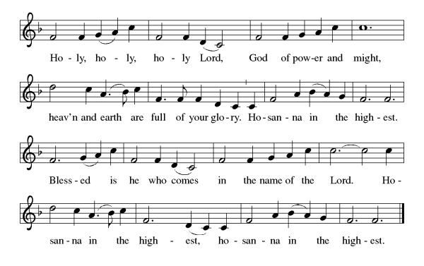
And so, with all the choirs of angels, with the church on earth and the hosts of heaven, we praise your name and join their unending hymn:

Eucharistic Prayer
(Words of Institution)
For as often as we eat of this bread and drink from this cup we proclaim the Lord’s death until He comes.
Christ has died
Christ is risen.
Christ will come again.
Remembering, therefore, his salutary command,
his life-giving passion and death, his glorious resurrection and ascension,
and the promise of his coming again,
we give thanks to you, O Lord God Almighty,
not as we ought but as we are able;
we ask you mercifully to accept our praise and thanksgiving and with your Word and Holy Spirit to bless us, your servants, and these your own gifts of bread and wine, so that we and all who share in the body and blood of Christ may be filled with heavenly blessing and grace,
and, receiving the forgiveness of sin,
may be formed to live as your holy people
and be given our inheritance with all your saints.
To you, O God, Father, Son, and Holy Spirit,
be all honor and glory in your holy church, now and forever. Amen.
Gathered into one, by the Holy Spirit let us listen to the words that Jesus taught us.

The Lord’s Prayer
Our Father, who art in heaven, hallowed be thy name, thy kingdom come, thy will be done, on earth as it is in heaven. Give us this day our daily bread; and forgive us our trespasses, as we forgive those who trespass against us; and lead us not into temptation but deliver us from evil. For thine is the kingdom, and the power, and the glory, forever and ever. Amen.

P: Taste and see that the Lord is good.
C: Thanks be to God.

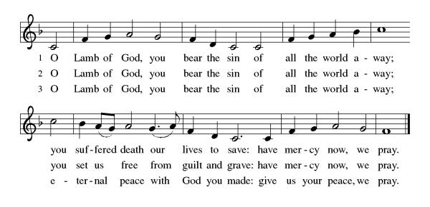
Invitation to Communion

Distribution of Communion – Come Forward to Receive
Communion Hymn: I Bind Unto Myself Today ELW 450

P – Now may the body and blood of our Lord and Savior Jesus Christ strengthen you and keep you in His grace!
C – Thank You Jesus!

Prayer after Communion
Compassionate God,
Through the gifts of bread and wine
our hearts are filled with the abundance of your love.
Strengthen us that we, through this Holy meal,
may share your love freely, as you have shared with us.
We ask this in the name of Jesus,
through the Spirit nourishing us now and forever.
Amen.

Words of dismissal and benediction
Know that the ever-present mystery we name God
is in your past forgiving you,
in your present loving you,
and in your future meeting you.
And may the blessing of the Source of life, love and hope,
the Word of life, compassion and wisdom
and Breath of life, grace and truth
surround, sustain and surprise you,
this day and all your days. Amen.

Sending Hymn: Lord, You Give the Great Commission ELW 579
1 Lord, you give the great commission:
"Heal the sick and preach the word."
Lest the church neglect its mission,
and the gospel go unheard,
help us witness to your purpose
with renewed integrity:
Refrain
With the Spirit's gifts empow'r us
for the work of ministry.
2 Lord, you call us to your service:
"In my name baptize and teach."
That the world may trust your promise,
life abundant meant for each,
give us all new fervor, draw us
closer in community: Refrain
3 Lord, you make the common holy:
"This my body, this my blood."
Let us all, for earth's true glory,
daily lift life heavenward,
asking that the world around us
share your children's liberty: Refrain
4 Lord, you show us love's true measure:
"Father, what they do, forgive."
Yet we hoard as private treasure
all that you so freely give.
May your care and mercy lead us
to a just society: Refrain
5 Lord, you bless with words assuring:
"I am with you to the end."
Faith and hope and love restoring,
may we serve as you intend
and, amid the cares that claim us,
hold in mind eternity: Refrain

Text: Jeffery Rowthorn, b. 1934
Text © 1978 Hope Publishing Company, Carol Stream, IL 60188. All rights reserved. Used by permission.
Duplication in any form prohibited without permission or valid license from copyright administrator.

Dismissal
P – Look and listen to S.A.M. Bob
C- Thanks be to God. Alleluia!

Postlude:
Unless otherwise noted, service materials used in this bulletin are:
Music is reprinted under OneLicense.Net #A712074 and/or Augsburg Fortress #SBL12176H. Scripture, unless otherwise noted, is from the New Revised Standard Version Bible, Copyright © 1989, Division of Christian Education of the National Council of the Churches of Christ in the United States of America. Used by permission. All rights reserved.

St Timothy’s is served by S.A.M. Robert Bonomo
Lay Minister Frank Hofstetter
Director of Music Sally Hennessey
Saturday Pianist Bill Robinson

Announcements for May 30th and 31st
ATTENDANCE
Saturday, May 23rd , 4pm 23
Sunday, May 24th, 9am 58
Drive-Up Communion 2
83

The altar flowers are given to the glory of God!
Serving our Lord this weekend:
Saturday, May 30th

Sunday, May 24th
Assisting Minister – Frank Hofstetter
Reader – Judi Schutrum
Ushers/Greeters – John & Jodie Gudorf

This Week at St. Timothy's
Monday, June 1st 10:30am – PB&J Ministry, 11am – Healthy Start
Tuesday, June 2nd
Wednesday, June 3rd 1pm – Card Makers
Thursday, June 4th SYNOD ASSEMBLY – NO BIBLE STUDY – NO CHOIR PRACTICE
Friday, June 5th SYNOD ASSEMBLY
Saturday, June 6th SYNOD ASSEMBLY - 4pm Worship, No Fellowship
Sunday, June 7th 9am Worship 10:30am – Adult SS, Coffee Fellowship

PRAYER LIST
Steve Cook
Family of Karen Adyniec
Vicky Quigley
Greg Schutrum
Debbie Lawrence
Carole Albert
Linda C.
Ashlee
Frani Barnes
Mark Duffy
Wyatt Toney
Jim & Rosa Neth
Melanie
Trish Bradley
Fowler Family
Nancy Brooks, Mike & David

