Welcome to St. Timothy Evangelical Lutheran Church
March 29, 2026
Sixth Sunday in Lent
Passion Sunday


Today, we encounter the paradox that defines our faith: Jesus Christ is glorified king and humiliated servant. We too are full of paradox: like Peter, we fervently desire to follow Christ, but find ourselves afraid, denying God. We wave palms in celebration today as Christ comes into our midst, and we follow with trepidation as his path leads to death on the cross. Amid it all we are invited into this paradoxical promise of life through Christ’s broken body and outpoured love in a meal of bread and wine. We begin this week that stands at the center of the church year, anticipating the completion of God’s astounding work.

Gathering
(Congregation gathers outside and receives Palm branches for processing.)
P – Blessed is the one who comes in the name of the Lord.
C - Hosanna in the highest!
P - Blessed is the one who comes in the name of the Lord.
C - Hosanna in the highest!
P – Blessed is the one who comes in the name of the Lord.
C - Hosanna in the highest!
P – The Lord be with you.
C – And also with you.

(The palms are blessed with Holy Water.)
P - Let us pray
We praise you, O God, for redeeming the world through our Savior Jesus Christ. Today he entered the holy city in triumph and was proclaimed messiah and king by those who spread garments and branches along his way. Bless these branches and those who carry them. Grant us grace to follow our Lord in the way of the cross, so that, joined to his death and resurrection, we enter into life with you; through the same Jesus Christ, who lives and reigns with you and the Holy Spirit, one God, now and forever.
C - Amen
Procession into Sanctuary
A - Let us go forth in peace.
C - in the name of Christ. Amen.

Gathering Hymn: All Glory, Laud and Honor ELW 344

Refrain
All glory, laud, and honor to you, redeemer, king,
to whom the lips of children made sweet hosannas ring.
1 You are the king of Israel and David's royal Son,
now in the Lord's name coming, our King and Blessed One. Refrain
2 The company of angels are praising you on high;
creation and all mortals in chorus make reply. Refrain
3 The multitude of pilgrims with palms before you went;
our praise and prayer and anthems before you we present. Refrain
4 To you, before your passion, they sang their hymns of praise.
To you, now high exalted, our melody we raise. Refrain
5 Their praises you accepted; accept the prayers we bring,
great author of all goodness, O good and gracious King. Refrain

Prayer of the Day
O God of mercy and might, in the mystery of the passion of your Son you offer your infinite life to the world. Gather us around the cross of Christ, and preserve us until the resurrection, through Jesus Christ, our Savior and Lord, who lives and reigns with you and the Holy Spirit, one God, now and forever.
Amen.

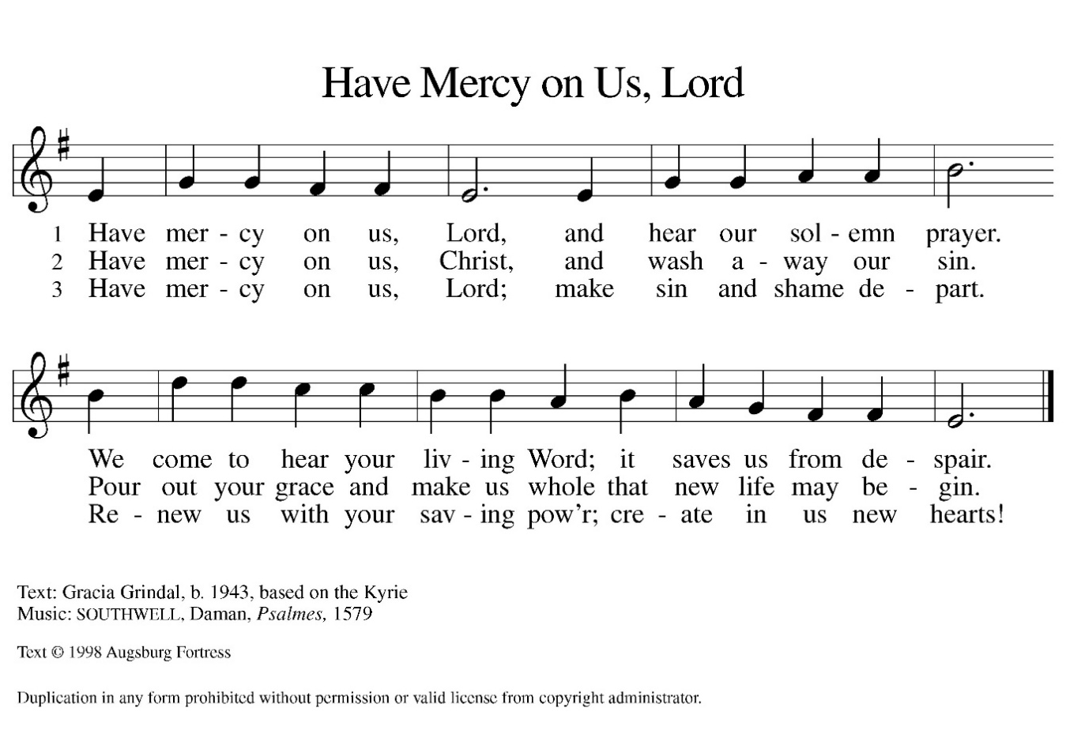

P- Please stand as you are able or please be seated.

P-The Passion of Our Lord, Jesus Christ, according to Mark.

C – Glory to You, O Lord.

(Congregation will refer to the booklet provided. Everyone that has a part will sit in the front row.)

P – This is the Passion of our Lord.

C – Praise to you, O Christ.

A moment of silence while people return to their pews.

Hymn of the day: There in God's Garden ELW 342
1 There in God's garden stands the Tree of Wisdom,
whose leaves hold forth the healing of the nations:
Tree of all knowledge, Tree of all compassion,
Tree of all beauty.
2 Its name is Jesus, name that says, "Our Savior!"
There on its branches see the scars of suff'ring;
see where the tendrils of our human
selfhood feed on its lifeblood.
3 Thorns not its own are tangled in its foliage;
our greed has starved it, our despite has choked it.
Yet, look! it lives! its grief has not destroyed
It nor fire consumed it.
4 See how its branches reach to us in welcome;
hear what the Voice says, "Come to me, ye weary!
Give me your sickness, give me all your
sorrow, I will give blessing."
5 This is my ending, this my resurrection;
into your hands, Lord, I commit my spirit.
This have I searched for; now I can possess it.
This ground is holy.
6 All heav'n is singing, "Thanks to Christ whose passion
offers in mercy healing, strength, and pardon.
Peoples and nations, take it, take it freely!"
Amen! My Master!
Text: Király Imre von Pécselyi, c. 1590-c. 1641; tr. Erik Routley, 1917-1982
Text © 1976 Hinshaw Music, Inc.
Duplication in any form prohibited without permission or valid license from copyright administrator.

The Apostle’s Creed
I believe in God, the Father almighty,
creator of heaven and earth.
I believe in Jesus Christ, God’s only Son, our Lord,
who was conceived by the Holy Spirit,
born of the virgin Mary,
suffered under Pontius Pilate,
was crucified, died, and was buried;
he descended to the dead.*
On the third day he rose again;
he ascended into heaven,
he is seated at the right hand of the Father,
and he will come to judge the living and the dead.
I believe in the Holy Spirit,
the holy catholic church,
the communion of saints,
the forgiveness of sins,
the resurrection of the body,
and the life everlasting. Amen.
From sundaysandseasons.com.
Copyright © 2026 Augsburg Fortress. All rights reserved.

Prayers of the People
Reconciled by God’s mercy and sustained by God’s presence, let us pray for the world and its needs.
A brief silence.
O God, you announce words of grace and truth. Give wisdom to all preachers in your church both globally and locally Open our hearts to encounter the infinite life you offer in Jesus. Hear us, O God.
Your mercy is great.
You hold the whole universe. Gather sun and moon, clouds and stars, land and sea, and plants and animals around the cross, so that all creation bears witness to your saving love. Hear us, O God.
Your mercy is great.
Your power is sure. Destroy inequity and division in every place, and build your beloved community among all people. Guide judges, attorneys, and juries so that they act with justice and fairness. Hear us, O God.
Your mercy is great.
Your heart breaks open at our pain. Send healing and vindication to all who, like Jesus, know the sting of betrayal, denial, abuse, or false accusations. Be with those experiencing pain or loss this day. Hear us, O God.
Your mercy is great.
Your ways show compassion. Let this same mind be in us as we enter Holy Week. Bless those here who will lead worship and tell the story of Jesus’ death and resurrection. Hear us, O God.
Your mercy is great.
O God, your embrace is eternal. Praise and thanks to you for all the faithful departed who rest in your mercy. Deliver us all from death’s power and raise us to life in you. Hear us, O God.
Your mercy is great.
Receive our prayers, O God, through Jesus Christ, our strength and salvation.
Amen.

P: May the peace of our Lord Jesus Christ be with you all.
C: And also with you.
P: Please remain in your pews. Let us now share this peace.

Offering is Brought to the Altar

Offertory Prayer
O God, maker of heaven and earth,
your steadfast love embraces all creation.
You send rain and sunshine to nourish the earth
and bring forth its bounty.
Through these gifts of bread and wine,
draw us into the death and life of your Son,
who calls us to bear witness to his saving work.
We ask this in Jesus’ name. Amen.
P: The Lord be with you.
C: And also with you.

P: Lift up your hearts.
C: We Lift them to the Lord.

P: Let us give thanks to the Lord our God.
C: It is right to give our thanks and praise.

Preface
(Words spoken by Bob)
We praise your name and join their unending hymn:

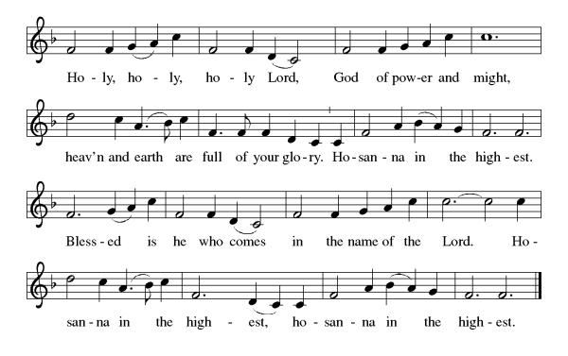
Eucharistic Prayer
(Words of Institution)

For as often as we eat of this bread and drink from this cup we proclaim the Lord’s death until He comes.
Christ has died
Christ is risen.
Christ will come again.
Remembering, therefore, his salutary command,
his life-giving passion and death, his glorious resurrection and ascension,
and the promise of his coming again,
we give thanks to you, O Lord God Almighty,
not as we ought but as we are able;
we ask you mercifully to accept our praise and thanksgiving and with your Word and Holy Spirit to bless us, your servants, and these your own gifts of bread and wine, so that we and all who share in the body and blood of Christ may be filled with heavenly blessing and grace,
and, receiving the forgiveness of sin,
may be formed to live as your holy people
and be given our inheritance with all your saints.
To you, O God, Father, Son, and Holy Spirit,
be all honor and glory in your holy church, now and forever. Amen.
Gathered into one, by the Holy Spirit let us listen to the words that Jesus taught us.

The Lord’s Prayer
Our Father, who art in heaven, hallowed be thy name, thy kingdom come, thy will be done, on earth as it is in heaven. Give us this day our daily bread; and forgive us our trespasses, as we forgive those who trespass against us; and lead us not into temptation but deliver us from evil. For thine is the kingdom, and the power, and the glory, forever and ever. Amen.

Invitation to Communion
P: This is the Lamb of God who takes away the sins of the world. Happy are those called to His supper.
C: Amen
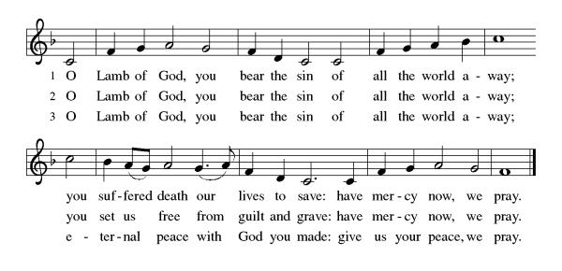
All may come.
Communion Anthem: Ride on, Ride on in Majesty ELW 346
P: Martin Luther's Post Communion Prayer German Mass 1526

We give You thanks, Almighty God, that You have refreshed us through this holy gift. We ask that, in Your mercy, You would strengthen us through it in faith toward You and in fervent love toward one another, through Jesus Christ, Your Son, our Lord.
C: Amen
Prayer After Communion
(In the spirit of Martin Luther’s reverent and Christ-centered tone)
Beloved Lord Jesus Christ,
On this day we remember Your humble entry into Jerusalem,
yet we also rejoice in Your triumph over sin, death, and the devil.
Through this holy meal, You have entered our hearts with grace and truth,
feeding us with Your body and blood,
sealing to us the promise of forgiveness and eternal life.
We praise You for this gift beyond measure.
Strengthen us now to follow You in the way of the cross—
with steadfast faith, patient endurance, and joyful hope.
Let the palms we wave in worship become the works of love we offer in daily life.
Keep us from turning away in the hour of trial,
and lead us to share in the victory of Your resurrection.
Grant that, when our earthly journey is done,
we may join the great multitude in heaven,
crying with one voice, “Hosanna to the Son of David! Blessed is He who comes in the name of the Lord!”
To You, O Christ, with the Father and the Holy Spirit,
be all glory, honor, and praise,
now and forever.
Amen.

Blessing
Receive the blessing of the holy Trinity:
God, who calls all things into existence,
Jesus Christ, who redeems us,
And the Holy Spirit, whose breath sustains creation,
☩ bless you now and always.
Amen.

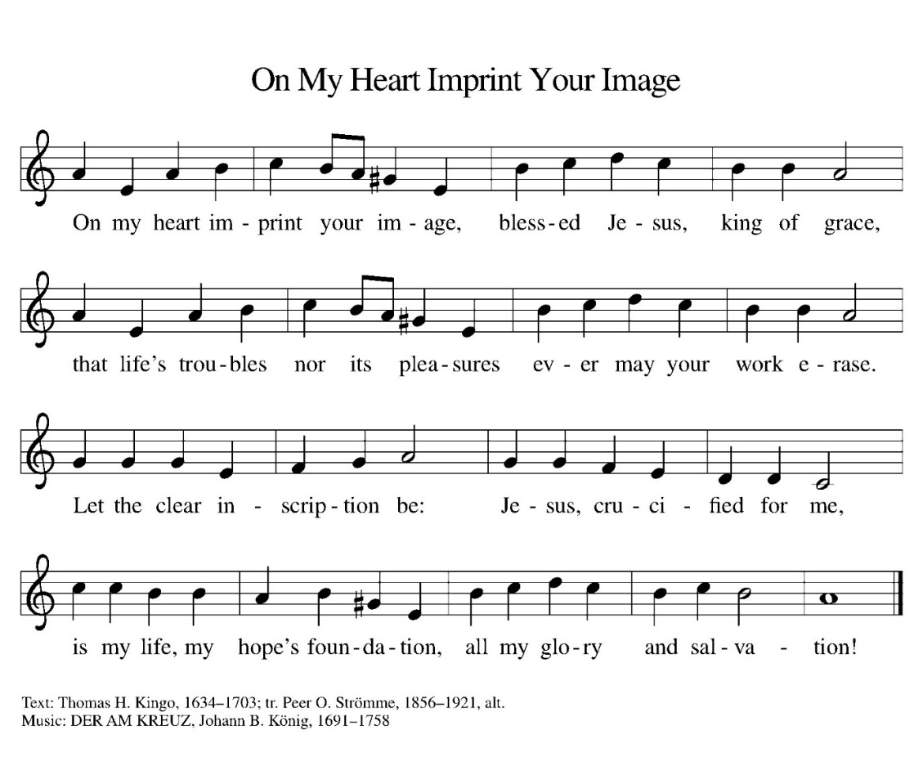
Sending Hymn: ELW 811

Dismissal
P: Everlasting God,
As we leave this gathering on this Palm Sunday, we remember the shouts of “Hosanna” that welcomed our Savior into Jerusalem. We know that the road ahead leads to the cross, yet also to the empty tomb.
Send us out with courage to follow Jesus in both joy and sacrifice this Holy Week.
May the branches we waved in celebration become symbols of our commitment to serve, to love, and to walk in Your ways.
Go before us into the week ahead—into our homes, our workplaces, and our communities—so that our words and actions may bear witness to Your kingdom.
And now, may the peace of Christ guard our hearts,
the love of God sustain our spirits,
and the power of the Holy Spirit guide our steps,
today and always.
C: Thanks be to God.
Postlude
Unless otherwise noted, materials used in this bulletin are:
From Sundays and Seasons.com. Copyright 2015 Augsburg Fortress. All rights reserved. Reprinted by permission under Augsburg Fortress Liturgies Annual License #SAS028635. Music is reprinted under OneLicense.Net #A712074 and/or Augsburg Fortress #SBL12176H. Scripture, unless otherwise noted, is from the New Revised Standard Version Bible, Copyright © 1989, Division of Christian Education of the National Council of the Churches of Christ in the United States of America. Used by permission. All rights reserved.

St. Timothy Evangelical Lutheran Church
1070 N. Suncoast Blvd.
Crystal River, FL 34429
Telephone number (Office): 352-795-5325
Office email address: crsttimothy@tampabay.rr.com

St Timothy Worship Team
S.A.M. Robert F. Bonomo
Lay Minister, Frank Hofstetter
Director of Music, Sally Hennessey
Saturday Pianist, Bill Robinson
Announcements for March 28th and 29th

ATTENDANCE
Wednesday, March 18th (Lent SS) 28
Saturday, March 21st, 4pm 27
Sunday, March 22nd, 9am 50
107

Serving our Lord this weekend:
Saturday, March 28th
Communion Assistant: Jean Fowler

Passion Sunday, March 29th
Readers:
Narrator, Patti Cyr Pilate, S.A.M. Bob Bonomo
High Priest, Ed Fialkowski Judas, S.A.M. Bob Bonomo
Jesus, Steve Brisson Bystander, Jackie Gregg
Servant Girl, Sarah Brisson Centurion, John Seasholtz
Peter, Lay Minister Frank Hofstetter

This Week at St. Timothy's
Monday, March 30th
Tuesday, March 31st
Wednesday, April 1st 11am – Citrus Blessings, 1pm – Card Makers
Maundy Thursday, April 2nd NO BIBLE STUDY, 11am – Miniatures, 4pm - Worship
Good Friday, April 3rd 12pm - Worship
Saturday, April 4th NO SATURDAY WORSHIP
Easter Sunday, April 5th 8am Worship, 9-10:30 Breakfast, 11amWorship
