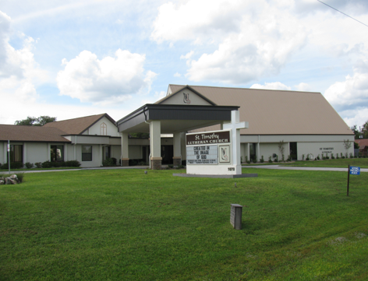

ST. TIMOTHY EVANGELICAL
LUTHERAN CHURCH
Vineyard Views
June 2026

Sam’s Corner
S.A.M. BOB BONOMO
Greetings from Our Lord and Savior, Jesus Christ.
Psalm 5:7
“But as for me, I will enter Your house by the abundance of Your loving devotion: in reverence I will bow down toward Your Holy temple.”
Please to try to remember the sacredness of His home by respecting Our Lord and others who might be in prayer. Yes, this is a gathering place, and we celebrate as a community of Faith.
Sally Hennessey and her team of volunteers work very hard to give us the songs of praise that lift us up as we prepare for Worship. Would you agree that we should be listening? And sometimes if you are just a few minutes late and it happens to the best of us, walk in just like a church mouse.
That is why fellowship after service is so wonderfully important. If you have never stayed for fellowship, you are missing a crowd of friendly jokers, who love St. Timothy’s Parish as we break bread and yes celebrate the third sacrament “COFFEE”.
The spring-cleaning gathering was led by Judi Schutrum and Jodi Gudorf, and we had about 20 or more folks that came on a Friday to complete their choice of work. (Buff cards were prepared in advance, with a list of the areas needed cleaned). The grounds outside were also spruced up. There is also an ongoing project pertaining to the underground sprinklers, worked by the property volunteers.
To say thank you does not do any justice for all the volunteers who make the time and have made the time during my tenure here. I am personally grateful and appreciative of your time, talent and love for St. Tim’s.
Please join the ice cream social which will take place on 6/24/26!!!! Time: TBD
Worship on Saturday averages about 20 people and Sunday has an average of about 50-55 people.
Royal Dalton is also growing in attendance. We lead worship for them on a monthly basis. All are invited to join worship with this wonderful residence. We celebrated Palm Sunday and Easter Sunday worship during the week for the residents last month.
St. Timothy ministries are working hard to continue as they have for years, support community efforts for those in need.
Bible study for beginners is 7 strong. We meet every Thursday.
Altar Guild is growing, which helps out tremendously.
I am hoping that all are enjoying the Member Blasts during the week.
Good people, my door is always open for conversation. Please feel free to come and speak with me about your concerns, or any ideas that you would like to offer.
“Peace be with every single one of you”
S.A.M. Bob, Interim
THE POWER OF PRAYER IN ACTION AND INSPIRATION

“SPROUTS”
By Barbara Carson

The word “Sprouts” came up when I was reading an advertisement about fresh produce, and I immediately thought about growth. Well, I am always praying to God about new words and ideas for my writings and classes and he always comes through. When I thought about growth, naturally Spiritual Growth came to mind. “Good Vibes Start Here” is pretty catchy. Good vibes can start with prayer. It just doesn’t give you conversation with God, but it gives you growth and opportunity. It can change you in different ways and you don’t even realize it until one day you are different, like sprouts of love, joy, peace, understanding which can turn you to a new way of life. It nourishes your soul, keeps you fresh and growing into a new you. That is what prayer does, “growth and opportunity”. Matt. 5:6 “Blessed are those who hunger and thirst for righteousness, for they shall be satisfied”.

In order to continue and renew spiritual growth, there are 5 things that are helpful. 1. Bible Study which is scriptural wisdom and a guide for living. 2. Prayer helps us to communicate with God along with giving gratitude, helping with our struggles and listening for direction. 3. Worship by giving praise and honor to God and not focusing on only ourselves. 4. Service which is faith in action and showing God’s love. 5. Stewardship by recognizing that everything we have is a gift from God and reflects your trust in God. Colossians 1:10 “So as to walk in a manner worthy of the Lord, fully pleasing to him; bearing fruit in every good work and increasing in the knowledge of God.”

When this happens, it changes our attitudes toward people and events, and the battle is being won as God is the ultimate victory as we can always look for new growth “sprouting” up within and around us. Keep those vibes going. Amen

Benevolence for June - Habitat for Humanity
Well known program for providing/building housing for needy families that involves the family in the construction.

Call Committee Corner

Dear Church Family,
The Call Committee did submit the Ministry Site Profile (MSP) electronically on the portal of the Florida-Bahamas ELCA Synod on April 22, 2026. It was pretty complicated and we truly appreciated the skills of our tech member, Richard Kleinsmith.
When Rich checked the status on our MSP with the Synod portal, we were dismayed to see that it had not been reviewed or approved. It was also noted that we were required to submit a survey link to a reference we had recommended on the MSP. So the reference survey link was sent to our recommended reference on May 17, 2026. The reference person will have to then open the link and fill out the survey. Reverend Eastwood stated that we would not be able to view the survey answers but she would.

The Call Committee drafted a letter to Reverend Nicole Eastwood and emailed to her on May 18, 2026, requesting an update on our status and clarification of some requirements as it was 4 weeks since the electronic submission of the MSP.
Later that evening we received a response letter from Reverend Eastwood, with the following statement related to our submission of the handwritten MSP along with the minutes of our meeting with church council and their approval on April 7, 2026, and I quote: " I was unable to review the MSP completely before it was submitted online, because not everything was clear through the scanned documents."
This was a bit concerning as after we had submitted the handwritten MSP for her to review for any edits required, this was her response on April 7, 2026, and I quote: " Thank you for your letter and profile. Both seem well thought out! Please have your computer person log onto the ELCA website to create the profile online." "When your profile is online, then you will want to think about an interview and what questions you will want to ask. " "Great work, team! We are praying with you!"
If Reverend Eastwood was having difficulty with the scanned documents, we would have immediately provided a printed copy and mailed it to her.
We also now have a Seven Reflections of Ministry Profile to fill out online and other suggestions by Reverend Eastwood to handle. Our next Call committee meeting will be on Sunday May 31, 2026.
We continue to ask for your prayers as we navigate a complicated journey. We trust our Lord to hear our prayers and He is always faithful.

Respectfully Submitted,
Mary Schlumberger & The Call Committee

Bump2Baby Update
At the end of the expo door prizes were given out. There are numerous pack and play cribs and car seats. The first drawing was for a crib. The first ticket drawn wasn't there. The second ticket didn't need it, so she got an alternate prize. The third ticket drawn was very excited to win. She was in tears when she also won a car seat. Come to find out, this lady is single, homeless and currently living at the Path. She has nothing. God through our hands and the hands of the program has given her love and things for her baby. Here are a few highlights provided by Blaire Cope, Community Relations Specialist of Central Healthy Start/WellFlorida Council:
- 33 moms, 13 dads, 102 total attendees
- Over 80% are on Medicaid or uninsured
- Learning positive parenting skills was the most desired service.

From the desk of Minister Robert
If the holy spirit has touched you to even thinking about becoming a council member, feel free to call me or come and see me.
Having a discussion does not mean in any way that you must say yes.

Blessings

DEADLINES
Announcements
Please be aware that if you have entries for the weekend worship announcements you need to have them in on Tuesday prior, as we are preparing and printing them no later than Thursday.

Vineyard Views
If you have submissions for the July Vineyard Views, please have them in the office no later than the end of day on Tuesday, June 23rd .

Please check for the following sign-up sheets
Serving Our Lord (Worship Helpers) – bulletin board by kitchen
Flower chart – WELCA board
Healthy Start –bulletin board by kitchen
PB&J Ministry – bulletin board by kitchen
Serving Hands - bulletin board by kitchen
Coffee Hour – in kitchen

ZOOM LINK FOR ADULT SUNDAY SCHOOL – 9/18
Topic: Adult Sunday School Class
Time: Sundays at 10:30am
Join Zoom Meeting
https://us02web.zoom.us/j/88640128252?pwd=asNJ6OiNGFFTNzwNA5yhkvPpmt6VCT.1
Meeting ID: 886 4012 8252
Passcode: 898938


INFORMATION FROM THE FINANCE COMMITTEE
AND YOUR TREASURERS
In the hope of getting ahead of our property, liability and flood insurance costs for next year, we have been trying to save toward those expenses. (Property and liability premiums are due by June 1st of each year, and flood is due November 1st.) We would appreciate any additional donation you could make. Please include that amount with your regular offering and designate it as “Insurance” on the offering envelope.
A security camera system to monitor the outside areas of our campus has been installed. The cost is $4,102.00. If you would like to donate to this purchase for the welfare of our safety and security, please designate “Security Expense” on your offering.
A weekly offering update is given with the email announcements. We are most grateful to all of you who support our programs through your prayers, offerings, time and talents.

Lynn Dively, Treasurer



THRIVENT FINANCIAL NEWS FOR JUNE 2026

$$$THRIVENT CHOICE DOLLARS®$$$
Thanks so much to our Thrivent Financial members and friends who direct their Thrivent Choice Dollars® to
available for activities and projects for our mission and ministry here at St. Timothy. If you are an eligible
Thrivent Financial member and have Choice Dollars® available, please call Thrivent (800-847-4836) and say “Thrivent Choice®” or go online to www.thrivent.com/thriventchoice and direct your dollars…hopefully to St. Timothy Lutheran Church in Crystal River. To date for 2026 our church has received $1744.00 through this program. Thanks to the following friends who recently directed their $$ to St. Timothy:
Linda Cashman Martha Hoagland

THRIVENT ACTION TEAMS
Thrivent Action Teams make it easy for you to bring people together to make a positive change in your community! When you see a need, apply to lead a volunteer team. Once your idea is approved, a Thrivent Action Kit is delivered to your door. It’s packed with everything you need to help make your project a success. It even includes $250.00 in seed money to help get your project started. After you finish the project, you report the results on-line to Thrivent. This program is brought to you by Thrivent Financial because they believe that being wise with money and living generously go hand in hand. All your questions and requests for this funding program will be answered by going to Thrivent.com/actionteam.***Please note that Thrivent Financial funds accessed for all programs and activities involving St. Timothy Lutheran Church need to be approved by a Committee and the Congregational Council. 2026Thrivent Action Teams that have been approved: Easter Food Boxes, Bump2Baby Expo and the PB&J Ministry.
THE $250 IN SEED MONEY IS A GIFT FROM THRIVENT THAT WE CAN USE TO HELP WITH COMMUNITY OUTREACH AND PROJECTS INVOLVING OUR CONGREGATION. THESE FUNDS ARE IN ADDITION TO OUR BUDGETED AMOUNTS AND OFFERINGS AND DONATIONS MADE BY OUR MEMBERS AND FRIENDS.

Financial Representatives for answering questions and offering advice on Thrivent investments and products are:
Katherine Gross Kevin Braunschweiger
in Gainesville, FL in Ocala, FL
352-505-8905 352-440-6784
Katherine.gross@thrivent.com
Virtual Advice Team – 855-303-7402

Submitted by Lynn Dively

Food Pantry
The food pantry continues to operate on the 2nd and 4th week of every month from 9AM- noon. We continue to inform the congregation as to the needs of the pantry via the weekly announcements. The current needs are fruit, spaghetti- 16oz., peanut butter, chili which serves 2 people and laundry detergent (dollar store is fine), saltines. Thanks to all who contribute food. You can also contribute monetarily by writing out a check made out to Life Tree Church with Food Pantry in the memo line or writing out a check to St. Timothy Lutheran and putting food pantry in the memo line, and placing it in my mailbox, #210. We will also accept cash donations. Please put it in an envelope in mailbox, #210 and put your name on it so I know who you are. If you would like a receipt, please let me know.
The next food pantry will be on June 23rd from 9-12.
Thank you. - Barbara J
Healthy Start – updated 6/3
Needs for July: 9 baby oil, 4 baby shampoo.
Carolyn Fialkowski

PB&J MINISTRY UPDATE
Our peanut butter lunch packing for DayStar is the first Monday of the month at 10:30. There is a sign-up sheet on the bulletin board in the hallway by the kitchen. We need about 6 people each time or let me know if you are interested. Thank you - Barbara Carson


MESSAGE FROM REGINA
Please, if you are at a church function, think about snapping a few photos for everyone to enjoy. Thank you in advance.

SERVING HANDS
Serving Hands is a program created to help members of our own congregation. Serving Hands is there for you if you need some help in the following areas: a meal brought to you, driving you to an appointment, a friendly visit, doing a household chore, communion brought to you, walking your dog, or picking up food for your pet, etc. These are one-time opportunities, not forever experiences. Please contact Carolyn Fialkowski at 814-392-4281, or Jean Fowler at 586-322-8337 if you need help.
Please don’t hesitate to call. We want to serve you! Also, if you are willing to help with any of these services, there is a sign-up chart on the kiosk in the entrance way of the church or call one of these ladies.

AED /Medical response :
We have a poster that is behind the kiosk across from our AED in the narthex. An emergency incident can happen at any time, and it is good to be prepared. The poster explains a “hands only “ CPR protocol as the first line of an emergency of that kind and is very easy for anyone. Please take a look and refresh yourself on the protocol. Our AED is valuable for saving lives but initiating CPR is essential. We do have several people in our congregation that have more detailed experience to assist as needed. For any questions, please ask Barbara Carson.
Instructional video on how to use the Philips AED.
https://youtu.be/t6GV9PAbgM4?si=dZuGq8aLjfvpFiM-
(ctrl + click to follow link)

ST TIMOTHY’S WEBSITE
Here is the St. Timothy website address: https://www.sttimlutherancrystalriver.com/
(ctrl + click to follow link)

There are links for the weekend’s services on the homepage. Please note that the links will change every week, since this is a YouTube file address; every service has its own link. Watch for an email with the updated links when they are ready. The video links for previous weekends will still be available at the bottom of the webpage, as the links are updated each week. Please contact us if you would like a CD of any of the services to listen to. Be sure to check out our children’s artwork at the bottom of the home page. We hope to add more as they send it to us.

Here is a link to St Timothy's YouTube:
https://www.youtube.com/channel/UC5xrMj8-8_6iyR_KxjFAwRQ/videos
(ctrl + click to follow link)

Facebook
See our Facebook page for information about upcoming events and Please feel free to message us with suggestions about content. - Regina

St. Timothy Evangelical Lutheran Church | Facebook
(ctrl + click to follow link)


The Sunshine Card Makers
The Card Makers meet the first Wednesday of the month at 1pm, in the Fellowship Hall.
-Kathy G

We have the July, August and September 2026 Christ in Our Home booklets. There are some on the table by the mailboxes or you may request one to be put in your box.

HERE AND THERE WITH THE FOLKS OF ST TIMOTHY
2026 Bump2Baby Expo
Thursday, April 30th

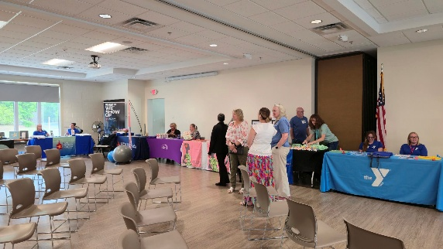
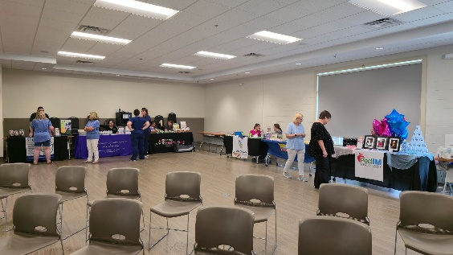

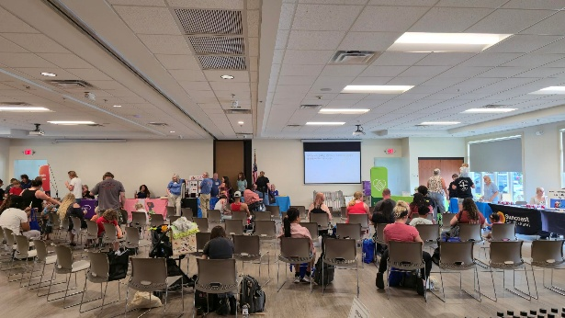
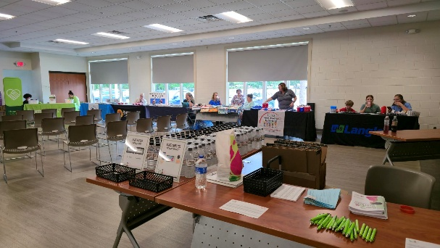

The Last Citrus Blessings of the 2025/2026 School Year
May 6th. We had 5 volunteers and delivered 205 packs.
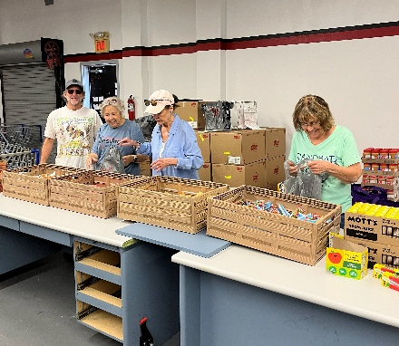
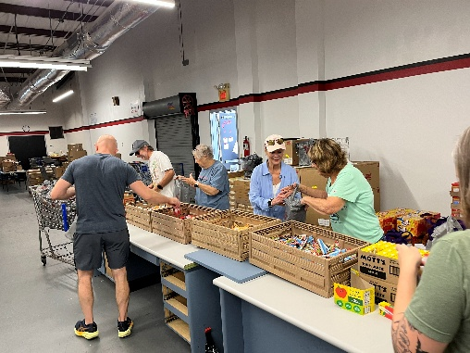
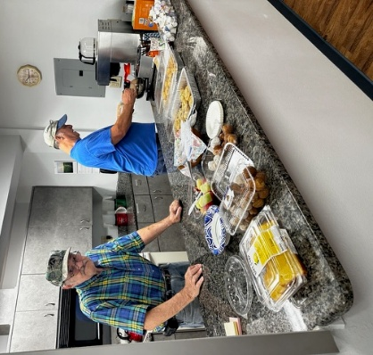
“Clean Up Crew” from our Indoor/Outdoor spring cleaning.
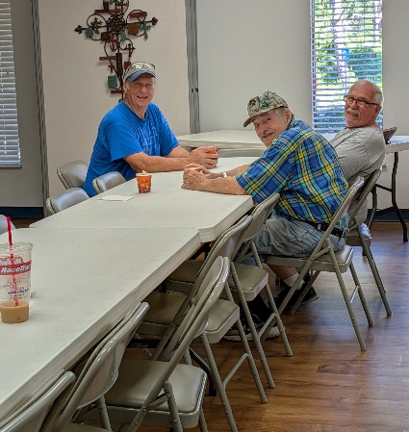
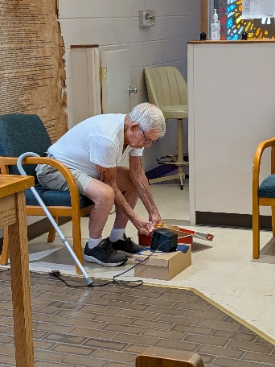
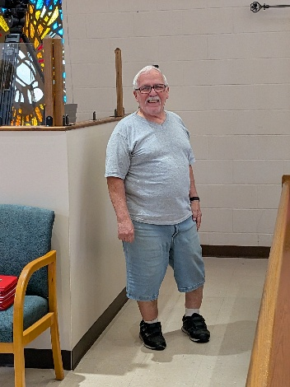
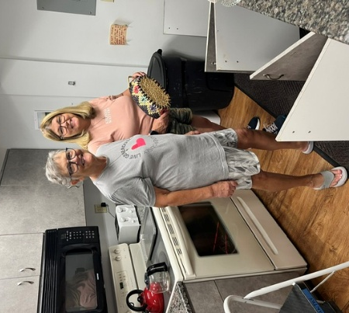
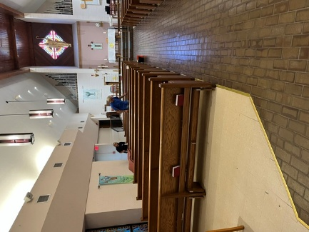
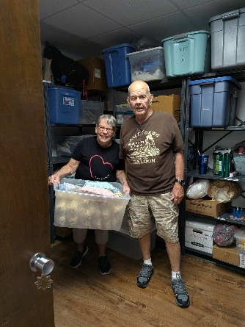
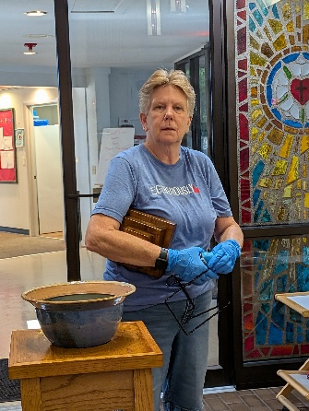
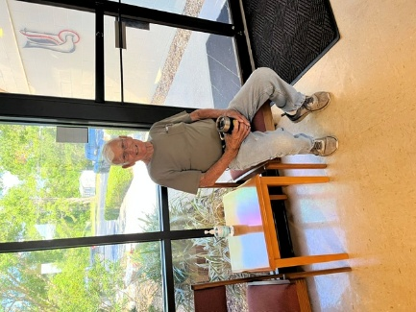
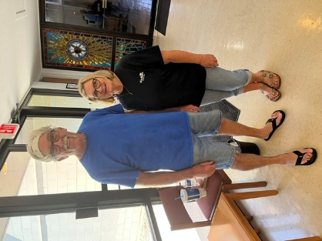

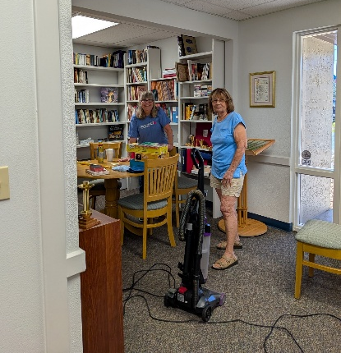
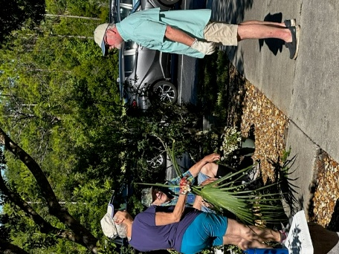

Pentecost Sunday/Installation of New Council Members
May 24th

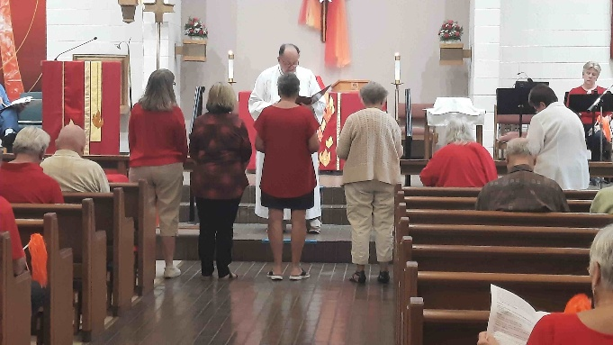
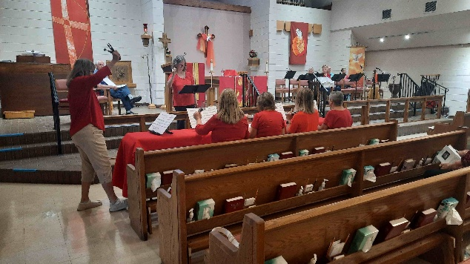

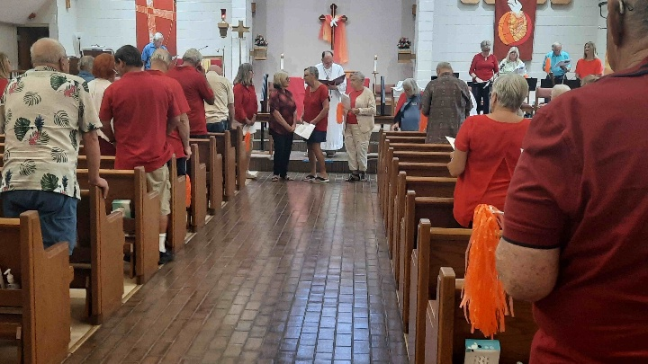
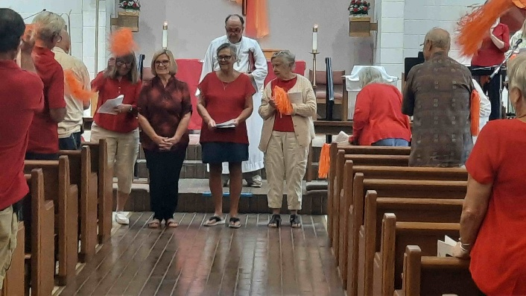
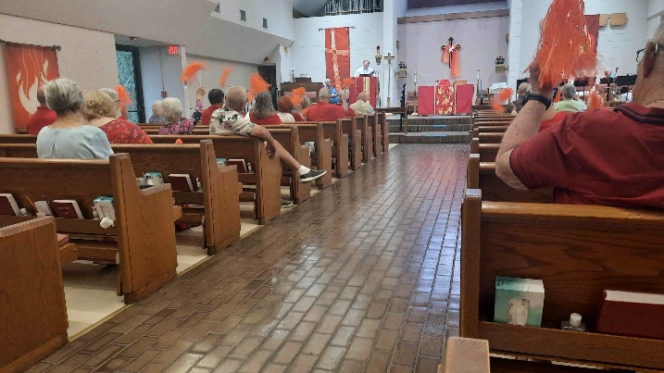
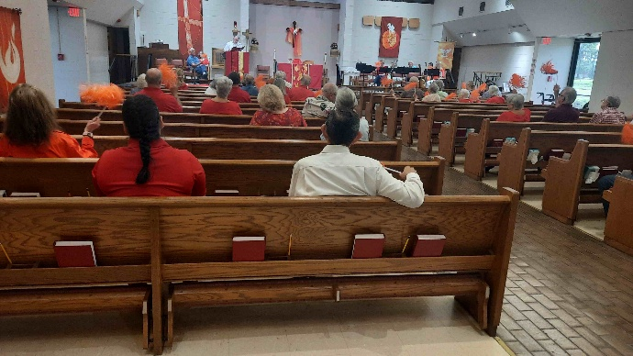
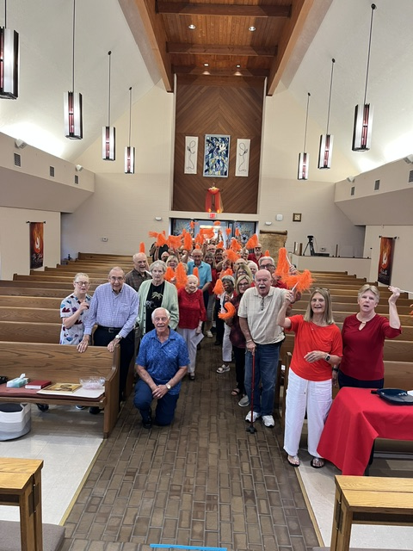
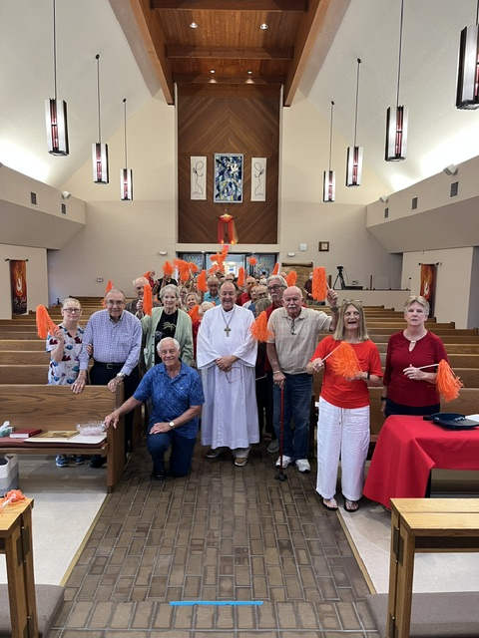


Jodie Gudorf 6/3
Mary Fraley 6/5
Pat Krepps 6/6
Louise Blodgett 6/9
Erica Wilson 6/10
Jake Jacobek 6/19
Sarah Brisson 6/20
Mary Cunningham 6/24

Birthday Blessings!

June
SUNDAY | MONDAY | TUESDAY | WEDNESDAY | THURSDAY | FRIDAY | SATURDAY
 | 1  10:30am PB&J  11am Healthy Start | 2 | 3  1pm Card Makers | 4  SYNOD ASSEMBLY  11am Miniatures  NO CHOIR PRACTICE | 5  SYNOD ASSEMBLY | 6  SYNOD ASSEMBLY  4pm Worship  No Fellowship
7  9am Worship  10:30 Adult SS, Coffee Fellowship | 8  NO RUTH CIRCLE | 9  9-12 Food Pantry | 10 | 11  11-12 Bible Study for Beginners  11am Miniatures  4:30 Choir | 12 | 13  4pm Worship  No Fellowship
14  9am Worship  10:30 Adult SS, Coffee Fellowship | 15 | 16  12pm “Hello Summer“  Luncheon @ Three Sisters Restaurant | 17  1pm Worship & Music | 18  11-12 Bible Study for Beginners, 12-1, V2A Meeting  No Miniatures  4:30 Choir | 19 | 20  4pm Worship  No Fellowship
21  9am Worship  10:30 Adult SS, Coffee Fellowship  Council | 22 | 23  9-12 Food Pantry | 24  12pm Ice Cream Social | 25  11-12 Bible Study for Beginners, 11am – Miniatures, 4:30 Choir | 26 | 27  4pm Worship  No Fellowship
28  9am Worship -  10:30 Adult SS, Coffee Fellowship | 29 | 30

St. Timothy Lutheran Church
S.A.M. Robert “Bob” Bonomo
1070 N. Suncoast Blvd.
Crystal River, FL 34429
Phone: 352-795-5325

Church email: crsttimothy@tampabay.rr.com
Website: www.sttimlutherancrystalriver.com
(ctrl + click to follow link)

Lay Minister: Frank Hofstetter
Director of Music: Sally Hennessey
Saturday Pianist: Bill Robinson
Church Secretary: Regina Mendicino
Sexton: William “Bill” Dexter

2026 Congregational Council Members
President: Barbara Carson
Vice-President: Barbara Johnson
Secretary: Carolyn Fialkowski
Treasurer: Lynn Dively
Council Members: Patti Cyr, Jodie Gudorf, Bob Bonomo

Weekly Worship
Saturdays 4pm
Sundays 9am
Holy Communion available at both services
Adult Sunday School - 10:30am
Sunday Services -YouTube links on website

