St. Timothy Lutheran Church
Sunday, November 2nd
The 21st Sunday after Pentecost
All Saints Sunday



In holy baptism God makes saints out of sinners. In holy communion God forgives the sins of all the saints. In worship today we give thanks for all the saints “who from their labors rest.” In the same breath we petition our God for the strength to hear and to heed the admonitions of Jesus in today’s gospel. Sealed by the Spirit and sustained by the Savior’s body and blood, we live with joy as God gives us breath, to the praise of God’s glory.

St Timothy Worship Planning Team
S.A.M. Bob Bonomo
Deacon, Frank Hofstetter
Director of Music, Sally Hennessey
Saturday Pianist, Bill Robinson

Pre-Service Music: Bring Forth the Kingdom W&P 22

Welcome and Sharing of Congregational News

Prelude

Confessions and Forgiveness
Blessed be the holy Trinity, ☩ one God,
who forgives all our sin,
whose mercy endures forever.
Amen.
Let us confess our sin in the presence of God
and of one another.
Silence is kept for reflection.
Faithful God,
you have shown us the ways of your heart,
yet we stray from your paths.
We are stuck in sinful systems of oppression
and do not embrace the freedom
of your faithful promises.
We ignore our neighbors.
We exploit the earth.
We reject your abundance,
trusting our impulses instead of your steadfast love.
Repair our relationships,
restore what we have broken,
renew our hearts,
and bring us to new life.
Amen.
Hear the good news:
God the Faithful One loves you,
☩ in Christ Jesus your sins are forgiven,
and by the power of the Holy Spirit you are set free.
Amen.

Gathering Hymn: Shall We Gather at the River ELW 423

1 Shall we gather at the river, where bright angel feet have trod,
with its crystal tide forever flowing by the throne of God?

Refrain
Yes, we'll gather at the river, the beautiful, the beautiful river;
gather with the saints at the river that flows by the throne of God.

2 On the margin of the river, washing up its silver spray,
we will walk and worship ever, all the happy golden day. Refrain

3 Ere we reach the shining river, lay we ev'ry burden down;
grace our spirits will deliver, and provide a robe and crown. Refrain

4 Soon we'll reach the shining river, soon our pilgrimage will cease;
soon our happy hearts will quiver with the melody of peace. Refrain

Text: Robert Lowry, 1826-1899

S.A.M. Bob - The Lord be with you.
C – And also with you.

Prayer of the Day
Almighty God, you have knit your people together in one communion in the mystical body of your Son, Jesus Christ our Lord. Grant us grace to follow your blessed saints in lives of faith and commitment, and to know the inexpressible joys you have prepared for those who love you, through Jesus Christ, our Savior and Lord, who lives and reigns with you and the Holy Spirit, one God, now and forever.
Amen.
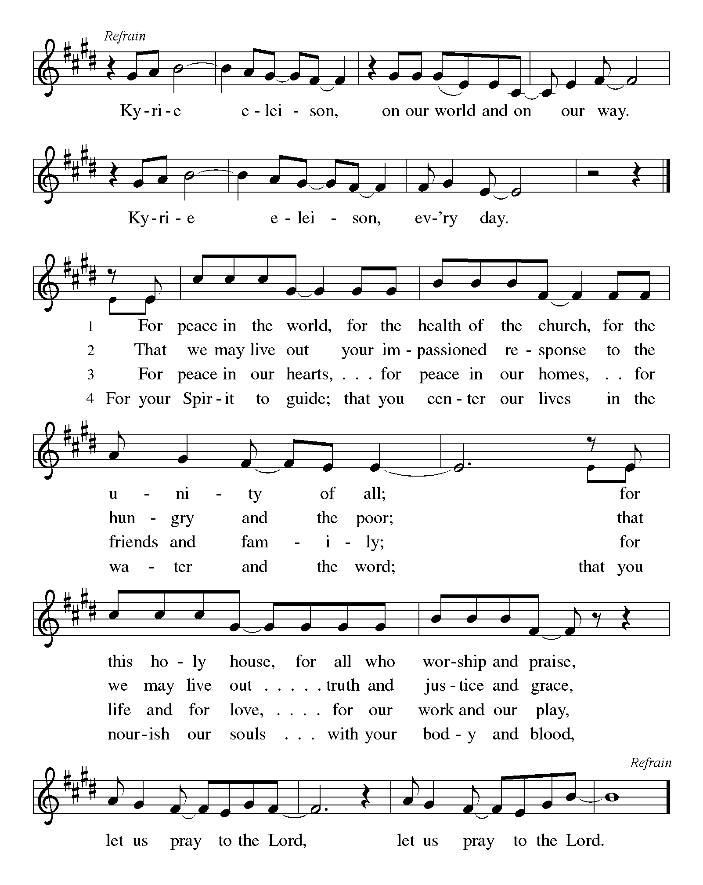
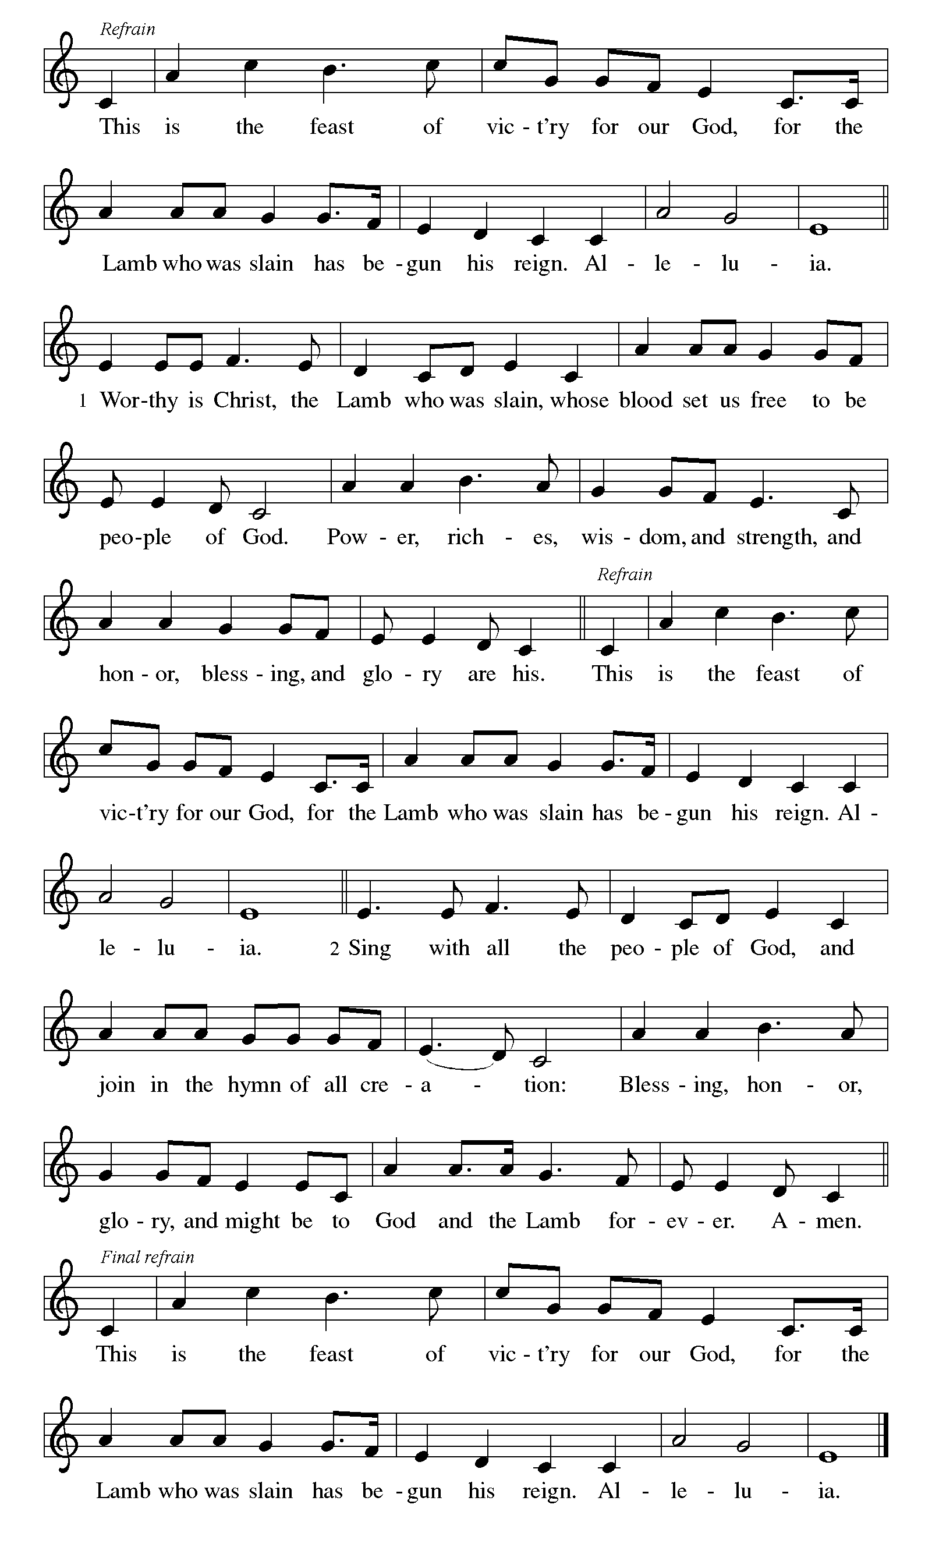

First Lesson: Daniel 7:1-3, 15-18
The book of Daniel was written in the second century BCE, when the Syrian king Antiochus Epiphanes was severely persecuting the Jews. Daniel’s vision of the four beasts proclaims that human kings will come and go, but the kingdom will ultimately belong to God and to God’s people.
¹ In the first year of King Belshazzar of Babylon, Daniel had a dream and visions of his head as he lay in bed. Then he wrote down the dream: ² I, Daniel, saw in my vision by night the four winds of heaven stirring up the great sea, ³ and four great beasts came up out of the sea, different from one another.
¹⁵ As for me, Daniel, my spirit was troubled within me, and the visions of my head terrified me. ¹⁶ I approached one of the attendants to ask him the truth concerning all this. So he said that he would disclose to me the interpretation of the matter: ¹⁷ “As for these four great beasts, four kings shall arise out of the earth. ¹⁸ But the holy ones of the Most High shall receive the kingdom and possess the kingdom forever—forever and ever.”

A – Word of God!

C – Words of Life!

Psalm 149
¹ Hallelujah! Sing to the Lord a new song,
God’s praise in the assembly of the faithful.
² Let Israel rejoice in their maker;
let the children of Zion be joyful in their ruler.
³ Let them praise their maker’s name with dancing;
let them sing praise with tambourine and harp.
⁴ For the Lord takes pleasure in the people
and adorns the poor with victory.
⁵ Let the faithful rejoice in triumph;
let them sing for joy on their beds.
⁶ Let the praises of God be in their throat
and a two-edged sword in their hand,
⁷ to wreak vengeance on the nations
and punishment on the peoples,
⁸ to bind their kings in chains
and their nobles with links of iron,
⁹ to inflict on them the judgment decreed;
this is glory for all God’s faithful ones. Hallelujah!

Second Lesson: Ephesians 1:11-23
After giving thanks for the faith of the Ephesians, the writer of this letter prays that they might understand the wisdom, hope, and power of God that is embodied in Jesus Christ.
¹¹ In Christ we have also obtained an inheritance, having been destined according to the purpose of him who accomplishes all things according to his counsel and will, ¹² so that we, who were the first to set our hope on Christ, might live for the praise of his glory. ¹³ In him you also, when you had heard the word of truth, the gospel of your salvation, and had believed in him, were marked with the seal of the promised Holy Spirit; ¹⁴ this is the pledge of our inheritance toward redemption as God’s own people, to the praise of his glory.
¹⁵ I have heard of your faith in the Lord Jesus and your love toward all the saints, and for this reason ¹⁶ I do not cease to give thanks for you as I remember you in my prayers, ¹⁷ that the God of our Lord Jesus Christ, the Father of glory, may give you a spirit of wisdom and revelation as you come to know him, ¹⁸ so that, with the eyes of your heart enlightened, you may perceive what is the hope to which he has called you, what are the riches of his glorious inheritance among the saints, ¹⁹ and what is the immeasurable greatness of his power for us who believe, according to the working of his great power. ²⁰ God put this power to work in Christ when he raised him from the dead and seated him at his right hand in the heavenly places, ²¹ far above all rule and authority and power and dominion and above every name that is named, not only in this age but also in the age to come. ²² And he has put all things under his feet and has made him the head over all things for the church, ²³ which is his body, the fullness of him who fills all in all.

A – Word of God!

C – Words of Life!

Gospel Acclamation

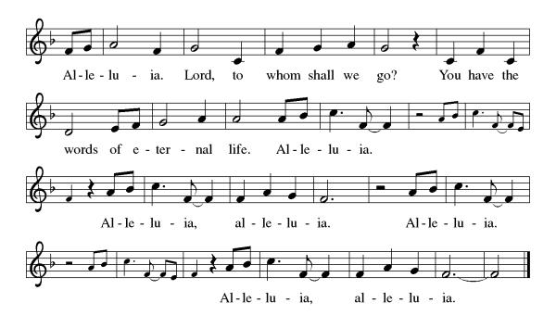

S.A.M. Bob: The Holy Gospel according to Luke, the 6th Chapter
C- Glory to you, O Lord.

Gospel: Luke 6:20-31
In echoes of the prophet Isaiah and Mary’s song of praise, Jesus reveals surprising things about who enjoys blessing and who endures woe. He invites his disciples to shower radical love, blessing, forgiveness, generosity, and trust even on enemies and outsiders.
²⁰ Then [Jesus] looked up at his disciples and said:
“Blessed are you who are poor,
for yours is the kingdom of God.
²¹ “Blessed are you who are hungry now,
for you will be filled.
“Blessed are you who weep now,
for you will laugh.
²² “Blessed are you when people hate you and when they exclude you, revile you, and defame you on account of the Son of Man. ²³ Rejoice on that day and leap for joy, for surely your reward is great in heaven, for that is how their ancestors treated the prophets.
²⁴ “But woe to you who are rich,
for you have received your consolation.
²⁵ “Woe to you who are full now,
for you will be hungry.
“Woe to you who are laughing now,
for you will mourn and weep.
²⁶ “Woe to you when all speak well of you, for that is how their ancestors treated the false prophets.
²⁷ “But I say to you who are listening: Love your enemies; do good to those who hate you; ²⁸ bless those who curse you; pray for those who mistreat you. ²⁹ If anyone strikes you on the cheek, offer the other also, and from anyone who takes away your coat do not withhold even your shirt. ³⁰ Give to everyone who asks of you, and if anyone takes away what is yours, do not ask for it back again. ³¹ Do to others as you would have them do to you.”

S.A.M. Bob- The Gospel of the Lord.
C - Praise to you, O Christ.
Sermon by S.A.M. Bob
Hymn of the Day: Give Thanks for Saints ELW 428

1 Give thanks for those whose faith is firm
when all around seems bleak:
on God's good promise they rely,
so while they live and when they die
how forcefully they speak—
the strong, who once were weak!

2 Give thanks for those whose hope is clear,
beyond mere mortal sight:
who seek the city God has planned,
the true, eternal promised land,
and steer on toward that light,
a beacon ever bright.

3 Give thanks for those whose love is pure,
a sparkling precious stone:
they show by what they say and do
an inward beauty, warm and true,
for God's concerns they own—
God's love through them is known.

4 Give thanks for saints of ages past
and saints alive today:
though often by this world despised,
their hearts by God are richly prized.
Give thanks that we may say
we share their pilgrim way.

Text: Martin E. Leckebusch, b. 1962 Text © 2003 Kevin Mayhew Ltd. Used by permission.

The Apostles’ Creed
I believe in God, the Father almighty,
creator of heaven and earth.
I believe in Jesus Christ, God’s only Son, our Lord,
who was conceived by the Holy Spirit,
born of the virgin Mary,
suffered under Pontius Pilate,
was crucified, died, and was buried;
he descended to the dead.
On the third day he rose again;
he ascended into heaven,
he is seated at the right hand of the Father,
and he will come to judge the living and the dead.
I believe in the Holy Spirit,
the holy catholic church,
the communion of saints,
the forgiveness of sins,
the resurrection of the body,
and the life everlasting. Amen.

Lord, listen to your children praying,
Lord, send your Spirit in this place;
Lord, listen to your children praying,
send us love, send us pow'r, send us grace.

Prayers of the People

ALL SAINTS DAY
Gathered with one voice, we offer our prayers for the church, the world, and all who are in need.
A brief silence.
God of all that is, delight in the praises of your people and revive the spirit of your church. Move through us with boldness so that we proclaim the gospel of Christ throughout the world. Renew and revive pastors, deacons, and lay leaders.
Hear us, O God. Your mercy is great.

God of all our days, guide the leaders of governments, nations, municipalities, and all those seeking office. Accompany election officials and volunteers. Dismantle injustice and oppression wherever it is found.

Hear us, O God. Your mercy is great.

God of comfort in troubled times, we pray for those in need of protection and care especially those in arms way from hurricane Melissa, those who suffer at the hands of oppressors, those who do not have a roof over their heads and those who are hungry, thirsty, and tired. Protect those who seek safety and solace.

Hear us, O God. Your mercy is great.

God of what is yet to come, encourage, inspire, and open the hearts of those who may be thinking about volunteering at this church, Your church Lord. There is time and talent in all of us. If all of us put forth an effort it would further the work of St. Timothy’s ministry and uplift Your Gospel.

Hear us, O God. Your mercy is great.

God of Grace Truth and Promise, we give thanks for all that have gone before us. Sustain us in hope of our eternal unity in Christ. Hear the prayer of those who grieve and bless them with Your love.

Names of all the members OF St. Timothy who passed this year.

Margo Blum
Kathy Burkett
Reverend Joanie Holden
Keith Johns
Michael Koch
Dorth Rainear
Joyce Santti
Nancy Strange

Hear us, O God. Your mercy is great.

We offer these and all our prayers to you, O God, trusting in your grace and unyielding love, through Jesus Christ, our Lord.
Amen.

S.A.M.: May the peace of our Lord Jesus Christ be with you all.
C: And also with you.
S.A.M.: Let us now share this peace.

While offerings and pledges are being brought up.

We Give Thee but Thine Own ELW 686
1 We give thee but thine own,
whate'er the gift may be;
all that we have is thine alone,
a trust, O Lord, from thee.

2 May we thy bounties thus
as stewards true receive,
and gladly, as thou blessest us,
to thee our firstfruits give.

Text: William W. How, 1823-1897, alt.

S.A.M. Bob: The Lord be with you.
C: And also with you.

S.A.M. Bob: Lift up your hearts.
C: We lift them up to the Lord.

S.A.M. Bob: Let us give thanks to the Lord our God.
C: It is right to give our thanks and praise.

Preface
It is indeed right, our duty and our joy,
that we should at all times and in all places
give thanks and praise to you, almighty and merciful God,
through our Savior Jesus Christ;
who on this day overcame death and the grave,
and by his glorious resurrection opened to us the way of everlasting life.
And so, with all the choirs of angels,
with the church on earth and the hosts of heaven,
we praise your name and join their unending hymn:

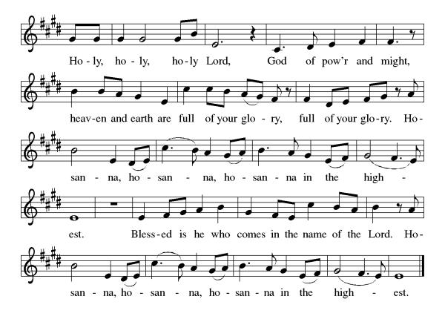

Eucharistic Prayer
Blessed are you, O God of the universe. Your mercy is everlasting, and your faithfulness endures from age to age.
Praise to you for creating the heavens and the earth. Praise to you for saving the earth from the waters of the flood. Praise to you for bringing the Israelites safely through the sea. Praise to you for leading your people through the wilderness to the land of milk and honey. Praise to you for the death and resurrection of Christ. Praise to you for your Spirit poured out on all nations.
In the night he was betrayed, our Lord Jesus took bread and gave thanks; broke it, and gave it to his disciples saying: Take and eat; this is my body given for you. Do this for the remembrance of me.
After supper he took the cup, gave thanks and gave it for all to drink saying: This cup is the new covenant in my blood, shed for you and for all people for the forgiveness of sin, Do this for the remembrance of me.
For as often as we eat of this bread and drink from this cup we proclaim the Lord’s death until He comes.

Christ has died
Christ is risen.
Christ will come again.

Gathered into one, by the Holy Spirit let us listen to the words that Jesus taught us.

The Lord’s Prayer
Our Father, who art in heaven, hallowed be thy name, thy kingdom come, thy will be done, on earth as it is in heaven. Give us this day our daily bread; and forgive us our trespasses, as we forgive those who trespass against us; and lead us not into temptation but deliver us from evil. For thine is the kingdom, and the power, and the glory, forever and ever. Amen.

Invitation to Communion
S.A.M. Bob: This is the Lamb of God who takes away the sins of the world. Happy are those who are called to His supper. Come and taste on your lips a Love we cannot comprehend.
C: Amen
Please come forward to receive

Names of deceased loved ones will be read aloud.

S.A.M. Bob: We are now a tabernacle with Christ inside of us. Let us rejoice and be glad at the Lord’s table.
C: Amen

Prayer after Communion
O God, through this meal you have strengthened us
and appointed us to be your servants. Send us to do good and to share our possessions with all in need.
We ask this in Jesus’ name.
Amen

Blessing
B: The God of righteousness, who gives justice to the oppressed,
who gives food to the hungry, who sets the prisoners free,
☩ bless you now and forever.
C: Amen.

Sending Hymn: For All the Saints ELW 422 (v 1-3 & 7)

1 For all the saints who from their labors rest,
who thee by faith before the world confessed,
thy name, O Jesus, be forever blest.
Alleluia! Alleluia!

2 Thou wast their rock, their fortress, and their might;
thou, Lord, their captain in the well-fought fight;
thou, in the darkness drear, their one true light.
Alleluia! Alleluia!

3 Oh, blest communion, fellowship divine,
we feebly struggle, they in glory shine;
yet all are one in thee, for all are thine.
Alleluia! Alleluia!

7 From earth's wide bounds, from ocean's farthest coast,
through gates of pearl streams in the countless host,
singing to Father, Son, and Holy Ghost:
Alleluia! Alleluia!

Text: William W. How, 1823-1897

Dismissal
S.A.M: Go in peace to love and serve our Lord.
C: Thanks be to God.
Postlude: instrumental
Unless otherwise noted, materials used in this bulletin are:
From Sundays and Seasons.com. Copyright 2015 Augsburg Fortress. All rights reserved. Reprinted by permission under Augsburg Fortress Liturgies Annual License #SAS028635. Music is reprinted under OneLicense.Net #A712074 and/or Augsburg Fortress #SBL12176H. Scripture, unless otherwise noted, is from the New Revised Standard Version Bible, Copyright © 1989, Division of Christian Education of the National Council of the Churches of Christ in the United States of America. Used by permission. All rights reserved.
Announcements for November 1st and 2nd

ATTENDANCE
No Saturday Service
Sunday, October 26th, 10am 105
Drive-Up Communion 2
107

The Altar Flowers are given this week by Gwen Pringle, in memory of Fred’s birthday and Gwen’s sister, Beverly Spotswood!
This Week at St. Timothy's
Monday, November 3rd Bob Off, 11am – Healthy Start
Tuesday, November 4th Bob Off
Wednesday, November 5th 1pm – Card Makers, 2pm – Prayer Time
Thursday, November 6th 9:30am – Prayer Group, 11am - Miniatures, 4:30pm - Choir
Friday, November 7th Bob Work
Saturday, November 8th 4pm - Worship
Sunday, November 9th 9am – Worship, 10:15-10:45 – Drive Up Communion, 10:30 – Adult SS, Coffee Fellowship

New members will be installed on Sunday, November 16th.

There will be a memorial service for Dorth Rainear at St. Timothy on Friday, November 21st at 1pm.



St. Timothy Lutheran Church
Sunday, October 26, 2025
Dear Church Family,
We are so grateful to our members and friends who helped us celebrate our 50th Anniversary last Sunday. There were many hands helping to beautifying the inside and outside of our church and grounds, planning the service and Bishop and Mrs. Suárez’s weekend with us, setting up displays, decorating, planning the program during the luncheon, preparing and serving the delicious food for the luncheon, cleaning up and putting all areas back in order. Our church has been blessed by God for the last 50 years in service to Him, and we are especially thankful for all you do in your service to St. Timothy Lutheran Church.
50th Anniversary Committee
