St Timothy Lutheran Church
Saturday, May 23rd, 2026

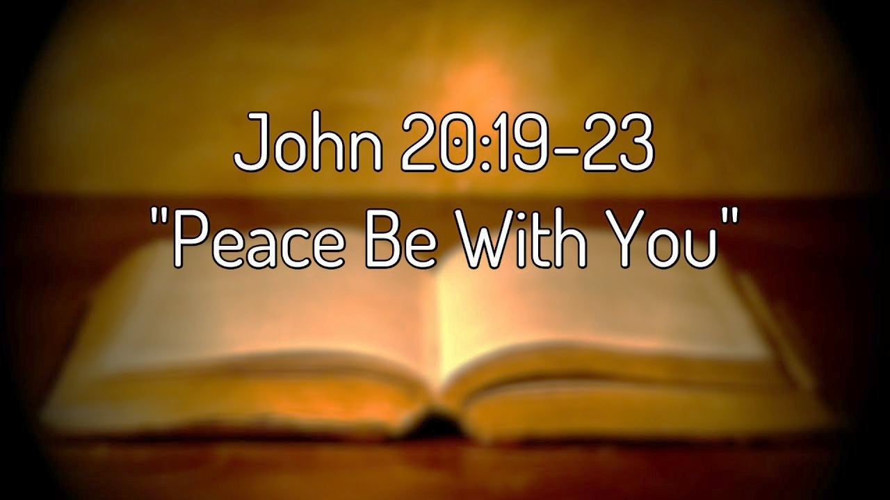

Pentecost derives its name from the Jewish festival celebrating the harvest and the giving of the law on Mount Sinai fifty days after Passover. Fifty days after Easter, we celebrate the Holy Spirit as God’s presence within and among us. In Acts the Spirit arrives in rushing wind and flame, bringing God’s presence to all people. Paul reminds us that though we each have different capacities, we are unified in the Spirit that equips us with these gifts. Jesus breathes the Holy Spirit on his disciples, empowering them to forgive sin. We celebrate that we too are given the breath of the Holy Spirit and sent out to proclaim God’s redeeming love to all the world.

Preservice: Chimes – Spirit of God
Welcome!
Prelude
P – Preparing our hearts for Worship
Confession and forgiveness
The assembly stands. All may make the sign of the cross, the sign that is marked at baptism, as the presiding minister begins.
In the name of the Father,
and of the ☩ Son,
and of the Holy Spirit.
Amen.

God of all mercy and consolation, come to the help of your people, turning us from our sin to live for you alone. Give us the power of your Holy Spirit that we may confess our sin, receive your forgiveness, and grow into the fullness of Jesus Christ, our Savior and Lord.
Amen.
Let us confess our sin in the presence of God and of one another.
The assembly kneels or stands. Silence is kept for reflection.
Most merciful God,
we confess that we are captive to sin and cannot free ourselves. We have sinned against you in thought, word, and deed, by what we have done and by what we have left undone. We have not loved you with our whole heart; we have not loved our neighbors as ourselves. For the sake of your Son, Jesus Christ, have mercy on us. Forgive us, renew us, and lead us, so that we may delight in your will and walk in your ways, to the glory of your holy name.
Amen.
In the mercy of almighty God, Jesus Christ was given to die for us, and for his sake God forgives us all our sins. As a called and ordained minister of the church of Christ, and by his authority, I therefore declare to you the entire forgiveness of all your sins, in the name of the Father, and of the ☩ Son, and of the Holy Spirit.
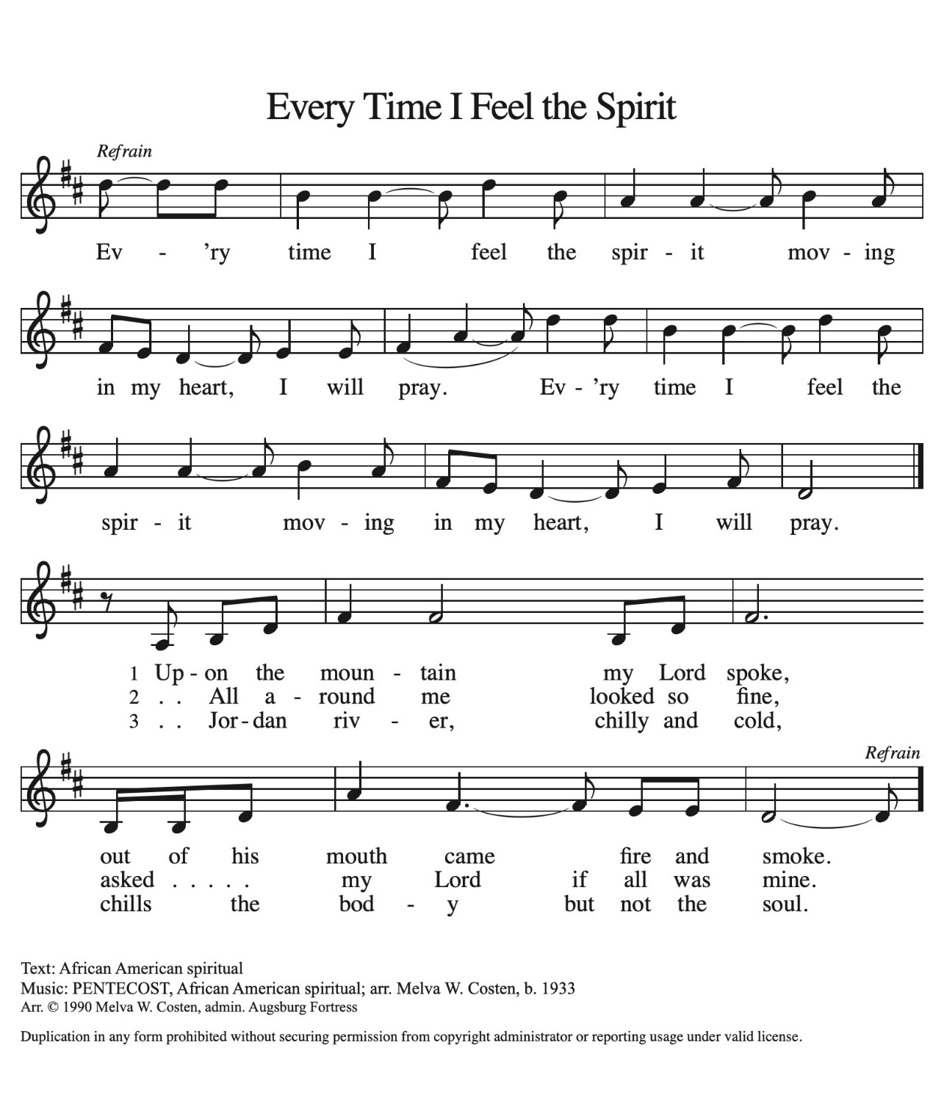
Amen.
Gathering Hymn: ACS 942

P - The grace of our Lord Jesus Christ, the love of God and the communion of the Holy Spirit be with you all.
C - And also with you.

Prayer of the Day
O God, on this day you open the hearts of your faithful people by sending into us your Holy Spirit. Direct us by the light of that Spirit, that we may have a right judgment in all things and rejoice at all times in your peace, through Jesus Christ, your Son and our Lord, who lives and reigns with you and the Holy Spirit, one God, now and forever.
Amen.

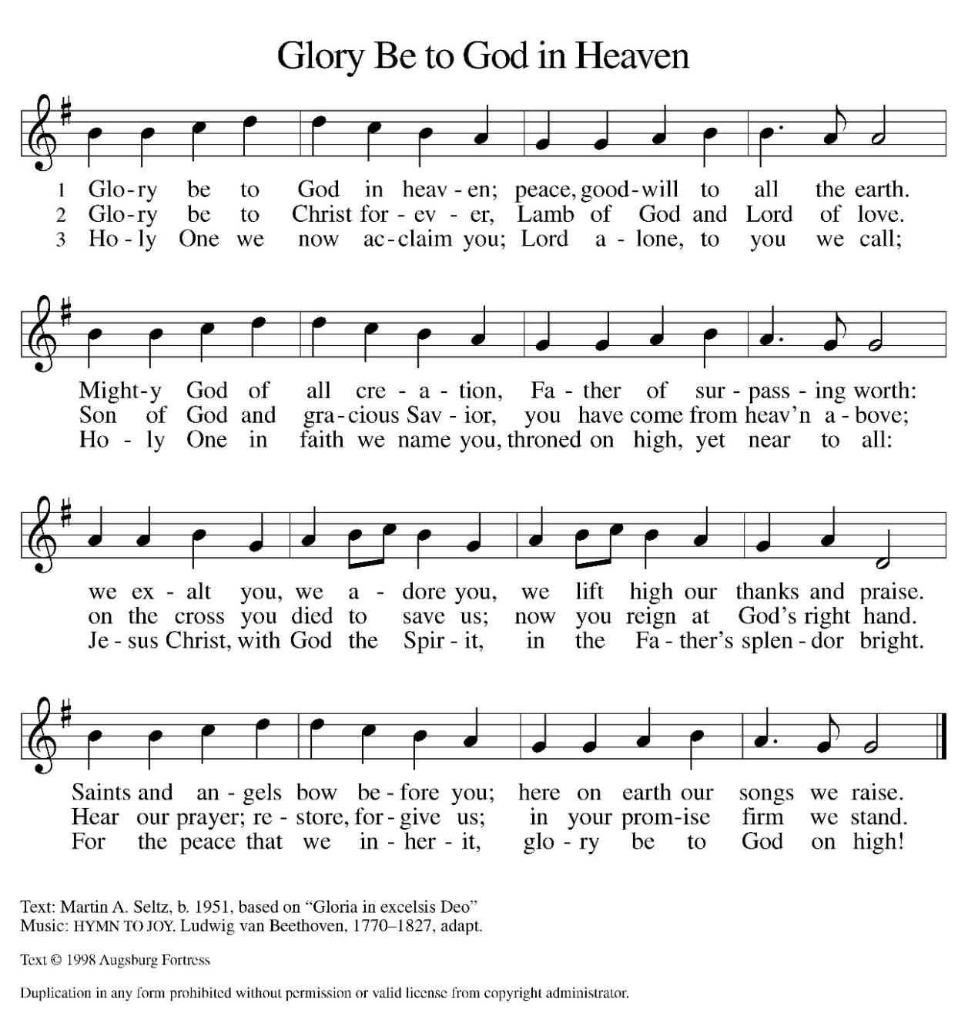
Hymn of Praise:

Please be seated.

Reading: Acts 2:1-21
Pentecost was a Jewish harvest festival that marked the fiftieth day after Passover. Luke portrays the Holy Spirit being poured out upon the disciples before the gathered and astonished people assembled in Jerusalem for the festival. Filled with the Spirit, the disciples were able to witness to the power of Christ’s resurrection.
¹ When the day of Pentecost had come, [the apostles] were all together in one place. ² And suddenly from heaven there came a sound like the rush of a violent wind, and it filled the entire house where they were sitting. ³ Divided tongues, as of fire, appeared among them, and a tongue rested on each of them. ⁴ All of them were filled with the Holy Spirit and began to speak in other languages, as the Spirit gave them ability.
⁵ Now there were devout Jews from every people under heaven living in Jerusalem. ⁶ And at this sound the crowd gathered and was bewildered, because each one heard them speaking in the native language of each. ⁷ Amazed and astonished, they asked, “Are not all these who are speaking Galileans? ⁸ And how is it that we hear, each of us, in our own native language? ⁹ Parthians, Medes, Elamites, and residents of Mesopotamia, Judea and Cappadocia, Pontus and Asia, ¹⁰ Phrygia and Pamphylia, Egypt and the parts of Libya belonging to Cyrene, and visitors from Rome, both Jews and proselytes, ¹¹ Cretans and Arabs—in our own languages we hear them speaking about God’s deeds of power.” ¹² All were amazed and perplexed, saying to one another, “What does this mean?” ¹³ But others sneered and said, “They are filled with new wine.”
¹⁴ But Peter, standing with the eleven, raised his voice and addressed them, “Fellow Jews and all who live in Jerusalem, let this be known to you, and listen to what I say. ¹⁵ Indeed, these are not drunk, as you suppose, for it is only nine o’clock in the morning. ¹⁶ No, this is what was spoken through the prophet Joel:
¹⁷ ‘In the last days it will be, God declares,
that I will pour out my Spirit upon all flesh,
and your sons and your daughters shall prophesy,
and your young men shall see visions,
and your old men shall dream dreams.
¹⁸ Even upon my slaves, both men and women,
in those days I will pour out my Spirit,
and they shall prophesy.
¹⁹ And I will show portents in the heaven above
and signs on the earth below,
blood, and fire, and smoky mist.
²⁰ The sun shall be turned to darkness
and the moon to blood,
before the coming of the Lord’s great and glorious day.
²¹ Then everyone who calls on the name of the Lord shall be saved.’ ”
A – Here ends the reading!
C – Thanks be to God!

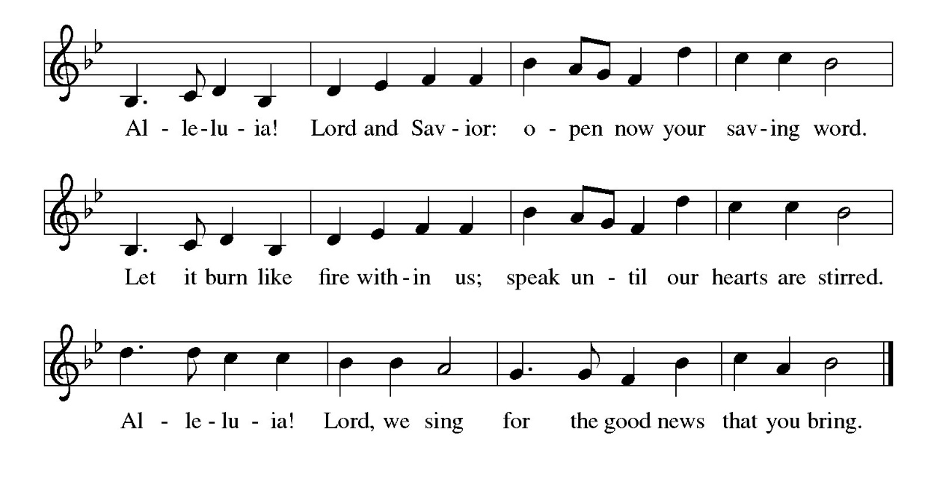
Gospel Acclamation

P - The Holy Gospel according to John, the 20th Chapter
C - Glory to You O Lord!

Gospel: John 20:19-23
The risen Jesus appears to his disciples, offering them a benediction, a commission, and the gift of the Holy Spirit.
¹⁹ When it was evening on that day, the first day of the week, and the doors were locked where the disciples were, for fear of the Jews, Jesus came and stood among them and said, “Peace be with you.” ²⁰ After he said this, he showed them his hands and his side. Then the disciples rejoiced when they saw the Lord. ²¹ Jesus said to them again, “Peace be with you. As the Father has sent me, so I send you.” ²² When he had said this, he breathed on them and said to them, “Receive the Holy Spirit. ²³ If you forgive the sins of any, they are forgiven them; if you retain the sins of any, they are retained.”
P - The Gospel of the Lord.
C – Praise to you, O Christ!

Sermon

Hymn of the Day: Gracious Spirit, Heed Our Pleading ELW 401
1 Gracious Spirit, heed our pleading,
fashion us all anew.
It's your leading that we're needing,
help us to follow you.

Refrain
Come, come, come, Holy Spirit, come.
Come, come, come, Holy Spirit, come.

2 Come to teach us, come to nourish
those who believe in Christ.
Bless the faithful, may they flourish,
strengthened by grace unpriced. Refrain

3 Guide our thinking and our speaking
done in your holy name.
Motivate all in their seeking,
freeing from guilt and shame. Refrain

4 Not mere knowledge, but discernment,
nor rootless liberty;
turn disquiet to contentment,
doubt into certainty. Refrain

5 Keep us fervent in our witness;
unswayed by earth's allure.
Ever grant us zealous fitness,
which you alone assure. Refrain
Text: Wilson Niwagila; tr. Howard S. Olson, b. 1922
English and Swahili text © Lutheran Theological College, Makumira, Tanzania, admin. Augsburg Fortress.
Duplication in any form prohibited without permission or valid license from copyright administrator.

The Apostle’s Creed
I believe in God, the Father almighty,
creator of heaven and earth.
I believe in Jesus Christ, God’s only Son, our Lord,
who was conceived by the Holy Spirit,
born of the virgin Mary,
suffered under Pontius Pilate,
was crucified, died, and was buried;
he descended to the dead.*
On the third day he rose again;
he ascended into heaven,
he is seated at the right hand of the Father,
and he will come to judge the living and the dead.
I believe in the Holy Spirit,
the holy catholic church,
the communion of saints,
the forgiveness of sins,
the resurrection of the body,
and the life everlasting. Amen.
From sundaysandseasons.com.
Copyright © 2026 Augsburg Fortress. All rights reserved.

Prayers of the People
Come, Holy Spirit,
fill the hearts of Your people,
and kindle in us the fire of Your love.
Send forth Your Spirit, and we shall be renewed;
and You shall renew the face of the earth.
Lord in Your mercy,
Bless us with the Holy Spirit

For the Church
Lord of wind and flame,
on this Pentecost Sunday we remember the birth of Your Church.
We pray for Your people across the world —
for pastors, teachers, missionaries, and all who serve in Your name.
May Your Spirit unite us across languages, cultures, and traditions,
so that together we may proclaim the good news of Jesus Christ.
Lord in Your mercy,
Bless us with the Holy Spirit

For the World
Spirit of peace,
we lift before You the nations of the earth.
Where there is war, bring reconciliation.
Where there is injustice, bring righteousness.
Where there is despair, bring hope.
Breathe new life into leaders and communities,
that they may seek the common good and walk in Your ways.
Lord in Your mercy,
Bless us with the Holy Spirit

For the Needy and Suffering
Comforter and Healer,
we pray for those who are sick in body, mind, or spirit.
We remember the lonely, the grieving, the unemployed,
and those weighed down by anxiety or fear.
May Your Spirit bring them strength, healing, and peace.
We name before You now, in silence or aloud, those on our hearts… (pause)
Lord in Your mercy,
Bless us with the Holy Spirit

For the Renewal of Creation
Creator Spirit,
You hovered over the waters at the dawn of time.
We pray for the earth You have made —
for clean air, pure water, fertile soil, and thriving creatures.
Teach us to live as faithful stewards of Your creation,
so that generations to come may rejoice in its beauty.
Lord in Your mercy,
Bless us with the Holy Spirit

For Ourselves
Spirit of truth,
fill us with courage to speak Your word,
with compassion to serve our neighbors,
and with joy to live as witnesses of Christ’s resurrection.
May the fire of Pentecost burn brightly in our hearts today and always.
Lord in Your mercy,
Bless us with the Holy Spirit

Closing Prayer
Come, Holy Spirit,
renew Your Church,
renew Your world,
renew our hearts.
Amen.

P – The Peace of the Lord be with you always.
C – And also with you.

The Offering is Brought to the Altar
Offertory Prayer
Merciful God,
accept the fruits of our labor, gathered to give you glory.
You have set a table before us, a glimpse of that great day
when we will hunger and thirst no more.
Nourish us with the body and blood of Jesus,
that goodness and mercy may follow us
and bless the world you love.
In the name of Jesus,
Amen.

P – The Lord be with You
C – And also with you.
P – Lift up your hearts
C – We lift them to the Lord.
P – Let us give thanks to the Lord, our God
C – It is right to give Him our thanks and praise.

Preface
And so, with Mary Magdalene and Peter and all the witnesses of the resurrection, with earth and sea and all their creatures, and with angels and archangels, cherubim and seraphim, we praise your name and join their unending hymn:
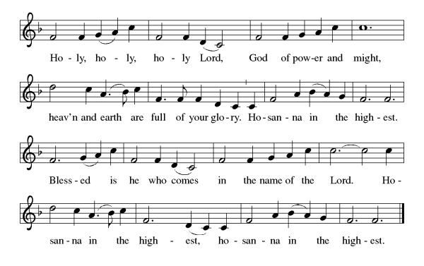

Eucharistic Prayer
(Words of Institution)
For as often as we eat of this bread and drink from this cup we proclaim the Lord’s death until He comes.
Christ has died
Christ is risen.
Christ will come again.
Remembering, therefore, his salutary command,
his life-giving passion and death, his glorious resurrection and ascension, and the promise of his coming again,
we give thanks to you, O Lord God Almighty,
not as we ought but as we are able;
we ask you mercifully to accept our praise and thanksgiving and with your Word and Holy Spirit to bless us, your servants, and these your own gifts of bread and wine, so that we and all who share in the body and blood of Christ may be filled with heavenly blessing and grace, and, receiving the forgiveness of sin,
may be formed to live as your holy people
and be given our inheritance with all your saints.
To you, O God, Father, Son, and Holy Spirit,
be all honor and glory in your holy church, now and forever. Amen.

Gathered into one, by the Holy Spirit let us listen to the words that Jesus taught us.
The Lord’s Prayer
Our Father, who art in heaven, hallowed be thy name, thy kingdom come, thy will be done, on earth as it is in heaven. Give us this day our daily bread; and forgive us our trespasses, as we forgive those who trespass against us; and lead us not into temptation but deliver us from evil. For thine is the kingdom, and the power, and the glory, forever and ever. Amen.
P: Taste and see that the Lord is good.
C: Thanks be to God.
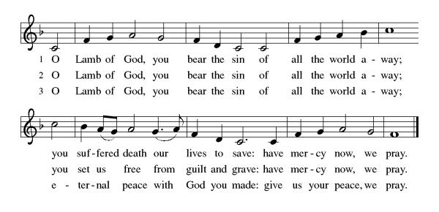
Invitation to Communion

Distribution of Communion – Come Forward to Receive
Communion Hymn: For the Bread Which You Have Broken ELW 494

P – Now may the body and blood of our Lord and Savior Jesus Christ strengthen you and keep you in His grace!
C – Thank You Jesus!

Prayer after Communion
God of abundance,
with this bread of life and cup
of salvation you have
united us with Christ,
making us one with all
your people. Now send
us forth in the power of
your Spirit, that we may
proclaim your redeeming
love to the world and
continue forever in the
risen life of Jesus Christ,
our Lord.
Amen.

Benediction
Psalm 29:11
“The Lord gives strength to His people; the Lord blesses His people with peace. Lord, as we close this time of worship, we ask for Your peace to rest upon every heart present. Let every burden be lifted, and every anxious thought be silenced by Your presence. May Your blessing and strength go with us as we return to our daily lives.
May almighty God bless you Father, Son, and Holy Spirit. Amen

Sending Hymn: God of Tempest, God of Whirlwind ELW 400
- God of tempest, God of whirlwind, as on Pentecost
descend! Drive us out from sheltered comfort;
past these walls your people send! Sweep us into costly service,
there with Christ to bear the cross, there with Christ to bear the cross!

- God of blazing, God of burning, all that blocks your
purpose, purge! Through your church, Christ's living Body,
let your flaming Spirit surge! Where deceit conceals injustice,
kindle us to speak your truth, kindle us to speak your truth!

- God of earthquake, God of thunder, shake us loose from
lethargy! Break the chains of sin asunder,
for earth's healing set us free! Crumble walls that still divide us;
make us one in Christ our Lord, make us one in Christ our Lord!

- God of passion, God unsleeping, stir in us love's
restlessness! Where the people cry in anguish,
may we share your heart's distress. Rouse us from content with evil;
claim us for your kingdom's work, claim us for your kingdom's work!
Text: Herman G. Stuempfle Jr., b. 1923
Text © 2000 GIA Publications, Inc., 7404 S. Mason Ave., Chicago, IL 60638. www.giamusic.com. 800.442.3358. All rights reserved. Used by permission.
Duplication in any form prohibited without permission or valid license from copyright administrator.
Dismissal
P – Look and listen to S.A.M. Bob
C- Thanks be to God. Alleluia!

Postlude:
Unless otherwise noted, service materials used in this bulletin are:
Music is reprinted under OneLicense.Net #A712074 and/or Augsburg Fortress #SBL12176H. Scripture, unless otherwise noted, is from the New Revised Standard Version Bible, Copyright © 1989, Division of Christian Education of the National Council of the Churches of Christ in the United States of America. Used by permission. All rights reserved.

St Timothy’s is served by S.A.M. Robert Bonomo
Lay Minister Frank Hofstetter
Director of Music Sally Hennessey
Saturday Pianist Bill Robinson
Announcements for May 23rd and 24th
ATTENDANCE
Saturday, May 16th, 4pm 20
Sunday, May 17th, 9am 54
Drive-Up Communion 1
75

The altar flowers are given, this week, by Diane Mason, in honor of Chase Messier’s birthday!
Serving our Lord this weekend:
Saturday, May 23rd
Assisting Minister – Carolyn Fialkowski
Reader – Jean Fowler
Communion Assistant – Carolyn Fialkowski
Sunday, May 24th
Assisting Minister – Kathy Geer
Reader – Sarah Brisson

This Week at St. Timothy's
Monday, May 25th
Tuesday, May 26th 9-12 – Food Pantry, 1pm Royal Dalton, 7pm ZOOM Pre-assembly Bible Study
Wednesday, May 27th
Thursday, May 28th 11am Bible Study for Beginners, 11am – Miniatures, 3:30 – Chimes, 4:30pm - Choir
Friday, May 29th
Saturday, May 30th 4pm Worship, No Fellowship
Sunday, May 31st 9am Worship 10:30am – Adult SS, Coffee Fellowship

Prayer List
Steve Cook
Family of Karen Adyniec
Vicky Quigley
Greg Schutrum
Debbie Lawrence
Carole Albert
Linda C.
Ashlee
Frani Barnes
Mark Duffy (work accident)
Wyatt Toney
Jim & Rosa Neth
Melanie
Trish Bradley

