St Timothy Lutheran Church
Saturday, September 12th, 2026



Living Together Beyond Judgment
In his letter to the Romans, Paul writes, “We are the Lord’s” (14:8). He says this to a group of tense people experiencing everyday disagreements over food laws, personal convictions and holy days. They’re bickering and thinking they know best without meeting and without hearing the other side. What does Paul do? He tells them to stop judging and casting stones at one another, to embrace their differences. This text shows us a practical method for living in forgiveness. We must stay connected, embrace our differences and love one another despite it all. We mustn’t let those differences distance us from one another. As the body of Christ, we must learn how to navigate and uplift the beautiful complexities of the church, which is made up of a multitude of people.
Preservice: Come, Holy Spirit, Descend (vs 1,2,3) ACS 980
Welcome!
Prelude

Confession and Forgiveness
All may make the sign of the cross, the sign that is marked at baptism, as the presiding minister begins.
Blessed be the holy Trinity,☩ one God,
whose compassion endures forever.
Amen.
Let us confess our sin to God.
Silence is kept for reflection.
Compassionate God,
we confess to you all our sins.
Our burden is heavy, and we cannot free ourselves.
In your mercy, call us back to you.
Your yoke is easy and your burden is light.
Restore us to dwell in your peace.
In Christ’s name we pray,
Amen.
Jesus says, “Come to me,
all you who are weary
and are carrying heavy burdens,
and I will give you rest.”
In the name of God,
Father, ☩ Son, and Holy Spirit,
your sins are forgiven.
Rest in God’s love.
Amen.
Gathering Hymn: All Creatures, Worship God Most High! ELW 835
1 All creatures, worship God most high!
Sound ev'ry voice in earth and sky: Alleluia! Alleluia!
Sing, brother sun, in splendor bright;
sing, sister moon and stars of night:
Alleluia, alleluia, alleluia, alleluia, alleluia!

2 Sing, brother wind; with clouds and rain
you grow the gifts of fruit and grain: Alleluia! Alleluia!
Dear sister water, useful, clear,
make music for your Lord to hear:
Alleluia, alleluia, alleluia, alleluia, alleluia!

3 Sing, brother fire, so mirthful, strong,
drive far the shadows, join the throng: Alleluia! Alleluia!
Dear mother earth, so rich in care,
praise God in colors bright and rare:
Alleluia, alleluia, alleluia, alleluia, alleluia!

4 All who for love of God forgive,
all who in pain and sorrow grieve: Alleluia! Alleluia!
Christ bears your burdens and your fears;
still make your song amid the tears:
Alleluia, alleluia, alleluia, alleluia, alleluia!

5 And you, most gentle sister death,
waiting to hush our final breath: Alleluia! Alleluia!
Since Christ our light has pierced your gloom,
fair is the night that leads us home.
Alleluia, alleluia, alleluia, alleluia, alleluia!

6 O sisters, brothers, take your part,
and worship God with humble heart: Alleluia! Alleluia!
All creatures, bless the Father, Son,
and Holy Spirit, Three in One:
Alleluia, alleluia, alleluia, alleluia, alleluia!

Text: Francis of Assisi, 1182-1226; tr. composite
Text © 1997 Augsburg Fortress.
Duplication in any form prohibited without permission or valid license from copyright administrator.

P - The grace of our Lord Jesus Christ, the love of God and the communion of the Holy Spirit be with you all.
C - And also with you.
Prayer of the Day
O, Lord God, merciful judge, you are the inexhaustible fountain of forgiveness. Replace our hearts of stone with hearts that love and adore you, that we may delight in doing your will, through Jesus Christ, our Savior and Lord. Amen.

First Reading: Genesis 50:15-21
After Jacob’s death the brothers of Joseph begged for forgiveness for the crime they had done against him. You intended to do me harm, Joseph said, but God used this as an opportunity to do good and save many lives.
¹⁵ Realizing that their father was dead, Joseph’s brothers said, “What if Joseph still bears a grudge against us and pays us back in full for all the wrong that we did to him?” ¹⁶ So they approached Joseph, saying, “Your father gave this instruction before he died, ¹⁷ ‘Say to Joseph: I beg you, forgive the crime of your brothers and the wrong they did in harming you.’ Now therefore please forgive the crime of the servants of the God of your father.” Joseph wept when they spoke to him. ¹⁸ Then his brothers also wept, fell down before him, and said, “We are here as your slaves.” ¹⁹ But Joseph said to them, “Do not be afraid! Am I in the place of God? ²⁰ Even though you intended to do harm to me, God intended it for good, in order to preserve a numerous people, as he is doing today. ²¹ So have no fear; I myself will provide for you and your little ones.” In this way he reassured them, speaking kindly to them.

A – Here ends the reading!
C – Thanks be to God!
P - The Holy Gospel according to Matthew, the 18th Chapter
C - Glory to You O Lord!

Gospel: Matthew 18:21-35
When Peter asks about the limits of forgiveness, Jesus responds with a parable that suggests human forgiveness should mirror the unlimited mercy of God.
²¹ Peter came and said to [Jesus,] “Lord, if my brother or sister sins against me, how often should I forgive? As many as seven times?” ²² Jesus said to him, “Not seven times, but, I tell you, seventy-seven times.
²³ “For this reason the kingdom of heaven may be compared to a king who wished to settle accounts with his slaves. ²⁴ When he began the reckoning, one who owed him ten thousand talents was brought to him, ²⁵ and, as he could not pay, the lord ordered him to be sold, together with his wife and children and all his possessions and payment to be made. ²⁶ So the slave fell on his knees before him, saying, ‘Have patience with me, and I will pay you everything.’ ²⁷ And out of pity for him, the lord of that slave released him and forgave him the debt. ²⁸ But that same slave, as he went out, came upon one of his fellow slaves who owed him a hundred denarii, and seizing him by the throat he said, ‘Pay what you owe.’ ²⁹ Then his fellow slave fell down and pleaded with him, ‘Have patience with me, and I will pay you.’ ³⁰ But he refused; then he went and threw him into prison until he would pay the debt. ³¹ When his fellow slaves saw what had happened, they were greatly distressed, and they went and reported to their lord all that had taken place. ³² Then his lord summoned him and said to him, ‘You wicked slave! I forgave you all that debt because you pleaded with me. ³³ Should you not have had mercy on your fellow slave, as I had mercy on you?’ ³⁴ And in anger his lord handed him over to be tortured until he would pay his entire debt. ³⁵ So my heavenly Father will also do to every one of you, if you do not forgive your brother or sister from your heart.”

P - The Gospel of the Lord.
C – Praise to you, O Christ!
Sermon by S.A.M. Robert Bonomo

Hymn of the Day: I Come with Joy ELW 482
1 I come with joy, a child of God,
forgiven, loved, and free,
the life of Jesus to recall
in love laid down for me,
in love laid down for me.

2 I come with Christians far and near
to find, as all are fed,
the new community of love
in Christ's communion bread,
in Christ's communion bread.

3 As Christ breaks bread and bids us share,
each proud division ends.
The love that made us, makes us one,
and strangers now are friends,
and strangers now are friends.

4 The Spirit of the risen Christ,
unseen, but ever near,
is in such friendship better known,
alive among us here,
alive among us here.

5 Together met, together bound
by all that God has done,
we'll go with joy, to give the world
the love that makes us one,
the love that makes us one.
Text: Brian A. Wren, b. 1936
Text © 1971, rev. 1995 Hope Publishing Company, Carol Stream, IL 60188. All rights reserved. Used by permission.
Duplication in any form prohibited without permission or valid license from copyright administrator.

The Apostle’s Creed
I believe in God, the Father almighty,
creator of heaven and earth.
I believe in Jesus Christ, God’s only Son, our Lord,
who was conceived by the Holy Spirit,
born of the virgin Mary,
suffered under Pontius Pilate,
was crucified, died, and was buried;
he descended to the dead.*
On the third day he rose again;
he ascended into heaven,
he is seated at the right hand of the Father,
and he will come to judge the living and the dead.
I believe in the Holy Spirit,
the holy catholic church,
the communion of saints,
the forgiveness of sins,
the resurrection of the body,
and the life everlasting. Amen.
From sundaysandseasons.com.
Copyright © 2026 Augsburg Fortress. All rights reserved.

Prayers of the People
Reminded of God’s gracious and abundant love, we offer our prayers, confident that God hears us.

Brief Silence

Almighty God, we give thanks for children, youth, and adults who serve in our communities through acts of service, partnering with congregations, Lutheran agencies, and local organizations. May their hands and hearts reflect your love and grace, and may their work bear fruit for the good of all people and creation
We thank You Lord,
Your mercy is great

Holy Lord, guide those who lead and govern, and grant wisdom, compassion, and perseverance to all who bear another’s burdens. Strengthen those working in healthcare, education, and social services, that they may serve with humility and dedication.
We thank You Lord
Your mercy is great

Merciful God, we lift up those who are weary, hungry, or marginalized. Inspire us to advocate for justice, provide relief for the poor, and care for creation. May our hands work to bring healing, hope, and reconciliation to our neighbors near and far.
We thank You Lord,
Your mercy is great
For Spiritual Growth and Faithfulness
Lord, help us to pattern our lives on Jesus Christ, serving others in gratitude and love. May our acts of service flow from a living confidence in your grace, and may we be strengthened to witness boldly and serve joyfully in every calling.
We thank You Lord
Your mercy is great

Ground this congregation in the welcome you show us in forgiving our sin. Inspire each of us to welcome others for your honor and glory.
We thank You Lord
Your mercy is great.

With You is found the joy and promise of eternal life. Keep us in that joy as we remember all those who have gone before us.
We thank You Lord
Your mercy is great.

Grant the prayers we have offered, what we have forgotten to ask, and whatever else you see that we need. We ask this in Jesus’ name.
Amen.

P – The Peace of the Lord be with you always.
C – And also with you.

The Offering is Brought to the Altar
Offering Prayer

We lift our voices, we lift our hands, we lift our lives up to you; we are an Offering. Lord, use our voices, Lord, use our hands, Lord, use our lives, they are yours: we are an offering. All that we have, all that we are, all that we hope to be, we give to you, we give to you. We lift our voices, we lift our hands, we lift our lives up to you; we are an offering, we are an offering.

The Great Thanksgiving

P – The Lord be with You
C – And also with you.
P – Lift up your hearts
C – We lift them to the Lord.
P – Let us give thanks to the Lord, our God
C – It is right to give Him our thanks and praise.

Preface
And so, with all the choirs of angels, with the church on earth and the hosts of heaven, we praise your name and join their unending hymn:
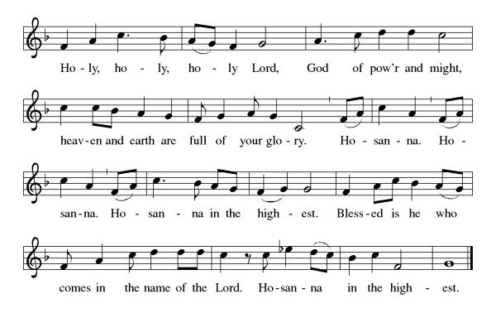

Eucharistic Prayer
(Words of Institution)
For as often as we eat of this bread and drink from this cup we proclaim the Lord’s death until He comes.
Christ has died
Christ is risen.
Christ will come again.
Remembering, therefore, his salutary command,
his life-giving passion and death, his glorious resurrection and ascension,
and the promise of his coming again,
we give thanks to you, O Lord God Almighty,
not as we ought but as we are able;
we ask you mercifully to accept our praise and thanksgiving and with your Word and Holy Spirit to bless us, your servants, and these your own gifts of bread and wine, so that we and all who share in the body and blood of Christ may be filled with heavenly blessing and grace,
and, receiving the forgiveness of sin,
may be formed to live as your holy people
and be given our inheritance with all your saints.
To you, O God, Father, Son, and Holy Spirit,
be all honor and glory in your holy church, now and forever. Amen.

Gathered into one, by the Holy Spirit let us listen to the words that Jesus taught us.

The Lord’s Prayer
Our Father, who art in heaven, hallowed be thy name, thy kingdom come, thy will be done, on earth as it is in heaven. Give us this day our daily bread; and forgive us our trespasses, as we forgive those who trespass against us; and lead us not into temptation but deliver us from evil. For thine is the kingdom, and the power, and the glory, forever and ever. Amen.
P: Taste and see that the Lord is good.
C: Thanks be to God.

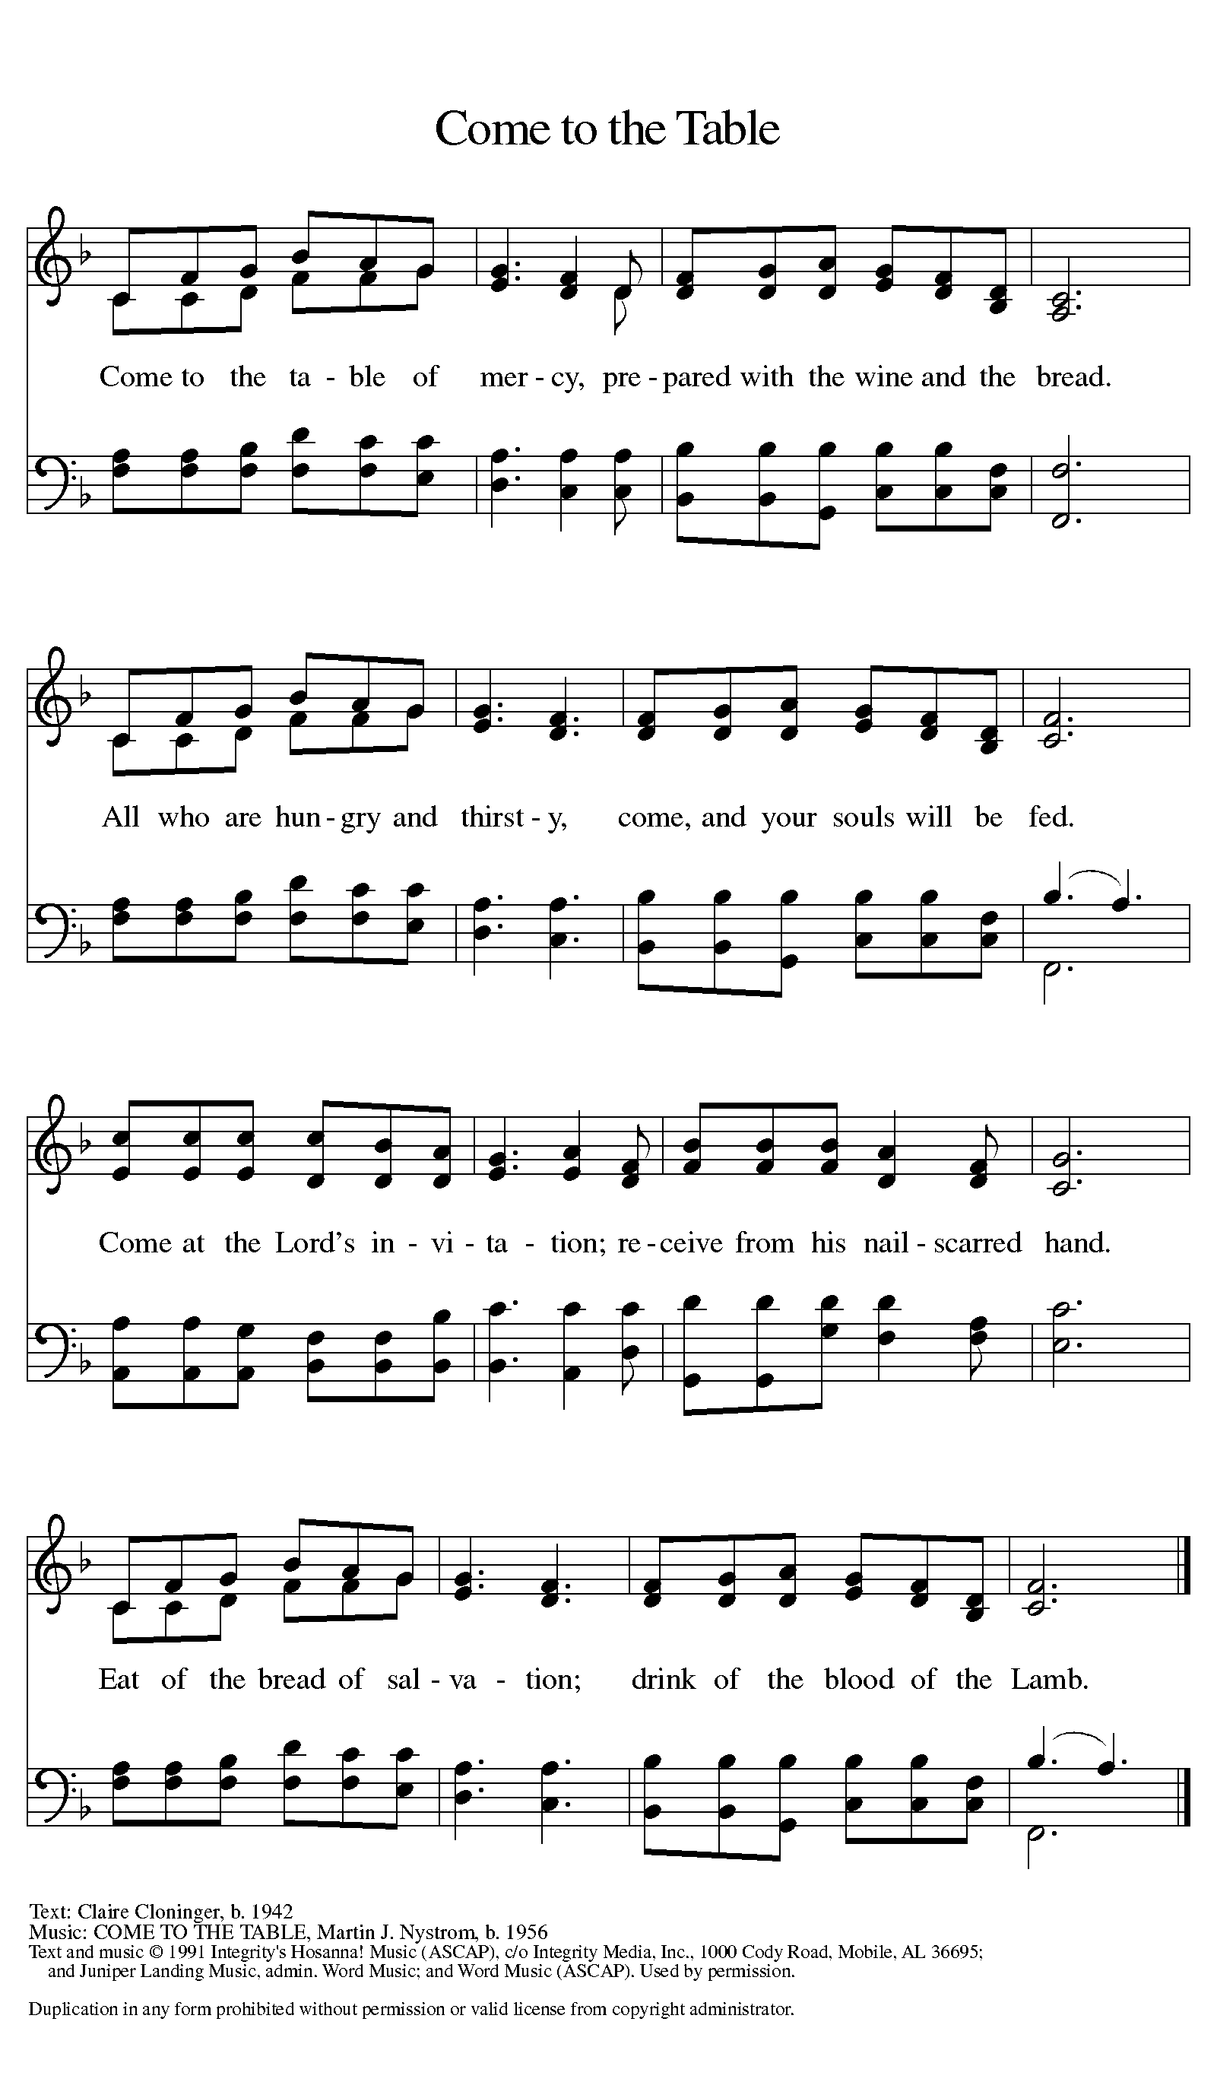
Invitation to Communion

Distribution of Communion – Come Forward to Receive
Communion Hymn: Come Ye Disconsolate ELW 607, Where Charity and Love Prevail ELW 359
P – Now may the body and blood of our Lord and Savior Jesus Christ strengthen you and keep you in His grace!
C – Thank You Jesus!
Prayer After Communion
Holy Jesus,
in this meal you have fed and nourished us to work in your beloved world. Send us now, filled with yourself and strengthened by your Spirit to live your love for others. Amen.

Words of dismissal and benediction
Friends in Christ: Today we give thanks to God and seek God’s blessing as we send these volunteers to pack the bags of goodies supplied by our congregation to be delivered to EMS, Fire Department and Police Departments in our community.

Renew in us the commitment to use our gifts in the service of others, especially of those in need. Let us be your hands to feed the hungry, shelter the homeless, clothe the naked, comfort the weary and outcast, welcome the stranger, care for creation, and be loving neighbors to all people.

Bless these gifts of love for our community. May those who receive them be nourished and strengthened, and may these gifts be a sign of your love to all people.

CELEBRATION OF VOCATION AND BLESSING OF HANDS FOR MINISTRY
We are called to proclaim the good news:
God is at work!
This good news is not left in some history long ago or a place far away:
God is at work in the world still today!
In us and through us, God is glorified in our work.
When we offer a helping hand, God is praised.
When we share of our abundance, God is known in the world.
God is at work in us!
In our service today and in our daily lives,
let us live out what God has called us to in baptism.
God is at work through our hands!

May Almighty God bless you.
The Father, The Son and the Holy Spirit.
Amen.

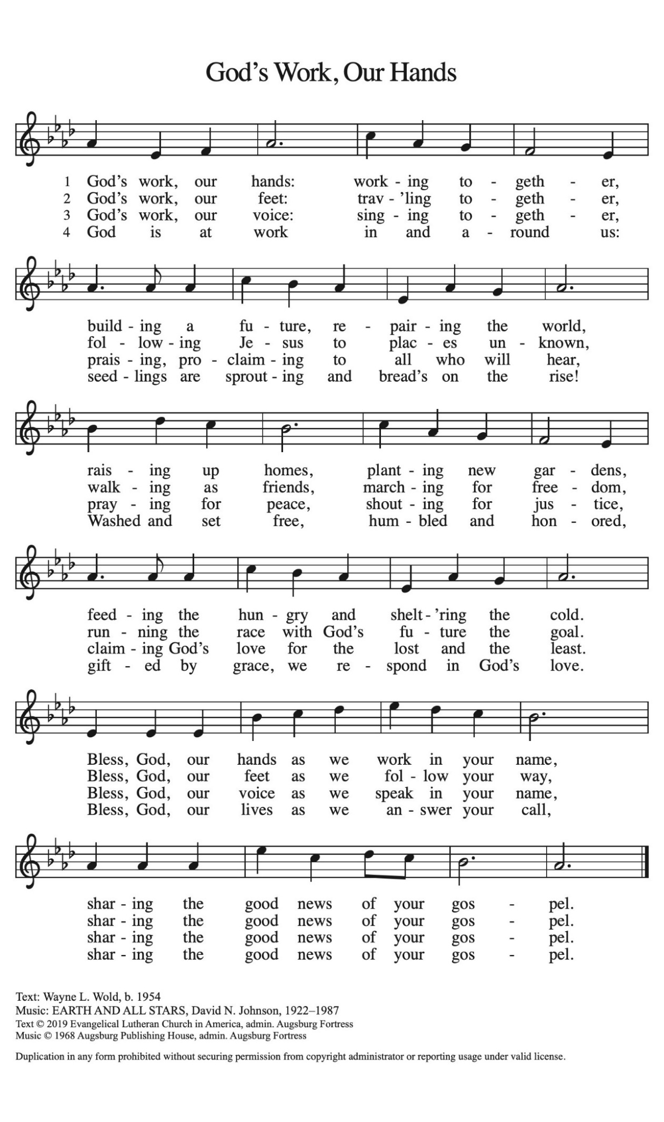

Sending Hymn: ACS 1000

Dismissal
P – Go in peace. You are God’s hands at work in the world!
C- Thanks be to God.

Postlude:
Unless otherwise noted, service materials used in this bulletin are:
Music is reprinted under OneLicense.Net #A712074 and/or Augsburg Fortress #SBL12176H. Scripture, unless otherwise noted, is from the New Revised Standard Version Bible, Copyright © 1989, Division of Christian Education of the National Council of the Churches of Christ in the United States of America. Used by permission. All rights reserved.
St. Timothy’s is served by S.A.M. Robert “Bob” Bonomo
Lay Minister Frank Hofstetter
Director of Music Sally Hennessey
Saturday Pianist Bill Robinson
Announcements for September 12th and 13th
ATTENDANCE
Saturday, September 5th, 4pm 31
Sunday, September 6th, 9am 54
Drive-Up Communion 4
89

The altar flowers are given this week by Debbie Lawrence, in honor of her husband Marshall’s birthday!

Serving our Lord this weekend:
Saturday, September 12th

Sunday, September 13th
Assisting Minister – Sarah Haley
Reader – Sarah Brisson
Altar Guild – Steve & Sarah Brisson
Greeters - John & Jodie Gudorf

This Week at St. Timothy's
Monday, September 14th 10:30am - Ruth Circle @ Barbara C’s house, 1pm – Garden Club
Tuesday, September 15th 1pm – Food Pantry
Wednesday, September 16th 9:30 – Child Safety Class, 11am - Council
Thursday, September 17th 11-12 Bible Study, 11am – Miniatures, 3:30 - Chimes, 4:30 - Choir
Friday, September 18th
Saturday, September 19th 4pm Worship, No Fellowship
Sunday, September 20th 9am Worship, 10:30 – Adult SS, Coffee Fellowship

PRAYER LIST

Family of baby Atticus
Phil
Sue
Dixie
Tyler
Marsha Gibson
Thea
May
Ben
Sarah Brisson
Sheila
Marie Demastus
Sharon Grimes
Ginny
Cindy
Mary Schlumberger
Marcia & Harry Treber
Teresa York
Debbie Lawrence
Carole Albert
Linda C.
Ashlee
Frani Barnes
Mark Duffy
Wyatt Toney
Jim & Rosa Neth
Melanie
Trish Bradley
Fowler Family
Marcus

