St Timothy Lutheran Church
Sunday, July 5, 2026
^{6th} Sunday after Pentecost



The mystery of God’s ways is sometimes hidden from the wise and intelligent. Jesus associates with those often excluded from the religious community. Like Paul, we struggle with our own selfish desires and seek God’s mercy and forgiveness. We gather to be refreshed by Christ’s invitation: “Come to me, all you that are weary.” Gathered around word, water, and meal, we find rest for our souls.

Preservice: Morning Has Broken ELW 556
Welcome!
Prelude
P – Preparing our hearts for Worship

Confession and Forgiveness
All may make the sign of the cross, the sign that is marked at baptism, as the presiding minister begins.
Blessed be the holy Trinity,☩ one God,
whose compassion endures forever.
Amen.
Let us confess our sin to God.
Silence is kept for reflection.
Compassionate God,
we confess to you all our sins.
Our burden is heavy, and we cannot free ourselves.
In your mercy, call us back to you.
Your yoke is easy and your burden is light.
Restore us to dwell in your peace.
In Christ’s name we pray,
Amen.
Jesus says, “Come to me,
all you who are weary
and are carrying heavy burdens,
and I will give you rest.”
In the name of God,
Father, ☩ Son, and Holy Spirit,
your sins are forgiven.
Rest in God’s love.
Amen.
Gathering Hymn: What a Friend We Have in Jesus ELW 742

1 What a friend we have in Jesus, all our sins and griefs to bear!
What a privilege to carry ev'rything to God in prayer!
Oh, what peace we often forfeit; oh, what needless pain we bear--
all because we do not carry ev'rything to God in prayer!

2 Have we trials and temptations? Is there trouble anywhere?
We should never be discouraged-- take it to the Lord in prayer.
Can we find a friend so faithful who will all our sorrows share?
Jesus knows our ev'ry weakness-- take it to the Lord in prayer.

3 Are we weak and heavy-laden, cumbered with a load of care?
Precious Savior, still our refuge-- take it to the Lord in prayer.
Do your friends despise, forsake you? Take it to the Lord in prayer.
In his arms he'll take and shield you; you will find a solace there.
Text: Joseph Scriven, 1820-1886

P - The grace of our Lord Jesus Christ, the love of God and the communion of the Holy Spirit be with you all.
C - And also with you.

Prayer of the Day
You are great, O God, and greatly to be praised. You have made us for yourself, and our hearts are restless until they rest in you. Grant that we may believe in you, call upon you, know you, and serve you, through your Son, Jesus Christ, our Savior and Lord.
Amen.

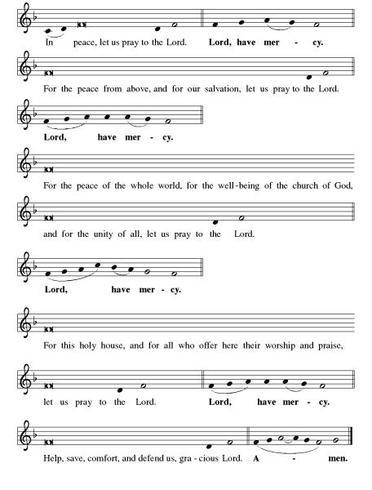
Kyrie ELW pg 138

Hymn of Praise: This is the Feast ELW pg 140-141

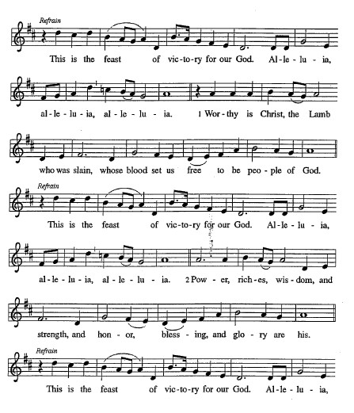

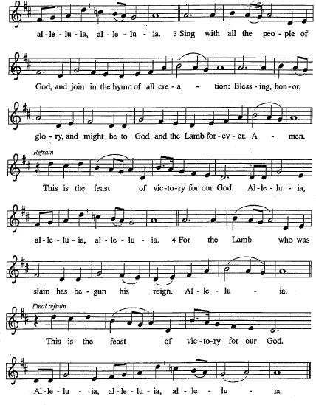
Please be seated.

First Reading: Zechariah 9:9-12
The coming messianic king will inaugurate an era of disarmament and prosperity. Because of God’s covenant with Israel, the people are designated as “prisoners of hope.”
⁹ Rejoice greatly, O daughter Zion!
Shout aloud, O daughter Jerusalem!
See, your king comes to you;
triumphant and victorious is he,
humble and riding on a donkey,
on a colt, the foal of a donkey.
¹⁰ He will cut off the chariot from Ephraim
and the war horse from Jerusalem;
and the battle bow shall be cut off,
and he shall command peace to the nations;
his dominion shall be from sea to sea
and from the River to the ends of the earth.
¹¹ As for you also, because of the blood of my covenant with you,
I will set your prisoners free from the waterless pit.
¹² Return to your stronghold, O prisoners of hope;
today I declare that I will restore to you double.

A – Here ends the first reading!

C – Thanks be to God!

Psalm 145:8-14
⁸ The Lord is gracious and full of compassion,
slow to anger and abounding in steadfast love.
⁹ Lord, you are good to all,
and your compassion is over all your works.
¹⁰ All your works shall praise you, O Lord,
and your faithful ones shall bless you.
¹¹ They shall tell of the glory of your kingdom
and speak of your power,
¹² that all people may know of your power
and the glorious splendor of your kingdom.
¹³ Your kingdom is an everlasting kingdom; your dominion endures throughout all ages.
You, Lord, are faithful in all your words, and loving in | all your works.
¹⁴ The Lord upholds all those who fall
and lifts up those who are bowed down.

Second Reading: Romans 7:15-25a
Life captive to sin is a catch-22 existence in which we know good but do not do it and do things we know to be wrong. Through Jesus Christ, God has set us free from such a futile existence.
¹⁵ I do not understand my own actions. For I do not do what I want, but I do the very thing I hate. ¹⁶ Now if I do what I do not want, I agree that the law is good. ¹⁷ But in fact it is no longer I who do it but sin that dwells within me. ¹⁸ For I know that the good does not dwell within me, that is, in my flesh. For the desire to do the good lies close at hand, but not the ability. ¹⁹ For I do not do the good I want, but the evil I do not want is what I do. ²⁰ Now if I do what I do not want, it is no longer I who do it but sin that dwells within me.
²¹ So I find it to be a law that, when I want to do what is good, evil lies close at hand. ²² For I delight in the law of God in my inmost self, ²³ but I see in my members another law at war with the law of my mind, making me captive to the law of sin that dwells in my members. ²⁴ Wretched person that I am! Who will rescue me from this body of death? ^{25a} Thanks be to God through Jesus Christ our Lord!

A – Here ends the second reading!
C – Thanks be to God!

Gospel Acclamation
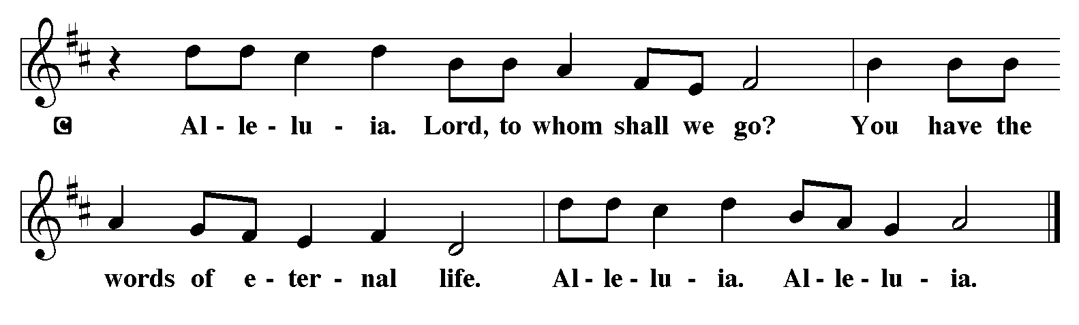
P - The Holy Gospel according to Matthew, the 11th Chapter
C - Glory to You O Lord!

Gospel: Matthew 11:16-19, 25-30
Jesus chides people who find fault with both his ministry and that of John the Baptist. He thanks God that wisdom and intelligence are not needed to receive what God has to offer.
[Jesus spoke to the crowd saying:] ¹⁶ “To what will I compare this generation? It is like children sitting in the marketplaces and calling to one another,
¹⁷ ‘We played the flute for you, and you did not dance;
we wailed, and you did not mourn.’
¹⁸ “For John came neither eating nor drinking, and they say, ‘He has a demon’; ¹⁹ the Son of Man came eating and drinking, and they say, ‘Look, a glutton and a drunkard, a friend of tax collectors and sinners!’ Yet wisdom is vindicated by her deeds.”
²⁵ At that time Jesus said, “I thank you, Father, Lord of heaven and earth, because you have hidden these things from the wise and the intelligent and have revealed them to infants; ²⁶ yes, Father, for such was your gracious will. ²⁷ All things have been handed over to me by my Father, and no one knows the Son except the Father, and no one knows the Father except the Son and anyone to whom the Son chooses to reveal him.
²⁸ “Come to me, all you who are weary and are carrying heavy burdens, and I will give you rest. ²⁹ Take my yoke upon you, and learn from me, for I am gentle and humble in heart, and you will find rest for your souls. ³⁰ For my yoke is easy, and my burden is light.”

P - The Gospel of the Lord.
C – Praise to you, O Christ!
Sermon
Hymn of the Day: Softly and Tenderly, Jesus is Calling ELW 608

- Softly and tenderly Jesus is calling, calling for
you and for me. See, on the portals he's waiting and watching,
watching for you and for me. Refrain

Refrain
"Come home, (Come home,)
come home! (come home!)
You who are weary, come home."
Earnestly, tenderly, Jesus is calling,
calling, "O sinner, come home!"

- Why should we tarry when Jesus is pleading, pleading for
you and for me? Why should we linger and heed not his mercies,
mercies for you and for me? Refrain

- Oh, for the wonderful love he has promised, promised for
you and for me! Though we have sinned, he has mercy and pardon,
pardon for you and for me. Refrain
Text: Will L. Thompson, 1847-1909
The Apostle’s Creed
I believe in God, the Father almighty,
creator of heaven and earth.
I believe in Jesus Christ, God’s only Son, our Lord,
who was conceived by the Holy Spirit,
born of the virgin Mary,
suffered under Pontius Pilate,
was crucified, died, and was buried;
he descended to the dead.*
On the third day he rose again;
he ascended into heaven,
he is seated at the right hand of the Father,
and he will come to judge the living and the dead.
I believe in the Holy Spirit,
the holy catholic church,
the communion of saints,
the forgiveness of sins,
the resurrection of the body,
and the life everlasting. Amen.
From sundaysandseasons.com.
Copyright © 2026 Augsburg Fortress. All rights reserved.

Prayers of the People
Let us pray for the whole people of God in Christ Jesus, and for all people according to their needs. Lord, we ask for You to lift up this Congregation and all Congregations to lift up their hopes, their needs and their burdens.
Brief silence
Holy Lord, all glory and praise are offered to You, for You are our Redeemer and King, our Savior and Friend. We adore You and exalt Your holy name.
Lord Jesus
Come and save us
Merciful Lord, Your grace is sufficient for all our needs, and You have promised to be the strength of the weary, the hope of those who fear, the healing of the ill, and the peace of all who are distressed. Hear us on behalf of all in need, that they may be well supplied by Your grace in every time of trouble. We also pray for those that are tired, defeated, hungry, homeless, poor in spirit, those who do not know Your love and those who refuse Your love
Lord Jesus
Come and save us
Lord, in the words of the prophet, “Blessed are the meek, for they shall inherit the earth.” May Your Spirit grow in us a spirit of humility and gentleness, that we may live as Your disciples, bearing Your love in word and deed.
Lord Jesus
Come and save us

Lord, we thank You for 250 years of blessings, guidance, and mercy over our nation. On this Independence Day, we remember the courage, sacrifice, and vision that shaped our freedom. Grant us wisdom to walk in unity, strength to uphold justice, and compassion to care for one another. May our future be marked by peace, integrity, and hope.
Lord Jesus
Come and save us

Lord, in the stillness of Your presence, we find rest and renewal. May we learn to trust in Your timing, to rest in Your care, and to find peace in Your promises.
Lord Jesus
Come and save us

We pray for all those who are sick, hospitalized, tired, defeated, hungry, homeless, poor in spirit, those who do not know Your love and those who refuse Your love
Lord Jesus
Come and save us

We give you thanks for the saints who have gone before us and now rest in your eternal care. Keep us steadfast in faith until we join them in your everlasting kingdom.
Lord Jesus
Come and save us

Into Your hands, O Lord, we commend all for whom we pray, trusting in Your mercy, through Jesus Christ, our Lord.
Amen

P – The Peace of the Lord be with you always.
C – And also with you.
The Offering is Brought to the Altar
Offertory Prayer
Loving God,
we offer at your table the gifts of our hearts.
Help us take heart in you and share freely of your love,
so that all creation can taste your abundance.
We ask this in the name of Jesus,
through the Spirit abiding with us now and forever.
Amen.
The Great Thanksgiving

P – The Lord be with You
C – And also with you.
P – Lift up your hearts
C – We lift them to the Lord.
P – Let us give thanks to the Lord, our God
C – It is right to give Him our thanks and praise.
Preface
And so, with all the choirs of angels, with the church on earth and the hosts of heaven, we praise your name and join their unending hymn:

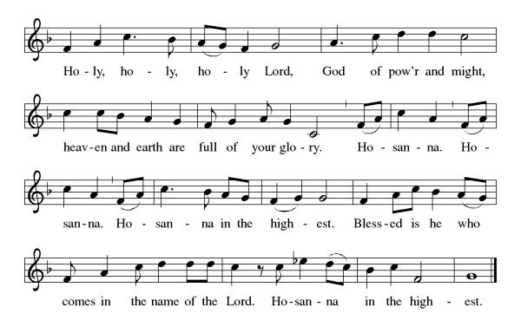

Eucharistic Prayer
(Words of Institution)
For as often as we eat of this bread and drink from this cup we proclaim the Lord’s death until He comes.
Christ has died
Christ is risen.
Christ will come again.
Remembering, therefore, his salutary command,
his life-giving passion and death, his glorious resurrection and ascension,
and the promise of his coming again,
we give thanks to you, O Lord God Almighty,
not as we ought but as we are able;
we ask you mercifully to accept our praise and thanksgiving and with your Word and Holy Spirit to bless us, your servants, and these your own gifts of bread and wine, so that we and all who share in the body and blood of Christ may be filled with heavenly blessing and grace,
and, receiving the forgiveness of sin,
may be formed to live as your holy people
and be given our inheritance with all your saints.
To you, O God, Father, Son, and Holy Spirit,
be all honor and glory in your holy church, now and forever. Amen.
Gathered into one, by the Holy Spirit let us listen to the words that Jesus taught us.

The Lord’s Prayer
Our Father, who art in heaven, hallowed be thy name, thy kingdom come, thy will be done, on earth as it is in heaven. Give us this day our daily bread; and forgive us our trespasses, as we forgive those who trespass against us; and lead us not into temptation but deliver us from evil. For thine is the kingdom, and the power, and the glory, forever and ever. Amen.
P: Taste and see that the Lord is good.
C: Thanks be to God.

Invitation to Communion
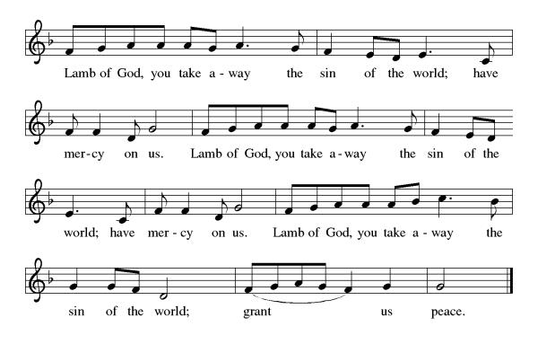
P – Come, feast at His table. He is waiting for you.
C – Amen.

Distribution of Communion – Come Forward to Receive
Communion Hymn: Come to Me, All Pilgrims Thirsty ELW 777

P – Now may the body and blood of our Lord and Savior Jesus Christ strengthen you and keep you in His grace!
C – Thank You Jesus!

Prayer after Communion
Compassionate God,
Through the gifts of bread and wine
our hearts are filled with the abundance of your love.
Strengthen us that we, through this Holy meal,
may share your love freely, as you have shared with us.
We ask this in the name of Jesus,
through the Spirit nourishing us now and forever.
Amen.

Words of dismissal and benediction
Know that the ever-present mystery we name God
is in your past forgiving you,
in your present loving you,
and in your future meeting you.
And may the blessing of the Source of life, love and hope,
the Word of life, compassion and wisdom
and Breath of life, grace and truth
surround, sustain and surprise you,
this day and all your days. Amen.

Sending Hymn: Just a Closer Walk with Thee ELW 697

Refrain
Just a closer walk with thee, grant it, Jesus, is my plea;
daily walking close to thee, let it be, dear Lord, let it be.

1 I am weak but thou art strong: Jesus, keep me from all wrong;
I'll be satisfied as long as I walk, let me walk close to thee. Refrain

2 Through this world of toil and snares, if I falter, Lord, who cares?
Who with me my burden shares? None but thee, dear Lord, none but thee. Refrain

3 When my feeble life is o'er, time for me will be no more;
guide me gently, safely o'er to thy kingdom shore, to thy shore. Refrain
Text: North American traditional
Dismissal
P – Look and listen to S.A.M. Bob
C- Thanks be to God. Alleluia!

Postlude:
Unless otherwise noted, service materials used in this bulletin are:
Music is reprinted under OneLicense.Net #A712074 and/or Augsburg Fortress #SBL12176H. Scripture, unless otherwise noted, is from the New Revised Standard Version Bible, Copyright © 1989, Division of Christian Education of the National Council of the Churches of Christ in the United States of America. Used by permission. All rights reserved.

St Timothy’s is served by S.A.M. Robert Bonomo
Lay Minister Frank Hofstetter
Director of Music Sally Hennessey
Saturday Pianist Bill Robinson

Announcements for July 4th and 5th
ATTENDANCE
Saturday, June 27th, 4pm 24
Sunday, June 28th , 9am 60
84

The altar flowers are given this week by Frank & Eileen Hofstetter in remembrance of Erika Steinbicker.

Serving our Lord this weekend:
Saturday, July 4th
Assisting Minister – Carolyn Fialkowski
Reader – Ed Fialkowski

Sunday, July 5th
Reader – Dick Kleinsmith
Altar Guild – Kris & Carl Harper
Greeters – John & Jodie Gudorf

This Week at St. Timothy's
Monday, July 6th 10:30am – PB&J, 11am – Healthy Start
Tuesday, July 7th
Wednesday, July 8th
Thursday, July 9th 11-12 – Bible Study, 11am - Miniatures, 4:30 - Choir
Friday, July 10th
Saturday, July 11th 2pm Visitors from Holy Land & handmade wooden religious items, 4pm Worship, No Fellowship
Sunday, July 12th 9am Worship, 10:30 – Adult SS, Coffee Fellowship

PRAYER LIST
Family of Greg Schutrum
Teresa York
Debbie Lawrence
Carole Albert
Linda C.
Ashlee
Frani Barnes
Mark Duffy
Wyatt Toney
Jim & Rosa Neth
Melanie
Trish Bradley
Fowler Family
Marcus

Our prayer list has been purged. If you want to put a name back on, please let us know.

