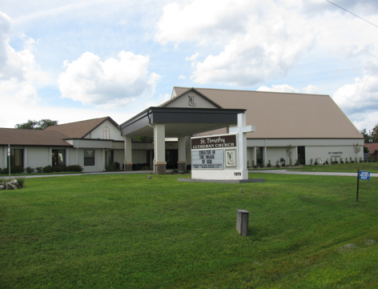

ST. TIMOTHY EVANGELICAL
LUTHERAN CHURCH
Vineyard Views
February 2026

S.A.M.’s Corner
S.A.M. BOB BONOMO
February 2026
Greetings from Our Lord and Savior Jesus Christ.

Do you believe in miracles? The power of bold prayer is alive. Sometimes a miracle is right in front of us, but we do not see it. Let’s take a look at the miracles that I have seen at St. Tim’s. Unless it is wishful thinking on my part, I see a small growth in attendance for Saturday and Sunday Worship. I see dedicated members who volunteer, where the Holy Spirit guides them. I see spiritual gifts being used to do God’s work outside the walls of St. Tim’s. I see members accepting change, not easy to do, and I will always be grateful for those who came before us and brought St. Timothy’s Parish to where we are today. I hear less of “We always did this that way.” I see some folks burned out from church tasks that they may have been doing for a long time. Sometimes ill health prevents us from giving it our all. It is okay to take time off from a committee. This would be an opportunity for a member to step in and learn about the committee of their choice.
This is God’s plan for St. Tim’s. It could be a negative, but it is actually a positive. As volunteers move on, I do not see back up. This is the miracle of listening to the Holy Spirit. If you are not involved, pray boldly that your spiritual gift would be used for the glory of God. When Lay Minister Frank and I went over the time and talent sheets, we were so full of joy for the number of members who volunteered their time and talent.
We had our Annual Congregational meeting in January. No one volunteered to be a member of the council. As a result of this, we have six active people on council, of which one cannot vote and the other is your Interim. Two members are unable to attend due to illness.
This is definitely not sufficient to make a difference. Please consider this position in your prayers.
We are Church: We are community: We are a Family all for the Glory of God!

May the Peace that only HE can give to us be with all you always,
Robert (Bob) Bonomo
S.A.M. Interim

Message from new Council President
The Church Council is starting a new year, and we still could use more members. It is still time to join. It would be nice if we had a variety of men and women which will give us new ideas and insight. The more people we have the more constructive work we can do to meet all the needs of our congregation. Everyone has a voice which can make our church a fellowship of meeting their needs spiritually and physically. Please pray for discernment on the direction God wants you to go.

I am listing some responsibilities for a council member if anyone if wondering what the office entails. It not hard!
- Attend monthly meetings - 3rd Sunday of the month at 11:30 for approximately 1-1/2 hours.
- Report on one of our church committees. You will be given a designated person to contact.
- Take part in decision making and voting.
- Take part in discussion of new and old ideas pertaining to the congregation and church
- Attend Emergency meetings if needed.
If you have any questions let me know.

Barbara Carson, Council President

WELCA ANNOUNCEMENT FOR FEBRUARY VINEYARD VIEWS
"Sisters in Christ, are sisters for life!"

Dear Sisters in Christ,
Did you know that if you are a woman, and you attend St. Timothy Lutheran, you are a member of WELCA (Women of the ELCA). We either have a membership meeting, or a luncheon each month on the third Tuesday.
On January 20, 2026, we welcomed back to St. Timothy, Citrus County Resident, author, and Chronicle writer, Nancy Kennedy. She spoke on Hope & Hallelujah, two words that we definitely need in the world today. Everyone in attendance, was inspired by Nancy to keep hope in our lives, the hope that we have in Jesus Christ and our Father God, and that in all journeys of life we can remember to say a Hallelujah to God to thank Him and Praise Him in good times and bad.
On Friday, February 13, 2026 from 8:00am to 2:00pm we will have our Mini Granny's Attic sale. This event is our only fundraiser for the year. The funds that WELCA & MOST take in are combined, then split between the two groups. From those funds, WELCA & MOST choose a local charity(ies) to donate to. The membership votes on which charity(ies) to donate to. So if you have one in mind, please let me or one of the other board members know so that we can check it out. We will begin accepting items for Granny's Attic sale beginning on Saturday, February 7, 2026. There will be a space in the fellowship hall designated to place your items. We need volunteers to help with the setup beginning Tuesday, February 10, 2026 as well as the day of the sale. THE VOLUNTEER SIGN UP SHEET IS ON THE WELCA BULLETIN BOARD. When you sign up to volunteer please put what time you can help for the setup, sale day, & clean up. We appreciate all of you and thank you so much for joining the fun of Granny's.
On Tuesday, February 17, 2026 at 1:00pm in Bradford Fellowship Hall, we will have a regular WELCA Meeting.
On Saturday, March 7, 2026, we have the PINELANDS CONFERENCE SPRING GATHERING AT HOPE LUTHERAN CHURCH IN THE VILLAGES. The sign-up sheet is on the Welca Bulletin Board. Registration & Breakfast begins at 8:00am. So, we will need to leave St. Timothy at 7:00am. We will be carpooling to this event. Come join us and meet your other sisters in Christ from the Pinelands Conference. We will let you know the cost of the event when we have our Spring Gathering Planning Meeting. In the past it has been $10.00 which gives us all breakfast & lunch. There is a bible study and a worship service. We finish up around 2:00 p.m and will then head back to St. Timothy.
On Tuesday, March 17, 2026, we will have our St. Patrick's Day Tea Party at 12:00pm in Bradford Fellowship Hall. Look for the sign up sheets on the Bulletin Board.
Thank you for all of your love & prayers during my recent illness. I will be allowed to put weight on my left foot just in time for Granny's Attic. Praise the Lord!
Blessings,
Mary C. Schlumberger - President

THE POWER OF PRAYER AND INSPIRATION
“WEEBLES AND WOBBLES”
By Barbara Carson

You may remember the little roly- poly Weeble toy characters all decorated to look like little people. One thing about them was they never fell over. Do you remember the saying “Weeble Wobble but they never fall”? That was because they had a strong foundation. It’s like the faith in God. God will never let us fall if we trust in him. Isaiah 41:10 “Do not fear for I am with you. I will strengthen you and help you.” The story in Matthew 14:22-23 tells about Peter when he was in the boat and a terrible storm came up. Peter was so afraid he would drown, but Jesus told him to go on the water and come to him. When he finally did, he took Jesus’s hand and was saved. Our faith teaches us to trust and that Jesus will never abandon us.
When we are facing many trials and decisions, if our foundation is strong or if we are “wobbling”, Jesus will not let us fall. Psalm 37:24 says “Though he may stumble, he will not fall. For the Lord will hold him with his hand.”

Pope Francis once said that our faith is often weak and can cause us to wobble, but our foundation is firm and we just have to call out to God and let Him take over. He is there ready to save us. Pope Francis also said that “calling out to the Lord is a beautiful prayer.”

We all wobble in our faith at times but our Lord and Savior can steady us through these times. Faith is the remedy God provides through the Holy Spirit equipping us with the Grace that heals us from all despair.

So, think of the Weebles, like us we too can’t fall down. Jesus is there! Amen

Benevolence for February - Together in Mission – Evangelical Outreach Projects – Synod
Florida-Bahamas Synod program to help during crisis in the synod and beyond, as well as helping with food and shelter issues.

From the desk of Minister Robert
If the holy spirit has touched you to even thinking about becoming a council member, feel free to call me or come and see me.
Having a discussion does not mean, in any way that you must say yes.

Blessings


2026 MINI GRANNY’S ATTIC
Where: ST. TIMOTHY LUTHERAN CHURCH
1070 N. SUNCOAST BLVD.
CRYSTAL RIVER, FL 34429
(352) 795-5325

When: FRIDAY, FEBRUARY 13, 2026
8:00 am to 2:00 pm

What: Delicious homemade goodies in the Bake Shop
Ever-popular men’s outdoor treasures
Terrific Buys Throughout Granny’s Attic

Save the date. Come join in the fun!
MINI GRANNY’S ATTIC

CALLING ALL BAKERS!!!
We need cookies, cakes, cupcakes, brownies, candy, breads, etc. for our Bake Sale on
Friday, February 13, 2026.
- You may package your goodies, or we can
do that for you.
- Please mark the goodies if they are gluten
free and/or sugar free.
- Please note if there are nuts in the baked
goods.
- Please bring the items to the Church
either Thursday, February 12th or early
Friday morning, February 13th.
Thanks so much for your help and support.

Questions: Call Eileen at 352-419-6610 or Lynn at 352-382-0435.


We kicked off the Souper Bowl of Caring on January 17, 2026, and it will last until the Super Bowl is played on February 08, 2026. We are collecting soup along with canned fruit and canned vegetables. On February 8th, me, Randy, and whoever else wants to join us will tabulate the cans and come up with the winner. We will compare our “score” to the actual score and see how well we predicted the winner. All cans collected will then be brought to the Life Tree Church Food Pantry on Tuesday, February 10th, who is the real winner of this event.
Thanks so much
Barbara, "The Coach"

Please check for the following sign-up sheets
Serving Our Lord (Worship Helpers) – bulletin board by music room
Flower chart – bulletin board across from nursery
Healthy Start – WELCA bulletin board
PB&J Ministry – WELCA board
Coffee Hour – in kitchen
Pinelands Conference Spring Gathering (coming soon to WELCA board)
St. Patrick’s Day/Spring Tea (coming soon to WELCA board)

DEADLINES
Announcements
Please be aware that if you have entries for the weekend worship announcements you need to have them in on Tuesday prior, as we are preparing and printing them no later than Thursday.
Vineyard Views
If you have submissions for the March Vineyard Views, please have them in the office no later than the end of day on Tuesday, February 24th.

NEW ZOOM LINK FOR ADULT SUNDAY SCHOOL – 9/18
Topic: Adult Sunday School Class
Time: Sep 21, 2025 10:30 AM Eastern Time (US and Canada)
Every week on Sun, 97 occurrence(s)
Please download and import the following iCalendar (.ics) files to your calendar system.
Weekly: https://us02web.zoom.us/meeting/tZwrc-mprDMoH9YRklu1WcmVIop862c72xVO/ics?icsToken=DBOIHJoC7iVwo_7kCQAALAAAABAB_uGypwq2ymkMO9EqrhDMoZY3vO7cudxQ3PHNM4LxWE7vm8v6Hf2LmVyJEkPyvcQ1Vmg_NR4W6BglNTAwMDAwMQ&meetingMasterEventId=3pLv0et_SMuCQYJkMknIyQ
Join Zoom Meeting
https://us02web.zoom.us/j/88640128252?pwd=asNJ6OiNGFFTNzwNA5yhkvPpmt6VCT.1
Meeting ID: 886 4012 8252
Passcode: 898938

CALLING ALL RINGERS OR POTENTIAL RINGERS!!
We’d like to expand the chimes choir (and have enough ringers for when people are out of town). Contact Sally Hennessey or Barbara Johnson.


INFORMATION FROM THE FINANCE COMMITTEE
AND YOUR TREASURERS
In the hope of getting ahead of our property, liability and flood insurance costs for next year, we have been trying to save toward those expenses. (Property and liability premiums are due by June 1st of each year, and flood is due November 1st.) We would appreciate any additional donation you could make. Please include that amount with your regular offering and designate it as “Insurance” on the offering envelope.
The lighting updates and replacements in the Sanctuary and throughout St. Timothy have been completed. What a wonderful improvement it is! The cost of this project was $9,500.00. As of January 11, 2026, we have received $5,758.38 in designated offerings to help with this expense. If you would like to help defray the cost, please note your donation as “Lighting Expense” on your offering envelope.

If you have not completed and returned your Time and Talent Sheets and Giving Card for 2026, please do so as soon as possible. This helps us plan for the current year.

A weekly offering update is given with the email announcements. We are most grateful to all of you who support our programs through your prayers, offerings, time and talents.


THRIVENT FINANCIAL NEWS FOR FEBRUARY 2026
$$$THRIVENT CHOICE DOLLARS®$$$
Thanks so much to our Thrivent Financial members and friends who direct their Thrivent Choice Dollars® to
available for activities and projects for our mission and ministry here at St. Timothy. If you are an eligible
Thrivent Financial member and have Choice Dollars® available, please call Thrivent (800-847-4836) and say “Thrivent Choice®” or go online to www.thrivent.com/thriventchoice and direct your dollars…hopefully to St. Timothy Lutheran Church in Crystal River. For this our church has received $36.00 through this program. Many thanks to our members who recently designated their dollars:
Stephen Brisson DuWayne Fowler
PLEASE NOTE: If you have Choice Dollars remaining for 2025 that you haven’t designated, please do so before March 31, 2026.
THRIVENT ACTION TEAMS
Thrivent Action Teams make it easy for you to bring people together to make a positive change in your community! When you see a need, apply to lead a volunteer team. Once your idea is approved, a Thrivent Action Kit is delivered to your door. It’s packed with everything you need to help make your project a success. It even includes $250.00 in seed money to help get your project started. After you finish the project, you report the results on-line to Thrivent. This program is brought to you by Thrivent Financial because they believe that being wise with money and living generously go hand in hand. All your questions and requests for this funding program will be answered by going to Thrivent.com/actionteam.***Please note that Thrivent Financial funds accessed for all programs and activities involving St. Timothy Lutheran Church need to be approved by a Committee and the Congregational Council. 2026Thrivent Action Teams that have been approved: Easter Food Boxes.
THE $250 IN SEED MONEY IS A GIFT FROM THRIVENT THAT WE CAN USE TO HELP WITH COMMUNITY OUTREACH AND PROJECTS INVOLVING OUR CONGREGATION. THESE FUNDS ARE IN ADDITION TO OUR BUDGETED AMOUNTS AND OFFERINGS AND DONATIONS MADE BY OUR MEMBERS AND FRIENDS.

Financial Representatives for answering questions and offering advice on Thrivent investments and products are:

Katherine Gross Kevin Braunschweiger
in Gainesville, FL in Ocala, FL
352-505-8905 352-440-6784
Katherine.gross@thrivent.com
Virtual Advice Team – 855-303-7402

Food Pantry-updated 1/28
The food pantry continues to operate on the 2nd and 4th week of every month from 9AM- noon. We continue to inform the congregation as to the needs of the pantry via the weekly announcements. The current needs are fruit, spaghetti- 16oz., peanut butter, chili which serves 2 people and laundry detergent (dollar store is fine). Thanks to all who contribute food. You can also contribute monetarily by writing out a check made out to Life Tree Church with Food Pantry in the memo line or writing out a check to Barbara Johnson and putting food pantry in the memo line, and placing it in my mailbox, #210. We will also accept cash donations. Please put it in an envelope in my mailbox, #210 and put your name on it so I know who you are. If you would like a receipt, please let me know. The next food pantry will be January 27, 2026.
On January 17, we kicked off “Souper Bowl of Caring” and it will last until the Super Bowl is played on February 8, 2026. We are collecting soup along with canned fruit and canned vegetables. On February 8, we will tabulate the cans and come up with the winner. We will compare our “score” to the actual score and see how well we predicted the winner. All cans collected will then be brought to the Life Tree Church Food Pantry on Tuesday, February 10, who is the real winner of this event.
On January 27, 2026, the food pantry had 64 individual people come in which consisted of 134 adults and 15 children for a total of 149 people. We had 3 new families consisting of 5 adults and 1 child.
The next food pantry is February 10th
Respectfully submitted, Barbara Johnson

Healthy Start – updated 1/8
Nothing is needed for February. Please help us stock up for March.
Baby bibs, baby blankets, baby lotion, baby oil, baby shampoo, baby wipes, booties or socks, diaper cream, gentle soap (like ivory), toy or teething ring, wash cloths, and Vaseline.

Carolyn Fialkowski

PB&J MINISTRY UPDATE – 12/30
There is a sign-up sheet on the board next to the kitchen. We will be packing on the first Monday of the month at 10am. We need about 6 people so we are done by 11. Please let me know if you can help. Barbara Carson


MESSAGE FROM REGINA
Please, if you are at a church function, think about snapping a few photos for everyone to enjoy. Thank you in advance.

SERVING HANDS
Serving Hands is a program created to help members of our own congregation. Serving Hands is there for you if you need some help in the following areas: a meal brought to you, driving you to an appointment, a friendly visit, doing a household chore, communion brought to you, walking your dog, or picking up food for your pet, etc. These are one-time opportunities, not forever experiences. Please contact Carolyn Fialkowski at 814-392-4281, or Jean Fowler at 586-322-8337 if you need help.
Please don’t hesitate to call. We want to serve you! Also, if you are willing to help with any of these services, there is a sign-up chart on the kiosk in the entrance way of the church or call one of these ladies.

AED /Medical response :
We have a poster that is behind the kiosk across from our AED in the narthex. An emergency incident can happen at any time, and it is good to be prepared. The poster explains a “hands only “ CPR protocol as the first line of an emergency of that kind and is very easy for anyone. Please take a look and refresh yourself on the protocol. Our AED is valuable for saving lives but initiating CPR is essential. We do have several people in our congregation that have more detailed experience to assist as needed. For any questions, please ask Barbara Carson.
Instructional video on how to use the Philips AED.
https://youtu.be/t6GV9PAbgM4?si=dZuGq8aLjfvpFiM-

ST TIMOTHY’S WEBSITE
Here is the St. Timothy website address: https://www.sttimlutherancrystalriver.com/

There are links for the weekend’s services on the homepage. Please note that the links will change every week, since this is a YouTube file address; every service has its own link. Watch for an email with the updated links when they are ready. The video links for previous weekends will still be available at the bottom of the webpage, as the links are updated each week. Please contact us if you would like a CD of any of the services to listen to. Be sure to check out our children’s artwork at the bottom of the home page. We hope to add more as they send it to us.

Here is a link to St Timothy's YouTube:


https://www.youtube.com/channel/UC5xrMj8-8_6iyR_KxjFAwRQ/videos

Facebook
See our Facebook page for information about upcoming events and Please feel free to message us with suggestions about content. - Regina


St. Timothy Evangelical Lutheran Church | Facebook


The Sunshine Card Makers
The Card Makers meet the first Wednesday of the month at 1pm, in the Fellowship Hall.
-Kathy G

Senior Care Resources
Caring.com is a free resource that provides comprehensive information on topics like financial support, and care options to family caregivers seeking information as they care for aging parents by AARP, The Administration for Community Living, The National Legal Resource Center, and Forbes, as well as referenced by many governmental agencies and organizations across the internet.
https://www.caring.com/senior-living/memory-care-facilities/
https://www.caring.com/senior-living/memory-care-facilities/florida
https://www.caring.com/caregivers/alzheimers/
https://www.caring.com/caregivers/dementia/

WE HAVE SEVERAL HANDBOOKS ON DEMENTIA IN THE CHURCH LIBRARY, IF ANYONE WOULD LIKE INFORMATION

We have the January, February, and March 2026 Christ in Our Home booklets. There are some on the table by the mailboxes or you may request one to be put in your box.

HERE AND THERE WITH THE FOLKS OF ST TIMOTHY

Coffee Fellowship
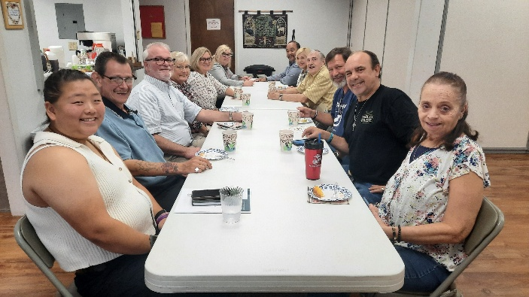
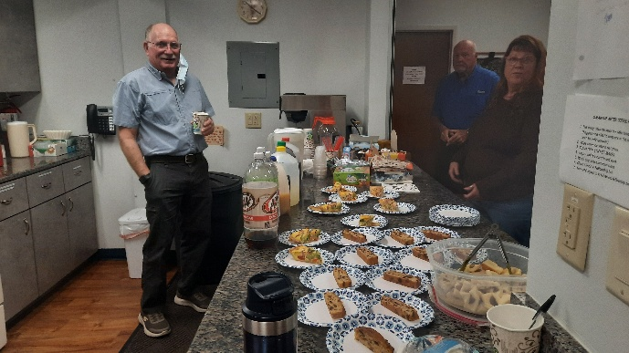


Bob Miller 2/3
Greg White 2/14
Zell Boggus 2/17
Teresa York 2/21
Judi Schutrum 2/25

Birthday Blessings!
SUNDAY | MONDAY | TUESDAY | WEDNESDAY | THURSDAY | FRIDAY | SATURDAY
1  9am Worship  10:15-10:45 D-UP Communion  10:30 Adult SS, Coffee Fellowship | 2  10am PB&J  11am Healthy Start | 3 | 4  11am Citrus Blessings  1pm Card Makers | 5  11-12 Bible Study for Beginners  11am Miniatures  4:30 Choir | 6 | 7  4pm Worship
8  9am Worship  10:15-10:45 D-UP Communion  10:30 Adult SS, Coffee Fellowship | 9  10:30 Ruth Circle @ Barb C’s house | 10  9-12 Food Pantry | 11  1pm Worship & Music | 12  11-12 Bible Study for Beginners  11am Miniatures  4:30 Choir | 13 | 14
15  9am Worship  10:15-10:45 D-UP Communion  10:30 Adult SS, Coffee Fellowship  Council | 16 | 17  1pm WELCA  Shrove Tuesday | 18  Ash Wednesday  Lent begins | 19  11-12 Bible Study for Beginners  11am Miniatures  4:30 Choir | 20  1pm Royal Dalton Memory Care | 21
22  9am Worship  10:15-10:45 D-UP Communion  10:30 Adult SS, Coffee Fellowship | 23 | 24  9-12 Food Pantry | 25  Lenten Studies followed by Soup Supper | 26  11-12 Bible Study for Beginners  11am Miniatures  4:30 Choir | 27 | 28
February 2026

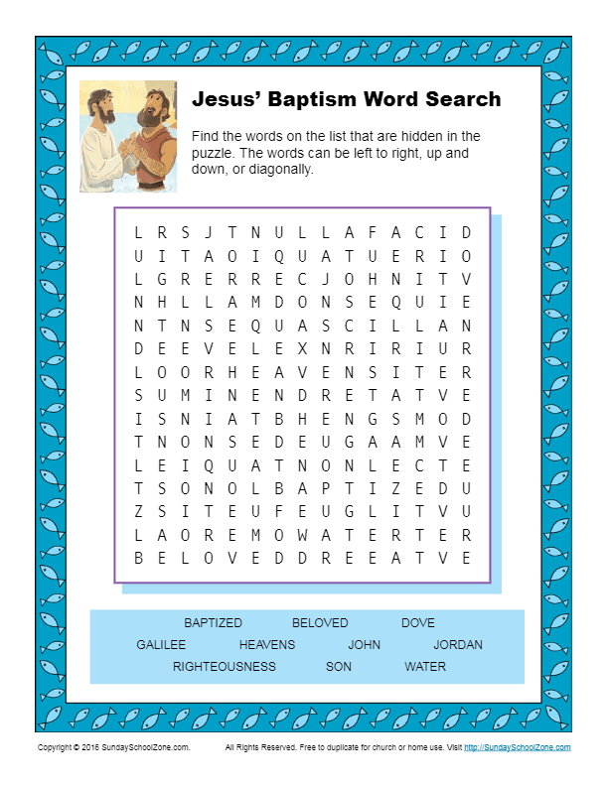
St. Timothy Lutheran Church
S.A.M. Robert “Bob” Bonomo
1070 N. Suncoast Blvd.
Crystal River, FL 34429
Phone: 352-795-5325

Church email: crsttimothy@tampabay.rr.com
Website: www.sttimlutherancrystalriver.com

Lay Minister: Frank Hofstetter
Director of Music: Sally Hennessey
Saturday Pianist: Bill Robinson
Church Secretary: Regina Mendicino
Sexton: William “Bill” Dexter

2025 Congregational Council
President: Barbara Carson
Vice-President: Barbara Johnson
Secretary: Carolyn Fialkowski
Treasurers: Lynn Dively & Cheryl VanHorn
Financial Secretary: Randy Holden & Dick Kleinsmith
Council Members: Andrea Mitchell, Fola Long, and Marsha Gibson

Weekly Worship
Saturdays 4pm
Sundays 9am
Communion available at both services
Children’s Sunday School - 9am
Adult Sunday School - 10:30am
Drive-Up Communion – 10:15-10:45
Saturday and Sunday Services - links ONLINE

