Welcome to St. Timothy Evangelical Lutheran Church
February 22, 2026
First Sunday in Lent

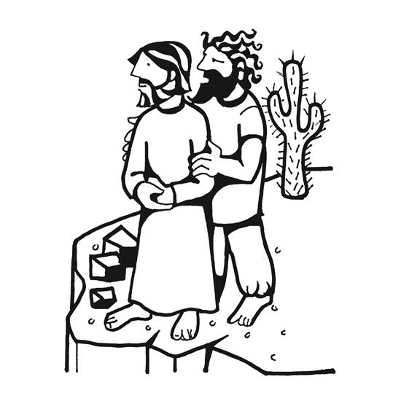

Today's gospel tells of Jesus’ temptation in the desert. His forty-day fast becomes the basis of our Lenten pilgrimage. In the early church Lent was a time of intense preparation for those to be baptized at the Easter Vigil. This catechetical focus on the meaning of faith is at the heart of our Lenten journey to the baptismal waters of Easter. Hungry for God’s mercy, we receive the bread of life to nourish us for the days ahead.

Pre-Service: I Want Jesus to Walk with Me ELW 325
Welcome and Sharing of Congregational News
Prelude

Confession and Forgiveness
All may make the sign of the cross, the sign that is marked at baptism, as the presiding minister begins.
Blessed be the holy Trinity, ☩ one God,
who forgives all our sin,
whose mercy endures forever.
Amen.
Let us confess our sin before God, who removes our guilt
and blots out all offenses.
Silence is kept for reflection.
Gracious God,
have mercy on us according to your steadfast love.
For seeking worldly delights that deceive us and dishonor you:
Gracious God,
have mercy on us according to your steadfast love.
For desiring self-reliance instead of hungering for your word:
Gracious God,
have mercy on us according to your steadfast love.
For failing to recognize your coming reign,
and for hindering the work of the Spirit: Gracious God,
have mercy on us according to your steadfast love.
For drawing from the well of self-serving ambition,
and for disdaining the living water Christ offers: Gracious God,
have mercy on us according to your steadfast love.
For disregarding voices from the margin,
and for distrusting signs of your healing and hope in the world:

Gracious God,
have mercy on us according to your steadfast love.
For dwelling in tombs of self-pity and discontent,
and for disregarding Christ’s call to come forth to life:
Gracious God,
have mercy on us according to your steadfast love.
God’s steadfast love, grace, and forgiveness abound.
Through faith, the free gift of God,
you have been clothed in the righteousness of Christ.
In the name of ☩ Jesus Christ, your sins are forgiven.
The Spirit of the One who raised Christ from the dead
dwells in you,
pours God’s love into your hearts,
and gives you life and peace.
Amen.
Greeting
P: The joy of our Lord Jesus Christ, the compassion of God, and the creative power of the Holy Spirit be with you all.
C: And also with you.

Gathering Hymn: O Lord, Throughout These Forty Days ELW 319
- O Lord, throughout these forty days you
prayed and kept the fast; inspire repentance
for our sin, and free us from our past.

- You strove with Satan, and you won; your
faithfulness endured; lend us your nerve, your
skill, and trust in God's eternal word.

- Though parched and hungry, yet you prayed and
fixed your mind above; so teach us to deny
ourselves that we may know God's love.

- Be with us through this season, Lord, and
all our earthly days, that when the final
Easter dawns, we join in heaven's praise.
Text: based on Claudia F. Hernaman, 1838-1898; para. Gilbert E. Doan Jr., b. 1930
Text © 1978 Lutheran Book of Worship, admin. Augsburg Fortress.
Text © 1991 GIA Publications, Inc., 7404 S. Mason Ave., Chicago, IL 60638. www.giamusic.com. 800.442.3358. All rights reserved. Used by permission.

Prayer of the Day
Lord God, our strength, the struggle between good and evil rages within and around us, and the devil and all the forces that defy you tempt us with empty promises. Keep us steadfast in your word, and when we fall, raise us again and restore us through your Son, Jesus Christ, our Savior and Lord, who lives and reigns with you and the Holy Spirit, one God, now and forever.
Amen.

Have Mercy on Us, Lord
Have mercy on us, Lord, and hear our solemn prayer.
We come to hear your living Word; it saves us from dispair.
Have mercy on us, Christ, and wash away our sin.
Pour out your grace and make us whole that new life may begin.
Have mercy on us, Lord; make sin and shame depart.
Renew us with your saving pow’r, create in us new hearts!

First Reading: Genesis 2:15-17; 3:1-7
Human beings were formed with great care, to be in relationship with the creator, creation, and one another. The serpent’s promise to the first couple that their eyes would be opened led, ironically, to the discovery only that they were naked.
¹⁵ The Lord God took the man and put him in the garden of Eden to till it and keep it. ¹⁶ And the Lord God commanded the man, “You may freely eat of every tree of the garden, ¹⁷ but of the tree of the knowledge of good and evil you shall not eat, for in the day that you eat of it you shall die.”
^{3:1} Now the serpent was more crafty than any other wild animal that the Lord God had made. He said to the woman, “Did God say, ‘You shall not eat from any tree in the garden’?” ² The woman said to the serpent, “We may eat of the fruit of the trees in the garden, ³ but God said, ‘You shall not eat of the fruit of the tree that is in the middle of the garden, nor shall you touch it, or you shall die.’ ” ⁴ But the serpent said to the woman, “You will not die, ⁵ for God knows that when you eat of it your eyes will be opened, and you will be like God, knowing good and evil.” ⁶ So when the woman saw that the tree was good for food and that it was a delight to the eyes and that the tree was to be desired to make one wise, she took of its fruit and ate, and she also gave some to her husband, who was with her, and he ate. ⁷ Then the eyes of both were opened, and they knew that they were naked, and they sewed fig leaves together and made loincloths for themselves.

P: The Word of the Lord.
C: Thanks be to God!

Psalm 32
¹ Happy are they whose transgressions are forgiven,
and whose sin is put away!
² Happy are they to whom the Lord imputes no guilt,
and in whose spirit there is no guile!
³ While I held my tongue, my bones withered away,
because of my groaning all day long.
⁴ For your hand was heavy upon me day and night;
my moisture was dried up as in the heat of summer.
⁵ Then I acknowledged my sin to you, and did not conceal my guilt.
I said, “I will confess my transgressions to the Lord.” Then you forgave me the guilt of my sin.
⁶ Therefore all the faithful will make their prayers to you in time of trouble;
when the great waters overflow, they shall not reach them.
⁷ You are my hiding-place; you preserve me from trouble;
you surround me with shouts of deliverance.
⁸ “I will instruct you and teach you in the way that you should go;
I will guide you with my eye.
⁹ Do not be like horse or mule, which have no understanding;
who must be fitted with bit and bridle, or else they will not stay near you.”
¹⁰ Great are the tribulations of the wicked;
but mercy embraces those who trust in the Lord.
¹¹ Be glad, you righteous, and rejoice in the Lord;
shout for joy, all who are true of heart.

Second Reading: Romans 5:12-19
Through Adam’s disobedience, humanity came under bondage to sin and death, from which we cannot free ourselves. In Christ’s obedient death, God graciously showers on us the free gift of liberation and life.
¹² Just as sin came into the world through one man, and death came through sin, and so death spread to all because all have sinned ¹³ for sin was indeed in the world before the law, but sin is not reckoned when there is no law. ¹⁴ Yet death reigned from Adam to Moses, even over those who did not sin in the likeness of Adam, who is a pattern of the one who was to come.
¹⁵ But the free gift is not like the trespass. For if the many died through the one man’s trespass, much more surely have the grace of God and the gift in the grace of the one man, Jesus Christ, abounded for the many. ¹⁶ And the gift is not like the effect of the one man’s sin. For the judgment following one trespass brought condemnation, but the gift following many trespasses brings justification. ¹⁷ If, because of the one man’s trespass, death reigned through that one, much more surely will those who receive the abundance of grace and the gift of righteousness reign in life through the one man, Jesus Christ.
¹⁸ Therefore just as one man’s trespass led to condemnation for all, so one man’s act of righteousness leads to justification and life for all. ¹⁹ For just as through the one man’s disobedience the many were made sinners, so through the one man’s obedience the many will be made righteous.
P: The Word of the Lord.
C: Thanks be to God!
Gospel Acclamation
We are turning, Lord, to hear you; you are merciful and kind—slow to anger, rich in blessing, and with love to us inclined.

P: The Holy Gospel according to Matthew 6:1-6, 16-21
C: Glory to you O Lord.

Gospel: Matthew 4:1-11
Jesus experiences anew the temptations that Israel faced in the wilderness. As the Son of God, he endures the testing of the evil one.
¹ Jesus was led up by the Spirit into the wilderness to be tested by the devil. ² He fasted forty days and forty nights, and afterward he was famished. ³ The tempter came and said to him, “If you are the Son of God, command these stones to become loaves of bread.” ⁴ But he answered, “It is written,
‘One does not live by bread alone,
but by every word that comes from the mouth of God.’ ”
⁵ Then the devil took him to the holy city and placed him on the pinnacle of the temple, ⁶ saying to him, “If you are the Son of God, throw yourself down, for it is written,
‘He will command his angels concerning you,’
and ‘On their hands they will bear you up,
so that you will not dash your foot against a stone.’ ”
⁷ Jesus said to him, “Again it is written, ‘Do not put the Lord your God to the test.’ ”
⁸ Again, the devil took him to a very high mountain and showed him all the kingdoms of the world and their glory, ⁹ and he said to him, “All these I will give you, if you will fall down and worship me.” ¹⁰ Then Jesus said to him, “Away with you, Satan! for it is written,
‘Worship the Lord your God,
and serve only him.’ ”
¹¹ Then the devil left him, and suddenly angels came and waited on him.

P: The Gospel of Our Lord!
C: Praise to You O Christ!
Sermon by Bob

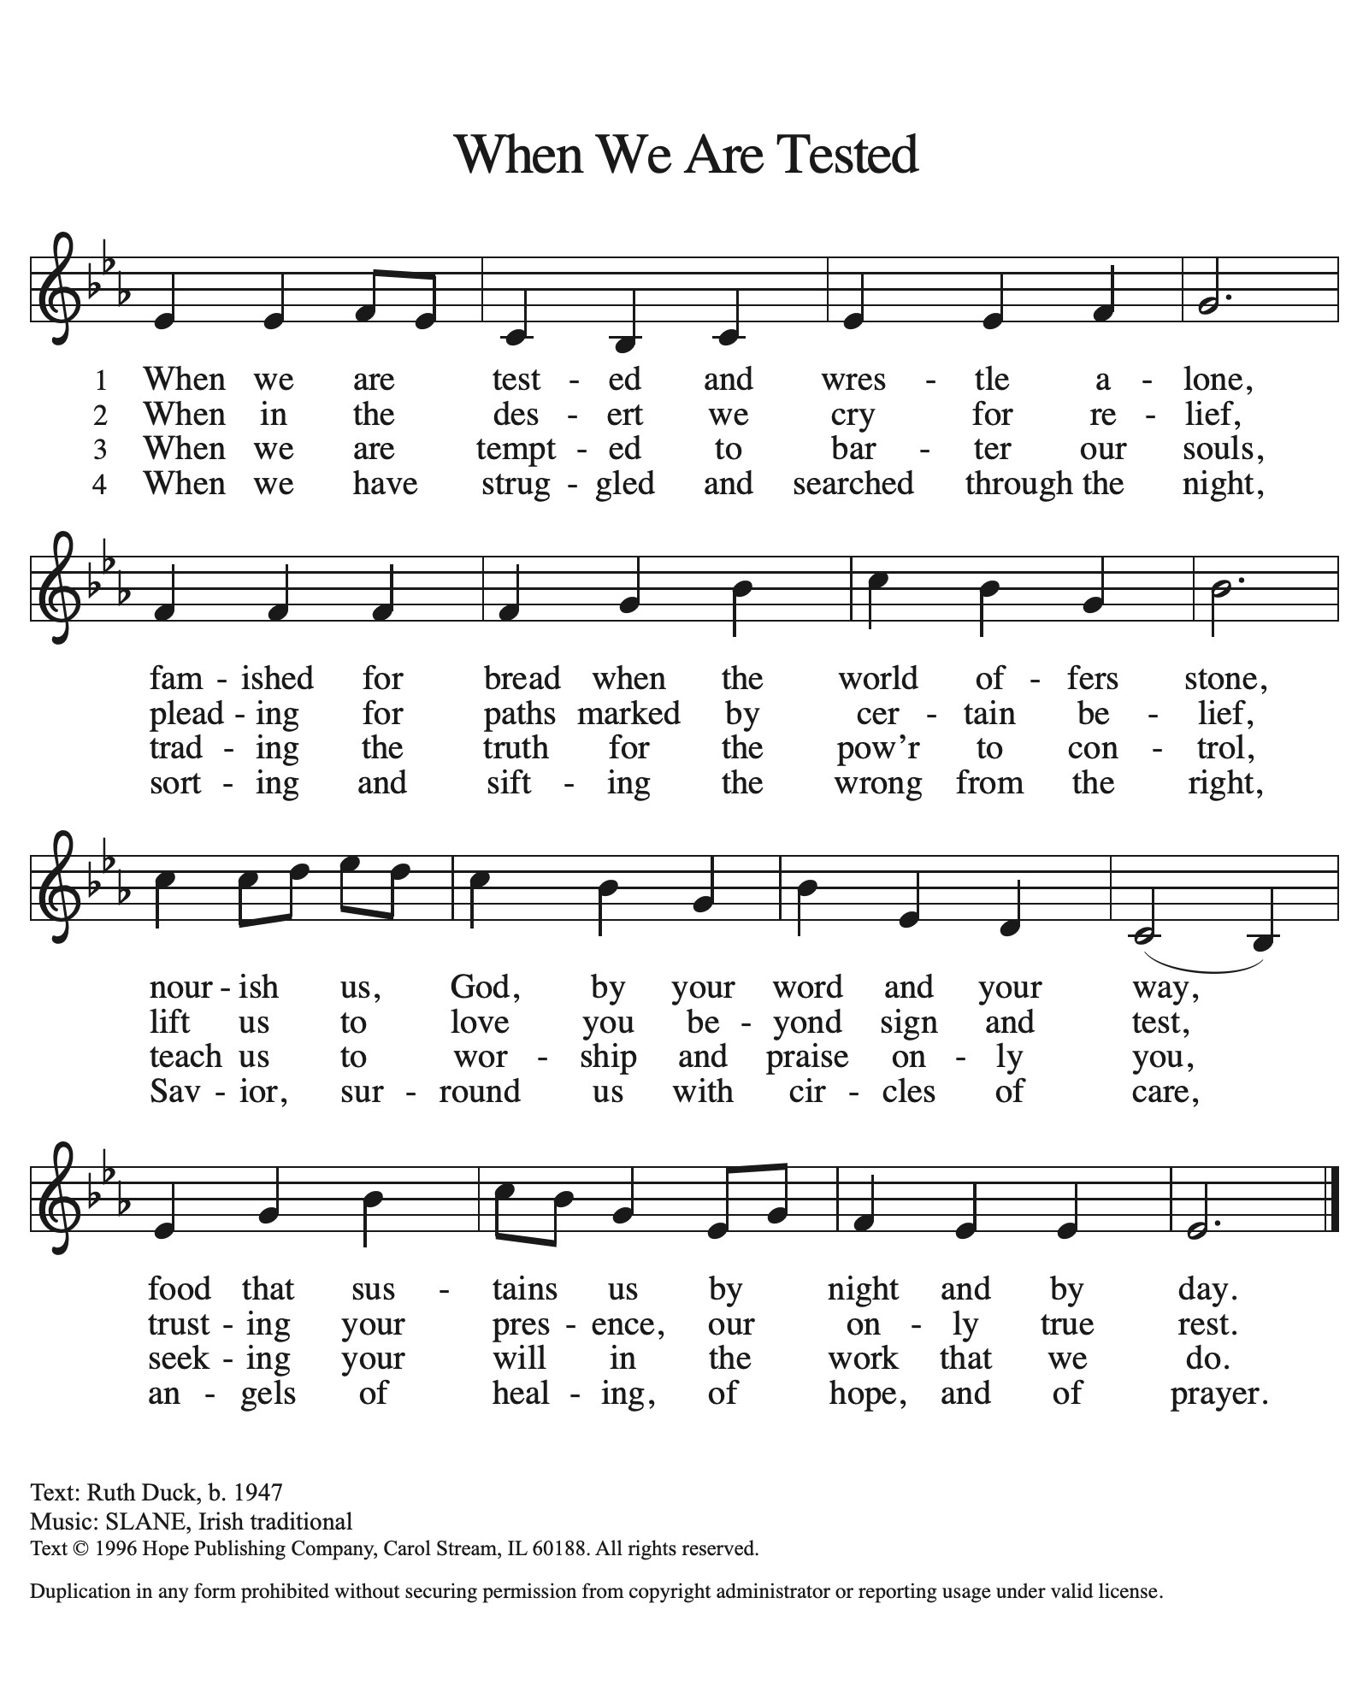
Hymn of the Day ACS 922

Nicene Creed
We believe in one God,
the Father, the Almighty,
maker of heaven and earth,
of all that is, seen and unseen.
We believe in one Lord, Jesus Christ,
the only Son of God,
eternally begotten of the Father,
God from God, Light from Light,
true God from true God,
begotten, not made,
of one Being with the Father;
through him all things were made.
For us and for our salvation
he came down from heaven,
was incarnate of the Holy Spirit and the Virgin Mary
and became truly human.
For our sake he was crucified under Pontius Pilate;
he suffered death and was buried.
On the third day he rose again
in accordance with the Scriptures;
he ascended into heaven
and is seated at the right hand of the Father.
He will come again in glory to judge the living and the dead,
and his kingdom will have no end.
We believe in the Holy Spirit, the Lord, the giver of life,
who proceeds from the Father and the Son,
who with the Father and the Son is worshiped and glorified,
who has spoken through the prophets.
We believe in one holy catholic and apostolic church.
We acknowledge one baptism for the forgiveness of sins.
We look for the resurrection of the dead,
and the life of the world to come. Amen.
From sundaysandseasons.com.
Copyright © 2026 Augsburg Fortress. All rights reserved.

Prayers of the People
Response (after “Hear us, O God”): “Your mercy is great”
Receive our prayers, O God, through Jesus Christ, our strength and salvation.
Amen.
P: May the peace of our Lord Jesus Christ be with you all.
C: And also with you.
P: Let us now share this peace.
Offering is Brought to the Altar

Offertory Prayer
O God, maker of heaven and earth,
your steadfast love embraces all creation.
You send rain and sunshine to nourish the earth
and bring forth its bounty.
Through these gifts of bread and wine,
draw us into the death and life of your Son,
who calls us to bear witness to his saving work.
We ask this in Jesus’ name. Amen.
P: The Lord be with you.
C: And also with you.

P: Lift up your hearts.
C: We Lift them to the Lord.

P: Let us give thanks to the Lord our God.
C: It is right to give our thanks and praise.

Preface
(Words spoken by Bob)

Holy, holy, holy Lord,
God of power and might,
heav’n and earth are full of your glory.
Hosanna in the highest.
Blessed is he who comes in the name of the Lord.
Hosanna in the highest,
hosanna in the highest.

Eucharistic Prayer
(Words of Institution)

For as often as we eat of this bread and drink from this cup we proclaim the Lord’s death until He comes.
Christ has died
Christ is risen.
Christ will come again.
Remembering, therefore, his salutary command,
his life-giving passion and death, his glorious resurrection and ascension,
and the promise of his coming again,
we give thanks to you, O Lord God Almighty,
not as we ought but as we are able;
we ask you mercifully to accept our praise and thanksgiving and with your Word and Holy Spirit to bless us, your servants, and these your own gifts of bread and wine, so that we and all who share in the body and blood of Christ may be filled with heavenly blessing and grace,
and, receiving the forgiveness of sin,
may be formed to live as your holy people
and be given our inheritance with all your saints.
To you, O God, Father, Son, and Holy Spirit,
be all honor and glory in your holy church, now and forever. Amen.

Gathered into one, by the Holy Spirit let us listen to the words that Jesus taught us.
The Lord’s Prayer
Our Father, who art in heaven, hallowed be thy name, thy kingdom come, thy will be done, on earth as it is in heaven. Give us this day our daily bread; and forgive us our trespasses, as we forgive those who trespass against us; and lead us not into temptation but deliver us from evil. For thine is the kingdom, and the power, and the glory, forever and ever. Amen.

Invitation to Communion
P: Come to the table. Feast on God’s goodness and mercy.
C: Amen

Lamb of God, you bear the sin of all the world away;
you suffered death our lives to save: have mercy now, we pray. O Lamb of God, you bear the sin of all the world away; you set us free from guilt and grave: have mercy now, we pray. O Lamb of God, you bear the sin of all the world away; eternal peace with God you made: give us your peace, we pray.

All may come.
Communion Anthem: In Adam We Have All Been One LBW 372 (to the tune of Martyrdom)
P: We are now a tabernacle with Christ inside of us. Let us rejoice and be glad at the Lord’s table. C: Amen

Prayer after Communion
God of our salvation,
We give you thanks for this meal that restores our souls,
Reconciles us to you, and strengthens us for the journey.
Through the body and blood of your Son,
May we become Christ’s body in the world,
Bearing witnewss to your love for all creation,
Through Jesus Christ, our Savior and Lord.
Amen.

Blessing
Receive the blessing of the holy Trinity:
God, who calls all things into existence,
Jesus Christ, who redeems us,
and the Holy Spirit, whose breath sustains creation,
☩ bless you now and always.
Amen.

Sending Hymn: Jesus, Still Lead On ELW 624
- Jesus, still lead on, till our rest be won; and, although the
way be cheerless, we will follow, calm and fearless;
guide us by your hand to the promised land.

- If the way be drear, if the foe be near, let no faithless
fears o'ertake us, let not faith and hope forsake us;
safely past the foe to our home we go.

3 When we seek relief from a long-felt grief, when temptations come alluring make us patient and enduring;
show us that bright shore where we weep no more.

4 Jesus, still lead on, till our rest be won; heav'nly leader,
still direct us, still support, console, protect us,
till we safely stand in the promised land.
Text: Nicolaus L. von Zinzendorf, 1700-1760; tr. Jane L. Borthwick, 1813-1897, alt.

Dismissal
P: Go in peace. Believe the good news.
C: Thanks be to God.
Postlude
Unless otherwise noted, materials used in this bulletin are:
From Sundays and Seasons.com. Copyright 2015 Augsburg Fortress. All rights reserved. Reprinted by permission under Augsburg Fortress Liturgies Annual License #SAS028635. Music is reprinted under OneLicense.Net #A712074 and/or Augsburg Fortress #SBL12176H. Scripture, unless otherwise noted, is from the New Revised Standard Version Bible, Copyright © 1989, Division of Christian Education of the National Council of the Churches of Christ in the United States of America. Used by permission. All rights reserved.

St. Timothy Evangelical Lutheran Church
1070 N. Suncoast Blvd.
Crystal River, FL 34429
Telephone number (Office): 352-795-5325
Office email address: crsttimothy@tampabay.rr.com

St Timothy Worship Team
S.A.M. Robert F. Bonomo
Lay Minister, Frank Hofstetter
Director of Music, Sally Hennessey
Saturday Pianist, Bill Robinson
Announcements for February 21st and 22nd

ATTENDANCE
Saturday, February 14, 4pm 21
Sunday, February 15, 9am 49
Drive-Up Communion 2
72

The Altar Flowers are given this week by Debbie Lawrence, in memory of her father, Al Stark’s birthday!

Serving our Lord this weekend:
Saturday
Reader – Jean Fowler
Sunday
Assisting Minister – Sallie Haley
Reader –Sarah Brisson
This Week at St. Timothy's
Monday, February 23rd
Tuesday, February 24th 9-12 Food Pantry, Vineyard Views Deadline
Wednesday, February 25th 4pm Lenten Studies followed by Soup Supper
Thursday, February 26th 11am Bible Study for Beginners (bring bible) 11am – Miniatures, 3:30 Chimes, 4:30pm - Choir
Friday, February 27th
Saturday, February 28th 4pm - Worship
Sunday, March 1st 9am – Worship, 10:15-10:45 – Drive Up Communion, Adult SS, Coffee Fellowship
