St Timothy Lutheran Church
Sunday, August 23, 2026
^{13th} Sunday after Pentecost

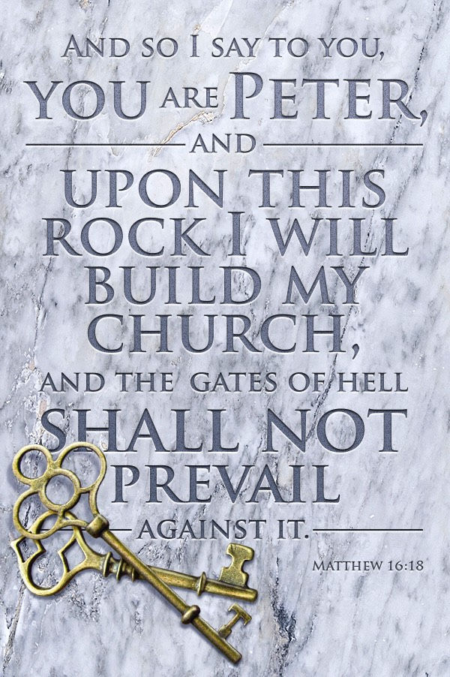

In Isaiah the people are advised to look to their spiritual ancestors as the rock from which they were hewn. Jesus declares that the church will be built on the rock of Peter’s bold confession of faith. God’s word of reconciliation and God’s mercy are keys to the church’s mission. Paul urges us to not be conformed to this world but to offer our bodies as a living sacrifice, using our individual gifts to build up the body of Christ. From the table we go forth to offer our spiritual worship through word and deed.

Preservice: Making Their Way ACS 979
Welcome!
Prelude
P – Preparing our hearts for Worship

Confession and Forgiveness
All may make the sign of the cross, the sign that is marked at baptism, as the presiding minister begins.
Blessed be the holy Trinity,☩ one God,
whose compassion endures forever.
Amen.
Let us confess our sin to God.
Silence is kept for reflection.
Compassionate God,
we confess to you all our sins.
Our burden is heavy, and we cannot free ourselves.
In your mercy, call us back to you.
Your yoke is easy and your burden is light.
Restore us to dwell in your peace.
In Christ’s name we pray,
Amen.
Jesus says, “Come to me,
all you who are weary
and are carrying heavy burdens,
and I will give you rest.”
In the name of God,
Father, ☩ Son, and Holy Spirit,
your sins are forgiven.
Rest in God’s love. Amen.

Gathering Hymn: Here I Am, Lord ELW 574
1 "I, the Lord of sea and sky, I have heard my people cry.
All who dwell in dark and sin my hand will save.
I, who made the stars of night, I will make their darkness bright.
Who will bear my light to them? Whom shall I send?"

Refrain
Here I am, Lord. Is it I, Lord? I have heard you
calling in the night. I will go, Lord, if you
lead me. I will hold your people in my heart.

2 "I, the Lord of snow and rain, I have borne my people's pain.
I have wept for love of them. They turn away.
I will break their hearts of stone, give them hearts for love alone.
I will speak my word to them. Whom shall I send?" Refrain

3 "I, the Lord of wind and flame, I will tend the poor and lame.
I will set a feast for them. My hand will save.
Finest bread I will provide till their hearts be satisfied.
I will give my life to them. Whom shall I send?" Refrain

Text: Daniel L. Schutte, b. 1946
Text © 1981 OCP Publications, Inc., 5536 NE Hassalo, Portland, OR 97213. All rights reserved. Used by permission.
Duplication in any form prohibited without permission or valid license from copyright administrator.

P - The grace of our Lord Jesus Christ, the love of God and the communion of the Holy Spirit be with you all.
C - And also with you.

Prayer of the Day
O God, with all your faithful followers of every age, we praise you, the rock of our life. Be our strong foundation and form us into the body of your Son, that we may gladly minister to all the world, through Jesus Christ, our Savior and Lord.
Amen.

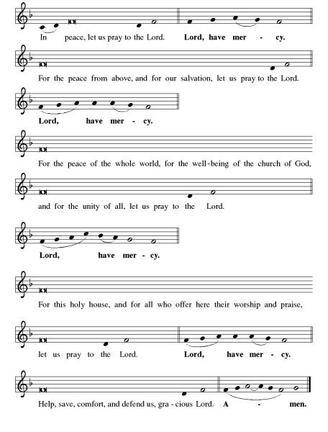
Kyrie ELW pg 138

Hymn of Praise: This is the Feast ELW pg 140-141

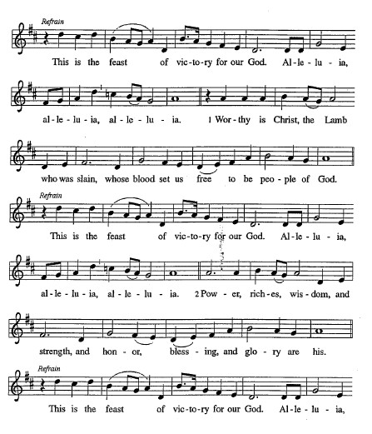

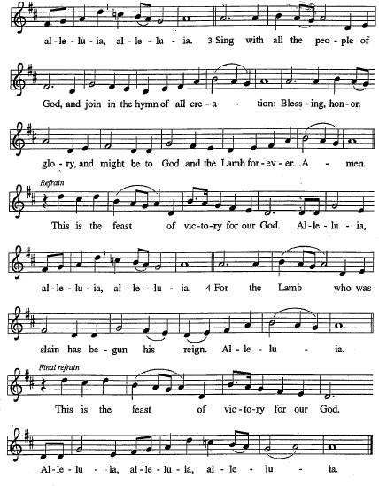
Please be seated.

First Reading: Isaiah 51:1-6
Just as God had called Abraham and Sarah and given them many descendants, so now God offers comfort to Zion. God’s deliverance will come soon and will never end.
¹ Listen to me, you who pursue righteousness,
you who seek the Lord.
Look to the rock from which you were hewn
and to the quarry from which you were dug.
² Look to Abraham your father
and to Sarah, who bore you,
for he was but one when I called him,
but I blessed him and made him many.
³ For the Lord will comfort Zion;
he will comfort all her waste places
and will make her wilderness like Eden,
her desert like the garden of the Lord;
joy and gladness will be found in her,
thanksgiving and the voice of song.
⁴ Listen to me, my people,
and give heed to me, my nation,
for a teaching will go out from me
and my justice for a light to the peoples.
⁵ I will bring near my deliverance swiftly;
my salvation has gone out,
and my arms will rule the peoples;
the coastlands wait for me,
and for my arm they hope.
⁶ Lift up your eyes to the heavens
and look at the earth beneath,
for the heavens will vanish like smoke,
the earth will wear out like a garment,
and those who live on it will die like gnats,
but my salvation will be forever,
and my deliverance will never be ended.

A – Here ends the first reading!

C – Thanks be to God!

Psalm 138
¹ I will give thanks to you, O Lord, with my whole heart;
before the gods I will sing your praise.
² I will bow down toward your holy temple and praise your name, because of your steadfast love and faithfulness;
for you have glorified your name and your word
above all things.
³ When I called, you answered me;
you increased my strength within me.
⁴ All the rulers of the earth will praise you, O Lord,
when they have heard the words of your mouth.
⁵ They will sing of the ways of the Lord,
that great is the glory of the Lord.
⁶ The Lord is high, yet cares for the lowly,
perceiving the haughty from afar.
⁷ Though I walk in the midst of trouble, you keep me safe;
you stretch forth your hand against the fury of my enemies; your right hand shall save me.
⁸ You will make good your purpose for me;
O Lord, your steadfast love endures forever; do not abandon the works of your hands.

Second Reading: Romans 12:1-8
In response to God’s merciful activity, we are to worship by living holistic, God-pleasing lives. Our values and viewpoints are not molded by the time in which we live but are transformed by the Spirit’s renewing work. God’s grace empowers different forms of service among Christians, but all forms of ministry function to build up the body of Christ.
¹ I appeal to you therefore, brothers and sisters, on the basis of God’s mercy, to present your bodies as a living sacrifice, holy and acceptable to God, which is your reasonable act of worship. ² Do not be conformed to this age, but be transformed by the renewing of the mind, so that you may discern what is the will of God—what is good and acceptable and perfect.
³ For by the grace given to me I say to everyone among you not to think of yourself more highly than you ought to think but to think with sober judgment, each according to the measure of faith that God has assigned. ⁴ For as in one body we have many members and not all the members have the same function, ⁵ so we, who are many, are one body in Christ, and individually we are members one of another. ⁶ We have gifts that differ according to the grace given to us: prophecy, in proportion to faith; ⁷ ministry, in ministering; the teacher, in teaching; ⁸ the encourager, in encouragement; the giver, in sincerity; the leader, in diligence; the compassionate, in cheerfulness.

A – Here ends the second reading!
C – Thanks be to God!

Gospel Acclamation
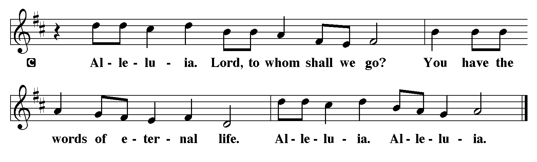
P - The Holy Gospel according to Matthew, the 16th Chapter
C - Glory to You O Lord!

Gospel: Matthew 16:13-20
At a climactic point in Jesus’ ministry, God reveals to Peter that Jesus is “the Messiah, the Son of the living God,” and Jesus responds with the promise of a church that will overcome the very gates of Hades.
¹³ Now when Jesus came into the district of Caesarea Philippi, he asked his disciples, “Who do people say that the Son of Man is?” ¹⁴ And they said, “Some say John the Baptist but others Elijah and still others Jeremiah or one of the prophets.” ¹⁵ He said to them, “But who do you say that I am?” ¹⁶ Simon Peter answered, “You are the Messiah, the Son of the living God.” ¹⁷ And Jesus answered him, “Blessed are you, Simon son of Jonah! For flesh and blood has not revealed this to you but my Father in heaven. ¹⁸ And I tell you, you are Peter, and on this rock I will build my church, and the gates of Hades will not prevail against it. ¹⁹ I will give you the keys of the kingdom of heaven, and whatever you bind on earth will be bound in heaven, and whatever you loose on earth will be loosed in heaven.” ²⁰ Then he sternly ordered the disciples not to tell anyone that he was the Messiah.

P - The Gospel of the Lord.
C – Praise to you, O Christ!
Sermon by S.A.M. Robert Bonomo

Hymn of the Day: My Hope Is Built on Nothing Less ELW 597
1 My hope is built on nothing less
than Jesus' blood and righteousness;
no merit of my own I claim,
but wholly lean on Jesus' name.

Refrain
On Christ, the solid rock, I stand;
all other ground is sinking sand.

2 When darkness veils his lovely face,
I rest on his unchanging grace;
in ev'ry high and stormy gale
my anchor holds within the veil. Refrain

3 His oath, his covenant, his blood
sustain me in the raging flood;
when all supports are washed away,
he then is all my hope and stay. Refrain

4 When he shall come with trumpet sound,
oh, may I then in him be found,
clothed in his righteousness alone,
redeemed to stand before the throne! Refrain

Text: Edward Mote, 1797-1874, alt.

The Apostle’s Creed
I believe in God, the Father almighty,
creator of heaven and earth.
I believe in Jesus Christ, God’s only Son, our Lord,
who was conceived by the Holy Spirit,
born of the virgin Mary,
suffered under Pontius Pilate,
was crucified, died, and was buried;
he descended to the dead.*
On the third day he rose again;
he ascended into heaven,
he is seated at the right hand of the Father,
and he will come to judge the living and the dead.
I believe in the Holy Spirit,
the holy catholic church,
the communion of saints,
the forgiveness of sins,
the resurrection of the body,
and the life everlasting. Amen.
From sundaysandseasons.com.
Copyright © 2026 Augsburg Fortress. All rights reserved.

Prayers of the People
With bold trust in God’s unfailing provision, we pray for the church, those in need, and all of God’s creation.
A brief silence.
God, our rock, you are the foundation on which the church is built. Strengthen and encourage your faithful people everywhere they gather, that they boldly proclaim your word of life to all the world.
Merciful God,
receive our prayer.

We ask You Lord to bless our children as they embark into a new school year. May all Principals and Assistant Principals, teachers, teachers aids, district staff, volunteers, office workers, bus drivers, parents and guardians set examples needed for these children to look up to educationally and emotionally.
Merciful God,
receive our prayer.

You bring relief to nations and peoples. Come to the aid of nations experiencing war, conflict, disease, famine, and disaster. Guide the work of relief agencies and peacemaking organizations.
Merciful God,
Receive our prayer.

You regard the lowly and hear us when we cry out to you. Be present among all who struggle with addiction, housing insecurity, incarceration, and mental illness, that they know they are not alone. Hear our prayers for all in need this day. ( Share your concerns aloud, or keep them close to your heart)
Merciful God,
Receive our prayer.

You draw together in Your house people with different gifts. Lift up the many and varied gifts and talents of this congregation and strengthen the bonds of fellowship that all may be united as the body of Christ.
Merciful God,
Receive our prayer.

Your steadfast love endures forever. We give thanks for the faithful who died in the hope of this promise. Strengthen us in faith until the day we join them at your eternal banquet.
Merciful God,
Receive our prayer.

Today in Matthew’s Gospel: Jesus asked: “But who do you say that I am?” ¹⁶ Simon Peter answered, “You are the Messiah, the Son of the living God.” Receive our prayers and answer, O God, as you have promised. All this we ask in the name of your Son, Jesus Christ our Lord.
Amen.

P – The Peace of the Lord be with you always.
C – And also with you.
The Offering is Brought to the Altar
Offertory Prayer
Loving God,
we offer at your table the gifts of our hearts.
Help us take heart in you and share freely of your love,
so that all creation can taste your abundance.
We ask this in the name of Jesus,
through the Spirit abiding with us now and forever.
Amen.
The Great Thanksgiving

P – The Lord be with You
C – And also with you.
P – Lift up your hearts
C – We lift them to the Lord.
P – Let us give thanks to the Lord, our God
C – It is right to give Him our thanks and praise.
Preface
And so, with all the choirs of angels, with the church on earth and the hosts of heaven, we praise your name and join their unending hymn:

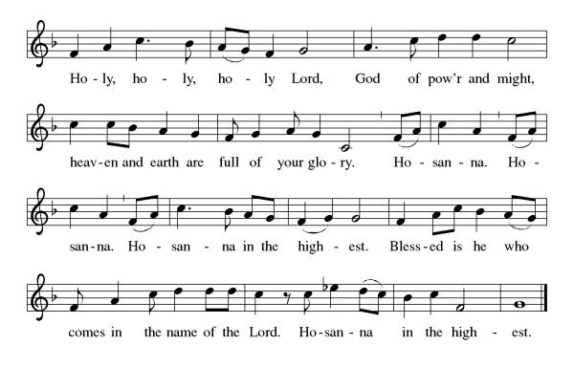

Eucharistic Prayer
(Words of Institution)
For as often as we eat of this bread and drink from this cup we proclaim the Lord’s death until He comes.
Christ has died
Christ is risen.
Christ will come again.
Remembering, therefore, his salutary command,
his life-giving passion and death, his glorious resurrection and ascension,
and the promise of his coming again,
we give thanks to you, O Lord God Almighty,
not as we ought but as we are able;
we ask you mercifully to accept our praise and thanksgiving and with your Word and Holy Spirit to bless us, your servants, and these your own gifts of bread and wine, so that we and all who share in the body and blood of Christ may be filled with heavenly blessing and grace,
and, receiving the forgiveness of sin,
may be formed to live as your holy people
and be given our inheritance with all your saints.
To you, O God, Father, Son, and Holy Spirit,
be all honor and glory in your holy church, now and forever. Amen.
Gathered into one, by the Holy Spirit let us listen to the words that Jesus taught us.

The Lord’s Prayer
Our Father, who art in heaven, hallowed be thy name, thy kingdom come, thy will be done, on earth as it is in heaven. Give us this day our daily bread; and forgive us our trespasses, as we forgive those who trespass against us; and lead us not into temptation but deliver us from evil. For thine is the kingdom, and the power, and the glory, forever and ever. Amen.
P: Taste and see that the Lord is good.
C: Thanks be to God.

Invitation to Communion
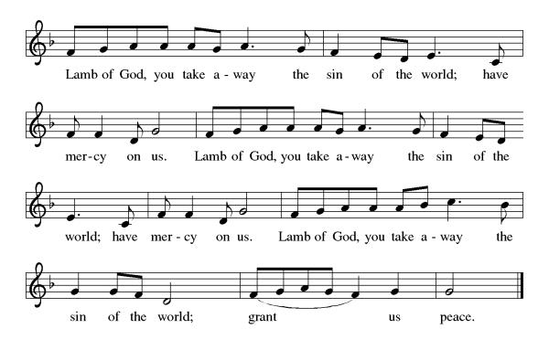
P – Come, feast at His table. He is waiting for you.
C – Amen.

Distribution of Communion – Come Forward to Receive
Communion Hymn: How Sweet the Name of Jesus Sounds ELW 620
P – Now may the body and blood of our Lord and Savior Jesus Christ strengthen you and keep you in His grace!
C – Thank You Jesus!

Prayer after Communion
Compassionate God,
Through the gifts of bread and wine
our hearts are filled with the abundance of your love.
Strengthen us that we, through this Holy meal,
may share your love freely, as you have shared with us.
We ask this in the name of Jesus,
through the Spirit nourishing us now and forever.
Amen.

Words of dismissal and benediction
Know that the ever-present mystery we name God
was in your past forgiving you,
in your present loving you,
and in your future meeting you.
And may the blessing of the Source of life, love and hope,
the Word of life, compassion and wisdom
and Breath of life, grace and truth,
Father, ☩ Son, and Holy Spirit,
surround, sustain and surprise you,
this day and all your days. Amen.

Sending Hymn: Faith of Our Fathers ELW 812
1 Faith of our fathers, living still
in spite of dungeon, fire, and sword.
Oh, how our hearts beat high with joy
whene'er we hear that glorious word.

Refrain
Faith of our fathers, holy faith,
we will be true to thee till death.

2 The martyrs, chained in prisons dark,
were still in heart and conscience free;
and blest would be their children's fate
if they, like them, should die for thee. Refrain

3 Faith of our fathers! We will love
both friend and foe in all our strife;
proclaim thee too, as love knows how,
by saving word and faithful life. Refrain
Text: Frederick W. Faber, 1814-1863, alt.

Dismissal
P – Look, and listen to S.A.M. Bob.
C- Thanks be to God.

Postlude:
Unless otherwise noted, service materials used in this bulletin are:
Music is reprinted under OneLicense.Net #A712074 and/or Augsburg Fortress #SBL12176H. Scripture, unless otherwise noted, is from the New Revised Standard Version Bible, Copyright © 1989, Division of Christian Education of the National Council of the Churches of Christ in the United States of America. Used by permission. All rights reserved.

St. Timothy’s is served by S.A.M. Robert “Bob” Bonomo
Lay Minister Frank Hofstetter
Director of Music Sally Hennessey
Saturday Pianist Bill Robinson
Announcements for August 22nd and 23rd
ATTENDANCE
Saturday, August 15th, 4pm 23
Sunday, August 16th 9am 39
Drive-Up Communion 4
66

The altar flowers are given this week by Eddie and Diane Mason, to the glory of God!

Serving our Lord this weekend:
Saturday, August 22nd
Assisting Minister – Carolyn Fialkowski
Reader – Jean Fowler

Sunday, August 23rd
Assisting Minister – Judi Schutrum
Reader – Dick Kleinsmith
Altar Guild – John and Jodie Gudorf
Greeters – John and Jodie Gudorf

This Week at St. Timothy's
Monday, August 24th
Tuesday, August 25th 9-12 Food Pantry
Wednesday, August 26th
Thursday, August 27th 11-12 Bible Study, 11am – Miniatures, 4:30 - Choir
Friday, August 28th
Saturday, August 29th 4pm Worship, No Fellowship
Sunday, August 30th 9am Worship, 10:30 – Adult SS, Coffee Fellowship

PRAYER LIST
Sharon Grimes
Teresa York
Debbie Lawrence
Carole Albert
Linda C.
Ashlee
Frani Barnes
Mark Duffy
Wyatt Toney
Jim & Rosa Neth
Melanie
Trish Bradley
Fowler Family
Marcus

Our prayer list has been purged. If you want to put a name back on, please let us know.

