A Service of Worship, Praise and Hope

Welcome to St. Timothy Saturday Evening Worship!

July 12th,

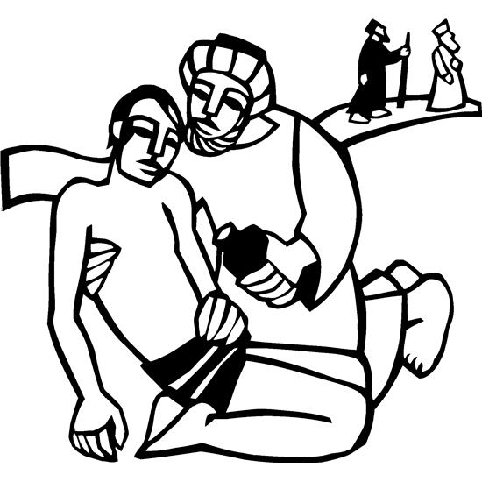

"Equip people to grow as Disciples faithfully serving our community"

We are glad to have you worship with us. All are welcome at communion. If you need gluten-free – please let us know when you go up for communion. If you have any questions – just ask the Welcomer at the back of the sanctuary.

*Please note** if you use a pew envelope for your offering – please write your name on the envelope so that the financial secretaries can post it as a gift from you. Thank You!*

**St Timothy Worship Planning Team**

S.A.M. Bob Bonomo

Deacon, Frank Hofstetter

The Altar Flowers are given this week by DuWayne and Jean Fowler, in honor of all the family birthdays in July!

**This Week at St. Timothy's**

Monday, July 14th Bob on vacation

Tuesday, July 15th Bob on vacation – 1pm WELCA

Wednesday, July 16th Bob on vacation

Thursday, July 17th Bob returns - 9:30 am – Prayer Group, 11:00 am – Miniatures

Friday, July 18th

Saturday, July 19th 4 pm – Worship

Sunday, July 20th 9 am – Worship, 10:15-10:45 – Drive-Up Communion, 10:30 - Sunday School, Coffee Fellowship

*Rooted in the past and growing into the future, the church must always be reformed in order to live out the love of Christ in an ever-changing world. We celebrate the good news of God’s grace, that Jesus Christ sets us free every day to do this life-transforming work. Trusting in the freedom given to us in baptism, we pray for the church, that Christians will unite more fully in worship and mission.*

*(from Sundays and Seasons for Reformation Weekend)*

**Welcome and Sharing of Congregational News**

***Preparation Hymn: Someone In Need of Your Love DH 94***

### *Gathering Hymn: God Is Here! ELW 526*

1. God is here! As we your people meet to offer

praise and prayer, may we find in fuller measure

what it is in Christ we share. Here, as in the

world around us, all our varied skills and arts

wait the coming of the Spirit into open minds and hearts.

1. Here are symbols to remind us of our lifelong

need of grace; here are table, font, and pulpit;

here the cross has central place. Here in honesty

of preaching, here in silence, as in speech,

here, in newness and renewal, God the Spirit comes to each.

3 Here our children find a welcome in the Shepherd's

flock and fold; here as bread and wine are taken,

Christ sustains us as of old. Here the servants

of the Servant seek in worship to explore

what it means in daily living to believe and to adore.

1. Lord of all, of church and kingdom, in an age of

change and doubt, keep us faithful to the gospel;

help us work your purpose out. Here, in this day's

dedication, all we have to give, receive;

we, who cannot live without you, we adore you! We believe!

**Confession and Forgiveness**

P- In the name of the Father, and of the Son, and of the Holy Spirit.

**C – Amen**

Let us confess our sins in front of God and one another.

**C-Merciful God,**

**you free us to love others,**

**but we neglect our neighbors and follow our own way.**

**You lead us by the Spirit of joy and peace,**

**but we turn away from the abundant life you offer.**

**You surround us with patience, kindness,**

**and generosity,**

**but we grow weary in doing what is right.**

**In your mercy, forgive us.**

**Do not give up on us.**

**Heal us, break our bonds,**

**and show us the path of life.**

**Amen.**

P -You belong to Christ Jesus

and you are God’s children through faith.

In the cross of ☩ Christ,

and through the power of the Holy Spirit,

your sins are forgiven.

Clothed with Christ, you are a new creation.

**Amen.**

P – Let us pray.

We give you thanks, O God, that through water and the Holy Spirit you give us new birth, cleanse us from sin, and raise us to eternal life.

Stir up in St Timothy’s congregation the gift of your Holy Spirit: the spirit of wisdom and understanding, the spirit of counsel and might, the spirit of knowledge and the fear of the Lord, the spirit of joy in your presence, both now and forever.

**C – Amen.**

**Greeting**

P: The joy of our Lord Jesus Christ, the compassion of God, and the creative power of the Holy Spirit be with you all.

**C: And also with you.**

### Prayer of the Day

**O Lord God, your mercy delights us, and the world longs for your loving care. Hear the cries of everyone in need, and turn our hearts to love our neighbors with the love of your Son, Jesus Christ, our Savior and Lord.**

**Amen.**

### Lesson: Colossians 1:1-14

The letter to the Colossians was written to warn its readers of various false teachings. The first part of the letter is an expression of thanks for the faith, hope, and love that mark this community, including a prayer for strength and courage.

1 Paul, an apostle of Christ Jesus by the will of God, and Timothy our brother,  
  2 To the saints and faithful brothers and sisters in Christ in Colossae:   
  Grace to you and peace from God our Father.  
  
  3 In our prayers for you we always thank God, the Father of our Lord Jesus Christ, 4 for we have heard of your faith in Christ Jesus and of the love that you have for all the saints, 5 because of the hope laid up for you in heaven. You have heard of this hope before in the word of the truth, the gospel 6 that has come to you. Just as it is bearing fruit and growing in the whole world, so it has been bearing fruit among yourselves from the day you heard it and truly comprehended the grace of God. 7 This you learned from Epaphras, our beloved fellow servant. He is a faithful minister of Christ on our behalf, 8 and he has made known to us your love in the Spirit.  
  9 For this reason, since the day we heard it, we have not ceased praying for you and asking that you may be filled with the knowledge of God’s will in all spiritual wisdom and understanding, 10 so that you may walk worthy of the Lord, fully pleasing to him, as you bear fruit in every good work and as you grow in the knowledge of God. 11 May you be made strong with all the strength that comes from his glorious power, so that you may have all endurance and patience, joyfully 12 giving thanks to the Father, who has enabled you to share in the inheritance of the saints in the light. 13 He has rescued us from the power of darkness and transferred us into the kingdom of his beloved Son, 14 in whom we have redemption, the forgiveness of sins.

### A: Word of God!

**C: Words of Life!**

P: The Holy Gospel according to **Luke, Chapter 10**

**C: Glory to you O Lord.**

### Gospel: Luke 10:25-37

Jesus is challenged to explain what is involved in obeying the greatest commandment. He tells a parable rich in surprises: those expected to show pity display hard hearts while the lowly give and receive unexpected and lavish mercy.

25 An expert in the law stood up to test Jesus. “Teacher,” he said, “what must I do to inherit eternal life?” 26 He said to him, “What is written in the law? What do you read there?” 27 He answered, “You shall love the Lord your God with all your heart and with all your soul and with all your strength and with all your mind and your neighbor as yourself.” 28 And he said to him, “You have given the right answer; do this, and you will live.”  
  29 But wanting to vindicate himself, he asked Jesus, “And who is my neighbor?” 30 Jesus replied, “A man was going down from Jerusalem to Jericho and fell into the hands of robbers, who stripped him, beat him, and took off, leaving him half dead. 31 Now by chance a priest was going down that road, and when he saw him he passed by on the other side. 32 So likewise a Levite, when he came to the place and saw him, passed by on the other side. 33 But a Samaritan while traveling came upon him, and when he saw him he was moved with compassion. 34 He went to him and bandaged his wounds, treating them with oil and wine. Then he put him on his own animal, brought him to an inn, and took care of him. 35 The next day he took out two denarii, gave them to the innkeeper, and said, ‘Take care of him, and when I come back I will repay you whatever more you spend.’ 36 Which of these three, do you think, was a neighbor to the man who fell into the hands of the robbers?” 37 He said, “The one who showed him mercy.” Jesus said to him, “Go and do likewise.”

P: The Gospel of Our Lord!

**C: Praise to You O Christ!**

***Sermon by Pr. Dennis Koch***

### 

### *****Hymn of the Day:******Jesu, Jesu, Fill Us with Your Love ELW 708*

***Refrain***

**Jesu, Jesu, fill us with your love, show**

**us how to serve the neighbors we have from you.**

1 Kneels at the feet of his friends, silently washes their feet,

master who acts as a slave to them. ***Refrain***

2 Neighbors are wealthy and poor, varied in color and race,

neighbors are nearby and far away. ***Refrain***

3 These are the ones we will serve, these are the ones we will love;

all these are neighbors to us and you. ***Refrain***

4 Kneel at the feet of our friends, silently washing their feet:

this is the way we will live with you. ***Refrain***

**Apostles’ Creed**

**I believe in God, the Father almighty,**

**creator of heaven and earth.**

**I believe in Jesus Christ, God’s only Son, our Lord,**

**who was conceived by the Holy Spirit,**

**born of the virgin Mary,**

**suffered under Pontius Pilate,**

**was crucified, died, and was buried;**

**he descended to the dead.**

**On the third day he rose again;**

**he ascended into heaven,**

**he is seated at the right hand of the Father,**

**and he will come to judge the living and the dead.**

**I believe in the Holy Spirit,**

**the holy catholic church,**

**the communion of saints,**

**the forgiveness of sins,**

**the resurrection of the body,**

**and the life everlasting. Amen.**

**Lord, listen to your children praying,**

**Lord, send your Spirit in this place;**

**Lord, listen to your children praying,**

**send us love, send us pow'r, send us grace.**

**Prayers of the people**

In solidarity with all creation, we join our voice to the voice of the whole church and pray for the needs of the world.

*A brief silence.*

Saving God, awaken your church to your truth as it follows your path of love. Encourage pastors, deacons, teachers, and seminarians, and lead them as they seek to learn your ways.

God of grace,

**hear our prayer.**

Prosper the harvests of fruit-bearing bushes, trees, and plants. Uphold farmers and farm workers as they labor through summer days, and bring relief to lands that are parched with heat.

God of grace,

**hear our prayer.**

Instill in leaders of the world a strong love for their neighbors. Compel them to govern with equity and to give aid and protection to people who are vulnerable, especially strangers, migrants, and asylum seekers.

God of grace,

**hear our prayer.**

Draw near to people in need of help, comfort, and healing (mention names out loud or silently). Provide protection and aid to children who are unsafe and undernourished while on summer break.

God of grace,

**hear our prayer.**

Go with all who travel and protect them from harm. Put in their paths people who offer aid. We pray especially for the safety of first responders.

God of grace,

**hear our prayer.**

We give you thanks for all who have gone before us and have made your love known. Help us to follow their witness as we await our share in the inheritance of the saints. God of grace,

**hear our prayer.**

Trusting in your lovingkindness, we place our prayer and hope in you, in the name of Jesus Christ.

**Amen.**

**P: May the peace of our Lord Jesus Christ be with you all.**

**C: And also with you.**

**P: Let us now share this peace.**

**Offering is Brought to the Altar**

**Offering Prayer**

**We lift our voices, we lift our hands, we lift our lives up to you; we are an Offering. Lord, use our voices, Lord, use our hands, Lord, use our lives, they are yours: we are an offering. All that we have, all that we are, all that we hope to be, we give to you, we give to you. We lift our voices, we lift our hands, we lift our lives up to you; we are an offering, we are an offering.**

P: The Lord be with you.

**C: And also with you.**

P: We lift up your hearts.

**C: We lift them to the Lord.**

P: Let us give thanks to the Lord our God.

**C: It is right to give our thanks and praise.**

**Preface**

It is indeed right, our duty and our joy,

that we should at all times and in all places

give thanks and praise to you, almighty and merciful God,

through our Savior Jesus Christ;

who on this day overcame death and the grave,

and by his glorious resurrection opened to us the way of everlasting life.

And so, with all the choirs of angels,

with the church on earth and the hosts of heaven,

we praise your name and join their unending hymn:

**Eucharist Prayer**

Blessed are you, O God of the universe. Your mercy is everlasting, and your faithfulness endures from age to age.

Praise to you for creating the heavens and the earth. Praise to you for saving the earth from the waters of the flood. Praise to you for bringing the Israelites safely through the sea. Praise to you for leading your people through the wilderness to the land of milk and honey. Praise to you for the death and resurrection of Christ. Praise to you for your Spirit poured out on all nations.

In the night he was betrayed, our Lord Jesus took bread and gave thanks; broke it, and gave it to his disciples saying: Take and eat; this is my body given for you. Do this for the remembrance of me.

After supper he took the cup, gave thanks and gave it for all to drink saying: This cup is the new covenant in my blood, shed for you and for all people for the forgiveness of sin, Do this for the remembrance of me.

For as often as we eat of this bread and drink from this cup we proclaim the Lord’s death until He comes.

**Christ has died**

**Christ is risen.**

**Christ will come again.**

Gathered into one, by the Holy Spirit let us pray as Jesus taught us.

**The Lord’s Prayer**

**Our Father, who art in heaven, hallowed be thy name, thy kingdom come, thy will be done, on earth as it is in heaven. Give us this day our daily bread; and forgive us our trespasses, as we forgive those who trespass against us; and lead us not into temptation but deliver us from evil. For thine is the kingdom, and the power, and the glory, forever and ever. Amen.**

**Invitation to Communion**

P: Come to this Table where God really does come to us!

**C: Thank You Jesus!**

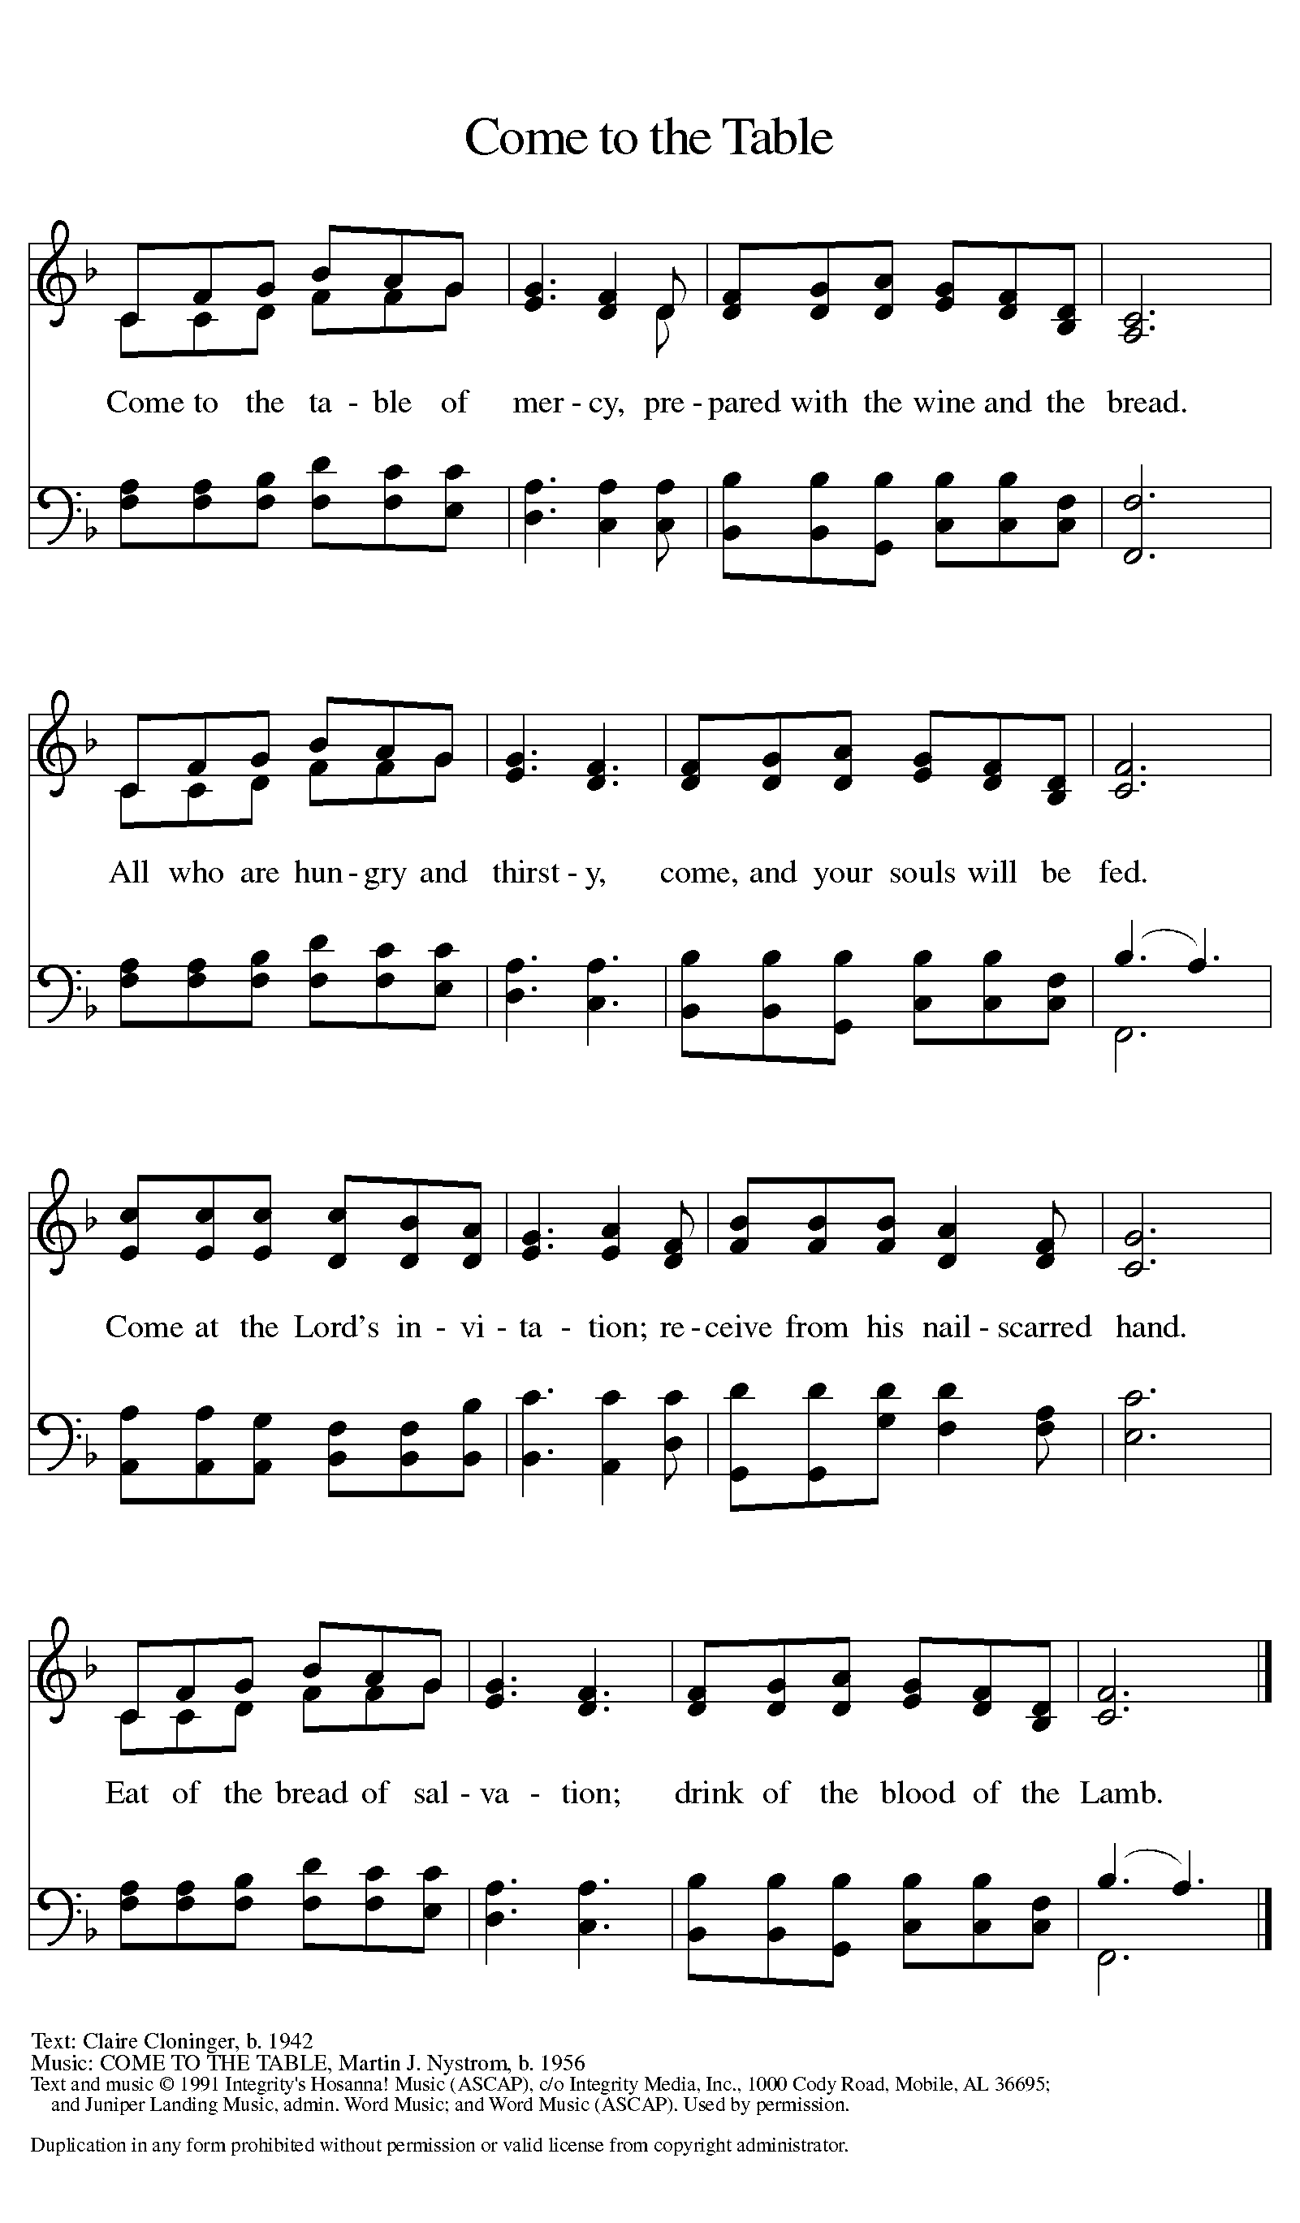

**Distribution - Please come forward to receive**

***Communion Anthem: I Come With Joy ELW 482***

P: Now may the body and blood of our Lord Jesus Christ strengthen you and keep you in his grace.

**C: Amen**

**Prayer After Communion**

**Life-giving God, through this meal you have bandaged our wounds and fed us with your mercy. Now send us forth to live for others, both friend and stranger, that all may come to know your love. This we pray in the name of Jesus. Amen.**

**Sending**

**Blessing**

P: God Almighty send you light and truth to keep you all the days of your life. The hand of God protect you; the holy angels accompany you; and the blessing of almighty God, the Father, the ☩ Son, and the Holy Spirit, be with you now and forever.

**C: Amen**

***Sending Hymn: God's Work, Our Hands ACS 1000***

1 God's work, our hands: working together,

building a future, repairing the world,

raising up homes, planting new gardens,

feeding the hungry and shelt'ring the cold.

Bless, God, our hands as we work in your name,

sharing the good news of your gospel.

2 God's work, our feet: trav'ling together,

following Jesus to places unknown,

walking as friends, marching for freedom,

running the race with God's future the goal.

Bless, God, our feet as we follow your way,

sharing the good news of your gospel.

3 God's work, our voice: singing together,

praising, proclaiming to all who will hear,

praying for peace, shouting for justice,

claiming God's love for the lost and the least.

Bless, God, our voice as we speak in your name,

sharing the good news of your gospel.

4 God is at work in and around us:

seedlings are sprouting and bread's on the rise!

Washed and set free, humbled and honored,

gifted by grace, we respond in God's love.

Bless, God, our lives as we answer your call,

sharing the good news of your gospel.

**Dismissal**

P: Go in peace. Proclaim the Good News!

**C: By the Grace of God we will – Alleluia!**

***Postlude:***

Unless otherwise noted, materials used in this bulletin are:

From Sundays and Seasons.com. Copyright 2015 Augsburg Fortress. All rights reserved. Reprinted by permission under Augsburg Fortress Liturgies Annual License #SAS028635. Music is reprinted under OneLicense.Net #A712074 and/or Augsburg Fortress #SBL12176H. Scripture, unless otherwise noted, is from the New Revised Standard Version Bible, Copyright © 1989, Division of Christian Education of the National Council of the Churches of Christ in the United States of America. Used by permission. All rights reserved.

**Announcements for July 12th and 13th**

**ATTENDANCE**

Saturday, July 5th , 4pm 28

Sunday, July 6th , 9am 41

Drive-Up Communion 3

72

