***A Service of Worship, Praise and Hope***

***Welcome to St. Timothy Saturday Evening Worship!***

***April 13, 2024, Third Week of Easter***

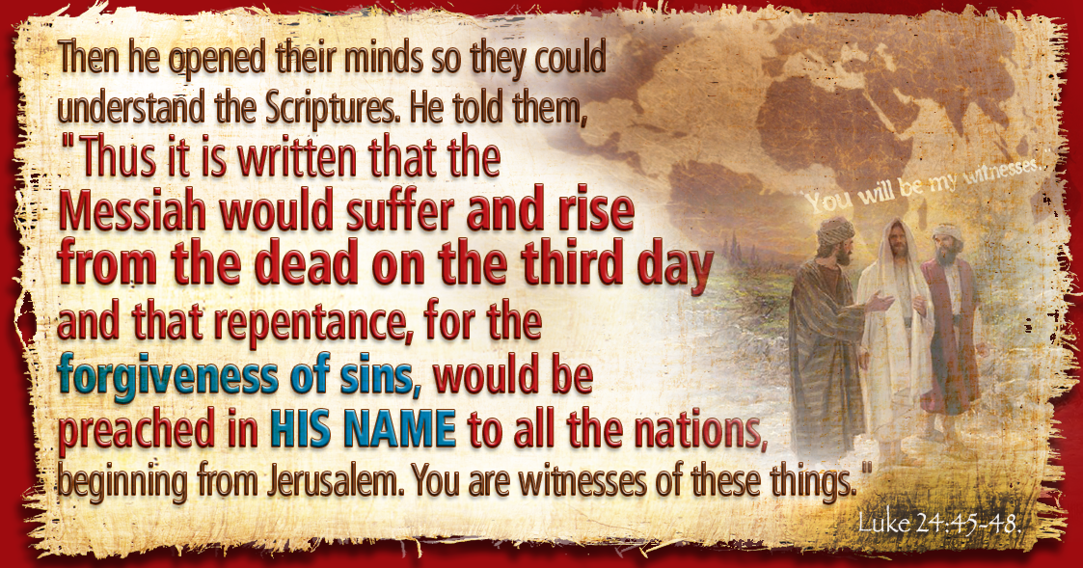

**"Equip people to grow as Disciples faithfully serving our community"**

**We are glad to have you worship with us. All are welcome at communion. If you need gluten-free – please tell Pastor Joanie when you go up for communion. If you have any questions – just ask the Welcomer at the back of the sanctuary.**

***Please note** if you use a pew envelope for your offering – please write your name on the envelope so that the financial secretaries can post it as a gift from you. Thank You!***

**St Timothy Worship Planning Team**

**The Reverend Joan E. Holden 850-774-7730**

**Eric Mortensen – Director of Music**

**Frank Hofstetter, Parish Deacon**

**The Altar Flowers are given by Sue Gable, to the glory of God!**

**This Week at St. Timothy's**

**Monday, April 15th PJ OFF**

**Tuesday, April 16th**

**Wednesday, April 17th 10am – OT BS, 1pm – Royal Dalton (Memory Care)**

**Thursday, April 18th 9:30am – Prayer Group, 11:00 am – Miniatures , 4:30pm - Choir**

**Friday, April 19th 10am – NT BS**

**Saturday, April 20th 4 pm – Worship**

**Sunday, April 21st 9 am – Worship – Childrens SS, 10:30 am – Adult Sunday School, 11-11:30 am – Drive Up Communion, 12 - Council**

***Rooted in the past and growing into the future, the church must always be reformed in order to live out the love of Christ in an ever-changing world. We celebrate the good news of God’s grace, that Jesus Christ sets us free every day to do this life-transforming work. Trusting in the freedom given to us in baptism, we pray for the church, that Christians will unite more fully in worship and mission.***

***(from Sundays and Seasons for Reformation Weekend)***

***“Shout to the Lord” is the last pre-service hymn the choir sings, it is Hymn #821 and everyone is welcome to sing with the choir.***

**Welcome and Sharing of Congregational News**

## ***Preparation Anthem: Come and See 29 W&P***

***Gathering Hymn: Alleluia! Jesus Is Risen! ELW 377***

1 Alleluia! Jesus is risen!

Trumpets resounding in glorious light!

Splendor, the Lamb, heaven forever!

Oh, what a miracle God has in sight!

***Refrain***

***Jesus is risen and we shall arise.***

***Give God the glory! Alleluia!***

2 Walking the way, Christ in the center

telling the story to open our eyes;

breaking our bread, giving us glory:

Jesus our blessing, our constant surprise. ***Refrain***

3 Jesus the vine, we are the branches;

life in the Spirit the fruit of the tree;

heaven to earth, Christ to the people,

gift of the future now flowing to me. ***Refrain***

4 Weeping, be gone; sorrow, be silent:

death put asunder, and Easter is bright.

Cherubim sing: O grave, be open!

Clothe us in wonder, adorn us in light. ***Refrain***

5 City of God, Easter forever,

golden Jerusalem, Jesus the Lamb,

river of life, saints and archangels,

sing with creation to God the I AM! ***Refrain***

P - The grace of our Lord Jesus Christ, the love of God and the communion of the Holy Spirit be with you all.

**C - And also with you.**

**Confession and Forgiveness**

P - Blessed be the Holy Trinity, + one God, whose name is majestic in all the earth, who rescues and heals in every time of trouble, who does all things well.

**C – Amen**

P - Let us come before God, seeking forgiveness and life.

*(Silence is kept for reflection and self-examination)*

P - Steadfast and saving God,

**C - Have mercy on us. We confess to you all our sins and that in these continuing times of uncertainty and fear, we have trouble trusting you and feeling your presence. Forgive us our sins, our doubts, our fears and lack of patience with others. Strengthen our faith and help us to let your hope and light shine through us in these dark times. We ask for mercy, wisdom and guidance, through Jesus Christ, our Savior and Lord. Amen.**

P - In the name of + Jesus, the Son of God, receive mercy and find grace in your time of need. Your sins are forgiven; God's love is healing balm for your wounds. Rejoice, for God raises you up to new life in Christ.

**C - Amen**

**Greeting**

P - The joy of our Lord Jesus Christ, the compassion of God, and the creative power of the Holy Spirit be with you all.

**C - And also with you.**

### Prayer of the Day

**Holy and righteous God, you are the author of life, and you adopt us to be your children. Fill us with your words of life, that we may live as witnesses to the resurrection of your Son, Jesus Christ, our Savior and Lord, who lives and reigns with you and the Holy Spirit, one God, now and forever. Amen.**

**Word**

### First Lesson: Acts 3:12-19

After healing a man unable to walk, Peter preaches to the people, describing how God’s promises to Israel have been fulfilled in Jesus. Through the proclamation of Christ’s death and resurrection, God is offering them forgiveness and restoration in Jesus’ name.

12[Peter] addressed the people, “You Israelites, why do you wonder at this, or why do you stare at us, as though by our own power or piety we had made him walk?13The God of Abraham, the God of Isaac, and the God of Jacob, the God of our ancestors has glorified his servant Jesus, whom you handed over and rejected in the presence of Pilate, though he had decided to release him. 14But you rejected the Holy and Righteous One and asked to have a murderer given to you, 15and you killed the Author of life, whom God raised from the dead. To this we are witnesses. 16And by faith in his name, his name itself has made this man strong, whom you see and know; and the faith that is through Jesus has given him this perfect health in the presence of all of you.  
 17“And now, friends, I know that you acted in ignorance, as did also your rulers. 18In this way God fulfilled what he had foretold through all the prophets, that his Messiah would suffer. 19Repent therefore, and turn to God so that your sins may be wiped out.”

### P – The Holy Gospel according to Luke, Chapter 24

### C – Glory to you O Lord.

### Gospel: Luke 24:36b-48

In this account of an appearance after his resurrection, Jesus opens the minds of the disciples to understand him as Messiah. Jesus convinces them that he has been raised and sends them on a mission to proclaim the message of repentance and forgiveness.

36bJesus himself stood among [the disciples] and said to them, “Peace be with you.” 37They were startled and terrified, and thought that they were seeing a ghost. 38He said to them, “Why are you frightened, and why do doubts arise in your hearts? 39Look at my hands and my feet; see that it is I myself. Touch me and see; for a ghost does not have flesh and bones as you see that I have.” 40And when he had said this, he showed them his hands and his feet. 41While in their joy they were disbelieving and still wondering, he said to them, “Have you anything here to eat?” 42They gave him a piece of broiled fish, 43and he took it and ate in their presence.  
 44Then he said to them, “These are my words that I spoke to you while I was still with you—that everything written about me in the law of Moses, the prophets, and the psalms must be fulfilled.” 45Then he opened their minds to understand the scriptures, 46and he said to them, “Thus it is written, that the Messiah is to suffer and to rise from the dead on the third day, 47and that repentance and forgiveness of sins is to be proclaimed in his name to all nations, beginning from Jerusalem. 48You are witnesses of these things.”

P - The Gospel of Our Lord!

**C - Praise to You O Christ!**

***Hymn of the Day: As We Gather at Your Table ELW 522***

1 As we gather at your table, as we listen to your word,

help us know, O God, your presence; let our hearts and minds be stirred.

Nourish us with sacred story till we claim it as our own;

teach us through this holy banquet how to make Love's vict'ry known.

2 Turn our worship into witness in the sacrament of life;

send us forth to love and serve you, bringing peace where there is strife.

Give us, Christ, your great compassion to forgive as you forgave;

may we still behold your image in the world you died to save.

3 Gracious Spirit, help us summon other guests to share that feast

where triumphant Love will welcome those who had been last and least.

There no more will envy blind us nor will pride our peace destroy,

as we join with saints and angels to repeat the sounding joy.

***Message:***

**Apostles’ Creed**

**I believe in God, the Father almighty,**

**creator of heaven and earth.**

**I believe in Jesus Christ, God’s only Son, our Lord,**

**who was conceived by the Holy Spirit,**

**born of the virgin Mary,**

**suffered under Pontius Pilate,**

**was crucified, died, and was buried;**

**he descended to the dead.**

**On the third day he rose again;**

**he ascended into heaven,**

**he is seated at the right hand of the Father,**

**and he will come to judge the living and the dead.**

**I believe in the Holy Spirit,**

**the holy catholic church,**

**the communion of saints,**

**the forgiveness of sins,**

**the resurrection of the body,**

**and the life everlasting. Amen.**

**Lord, listen to your children praying,**

**Lord, send your Spirit in this place;**

**Lord, listen to your children praying,**

**send us love, send us pow'r, send us grace.**

### Prayers of the People *(Please stand, sit or kneel as you are able)*

Rejoicing that Jesus is risen and love has triumphed over fear, let us pray for the church, the world, and all those in need of good news. *A brief silence.*

O God our holy one, you feed our deepest hungers. As we share the holy meal that is the body and blood of Jesus given for us, lead us to share all that we have, and find, in generosity, abundant life. God of grace, **hear our prayer.**

O God our creator, you bring forth all life on earth. Calm storms, bring water to parched places, and protect the climate, that this planet would sustain life in all its variety. God of grace, **hear our prayer.**

O God our savior, you offer wisdom and guidance beyond all human knowledge. Instruct lawmakers, judges, and elected officials to make decisions grounded in your justice and care for all people. God of grace, **hear our prayer.**

O God our elder, you care for all your children. Encourage those who are in times of transition, facing the loss of old ways and routines and anticipating change. Guide those who journey in grief, hope, and uncertainty. God of grace, **hear our prayer.**

O God our center, you bring all people together in you. Help us to remember our identity and purpose in our ministry. Move us to love our neighbors as ourselves and to share in beloved community. God of grace, **hear our prayer.**

*At this time anyone can lift up prayers*

*God of grace,* ***hear our prayer.***

O God our resting place, your Son Jesus promised that we are held in your love forever. We remember our beloved who have died. As we remember and share their love, comfort those who mourn. God of grace, **hear our prayer.**

Into your hands, most merciful God, we commend all for whom we pray, trusting in your abiding love; through Jesus Christ, our resurrected and living Lord.

**Amen.**

**Peace**

P- The Peace of the Lord be with you always.

**C – And also with you.**

**We Share Christ’s Peace**

**Offering is Brought to the Altar**

**Offering Prayer**

**We lift our voices, we lift our hands, we lift our lives up to you; we are an Offering. Lord, use our voices, Lord, use our hands, Lord, use our lives, they are yours: we are an offering. All that we have, all that we are, all that we hope to be, we give to you, we give to you. We lift our voices, we lift our hands, we lift our lives up to you; we are an offering, we are an offering.**

**Jesus’ Words of Promise and Gift of Life**

Dear Lord, Jesus Christ:

in the night in which you were betrayed,

You took bread, broke it and gave thanks,

then you gave it to your disciples saying:

take and eat, this is my body I am giving for you.

Do this in remembrance of me.

Again, after supper, Dear Lord Jesus,

You took the cup, gave thanks

and gave it for everyone to drink saying:

this cup is the new covenant in my blood,

I am shedding for you and for all people for the forgiveness of sin.

Do this for the remembrance of me. **Amen.**

**Our Lord's Prayer**

**Our Father in heaven, hallowed be your name, your kingdom come, your will be done, on earth as in heaven. Give us today our daily bread. Forgive us our sins as we forgive those who sin against us. Save us from the time of trial and deliver us from evil. For the kingdom, the power, and the glory are yours, now and forever. Amen.**

**Invitation to Communion**

P: Come to this Table where God really does come to us!

**C: Thank You Jesus!**

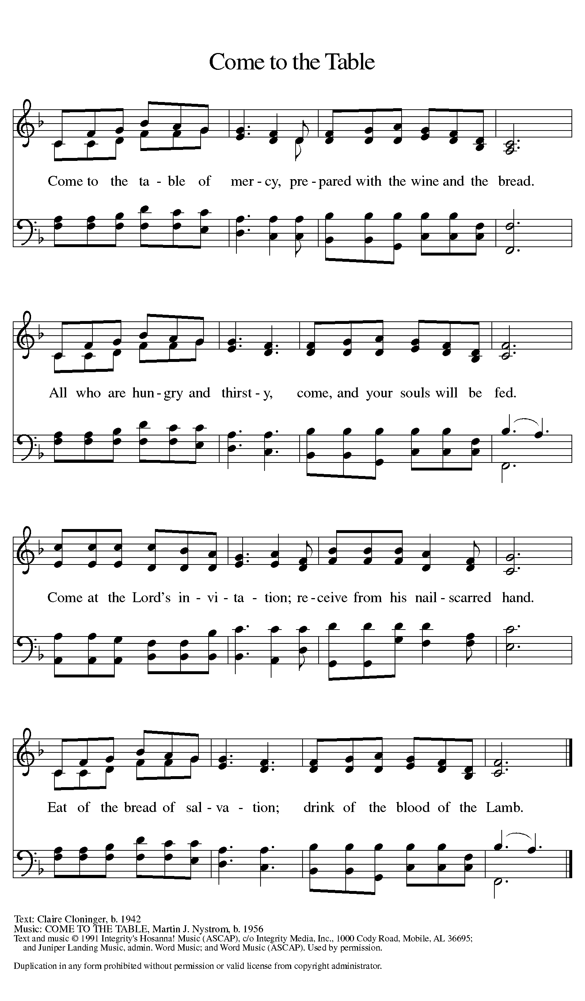

***Distribution - Please come forward to receive***

### *Communion Anthem: God Moves in a Mysterious Way LBW 483 God My Lord, My Strength LBW 484*

P - Now may the body and blood of our Lord Jesus Christ strengthen you and keep you in his grace…. Jesus Loves You!

**C – Thank You Jesus!**

### Prayer after Communion

**Shepherding God, you have prepared a table before us and nourished us with your love. Send us forth from this banquet to proclaim your goodness and share the abundant mercy of Jesus, our redeemer and friend. Amen.**

**Sending**

**Blessing**

P - God Almighty send you light and truth to keep you all the days of your lives. The hand of God protect you; the holy angels accompany you; and the blessing of almighty God, the Father, the ☩ Son, and the Holy Spirit, be with you now and forever.

**C -Amen.**

### *Sending Hymn: Let Us Talents and Tongues Employ ELW 674*

1 Let us talents and tongues employ, reaching out with a shout of joy:

bread is broken, the wine is poured, Christ is spoken and seen and heard.

***Refrain***

***Jesus lives again, earth can breathe again,***

***pass the Word around: loaves abound!***

***Jesus lives again, earth can breathe again,***

***pass the Word around: loaves abound!***

2 Christ is able to make us one, at the table he sets the tone,

teaching people to live to bless, love in word and in deed express. ***Refrain***

3 Jesus calls us in, sends us out bearing fruit in a world of doubt,

gives us love to tell, bread to share: God (Immanuel) ev'rywhere! ***Refrain***

### Dismissal

P: Thanks be to God

**C: Alleluia!**

***Postlude: All Hail King Jesus W&P 3***

Unless otherwise noted, materials used in this bulletin are:

From Sundays and Seasons.com. Copyright 2015 Augsburg Fortress. All rights reserved. Reprinted by permission under Augsburg Fortress Liturgies Annual License #SAS028635. Music is reprinted under OneLicense.Net #A712074 and/or Augsburg Fortress #SBL12176H. Scripture, unless otherwise noted, is from the New Revised Standard Version Bible, Copyright © 1989, Division of Christian Education of the National Council of the Churches of Christ in the United States of America. Used by permission. All rights reserved.

**REMEMBRANCE**

**Olavus Petri, priest, died 1552; Laurentius Petri, Bishop of Uppsala, died 1573; renewers of the church**

These two brothers studied with Luther at the University of Wittenberg and then returned to their native Sweden to introduce the Lutheran reforms. Olavus published a catechism and hymnal; Laurentius was a professor who defended the office of bishop and later became one.

**Announcements for April 13th and 14th**

**ATTENDANCE**

Saturday, April 6th 4pm 28

Sunday, April 7th, 9am 50

Drive-Up Communion 4

82

