A Service of Worship, Praise and Hope
Welcome to St. Timothy Saturday Evening Worship!
19th Weekend after Pentecost
October 18th



Pray always. Do not lose heart. This is Christ’s encouragement in the gospel today. Wrestle with the word. Remember your baptism again and again. Come regularly to Christ’s table. Persistence in our every encounter with the divine will be blessed.

Please note** if you use a pew envelope for your offering – please write your name on the envelope so that the financial secretaries can post it as a gift from you. Thank You!
St Timothy Worship Planning Team
S.A.M. Bob Bonomo
Deacon, Frank Hofstetter
Director of Music, Sally Hennessey
Saturday Pianist, Bill Robinson

Pre-Service Music:

Welcome and Sharing of Congregational News

Prelude

Gathering Hymn: Precious Lord, Take My Hand ELW 773

- Precious Lord, take my hand, lead me on, let me stand.
I am tired, I am weak, I am worn.
Through the storm, through the night, lead me on to the light.
Take my hand, precious Lord, lead me home.

- When my way grows drear, precious Lord, linger near,
when my life is almost gone,
hear my cry, hear my call, hold my hand lest I fall.
Take my hand, precious Lord, lead me home.

- When the darkness appears and the night draws near,
And the day is past and gone,
At the river I stand, guide my feet, hold my hand.
Take my hand, precious Lord, lead me home.

Text: Thomas A. Dorsey, 1899-1993
Music: George N. Allen, 1812-1877, adapt. Thomas A. Dorsey

Confession and Forgiveness
P- In the name of the Father, and of the Son, and of the Holy Spirit.
C – Amen
Let us confess our sins in front of God and one another.
C-Merciful God,
you free us to love others,
but we neglect our neighbors and follow our own way.
You lead us by the Spirit of joy and peace,
but we turn away from the abundant life you offer.
You surround us with patience, kindness,
and generosity,
but we grow weary in doing what is right.
In your mercy, forgive us.
Do not give up on us.
Heal us, break our bonds,
and show us the path of life.
Amen.

P -You belong to Christ Jesus
and you are God’s children through faith.
In the cross of ☩ Christ,
and through the power of the Holy Spirit,
your sins are forgiven.
Clothed with Christ, you are a new creation.
Amen.
P – Let us pray.
We give you thanks, O God, that through water and the Holy Spirit you give us new birth, cleanse us from sin, and raise us to eternal life.
Stir up in St Timothy’s congregation the gift of your Holy Spirit: the spirit of wisdom and understanding, the spirit of counsel and might, the spirit of knowledge and the fear of the Lord, the spirit of joy in your presence, both now and forever.
C – Amen.
Greeting
P: The joy of our Lord Jesus Christ, the compassion of God, and the creative power of the Holy Spirit be with you all.
C: And also with you.

Prayer of the Day
O Lord God, tireless guardian of your people, you are always ready to hear our cries. Teach us to rely day and night on your care. Inspire us to seek your enduring justice for all this suffering world, through Jesus Christ, our Savior and Lord.
Amen.

Lesson: 2 Timothy 3:14—4:5
The writer of this letter continues his instruction of Timothy, his younger colleague in ministry, by emphasizing the importance of faithful teaching despite opposition.
¹⁴ But as for you, continue in what you have learned and firmly believed, knowing from whom you learned it ¹⁵ and how from childhood you have known sacred writings that are able to instruct you for salvation through faith in Christ Jesus. ¹⁶ All scripture is inspired by God and is useful for teaching, for reproof, for correction, and for training in righteousness, ¹⁷ so that the person of God may be proficient, equipped for every good work.
^{4:1} In the presence of God and of Christ Jesus, who is to judge the living and the dead, and in view of his appearing and his kingdom, I solemnly urge you: ² proclaim the message; be persistent whether the time is favorable or unfavorable; convince, rebuke, and encourage with the utmost patience in teaching. ³ For the time is coming when people will not put up with sound teaching, but, having their ears tickled, they will accumulate for themselves teachers to suit their own desires ⁴ and will turn away from listening to the truth and wander away to myths. ⁵ As for you, be sober in everything, endure suffering, do the work of an evangelist, carry out your ministry fully.

A: Word of God!
C: Words of Life!
P: The Holy Gospel according to Luke, Chapter 18
C: Glory to you O Lord.

Gospel: Luke 18:1-8
Jesus tells a parable of an unjust judge who is worn down by a widow’s pleas. Jesus is calling God’s people to cry out for justice and deliverance. For if an unethical judge will ultimately grant the plea of a persistent widow, how much more will God respond to those who call.
¹ Then Jesus told them a parable about their need to pray always and not to lose heart. ² He said, “In a certain city there was a judge who neither feared God nor had respect for people. ³ In that city there was a widow who kept coming to him and saying, ‘Grant me justice against my accuser.’ ⁴ For a while he refused, but later he said to himself, ‘Though I have no fear of God and no respect for anyone, ⁵ yet because this widow keeps bothering me, I will grant her justice, so that she may not wear me out by continually coming.’ ” ⁶ And the Lord said, “Listen to what the unjust judge says. ⁷ And will not God grant justice to his chosen ones who cry to him day and night? Will he delay long in helping them? ⁸ I tell you, he will quickly grant justice to them. And yet, when the Son of Man comes, will he find faith on earth?”

P: The Gospel of Our Lord!
C: Praise to You O Christ!

Sermon by S.A.M. Bob

Hymn of the Day: Lord, Keep Us Steadfast in Your Word ELW 517

1 Lord, keep us steadfast in your word;
curb those who by deceit or sword
would wrest the kingdom from your Son
and bring to naught all he has done.

2 Lord Jesus Christ, your pow'r make known,
for you are Lord of lords alone;
defend your holy church, that we
may sing your praise eternally.

3 O Comforter of priceless worth,
send peace and unity on earth;
support us in our final strife
and lead us out of death to life.

Text: Martin Luther, 1483-1546; tr. Catherine Winkworth, 1827-1878, alt.

Apostles’ Creed
I believe in God, the Father almighty,
creator of heaven and earth.
I believe in Jesus Christ, God’s only Son, our Lord,
who was conceived by the Holy Spirit,
born of the virgin Mary,
suffered under Pontius Pilate,
was crucified, died, and was buried;
he descended to the dead.
On the third day he rose again;
he ascended into heaven,
he is seated at the right hand of the Father,
and he will come to judge the living and the dead.
I believe in the Holy Spirit,
the holy catholic church,
the communion of saints,
the forgiveness of sins,
the resurrection of the body,
and the life everlasting. Amen.

Lord, listen to your children praying,
Lord, send your Spirit in this place;
Lord, listen to your children praying,
send us love, send us pow'r, send us grace.

PRAYERS OF THE PEOPLE

Renewed in God’s everlasting grace, let us pray for the church, the world, and all creation.
A brief silence.
We pray for the church universal. O God, who unites the church across the globe, bring unity and peace to a world divided by hatred and opposition. Turn our hearts toward the gospel of Jesus Christ. God of grace,
receive our prayer.
We pray for creation. O God, who made heaven and earth, draw us to the beauty of the whole creation. Turn us toward a right relationship with the entire cosmos.
God of grace,
receive our prayer.
We pray for all nations, states, cities, and towns. O God, you rule over all the earth. Grant our elected officials (names of officials) humility in their decision-making for the sake of the entire world. God of grace,
receive our prayer.
We pray for those who suffer in body, mind, or spirit. O God, who heals and strengthens, our help comes from you in times of need. Support, comfort, and heal those who suffer (especially).
God of grace,
receive our prayer.
We pray for St. Timothy Lutheran Church. O God, who guides this congregation, encourage us to share the good news of Jesus Christ. Nurture our relationships with the community, that we serve and advocate for those who come to us in need.
God of grace,
receive our prayer.
At this time anyone can lift up prayers….
God of grace,
receive our prayer.
We offer thanksgiving for the faithful departed. O God, whose promises never end, we thank you for all the saints who have shown us the way of your Son, Jesus Christ (especially).
God of grace,
receive our prayer.
We offer our prayers, O God, trusting in your everlasting grace and mercy, through Jesus Christ our Lord.
Amen.
P: May the peace of our Lord Jesus Christ be with you all.
C: And also with you.
P: Let us now share this peace.
Offering is Brought to the Altar
Offering Prayer

We lift our voices, we lift our hands, we lift our lives up to you; we are an Offering. Lord, use our voices, Lord, use our hands, Lord, use our lives, they are yours: we are an offering. All that we have, all that we are, all that we hope to be, we give to you, we give to you. We lift our voices, we lift our hands, we lift our lives up to you; we are an offering, we are an offering.
P: The Lord be with you.
C: And also with you.

P: Lift up your hearts.
C: Lift them to the Lord.

P: Let us give thanks to the Lord our God.
C: It is right to give our thanks and praise.

Preface
It is indeed right, our duty and our joy,
that we should at all times and in all places
give thanks and praise to you, almighty and merciful God,
through our Savior Jesus Christ;
who on this day overcame death and the grave,
and by his glorious resurrection opened to us the way of everlasting life.
And so, with all the choirs of angels,
with the church on earth and the hosts of heaven,
we praise your name and join their unending hymn:
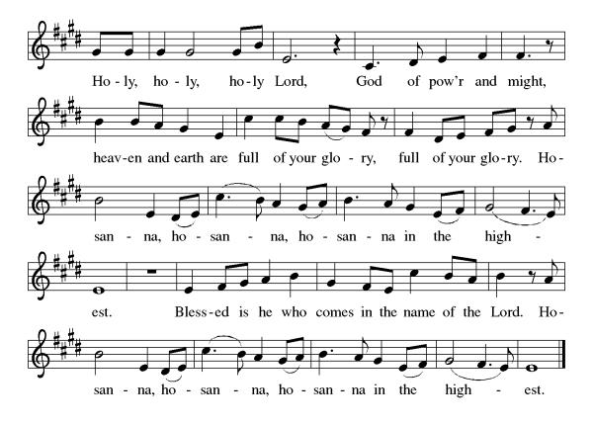

Eucharistic Prayer
Blessed are you, O God of the universe. Your mercy is everlasting, and your faithfulness endures from age to age.
Praise to you for creating the heavens and the earth. Praise to you for saving the earth from the waters of the flood. Praise to you for bringing the Israelites safely through the sea. Praise to you for leading your people through the wilderness to the land of milk and honey. Praise to you for the death and resurrection of Christ. Praise to you for your Spirit poured out on all nations.
In the night he was betrayed, our Lord Jesus took bread and gave thanks; broke it, and gave it to his disciples saying: Take and eat; this is my body given for you. Do this for the remembrance of me.
After supper he took the cup, gave thanks and gave it for all to drink saying: This cup is the new covenant in my blood, shed for you and for all people for the forgiveness of sin, Do this for the remembrance of me.
For as often as we eat of this bread and drink from this cup we proclaim the Lord’s death until He comes.
Christ has died
Christ is risen.
Christ will come again.
Gathered into one, by the Holy Spirit let us listen to the words that Jesus taught us.

The Lord’s Prayer
Our Father, who art in heaven, hallowed be thy name, thy kingdom come, thy will be done, on earth as it is in heaven. Give us this day our daily bread; and forgive us our trespasses, as we forgive those who trespass against us; and lead us not into temptation but deliver us from evil. For thine is the kingdom, and the power, and the glory, forever and ever. Amen.

Invitation to Communion
P: This is the Lamb of God who takes away the sins of the world. Happy are those who are called to His supper. Come and taste on your lips a Love we cannot comprehend.
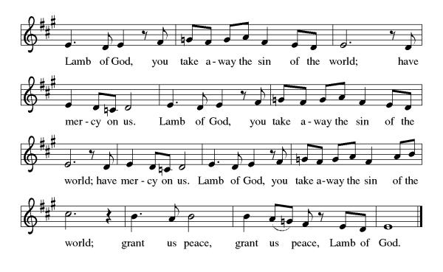
C: Amen

Please come forward to receive
Communion Anthem: Beautiful Savior ELW 838

P: We are now a tabernacle with Christ inside of us. Let us rejoice and be glad at the Lord’s table.
C: Amen

Prayer After Communion
Life-giving God, through this meal you have bandaged our wounds and fed us with your mercy. Now send us forth to live for others, both friend and stranger, that all may come to know your love. This we pray in the name of Jesus. Amen.

Sending

Blessing
P: Lord, thank you for your abundant love and care for us. Thank you for forgiving our sins, even for the sins we do not realize we commit. Lord, please fill us with your wisdom and your compassion for others. May Almighty God Bless you "The Father, Son and Holy Spirit"
C: Amen

Sending Hymn: What a Fellowship, What a Joy Divine ELW 774

1 What a fellowship, what a joy divine,
leaning on the everlasting arms;
what a blessedness, what a peace is mine,
leaning on the everlasting arms.

Refrain
Leaning, leaning, (Leaning on Jesus, leaning on Jesus,)
safe and secure from all alarms;
leaning, leaning, (leaning on Jesus, leaning on Jesus,)
leaning on the everlasting arms.

2 Oh, how sweet to walk in this pilgrim way,
leaning on the everlasting arms;
oh, how bright the path grows from day to day,
leaning on the everlasting arms. Refrain

3 What have I to dread, what have I to fear,
leaning on the everlasting arms?
I have blessed peace with my Lord so near,
leaning on the everlasting arms. Refrain

Text: Elisha A. Hoffman, 1839-1929

Dismissal
P: Go in peace. Live by the Spirit.
C: Thanks be to God.
Postlude: instrumental
Unless otherwise noted, materials used in this bulletin are:
From Sundays and Seasons.com. Copyright 2015 Augsburg Fortress. All rights reserved. Reprinted by permission under Augsburg Fortress Liturgies Annual License #SAS028635. Music is reprinted under OneLicense.Net #A712074 and/or Augsburg Fortress #SBL12176H. Scripture, unless otherwise noted, is from the New Revised Standard Version Bible, Copyright © 1989, Division of Christian Education of the National Council of the Churches of Christ in the United States of America. Used by permission. All rights reserved.
Announcements for October 18th and 19th

ATTENDANCE
Saturday, October 11th, 4pm 19
Sunday, October 12th, 9am 46
Drive-Up Communion 0
65

The Altar Flowers are given this week to the glory of God!

This Week at St. Timothy's
Monday, October 20th
Tuesday, October 21st 1pm - WELCA
Wednesday, October 22nd 2pm – Prayer Time
Thursday, October 23rd NO MINIATURES, 4:30pm - Choir
Friday, October 24th
Saturday, October 25th NO WORSHIP
Sunday, October 26^{h} Reformation Sunday – 50th Anniversary Celebration – 9:45 pre-service music, 10am – worship, anniversary celebration follows svc

USHERS NEEDED – ESPECIALLY FOR 50TH ANNIVERSARY!!!!

S.A.M. Bob, Chair of Stewardship, is asking for 3-4 more people to be part of the Stewardship Team. Contact Regina or email Bob.

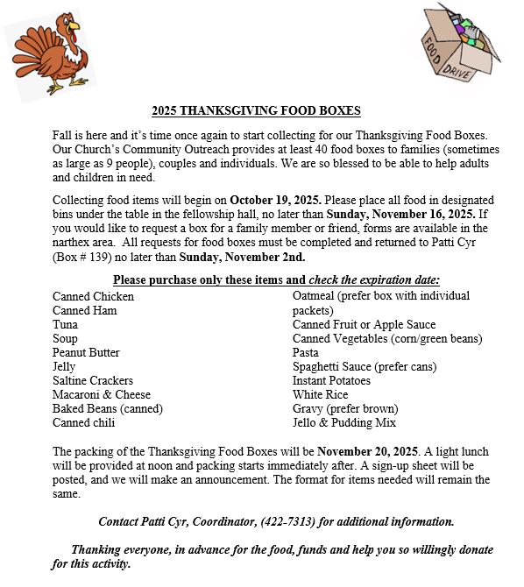


St. Timothy Lutheran Church will be celebrating our 50th Anniversary on Reformation Sunday, October 26, 2025. There will be no Saturday Service that weekend. Our celebration begins Sunday morning as follows:

Pre-service Music – 9:45 am
Service – 10:00 am
A luncheon will follow the Service.

Our Florida-Bahamas Bishop as well as other friends and former members have been invited. Please mark this date on your calendar and join our church family for this very special occasion.
In order to prepare for the luncheon, we are asking all our members to RSVP. There are (two) 2 sign-up sheets on the WELCA bulletin board in the narthex area. Please sign up on both sheets. One sign-up sheet is for attendance, and the other sign-up sheet is for bringing food for the luncheon. Ham, turkey, stuffing, beverages and dessert will be provided. We need vegetables, salads and other side dishes noted on the sheets.
If you have questions regarding the meal, please contact Eileen Hofstetter at 352-419-6610.

