Welcome to St. Timothy Evangelical Lutheran Church
Saturday, January 24th
Third Weekend After Epiphany
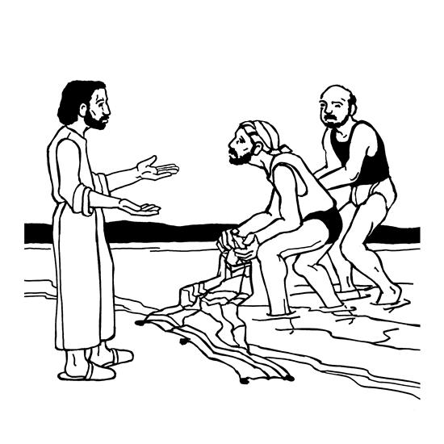

Jesus begins his public ministry by calling fishers to leave their nets and follow him. In Jesus the kingdom of God has come near. We who have walked in darkness have seen a great light. We see this light most profoundly in the cross—as God suffers with us and all who are oppressed by sickness, sin, or evil. Light dawns for us as we gather around the word, the font, and the holy table. We are then sent to share the good news that others may be “caught” in the net of God’s grace and mercy.

Welcome and Sharing of Congregational News
Preservice: Listen, God is calling ELW 513
Prelude

Confession and Forgiveness
All may make the sign of the cross, the sign that is marked at baptism, as the presiding minister begins.
Blessed be the holy Trinity, ☩ one God,
the Creator of heaven and earth,
the Word who spoke life into being,
the Wind stirring the waters.
Amen.
Let us turn in confession to the one who knows us completely.
Silence is kept for reflection.
Mighty God, lover of justice,
you call us to life in community,
but we have served our own interests
at the expense of our neighbors.
We have sown deceit where honesty was needed.
We say the right words,
but our hearts are far from you.
Turn us to seek your face.
Knit us together and give us the mind of Christ,
that we may do justice, love mercy,
and walk humbly with you, our God.
Amen.
Forgiveness
The former things have passed away,
and new things God now declares:
Like a spring of water that never fails,
God covers you in the righteousness of Christ,
and forgives your sin in ☩ Jesus’ name.
May the Spirit give you strength to live for others,
and bless you with the gift of peace.
Amen.
Greeting
P: The joy of our Lord Jesus Christ, the compassion of God, and the creative power of the Holy Spirit be with you all.
C: And also with you.

Gathering Hymn: Come, Follow Me, the Savior Spake ELW 799

1 "Come, follow me," the Savior spake, "all in my way abiding;
deny yourselves, the world forsake, obey
my call and guiding. Oh, bear the cross, whate'er
betide; take my example for your guide."

2 "I am the light; I light the way, a godly life displaying;
I bid you walk as in the day; I
keep your feet from straying. I am the way, and
well I show how you should sojourn here below."

3 "I teach you how to shun and flee what harms your soul's salvation;
from ev'ry guile your heart to free, from
sin and its temptation. I am the refuge
of the soul and lead you to your heav'nly goal."

4 Then let us follow Christ, our Lord, and take the cross appointed,
and, firmly clinging to his word, in
suffering be undaunted. For those who bear the
battle's strain the crown of heav'nly life obtain.
Text: Johann Scheffler, 1624-1677; tr. Charles W. Schaeffer, 1813-1896, alt.

Prayer of the Day
Lord God, your lovingkindness always goes before us and follows after us. Summon us into your light, and direct our steps in the ways of goodness that come through the cross of your Son, Jesus Christ, our Savior and Lord.
Amen.
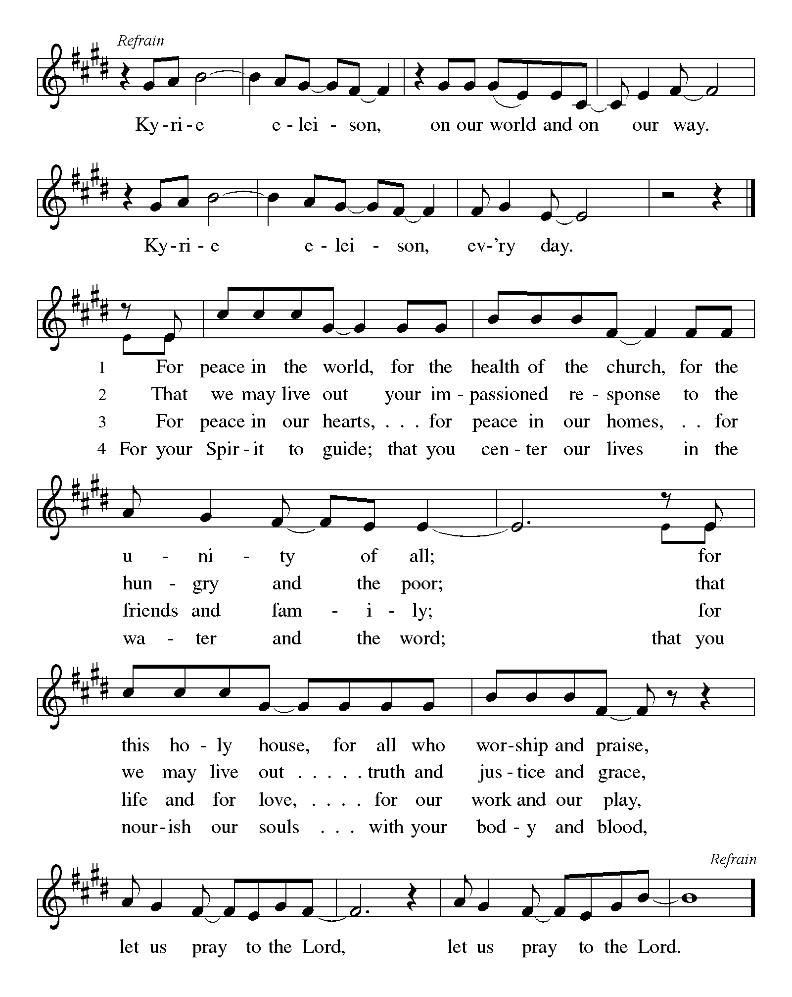

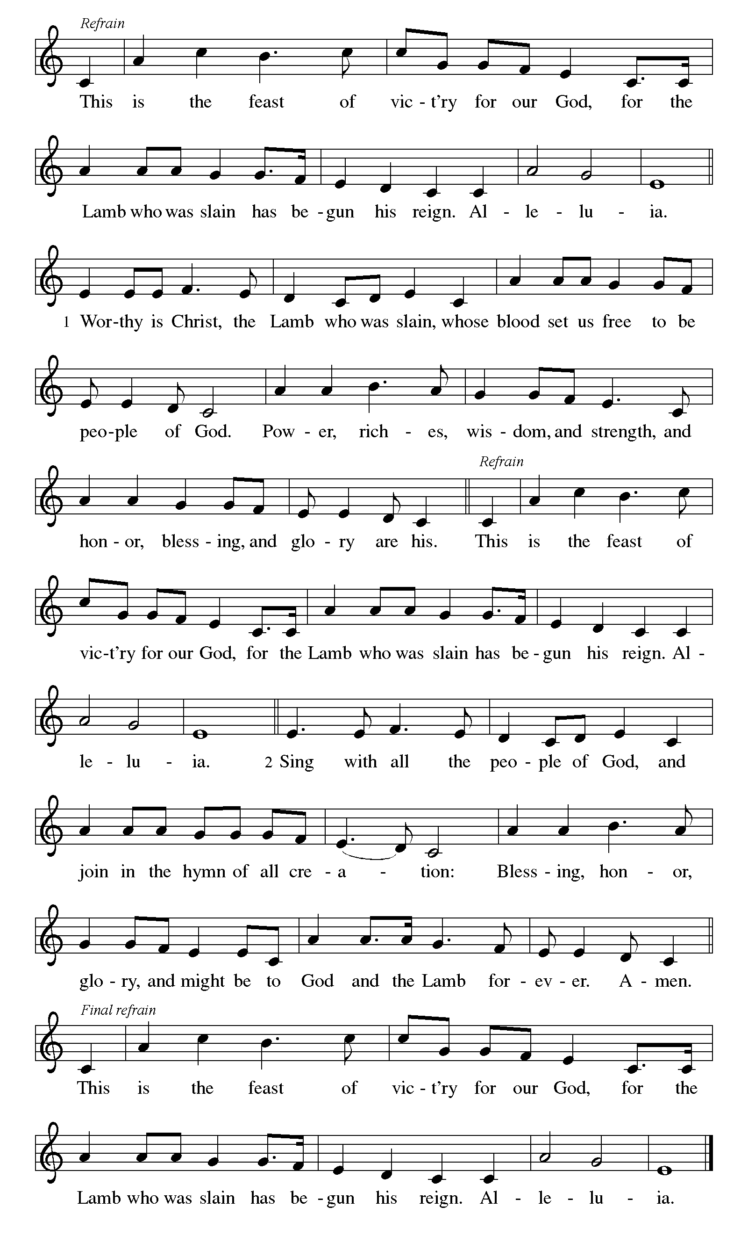

First Reading: Isaiah 9:1-4
The northern tribes of Zebulun and Naphtali experienced the gloom of defeat by Assyrian military forces, but they are assured that their condition will be reversed when God makes a light-filled appearance. The joy they will experience will resemble celebrations of great harvests, because God will deliver them from everything that diminishes or oppresses them.
¹ There will be no gloom for those who were in anguish. In the former time [the Lord] brought into contempt the land of Zebulun and the land of Naphtali, but in the latter time he will make glorious the way of the sea, the land beyond the Jordan, Galilee of the nations.
² The people who walked in darkness
have seen a great light;
those who lived in a land of deep darkness—
on them light has shined.
³ You have multiplied exultation;
you have increased its joy;
they rejoice before you
as with joy at the harvest,
as people exult when dividing plunder.
⁴ For the yoke of their burden
and the bar across their shoulders,
the rod of their oppressor,
you have broken as on the day of Midian.

P: Here ends our first reading.
C: Thanks be to God!

Psalm 27:1, 4-9
¹ The Lord is my light and my salvation; whom then shall I fear?
The Lord is the stronghold of my life; of whom shall I be afraid?
⁴ One thing I ask of the Lord; one thing I seek;
that I may dwell in the house of the Lord all the days of my life; to gaze upon the beauty of the Lord and to seek God in the temple.
⁵ For in the day of trouble God will give me shelter,
hide me in the hidden places of the sanctuary, and raise me high upon a rock.
⁶ Even now my head is lifted up above my enemies who surround me.
Therefore I will offer sacrifice in the sanctuary, sacrifices of rejoicing; I will sing and make music to the Lord.
⁷ Hear my voice, O Lord, when I call;
have mercy on me and answer me.
⁸ My heart speaks your message— “Seek my face.”
Your face, O Lord, I will seek.
⁹ Hide not your face from me, turn not away from your servant in anger.
Cast me not away—you have been my helper; forsake me not, O God of my salvation.

Second Reading: 1 Corinthians 1:10-18
Paul calls on the Corinthians to end their dissensions and share the unified outlook of the gospel. Discord arises when we forget that we belong not to human leaders or institutions but to Christ. Indeed, the unifying word of the cross of Christ is the center of the gospel and the power of God’s salvation.
¹⁰ Now I appeal to you, brothers and sisters, by the name of our Lord Jesus Christ, that all of you be in agreement and that there be no divisions among you but that you be knit together in the same mind and the same purpose. ¹¹ For it has been made clear to me by Chloe’s people that there are quarrels among you, my brothers and sisters. ¹² What I mean is that each of you says, “I belong to Paul,” or “I belong to Apollos,” or “I belong to Cephas,” or “I belong to Christ.” ¹³ Has Christ been divided? Was Paul crucified for you? Or were you baptized in the name of Paul? ¹⁴ I thank God that I baptized none of you except Crispus and Gaius, ¹⁵ so that no one can say that you were baptized in my name. ¹⁶ I did baptize also the household of Stephanas; beyond that, I do not know whether I baptized anyone else. ¹⁷ For Christ did not send me to baptize but to proclaim the gospel—and not with eloquent wisdom, so that the cross of Christ might not be emptied of its power.
¹⁸ For the message about the cross is foolishness to those who are perishing, but to us who are being saved it is the power of God.
P: Here ends our second reading.
C: Thanks be to God!
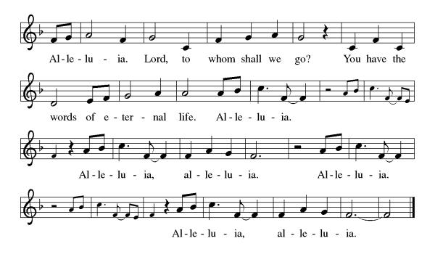
Gospel Acclamation

P: The Holy Gospel according to Matthew 4:12-23
C: Glory to you O Lord.

Gospel: Matthew 4:12-23
Jesus begins his public ministry shortly after John the Baptist is imprisoned by Herod. He proclaims the nearness of God’s reign and calls four fishermen to be his first disciples.
¹² Now when Jesus heard that John had been arrested, he withdrew to Galilee. ¹³ He left Nazareth and made his home in Capernaum by the sea, in the territory of Zebulun and Naphtali, ¹⁴ so that what had been spoken through the prophet Isaiah might be fulfilled:
¹⁵ “Land of Zebulun, land of Naphtali,
on the road by the sea, across the Jordan, Galilee of the gentiles—
¹⁶ the people who sat in darkness
have seen a great light,
and for those who sat in the region and shadow of death
light has dawned.”
¹⁷ From that time Jesus began to proclaim, “Repent, for the kingdom of heaven has come near.”
¹⁸ As he walked by the Sea of Galilee, he saw two brothers, Simon, who is called Peter, and Andrew his brother, casting a net into the sea—for they were fishers. ¹⁹ And he said to them, “Follow me, and I will make you fishers of people.” ²⁰ Immediately they left their nets and followed him. ²¹ As he went from there, he saw two other brothers, James son of Zebedee and his brother John, in the boat with their father Zebedee, mending their nets, and he called them. ²² Immediately they left the boat and their father and followed him.
²³ Jesus went throughout all Galilee, teaching in their synagogues and proclaiming the good news of the kingdom and curing every disease and every sickness among the people.

P: The Gospel of Our Lord!
C: Praise to You O Christ!
Sermon by Bob

Hymn of the Day: Will You Come and Follow Me ELW 798
- "Will you come and follow me if I but call
your name? Will you go where you don't
know and never be the same?
Will you let my love be shown, will you let my
name be known, will you let my life be
grown in you and you in me?
- "Will you leave yourself behind if I but call
your name? Will you care for cruel and
kind and never be the same?
Will you risk the hostile stare, should your life attract
or scare? Will you let me answer
pray'r in you and you in me?
- "Will you let the blinded see if I but call
your name? Will you set the pris'ners
free and never be the same?
Will you kiss the leper clean, and do such as
this unseen, and admit to what I
mean in you and you in me?
- "Will you love the you you hide if I but call
your name? Will you quell the fear inside
and never be the same?
Will you use the faith you've found to reshape the
world around, through my sight and touch and
sound in you and you in me?"
- Lord, your summons echoes true when you but call
my name. Let me turn and follow
you and never be the same.
In your company I'll go where your love and
footsteps show. Thus I'll move and live and
grow in you and you in me.
Text: John L. Bell, b. 1949
Text © 1987 Iona Community, GIA Publications, Inc., agent 7404 S. Mason Ave., Chicago, IL 60638. www.giamusic.com. 800.442.3358. All rights reserved. Used by permission.

Apostles’ Creed
I believe in God, the Father almighty,
creator of heaven and earth.
I believe in Jesus Christ, God’s only Son, our Lord,
who was conceived by the Holy Spirit,
born of the virgin Mary,
suffered under Pontius Pilate,
was crucified, died, and was buried;
he descended to the dead.
On the third day he rose again;
he ascended into heaven,
he is seated at the right hand of the Father,
and he will come to judge the living and the dead.
I believe in the Holy Spirit,
the holy catholic church,
the communion of saints,
the forgiveness of sins,
the resurrection of the body,
and the life everlasting. Amen.

Lord, listen to your children praying,
Lord, send your Spirit in this place;
Lord, listen to your children praying,
send us love, send us pow'r, send us grace.

Prayers of the People

Response (after “Lord in your mercy.”): “Hear our prayer.”

P: May the peace of our Lord Jesus Christ be with you all.
C: And also with you.
P: Let us now share this peace.
Offering is Brought to the Altar

Offertory Prayer
God of majesty,
no eye has seen, no ear has heard
what you have prepared for those who love you,
yet in this meal you reveal the wideness of your mercy.
Use what we have gathered
to feed us with the reign of God come near,
Jesus Christ, our Savior and Lord.
Amen.
P: The Lord be with you.
C: And also with you.

P: Lift up your hearts.
C: Lift them to the Lord.

P: Let us give thanks to the Lord our God.
C: It is right to give our thanks and praise.

Preface
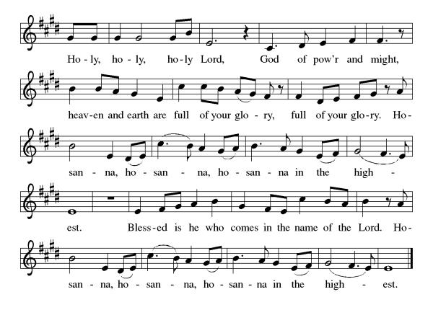
(Words spoken by Bob)

Eucharistic Prayer
(Words of Institution)

For as often as we eat of this bread and drink from this cup we proclaim the Lord’s death until He comes.
Christ has died
Christ is risen.
Christ will come again.
Gathered into one, by the Holy Spirit let us listen to the words that Jesus taught us.

The Lord’s Prayer
Our Father, who art in heaven, hallowed be thy name, thy kingdom come, thy will be done, on earth as it is in heaven. Give us this day our daily bread; and forgive us our trespasses, as we forgive those who trespass against us; and lead us not into temptation but deliver us from evil. For thine is the kingdom, and the power, and the glory, forever and ever. Amen.

Invitation to Communion
P: Here is the Lamb of God who takes away the sins of the world! Come to His table and taste on your lips a Love we cannot comprehend.
C: Amen
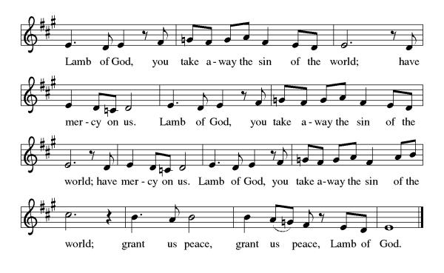

All may come.
Communion Anthem: Come and Seek the Ways of Wisdom ACS 971
P: We are now a tabernacle with Christ inside of us. Let us rejoice and be glad at the Lord’s table.
C: Amen

Prayer after Communion
Radiant God,
we have seen your glory in the face of Jesus Christ.
In the sacrament of his body and blood
you have drawn us to your heart.
Send us from this table with delight,
that our lives may reflect the beauty of your love,
and bear witness to all we have seen and heard,
through Jesus Christ, our Savior and Lord.
Amen.

Blessing
May the triune God,
Who has put a new song in your mouth
And tuned your heart for praise
☩ bless you now and forever
Amen.

Sending Hymn: I Want to Walk as a Child of the Light ELW 815
- I want to walk as a child of the light. I want to
follow Jesus. God set the stars to give
light to the world. The star of my life is Jesus.

Refrain
In him there is no darkness at all. The night and the
day are both alike. The Lamb is the light of the
city of God. Shine in my heart, Lord Jesus.

2 I want to see the brightness of God. I want to
Look at Jesus. Clear Sun of righteousness,
shine on my path, and show me the way to the Father. Refrain

- I'm looking for the coming of Christ. I want to
be with Jesus. When we have run with
patience the race, we shall know the joy of Jesus. Refrain
Text: Kathleen Thomerson, b. 1934 Text © 1970, 1975 Celebration.
Dismissal
P: Go in peace. Do justice. Love mercy.
C: Thanks be to God.
Postlude
Unless otherwise noted, materials used in this bulletin are:
From Sundays and Seasons.com. Copyright 2015 Augsburg Fortress. All rights reserved. Reprinted by permission under Augsburg Fortress Liturgies Annual License #SAS028635. Music is reprinted under OneLicense.Net #A712074 and/or Augsburg Fortress #SBL12176H. Scripture, unless otherwise noted, is from the New Revised Standard Version Bible, Copyright © 1989, Division of Christian Education of the National Council of the Churches of Christ in the United States of America. Used by permission. All rights reserved.

St. Timothy Evangelical Lutheran Church
1070 N. Suncoast Blvd.
Crystal River, FL 34429
Telephone number (Office): 352-795-5325
Office email address: crsttimothy@tampabay.rr.com

St Timothy Worship Team
S.A.M. Robert F. Bonomo
Lay Minister, Frank Hofstetter
Director of Music, Sally Hennessey
Saturday Pianist, Bill Robinson
Announcements for January 24th and 25th

ATTENDANCE
Saturday, January 10th, 4pm 24
Sunday, January 11th , 9am 62
Drive-Up Communion 0
86

The Altar Flowers are given this week to the glory of God!

This Week at St. Timothy's
Monday, January 26th
Tuesday, January 27th 9-12 Food Pantry
Wednesday, January 28th
Thursday, January 29th 9:30am Prayer Group, 11am Bible Study for Beginners (bring bible) 11am – Miniatures, 4:30pm - Choir
Friday, January 30th
Saturday, January 31st 4pm - Worship
Sunday, February 1st 9am – Worship, 10:15-10:45 – Drive Up Communion, Adult SS, Coffee Fellowship




