St Timothy Lutheran Church
Saturday, April 11, 2026
Second Saturday of Easter



In today’s gospel the risen Christ appears to the disciples and offers them the gift of peace. Even amid doubts and questions, we experience the resurrection in our Sunday gathering around word and meal, and in our everyday lives. Throughout the coming Sundays of Easter the first two readings will be from the Acts of the Apostles and the first letter of Peter. Even as the early Christians proclaimed the resurrection, we rejoice in the new birth and living hope we receive in baptism.

Preservice Music: Christ is Living! ACS 934
Welcome!
P – Preparing our hearts for Worship

Thanksgiving for Baptism
All may make the sign of the cross, the sign that is marked at baptism, as the presiding minister begins.
Alleluia! Christ is risen.
Christ is risen indeed. Alleluia!
Salvation belongs to our God who is seated on the throne
and to the Lamb!
Amen.
Let us give thanks for the gifts of baptism.
P - Merciful God,
you are the one who was, who is, and who is to come.
You lead us beside still waters.
We thank you for the waters of creation:
morning dew, gentle rain, roaring waves.
We thank you for the waters that nourish us.
Blessed are you.
You guide us to springs of the water of life.
Jesus Christ, you are the faithful witness
who accompanies us on our journeys.
We give you thanks for your life-giving death and resurrection.
We praise you for joining us in joy and sorrow.
Blessed are you.
You guide us to springs of the water of life.
Holy Spirit, you anoint our head with oil and our cup overflows.
Break down barriers that divide us.
Fill us with the breath of peace.
Blessed are you.
You guide us to springs of the water of life.
Holy One, we thank you for the gifts and grace of baptism,
and for making us a new creation.
We join with saints and angels, giving you honor and praise,
now and forever.
Amen.

Gathering Hymn: Now All the Vault of Heaven Resounds ELW 367

1 Now all the vault of heav'n resounds
in praise of love that still abounds: "Christ has
triumphed! He is living!" Sing, choirs of
angels, loud and clear! Repeat their song of glory
here: "Christ has triumphed! He is living!"
Alleluia, alleluia, alleluia!

2 Eternal is the gift he brings,
therefore our heart with rapture sings: "Christ has
triumphed! He is living!" Now still he
comes to give us life and by his presence stills all
strife. "Christ has triumphed! He is living!"
Alleluia, alleluia, alleluia!

3 Oh, fill us, Lord, with dauntless love;
set heart and will on things above that we
conquer through your triumph; grant grace sufficient
for life's day that by our lives we truly
say: "Christ has triumphed! He is living!"
Alleluia, alleluia, alleluia!

4 Adoring praises now we bring
and with the heav'nly blessed sing: "Christ has
triumphed! Alleluia!" Be to the
Father, and our Lord, to Spirit blest, most holy
God, all the glory, never ending!
Alleluia, alleluia, alleluia!

Text: Paul Z. Strodach, 1876-1947, alt.
Text © 1958 Service Book and Hymnal, admin. Augsburg Fortress.
Duplication in any form prohibited without permission or valid license from copyright administrator.

P - The grace of our Lord Jesus Christ, the love of God and the communion of the Holy Spirit be with you all.
C - And also with you.

Prayer of the Day
Almighty and eternal God, the strength of those who believe and the hope of those who doubt, may we, who have not seen, have faith in you and receive the fullness of Christ’s blessing, who lives and reigns with you and the Holy Spirit, one God, now and forever.
Amen.

P – The Lord be with you!
C – And also with you!

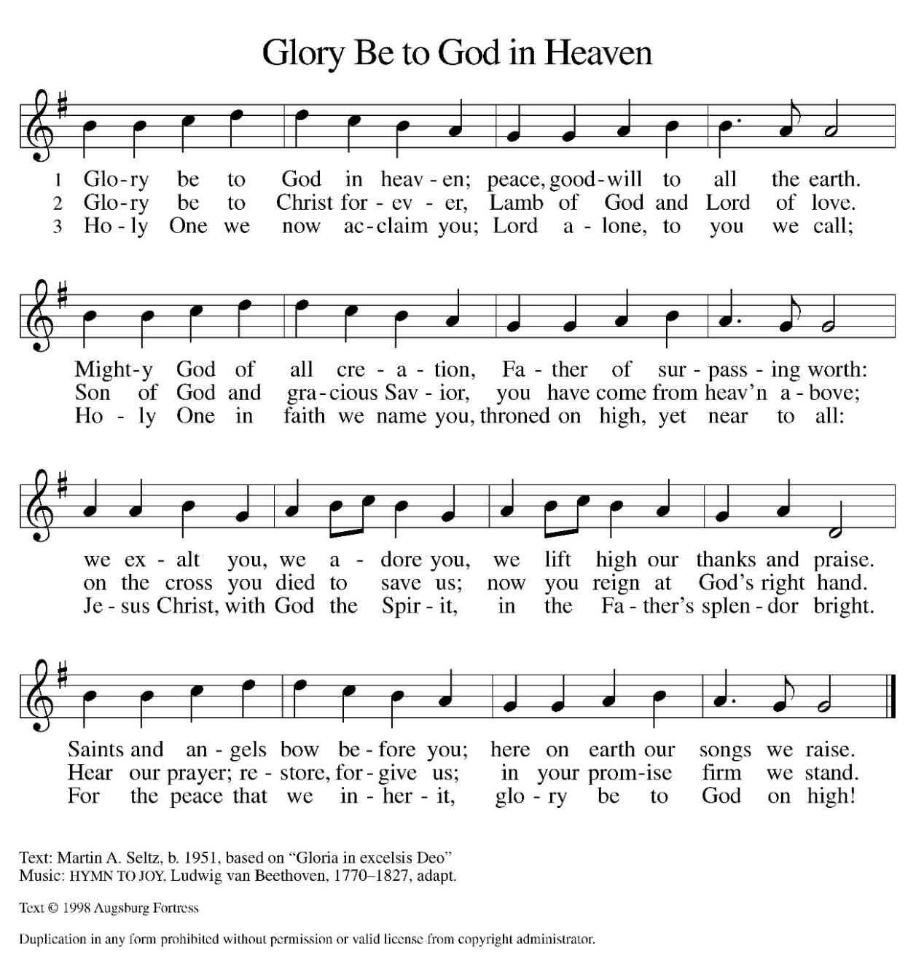
Hymn of Praise

(Please be seated)

Reading: Acts 2:14a, 22-32
After the Holy Spirit comes to the apostles on Pentecost, Peter preaches the gospel to the gathered crowd. He tells them that Jesus, who obediently went to his death according to God’s plan, was raised from the dead by God. Finally, he appeals to scripture, quoting Psalm 16:8-11, to show that Jesus is the Messiah: though crucified, the risen Jesus is now enthroned.
^{14a} Peter, standing with the eleven, raised his voice and addressed [the crowd]: ²² “Fellow Israelites, listen to what I have to say: Jesus of Nazareth, a man attested to you by God with deeds of power, wonders, and signs that God did through him among you, as you yourselves know ²³ this man, handed over to you according to the definite plan and foreknowledge of God, you crucified and killed by the hands of those outside the law. ²⁴ But God raised him up, having released him from the agony of death, because it was impossible for him to be held in its power. ²⁵ For David says concerning him,
‘I saw the Lord always before me,
for he is at my right hand so that I will not be shaken;
²⁶ therefore my heart was glad, and my tongue rejoiced;
moreover, my flesh will live in hope.
²⁷ For you will not abandon my soul to Hades
or let your Holy One experience corruption.
²⁸ You have made known to me the ways of life;
you will make me full of gladness with your presence.’
²⁹ “Fellow Israelites, I may say to you confidently of our ancestor David that he both died and was buried, and his tomb is with us to this day. ³⁰ Since he was a prophet, he knew that God had sworn with an oath to him that he would put one of his descendants on his throne. ³¹ Foreseeing this, David spoke of the resurrection of the Messiah, saying,
‘He was not abandoned to Hades,
nor did his flesh experience corruption.’
³² “This Jesus God raised up, and of that all of us are witnesses.”

A – Here ends the reading!

C – Thanks be to God!
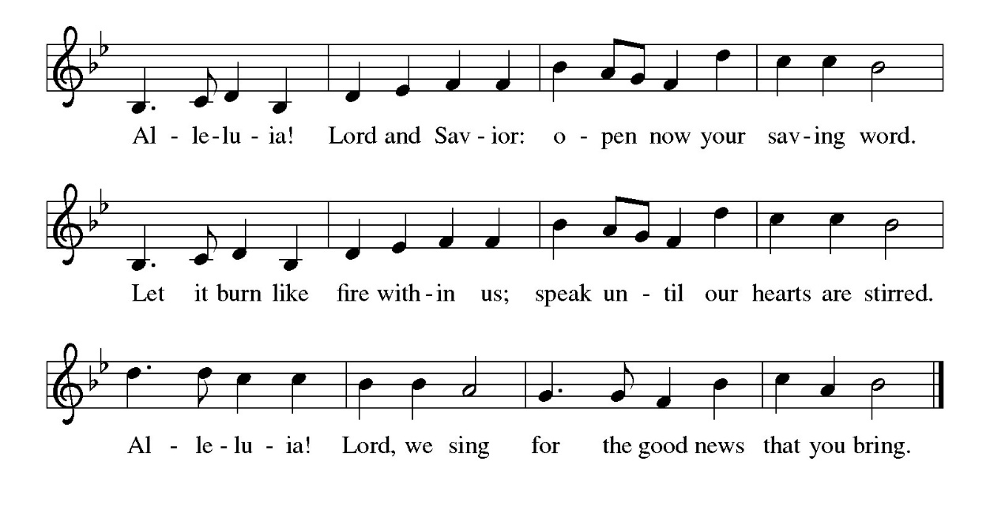
Gospel Acclamation
P - The Holy Gospel according to John, the 20th Chapter
C - Glory to You O Lord!

Gospel: John 20:19-31
The risen Jesus appears to his disciples, offering them a benediction, a commission, and the gift of the Holy Spirit. But one of their number is missing, and his unbelief prompts another visit from the Lord.
¹⁹ When it was evening on that day, the first day of the week, and the doors were locked where the disciples were, for fear of the Jews, Jesus came and stood among them and said, “Peace be with you.” ²⁰ After he said this, he showed them his hands and his side. Then the disciples rejoiced when they saw the Lord. ²¹ Jesus said to them again, “Peace be with you. As the Father has sent me, so I send you.” ²² When he had said this, he breathed on them and said to them, “Receive the Holy Spirit. ²³ If you forgive the sins of any, they are forgiven them; if you retain the sins of any, they are retained.”
²⁴ But Thomas (who was called the Twin), one of the twelve, was not with them when Jesus came. ²⁵ So the other disciples told him, “We have seen the Lord.” But he said to them, “Unless I see the mark of the nails in his hands and put my finger in the mark of the nails and my hand in his side, I will not believe.”
²⁶ A week later his disciples were again in the house, and Thomas was with them. Although the doors were shut, Jesus came and stood among them and said, “Peace be with you.” ²⁷ Then he said to Thomas, “Put your finger here and see my hands. Reach out your hand and put it in my side. Do not doubt but believe.” ²⁸ Thomas answered him, “My Lord and my God!” ²⁹ Jesus said to him, “Have you believed because you have seen me? Blessed are those who have not seen and yet have come to believe.”
³⁰ Now Jesus did many other signs in the presence of his disciples that are not written in this book. ³¹ But these are written so that you may continue to believe that Jesus is the Messiah, the Son of God, and that through believing you may have life in his name.
P - The Gospel of the Lord.
C – Praise to you, O Christ!

Sermon

Hymn of the Day: That Easter Day with Joy Was Bright ELW 384
1 That Easter day with joy was bright;
the sun shone out with fairer light
when, to their longing eyes restored,
th'apostles saw their risen Lord!

2 O Jesus, king of gentleness,
with constant love our hearts possess;
to you our lips will ever raise
the tribute of our grateful praise.

3 O Christ, you are the Lord of all
in this our Easter festival,
for you will be our strength and shield
from ev'ry weapon death can wield.

4 All praise, O risen Lord, we give
to you, once dead, but now alive!
To God the Father equal praise,
and God the Spirit, now we raise!
Text: Latin hymn, 5th cent.; tr. John Mason Neale, 1818-1866, alt.

The Apostle’s Creed
I believe in God, the Father almighty,
creator of heaven and earth.
I believe in Jesus Christ, God’s only Son, our Lord,
who was conceived by the Holy Spirit,
born of the virgin Mary,
suffered under Pontius Pilate,
was crucified, died, and was buried;
he descended to the dead.*
On the third day he rose again;
he ascended into heaven,
he is seated at the right hand of the Father,
and he will come to judge the living and the dead.
I believe in the Holy Spirit,
the holy catholic church,
the communion of saints,
the forgiveness of sins,
the resurrection of the body,
and the life everlasting. Amen.
From sundaysandseasons.com.
Copyright © 2026 Augsburg Fortress. All rights reserved.

Prayers of the People
Trusting in the power of Christ’s resurrection to heal and redeem our broken world, let us pray for the needs of all creation.
A brief silence.
Almighty God, you give life to the dead and call into existence things that do not exist. Breathe your Spirit upon us, that our faith may be renewed day by day.
Risen Jesus.
Receive our prayer.
Maker of heaven and earth, your mercies are new every morning. Open us to the wonders of creation, the renewal that brings us Springtime and the promise of eternal life.
Risen Jesus
Receive our prayer.
God of peace, in every place where conflict rages, sow seeds of calm and openness to reconciliation. Strengthen the resolve of leaders and citizens to work for peace world wide.
Risen Jesus
Receive our prayer.
Healing God, come alongside all who are doubting, fearful, or suffering in any way (especially). Reveal to them your presence and assure them of the inheritance you have prepared for them.
Risen Jesus
Receive our prayer.
Giver of joy, spread among the people of St. Timothy’s genuine love and mutual affection. Deepen our care for one another and help us to embody your forgiving and sacrificial love so we are able to take this love throughout our communities.
Risen Jesus
Receive our prayer.

Eternal One, we give thanks for saints who were faithful unto death and have joined the church triumphant. Inspire us by their witness and bring us with them into your glorious presence.
Risen Jesus
Receive our prayer.
God of resurrection power, use us and these prayers to proclaim the Good News of new life to all the world, through Jesus Christ, our risen Savior.
Amen.

P – The Peace of the Lord be with you always.
C – And also with you.
The Offering is Brought to the Altar
Offertory Prayer
Merciful God,
accept the fruits of our labor, gathered to give you glory.
You have set a table before us, a glimpse of that great day
when we will hunger and thirst no more.
Nourish us with the body and blood of Jesus,
that goodness and mercy may follow us
and bless the world you love.
In the name of Jesus,
Amen.

P – The Lord be with You
C – And also with you.
P – Lift up your hearts
C – We lift them to the Lord.
P – Let us give thanks to the Lord, our God
C – It is right to give Him our thanks and praise.

Preface
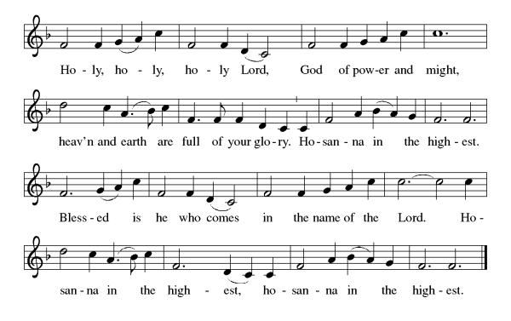
And so, with Mary Magdalene and Peter and all the witnesses of the resurrection, with earth and sea and all their creatures, and with angels and archangels, cherubim and seraphim, we praise your name and join their unending hymn:

Eucharistic Prayer
(Words of Institution)

For as often as we eat of this bread and drink from this cup we proclaim the Lord’s death until He comes.
Christ has died
Christ is risen.
Christ will come again.

Remembering, therefore, his salutary command,
his life-giving passion and death, his glorious resurrection and ascension, and the promise of his coming again,
we give thanks to you, O Lord God Almighty,
not as we ought but as we are able;
we ask you mercifully to accept our praise and thanksgiving and with your Word and Holy Spirit to bless us, your servants, and these your own gifts of bread and wine, so that we and all who share in the body and blood of Christ may be filled with heavenly blessing and grace, and, receiving the forgiveness of sin,
may be formed to live as your holy people
and be given our inheritance with all your saints.
To you, O God, Father, Son, and Holy Spirit,
be all honor and glory in your holy church, now and forever. Amen.

Gathered into one, by the Holy Spirit let us listen to the words that Jesus taught us.
The Lord’s Prayer
Our Father, who art in heaven, hallowed be thy name, thy kingdom come, thy will be done, on earth as it is in heaven. Give us this day our daily bread; and forgive us our trespasses, as we forgive those who trespass against us; and lead us not into temptation but deliver us from evil. For thine is the kingdom, and the power, and the glory, forever and ever. Amen.
P: God feeds those who hunger, Come! Be fed and be healed!
C: Thanks be to God.
Invitation to Communion
P – This is the Lamb of God who takes away the sins of the world. Happy are those that are called to His supper. Come and touch the body of Christ as His disciple Thomas witnessed.
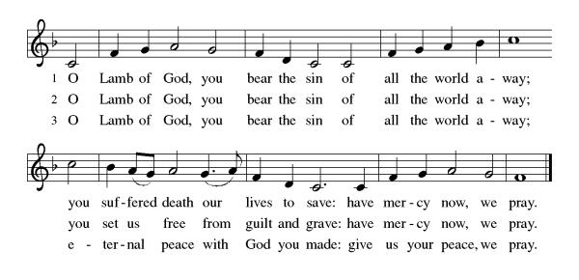

Distribution of Communion – Come Forward to Receive
Communion Anthem: Awake, My Heart, with Gladness ELW 378

P – Now may the body and blood of our Lord and Savior Jesus Christ strengthen you and keep you in His grace!
C – Thank You Jesus!

Prayer after Communion
Holy One,
through this meal you have made your home among us
and are making all things new.
Send us now to speak peace to anxious hearts,
to love our enemies,
and to bring your healing to the nations.
In the name of Jesus,
Amen.

Blessing
God Almighty, who is the beginning and the end,
Jesus Christ, the firstborn of the dead,
and the Spirit, our advocate and peace,
☩ bless you now and forever.
Amen.

Sending Hymn: Good Christian Friends, Rejoice and Sing! ELW 385

1 Good Christian friends, rejoice and sing!
Now is the triumph of our king!
To all the world glad news we bring:
Alleluia, alleluia, alleluia!

2 The Lord of life is ris'n this day;
death's mighty stone is rolled away;
let all the world rejoice and say:
Alleluia, alleluia, alleluia!

3 Praise we in songs of victory
that love, that life, which cannot die,
and sing with hearts uplifted high:
Alleluia, alleluia, alleluia!

4 Your name we bless, O risen Lord,
and sing today with one accord,
the life laid down, the life restored:
Alleluia, alleluia, alleluia!

Text: Cyril A. Alington, 1872-1955, alt.
Text © 1952, ren. 1986 Hymns Ancient & Modern, admin. Hope Publishing Company, Carol Stream, IL 60188. All rights reserved. Used by permission.
Duplication in any form prohibited without permission or valid license from copyright administrator.

Dismissal
P – Look and listen to S.A.M. Bob
C- Thanks be to God. Alleluia!

Postlude:
Unless otherwise noted, service materials used in this bulletin are:
"Reprinted from the 1995 Moravian Book of Worship with permission of the Interprovincial Board of Communication, Moravian Church in North America."
Music is reprinted under OneLicense.Net #A712074 and/or Augsburg Fortress #SBL12176H. Scripture, unless otherwise noted, is from the New Revised Standard Version Bible, Copyright © 1989, Division of Christian Education of the National Council of the Churches of Christ in the United States of America. Used by permission. All rights reserved.
St Timothy’s is served by S.A.M. Robert Bonomo
Lay Minister Frank Hofstetter
Director of Music Sally Hennessey
Saturday Pianist Bill Robinson

Announcements for April 11th and 12th

ATTENDANCE
Maundy Thursday, April 2, 4pm 42
Good Friday, April 3, 12pm 47
Easter Sunday, April 5, 8am 39
11am 87
215

Serving our Lord this weekend:
Saturday, April 11th

Sunday, April 12th
Assisting Minister: Dick Kleinsmith
Reader: Barbara Carson

This Week at St. Timothy's
Monday, April 13th 10:30 Ruth Circle @ Barbara Carson’s house
Tuesday, April 14th 9-12 Food Pantry
Wednesday, April 15th
Thursday, April 16th 11am Bible Study for Beginners, 11am – Miniatures, 3:30 Chimes, 4pm - Choir
Friday, April 17th
Saturday, April 18th 4pm Worship
Sunday, April 19th 9am Worship, 10:30am – Adult SS, Coffee Fellowship, Council

