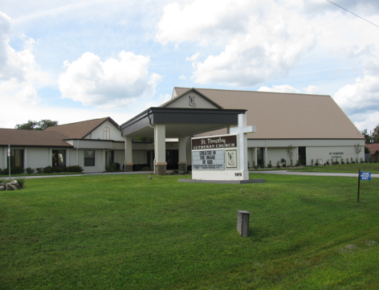

ST. TIMOTHY EVANGELICAL
LUTHERAN CHURCH
Vineyard Views
December 2025

S.A.M.’s Corner
S.A.M. BOB BONOMO
DECEMBER 2025
Greetings from Our Lord and Savior Jesus Christ.
I have been blessed more than I deserve to stand with all of you as your S.A.M. Interim Shepherd for the past nine months. I came to you at a very delicate, sad time in the life of this Congregation. I want all of you to know that I too share that loss for you and just maybe there is a reason for this walk with you. Thank you for opening your minds and hearts to me as I dove in headfirst, or as they say “Baptism by Fire. St. Timothy lost many good people this year, but we know the gift of His Grace was given to them as they entered into His home.
First let me share with you that Christmas and Advent should never be connected as one. Advent and Christmas are separate for a reason. Advent gives us the focus we need to meditate and repent so we can appreciate the coming of The Baby Jesus. Past history dictates that Advent was about repentance and waiting.
Advent later merged into the tradition we know today—one centered on worship, weekly candle lighting, and the spiritual themes of hope, peace, joy, and love. Repenting strengthens our waiting for the second coming.
Every Christmas, we celebrate the birth of a baby who will give us eternal life. The peace of His birth, His love pouring out to us in human form, and the love of the Blessed Mother and Joseph who accepted God’s will, is a day to celebrate.
This year our Advent Wednesday’s theme is “While we wait.” The word Advent means coming. He will come again to bring all those who accepted Jesus as their Lord and Savior with Him to the Father in Heaven.
Our time together during Advent will be spiritual, fun, enjoyable time, with arts and crafts, advent calendars for your home, advent wreaths made with clay and candles to bring home while we listen to some scripture and discuss the word of the week, as we partake in a light supper. This discussion is all yours to share with your church family. Word of the week will be in this order” #1“HOPE” #2“PEACE” #3“JOY” #4“LOVE”
St. Timothy’s choir will be singing a Christmas Cantata on Saturday 12/20/25 at the 4pm Service and on Sunday 12/21/25 at the 9AM Service. For Christmas Eve Service the bell ringers will be part of the preservice music. On 12/27/25 and 12/28/25 we will partake in Lessons and Carols with the Holy Eucharist at both services.
My prayer for all of you this Advent and Christmas Season is that Hope brings you closer to Him. Peace, be in your lives every day, joy in your hearts, and enough Love to share yourselves with others.
Blessings,
S.A. M. Bob

Benevolence for December - Day Star
A local program through St. Benedicts Catholic Church that offers a food pantry and social services program for additional assistance such as rent and clothing.

CHRISTMAS PARTY/POTLUCK
We will be having our Christmas Party/Potluck on Tuesday, December 16th at 12pm in the fellowship hall. Please bring a $10 grab bag gift. The sign-up sheets are posted on the WELCA board. Please sign up on the attendance sheet AND the side-dish sheet.

Thanksgiving Food Boxes – Update
Once again our Thanksgiving Food Boxes were a GREAT success! Our congregation’s generosity has gone above and beyond. I am so full of gratitude and thanks for everyone’s help and support. We packed 51 boxes for a total of 155 people, consisting of 82 adults and 73 children. There were 6 diabetic boxes and 1 gluten-free box. We had 36 “Angel” packers who rocked! Blessings and Thanks to Everyone!
- Patti Cyr

Call Committee -Survey Update
Just a reminder of how the surveys should be filled out. Pick only 5 of the 10 tasks listed, and then rank them according to importance from 1-5, with 1 being the MOST IMPORTANT and 5 being the LEAST important. We are going to extend the deadline until December 28th. Also, if you would like to add comments please do so. We would also like to know if you like Bob or not and WHY/WHY NOT. Barbara Johnson will give a talk this weekend on the topic.

WELCA ANNOUNCEMENT FOR DECEMBER VINEYARD VIEWS
"Sisters in Christ, are sisters for life!"

Dear Sisters In Christ,

Did you know that if you are a woman, and you attend St. Timothy Lutheran, you are a member of WELCA (Women of the ELCA). We either have a membership meeting or a luncheon each month on the third Tuesday of the month. We hope to see all of you and your significant others at our annual Christmas Party luncheon on Tuesday, December 16, 2025, at 12:00 p.m. It is a potluck luncheon. The men are all invited as well. The sign-up sheets for attendance & what you would like to bring food wise is on the WELCA bulletin board.

If you so desire, you can bring a $10.00 grab bag gift. The men's grab bag gifts will be given to the men. Come enjoy the fellowship, food, fun, & music by our resident DJ - Buzz Chainey. Tune up your voices and join us in the Sing a long, test your brain on Christmas Trivia, and give yourself an afternoon of joy & laughter.

In January we have a special guest speaker lined up for our membership meeting on Tuesday, January 20, 2026. Our guest speaker is a Citrus County Resident, author, and Chronicle writer, Nancy Kennedy. I do not know what her topic will be, but if you have ever read any of her books or writings, you know that she has the talent to mix life & faith with a touch of humor. Let's pack the fellowship hall and give her a warm St. Timothy welcome. She was with us to cover our 50th Anniversary Celebration and she told me that she felt very welcome.

Looking forward to a blessed Christmas season & a hopeful New Year.
Blessings,
Mary C. Schlumberger - President

Please check for the following sign-up sheets
Worship Helpers – bulletin board

DEADLINES
Announcements
Please be aware that if you have entries for the weekend worship announcements you need to have them in on Tuesday prior, as we are preparing and printing them no later than Thursday.

Vineyard Views
If you have submissions for the January Vineyard Views, please have them in the office no later than the end of day on Tuesday, December 30th.

NEW ZOOM LINK FOR ADULT SUNDAY SCHOOL – 9/18
Topic: Adult Sunday School Class
Time: Sep 21, 2025 10:30 AM Eastern Time (US and Canada)
Every week on Sun, 97 occurrence(s)
Please download and import the following iCalendar (.ics) files to your calendar system.
Weekly: https://us02web.zoom.us/meeting/tZwrc-mprDMoH9YRklu1WcmVIop862c72xVO/ics?icsToken=DBOIHJoC7iVwo_7kCQAALAAAABAB_uGypwq2ymkMO9EqrhDMoZY3vO7cudxQ3PHNM4LxWE7vm8v6Hf2LmVyJEkPyvcQ1Vmg_NR4W6BglNTAwMDAwMQ&meetingMasterEventId=3pLv0et_SMuCQYJkMknIyQ
Join Zoom Meeting
https://us02web.zoom.us/j/88640128252?pwd=asNJ6OiNGFFTNzwNA5yhkvPpmt6VCT.1
Meeting ID: 886 4012 8252
Passcode: 898938

CALLING ALL RINGERS OR POTENTIAL RINGERS!!
We’d like to expand the chimes choir (and have enough ringers for when people are out of town). Contact Sally Hennessey or Barbara Johnson.



INFORMATION FROM THE FINANCE COMMITTEE
AND YOUR TREASURERS
In the hope of getting ahead of our property, liability and flood insurance costs for next year, we have been trying to save toward those expenses. (Property and liability premiums are due by June 1st of each year, and flood is due November 1st.) We would appreciate any additional donation you could make. Please include that amount with your regular offering and designate it as “Insurance” on the offering envelope.
The lighting updates and replacements in the Sanctuary and throughout St. Timothy have been completed. What a wonderful improvement it is! The cost of this project was $9,500.00. As of November 16^{th,} we have received $5,328.38 in designated offerings to help with this expense. If you would like to help defray the cost, please note your donation as “Lighting Expense” on your offering envelope.

Stewardship information has been put in your church mailbox or mailed to you. Please prayerfully return your Time and Talent Sheets and Giving Card as soon as possible. This helps us plan for 2026.

A weekly offering update is given with the email announcements. We are most grateful to all of you who support our programs through your prayers, offerings, time and talents.

PLEASE NOTE; If you want your offering credited for 2025, it must be in the church office no later than Tuesday, December 30, 2025.


Thanks again for your prayers and support. Have a
Blessed Christmas and a Happy and Healthy 2026!


THRIVENT FINANCIAL NEWS FOR DECEMBER 2025
$$$THRIVENT CHOICE DOLLARS®$$$
Thanks so much to our Thrivent Financial members and friends who direct their Thrivent Choice Dollars® to available for activities and projects for our mission and ministry here at St. Timothy. If you are an eligible Thrivent Financial member and have Choice Dollars® available, please call Thrivent (800-847-4836) and say “Thrivent Choice®” or go online to ww.thrivent.com/thriventchoice and direct your dollars…hopefully to St. Timothy Lutheran Church in Crystal River. Since the beginning of 2025, our church has received $2035.00 through this program. Many thanks to our friend who recently designated her dollars:
Martha Hoagland
THRIVENT ACTION TEAMS
Thrivent Action Teams make it easy for you to bring people together to make a positive change in your community! When you see a need, apply to lead a volunteer team. Once your idea is approved, a Thrivent Action Kit is delivered to your door. It’s packed with everything you need to help make your project a success. It even includes $250.00 in seed money to help get your project started. After you finish the project, you report the results on-line to Thrivent. This program is brought to you by Thrivent Financial because they believe that being wise with money and living generously go hand in hand. All your questions and requests for this funding program will be answered by going to Thrivent.com/actionteam.***Please note that Thrivent Financial funds accessed for all programs and activities involving St. Timothy Lutheran Church need to be approved by a Committee and the Congregational Council. 2025 Thrivent Action Teams that have been approved: World’s Greatest Baby Shower (Bump2Baby), Easter Food Boxes, Life Tree Food Pantry, God’s Work Our Hands, Thanksgiving Food Boxes, Ruth Circle’s December Project and PB&J Ministry.
THE $250 IN SEED MONEY IS A GIFT FROM THRIVENT THAT WE CAN USE TO HELP WITH COMMUNITY OUTREACH AND PROJECTS INVOLVING OUR CONGREGATION. THESE FUNDS ARE IN ADDITION TO OUR BUDGETED AMOUNTS AND OFFERINGS AND DONATIONS MADE BY OUR MEMBERS AND FRIENDS.

Financial Representatives for answering questions and offering advice on Thrivent investments and products are:
Katherine Gross Kevin Braunschweiger

in Gainesville, FL in Ocala, FL
352-505-8905 352-440-6784
Katherine.gross@thrivent.com
Virtual Advice Team – 855-303-7402

HAVE A BLESSED CHRISTMAS AND A HAPPY AND HEALTHY 2026!

Food Pantry
The food pantry continues to operate on the 2nd and 4th week of every month from 9AM- noon. We continue to inform the congregation as to the needs of the pantry via the weekly announcements. The current needs are fruit, spaghetti- 16oz., peanut butter, chili which serves 2 people and laundry detergent (dollar store is fine). Thanks to all who contribute food. You can also contribute monetarily by writing out a check made out to Life Tree Church with Food Pantry in the memo line or writing out a check to Barbara Johnson and putting food pantry in the memo line, and placing it in my mailbox, #210. We will also accept cash donations. Please put it in an envelope in my mailbox, #210 and put your name on it so I know who you are. If you would like a receipt, please let me know. The next food pantry will be December 9, 2025.

Healthy Start – updated 12/4
January needs: 12 baby lotion, 4 baby oil, 7 baby shampoo, 9 diaper cream, 7 gentle soap (like Ivory), 8 teething ring or toy
Carolyn Fialkowski

PB & J Ministry – update
On Monday the 15th we are packing bag lunches in cooperation with DayStar for their homeless distribution. We will be at the church at 10:00 to make about 20 sandwiches. Contact me if interested. Barbara Carson


MESSAGE FROM REGINA
Please, if you are at a church function, think about snapping a few photos for everyone to enjoy. Thank you in advance.

SERVING HANDS
Serving Hands is a program created to help members of our own congregation. Serving Hands is there for you if you need some help in the following areas: a meal brought to you, driving you to an appointment, a friendly visit, doing a household chore, communion brought to you, walking your dog, or picking up food for your pet, etc. These are one-time opportunities, not forever experiences. Please contact Carolyn Fialkowski at 814-392-4281, or Jean Fowler at 586-322-8337 if you need help.
Please don’t hesitate to call. We want to serve you! Also, if you are willing to help with any of these services, there is a sign-up chart on the kiosk in the entrance way of the church or call one of these ladies.

AED /Medical response :
We have a poster that is behind the kiosk across from our AED in the narthex. An emergency incident can happen at any time, and it is good to be prepared. The poster explains a “hands only “ CPR protocol as the first line of an emergency of that kind and is very easy for anyone. Please take a look and refresh yourself on the protocol. Our AED is valuable for saving lives but initiating CPR is essential. We do have several people in our congregation that have more detailed experience to assist as needed. For any questions, please ask Barbara Carson.
Instructional video on how to use the Philips AED.
https://youtu.be/t6GV9PAbgM4?si=dZuGq8aLjfvpFiM-

ST TIMOTHY’S WEBSITE
Here is the St. Timothy website address: https://www.sttimlutherancrystalriver.com/

There are links for the weekend’s services on the homepage. Please note that the links will change every week, since this is a YouTube file address; every service has its own link. Watch for an email with the updated links when they are ready. The video links for previous weekends will still be available at the bottom of the webpage, as the links are updated each week. Please contact us if you would like a CD of any of the services to listen to. Be sure to check out our children’s artwork at the bottom of the home page. We hope to add more as they send it to us.

Here is a link to St Timothy's YouTube:


https://www.youtube.com/channel/UC5xrMj8-8_6iyR_KxjFAwRQ/videos

Facebook
See our Facebook page for information about upcoming events and Please feel free to message us with suggestions about content. - Regina

St. Timothy Evangelical Lutheran Church | Facebook


The Sunshine Card Makers
The Card Makers meet the first Wednesday of the month at 1pm, in the Fellowship Hall.
-Kathy G

Senior Care Resources
Caring.com is a free resource that provides comprehensive information on topics like financial support, and care options to family caregivers seeking information as they care for aging parents by AARP, The Administration for Community Living, The National Legal Resource Center, and Forbes, as well as referenced by many governmental agencies and organizations across the internet.
https://www.caring.com/senior-living/memory-care-facilities/
https://www.caring.com/senior-living/memory-care-facilities/florida
https://www.caring.com/caregivers/alzheimers/
https://www.caring.com/caregivers/dementia/

WE HAVE SEVERAL HANDBOOKS ON DEMENTIA IN THE CHURCH LIBRARY, IF ANYONE WOULD LIKE INFORMATION

We have the January, February, March Christ in Our Home booklets. There are some on the table in the narthex or you may request one to be put in your box.
HERE AND THERE WITH THE FOLKS OF ST TIMOTHY

A few more photos from Reformation Sunday/50th Anniversary
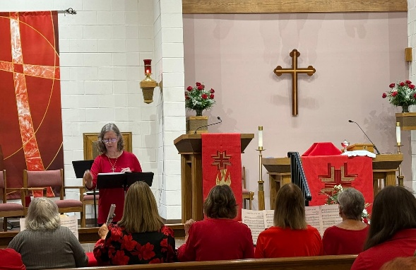
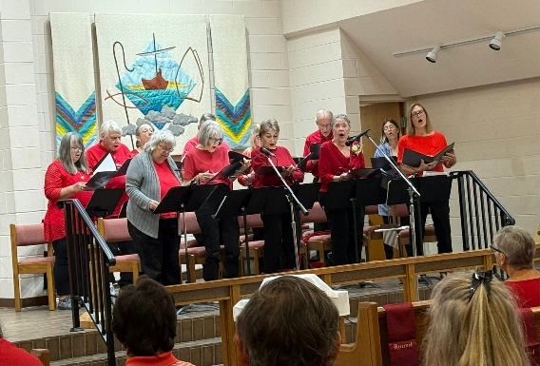
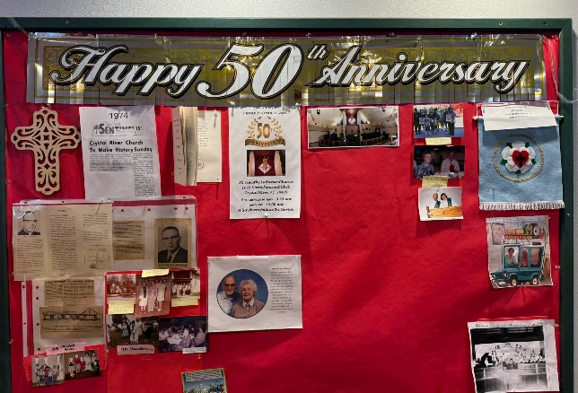
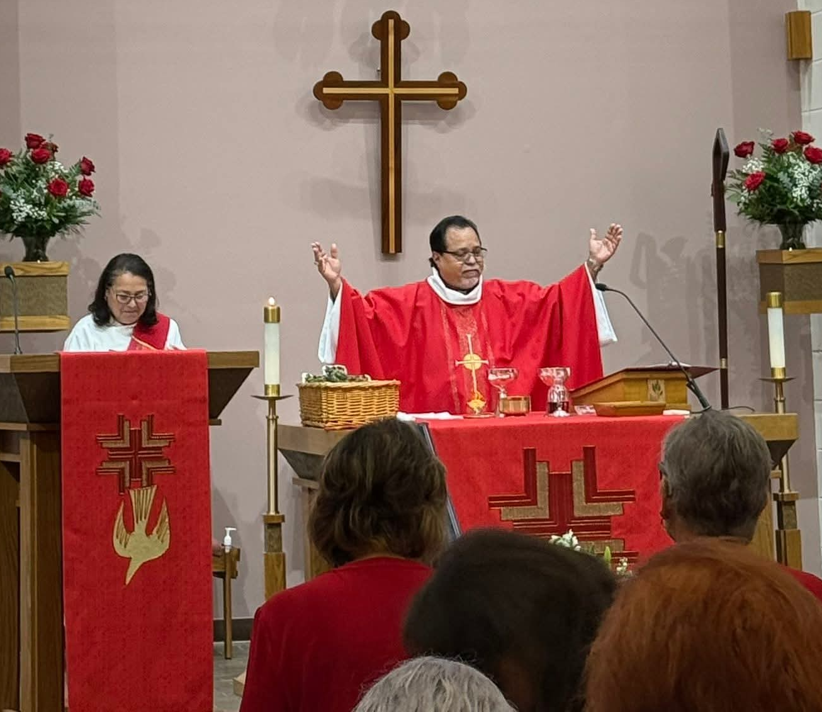
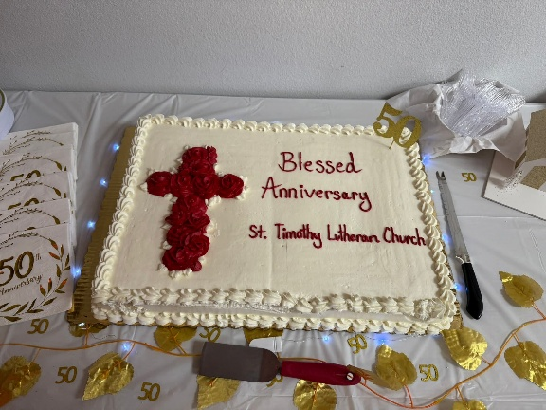
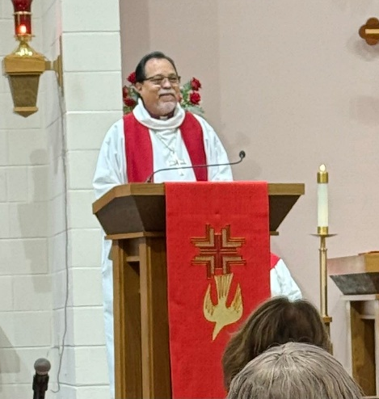
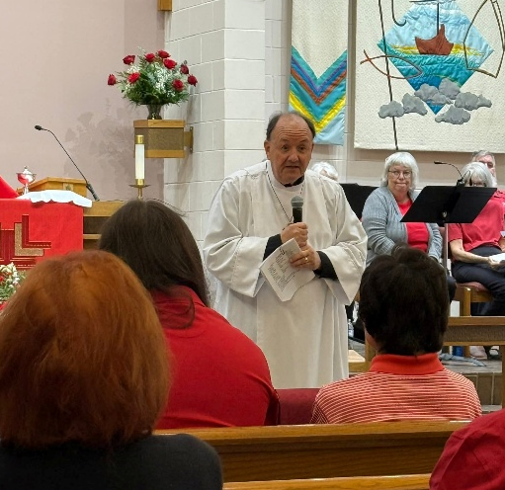
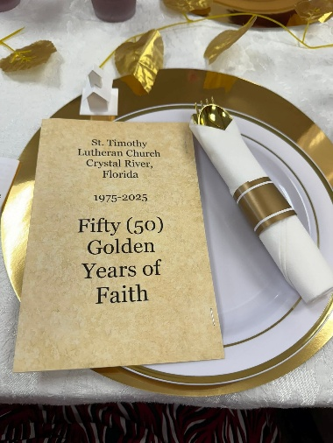
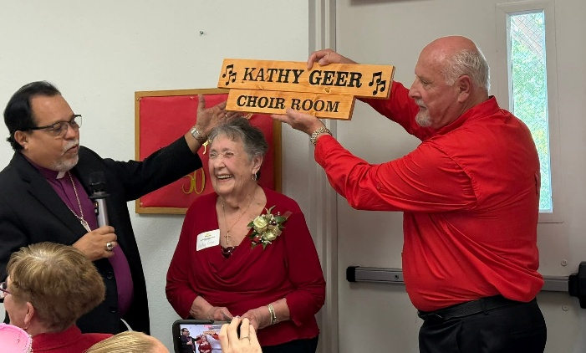
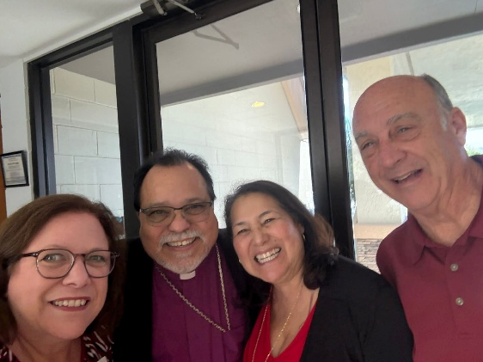
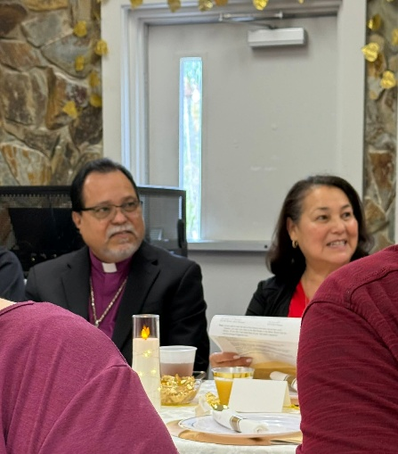
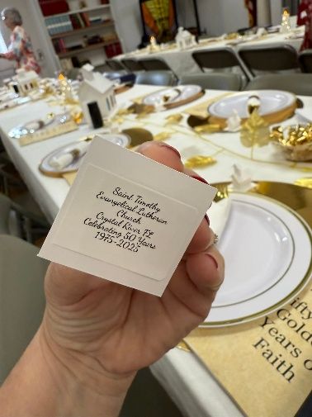
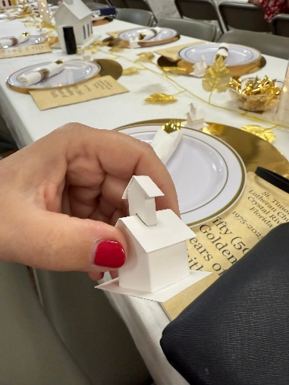

50th Anniversary Planning Committee last meeting.
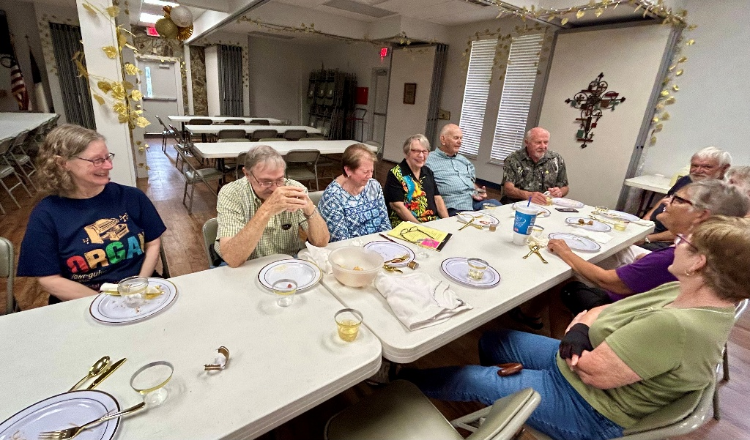

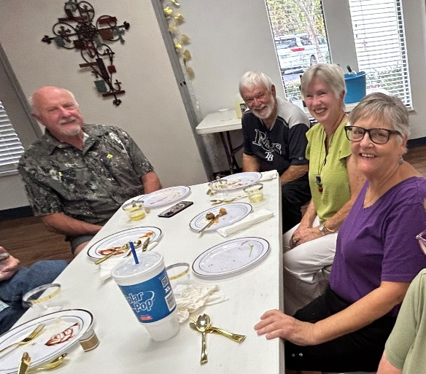
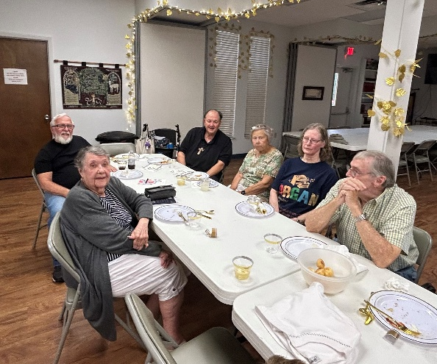
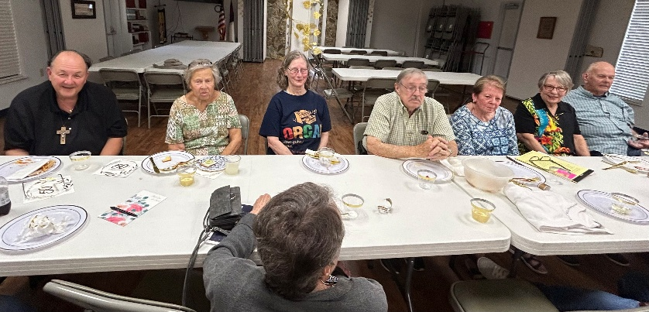
On

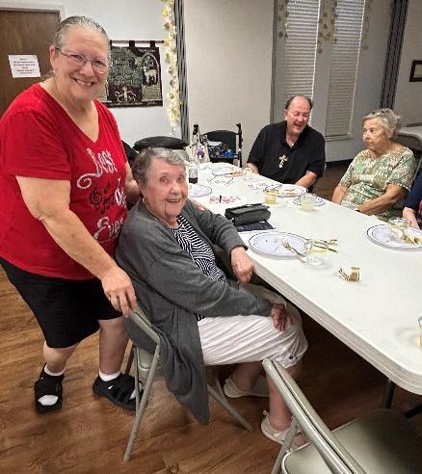

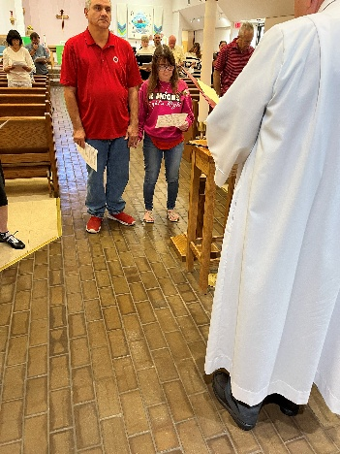
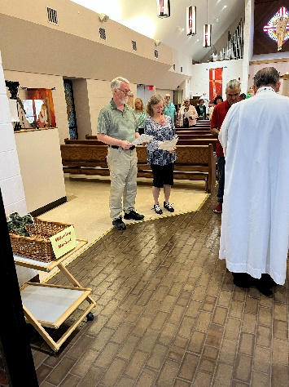
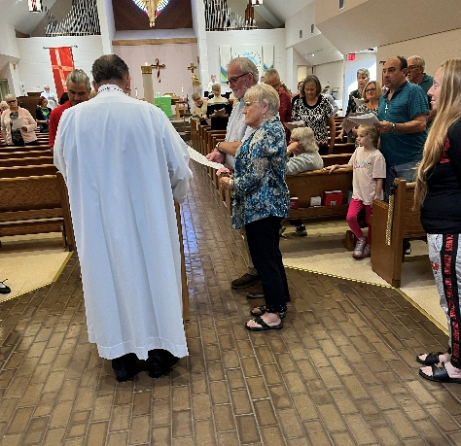
November 16th we installed new members.

Ernie “Buzz” & Patrick & Sally Steve & Sarah
Chainey Hennessey Brisson
December 2, Citrus Blessings
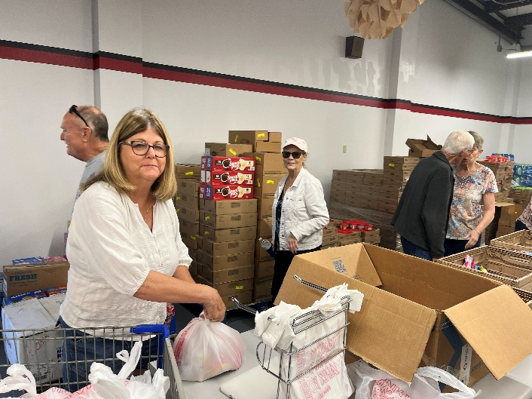
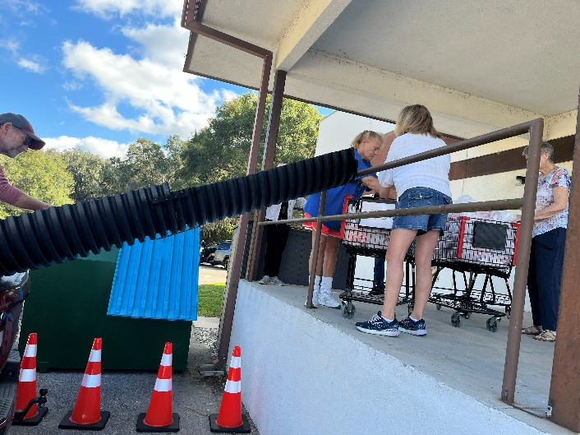
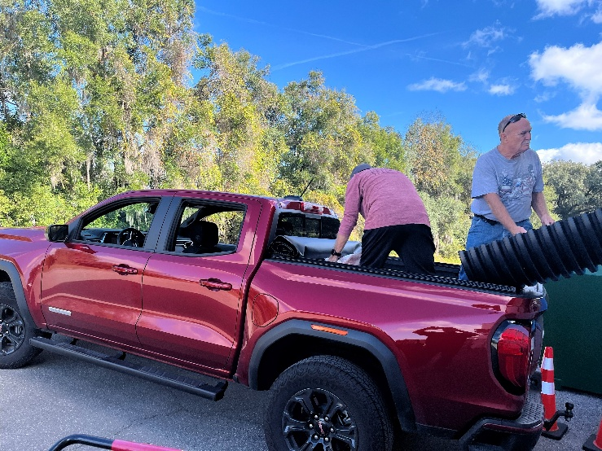



Fola Long 12/06
Aidan Sisneros 12/08
Gena Vee John 12/12
Marsha Gibson 12/15
Ginny Owen 12/18
Ron Roecker 12/20
Sandra Corpron 12/20
Lorayne Davis 12/21
Marcia Jacobek 12/21
Stephanie Yeager 12/24
Donna Moyer 12/24
Steve Brisson 12/24
Karen Paganini-Roemer 12/27
Greg Schutrum 12/29
Bob Carini 12/30
Glamel Davis 12/31
Michael Perate 12/31

Birthday Blessings!


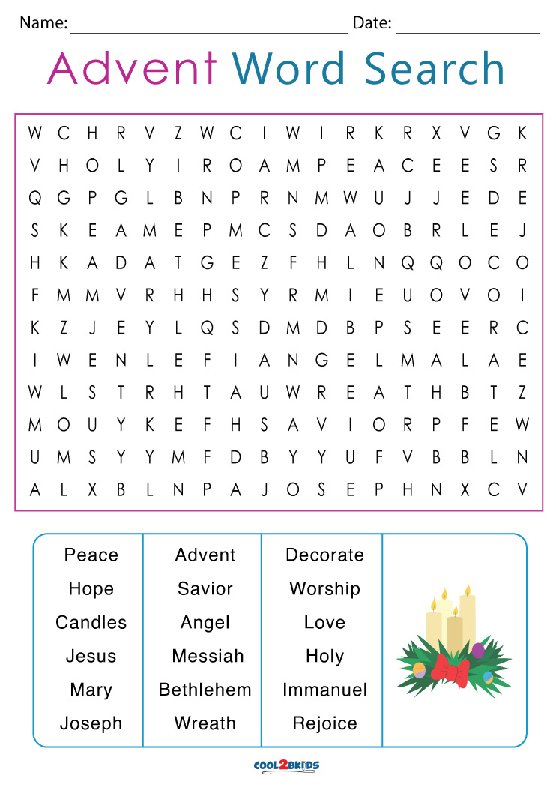
SUNDAY | MONDAY | TUESDAY | WEDNESDAY | THURSDAY | FRIDAY |  | SATURDAY
 | 1  11am Healthy Start | 2 | 3  1pm Card Makers  4pm Advent Soup Supper | 4  11:00 Miniatures  3:30 Chimes  4:30 Choir | 5  9:30am Prayer Group |  | 6  4pm Worship
7  9am Worship  10:15-10:45 Drive-Up Communion  10:30 Coffee Fellowship, Adult SS | 8  10:30 – Ruth Circle@ Barb C’s house | 9  9-12 Food Pantry | 10  1pm Worship & Music  4pm Advent Soup Supper | 11  9:30am Prayer Group  11:00 Miniatures  1pm Royal Dalton Christmas Carols  3:30 Chimes  4:30 Choir | 12 |  | 13  4pm Worship
14  9am Worship  10:15-10:45 Drive-Up Communion  10:30 Adult SS, Coffee Fellowship  PB&J Ministry | 15 | 16  12pm Christmas Party | 17  4pm Advent Soup Supper | 18  9:30 – Prayer Group  11:00 Miniatures  1pm – R.D.  3:30 Chimes  4:30 Choir | 19 |  | 20  4pm Worship
21  9am Worship  10:15-10:45 Drive-Up Communion  10:30 Adult SS, Coffee Fellowship | 22 | 23 | 24  4:30 Pre-Service Music  5:00pm  Christmas Eve Svc | 25  10am Christmas Day Service | 26 |  | 27  4pm Worship
28  9am Worship,  10:15-10:45 Drive-Up Communion  10:30, Coffee Fellowship | 29  Bob on vacation until 1/6 | 30  Bob on vacation until 1/6 | 31  Bob on vacation until 1/6


St. Timothy Lutheran Church
S.A.M. Bob Bonomo
1070 N. Suncoast Blvd.
Crystal River, FL 34429
Phone: 352-795-5325

Church email: crsttimothy@tampabay.rr.com
Website: www.sttimlutherancrystalriver.com

Deacon: Frank Hofstetter
Director of Music: Sally Hennessey
Saturday Pianist: Bill Robinson
Church Secretary: Regina Mendicino
Sexton: William “Bill” Dexter

2025 Congregational Council
President: Ron Roecker
Vice-President: Barbara Johnson
Secretary: Jean Fowler
Treasurers: Lynn Dively & Cheryl VanHorn
Financial Secretary: Randy Holden & Dick Kleinsmith
Council Members: Carolyn Fialkowski, Andrea Mitchell, Fola Long, and Marsha Gibson

Weekly Worship
Saturdays 4pm
Sundays 9am
Communion available at both services
Children’s Sunday School - 9am
Adult Sunday School - 10:30am
Drive-Up Communion – 10:15-10:45
Saturday and Sunday Services - links ONLINE

