Welcome to St. Timothy Evangelical Lutheran Church
Saturday, January 17th
Second Weekend After Epiphany

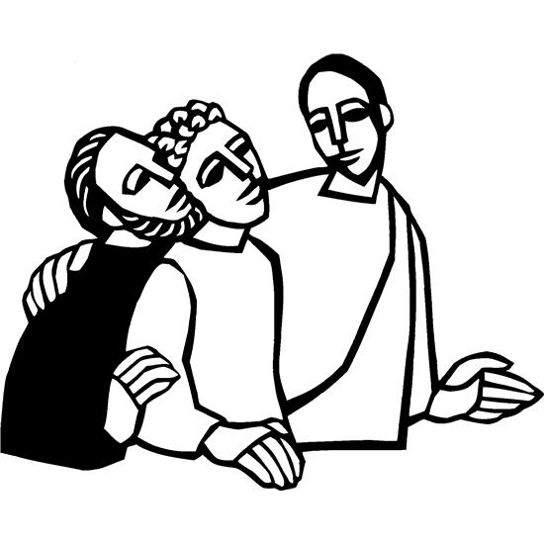

Today’s gospel opens with further reflection on Jesus’ baptism. He is the Lamb of God who takes away the sin of the world and the one anointed by the Spirit. In the liturgy we come and see Christ revealed among us in word and meal. We go forth to invite others to come and worship the Holy One and to receive the gifts of grace and peace made known among us.

Welcome and Sharing of Congregational News
Prelude

Confession and Forgiveness
All may make the sign of the cross, the sign that is marked at baptism, as the presiding minister begins.
Blessed be the holy Trinity, ☩ one God,
the Creator of heaven and earth,
the Word who spoke life into being,
the Wind stirring the waters.
Amen.
Let us turn in confession to the one who knows us completely.
Silence is kept for reflection.
Mighty God, lover of justice,
you call us to life in community,
but we have served our own interests
at the expense of our neighbors.
We have sown deceit where honesty was needed.
We say the right words,
but our hearts are far from you.
Turn us to seek your face.
Knit us together and give us the mind of Christ,
that we may do justice, love mercy,
and walk humbly with you, our God.
Amen.
Forgiveness
The former things have passed away,
and new things God now declares:
Like a spring of water that never fails,
God covers you in the righteousness of Christ,
and forgives your sin in ☩ Jesus’ name.
May the Spirit give you strength to live for others,
and bless you with the gift of peace.
Amen.
Greeting
P: The joy of our Lord Jesus Christ, the compassion of God, and the creative power of the Holy Spirit be with you all.
C: And also with you.

Gathering Hymn: Hail to the Lord's Anointed ELW 311
1 Hail to the Lord's anointed, great David's greater Son!
Hail, in the time appointed, your reign on earth begun!
You come to break oppression, to set the captive
free, to take away transgression and
rule in equity.
2 You come with rescue speedy to those who suffer wrong,
to help the poor and needy, and bid the weak be strong;
to give them songs for sighing, their darkness turn to
light, whose souls, condemned and dying, are
precious in your sight.
3 You shall come down like showers upon the fruitful earth;
love, joy, and hope, like flowers, spring in your path to birth.
Before you on the mountains shall peace, the herald,
go; and righteousness in fountains from
hill to valley flow.
4 Kings shall fall down before you, and gold and incense bring;
all nations shall adore you, your praise all people sing.
To you shall prayer unceasing and daily vows ascend;
your kingdom still increasing, a
kingdom without end.
Text: James Montgomery, 1771-1854, alt.

Prayer of the Day
Holy God, our strength and our redeemer, by your Spirit hold us forever, that through your grace we may worship you and faithfully serve you, follow you and joyfully find you, through Jesus Christ, our Savior and Lord.
Amen.
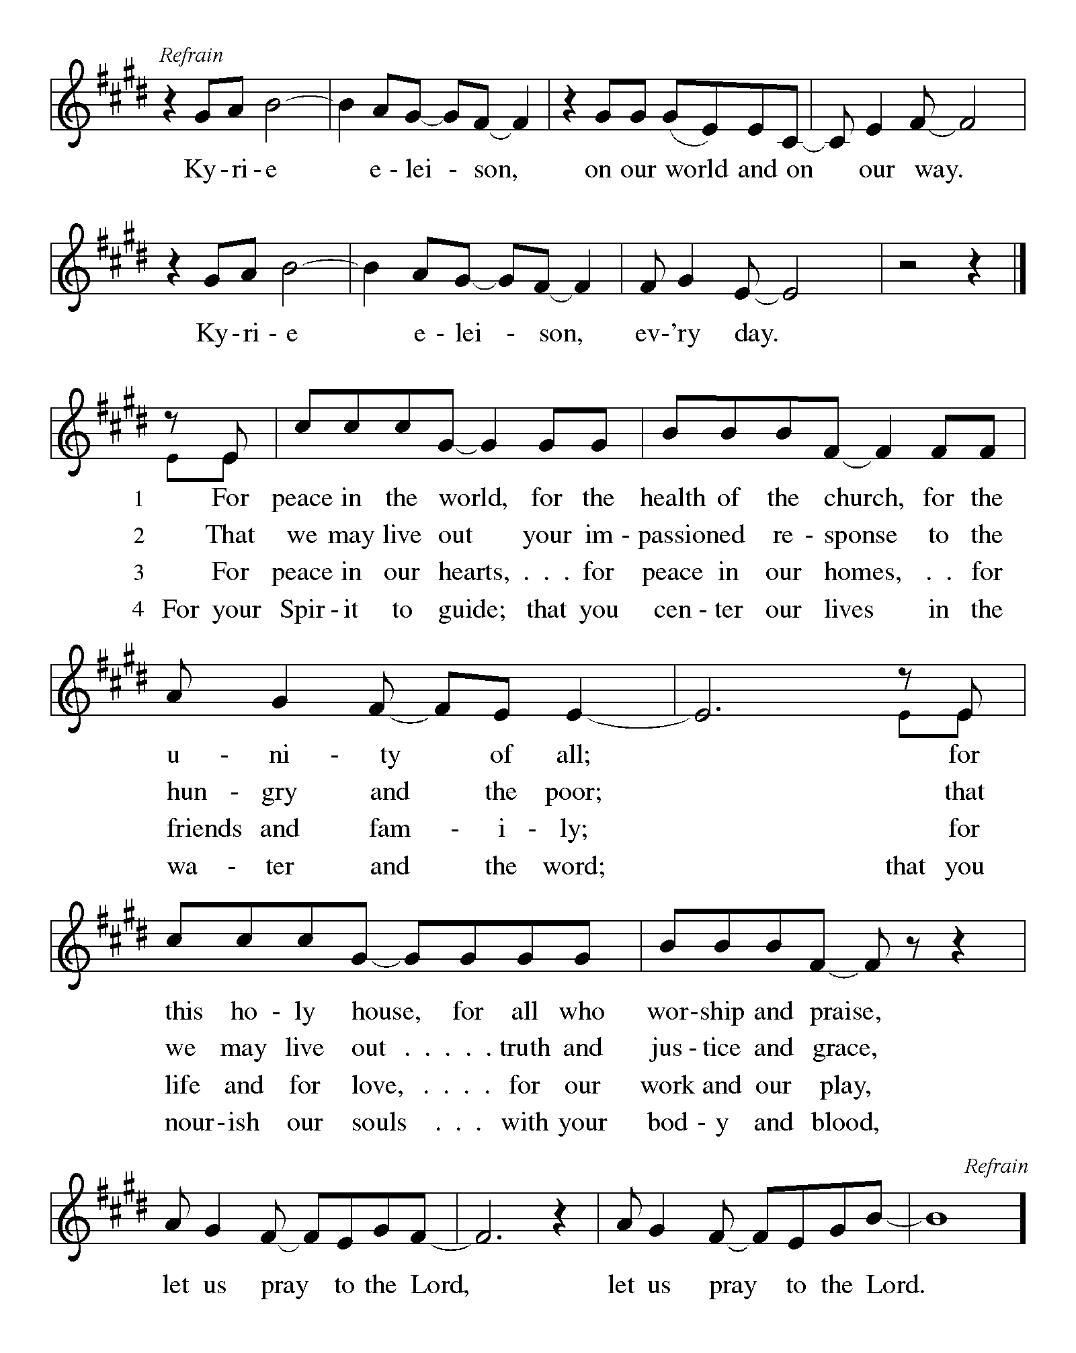

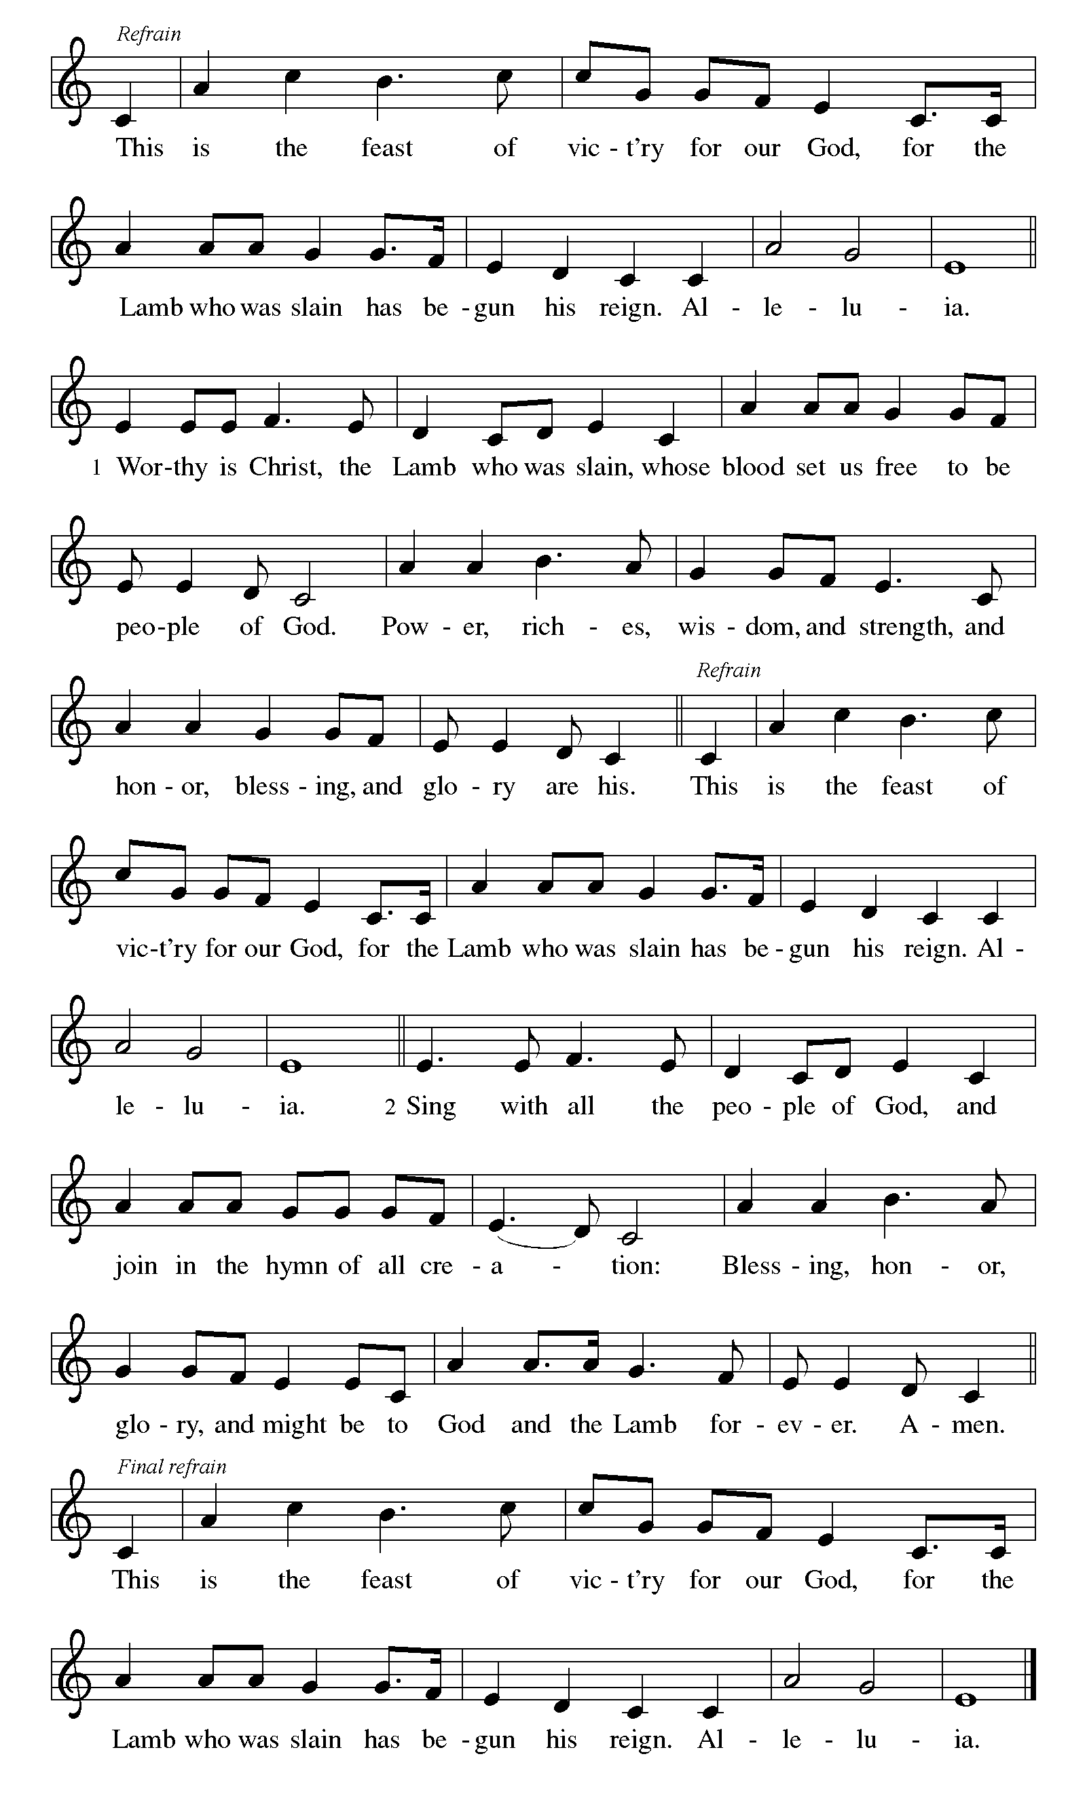

First Reading: Isaiah 49:1-7
Here the servant, identified as Israel, speaks for herself and describes her honored mission. Called before her birth like Jeremiah and John the Baptist, the servant is not only to restore Israel. The servant’s ultimate assignment is to bring news of God’s victory to the ends of the earth. God in faithfulness has chosen Israel for this task.
¹ Listen to me, O coastlands;
pay attention, you peoples from far away!
The Lord called me before I was born;
while I was in my mother’s womb he named me.
² He made my mouth like a sharp sword;
in the shadow of his hand he hid me;
he made me a polished arrow;
in his quiver he hid me away.
³ And he said to me, “You are my servant,
Israel, in whom I will be glorified.”
⁴ But I said, “I have labored in vain;
I have spent my strength for nothing and vanity;
yet surely my cause is with the Lord
and my reward with my God.”
⁵ And now the Lord says,
who formed me in the womb to be his servant,
to bring Jacob back to him,
and that Israel might be gathered to him,
for I am honored in the sight of the Lord,
and my God has become my strength—
⁶ he says,
“It is too light a thing that you should be my servant
to raise up the tribes of Jacob
and to restore the survivors of Israel;
I will give you as a light to the nations,
that my salvation may reach to the end of the earth.”
⁷ Thus says the Lord,
the Redeemer of Israel and his Holy One,
to one deeply despised, abhorred by the nations,
the slave of rulers,
“Kings shall see and stand up;
princes, and they shall prostrate themselves,
because of the Lord, who is faithful,
the Holy One of Israel, who has chosen you.”

P: Here ends our first reading.
C: Thanks be to God!

Psalm 40:1-11
¹ I waited patiently upon the Lord,
who stooped to me and heard my cry.
² The Lord lifted me out of the desolate pit, out of the miry clay,
and set my feet upon a high cliff, making my footing sure.
³ The Lord put a new song in my mouth, a song of praise to our God;
many shall see, and stand in awe, and put their trust in the Lord.
⁴ Happy are they who trust in the Lord!
They do not turn to enemies or to those who follow lies.
⁵ Great are the wonders you have done, O Lord my God! In your plans for us, none can be compared with you!
Oh, that I could make them known and tell them! But they are more than I can count.
⁶ Sacrifice and offering you do not desire;
you have opened my ears: burnt-offering and sin-offering you have not required.
⁷ And so I said, “Here I am; I come.
In the scroll of the book it is written of me:
⁸ ‘I love to do your will, O my God;
your law is deep within me.’ ”
⁹ I proclaimed righteousness in the great assembly;
I have not restrained my lips, O Lord, you know.
¹⁰ I have not hidden your righteousness in my heart; I have spoken of your faithfulness and your deliverance;
I have not concealed your steadfast love and truth from the great assembly.
¹¹ You are the Lord; do not withhold your compassion from me;
may your steadfast love and your truth continually keep me safe.

Second Reading: 1 Corinthians 1:1-9
Though God’s church in Corinth is a fractious congregation beset with many conflicts, Paul opens this letter by spotlighting the multiple ways God has enriched and sustained its life as part of the divine call into the fellowship of our Lord Jesus Christ.
¹ Paul, called to be an apostle of Christ Jesus by the will of God, and our brother Sosthenes,
² To the church of God that is in Corinth, to those who are sanctified in Christ Jesus, called to be saints, together with all those who in every place call on the name of our Lord Jesus Christ, both their Lord and ours:
³ Grace to you and peace from God our Father and the Lord Jesus Christ.
⁴ I give thanks to my God always for you because of the grace of God that has been given you in Christ Jesus, ⁵ for in every way you have been enriched in him, in speech and knowledge of every kind ⁶ just as the testimony of Christ has been strengthened among you ⁷ so that you are not lacking in any gift as you wait for the revealing of our Lord Jesus Christ. ⁸ He will also strengthen you to the end, so that you may be blameless on the day of our Lord Jesus Christ. ⁹ God is faithful, by whom you were called into the partnership of his Son, Jesus Christ our Lord.
P: Here ends our second reading.
C: Thanks be to God!
Gospel Acclamation
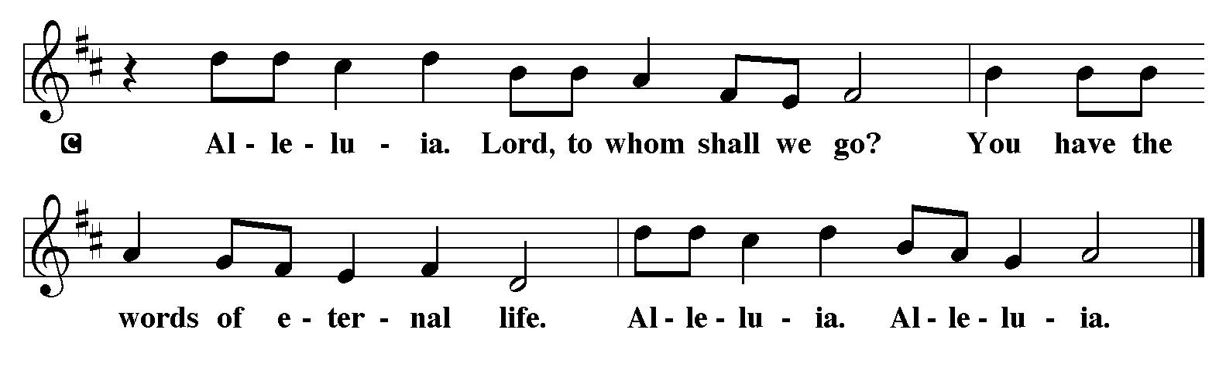
P: The Holy Gospel according to John 1:29-42
C: Glory to you O Lord.

Gospel: John 1:29-42
John the Baptist’s witness to Jesus initiates a chain of testimony as his disciples begin to share with others what they have found.
²⁹ [John the Baptist] saw Jesus coming toward him and declared, “Here is the Lamb of God who takes away the sin of the world!³⁰ This is he of whom I said, ‘After me comes a man who ranks ahead of me because he was before me.’ ³¹ I myself did not know him, but I came baptizing with water for this reason, that he might be revealed to Israel.” ³² And John testified, “I saw the Spirit descending from heaven like a dove, and it remained on him. ³³ I myself did not know him, but the one who sent me to baptize with water said to me, ‘He on whom you see the Spirit descend and remain is the one who baptizes with the Holy Spirit.’ ³⁴ And I myself have seen and have testified that this is the Chosen One.”
³⁵ The next day John again was standing with two of his disciples, ³⁶ and as he watched Jesus walk by he exclaimed, “Look, here is the Lamb of God!” ³⁷ The two disciples heard him say this, and they followed Jesus. ³⁸ When Jesus turned and saw them following, he said to them, “What are you looking for?” They said to him, “Rabbi” (which translated means Teacher), “where are you staying?” ³⁹ He said to them, “Come and see.” They came and saw where he was staying, and they remained with him that day. It was about four o’clock in the afternoon. ⁴⁰ One of the two who heard John speak and followed him was Andrew, Simon Peter’s brother. ⁴¹ He first found his brother Simon and said to him, “We have found the Messiah” (which is translated Anointed). ⁴² He brought Simon to Jesus, who looked at him and said, “You are Simon son of John. You are to be called Cephas” (which is translated Peter).

P: The Gospel of Our Lord!
C: Praise to You O Christ!
Sermon by S.A.M. Bob

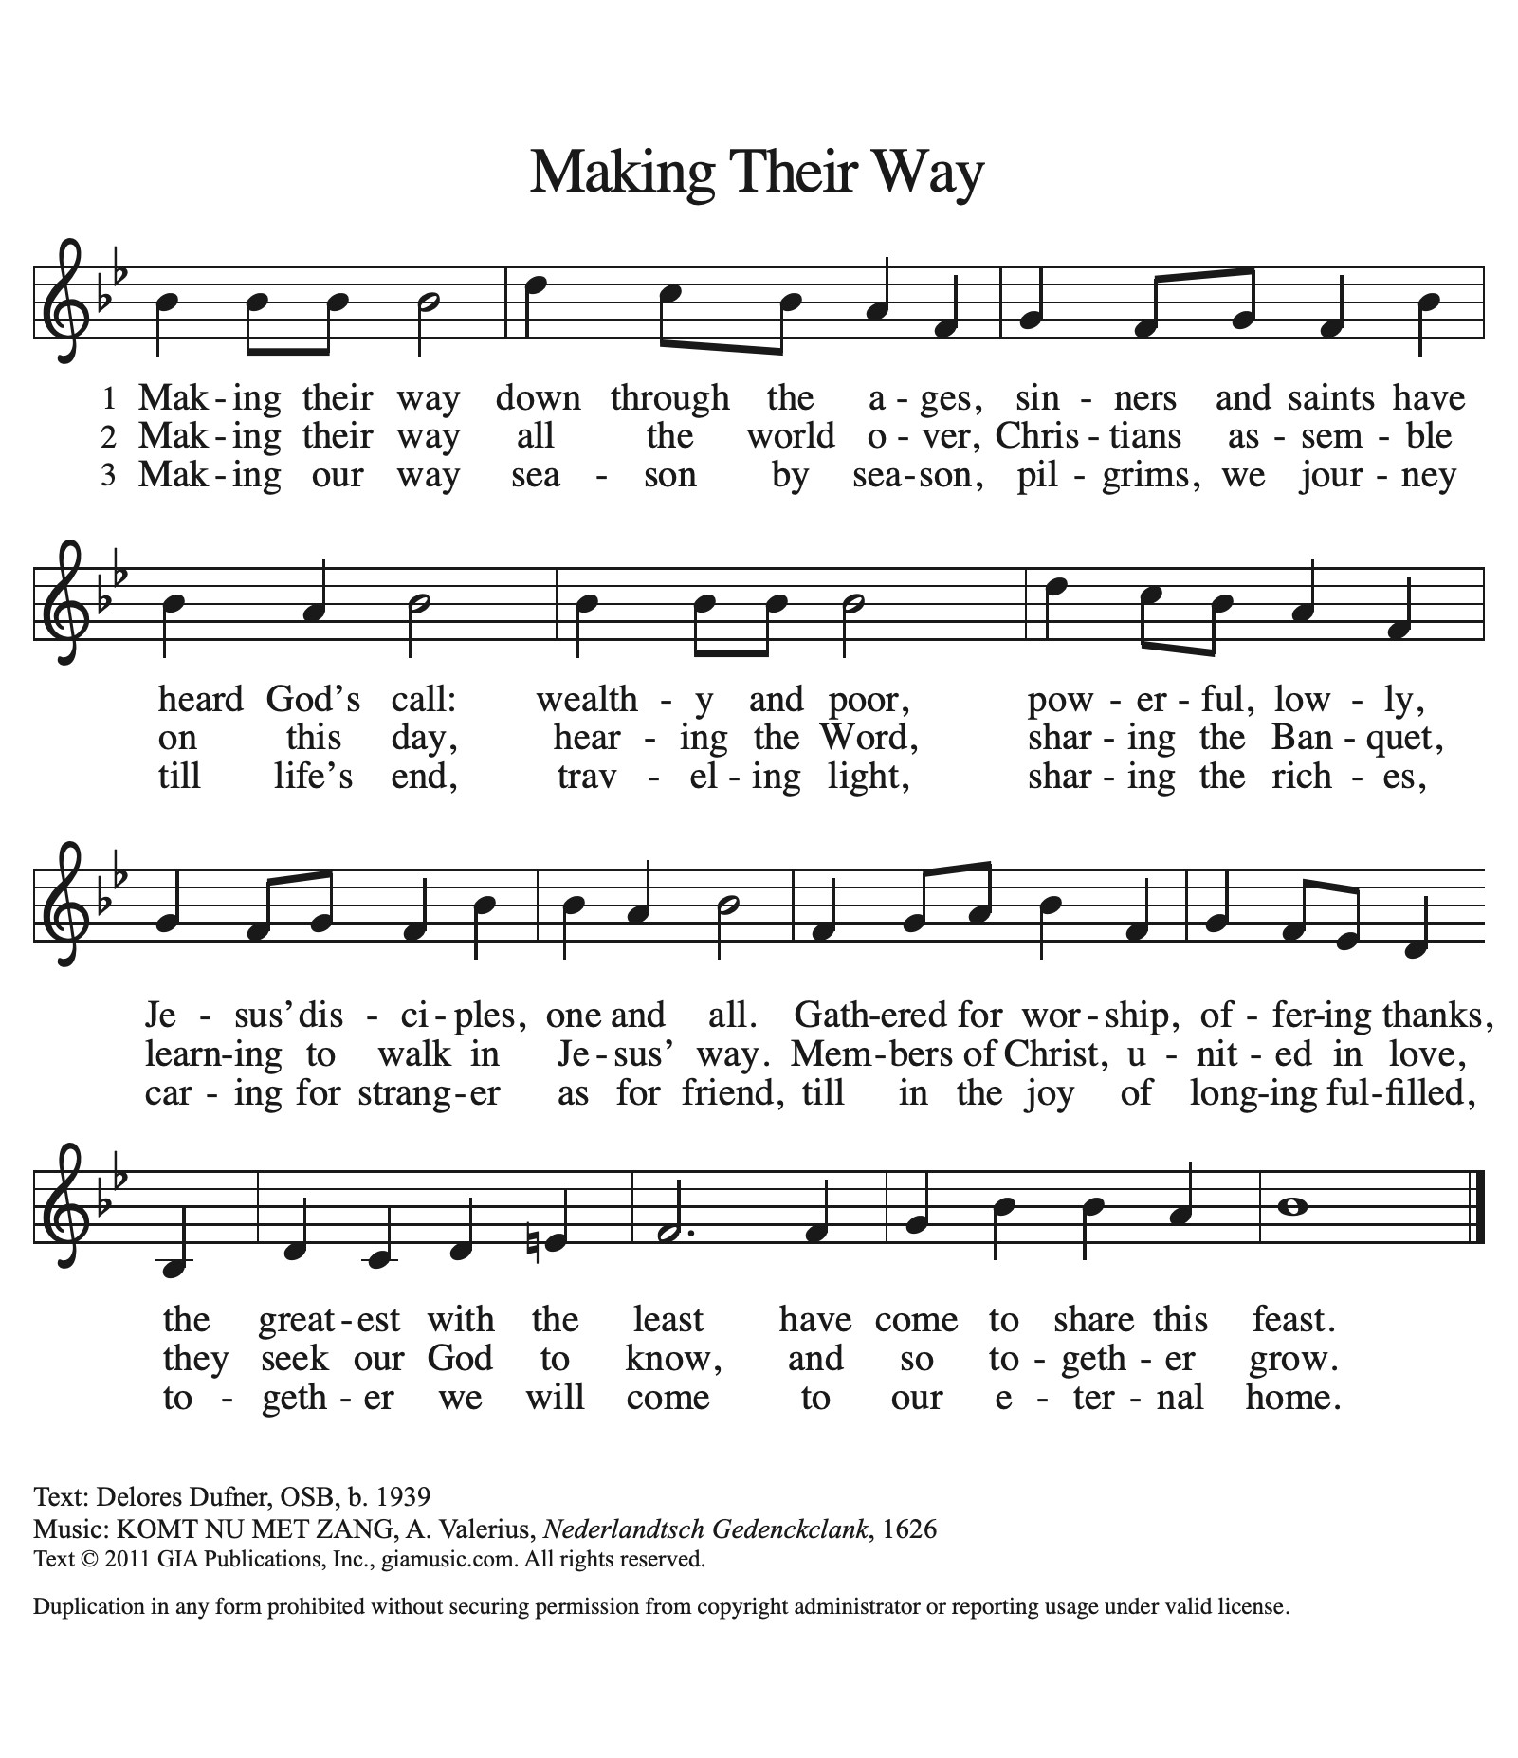
Hymn of the Day: ACS 979

Apostles’ Creed
I believe in God, the Father almighty,
creator of heaven and earth.
I believe in Jesus Christ, God’s only Son, our Lord,
who was conceived by the Holy Spirit,
born of the virgin Mary,
suffered under Pontius Pilate,
was crucified, died, and was buried;
he descended to the dead.
On the third day he rose again;
he ascended into heaven,
he is seated at the right hand of the Father,
and he will come to judge the living and the dead.
I believe in the Holy Spirit,
the holy catholic church,
the communion of saints,
the forgiveness of sins,
the resurrection of the body,
and the life everlasting. Amen.

Lord, listen to your children praying,
Lord, send your Spirit in this place;
Lord, listen to your children praying,
send us love, send us pow'r, send us grace.

Prayers of the People

Response (after “Merciful God.”): “Receive our prayer.”

P: May the peace of our Lord Jesus Christ be with you all.
C: And also with you.
P: Let us now share this peace.
Offering is Brought to the Altar

Offertory Prayer
God of majesty,
no eye has seen, no ear has heard
what you have prepared for those who love you,
yet in this meal you reveal the wideness of your mercy.
Use what we have gathered
to feed us with the reign of God come near,
Jesus Christ, our Savior and Lord.
Amen.
P: The Lord be with you.
C: And also with you.

P: Lift up your hearts.
C: Lift them to the Lord.

P: Let us give thanks to the Lord our God.
C: It is right to give our thanks and praise.

Preface
(Words spoken by S.A.M. Bob)

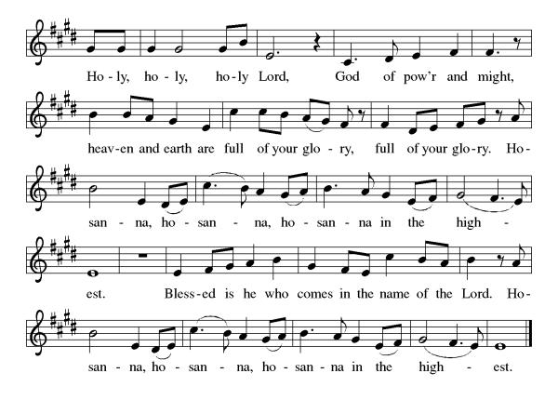
Eucharistic Prayer
(Words spoken by S.A.M. Bob)

Christ has died
Christ is risen.
Christ will come again.
Gathered into one, by the Holy Spirit let us listen to the words that Jesus taught us.

The Lord’s Prayer
Our Father, who art in heaven, hallowed be thy name, thy kingdom come, thy will be done, on earth as it is in heaven. Give us this day our daily bread; and forgive us our trespasses, as we forgive those who trespass against us; and lead us not into temptation but deliver us from evil. For thine is the kingdom, and the power, and the glory, forever and ever. Amen.

Invitation to Communion
P: Here is the Lamb of God who takes away the sins of the world! Come to His table and taste on your lips a Love we cannot comprehend.
C: Amen
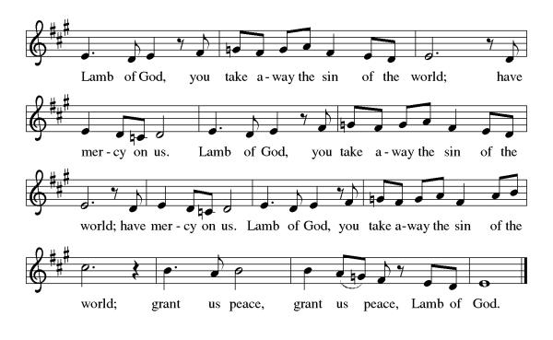
All may come.

Communion Anthem: Lamb of God ELW 336
P: We are now a tabernacle with Christ inside of us. Let us rejoice and be glad at the Lord’s table.
C: Amen

Prayer after Communion
Radiant God,
we have seen your glory in the face of Jesus Christ.
In the sacrament of his body and blood
you have drawn us to your heart.
Send us from this table with delight,
that our lives may reflect the beauty of your love,
and bear witness to all we have seen and heard,
through Jesus Christ, our Savior and Lord.
Amen.

Blessing
May the triune God,
Who has put a new song in your mouth
And tuned your heart for praise
☩ bless you now and forever
Amen.

Sending Hymn: O Lord, Now Let Your Servant ELW 313
1 O Lord, now let your servant depart in heav'nly peace,
for I have seen the glory of your redeeming grace:
a light to lead the nations unto your holy hill,
the glory of your people, your chosen Israel.

2 Then grant that I may follow your gleam, O glorious Light,
till earthly shadows scatter, and faith is changed to sight;
till raptured saints shall gather upon that shining shore,
where Christ, the blessed daystar, shall light them evermore.
Text: Ernest E. Ryden, 1886-1981, alt., based on the Nunc dimittis

Text © 1925 Board of Publication, Lutheran Church in America, admin. Augsburg Fortress.
Dismissal
P: Go in peace. Do justice. Love mercy.
C: Thanks be to God.
Postlude
Unless otherwise noted, materials used in this bulletin are:
From Sundays and Seasons.com. Copyright 2015 Augsburg Fortress. All rights reserved. Reprinted by permission under Augsburg Fortress Liturgies Annual License #SAS028635. Music is reprinted under OneLicense.Net #A712074 and/or Augsburg Fortress #SBL12176H. Scripture, unless otherwise noted, is from the New Revised Standard Version Bible, Copyright © 1989, Division of Christian Education of the National Council of the Churches of Christ in the United States of America. Used by permission. All rights reserved.

St. Timothy Evangelical Lutheran Church
1070 N. Suncoast Blvd.
Crystal River, FL 34429
Telephone number (Office): 352-795-5325
Office email address: crsttimothy@tampabay.rr.com

St Timothy Worship Team
S.A.M. Robert F. Bonomo
Lay Minister, Frank Hofstetter
Director of Music, Sally Hennessey
Saturday Pianist, Bill Robinson

Announcements for January 17th and 18th

ATTENDANCE
Saturday, January 10th, 4pm 24
Sunday, January 11th , 9am 51
Drive-Up Communion 3
78

The Altar Flowers are given this week by Barbara Johnson, in honor of her mother, Carol Johnson’s 90th birthday!

This Week at St. Timothy's
Monday, January 19th
Tuesday, January 20^{h} 1pm – WELCA (Guest Speaker Nancy Kennedy)
Wednesday, January 21st 1pm Worship & Music
Thursday, January 22nd 9:30am Prayer Group, 11am Bible Study for Beginners (bring bible) 11am – Miniatures, 4:30pm - Choir
Friday, January 23rd
Saturday, January 24th 4pm - Worship
Sunday, January 25th 9am – Worship, 10:15-10:45 – Drive Up Communion, Adult SS, Coffee Fellowship



