St Timothy Lutheran Church
Sunday, August 30, 2026
^{14th} Sunday after Pentecost



The prophet Jeremiah speaks of the incurable wound of his suffering yet finds in God’s words the delight of his heart. When Peter doesn’t grasp Jesus’ words about suffering, Jesus tells the disciples they will find their lives in losing them. Such sacrificial love is described by Paul when he urges us to associate with the lowly and not repay evil with evil. In worship we gather as a community that we might offer ourselves for the sake of our suffering world.

Preservice: Commonwealth is God’s Commandment ACS 1036
Welcome!
Prelude
P – Preparing our hearts for Worship

Confession and Forgiveness
All may make the sign of the cross, the sign that is marked at baptism, as the presiding minister begins.
Blessed be the holy Trinity,☩ one God,
whose compassion endures forever.
Amen.
Let us confess our sin to God.
Silence is kept for reflection.
Compassionate God,
we confess to you all our sins.
Our burden is heavy, and we cannot free ourselves.
In your mercy, call us back to you.
Your yoke is easy and your burden is light.
Restore us to dwell in your peace.
In Christ’s name we pray,
Amen.
Jesus says, “Come to me,
all you who are weary
and are carrying heavy burdens,
and I will give you rest.”
In the name of God,
Father, ☩ Son, and Holy Spirit,
your sins are forgiven.
Rest in God’s love. Amen.
Gathering Hymn: Lift High the Cross ELW 660
Refrain
Lift high the cross, the love of Christ proclaim
till all the world adore his sacred name.
1 Come, Christians, follow where our captain trod,
our king victorious, Christ, the Son of God. Refrain

2 All newborn servants of the Crucified
bear on their brows the seal of him who died. Refrain
3 O Lord, once lifted on the glorious tree,
as thou hast promised, draw us all to thee. Refrain
4 So shall our song of triumph ever be:
praise to the Crucified for victory! Refrain
Text: George W. Kitchin, 1827-1912; rev. Michael R. Newbolt, 1874-1956
Text © 1974 Hope Publishing Company, Carol Stream, IL 60188. All rights reserved. Used by permission.
Duplication in any form prohibited without permission or valid license from copyright administrator.

P - The grace of our Lord Jesus Christ, the love of God and the communion of the Holy Spirit be with you all.
C - And also with you.

Prayer of the Day
O God, we thank you for your Son, who chose the path of suffering for the sake of the world. Humble us by his example, point us to the path of obedience, and give us strength to follow your commands, through Jesus Christ, our Savior and Lord.
Amen.

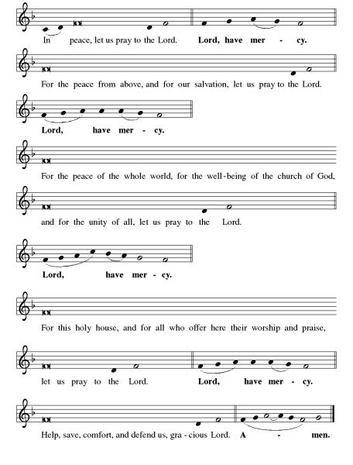
Kyrie ELW pg 138

Hymn of Praise: This is the Feast ELW pg 140-141

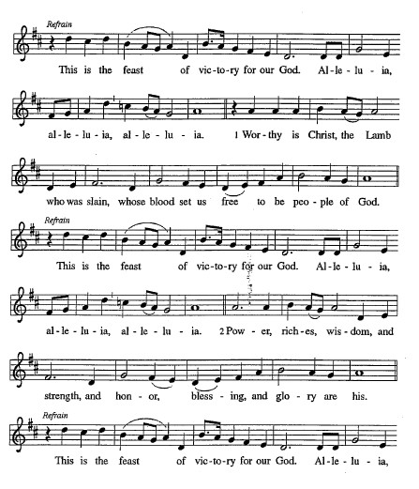

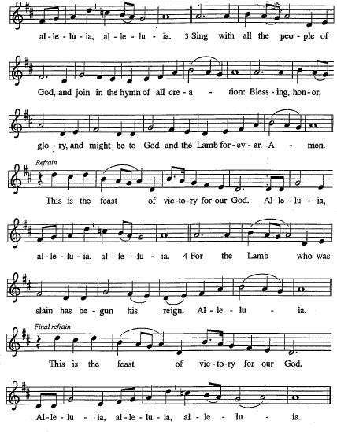
Please be seated.

First Reading: Jeremiah 15:15-21
Jeremiah’s delight in the word of the Lord is contradicted by the heaviness of God’s hand upon him and God’s seeming unfaithfulness. God’s tough love to Jeremiah says that if he repents, he will be allowed to continue in his strenuous ministry. Jeremiah is strengthened by the simple words, “I am with you.”
¹⁵ O Lord, you know;
remember me and visit me,
and bring down retribution for me on my persecutors.
In your forbearance do not take me away;
know that on your account I suffer insult.
¹⁶ Your words were found, and I ate them,
and your words became to me a joy
and the delight of my heart,
for I am called by your name,
O Lord, God of hosts.
¹⁷ I did not sit in the company of merrymakers,
nor did I rejoice;
under the weight of your hand I sat alone,
for you had filled me with indignation.
¹⁸ Why is my pain unceasing,
my wound incurable,
refusing to be healed?
Truly, you are to me like a deceitful brook,
like waters that fail.
¹⁹ Therefore thus says the Lord:
If you turn back, I will take you back,
and you shall stand before me.
If you utter what is precious and not what is worthless,
you shall serve as my mouth.
It is they who will turn to you,
not you who will turn to them.
²⁰ And I will make you to this people
a fortified wall of bronze;
they will fight against you,
but they shall not prevail over you,
for I am with you
to save you and deliver you,
says the Lord.
²¹ I will deliver you out of the hand of the wicked
and redeem you from the grasp of the ruthless.

A – Here ends the first reading!

C – Thanks be to God!

Psalm 26:1-8
¹ Give judgment for me, O Lord, for I have lived with integrity;
I have trusted in the Lord and have not faltered.
² Test me, O Lord, and try me;
examine my heart and my mind.
³ For your steadfast love is before my eyes;
I have walked faithfully with you.
⁴ I have not sat with the worthless,
nor do I consort with the deceitful.
⁵ I have hated the company of evildoers;
I will not sit down with the wicked.
⁶ I will wash my hands in innocence, O Lord,
that I may go in procession round your altar,
⁷ singing aloud a song of thanksgiving
and recounting all your wonderful deeds.
⁸ Lord, I love the house in which you dwell
and the place where your glory abides.

Second Reading: Romans 12:9-21
Paul presents benchmarks for faithful relationships with Christians and non-Christians. Love is the unflagging standard of our behavior. When we encounter evil, we do not resort to its tactics but seek to overcome it with good. While Christians cannot control the actions and attitudes of others, we seek to live at peace with all people.
⁹ Let love be genuine; hate what is evil; hold fast to what is good; ¹⁰ love one another with mutual affection; outdo one another in showing honor. ¹¹ Do not lag in zeal; be ardent in spirit; serve the Lord. ¹² Rejoice in hope; be patient in affliction; persevere in prayer. ¹³ Contribute to the needs of the saints; pursue hospitality to strangers.
¹⁴ Bless those who persecute you; bless and do not curse them. ¹⁵ Rejoice with those who rejoice; weep with those who weep. ¹⁶ Live in harmony with one another; do not be arrogant, but associate with the lowly; do not claim to be wiser than you are. ¹⁷ Do not repay anyone evil for evil, but take thought for what is noble in the sight of all. ¹⁸ If it is possible, so far as it depends on you, live peaceably with all. ¹⁹ Beloved, never avenge yourselves, but leave room for the wrath of God, for it is written, “Vengeance is mine; I will repay, says the Lord.” ²⁰ Instead, “if your enemies are hungry, feed them; if they are thirsty, give them something to drink, for by doing this you will heap burning coals on their heads.” ²¹ Do not be overcome by evil, but overcome evil with good.

A – Here ends the second reading!
C – Thanks be to God!

Gospel Acclamation
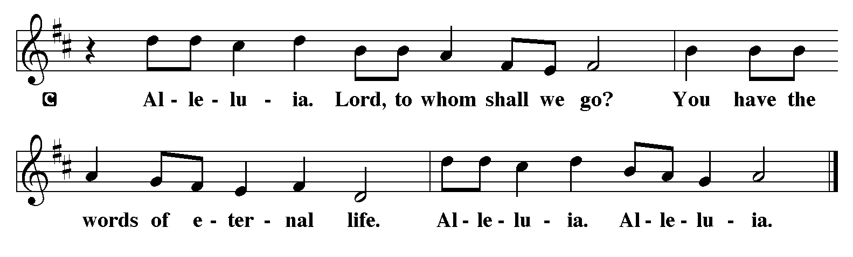
P - The Holy Gospel according to Matthew, the 16th Chapter
C - Glory to You O Lord!

Gospel: Matthew 16:21-28
After Peter confesses that Jesus is “the Messiah, the Son of the living God” (16:16), Jesus reveals the ultimate purpose of his ministry. These words prove hard to accept, even for a disciple whom Jesus has called a “rock.”
²¹ From that time on, [after Peter confessed that Jesus was the Messiah,] Jesus began to show his disciples that he must go to Jerusalem and undergo great suffering at the hands of the elders and chief priests and scribes and be killed and on the third day be raised. ²² And Peter took him aside and began to rebuke him, saying, “God forbid it, Lord! This must never happen to you.” ²³ But he turned and said to Peter, “Get behind me, Satan! You are a hindrance to me, for you are setting your mind not on divine things but on human things.”
²⁴ Then Jesus told his disciples, “If any wish to come after me, let them deny themselves and take up their cross and follow me. ²⁵ For those who want to save their life will lose it, and those who lose their life for my sake will find it. ²⁶ For what will it profit them if they gain the whole world but forfeit their life? Or what will they give in return for their life?
²⁷ “For the Son of Man is to come with his angels in the glory of his Father, and then he will repay everyone for what has been done. ²⁸ Truly I tell you, there are some standing here who will not taste death before they see the Son of Man coming in his kingdom.”

P - The Gospel of the Lord.
C – Praise to you, O Christ!
Sermon by S.A.M. Robert Bonomo

Hymn of the Day: Will You Come and Follow Me ELW 798
1 "Will you come and follow me if I but call your name?
Will you go where you don't know and never be the same?
Will you let my love be shown, will you let my name be known,
will you let my life be grown in you and you in me?

2 "Will you leave yourself behind if I but call your name?
Will you care for cruel and kind and never be the same?
Will you risk the hostile stare, should your life attract or scare?
Will you let me answer pray'r in you and you in me?

3 "Will you let the blinded see if I but call your name?
Will you set the pris'ners free and never be the same?
Will you kiss the leper clean, and do such as this unseen,
and admit to what I mean in you and you in me?

4 "Will you love the you you hide if I but call your name?
Will you quell the fear inside and never be the same?
Will you use the faith you've found to reshape the world around,
through my sight and touch and sound in you and you in me?"

5 Lord, your summons echoes true when you but call my name.
Let me turn and follow you and never be the same.
In your company I'll go where your love and footsteps show.
Thus I'll move and live and grow in you and you in me.

Text: John L. Bell, b. 1949
Text © 1987 Iona Community, GIA Publications, Inc., agent 7404 S. Mason Ave., Chicago, IL 60638. www.giamusic.com. 800.442.3358. All rights reserved. Used by permission.
Duplication in any form prohibited without permission or valid license from copyright administrator.
The Apostle’s Creed
I believe in God, the Father almighty,
creator of heaven and earth.
I believe in Jesus Christ, God’s only Son, our Lord,
who was conceived by the Holy Spirit,
born of the virgin Mary,
suffered under Pontius Pilate,
was crucified, died, and was buried;
he descended to the dead.*
On the third day he rose again;
he ascended into heaven,
he is seated at the right hand of the Father,
and he will come to judge the living and the dead.
I believe in the Holy Spirit,
the holy catholic church,
the communion of saints,
the forgiveness of sins,
the resurrection of the body,
and the life everlasting. Amen.
From sundaysandseasons.com.
Copyright © 2026 Augsburg Fortress. All rights reserved.

Prayers of the People
With bold trust in God’s unfailing provision, we pray for the church, those in need, and all of God’s creation. A brief silence.
For the church in every land, that its mission and ministry is anchored in the love of Christ. When threats or challenges arise, teach us to take up our cross and follow you in faith.
Hear us O God,
Your mercy is great.

For the nations and all in authority, they seek to live in peace with one another. Bless the work of international and diplomatic organizations and all who work to bring peace to a world scared by violence.
Hear us O God,
Your mercy is great

For all those in need, they be satisfied. Ensure all your children have safe access to food, water, shelter, and medical care. Bring healing to all who bear wounds in body, mind, and spirit.
Hear us O God
Your mercy is great

Lord, shape our attitudes to be like yours, humble, obedient, and faithful.
May we all live in the light of Your cross, not in the shadow of our own comfort. Hear us for the whole people of God, for those who are weary, for the sick, for the oppressed, for the homeless and those hungry, and for all who seek Your mercy.

Hear us O God
Your mercy is great

We confess that we often follow you from a safe distance, avoiding the cross clinging to our own ways and resisting the call to self-denial Forgive us O God, and renew our strength to walk the path of discipleship even when it is difficult to do so.
Hear us O God
Your mercy is great

For the congregation gathered here to serve you, that they remain strong in faith and united in purpose. Guide our committees, study groups, and other meetings toward honesty and humility, always seeking genuine love.
Hear us O God
Your mercy is great

For the faithful departed, that their witness continues to strengthen and guide the church. Renew our hope in your promises in this life and the life to come.
Hear us O God,
Your mercy is great.

God, we pray for the church amid the confusion of the world yet called to be a light in darkness. Grant us new birth through repentance, that we may proclaim the ancient Gospel with boldness and love. Be with Your church that it may be a faithful witness to Your Kingdom.
Hear us O God
Your mercy is great

Into Your hands, O Lord, we commend all for whom we pray, trusting in Your mercy, through Jesus Christ, our Lord.
Amen
P – The Peace of the Lord be with you always.
C – And also with you.
The Offering is Brought to the Altar
Offertory Prayer
Loving God,
we offer at your table the gifts of our hearts.
Help us take heart in you and share freely of your love,
so that all creation can taste your abundance.
We ask this in the name of Jesus,
through the Spirit abiding with us now and forever.
Amen.
The Great Thanksgiving

P – The Lord be with You
C – And also with you.
P – Lift up your hearts
C – We lift them to the Lord.
P – Let us give thanks to the Lord, our God
C – It is right to give Him our thanks and praise.

Preface
And so, with all the choirs of angels, with the church on earth and the hosts of heaven, we praise your name and join their unending hymn:

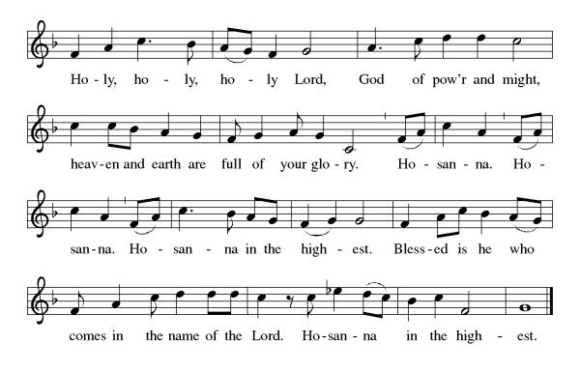

Eucharistic Prayer
(Words of Institution)
For as often as we eat of this bread and drink from this cup we proclaim the Lord’s death until He comes.
Christ has died
Christ is risen.
Christ will come again.
Remembering, therefore, his salutary command,
his life-giving passion and death, his glorious resurrection and ascension,
and the promise of his coming again,
we give thanks to you, O Lord God Almighty,
not as we ought but as we are able;
we ask you mercifully to accept our praise and thanksgiving and with your Word and Holy Spirit to bless us, your servants, and these your own gifts of bread and wine, so that we and all who share in the body and blood of Christ may be filled with heavenly blessing and grace,
and, receiving the forgiveness of sin,
may be formed to live as your holy people
and be given our inheritance with all your saints.
To you, O God, Father, Son, and Holy Spirit,
be all honor and glory in your holy church, now and forever. Amen.
Gathered into one, by the Holy Spirit let us listen to the words that Jesus taught us.

The Lord’s Prayer
Our Father, who art in heaven, hallowed be thy name, thy kingdom come, thy will be done, on earth as it is in heaven. Give us this day our daily bread; and forgive us our trespasses, as we forgive those who trespass against us; and lead us not into temptation but deliver us from evil. For thine is the kingdom, and the power, and the glory, forever and ever. Amen.
P: Taste and see that the Lord is good.
C: Thanks be to God.

Invitation to Communion
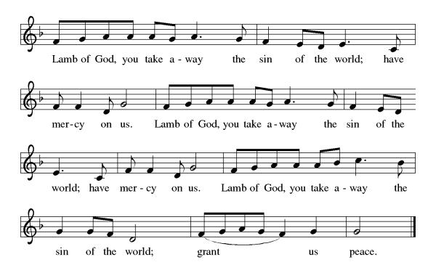
P – Come, feast at His table. He is waiting for you.
C – Amen.

Distribution of Communion – Come Forward to Receive
Communion Hymn: Will You Let Me Be Your Servant ELW 659
P – Now may the body and blood of our Lord and Savior Jesus Christ strengthen you and keep you in His grace!
C – Thank You Jesus!

Prayer after Communion
Compassionate God,
Through the gifts of bread and wine
our hearts are filled with the abundance of your love.
Strengthen us that we, through this Holy meal,
may share your love freely, as you have shared with us.
We ask this in the name of Jesus,
through the Spirit nourishing us now and forever.
Amen.

Words of dismissal and benediction
Know that the ever-present mystery we name God
was in your past forgiving you,
in your present loving you,
and in your future meeting you.
And may the blessing of the Source of life, love and hope,
the Word of life, compassion and wisdom
and Breath of life, grace and truth,
Father, ☩ Son, and Holy Spirit,
surround, sustain and surprise you,
this day and all your days. Amen.

Sending Hymn: Let Streams of Living Justice ELW 710
1 Let streams of living justice flow down upon the earth;
give freedom's light to captives, let all the poor have worth.
The hungry's hands are pleading, the workers claim their rights,
the mourners long for laughter, the blinded seek for sight.
Make liberty a beacon, strike down the iron pow'r;
abolish ancient vengeance: proclaim your people's hour.

2 For healing of the nations, for peace that will not end,
for love that makes us lovers, God grant us grace to mend.
Weave our varied gifts together; knit our lives as they are spun;
on your loom of time enroll us till our thread of life is run.
O great weaver of our fabric, bind church and world in one;
dye our texture with your radiance, light our colors with your sun.

3 Your city's built to music; we are the stones you seek;
your harmony is language; we are the words you speak.
Our faith we find in service, our hope in others' dreams,
our love in hand of neighbor; our homeland brightly gleams.
Inscribe our hearts with justice; your way—the path untried;
your truth—the heart of stranger; your life—the Crucified.
Text: William Whitla, b. 1934
Text © 1989 William Whitla.
Duplication in any form prohibited without permission or valid license from copyright administrator.

Dismissal
P – Look, and listen to S.A.M. Bob.
C- Thanks be to God.

Postlude:
Unless otherwise noted, service materials used in this bulletin are:
Music is reprinted under OneLicense.Net #A712074 and/or Augsburg Fortress #SBL12176H. Scripture, unless otherwise noted, is from the New Revised Standard Version Bible, Copyright © 1989, Division of Christian Education of the National Council of the Churches of Christ in the United States of America. Used by permission. All rights reserved.

St. Timothy’s is served by S.A.M. Robert “Bob” Bonomo
Lay Minister Frank Hofstetter
Director of Music Sally Hennessey
Saturday Pianist Bill Robinson
Announcements for August 29th and 30th
ATTENDANCE
Saturday, August 22nd, 4pm 27
Sunday, August 23rd 9am 52
Drive-Up Communion 2
81

The altar flowers are given this week by Sarah Haley, in honor of John Seasholtz and Joe Moore’s birthdays!

Serving our Lord this weekend:
Saturday, August 29th

Sunday, August 30th
Assisting Minister – Lay Minister Frank Hofstetter
Altar Guild – John & Jodie Gudorf
Greeters – John & Jodie Gudorf

This Week at St. Timothy's
Monday, August 31st
Tuesday, September 1st
Wednesday, September 2nd 1pm Card Makers
Thursday, September 3rd 11-12 Bible Study, 11am – Miniatures, 4:30 - Choir
Friday, September 4th
Saturday, September 5th 4pm Worship, No Fellowship
Sunday, September 6th 9am Worship, 10:30 – Adult SS, Coffee Fellowship

PRAYER LIST
Marsha Gibson
Thea
May
Ben
Sarah Brisson
Sheila
Marie Demastus
Sharon Grimes
Ginny
Cindy
Mary Schlumberger
Marcia & Harry Treber
Baby Atticus
Teresa York
Debbie Lawrence
Carole Albert
Linda C.
Ashlee
Frani Barnes
Mark Duffy
Wyatt Toney
Jim & Rosa Neth
Melanie
Trish Bradley
Fowler Family
Marcus

Our prayer list has been purged. If you want to put a name back on, please let us know.

