St Timothy Lutheran Church
Sunday, May 3rd, 2026
Fifth Sunday of Easter

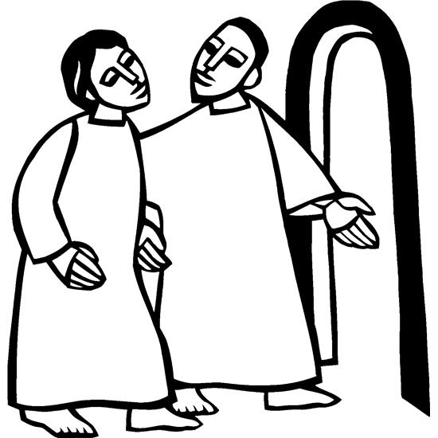

As we continue to celebrate the fifty days of Easter, today’s gospel includes Jesus’ promise that he goes to prepare a place for his followers in his Father’s house. Our baptism commissions us to share Jesus’ mission in the world. As 1 Peter reminds us, we are a holy people, called to proclaim the one who called us out of darkness into light. In words and deeds we bear witness to the risen Christ—our way, our truth, our life.

Preservice: Making Their Way ACS 979
Welcome!
Prelude
P – Preparing our hearts for Worship

Thanksgiving for Baptism
All may make the sign of the cross, the sign that is marked at Baptism, as the presiding minister begins.
Alleluia! Christ is risen.
Christ is risen indeed. Alleluia!
Salvation belongs to our God who is seated on the throne
and to the Lamb!
Amen.
Let us give thanks for the gifts of Baptism.
P - Merciful God,
you are the one who was, who is, and who is to come.
You lead us beside still waters.
We thank you for the waters of creation:
morning dew, gentle rain, roaring waves.
We thank you for the waters that nourish us.
Blessed are you.
You guide us to springs of the water of life.
Jesus Christ, you are the faithful witness
who accompanies us on our journeys.
We give you thanks for your life-giving death and resurrection.
We praise you for joining us in joy and sorrow.
Blessed are you.
You guide us to springs of the water of life.

Holy Spirit, you anoint our head with oil and our cup overflows.
Break down barriers that divide us.
Fill us with the breath of peace.
Blessed are you.
You guide us to springs of the water of life.
Holy One, we thank you for the gifts and grace of Baptism,
and for making us a new creation.
We join with saints and angels, giving you honor and praise,
now and forever.
Amen.

Gathering Hymn: Christ Has Arisen, Alleluia ELW 364
1 Christ has arisen, alleluia.
Rejoice and praise him, alleluia.
For our redeemer burst from the tomb,
even from death, dispelling its gloom.

Refrain
Let us sing praise to him with endless joy.
Death's fearful sting he has come to destroy.
Our sin forgiving, alleluia!
Jesus is living, alleluia!

2 For three long days the grave did its worst
until its strength by God was dispersed.
He who gives life did death undergo,
and in its conquest his might did show. Refrain

3 The angel said to them, "Do not fear.
You look for Jesus who is not here.
See for yourselves the tomb is all bare.
Only the graveclothes are lying there." Refrain

4 "Go spread the news: he's not in the grave.
He has arisen this world to save.
Jesus' redeeming labors are done.
Even the battle with sin is won." Refrain

5 Christ has arisen to set us free.
Alleluia, to him praises be.
Jesus is living! Let us all sing;
he reigns triumphant, heavenly king. Refrain
Text: Bernard Kyamanywa, b. 1938; tr. Howard S. Olson, b. 1922
Swahili text © 1968 Lutheran Theological College, Makumira, Tanzania, admin. Augsburg Fortress. English text © 1977 Howard S. Olson, admin. Augsburg Fortress.
Duplication in any form prohibited without permission or valid license from copyright administrator.

.

P - The grace of our Lord Jesus Christ, the love of God and the communion of the Holy Spirit be with you all.
C - And also with you.

Prayer of the Day
Almighty God, your Son Jesus Christ is the way, the truth, and the life. Give us grace to love one another, to follow in the way of his commandments, and to share his risen life with all the world, for he lives and reigns with you and the Holy Spirit, one God, now and forever.
Amen.

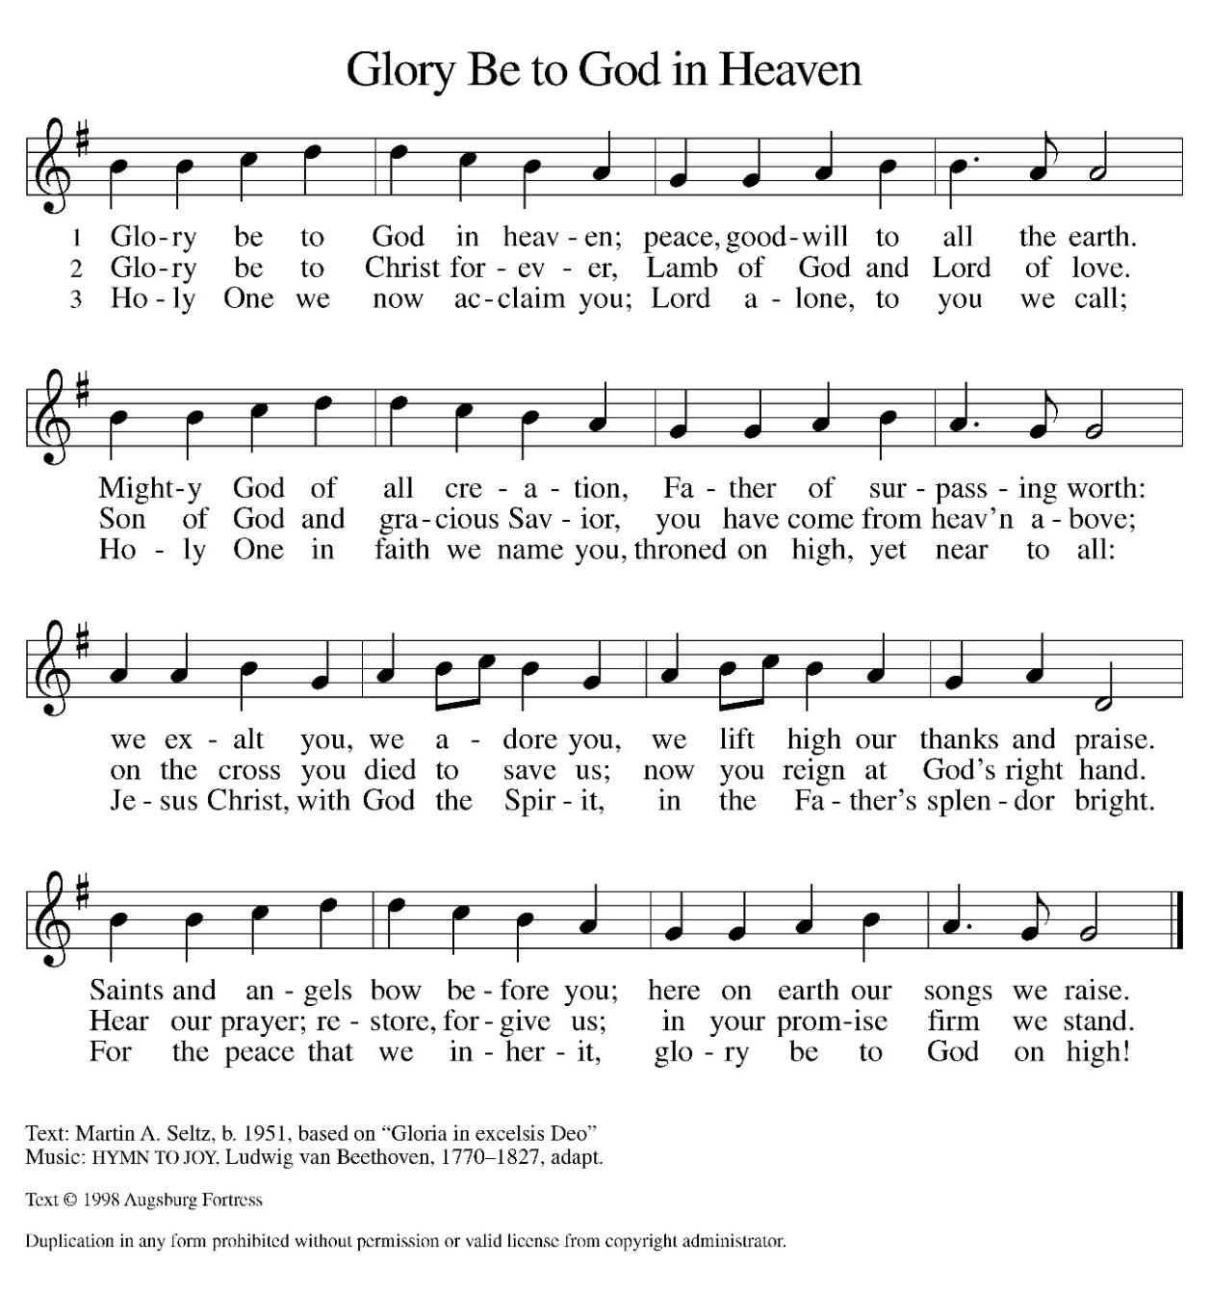
Hymn of Praise:

Please sit for our first reading.

First Reading: Acts 7:55-60
Stephen was one of the seven men chosen by the apostles to serve tables so that the apostles could be free to serve the word (Acts 6:1-6). Stephen does more than distribute food, however. For his preaching of God’s word, he becomes the first martyr of the faith.
⁵⁵ Filled with the Holy Spirit, [Stephen] gazed into heaven and saw the glory of God and Jesus standing at the right hand of God. ⁵⁶ “Look,” he said, “I see the heavens opened and the Son of Man standing at the right hand of God!” ⁵⁷ But they covered their ears, and with a loud shout all rushed together against him. ⁵⁸ Then they dragged him out of the city and began to stone him, and the witnesses laid their coats at the feet of a young man named Saul. ⁵⁹ While they were stoning Stephen, he prayed, “Lord Jesus, receive my spirit.” ⁶⁰ Then he knelt down and cried out in a loud voice, “Lord, do not hold this sin against them.” When he had said this, he died.

A – Here ends the first reading!

C – Thanks be to God!

Psalm 31:1-5, 15-16
¹ In you, O Lord, have I taken refuge; let me never be put to shame;
deliver me in your righteousness.
² Incline your ear to me;
make haste to deliver me.
³ Be my strong rock, a castle to keep me safe, for you are my crag and my stronghold;
for the sake of your name, lead me and guide me.
⁴ Take me out of the net that they have secretly set for me,
for you are my tower of strength.
⁵ Into your hands I commend my spirit,
for you have redeemed me, O Lord, God of truth.
¹⁵ My times are in your hand;
rescue me from the hand of my enemies, and from those who persecute me.
¹⁶ Let your face shine upon your servant;
save me in your steadfast love.”

Second Reading: 1 Peter 2:2-10
Christ is the cornerstone of God’s saving work and the foundation of our lives. We are God’s chosen, holy people who continuously celebrate and declare the mercy of God we experience through Jesus Christ.
² Like newborn infants, long for the pure, spiritual milk, so that by it you may grow into salvation—³ if indeed you have tasted that the Lord is good.
⁴ Come to him, a living stone, though rejected by mortals yet chosen and precious in God’s sight, and ⁵ like living stones let yourselves be built into a spiritual house, to be a holy priesthood, to offer spiritual sacrifices acceptable to God through Jesus Christ. ⁶ For it stands in scripture:
“See, I am laying in Zion a stone,
a cornerstone chosen and precious,
and whoever believes in him will not be put to shame.”
⁷ This honor, then, is for you who believe, but for those who do not believe,
“The stone that the builders rejected
has become the very head of the corner,”
⁸ and
“A stone that makes them stumble
and a rock that makes them fall.”
They stumble because they disobey the word, as they were destined to do.
⁹ But you are a chosen people, a royal priesthood, a holy nation, God’s own people, in order that you may proclaim the excellence of him who called you out of darkness into his marvelous light.
¹⁰ Once you were not a people,
but now you are God’s people;
once you had not received mercy,
but now you have received mercy.

A – Here ends the second reading!
C – Thanks be to God!

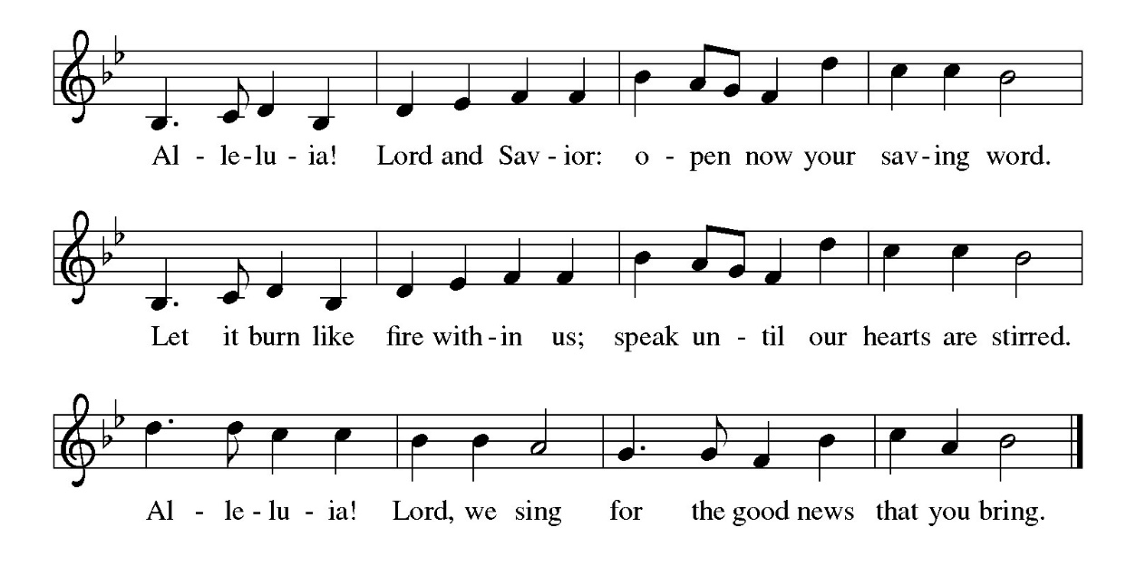
Gospel Acclamation

P - The Holy Gospel according to John, the 14th Chapter
C - Glory to You O Lord!

Gospel: John 14:1-14
On the night that he is to be arrested, Jesus shares final words with his disciples. As the one through whom God is known, he promises to go before them and act on their behalf.
[Jesus said to the disciples:] ¹ “Do not let your hearts be troubled. Believe in God; believe also in me. ² In my Father’s house there are many dwelling places. If it were not so, would I have told you that I go to prepare a place for you? ³ And if I go and prepare a place for you, I will come again and will take you to myself, so that where I am, there you may be also. ⁴ And you know the way to the place where I am going.” ⁵ Thomas said to him, “Lord, we do not know where you are going. How can we know the way?” ⁶ Jesus said to him, “I am the way and the truth and the life. No one comes to the Father except through me. ⁷ If you know me, you will know my Father also. From now on you do know him and have seen him.”
⁸ Philip said to him, “Lord, show us the Father, and we will be satisfied.” ⁹ Jesus said to him, “Have I been with you all this time, Philip, and you still do not know me? Whoever has seen me has seen the Father. How can you say, ‘Show us the Father’? ¹⁰ Do you not believe that I am in the Father and the Father is in me? The words that I say to you I do not speak on my own, but the Father who dwells in me does his works. ¹¹ Believe me that I am in the Father and the Father is in me, but if you do not, then believe because of the works themselves. ¹² Very truly, I tell you, the one who believes in me will also do the works that I do and, in fact, will do greater works than these, because I am going to the Father. ¹³ I will do whatever you ask in my name, so that the Father may be glorified in the Son. ¹⁴ If in my name you ask me for anything, I will do it.”

P - The Gospel of the Lord.
C – Praise to you, O Christ!

Sermon

Hymn of the Day: Christ Is Made the Sure Foundation ELW 645
1 Christ is made the sure foundation, Christ, our head and cornerstone, chosen of the Lord and precious,
binding all the church in one; holy Zion's
help forever and our confidence alone.

2 To this temple, where we call you, come, O Lord of
hosts, and stay; come, with all your lovingkindness,
hear your people as they pray; and your fullest
benediction shed within these walls today.

3 Here bestow on all your servants what they seek from
you to gain; what they gain from you, forever
with the blessed to retain; and hereafter
in your glory evermore with you to reign.

4 Praise and honor to the Father, praise and honor
to the Son, praise and honor to the Spirit,
ever three and ever one: one in might and
one in glory while unending ages run!
Text: Latin hymn, c. 7th cent.; tr. John Mason Neale, 1818-1866, alt.

The Apostle’s Creed
I believe in God, the Father almighty,
creator of heaven and earth.
I believe in Jesus Christ, God’s only Son, our Lord,
who was conceived by the Holy Spirit,
born of the virgin Mary,
suffered under Pontius Pilate,
was crucified, died, and was buried;
he descended to the dead.*
On the third day he rose again;
he ascended into heaven,
he is seated at the right hand of the Father,
and he will come to judge the living and the dead.
I believe in the Holy Spirit,
the holy catholic church,
the communion of saints,
the forgiveness of sins,
the resurrection of the body,
and the life everlasting. Amen.
From sundaysandseasons.com.
Copyright © 2026 Augsburg Fortress. All rights reserved.

Prayers of the People
Trusting in the power of Christ’s resurrection to heal and redeem our broken world, let us pray for the needs of all creation.
A brief silence.
God of glory, you have built your church on Christ the cornerstone. Inspire lay leaders, deacons, pastors, and bishops to proclaim forgiveness and your steadfast love to all whom they encounter.
Merciful God,
Receive our prayer.
God of majesty, you bring forth plants and animals, skies and seas, mountains and valleys. Protect all you have made from the ravages of pollution and climate disaster.
Merciful God,
Receive our prayer.
God of mercy, you intend governments and social service agencies to be instruments of peace and justice. Guide political leaders and organizations to be agents of compassion and raise up advocates for those who seek refuge and assistance.
Merciful God,
Receive our prayer.
God of well-being, you soothe those in distress, console all who grieve, provide for any in need, and comfort those who are sick (especially). Instill caregivers with a sense of purpose to be your healing hands in this world. Merciful God,
Receive our prayer.
God of community, you call us together as your people for mutual support and to witness to your love in the world. Make your presence known among those unable to attend worship today.
Merciful God,
Receive our prayer.

God who is the “I AM”, Grant the St. Timothy Call Committee discernment to recognize the gifts, the calling of the one You choose. Keep them rooted in prayer, respectful in discussion, and open to the leading of Your Spirit. May other call committees in the ELCA also listen to the Holy Spirit as they too wait for your blessing to call a Shepherd.
Merciful God,
Receive our prayer

God of eternal life, you have prepared dwelling places for your people, so that we are never separated from you. We give you thanks for the faithful departed who witnessed, to your mighty acts in word and deed.
Merciful God,
Receive our prayer.
God of resurrection power, use us and these prayers to proclaim the good news of new life to all the world, through Jesus Christ, our risen Savior.
Amen.

P – The Peace of the Lord be with you always.
C – And also with you.

The Offering is Brought to the Altar
Offertory Prayer
Merciful God,
accept the fruits of our labor, gathered to give you glory.
You have set a table before us, a glimpse of that great day
when we will hunger and thirst no more.
Nourish us with the body and blood of Jesus,
that goodness and mercy may follow us
and bless the world you love.
In the name of Jesus,
Amen.

P – The Lord be with You
C – And also with you.
P – Lift up your hearts
C – We lift them to the Lord.
P – Let us give thanks to the Lord, our God
C – It is right to give Him our thanks and praise.

Preface
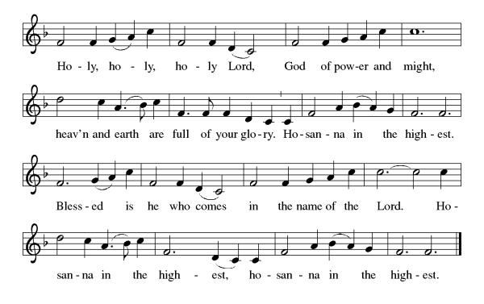
And so, with Mary Magdalene and Peter and all the witnesses of the resurrection, with earth and sea and all their creatures, and with angels and archangels, cherubim and seraphim, we praise your name and join their unending hymn:

Eucharistic Prayer
(Words of Institution)
For as often as we eat of this bread and drink from this cup we proclaim the Lord’s death until He comes.
Christ has died
Christ is risen.
Christ will come again.
Remembering, therefore, his salutary command,
his life-giving passion and death, his glorious resurrection and ascension,
and the promise of his coming again,
we give thanks to you, O Lord God Almighty,
not as we ought but as we are able;
we ask you mercifully to accept our praise and thanksgiving and with your Word and Holy Spirit to bless us, your servants, and these your own gifts of bread and wine, so that we and all who share in the body and blood of Christ may be filled with heavenly blessing and grace,
and, receiving the forgiveness of sin,
may be formed to live as your holy people
and be given our inheritance with all your saints.
To you, O God, Father, Son, and Holy Spirit,
be all honor and glory in your holy church, now and forever. Amen.

Gathered into one, by the Holy Spirit let us listen to the words that Jesus taught us.

The Lord’s Prayer
Our Father, who art in heaven, hallowed be thy name, thy kingdom come, thy will be done, on earth as it is in heaven. Give us this day our daily bread; and forgive us our trespasses, as we forgive those who trespass against us; and lead us not into temptation but deliver us from evil. For thine is the kingdom, and the power, and the glory, forever and ever. Amen.
P: God feeds those who hunger, Come! Be fed and be healed!
C: Thanks be to God.

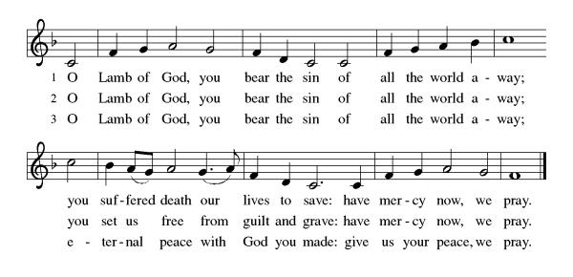
Invitation to Communion

Distribution of Communion – Come Forward to Receive
Communion Hymn: The Strife is O’er, the Battle Done ELW 366

P – Now may the body and blood of our Lord and Savior Jesus Christ strengthen you and keep you in His grace!
C – Thank You Jesus!

Prayer after Communion
Holy One,
through this meal you have made your home among us
and are making all things new.
Send us now to speak peace to anxious hearts,
to love our enemies,
and to bring your healing to the nations.
In the name of Jesus,
Amen.

Benediction
The time has come, O Lord – for us to leave this place;
guide us and protect us and lead us in they Grace.
Wherever life may take us as we go our separate ways,
help us share with others the things we’ve shared today.
May the peace of God, the Father, and the love of Christ, His Son,
guide us in the days ahead and strengthen us each one.
May the blessing of the spirit fill us from within;
God bless us and return us to the fellowship once again.
May Almighty God bless you, Father. Son and Holy Spirit.
Amen.

Sending Hymn: Christ is Alive! Let Christians Sing ELW 389

- Christ is alive! Let Christians sing. The cross stands
empty to the sky. Let streets and homes with
praises ring. Love, drowned in death, shall never die.

- Christ is alive! No longer bound to distant
years in Palestine, but saving, healing,
here and now, and touching ev’ry place and time.

- In ev’ry insult, rift, and war, where color,
scorn, or wealth divide, Christ suffers still, yet
loves the more, and lives, where even hope has died.

4 Women and men, in age and youth, can feel the
Spirit, hear the call, and find the way, the
life, the truth, revealed in Jesus, freed for all.

- Christ is alive, and comes to bring good news to
this and every age, till earth and sky and
ocean ring with joy, with justice, love, and praise.

Text: Brian A. Wren, b. 1936
Text © 1975, rev. 1995 Hope Publishing Company, Carol Stream, IL 60188. All rights reserved. Used by permission.
Duplication in any form prohibited without permission or valid license from copyright administrator.
Dismissal
P – Look and listen to S.A.M. Bob
C- Thanks be to God. Alleluia!

Postlude:
Unless otherwise noted, service materials used in this bulletin are:
"Reprinted from the 1995 Moravian Book of Worship with permission of the Interprovincial Board of Communication, Moravian Church in North America."
Music is reprinted under OneLicense.Net #A712074 and/or Augsburg Fortress #SBL12176H. Scripture, unless otherwise noted, is from the New Revised Standard Version Bible, Copyright © 1989, Division of Christian Education of the National Council of the Churches of Christ in the United States of America. Used by permission. All rights reserved.
St Timothy’s is served by S.A.M. Robert Bonomo
Lay Minister Frank Hofstetter
Director of Music Sally Hennessey
Saturday Pianist Bill Robinson
Announcements for May 2nd and 3rd
ATTENDANCE
Saturday, April 25, 4pm 23
Sunday, April 26, 8am 50
Drive-Up Communion 2
75

The altar flowers are given, this week, by Lay Minister Frank Hofstetter and his wife, Eileen, in honor of their wedding anniversary!

Serving our Lord this weekend:
Saturday, May 2nd
Sunday, May 3rd
Assisting Minister: Sarah Brisson
Reader: Ginny Gopadze

This Week at St. Timothy's
Monday, May 4th 10:30am – PB&J Packing, 11am – Healthy Start
Tuesday, May 5th
Wednesday, May 6th 11am – Final Citrus Blessings for this school year, 1pm - Card Makers
Thursday, May 7th 11am Bible Study for Beginners, 11am – Miniatures, 3:30 – Chimes, 4:30pm - Choir
Friday, May 8th
Saturday, May 9th 4pm Worship
Sunday, May 10th MOTHER’S DAY
9am -Worship, 10:30am – Adult SS, Coffee Fellowship

