Welcome to St. Timothy Evangelical Lutheran Church
February 14th & 15th
Transfiguration of Our Lord
Last Sunday After Epiphany

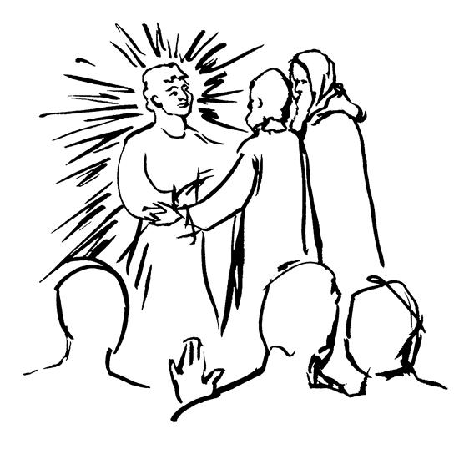

Today’s festival is a bridge between the Advent-Christmas-Epiphany cycle that comes to a close today and the Lent-Easter cycle that begins in several days. On a high mountain Jesus is revealed as God’s beloved Son, echoing the words at his baptism. This vision of glory sustains us as Jesus faces his impending death in Jerusalem. We turn this week to Ash Wednesday and our yearly baptismal journey from Lent to Easter. Some churches put aside the alleluia at the conclusion of today’s liturgy. This word of joy will be omitted during the penitential season of Lent and will be sung again at Easter.

Preservice: We Are Called W&P 147
Welcome and Sharing of Congregational News
Prelude

Confession and Forgiveness
All may make the sign of the cross, the sign that is marked at baptism, as the presiding minister begins.
Blessed be the holy Trinity, ☩ one God,
the Creator of heaven and earth,
the Word who spoke life into being,
the Wind stirring the waters.
Amen.
Let us turn in confession to the one who knows us completely.
Silence is kept for reflection.
Mighty God, lover of justice,
you call us to life in community,
but we have served our own interests
at the expense of our neighbors.
We have sown deceit where honesty was needed.
We say the right words,
but our hearts are far from you.
Turn us to seek your face.
Knit us together and give us the mind of Christ,
that we may do justice, love mercy,
and walk humbly with you, our God.
Amen.

Forgiveness
The former things have passed away,
and new things God now declares:
Like a spring of water that never fails,
God covers you in the righteousness of Christ,
and forgives your sin in ☩ Jesus’ name.
May the Spirit give you strength to live for others,
and bless you with the gift of peace.
Amen.
Greeting
P: The joy of our Lord Jesus Christ, the compassion of God, and the creative power of the Holy Spirit be with you all.
C: And also with you.

Gathering Hymn: Arise, Your Light Has Come! ELW 314
1 Arise, your light has come! The Spirit's call obey;
show forth the glory of your God which shines on you today.
2 Arise, your light has come! Fling wide the prison door;
proclaim the captive's liberty, good tidings to the poor.
3 Arise, your light has come! All you in sorrow born,
bind up the brokenhearted ones and comfort those who mourn.
4 Arise, your light has come! The mountains burst in song!
Rise up like eagles on the wing, God's pow'r will make us strong.
Text: Ruth Duck, b. 1947
Text © 1992 GIA Publications, Inc., 7404 S. Mason Ave., Chicago, IL 60638. www.giamusic.com. 800.442.3358. All rights reserved. Used by permission.

Prayer of the Day
O God, in the transfiguration of your Son you confirmed the mysteries of the faith by the witness of Moses and Elijah, and in the voice from the bright cloud declaring Jesus your beloved Son, you foreshadowed our adoption as your children. Make us heirs with Christ of your glory, and bring us to enjoy its fullness, through Jesus Christ, our Savior and Lord, who lives and reigns with you and the Holy Spirit, one God, now and forever.
Amen.
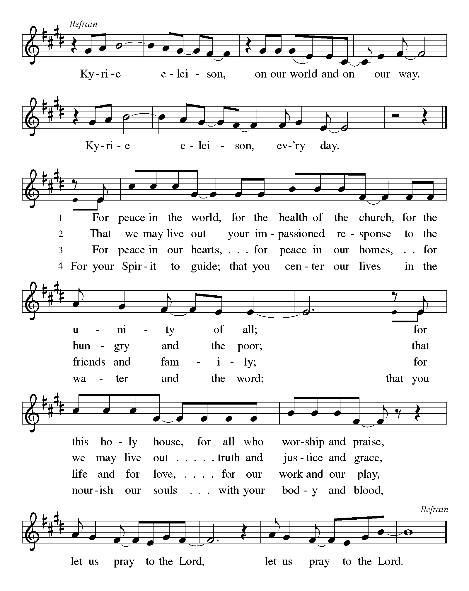

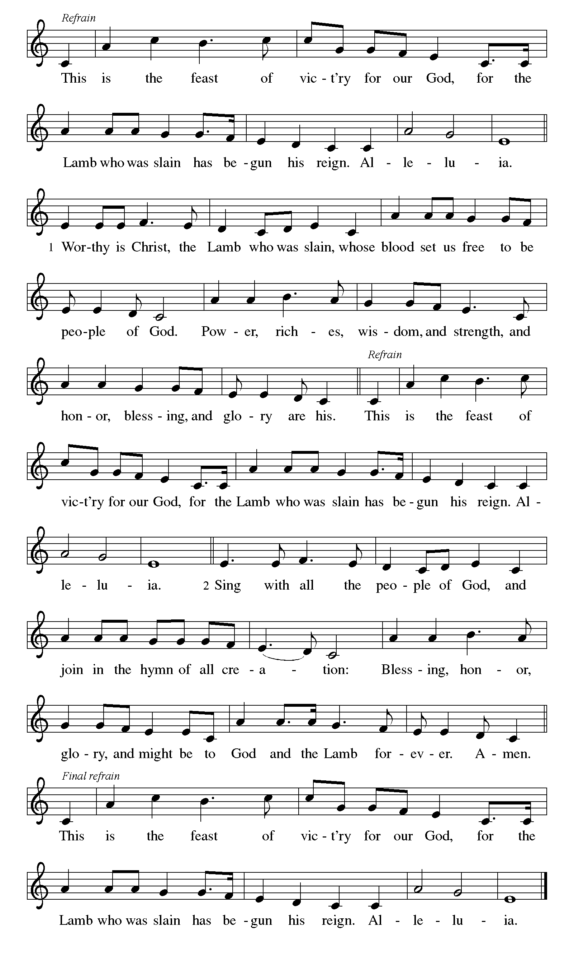

First Reading: Exodus 24:12-18
At Mount Sinai, Moses experienced the presence of God for forty days and forty nights. The “glory of the Lord” settled on the mountain, and on the seventh day God called out to Moses. On the mountain God gave Moses the stone tablets inscribed with the ten commandments.
¹² The Lord said to Moses, “Come up to me on the mountain and wait there; I will give you the tablets of stone, with the law and the commandment, which I have written for their instruction.” ¹³ So Moses set out with his assistant Joshua, and Moses went up onto the mountain of God. ¹⁴ To the elders he had said, “Wait here for us, until we come back to you. Look, Aaron and Hur are with you; whoever has a dispute may go to them.”
¹⁵ Then Moses went up on the mountain, and the cloud covered the mountain. ¹⁶ The glory of the Lord settled on Mount Sinai, and the cloud covered it for six days; on the seventh day he called to Moses out of the cloud. ¹⁷ Now the appearance of the glory of the Lord was like a devouring fire on the top of the mountain in the sight of the Israelites. ¹⁸ Moses entered the cloud and went up on the mountain. Moses was on the mountain for forty days and forty nights.

P: Here ends our first reading.
C: Thanks be to God!

Psalm 2
¹ Why are the nations in an uproar?
Why do the peoples mutter empty threats?
² Why do the kings of the earth rise up in revolt, and the princes plot together,
against the Lord and against the Lord’s anointed?
³ “Let us break their yoke,” they say;
“let us cast off their bonds from us.”
⁴ God whose throne is in heaven is laughing;
the Lord holds them in derision.
⁵ Then in wrath God speaks to them,
and in rage fills them with terror.
⁶ “As for me, I have anointed my king
upon Zion, my holy mountain.”
⁷ Let me announce the decree of the Lord,
who said to me, “You are my son; this day have I begotten you.
⁸ Ask of me, and I will give you the nations for | your inheritance
and the ends of the earth for your possession.
⁹ You shall crush them with an iron rod
and shatter them like a piece of pottery.”
¹⁰ And now, you kings, be wise;
be warned, you rulers of the earth.
¹¹ Submit to the Lord with fear,
and with trembling bow in worship;
¹² lest the Lord be angry, and you perish in a sudden blaze of wrath.
Happy are all who take refuge in God!

Second Reading: 2 Peter 1:16-21
At the transfiguration, God’s voice was heard, declaring Jesus to be the beloved Son. By the activity of the Holy Spirit, God’s voice continues to be heard through the word of scripture.
¹⁶ We did not follow cleverly devised myths when we made known to you the power and coming of our Lord Jesus Christ, but we had been eyewitnesses of his majesty. ¹⁷ For he received honor and glory from God the Father when that voice was conveyed to him by the Majestic Glory, saying, “This is my Son, my Beloved, with whom I am well pleased.” ¹⁸ We ourselves heard this voice come from heaven, while we were with him on the holy mountain.
¹⁹ So we have the prophetic message more fully confirmed. You will do well to be attentive to this as to a lamp shining in a dark place, until the day dawns and the morning star rises in your hearts. ²⁰ First of all you must understand this, that no prophecy of scripture is a matter of one’s own interpretation, ²¹ because no prophecy ever came by human will, but men and women moved by the Holy Spirit spoke from God.
P: Here ends our second reading.
C: Thanks be to God!
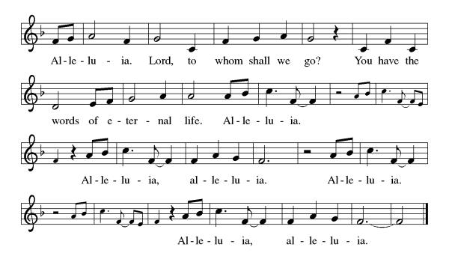
Gospel Acclamation

P: The Holy Gospel according to Matthew 17:1-9
C: Glory to you O Lord.

Gospel: Matthew 17:1-9
Shortly before he enters Jerusalem, where he will be crucified, Jesus is revealed to Peter, James, and John in a mountaintop experience of divine glory called the transfiguration.
¹ Six days later, Jesus took with him Peter and James and his brother John and led them up a high mountain, by themselves. ² And he was transfigured before them, and his face shone like the sun, and his clothes became bright as light. ³ Suddenly there appeared to them Moses and Elijah, talking with him. ⁴ Then Peter said to Jesus, “Lord, it is good for us to be here; if you wish, I will set up three tents here, one for you, one for Moses, and one for Elijah.” ⁵ While he was still speaking, suddenly a bright cloud overshadowed them, and a voice from the cloud said, “This is my Son, the Beloved; with him I am well pleased; listen to him!” ⁶ When the disciples heard this, they fell to the ground and were overcome by fear. ⁷ But Jesus came and touched them, saying, “Get up and do not be afraid.” ⁸ And when they raised their eyes, they saw no one except Jesus himself alone.
⁹ As they were coming down the mountain, Jesus ordered them, “Tell no one about the vision until after the Son of Man has been raised from the dead.”

P: The Gospel of Our Lord!
C: Praise to You O Christ!
Sermon by Bob

Hymn of the Day: How Good, Lord, to Be Here! ELW 315
1 How good, Lord, to be here! Your glory fills the night;
your face and garments, like the sun, shine with unborrowed light.
2 How good, Lord, to be here! your beauty to behold
where Moses and Elijah stand, your messengers of old.
3 Fulfiller of the past and hope of things to be,
we hail your body glorified and our redemption see.
4 Before we taste of death, we see your kingdom come;
we long to hold the vision bright and make this hill our home.
5 How good, Lord, to be here! Yet we may not remain;
but since you bid us leave the mount, come with us to the plain.
Text: Joseph A. Robinson, 1858-1933, alt.

Apostles’ Creed
I believe in God, the Father almighty,
creator of heaven and earth.
I believe in Jesus Christ, God’s only Son, our Lord,
who was conceived by the Holy Spirit,
born of the virgin Mary,
suffered under Pontius Pilate,
was crucified, died, and was buried;
he descended to the dead.
On the third day he rose again;
he ascended into heaven,
he is seated at the right hand of the Father,
and he will come to judge the living and the dead.
I believe in the Holy Spirit,
the holy catholic church,
the communion of saints,
the forgiveness of sins,
the resurrection of the body,
and the life everlasting. Amen.

Lord, listen to your children praying,
Lord, send your Spirit in this place;
Lord, listen to your children praying,
send us love, send us pow'r, send us grace.

Prayers of the People
Response (after “Merciful God”): “Receive our prayer”
Confident that the Holy Spirit receives our prayers and answers us, we commend all for whom we pray to God’s loving-kindness made known to us in Christ Jesus our Savior.
Amen.

P: May the peace of our Lord Jesus Christ be with you all.
C: And also with you.
P: Let us now share this peace.
Offering is Brought to the Altar

Offertory Prayer
God of majesty,
no eye has seen, no ear has heard
what you have prepared for those who love you,
yet in this meal you reveal the wideness of your mercy.
Use what we have gathered
to feed us with the reign of God come near,
Jesus Christ, our Savior and Lord.
Amen.
P: The Lord be with you.
C: And also with you.

P: Lift up your hearts.
C: We Lift them to the Lord.

P: Let us give thanks to the Lord our God.
C: It is right to give our thanks and praise.

Preface
(Words spoken by Bob)

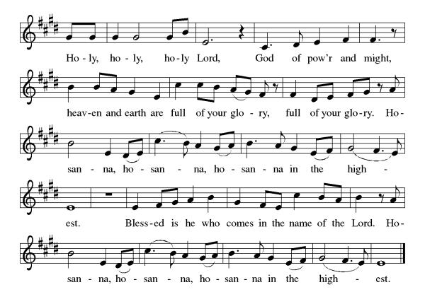
Eucharistic Prayer
(Words of Institution)

For as often as we eat of this bread and drink from this cup we proclaim the Lord’s death until He comes.
Christ has died
Christ is risen.
Christ will come again.
Gathered into one, by the Holy Spirit let us listen to the words that Jesus taught us.

The Lord’s Prayer
Our Father, who art in heaven, hallowed be thy name, thy kingdom come, thy will be done, on earth as it is in heaven. Give us this day our daily bread; and forgive us our trespasses, as we forgive those who trespass against us; and lead us not into temptation but deliver us from evil. For thine is the kingdom, and the power, and the glory, forever and ever. Amen.

Invitation to Communion
P: Here is the Lamb of God who takes away the sins of the world! Come to His table and taste on your lips a Love we cannot comprehend.
C: Amen
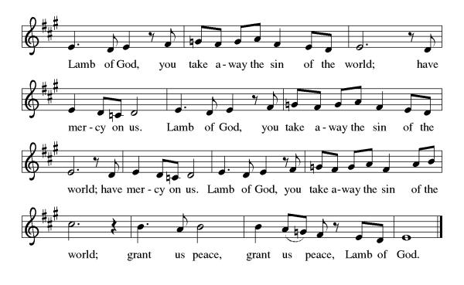

All may come.
Communion Anthem: Dazzling Presence on the Mountain ACS 917
P: We are now a tabernacle with Christ inside of us. Let us rejoice and be glad at the Lord’s table.
C: Amen

Prayer after Communion
Radiant God,
we have seen your glory in the face of Jesus Christ.
In the sacrament of his body and blood
you have drawn us to your heart.
Send us from this table with delight,
that our lives may reflect the beauty of your love,
and bear witness to all we have seen and heard,
through Jesus Christ, our Savior and Lord.
Amen.

Blessing
May the triune God,
Who has put a new song in your mouth
And tuned your heart for praise
☩ bless you now and forever
Amen.

Sending Hymn: Alleluia, Song of Gladness ELW 318
1 Alleluia, song of gladness, voice of joy that cannot die;
alleluia is the anthem ever dear to choirs on high;
in the house of God abiding thus they sing eternally.
2 Alleluia you are sounding, true Jerusalem and free;
alleluia, joyful mother, bring us to your jubilee;
here by Babylon's sad waters mourning exiles still are we.
3 Alleluia cannot always be our song while here below;
alleluia our transgressions make us for a while forgo;
for the solemn time is coming when our tears for sin shall flow.
4 In our hymns we pray with longing: Grant us, blessed Trinity,
at the last to keep glad Easter with the faithful saints on high;
there to you forever singing alleluia joyfully.
Text: Latin hymn, 11th cent.; tr. John Mason Neale, 1818-1866, alt.

Dismissal
P: Go in peace. Do justice. Love mercy.
C: Thanks be to God.
Postlude
Unless otherwise noted, materials used in this bulletin are:
From Sundays and Seasons.com. Copyright 2015 Augsburg Fortress. All rights reserved. Reprinted by permission under Augsburg Fortress Liturgies Annual License #SAS028635. Music is reprinted under OneLicense.Net #A712074 and/or Augsburg Fortress #SBL12176H. Scripture, unless otherwise noted, is from the New Revised Standard Version Bible, Copyright © 1989, Division of Christian Education of the National Council of the Churches of Christ in the United States of America. Used by permission. All rights reserved.

St. Timothy Evangelical Lutheran Church
1070 N. Suncoast Blvd.
Crystal River, FL 34429
Telephone number (Office): 352-795-5325
Office email address: crsttimothy@tampabay.rr.com

St Timothy Worship Team
S.A.M. Robert F. Bonomo
Lay Minister, Frank Hofstetter
Director of Music, Sally Hennessey
Saturday Pianist, Bill Robinson
Announcements for February 14th & 15th

ATTENDANCE
Saturday, February 7, 4pm 23
Sunday, February 8, 9am 48
Drive-Up Communion 0
71

The Altar Flowers are given this week by Steve and Teresa York, to the glory of God!

Serving our Lord this weekend:
Saturday
Communion Assistant – Jean Fowler
Sunday
Assisting Minister – Sarah Brisson
Reader – Dick Kleinsmith, Cross Bearer – Sarah Brisson
This Week at St. Timothy's
Monday, February 16th
Tuesday, February 17th 1pm WELCA, 5pm -Shrove Tuesday
Wednesday, February 18th 12pm Ash Wednesday Svc w/communion & ashes, Lent begins
Thursday, February 19th 11am Bible Study for Beginners (bring bible) 11am – Miniatures, 4:30pm - Choir
Friday, February 20th 1pm Royal Dalton Memory Care
Saturday, February 21st 4pm - Worship
Sunday, February 22nd 9am – Worship, 10:15-10:45 – Drive Up Communion, Adult SS, Coffee Fellowship


JOIN US ON TUESDAY, FEBRUARY 17TH AT 5PM FOR PANCAKES AND FELLOWSHIP. Sign-up sheet on the bulletin board nearest the kitchen.


Worship begins at 12pm with the Sacrament and Imposition of Ashes.

