***A Service of Worship, Praise and Hope***

***Welcome to St. Timothy Saturday Evening Worship!***

***April 20, 2024, Fourth Week of Easter***

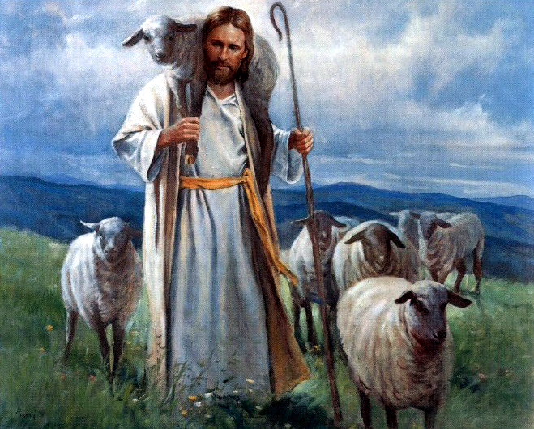

**"Equip people to grow as Disciples faithfully serving our community"**

**We are glad to have you worship with us. All are welcome at communion. If you need gluten-free – please tell Pastor Joanie when you go up for communion. If you have any questions – just ask the Welcomer at the back of the sanctuary.**

***Please note** if you use a pew envelope for your offering – please write your name on the envelope so that the financial secretaries can post it as a gift from you. Thank You!***

**St Timothy Worship Planning Team**

**The Reverend Joan E. Holden 850-774-7730**

**Eric Mortensen – Director of Music**

**Frank Hofstetter, Parish Deacon**

**The Altar Flowers are given by Jean Fowler, in honor of her birthday!**

**This Week at St. Timothy's**

**Monday, April 22nd PJ OFF**

**Tuesday, April 23rd 9-12 Food Pantry, May Vineyard Views deadline**

**Wednesday, April 24th 10am – OT BS**

**Thursday, April 25th 9:30am – Prayer Group, 11:00 am – Miniatures , 4:30pm - Choir**

**Friday, April 26th 10am – NT BS**

**Saturday, April 27th 4 pm – Worship**

**Sunday, April 28th 9 am – Worship – Childrens SS, 10:30 am – Adult Sunday School, 11-11:30 am – Drive Up Communion**

***Rooted in the past and growing into the future, the church must always be reformed in order to live out the love of Christ in an ever-changing world. We celebrate the good news of God’s grace, that Jesus Christ sets us free every day to do this life-transforming work. Trusting in the freedom given to us in baptism, we pray for the church, that Christians will unite more fully in worship and mission.***

***(from Sundays and Seasons for Reformation Weekend)***

***“Shout to the Lord” is the last pre-service hymn the choir sings, it is Hymn #821 and everyone is welcome to sing with the choir.***

**Welcome and Sharing of Congregational News**

## ***Preparation Anthem***

### *Gathering Hymn: Savior, like a Shepherd Lead Us ELW 789*

1 Savior, like a shepherd lead us; much we need your tender care.

In your pleasant pastures feed us, for our use your fold prepare.

Blessed Jesus, blessed Jesus, you have bought us; we are yours.

Blessed Jesus, blessed Jesus, you have bought us; we are yours.

2 We are yours; in love befriend us, be the guardian of our way;

keep your flock, from sin defend us, seek us when we go astray.

Blessed Jesus, blessed Jesus, hear us children when we pray.

Blessed Jesus, blessed Jesus, hear us children when we pray.

3 You have promised to receive us, poor and sinful though we be;

you have mercy to relieve us, grace to cleanse, and pow'r to free.

Blessed Jesus, blessed Jesus, early let us turn to you.

Blessed Jesus, blessed Jesus, early let us turn to you.

4 Early let us seek your favor, early let us do your will;

blessed Lord and only Savior, with your love our spirits fill.

Blessed Jesus, blessed Jesus, you have loved us, love us still.

Blessed Jesus, blessed Jesus, you have loved us, love us still.

P - The grace of our Lord Jesus Christ, the love of God and the communion of the Holy Spirit be with you all.

**C - And also with you.**

**Confession and Forgiveness**

P - Blessed be the Holy Trinity, + one God, whose name is majestic in all the earth, who rescues and heals in every time of trouble, who does all things well.

**C – Amen**

P - Let us come before God, seeking forgiveness and life.

*(Silence is kept for reflection and self-examination)*

P - Steadfast and saving God,

**C - Have mercy on us. We confess to you all our sins and that in these continuing times of uncertainty and fear, we have trouble trusting you and feeling your presence. Forgive us our sins, our doubts, our fears and lack of patience with others. Strengthen our faith and help us to let your hope and light shine through us in these dark times. We ask for mercy, wisdom and guidance, through Jesus Christ, our Savior and Lord. Amen.**

P - In the name of + Jesus, the Son of God, receive mercy and find grace in your time of need. Your sins are forgiven; God's love is healing balm for your wounds. Rejoice, for God raises you up to new life in Christ.

**C - Amen**

**Greeting**

P - The joy of our Lord Jesus Christ, the compassion of God, and the creative power of the Holy Spirit be with you all.

**C - And also with you.**

### Prayer of the Day

**O Lord Christ, good shepherd of the sheep, you seek the lost and guide us into your fold. Feed us, and we shall be satisfied; heal us, and we shall be whole. Make us one with you, for you live and reign with the Father and the Holy Spirit, one God, now and forever. Amen.**

**Word**

### First Lesson: 1 John 3:16-24

Jesus’ death on our behalf is the clearest demonstration of divine love. This is the very love we share with others, not just through our words but especially through our deeds. In sharing such love we fulfill God’s commandments.

16We know love by this, that [Jesus Christ] laid down his life for us—and we ought to lay down our lives for one another. 17How does God’s love abide in anyone who has the world’s goods and sees a brother or sister in need and yet refuses help?  
 18Little children, let us love, not in word or speech, but in truth and action. 19And by this we will know that we are from the truth and will reassure our hearts before him 20whenever our hearts condemn us; for God is greater than our hearts, and he knows everything. 21Beloved, if our hearts do not condemn us, we have boldness before God; 22and we receive from him whatever we ask, because we obey his commandments and do what pleases him.  
 23And this is his commandment, that we should believe in the name of his Son Jesus Christ and love one another, just as he has commanded us. 24All who obey his commandments abide in him, and he abides in them. And by this we know that he abides in us, by the Spirit that he has given us.

### P – The Holy Gospel according to John, Chapter 10

### C – Glory to you O Lord.

### Gospel: John 10:11-18

In language that recalls the twenty-third psalm, Jesus describes himself as the shepherd who cares for his sheep. He is willing to die for them, and he is able to overcome death for them.

[Jesus said:] 11“I am the good shepherd. The good shepherd lays down his life for the sheep. 12The hired hand, who is not the shepherd and does not own the sheep, sees the wolf coming and leaves the sheep and runs away—and the wolf snatches them and scatters them. 13The hired hand runs away because a hired hand does not care for the sheep. 14I am the good shepherd. I know my own and my own know me, 15just as the Father knows me and I know the Father. And I lay down my life for the sheep. 16I have other sheep that do not belong to this fold. I must bring them also, and they will listen to my voice. So there will be one flock, one shepherd. 17For this reason the Father loves me, because I lay down my life in order to take it up again. 18No one takes it from me, but I lay it down of my own accord. I have power to lay it down, and I have power to take it up again. I have received this command from my Father.”

### P - The Gospel of Our Lord!

**C - Praise to You O Christ!**

***Hymn of the Day: The Lord's My Shepherd ELW 778***

1 The Lord's my shepherd; I'll not want. He makes me down to lie

in pastures green; he leadeth me the quiet waters by.

He leadeth me, he leadeth me the quiet waters by.

2 My soul he doth restore again, and me to walk doth make

within the paths of righteousness, e'en for his own name's sake;

within the paths of righteousness, e'en for his own name's sake.

3 Yea, though I walk in death's dark vale, yet will I fear no ill;

for thou art with me, and thy rod and staff me comfort still;

for thou art with me, and thy rod and staff me comfort still.

4 My table thou hast richly spread in presence of my foes;

my head thou dost with oil anoint, and my cup overflows.

My head thou dost with oil anoint, and my cup overflows.

5 Goodness and mercy all my life shall surely follow me,

and in God's house forevermore my dwelling-place shall be;

and in God's house forevermore my dwelling-place shall be.

***Message:***

**Apostles’ Creed**

**I believe in God, the Father almighty,**

**creator of heaven and earth.**

**I believe in Jesus Christ, God’s only Son, our Lord,**

**who was conceived by the Holy Spirit,**

**born of the virgin Mary,**

**suffered under Pontius Pilate,**

**was crucified, died, and was buried;**

**he descended to the dead.**

**On the third day he rose again;**

**he ascended into heaven,**

**he is seated at the right hand of the Father,**

**and he will come to judge the living and the dead.**

**I believe in the Holy Spirit,**

**the holy catholic church,**

**the communion of saints,**

**the forgiveness of sins,**

**the resurrection of the body,**

**and the life everlasting. Amen.**

**Lord, listen to your children praying,**

**Lord, send your Spirit in this place;**

**Lord, listen to your children praying,**

**send us love, send us pow'r, send us grace.**

### Prayers of the People *please stand, sit or kneel as able*

Rejoicing that Jesus is risen and love has triumphed over fear, let us pray for the church, the world, and all those in need of good news. *A brief silence.*

Shepherding God, gather your church whenever we wander from you and one another. Empower our church in ministries around the world to worship and serve alongside global companions as equal partners and coworkers in the gospel. God of grace, **hear our prayer.**

Nurturing God, preserve the health of biomes and ecosystems. Inspire scientists, researchers, conservation organizations, and all people entrusted with the task of caring for creation, that we may be better stewards of the world around us. God of grace, **hear our prayer.**

Almighty God, lead nations and communities to share resources, cooperate in solving conflicts, and listen to the wisdom of Indigenous peoples. Help all those with power to share it and to use such power for good. God of grace, **hear our prayer.**

Loving God, protect the very young and the very old, those living without housing, victims of domestic abuse, and all who live with chronic illness or compromised immune systems, especially everyone on our prayer list and everyone we name out loud or silently in our hearts…... Guide communities to actively care for people who are vulnerable. God of grace, **hear our prayer.**

Gracious God, help this and all communities of faith to listen for your voice. Call us away from things that distract us from following you. Invite us to more deeply love and serve people who are lonely, isolated, and on the margins. God of grace, **hear our prayer.**

*At this time anyone can lift up prayers,*

*God of grace,* ***hear our prayer.***

Living God, we give thanks for our ancestors in faith. Strengthen us to share the good news in our own day. God of grace, **hear our prayer.**

Into your hands, most merciful God, we commend all for whom we pray, trusting in your abiding love; through Jesus Christ, our resurrected and living Lord. **Amen.**

**Peace**

P- The Peace of the Lord be with you always.

**C – And also with you.**

**We Share Christ’s Peace**

**Offering is Brought to the Altar**

**Offering Prayer**

**We lift our voices, we lift our hands, we lift our lives up to you; we are an Offering. Lord, use our voices, Lord, use our hands, Lord, use our lives, they are yours: we are an offering. All that we have, all that we are, all that we hope to be, we give to you, we give to you. We lift our voices, we lift our hands, we lift our lives up to you; we are an offering, we are an offering.**

**Jesus’ Words of Promise and Gift of Life**

Dear Lord, Jesus Christ:

in the night in which you were betrayed,

You took bread, broke it and gave thanks,

then you gave it to your disciples saying:

take and eat, this is my body I am giving for you.

Do this in remembrance of me.

Again, after supper, Dear Lord Jesus,

You took the cup, gave thanks

and gave it for everyone to drink saying:

this cup is the new covenant in my blood,

I am shedding for you and for all people for the forgiveness of sin.

Do this for the remembrance of me. **Amen.**

**Our Lord's Prayer**

**Our Father in heaven, hallowed be your name, your kingdom come, your will be done, on earth as in heaven. Give us today our daily bread. Forgive us our sins as we forgive those who sin against us. Save us from the time of trial and deliver us from evil. For the kingdom, the power, and the glory are yours, now and forever. Amen.**

**Invitation to Communion**

P: Come to this Table where God really does come to us!

**C: Thank You Jesus!**

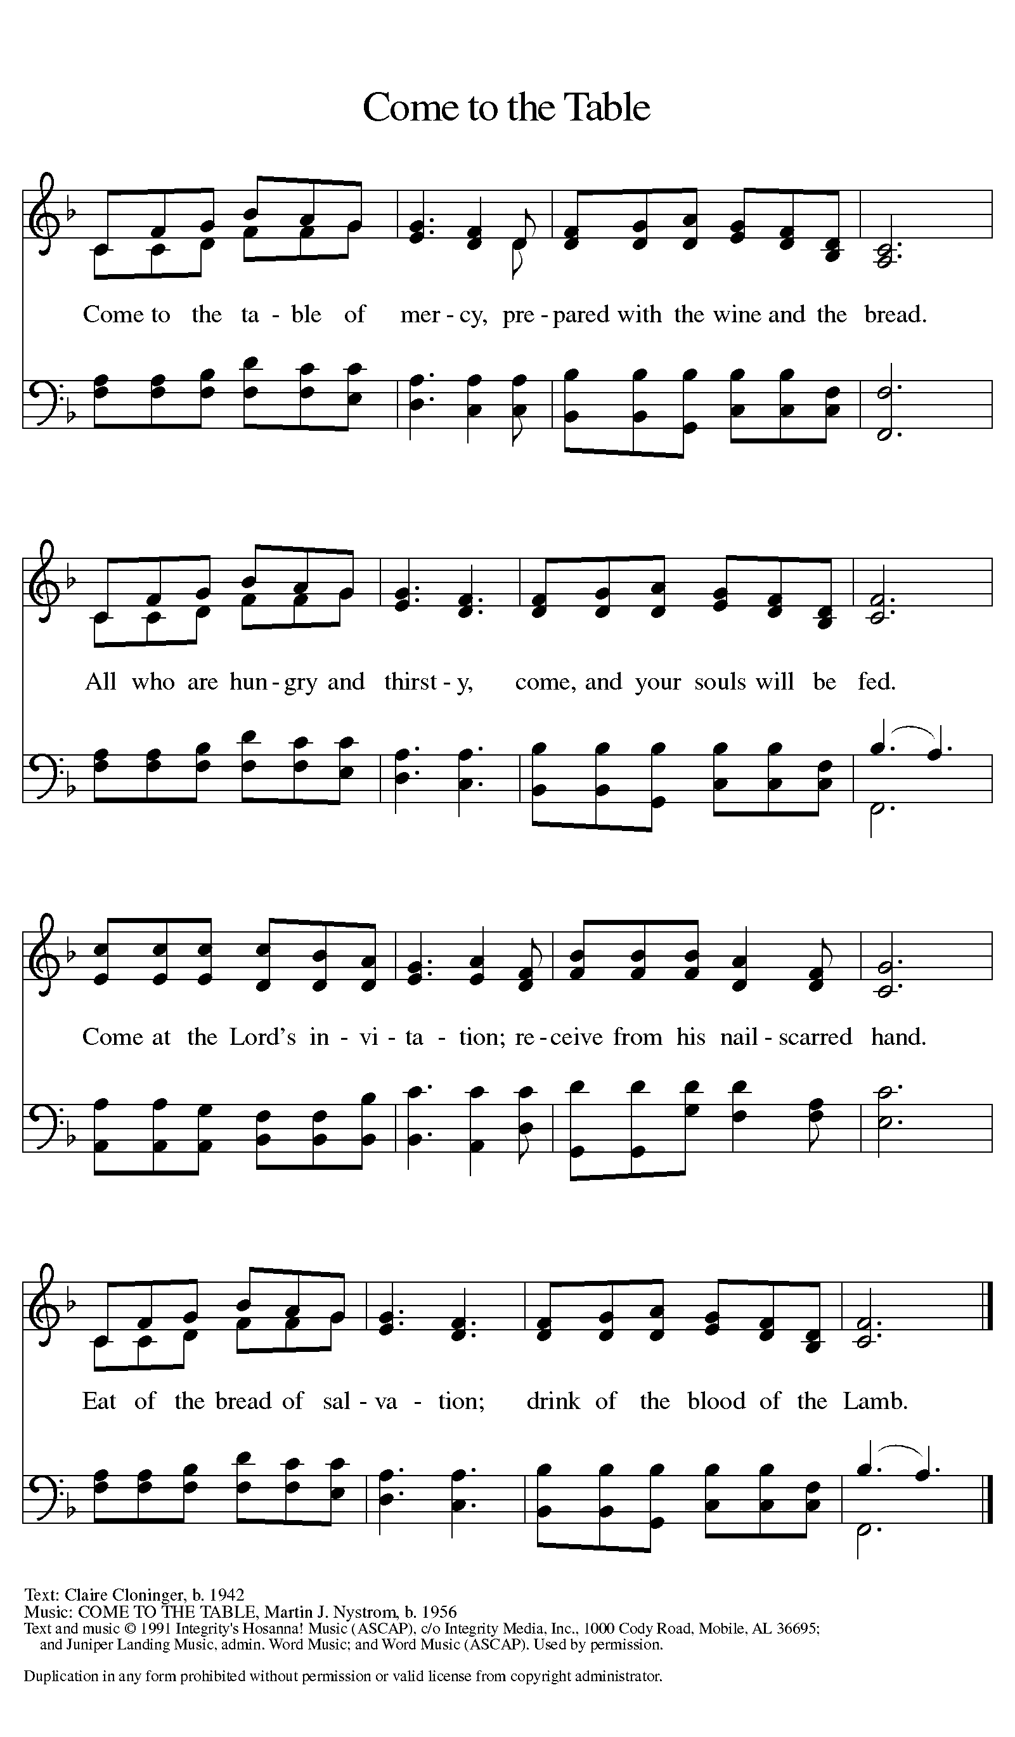

***Distribution - Please come forward to receive***

### *Communion Anthem*

P - Now may the body and blood of our Lord Jesus Christ strengthen you and keep you in his grace…. Jesus Loves You!

**C – Thank You Jesus!**

### Prayer after Communion

**Shepherding God, you have prepared a table before us and nourished us with your love. Send us forth from this banquet to proclaim your goodness and share the abundant mercy of Jesus, our redeemer and friend. Amen.**

**Sending**

**Blessing**

P - God Almighty send you light and truth to keep you all the days of your lives. The hand of God protect you; the holy angels accompany you; and the blessing of almighty God, the Father, the ☩ Son, and the Holy Spirit, be with you now and forever.

**C -Amen.**

### 

### *Sending Hymn: My Shepherd, You Supply My Need ELW 782*

1 My Shepherd, you supply my need; most holy is your name.

In pastures fresh you make me feed, beside the living stream.

You bring my wand'ring spirit back when I forsake your ways,

and lead me, for your mercy's sake, in paths of truth and grace.

2 When I walk through the shades of death, your presence is my stay;

one word of your supporting breath drives all my fears away.

Your hand, in sight of all my foes, does still my table spread;

my cup with blessings overflows, your oil anoints my head.

3 The sure provisions of my God attend me all my days;

oh, may your house be my abode and all my work be praise.

Here would I find a settled rest, while others go and come;

no more a stranger or a guest, but like a child at home.

### Dismissal

P: Thanks be to God

**C: Alleluia!**

***Postlude***

Unless otherwise noted, materials used in this bulletin are:

From Sundays and Seasons.com. Copyright 2015 Augsburg Fortress. All rights reserved. Reprinted by permission under Augsburg Fortress Liturgies Annual License #SAS028635. Music is reprinted under OneLicense.Net #A712074 and/or Augsburg Fortress #SBL12176H. Scripture, unless otherwise noted, is from the New Revised Standard Version Bible, Copyright © 1989, Division of Christian Education of the National Council of the Churches of Christ in the United States of America. Used by permission. All rights reserved.

**REMEMBRANCE**

**Toyohiko Kagawa, renewer of society, died 1960**

Born in Kobe, Japan, Kagawa was orphaned as a young child. Later, when he became Christian, he was disowned by the rest of his family. Wishing to bring Christian principles into society, he worked among poor people, established schools and hospitals, and worked for peace.

**Announcements for April 20th and 21st**

**ATTENDANCE**

**Saturday, April 13th 4pm 22**

**Sunday, April 14th, 9am 44**

**Drive-Up Communion 4**

**70**

**WELCA SPRING GATHERING.**

**PEACE, BE NOT ANXIOUS**

St. Timothy will be hosting the Pine Lands Conference Spring Gathering on May 4th .  ALL WOMEN ARE INVITED ! This event will include women from the churches in our conference .  We will start with a Breakfast and Registration at 9am . There is a $10 fee for the offering to the Florida-Bahama Women's Organization (SWO)  and expenses.  We will have a short meeting, a devotional SWO representative Leone Goding talk about WELCA and the changes to Lutheran World Relief. There will be a lunch provided with Gluten Free available.   We will end the day with a Communion Service led by Pastor Joanie.

Please join us for this wonderful day of fellowship with our Sisters from the Pine Lands Conference.  **RSVP BY APRIL 26 ON THE WELCA BOARD  SO THAT WE CAN BE ASSURED TO HAVE PLENTY OF SUPPLIES IF YOU ARE GLUTEN FREE PLEASE INDICATE THAT ON SIGN IN SHEET.  ANY QUESTIONS SEE SALLIE HALEY.**

