Welcome to St. Timothy Evangelical Lutheran Church
March 28, 2026
Sixth Saturday in Lent


Today, we encounter the paradox that defines our faith: Jesus Christ is glorified king and humiliated servant. We too are full of paradox: like Peter, we fervently desire to follow Christ, but find ourselves afraid, denying God. We wave palms in celebration today as Christ comes into our midst, and we follow with trepidation as his path leads to death on the cross. Amid it all we are invited into this paradoxical promise of life through Christ’s broken body and outpoured love in a meal of bread and wine. We begin this week that stands at the center of the church year, anticipating the completion of God’s astounding work.

Welcome and Sharing of Congregational News
Prelude

Confession and Forgiveness
All may make the sign of the cross, the sign that is marked at baptism, as the presiding minister begins.
Blessed be the holy Trinity, ☩ one God, who forgives all our sin,
whose mercy endures forever.
Amen.
Let us confess our sin before God, who removes our guilt
and blots out all offenses.
Silence is kept for reflection.
Gracious God,
have mercy on us according to your steadfast love.
For seeking worldly delights that deceive us and dishonor you:
Gracious God,
have mercy on us according to your steadfast love.
For desiring self-reliance instead of hungering for your word:
Gracious God,
have mercy on us according to your steadfast love.
For failing to recognize your coming reign,
and for hindering the work of the Spirit: Gracious God,
have mercy on us according to your steadfast love.
For drawing from the well of self-serving ambition,
and for disdaining the living water Christ offers: Gracious God,
have mercy on us according to your steadfast love.
For disregarding voices from the margin,
and for distrusting signs of your healing and hope in the world:
Gracious God,
have mercy on us according to your steadfast love.
For dwelling in tombs of self-pity and discontent,
and for disregarding Christ’s call to come forth to life:
Gracious God,
have mercy on us according to your steadfast love.
God’s steadfast love, grace, and forgiveness abound.
Through faith, the free gift of God,
you have been clothed in the righteousness of Christ.
In the name of ☩ Jesus Christ, your sins are forgiven.
The Spirit of the One who raised Christ from the dead
dwells in you,
pours God’s love into your hearts,
and gives you life and peace.
Amen.
Greeting
P: The joy of our Lord Jesus Christ, the compassion of God, and the creative power of the Holy Spirit be with you all.
C: And also with you.

Gathering Hymn: All Glory, Laud and Honor ELW 344

Refrain
All glory, laud, and honor to you, redeemer, king,
to whom the lips of children made sweet hosannas ring.
1 You are the king of Israel and David's royal Son,
now in the Lord's name coming, our King and Blessed One. Refrain
2 The company of angels are praising you on high;
creation and all mortals in chorus make reply. Refrain
3 The multitude of pilgrims with palms before you went;
our praise and prayer and anthems before you we present. Refrain
4 To you, before your passion, they sang their hymns of praise.
To you, now high exalted, our melody we raise. Refrain
5 Their praises you accepted; accept the prayers we bring,
great author of all goodness, O good and gracious King. Refrain

P- Please stand as you are able or please be seated.

Blessing of the Palms
P: Almighty God, on this day, your son Jesus Christ entered the holy city of Jerusalem and was proclaimed King by those who spread garments and palm branches along his way. Let these branches be signs for us of his victory, and grant that we who bear them in his name may always hail him as our Lord, and follow him in the way that leads to eternal life. In Jesus name we pray.
C: Amen.

Prayer of the Day
O God of mercy and might, in the mystery of the passion of your Son you offer your infinite life to the world. Gather us around the cross of Christ, and preserve us until the resurrection, through Jesus Christ, our Savior and Lord, who lives and reigns with you and the Holy Spirit, one God, now and forever.
Amen.
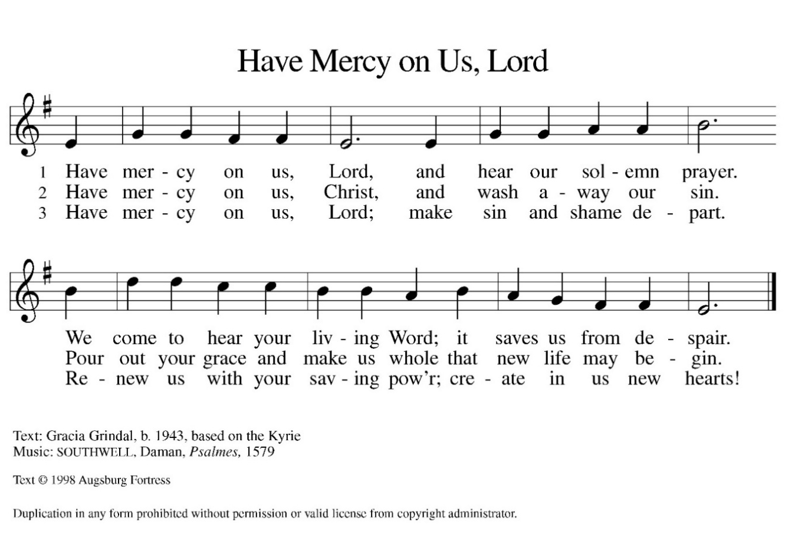

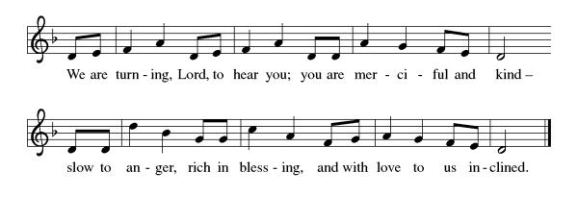
Gospel Acclamation

P: The Holy Gospel according to Matthew 27:11-54
C: Glory to you O Lord.

Gospel: Matthew 27:11-54
In fulfillment of scripture and obedience to God’s will, Jesus goes to the cross so that a new covenant in his blood may bring forgiveness of sins. Even the soldiers who crucify him recognize him to be the Son of God.
¹¹ Now Jesus stood before the governor, and the governor asked him, “Are you the king of the Jews?” Jesus said, “You say so.” ¹² But when he was accused by the chief priests and elders, he did not answer. ¹³ Then Pilate said to him, “Do you not hear how many accusations they make against you?” ¹⁴ But he gave him no answer, not even to a single charge, so that the governor was greatly amazed.
¹⁵ Now at the festival the governor was accustomed to release a prisoner for the crowd, anyone whom they wanted. ¹⁶ At that time they had a notorious prisoner called Jesus Barabbas. ¹⁷ So after they had gathered, Pilate said to them, “Whom do you want me to release for you, Jesus Barabbas or Jesus who is called the Messiah?” ¹⁸ For he realized that it was out of jealousy that they had handed him over. ¹⁹ While he was sitting on the judgment seat, his wife sent word to him, “Have nothing to do with that innocent man, for today I have suffered a great deal because of a dream about him.” ²⁰ Now the chief priests and the elders persuaded the crowds to ask for Barabbas and to have Jesus killed. ²¹ The governor again said to them, “Which of the two do you want me to release for you?” And they said, “Barabbas.” ²² Pilate said to them, “Then what should I do with Jesus who is called the Messiah?” All of them said, “Let him be crucified!” ²³ Then he asked, “Why, what evil has he done?” But they shouted all the more, “Let him be crucified!”
²⁴ So when Pilate saw that he could do nothing but rather that a riot was beginning, he took some water and washed his hands before the crowd, saying, “I am innocent of this man’s blood; see to it yourselves.” ²⁵ Then the people as a whole answered, “His blood be on us and on our children!” ²⁶ So he released Barabbas for them, and after flogging Jesus he handed him over to be crucified.
²⁷ Then the soldiers of the governor took Jesus into the governor’s headquarters, and they gathered the whole cohort around him. ²⁸ They stripped him and put a scarlet robe on him, ²⁹ and after twisting some thorns into a crown they put it on his head. They put a reed in his right hand and knelt before him and mocked him, saying, “Hail, King of the Jews!” ³⁰ They spat on him and took the reed and struck him on the head. ³¹ After mocking him, they stripped him of the robe and put his own clothes on him. Then they led him away to crucify him.
³² As they went out, they came upon a man from Cyrene named Simon; they compelled this man to carry his cross. ³³ And when they came to a place called Golgotha (which means Place of a Skull), ³⁴ they offered him wine to drink, mixed with gall, but when he tasted it, he would not drink it. ³⁵ And when they had crucified him, they divided his clothes among themselves by casting lots; ³⁶ then they sat down there and kept watch over him. ³⁷ Over his head they put the charge against him, which read, “This is Jesus, the King of the Jews.”
³⁸ Then two rebels were crucified with him, one on his right and one on his left. ³⁹ Those who passed by derided him, shaking their heads ⁴⁰ and saying, “You who would destroy the temple and build it in three days, save yourself! If you are the Son of God, come down from the cross.” ⁴¹ In the same way the chief priests also, along with the scribes and elders, were mocking him, saying, ⁴² “He saved others; he cannot save himself. He is the King of Israel; let him come down from the cross now, and we will believe in him. ⁴³ He trusts in God; let God deliver him now, if he wants to, for he said, ‘I am God’s Son.’ ” ⁴⁴ The rebels who were crucified with him also taunted him in the same way.
⁴⁵ From noon on, darkness came over the whole land until three in the afternoon. ⁴⁶ And about three o’clock Jesus cried with a loud voice, “Eli, Eli, lema sabachthani?” that is, “My God, my God, why have you forsaken me?” ⁴⁷ When some of the bystanders heard it, they said, “This man is calling for Elijah.” ⁴⁸ At once one of them ran and got a sponge, filled it with sour wine, put it on a stick, and gave it to him to drink. ⁴⁹ But the others said, “Wait, let us see whether Elijah will come to save him.” ⁵⁰ Then Jesus cried again with a loud voice and breathed his last. ⁵¹ At that moment the curtain of the temple was torn in two, from top to bottom. The earth shook, and the rocks were split. ⁵² The tombs also were opened, and many bodies of the saints who had fallen asleep were raised. ⁵³ After his resurrection they came out of the tombs and entered the holy city and appeared to many. ⁵⁴ Now when the centurion and those with him, who were keeping watch over Jesus, saw the earthquake and what took place, they were terrified and said, “Truly this man was God’s Son!”

P: The Gospel of Our Lord!
C: Praise to You O Christ!
Sermon by Bob

Hymn of the day: There in God's Garden ELW 342
1 There in God's garden stands the Tree of Wisdom,
whose leaves hold forth the healing of the nations:
Tree of all knowledge, Tree of all compassion,
Tree of all beauty.
2 Its name is Jesus, name that says, "Our Savior!"
There on its branches see the scars of suff'ring;
see where the tendrils of our human
selfhood feed on its lifeblood.
3 Thorns not its own are tangled in its foliage;
our greed has starved it, our despite has choked it.
Yet, look! it lives! its grief has not destroyed
It nor fire consumed it.
4 See how its branches reach to us in welcome;
hear what the Voice says, "Come to me, ye weary!
Give me your sickness, give me all your
sorrow, I will give blessing."
5 This is my ending, this my resurrection;
into your hands, Lord, I commit my spirit.
This have I searched for; now I can possess it.
This ground is holy.
6 All heav'n is singing, "Thanks to Christ whose passion
offers in mercy healing, strength, and pardon.
Peoples and nations, take it, take it freely!"
Amen! My Master!
Text: Király Imre von Pécselyi, c. 1590-c. 1641; tr. Erik Routley, 1917-1982
Text © 1976 Hinshaw Music, Inc.
Duplication in any form prohibited without permission or valid license from copyright administrator.

The Apostle’s Creed
I believe in God, the Father almighty,
creator of heaven and earth.
I believe in Jesus Christ, God’s only Son, our Lord,
who was conceived by the Holy Spirit,
born of the virgin Mary,
suffered under Pontius Pilate,
was crucified, died, and was buried;
he descended to the dead.*
On the third day he rose again;
he ascended into heaven,
he is seated at the right hand of the Father,
and he will come to judge the living and the dead.
I believe in the Holy Spirit,
the holy catholic church,
the communion of saints,
the forgiveness of sins,
the resurrection of the body,
and the life everlasting. Amen.
From sundaysandseasons.com.
Copyright © 2026 Augsburg Fortress. All rights reserved.

Prayers of the People
Reconciled by God’s mercy and sustained by God’s presence, let us pray for the world and its needs.
A brief silence.
O God, you announce words of grace and truth. Give wisdom to all preachers in your church both globally and locally Open our hearts to encounter the infinite life you offer in Jesus. Hear us, O God.
Your mercy is great.
You hold the whole universe. Gather sun and moon, clouds and stars, land and sea, and plants and animals around the cross, so that all creation bears witness to your saving love. Hear us, O God.
Your mercy is great.
Your power is sure. Destroy inequity and division in every place, and build your beloved community among all people. Guide judges, attorneys, and juries so that they act with justice and fairness. Hear us, O God.
Your mercy is great.
Your heart breaks open at our pain. Send healing and vindication to all who, like Jesus, know the sting of betrayal, denial, abuse, or false accusations. Be with those experiencing pain or loss this day. Hear us, O God.
Your mercy is great.
Your ways show compassion. Let this same mind be in us as we enter Holy Week. Bless those here who will lead worship and tell the story of Jesus’ death and resurrection. Hear us, O God.
Your mercy is great.
O God, your embrace is eternal. Praise and thanks to you for all the faithful departed who rest in your mercy. Deliver us all from death’s power and raise us to life in you. Hear us, O God.
Your mercy is great.
Receive our prayers, O God, through Jesus Christ, our strength and salvation.
Amen.

P: May the peace of our Lord Jesus Christ be with you all.
C: And also with you.
P: Let us now share this peace.

Offering is Brought to the Altar

Offertory Prayer
O God, maker of heaven and earth,
your steadfast love embraces all creation.
You send rain and sunshine to nourish the earth
and bring forth its bounty.
Through these gifts of bread and wine,
draw us into the death and life of your Son,
who calls us to bear witness to his saving work.
We ask this in Jesus’ name. Amen.
P: The Lord be with you.
C: And also with you.

P: Lift up your hearts.
C: We Lift them to the Lord.

P: Let us give thanks to the Lord our God.
C: It is right to give our thanks and praise.

Preface
(Words spoken by Bob)
We praise your name and join their unending hymn:

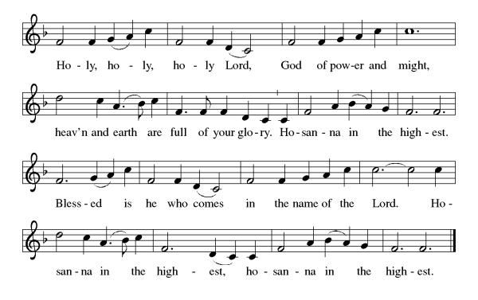
Eucharistic Prayer
(Words of Institution)

For as often as we eat of this bread and drink from this cup we proclaim the Lord’s death until He comes.
Christ has died
Christ is risen.
Christ will come again.
Remembering, therefore, his salutary command,
his life-giving passion and death, his glorious resurrection and ascension,
and the promise of his coming again,
we give thanks to you, O Lord God Almighty,
not as we ought but as we are able;
we ask you mercifully to accept our praise and thanksgiving and with your Word and Holy Spirit to bless us, your servants, and these your own gifts of bread and wine, so that we and all who share in the body and blood of Christ may be filled with heavenly blessing and grace,
and, receiving the forgiveness of sin,
may be formed to live as your holy people
and be given our inheritance with all your saints.
To you, O God, Father, Son, and Holy Spirit,
be all honor and glory in your holy church, now and forever. Amen.
Gathered into one, by the Holy Spirit let us listen to the words that Jesus taught us.

The Lord’s Prayer
Our Father, who art in heaven, hallowed be thy name, thy kingdom come, thy will be done, on earth as it is in heaven. Give us this day our daily bread; and forgive us our trespasses, as we forgive those who trespass against us; and lead us not into temptation but deliver us from evil. For thine is the kingdom, and the power, and the glory, forever and ever. Amen.

Invitation to Communion
P: This is the Lamb of God who takes away the sins of the world. Happy are those called to His supper.
C: Amen
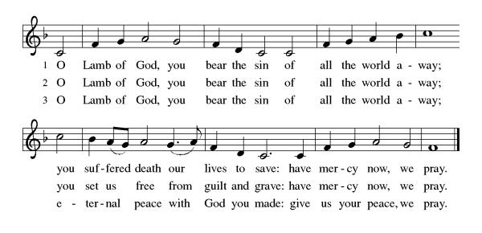
All may come.
Communion Anthem: Ride on, Ride on in Majesty ELW 346
P: Martin Luther's Post Communion Prayer German Mass 1526
We give You thanks, Almighty God, that You have refreshed us through this holy gift. We ask that, in Your mercy, You would strengthen us through it in faith toward You and in fervent love toward one another, through Jesus Christ, Your Son, our Lord.
C: Amen

Prayer after Communion
God of our salvation,
we give you thanks for this meal that restores our souls,
reconciles us to you, and strengthens us for the journey.
Through the body and blood of your Son,
may we become Christ’s body in the world,
bearing witness to your love for all creation,
through Jesus Christ, our Savior and Lord.
Amen.

Blessing
Receive the blessing of the holy Trinity:
God, who calls all things into existence,
Jesus Christ, who redeems us,
And the Holy Spirit, whose breath sustains creation,
☩ bless you now and always.
Amen.
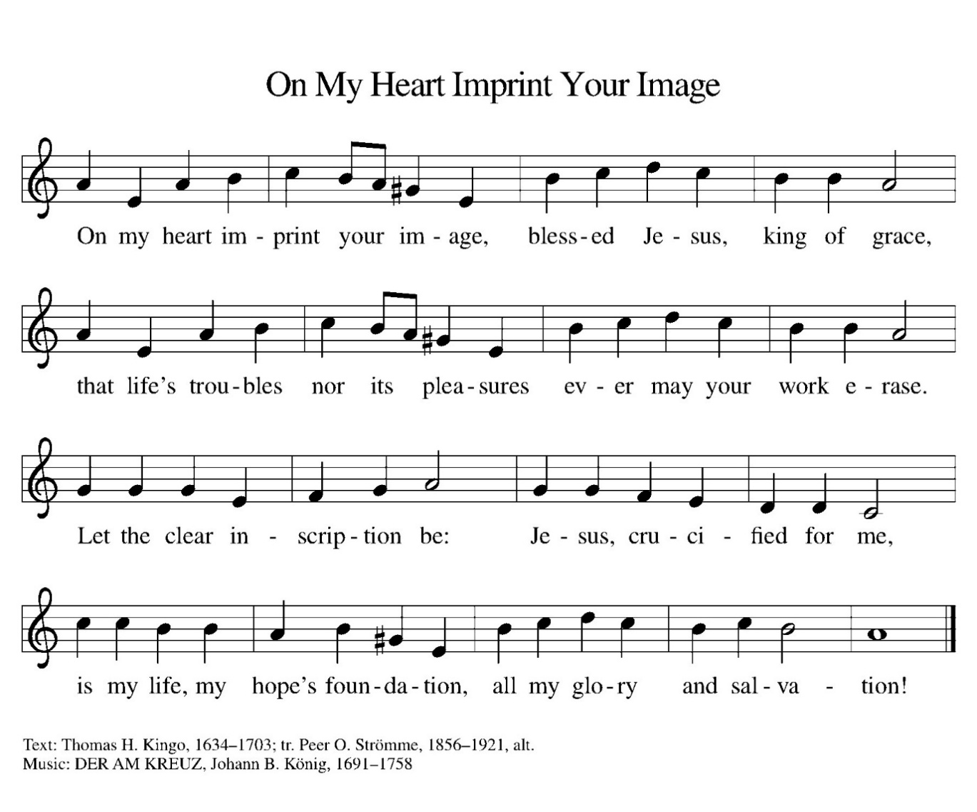
Sending Hymn: ELW 811

Dismissal
P: Everlasting God,
As we leave this gathering on this Palm Sunday, we remember the shouts of “Hosanna” that welcomed our Savior into Jerusalem. We know that the road ahead leads to the cross, yet also to the empty tomb.
Send us out with courage to follow Jesus in both joy and sacrifice this Holy Week.
May the branches we waved in celebration become symbols of our commitment to serve, to love, and to walk in Your ways.
Go before us into the week ahead—into our homes, our workplaces, and our communities—so that our words and actions may bear witness to Your kingdom.
And now, may the peace of Christ guard our hearts,
the love of God sustain our spirits,
and the power of the Holy Spirit guide our steps,
today and always.
C: Thanks be to God.
Postlude
Unless otherwise noted, materials used in this bulletin are:
From Sundays and Seasons.com. Copyright 2015 Augsburg Fortress. All rights reserved. Reprinted by permission under Augsburg Fortress Liturgies Annual License #SAS028635. Music is reprinted under OneLicense.Net #A712074 and/or Augsburg Fortress #SBL12176H. Scripture, unless otherwise noted, is from the New Revised Standard Version Bible, Copyright © 1989, Division of Christian Education of the National Council of the Churches of Christ in the United States of America. Used by permission. All rights reserved.

St. Timothy Evangelical Lutheran Church
1070 N. Suncoast Blvd.
Crystal River, FL 34429
Telephone number (Office): 352-795-5325
Office email address: crsttimothy@tampabay.rr.com

St Timothy Worship Team
S.A.M. Robert F. Bonomo
Lay Minister, Frank Hofstetter
Director of Music, Sally Hennessey
Saturday Pianist, Bill Robinson
Announcements for March 28th and 29th

ATTENDANCE
Wednesday, March 18th (Lent SS) 28
Saturday, March 21st, 4pm 27
Sunday, March 22nd, 9am 50
107

Serving our Lord this weekend:
Saturday, March 28th
Communion Assistant: Jean Fowler

Passion Sunday, March 29th
Readers:
Narrator, Patti Cyr
High Priest, Ed Fialkowski
Jesus, Steve Brisson
Servant Girl, Sarah Brisson
Peter, Lay Minister Frank Hofstetter
Pilate, S.A.M. Bob Bonomo
Judas, S.A.M. Bob Bonomo
Bystander, Jackie Gregg
Centurion, John Seasholtz

This Week at St. Timothy's
Monday, March 30th
Tuesday, March 31st
Wednesday, April 1st 11am – Citrus Blessings, 1pm – Card Makers
Maundy Thursday, April 2nd NO BIBLE STUDY, 11am – Miniatures, 4pm - Worship
Good Friday, April 3rd 12pm - Worship
Saturday, April 4th NO SATURDAY WORSHIP
Easter Sunday, April 5th 8am Worship, 9-10:30 Breakfast, 11amWorship

