***St. Timothy Lutheran Church***

***Sunday, July 27th***

"Equip people to grow as Disciples faithfully serving our community"

We are glad to have you worship with us. All are welcome at communion. If you need gluten-free – please let us know when you go up for communion. If you have any questions – just ask the Welcomer at the back of the sanctuary.

*Please note** if you use a pew envelope for your offering – please write your name on the envelope so that the financial secretaries can post it as a gift from you. Thank You!*

**St Timothy Worship Planning Team**

S.A.M. Bob Bonomo

Deacon, Frank Hofstetter

The Altar Flowers are given this week by Pr. Dennis and Linda Koch, to the glory of God!

**This Week at St. Timothy's**

Monday, July 28th

Tuesday, July 29th

Wednesday, July 30th

Thursday, July 31st 9:30 am – Prayer Group, 11:00 am – Miniatures

Friday, August 1st

Saturday, August 2nd 4 pm – Worship

Sunday, August 3rd 9 am – Worship, 10:15-10:45 – Drive-Up Communion, 10:30 - Sunday School, Coffee Fellowship

**Welcome and Congregational News**

***Preparation Hymn: Jesus, We Are Gathered ELW 529***

**Confession and Forgiveness**

V- In the name of the Father, and of the Son, and of the Holy Spirit.

**C – Amen**

Let us confess our sins in front of God and one another.

**C-Merciful God,**

**you free us to love others, but we neglect our neighbors and follow our own way. You lead us by the Spirit of joy and peace, but we turn away from the abundant life you offer. You surround us with patience, kindness, and generosity, but we grow weary in doing what is right. In your mercy, forgive us. Do not give up on us. Heal us, break our bonds, and show us the path of life. Amen.**

V -You belong to Christ Jesus

and you are God’s children through faith.

In the cross of ☩ Christ,

and through the power of the Holy Spirit,

your sins are forgiven.

Clothed with Christ, you are a new creation.

**Amen.**

### 

***Gathering Hymn: Come and Fill Our Hearts ELW 528***

Come and fill our hearts with your peace.

You alone, O Lord, are holy.

Come and fill our hearts with your peace*.*

Alleluia!

V – The Lord be with you.

**C – And also with you.** *(be seated)*

### Prayer of the Day

**Almighty and ever-living God, you are always more ready to hear than we are to pray, and you gladly give more than we either desire or deserve. Pour upon us your abundant mercy. Forgive us those things that weigh on our conscience, and give us those good things that come only through your Son, Jesus Christ, our Savior and Lord.**

**Amen.**

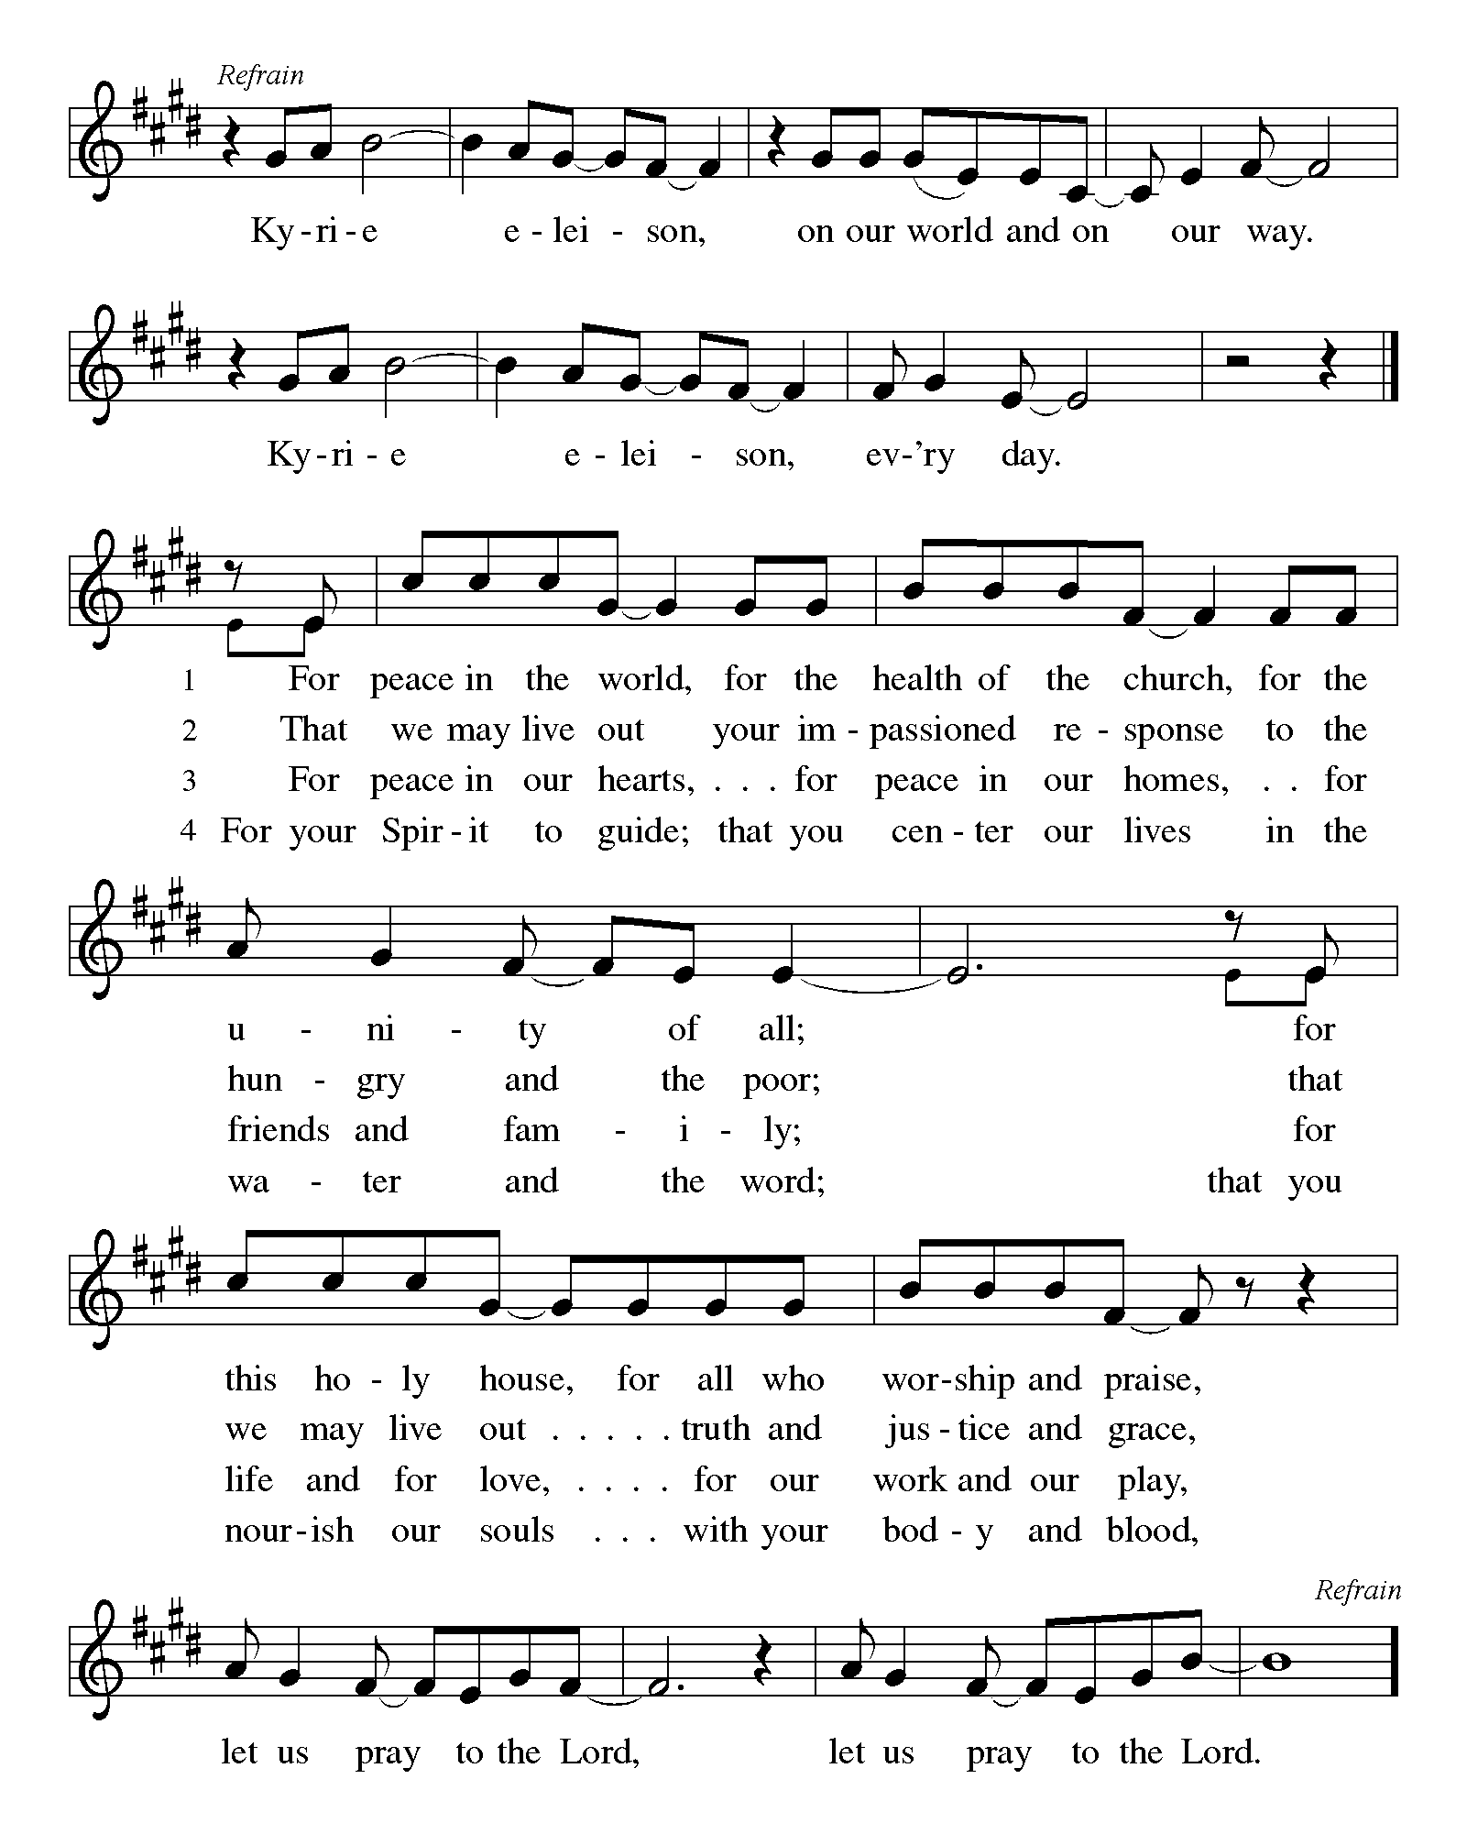

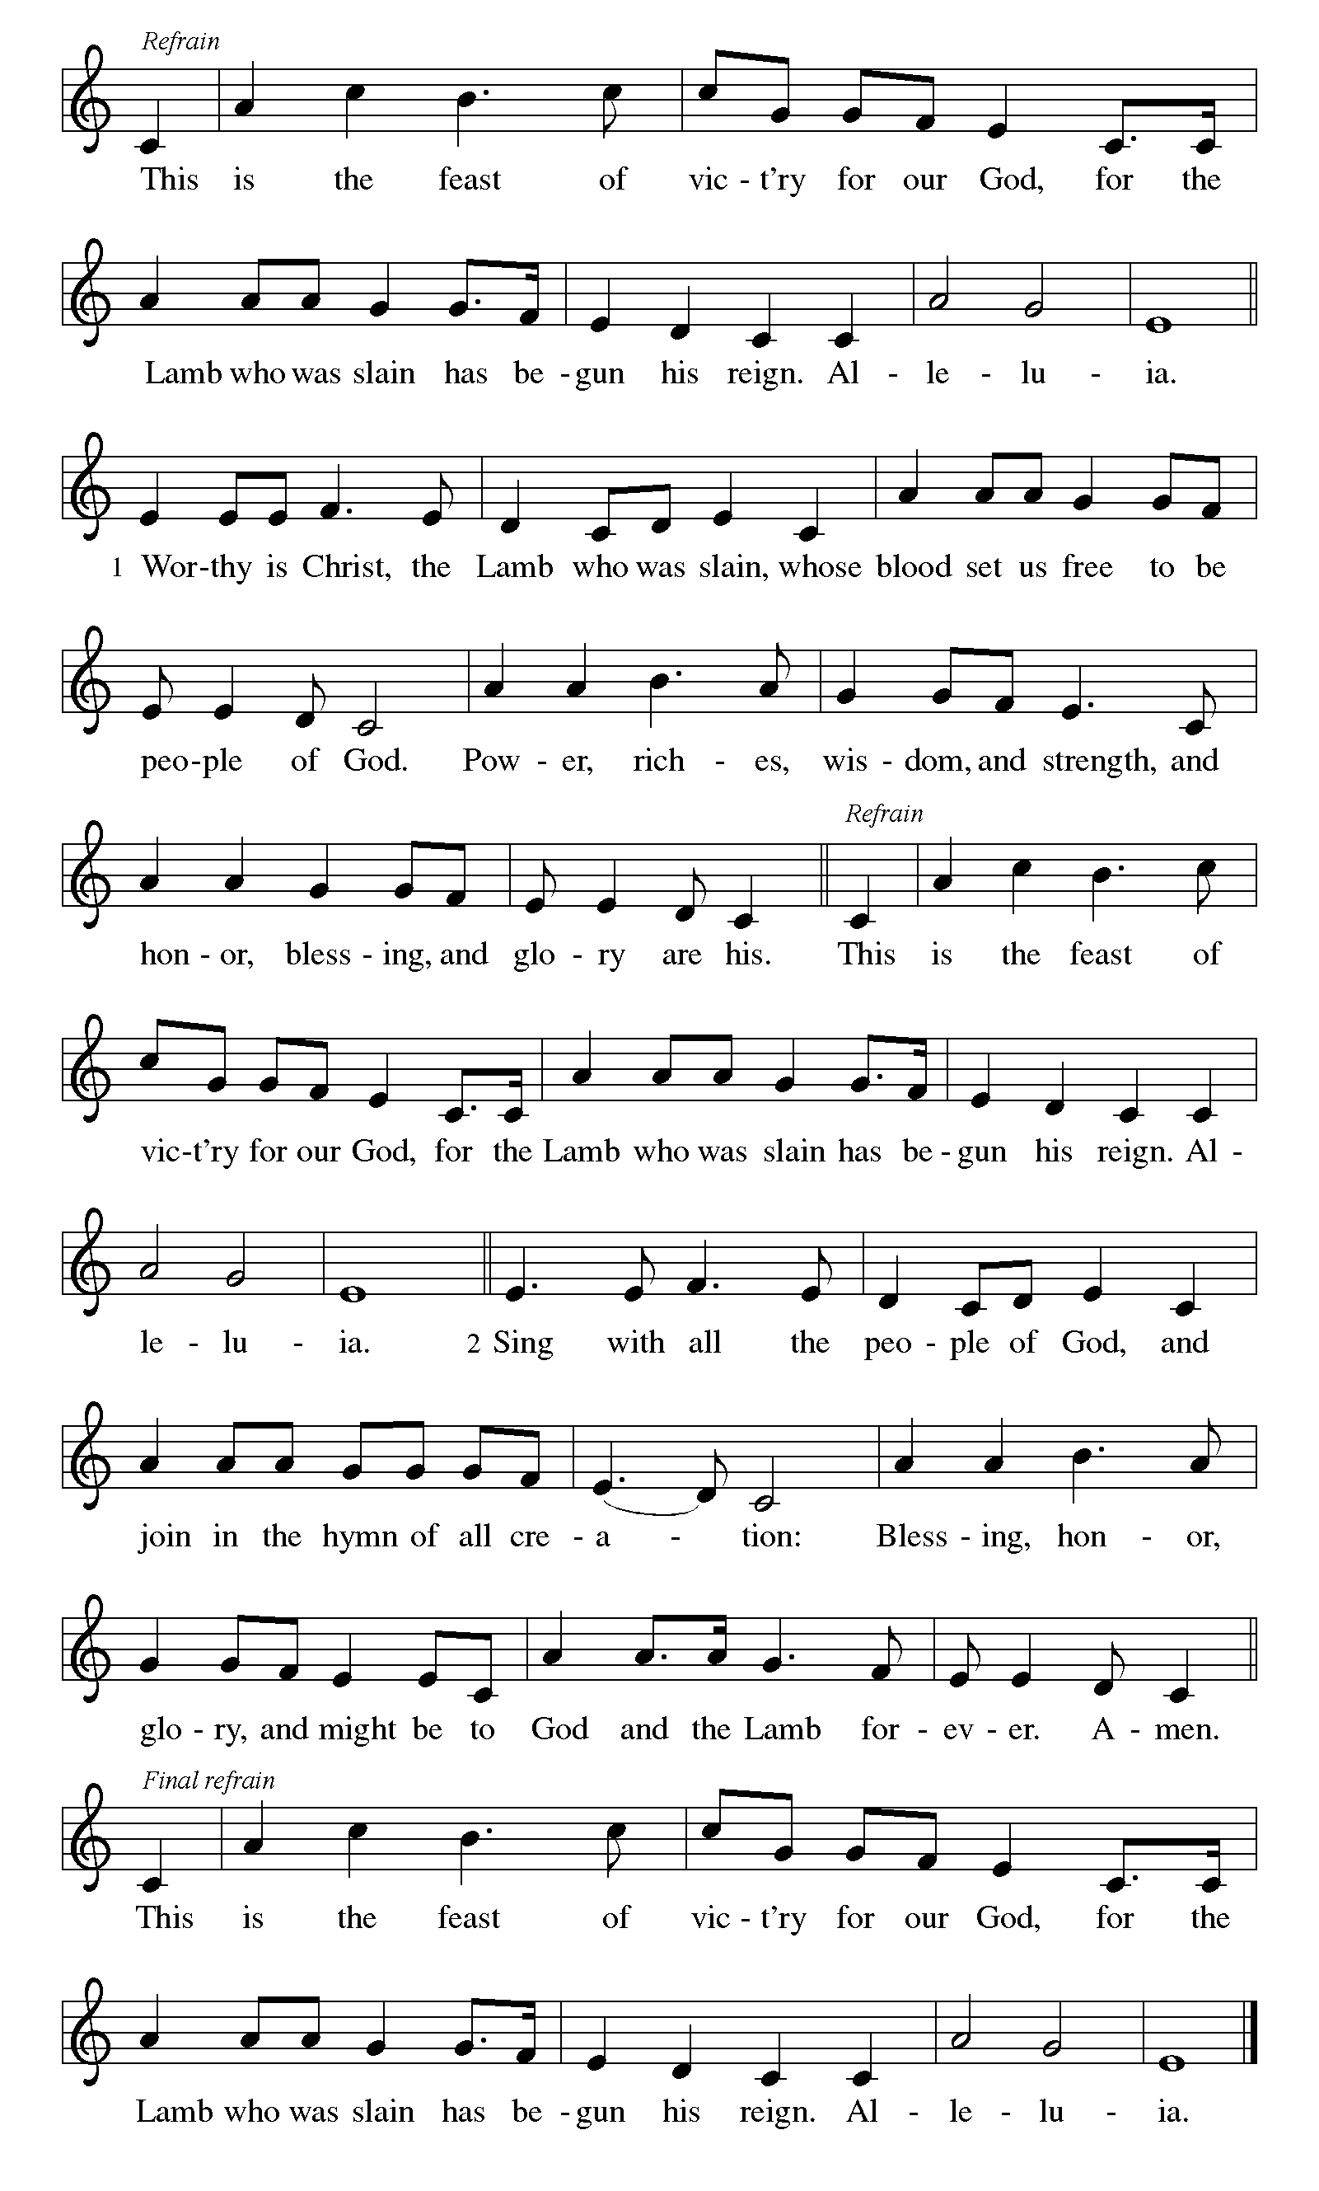

### First Lesson: Genesis 18:20-32

In today’s reading, Abraham undertakes the role of a mediator between God and sinful humanity. Appealing to God’s justice, Abraham boldly asks for mercy for the city of Sodom for the sake of the few righteous people there, including Abraham’s nephew, Lot.

20 Then the Lord said, “How great is the outcry against Sodom and Gomorrah and how very grave their sin! 21 I must go down and see whether they have done altogether according to the outcry that has come to me, and if not, I will know.”  
  22 So the men turned from there and went toward Sodom, while Abraham remained standing before the Lord. 23 Then Abraham came near and said, “Will you indeed sweep away the righteous with the wicked? 24 Suppose there are fifty righteous within the city; will you then sweep away the place and not forgive it for the fifty righteous who are in it? 25 Far be it from you to do such a thing, to slay the righteous with the wicked, so that the righteous fare as the wicked! Far be that from you! Shall not the Judge of all the earth do what is just?” 26 And the Lord said, “If I find at Sodom fifty righteous in the city, I will forgive the whole place for their sake.” 27 Abraham answered, “Let me take it upon myself to speak to my lord, I who am but dust and ashes. 28 Suppose five of the fifty righteous are lacking? Will you destroy the whole city for lack of five?” And he said, “I will not destroy it if I find forty-five there.” 29 Again he spoke to him, “Suppose forty are found there.” He answered, “For the sake of forty I will not do it.” 30 Then he said, “Oh, do not let my lord be angry if I speak. Suppose thirty are found there.” He answered, “I will not do it, if I find thirty there.” 31 He said, “Let me take it upon myself to speak to my lord. Suppose twenty are found there.” He answered, “For the sake of twenty I will not destroy it.” 32 Then he said, “Oh, do not let my lord be angry if I speak just once more. Suppose ten are found there.” He answered, “For the sake of ten I will not destroy it.”

### A – Word of God!

### C – Words of Life!

### Psalm 138

1 I will give thanks to you, O Lord, with my whole heart;  
  before the gods I will sing your praise.  
 2 **I will bow down toward your holy temple and praise your name, because of your steadfast love and faithfulness;**  
  **for you have glorified your name and your word above all things.**   
 3 When I called, you answered me;  
  you increased my strength within me.  
 4 **All the rulers of the earth will praise you, O Lord,**  
  **when they have heard the words of your mouth.**  
 5 They will sing of the ways of the Lord,  
  that great is the glory of the Lord.  
 6 **The Lord is high, yet cares for the lowly,**  
  **perceiving the haughty from afar.**   
 7 Though I walk in the midst of trouble, you keep me safe;  
  you stretch forth your hand against the fury of my enemies; your right **|** hand shall save me.  
 8 **You will make good your purpose for me;**  
  **O Lord, your steadfast love endures forever; do not abandon the works of your hands.**

### Second Lesson: Colossians 2:6-15 [16-19]

The writer of this letter warns the congregation in Colossae about “the empty lure” of philosophies and traditions that compromise faith. Through the gift of faith, the church is mystically connected with Christ in his death and resurrection which is enacted in baptism.

6 As you therefore have received Christ Jesus the Lord, continue to walk in him, 7 rooted and built up in him and established in the faith, just as you were taught, abounding in thanksgiving.  
  
  8 Watch out that no one takes you captive through philosophy and empty deceit, according to human tradition, according to the elemental principles of the world, and not according to Christ. 9 For in him the whole fullness of deity dwells bodily, 10 and you have come to fullness in him, who is the head of every ruler and authority. 11 In him also you were circumcised with a spiritual circumcision, by the removal of the body of the flesh in the circumcision of Christ; 12 when you were buried with him in baptism, you were also raised with him through faith in the power of God, who raised him from the dead. 13 And when you were dead in trespasses and the uncircumcision of your flesh, God made you alive together with him, when he forgave us all our trespasses, 14 erasing the record that stood against us with its legal demands. He set this aside, nailing it to the cross. 15 He disarmed the rulers and authorities and made a public example of them, triumphing over them in it. [  
  16 Therefore, do not let anyone condemn you in matters of food or drink or of observing festivals, new moons, or Sabbaths. 17 These are only a shadow of what is to come, but the body belongs to Christ. 18 Do not let anyone disqualify you, insisting on self-abasement and worship of angels, initiatory visions, puffed up without cause by a human way of thinking, 19 and not holding fast to the head, from whom the whole body, nourished and held together by its ligaments and tendons, grows with a growth that is from God.]

### A – Word of God!

**C – Words of Life!**

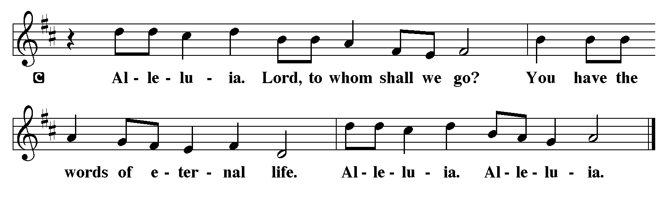

V- The Holy Gospel according to **Luke, the 10th Chapter**

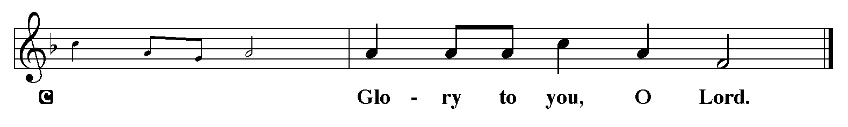

### Gospel: Luke 11:1-13

In teaching his disciples this prayer, Jesus also reminds them to focus on God’s coming reign, God’s mercy, and the strengthening of the community. Jesus encourages his disciples to childlike trust and persistence in prayer.

1 [Jesus] was praying in a certain place, and after he had finished, one of his disciples said to him, “Lord, teach us to pray, as John taught his disciples.”2 So he said to them, “When you pray, say:   
 Father, may your name be revered as holy.  
  May your kingdom come.  
  3 Give us each day our daily bread.  
  4 And forgive us our sins,  
   for we ourselves forgive everyone indebted to us.  
  And do not bring us to the time of trial.”  
  
  5 And he said to them, “Suppose one of you has a friend, and you go to him at midnight and say to him, ‘Friend, lend me three loaves of bread, 6 for a friend of mine has arrived, and I have nothing to set before him.’ 7 And he answers from within, ‘Do not bother me; the door has already been locked, and my children are with me in bed; I cannot get up and give you anything.’ 8 I tell you, even though he will not get up and give him anything out of friendship, at least because of his persistence he will get up and give him whatever he needs.  
  9 “So I say to you, Ask, and it will be given to you; search, and you will find; knock, and the door will be opened for you. 10 For everyone who asks receives, and everyone who searches finds, and for everyone who knocks, the door will be opened. 11 Is there anyone among you who, if your child asked for a fish, would give a snake instead of a fish? 12 Or if the child asked for an egg, would give a scorpion? 13 If you, then, who are evil, know how to give good gifts to your children, how much more will the heavenly Father give the Holy Spirit to those who ask him!”

V - The Gospel of the Lord.

**C - Praise to you, O Christ.** *(Sit)*

## Sermon by S.A.M. Bob

### *****Hymn of the Day:******Lord, Teach Us How to Pray Aright ELW 745*

1 Lord, teach us how to pray aright, with rev'rence and with fear.

Though dust and ashes in your sight, we may, we must draw near.

2 We perish if we cease from prayer; oh, grant us pow'r to pray.

And when to meet you we prepare, Lord, meet us on our way.

3 Give deep humility; the sense of godly sorrow give;

a strong desire, with confidence, to hear your voice and live;

4 Faith in the only sacrifice that can for sin atone;

to cast our hopes, to fix our eyes on Christ, on Christ alone.

5 Give these, and then your will be done; thus strengthened with all might,

we, through your Spirit and your Son, shall pray, and pray aright.

**The** **Apostles’ Creed**

**I believe in God, the Father almighty,**

**creator of heaven and earth.**

**I believe in Jesus Christ, God’s only Son, our Lord,**

**who was conceived by the Holy Spirit,**

**born of the virgin Mary,**

**suffered under Pontius Pilate,**

**was crucified, died, and was buried;**

**he descended to the dead.**

**On the third day he rose again;**

**he ascended into heaven,**

**he is seated at the right hand of the Father,**

**and he will come to judge the living and the dead.**

**I believe in the Holy Spirit,**

**the holy catholic church,**

**the communion of saints,**

**the forgiveness of sins,**

**the resurrection of the body,**

**and the life everlasting. Amen.**

**Lord, listen to your children praying,**

**Lord, send your Spirit in this place;**

**Lord, listen to your children praying,**

**send us love, send us pow'r, send us grace.**

**Prayers of The People**

Our Father who art in Heaven, you made all things beautiful. Your love for us is steadfast. Create in us and all people one voice as we pray for the needs of this world.

*A brief silence.*

Loving God, create in Your church a desire for union with You in prayer. Raise up leaders to teach Christ’s devotion to prayer and model Christ’s way of prayer, until all people experience prayerful intimacy with you.

God of our Hope,

**Help us to pray.**

Reveal to humanity the sacredness of all creation. With the breath of your Spirit, realign the balances of nature. Grant persistence in prayer and action for the sake of the earth, our common home.

God of our Hope,

**Help us to pray.**

Enlighten and teach leaders to sing of Your ways, caring for the lowly and having zero preference for the powerful. Give them Your vision of the Beatitudes so that the heart of every person will seek Your will on earth as in heaven.

God of our Hope,

**Help us to pray**

Lord, so many of us need You when we cry for Your help. Hear the prayers of your servants especially those who are suffering in poverty, the children who are hungry and those children living in the woods, those who live in fear, those with health issues, those in depression, those that are anxious, those who grieve a loss. To all whose prayers are cries for help, give your good gifts, and satisfy their deepest needs. (ESPECIALLY). Gather them to your constant, loving presence, that they may rest in the confidence of life with You.

God of our Hope,

**Help us to pray.**

Center the ministries of this assembly on prayer and service. Guide our relationships in the wider community, being ready to assist those who seek help. Strengthen feeding, clothing, and housing ministries and community partnerships.

God of our Hope,

**Help us to pray**

We give thanks for all who have gone before us. May we trust your steadfast love and continue in hope until we are united with all your saints.

God of our Hope,

**Help us to pray**

We love you Lord, we believe in You, we have hope in You and we place our prayers at Your altar, in the name of Jesus Christ.

**Amen.**

**V: May the peace of our Lord Jesus Christ be with you all.**

**C: And also with you.**

**V: Let us now share this peace.**

**The Offering is Brought to the Altar**

**Offering Prayer**

**We lift our voices, we lift our hands, we lift our lives up to you; we are an Offering. Lord, use our voices, Lord, use our hands, Lord, use our lives, they are yours: we are an offering. All that we have, all that we are, all that we hope to be, we give to you, we give to you. We lift our voices, we lift our hands, we lift our lives up to you; we are an offering, we are an offering.**

V: The Lord be with you.

**C: And also with you.**

V: We lift up your hearts.

**C: We lift them to the Lord.**

V: Let us give thanks to the Lord our God.

**C: It is right to give our thanks and praise.**

**Preface**

It is indeed right, our duty and our joy,

that we should at all times and in all places

give thanks and praise to you, almighty and merciful God,

through our Savior Jesus Christ;

who on this day overcame death and the grave,

and by his glorious resurrection opened to us the way of everlasting life.

And so, with all the choirs of angels,

with the church on earth and the hosts of heaven,

we praise your name and join their unending hymn:

**Eucharist Prayer**

Blessed are you, O God of the universe. Your mercy is everlasting, and your faithfulness endures from age to age.

Praise to you for creating the heavens and the earth. Praise to you for saving the earth from the waters of the flood. Praise to you for bringing the Israelites safely through the sea. Praise to you for leading your people through the wilderness to the land of milk and honey. Praise to you for the death and resurrection of Christ. Praise to you for your Spirit poured out on all nations.

In the night he was betrayed, our Lord Jesus took bread and gave thanks; broke it, and gave it to his disciples saying: Take and eat; this is my body given for you. Do this for the remembrance of me.

After supper he took the cup, gave thanks and gave it for all to drink saying: This cup is the new covenant in my blood, shed for you and for all people for the forgiveness of sin, Do this for the remembrance of me.

For as often as we eat of this bread and drink from this cup we proclaim the Lord’s death until He comes.

**Christ has died**

**Christ is risen.**

**Christ will come again.**

Gathered into one, by the Holy Spirit let us pray as Jesus taught us.

**The Lord’s Prayer**

**Our Father, who art in heaven, hallowed be thy name, thy kingdom come, thy will be done, on earth as it is in heaven. Give us this day our daily bread; and forgive us our trespasses, as we forgive those who trespass against us; and lead us not into temptation but deliver us from evil. For thine is the kingdom, and the power, and the glory, forever and ever. Amen.**

**Invitation to Communion**

V: Come to this Table where God really does come to us!

**C: Thank You Jesus!**

**♪Come to the Table ELW 481♪**

Come to the table of mercy, prepared with the wine and the bread. All who are hungry and thirsty, come, and your souls will be fed.

Come at the Lord's invitation; receive from his nail-scarred hand. Eat of the bread of salvation; drink of the blood of the Lamb.

**Distribution - Please come forward to receive**

***Communion Anthem: One Bread, One Body W&P 111***

V – Now may the body and blood of our Lord and Savior, Jesus Christ strengthen you and keep you in His grace … Jesus Loves You!

**C – Thank You Jesus!**

**Communion Prayer**

**Life-giving God, through this meal you have bandaged our wounds and fed us with your mercy. Now send us forth to live for others, both friend and stranger, that all may come to know your love. This we pray in the name of Jesus. Amen.**

**Blessing**

V: God Almighty send you light and truth to keep you all the days of your life. The hand of God protect you; the holy angels accompany you; and the blessing of almighty God, the Father, the ☩ Son, and the Holy Spirit, be with you now and forever.

**C: Amen.**

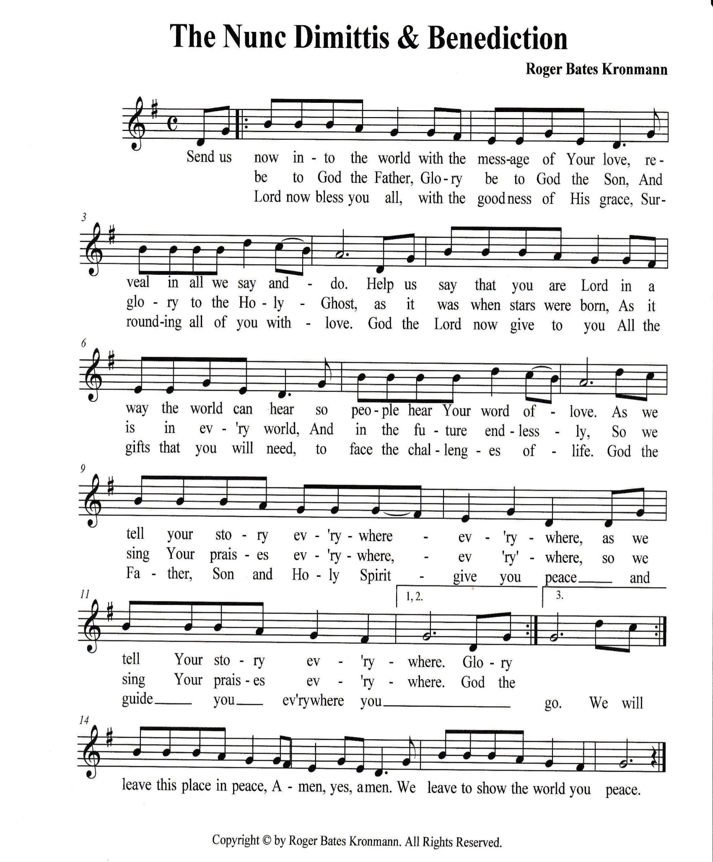

### *Sending Hymn: What A Friend We Have in Jesus ELW 742*

1 What a friend we have in Jesus, all our sins and griefs to bear!

What a privilege to carry ev'rything to God in prayer!

Oh, what peace we often forfeit; oh, what needless pain we bear--

all because we do not carry ev'rything to God in prayer!

2 Have we trials and temptations? Is there trouble anywhere?

We should never be discouraged-- take it to the Lord in prayer.

Can we find a friend so faithful who will all our sorrows share?

Jesus knows our ev'ry weakness-- take it to the Lord in prayer.

3 Are we weak and heavy-laden, cumbered with a load of care?

Precious Savior, still our refuge-- take it to the Lord in prayer.

Do your friends despise, forsake you? Take it to the Lord in prayer.

In his arms he'll take and shield you; you will find a solace there.

**Dismissal**

V: Go in peace. Proclaim the Good News!

**C: By the Grace of God we will – Alleluia!**

***Postlude:******This Is the Day W&P 141***

Unless otherwise noted, materials used in this bulletin are:

From Sundays and Seasons.com. Copyright 2015 Augsburg Fortress. All rights reserved. Reprinted by permission under Augsburg Fortress Liturgies Annual License #SAS028635. Music is reprinted under OneLicense.Net #A712074 and/or Augsburg Fortress #SBL12176H. Scripture, unless otherwise noted, is from the New Revised Standard Version Bible, Copyright © 1989, Division of Christian Education of the National Council of the Churches of Christ in the United States of America. Used by permission. All rights reserved.

**Announcements for July 26th and 27th**

**ATTENDANCE**

Saturday, July 19th , 4pm 24

Sunday, July 20th , 9am 42

Drive-Up Communion 5

71

**MID-YEAR GIVING STATEMENTS HAVE BEEN PRINTED AND PUT IN CHURCH MAILBOXES. IF YOU DIDN’T RECEIVE ONE, CONTACT RANDY.**

**A TIME FOR PRAYER**

JOIN US IN THE SANCTUARY FOR PRAYER TIME AT 2PM ON WEDNESDAYS IN AUGUST - 8/6, 8/13, 8/20, AND 8/27. Let us know you want to come. sign-up sheet on the kiosk in the narthex.

