St. Timothy Lutheran Church
4th Sunday of Advent



Today Isaiah prophesies that a young woman will bear a son and name him Emmanuel. The gospel is Matthew’s account of the annunciation and birth of the one named Emmanuel, God-with-us. During these final days of Advent we pray, “O come, O come, Emmanuel,” a beloved hymn based on the O Antiphons, ancient prayers appointed for the seven days preceding Christmas. On this final Sunday of Advent we prepare to celebrate the birth of the one born to save us from the power of sin and death.

St Timothy Worship Planning Team
S.A.M. Bob Bonomo
Deacon, Frank Hofstetter
Director of Music, Sally Hennessey
Saturday Pianist, Bill Robinson

Welcome and Sharing of Congregational News

Prelude

Confession and Forgiveness
Blessed be the holy Trinity, ☩ one God,
whose home is heaven and earth,
whose salvation is sure.
Amen.
Let us confess our sin in the presence of God
and of one another.
Silence is kept for reflection.
Long-expected God,
we confess that we look to ourselves
for the peace and security only you can provide.
We reach for swords and spears,
reluctant to release our grip on the ways of war.
We become impatient while waiting
and weary of keeping awake.
Free us from self-reliance,
and teach us to live in harmony with our neighbors.
Increase our trust in God’s timing,
and awaken us to your advent among us,
that we may abound in the hope you have promised.
Amen.
God judges us not as we deserve,
but according to God’s own righteousness.
☩ You are freed and forgiven,
saved by grace,
and ready to welcome the Savior.
Amen.
Greeting
S.A.M. Bob: The joy of our Lord Jesus Christ, the compassion of God, and the creative power of the Holy Spirit be with you all.
C: And also with you.

(Lighting of the Advent candle. Week 4)

Gathering Hymn: Come, Thou Long-Expected Jesus ELW 254

1 Come, thou long-expected Jesus,
born to set thy people free;
from our fears and sins release us;
let us find our rest in thee.
Israel's strength and consolation,
hope of all the earth thou art,
dear desire of ev'ry nation,
joy of ev'ry longing heart.

2 Born thy people to deliver,
born a child, and yet a king;
born to reign in us forever,
now thy gracious kingdom bring.
By thine own eternal Spirit
rule in all our hearts alone;
by thine all-sufficient merit
raise us to thy glorious throne.

Text: Charles Wesley, 1707-1788

S.A.M. Bob - The Lord be with you.
C – And also with you.

Prayer of the Day
Stir up your power, Lord Christ, and come. With your abundant grace and might, free us from the sin that hinders our faith, that eagerly we may receive your promises, for you live and reign with the Father and the Holy Spirit, one God, now and forever.
Amen.
Cantata begins
Christmas Carol Medley

S.A.M.Bob: The Holy Gospel according to Matthew, Chapter 1
(Bob reads Matthew 1:18-25)

Choir: and the Angels Sang
Reader 1
Choir: Soon and Very Soon
Reader 2
Choir: Jesus What a Wonderful Child

Hymn of the Day: Blessed Be the God of Israel ELW 250

1 Blessed be the God of Israel who comes to set us free
and raises up new hope for us: a Branch from David’s tree.
So have the prophets long declared that with a mighty arm
God would turn back our enemies and all who wish us harm.

2 With promised mercy will God still the covenant recall,
the oath once sworn to Abraham, from foes to save us all;
that we might worship without fear and offer lives of praise,
in holiness and righteousness to serve God all our days.

3 My child, as prophet of the Lord you will prepare the way,
to tell God’s people they are saved from sin’s eternal sway.
Then shall God’s mercy from on high shine forth and never cease
to drive away the gloom of death and lead us into peace.

Text: Carl P. Daw Jr., b. 1944, based on Luke 1:68-79
Text © 1989 Hope Publishing Company, Carol Stream, IL 60188. All rights reserved. Used by permission.

Apostles’ Creed
I believe in God, the Father almighty,
creator of heaven and earth.
I believe in Jesus Christ, God’s only Son, our Lord,
who was conceived by the Holy Spirit,
born of the virgin Mary,
suffered under Pontius Pilate,
was crucified, died, and was buried;
he descended to the dead.
On the third day he rose again;
he ascended into heaven,
he is seated at the right hand of the Father,
and he will come to judge the living and the dead.
I believe in the Holy Spirit,
the holy catholic church,
the communion of saints,
the forgiveness of sins,
the resurrection of the body,
and the life everlasting. Amen.

Prayers of the People
In our waiting and watching, we come to you in prayer, O God, trusting your promise to renew the church, the nations, and the whole creation.
A brief silence.
In the anticipation of these days, prepare our hearts for your arrival. Stir our spirits through the gifts of artists, musicians, poets, and preachers, as together we proclaim your advent among us. God of grace,
hear our prayer.
The earth breaks forth in singing as it heralds the Messiah’s coming. Fill our hearts with wonder as we join heaven and nature in announcing this holy birth. God of grace,
hear our prayer.
You send your saving grace and peace to the nations. Lead us in work for justice and care for the common good. May we meet the Christ-child we seek in the faces of our neighbors. God of grace,
hear our prayer.
When tears of grief, exhaustion, or loneliness come, or physical or emotional hurt overwhelms us, come to our aid. Uphold all who are anxious, who know the challenges of depression, or who are ill (especially). God of grace,
hear our prayer.
Surround expectant parents and those suffering from infant loss with communities of support. Bless young children and new parents. Guide us in ways that provide safety for all children and those who care for them. God of grace,
hear our prayer.
Here other prayers may be offered.
We give thanks for all who have treasured the gospel and lived in faithful service. Strengthen our earthly journeys until, at the last, your face shines upon us and we are held in your in love. God of grace,
hear our prayer.
Draw near to us, O God, as we commend all for whom we pray, trusting in your mercy through Jesus Christ, Emmanuel.
Amen.

S.A.M.: May the peace of our Lord Jesus Christ be with you all.
C: And also with you.
S.A.M.: Let us now share this peace.
Offering is Brought to the Altar

Offering Prayer
Nourishing God,
you are water in the wilderness and streams in the desert.
Through this meal, satisfy our parched places,
that we may rejoice and be for the world
signs of your kingdom come.
Amen.
S.A.M. Bob: The Lord be with you.
C: And also with you.

S.A.M. Bob: Lift up your hearts.
C: We lift them up to the Lord.

S.A.M. Bob: Let us give thanks to the Lord our God.
C: It is right to give our thanks and praise.

Preface
It is indeed right, our duty and our joy,
that we should at all times and in all places
give thanks and praise to you, almighty and merciful God, through our Savior Jesus Christ; who on this day overcame death and the grave, and by his glorious resurrection opened to us the way of everlasting life. And so, with all the choirs of angels,
with the church on earth and the hosts of heaven,
we praise your name and join their unending hymn:

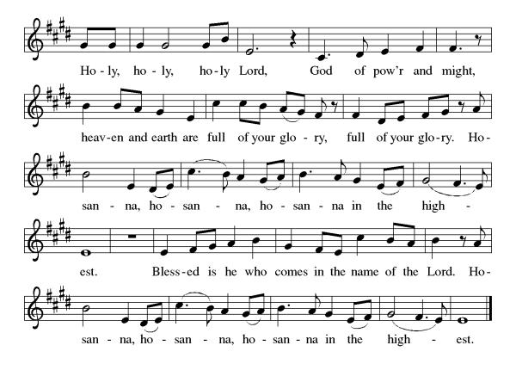

Eucharistic Prayer
Blessed are you, O God of the universe. Your mercy is everlasting, and your faithfulness endures from age to age.
Praise to you for creating the heavens and the earth. Praise to you for saving the earth from the waters of the flood. Praise to you for bringing the Israelites safely through the sea. Praise to you for leading your people through the wilderness to the land of milk and honey. Praise to you for the death and resurrection of Christ. Praise to you for your Spirit poured out on all nations.
In the night he was betrayed, our Lord Jesus took bread and gave thanks; broke it, and gave it to his disciples saying: Take and eat; this is my body given for you. Do this for the remembrance of me.
After supper he took the cup, gave thanks and gave it for all to drink saying: This cup is the new covenant in my blood, shed for you and for all people for the forgiveness of sin, Do this for the remembrance of me.
For as often as we eat of this bread and drink from this cup we proclaim the Lord’s death until He comes.

Gathered into one, by the Holy Spirit let us listen to the words that Jesus taught us.

The Lord’s Prayer
Our Father, who art in heaven, hallowed be thy name, thy kingdom come, thy will be done, on earth as it is in heaven. Give us this day our daily bread; and forgive us our trespasses, as we forgive those who trespass against us; and lead us not into temptation but deliver us from evil. For thine is the kingdom, and the power, and the glory, forever and ever. Amen.

Invitation to Communion
S.A.M. Bob: Here is life. God is with us. Come and taste on your lips a Love we cannot comprehend.
C: Amen
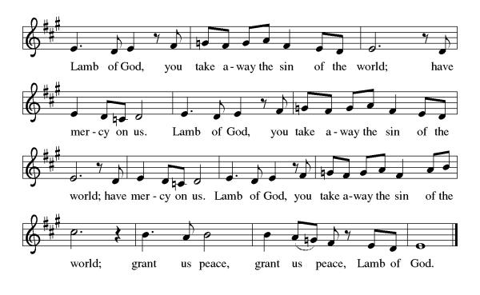

Please come forward to receive

Communion Anthem: Come Now, O God ACS 902
S.A.M. Bob: We are now a tabernacle with Christ inside of us. Let us rejoice and be glad at the Lord’s table.
C: Amen
Prayer after Communion
God our host,
at this table you have fed us with joy and gladness.
Send us forth, eager to share the feast,
welcome the stranger,
and bear good fruit in the name of Jesus.
Amen.
Blessing
May God who comes among us,
Father, ☩ Son, and Holy Spirit,
grant you patience in waiting, peace in the darkness,
and good news to share today and always.
Amen.

Sending Hymn: All Earth Is Hopeful ELW 266

1 All earth is hopeful, the Savior comes at last!
Furrows lie open for God's creative task:
this, the labor of people who struggle to see
how God's truth and justice set ev'rybody free.

2 People of Israel, you heard the prophet tell:
"A virgin mother will bear Emmanuel";
she conceived him, "God with us,"
our brother, whose birth
restores hope and courage to children of this earth.

3 Mountains and valleys will have to be prepared;
new highways opened, new protocols declared.
Almost here! God is nearing, in beauty and grace!
All clear ev'ry gateway, in haste, come out in haste!

4 We first saw Jesus a baby in a crib.
This same Lord Jesus today has come to live
in our world; he is present, in neighbors we see
our Jesus is with us, and ever sets us free.
Text: Alberto Taulé, b. 1932; tr. Madeleine Forell Marshall, b. 1946
Spanish text © 1993 and English text © 1995 Centro de Pastoral Liturgica, admin. OCP Publications, 5536 NE Hassalo, Portland, OR 97213.

Dismissal
S.A.M Bob: Go in peace. Keep awake.
C: Thanks be to God.
Postlude: instrumental
Unless otherwise noted, materials used in this bulletin are:
From Sundays and Seasons.com. Copyright 2015 Augsburg Fortress. All rights reserved. Reprinted by permission under Augsburg Fortress Liturgies Annual License #SAS028635. Music is reprinted under OneLicense.Net #A712074 and/or Augsburg Fortress #SBL12176H. Scripture, unless otherwise noted, is from the New Revised Standard Version Bible, Copyright © 1989, Division of Christian Education of the National Council of the Churches of Christ in the United States of America. Used by permission. All rights reserved.

Announcements for December 20th and 21st

ATTENDANCE
Saturday, December 13th, 4pm 24
Sunday, December 14^{h}, 9am 44
Drive-Up Communion 0
68

The Altar Flowers are given this week by Patie Pule, in honor of her mother’s birthday!

This Week at St. Timothy's
Monday, December 22nd
Tuesday, December 23rd
Wednesday, December 24th 4:30pm – Pre-Service Music, 5pm – Candlelight Service
Thursday, December 25th 10am – Christmas Day Service
Friday, December 26th
Saturday, December 27th 4pm - Worship
Sunday, December 28th 9am – Worship, 10:15-10:45 – Drive Up Communion, 10:30 – Adult SS, Coffee Fellowship



CHRISTMAS POINSETTIAS
If you wish to purchase a poinsettia for our Christmas services, there is a sign-up sheet on the bulletin board in the Narthex area. The cost per 6” plant is $15.00 which includes a $3.00 donation for the food pantry. Please put your payment in the church offering and designate it “Poinsettia”.

Christmas Schedule
Christmas Eve – Pre-service Music 4:30pm, Candlelight Service at 5pm

Christmas Day –Service at 10am.

