St. Timothy Lutheran Church
Sunday, October 26th
The 20th Sunday after Pentecost
Reformation Sunday



Rooted in the past and growing into the future, the church must always be reformed in order to live out the love of Christ in an ever-changing world. We celebrate the good news of God’s grace, that Jesus Christ sets us free every day to do this life-transforming work. Trusting in the freedom given to us in baptism, we pray for the church, that Christians will unite more fully in worship and mission.

St Timothy Worship Planning Team
Bishop Pedro Suarez presiding
S.A.M. Bob Bonomo
Deacon, Frank Hofstetter
Director of Music, Sally Hennessey
Saturday Pianist, Bill Robinson

Pre-Service Music:

B: Please stand as you are able and face the baptismal font.

B: Blessed be the holy Trinity, ☩ one God, the fountain of living water, the rock who gave us birth, our light and our salvation. Amen.

We give you thanks, O God, for in the beginning your Spirit moved over the waters and by your Word you created the world, calling forth life in which you took delight.

Through the waters of the flood you delivered Noah and his family. Through the sea you led your people Israel from slavery into freedom. At the river your Son was baptized by John and anointed with the Holy Spirit. By water and your Word you claim us as daughters and sons, making us heirs of your promise and servants of all.

We praise you for the gift of water that sustains life,
and above all we praise you for the gift of new life in Jesus Christ. Shower us with your Spirit, and renew our lives with your forgiveness, grace, and love.

To you be given honor and praise through Jesus Christ our Lord in the unity of the Holy Spirit, now and forever.
Amen.

Processional Hymn: Built on a Rock ELW 652
1 Built on a rock the church shall stand, even when steeples are falling; crumbled have spires in ev'ry land, bells still are chiming and calling— calling the young and old to rest, calling the souls of those distressed, longing for life everlasting.

2 Surely, in temples made with hands God the Most High is not dwelling— high in the heav'ns his temple stands, all earthly temples excelling. Yet God who dwells in heav'n above deigns to abide with us in love, making our bodies his temple.

3 Christ builds a house of living stones: we are his own habitation; he fills our hearts, his humble thrones, granting us life and salvation. Where two or three will seek his face, he in their midst will show his grace, blessings upon them bestowing.

4 Yet in this house, an earthly frame, Jesus the children is
blessing; hither we come to praise his name, faith in our
Savior confessing. Jesus to us his Spirit sent, making with
us his covenant, granting his children the kingdom.

5 Through all the passing years, O Lord,
grant that, when church bells are ringing,
many may come to hear your Word,
who here this promise is bringing:
"I know my own, my own know me;
you, not the world, my face shall see;
my peace I leave with you. Amen."

Text: Nicolai F. S. Grundtvig, 1783-1872; tr. Carl Doving, 1867-1937, adapt.
Text © 1958 Service Book and Hymnal, admin. Augsburg Fortress.

B – The Lord be with you.
C – And also with you.

Prayer of the Day
Almighty God, gracious Lord, we thank you that your Holy Spirit renews the church in every age. Pour out your Holy Spirit on your faithful people. Keep them steadfast in your word, protect and comfort them in times of trial, defend them against all enemies of the gospel, and bestow on the church your saving peace, through Jesus Christ, our Savior and Lord, who lives and reigns with you and the Holy Spirit, one God, now and forever.
Amen.
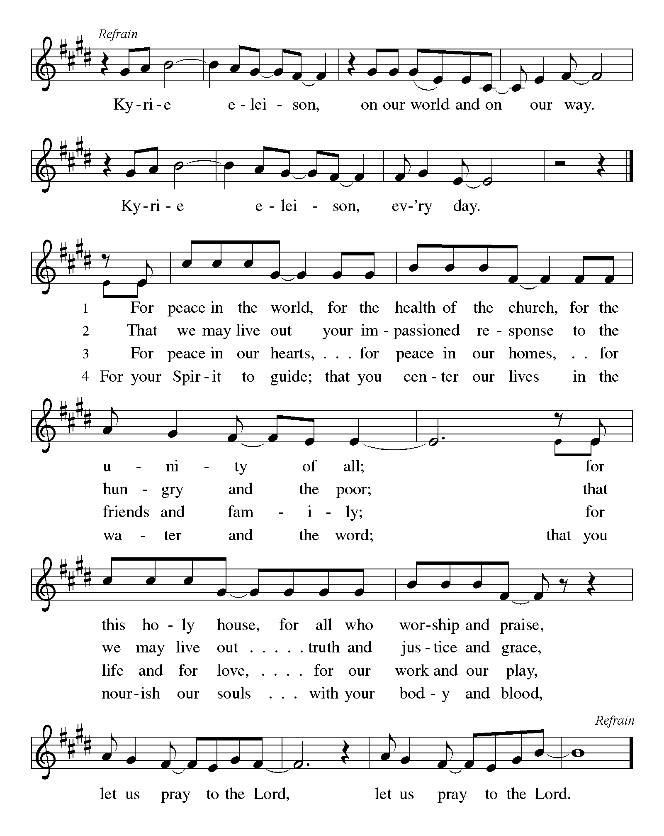
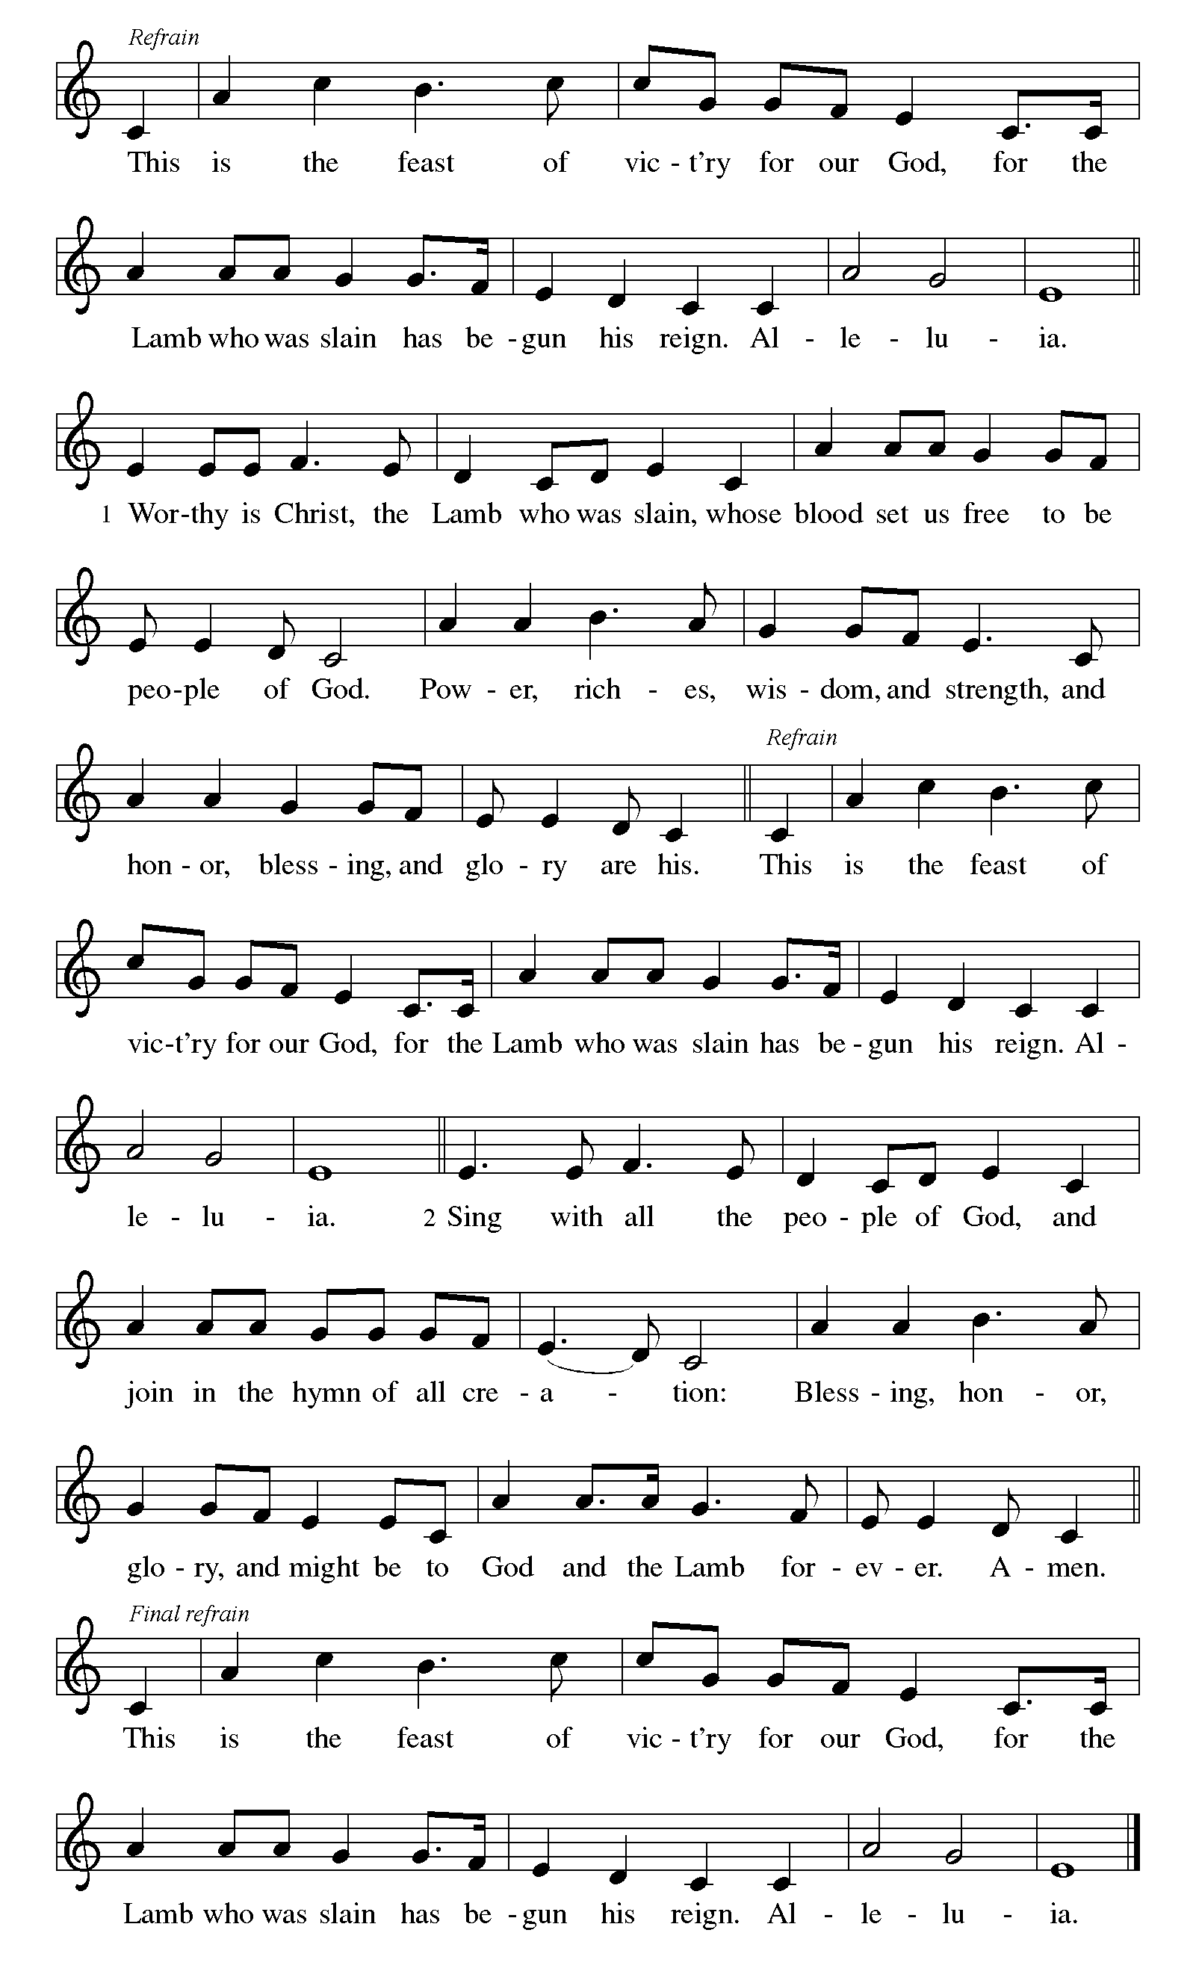

Please be seated

K.G. First Lesson: Jeremiah 31:31-34
The renewed covenant will not be breakable, but like the old covenant it will expect the people to live upright lives. To know the Lord means that one will defend the cause of the poor and needy. The renewed covenant is possible only because the Lord will forgive iniquity and not remember sin. Our hope lies in a God who forgets.
³¹ The days are surely coming, says the Lord, when I will make a new covenant with the house of Israel and the house of Judah. ³² It will not be like the covenant that I made with their ancestors when I took them by the hand to bring them out of the land of Egypt—a covenant that they broke, though I was their husband, says the Lord. ³³ But this is the covenant that I will make with the house of Israel after those days, says the Lord: I will put my law within them, and I will write it on their hearts, and I will be their God, and they shall be my people. ³⁴ No longer shall they teach one another or say to each other, “Know the Lord,” for they shall all know me, from the least of them to the greatest, says the Lord, for I will forgive their iniquity and remember their sin no more.

A – Word of God!

C – Words of Life!

D Psalm 46
¹ God is our refuge and strength,
a very present help in trouble.
² Therefore we will not fear, though the earth be moved,
and though the mountains shake in the depths of the sea;
³ though its waters rage and foam,
and though the mountains tremble with its tumult.
⁴ There is a river whose streams make glad the city of God,
the holy habitation of the Most High.
⁵ God is in the midst of the city; it shall not be shaken;
God shall help it at the break of day.
⁶ The nations rage, and the kingdoms shake;
God speaks, and the earth melts away.
⁷ The Lord of hosts is with us;
the God of Jacob is our stronghold.
⁸ Come now, regard the works of the Lord,
what desolations God has brought upon the earth;
⁹ behold the one who makes war to cease in all the world;
who breaks the bow, and shatters the spear, and burns the shields with fire.
¹⁰ “Be still, then, and know that I am God;
I will be exalted among the nations; I will be exalted in the earth.”
¹¹ The Lord of hosts is with us;
the God of Jacob is our stronghold.

K.G. Second Lesson: Romans 3:19-28
Paul’s words stand at the heart of the preaching of Martin Luther and other Reformation leaders. No human beings make themselves right with God through works of the law. We are brought into a right relationship with God through the divine activity centered in Christ’s death. This act is a gift of grace that liberates us from sin and empowers our faith in Jesus Christ.
¹⁹ Now we know that, whatever the law says, it speaks to those who are under the law, so that every mouth may be silenced and the whole world may be held accountable to God. ²⁰ For no human will be justified before him by deeds prescribed by the law, for through the law comes the knowledge of sin.
²¹ But now, apart from the law, the righteousness of God has been disclosed and is attested by the Law and the Prophets, ²² the righteousness of God through the faith of Jesus Christ for all who believe. For there is no distinction, ²³ since all have sinned and fall short of the glory of God; ²⁴ they are now justified by his grace as a gift, through the redemption that is in Christ Jesus, ²⁵ whom God put forward as a sacrifice of atonement by his blood, effective through faith. He did this to demonstrate his righteousness, because in his divine forbearance he had passed over the sins previously committed; ²⁶ it was to demonstrate at the present time his own righteousness, so that he is righteous and he justifies the one who has the faith of Jesus.
²⁷ Then what becomes of boasting? It is excluded. Through what kind of law? That of works? No, rather through the law of faith. ²⁸ For we hold that a person is justified by faith apart from works prescribed by the law.

A – Word of God!

C – Words of Life!

Please stand as we greet the Gospel.
Gospel Acclamation
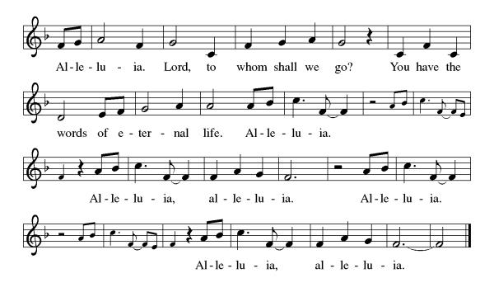

B The Holy Gospel according to John, the 8th Chapter
C- Glory to you, O Lord.

B Gospel: John 8:31-36
Jesus speaks of truth and freedom as spiritual realities known through his word. He reveals the truth that sets people free from sin.
³¹ Jesus said to the Jews who had believed in him, “If you continue in my word, you are truly my disciples, ³² and you will know the truth, and the truth will make you free.” ³³ They answered him, “We are descendants of Abraham and have never been slaves to anyone. What do you mean by saying, ‘You will be made free’?”
³⁴ Jesus answered them, “Very truly, I tell you, everyone who commits sin is a slave to sin. ³⁵ The slave does not have a permanent place in the household; the son has a place there forever. ³⁶ So if the Son makes you free, you will be free indeed.”

B - The Gospel of the Lord.
C - Praise to you, O Christ.
Sermon by Bishop Suarez

Hymn of the Day: The Church's One Foundation ELW 654

1 The church's one foundation is Jesus Christ, her Lord.
she is his new creation by water and the word.
From heav'n he came and sought her to be his holy bride;
with his own blood he bought her, and for her life he died.

2 Elect from ev'ry nation, yet one o'er all the earth,
her charter of salvation one Lord, one faith, one birth:
one holy name she blesses, partakes one holy food,
and to one hope she presses, with ev'ry grace endued.

3 Though with a scornful wonder this world sees her oppressed,
by schisms rent asunder, by heresies distressed,
yet saints their watch are keeping; their cry goes up: "How long?"
And soon the night of weeping shall be the morn of song.

4 Through toil and tribulation and tumult of her war,
she waits the consummation of peace forevermore;
till with the vision glorious her longing eyes are blest,
and the great church victorious shall be the church at rest.

5 Yet she on earth has union with God, the Three in One,
and mystic sweet communion with those whose rest is won.
Oh, blessed heav'nly chorus! Lord, save us by your grace,
that we, like saints before us, may see you face to face.
Text: Samuel J. Stone, 1839-1900

The Apostles’ Creed
I believe in God, the Father almighty,
creator of heaven and earth.
I believe in Jesus Christ, God’s only Son, our Lord,
who was conceived by the Holy Spirit,
born of the virgin Mary,
suffered under Pontius Pilate,
was crucified, died, and was buried;
he descended to the dead.
On the third day he rose again;
he ascended into heaven,
he is seated at the right hand of the Father,
and he will come to judge the living and the dead.
I believe in the Holy Spirit,
the holy catholic church,
the communion of saints,
the forgiveness of sins,
the resurrection of the body,
and the life everlasting. Amen.
Lord, listen to your children praying,
Lord, send your Spirit in this place;
Lord, listen to your children praying,
send us love, send us pow'r, send us grace.

S.A.M. Prayers of The People
Renewed in God’s everlasting grace, let us pray for the church, the world, and all creation.
A brief silence.
Gracious and Eternal God, We gather today with hearts full of gratitude for the gift of Your Word and the courage of those who sought to reform and renew Your church. We thank You for the legacy of faith that reminds us to always seek Your truth and to live boldly in Your grace. May we, like those before us, be instruments of Your love and justice in the world.
God of all Wisdom
We Thank You
Lord above All, We pray for Your church universal, that it may continue to be reformed and always reforming according to Your will. Strengthen its leaders, inspire its members, and guide its mission to reflect Your light in every corner of the earth. May we be united in purpose, diverse in expression, and steadfast in proclaiming the gospel of Jesus Christ.
God of all Wisdom
We Thank You
We lift up the world to You, broken and in need of healing. On this Reformation Sunday, we pray for renewal—not only in our churches but in our communities, nations, and hearts. May Your Spirit move among us, breaking down walls of division and building bridges of understanding. Help us to be agents of reconciliation and hope in a world longing for Your presence.
God of all Wisdom,
We Thank You
Merciful God, Heal all who suffer, and bring them peace. Draw near to people who are incarcerated. Give hope to people experiencing housing or employment insecurity, oppression, or discrimination. Heal those who are ill (mention names aloud or keep them in your heart) Be our stronghold at all times.
God of all Wisdom
We Thank You
Dear Lord, We humbly come before You, seeking Your Divine guidance for our Bishop Pedro Suarez and our newly elected presiding Bishop Yehiel Curry and all Bishops. Grant them wisdom, strength, and clarity as they lead our community. May Your Holy Spirit inspire their decisions and actions, helping them to shepherd us with love and grace. We also ask you to bless all Pastors, Deacons and laity as they serve You all for the Glory of God.
God of Wisdom
We Thank You

Bless those who are called to serve on the call committee. Give them the gifts they need to seek and find the Pastor of Your own nurturing, the Shepherd of Your own choosing, that we might be fed by Your holy word and Sacraments and grow in faith and love and ministry.
God of Wisdom
We Thank You

Dear Lord, We entrust our departed loved ones to your loving care. Grant their souls eternally rest and peace in Your Heavenly Kingdom. Help us to find comfort in the knowledge that they are safe with You.
God of Wisdom
We Thank You
As we leave this sanctuary we are a tabernacle holding You inside of us, may we carry the spirit of Reformation with us. Help us to live boldly in faith, humbly in service, and joyfully in your love. May our lives reflect your grace and truth, and may we always seek to glorify you in all that we do. In the name of Jesus Christ, our Savior and Redeemer, we pray. Amen.

B: May the peace of our Lord Jesus Christ be with you all.
C: And also with you.
B: Let us now share this peace.
Please stay in your seats and share the peace in your row.
The Offering is Brought to the Altar by
Pastor Dennis and Linda Koch.
Offering Prayer

We lift our voices, we lift our hands, we lift our lives up to you; we are an Offering. Lord, use our voices, Lord, use our hands, Lord, use our lives, they are yours: we are an offering. All that we have, all that we are, all that we hope to be, we give to you, we give to you. We lift our voices, we lift our hands, we lift our lives up to you; we are an offering, we are an offering.
B: The Lord be with you.
C: And also with you.

B: Lift up your hearts.
C: We lift them up to the Lord.

B: Let us give thanks to the Lord our God.
C: It is right to give our thanks and praise.

Preface
It is indeed right, our duty and our joy,
that we should at all times and in all places
give thanks and praise to you, almighty and merciful God,
through our Savior Jesus Christ;
who on this day overcame death and the grave,
and by his glorious resurrection opened to us the way of everlasting life.
And so, with all the choirs of angels,
with the church on earth and the hosts of heaven,
we praise your name and join their unending hymn:

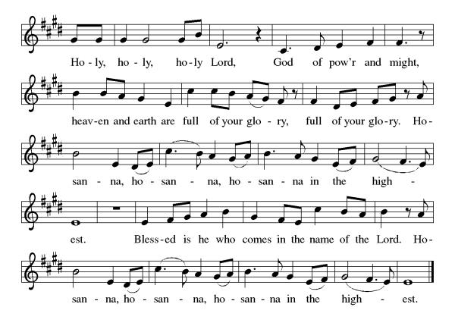

Eucharistic Prayer
Blessed are you, O God of the universe. Your mercy is everlasting, and your faithfulness endures from age to age.
Praise to you for creating the heavens and the earth. Praise to you for saving the earth from the waters of the flood. Praise to you for bringing the Israelites safely through the sea. Praise to you for leading your people through the wilderness to the land of milk and honey. Praise to you for the death and resurrection of Christ. Praise to you for your Spirit poured out on all nations.
In the night he was betrayed, our Lord Jesus took bread and gave thanks; broke it, and gave it to his disciples saying: Take and eat; this is my body given for you. Do this for the remembrance of me.
After supper he took the cup, gave thanks and gave it for all to drink saying: This cup is the new covenant in my blood, shed for you and for all people for the forgiveness of sin, Do this for the remembrance of me.
For as often as we eat of this bread and drink from this cup we proclaim the Lord’s death until He comes.

Christ has died
Christ is risen.
Christ will come again.

Gathered into one, by the Holy Spirit let us listen to the words that Jesus taught us.
The Lord’s Prayer
Our Father, who art in heaven, hallowed be thy name, thy kingdom come, thy will be done, on earth as it is in heaven. Give us this day our daily bread; and forgive us our trespasses, as we forgive those who trespass against us; and lead us not into temptation but deliver us from evil. For thine is the kingdom, and the power, and the glory, forever and ever. Amen.

Invitation to Communion

Bishop, please feel free to speak as the Holy Spirit moves you.

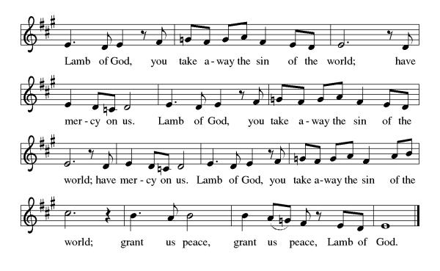
Please come forward to receive

Communion Anthem: The Church of Christ, In Every Age ELW 729

B: We are now a tabernacle with Christ inside of us. Let us rejoice and be glad at the Lord’s table.
C: Amen

Prayer after Communion
O God, through this meal you have strengthened us
and appointed us to be your servants. Send us to do good and to share our possessions with all in need.
We ask this in Jesus’ name.
Amen

Blessing
B: The God of righteousness, who gives justice to the oppressed,
who gives food to the hungry, who sets the prisoners free,
☩ bless you now and forever.
C: Amen.

Recessional Hymn: A Mighty Fortress Is Our God ELW 504
1 A mighty fortress is our God,
a sword and shield victorious;
he breaks the cruel oppressor's rod
and wins salvation glorious.
The old satanic foe
has sworn to work us woe!
With craft and dreadful might
he arms himself to fight.
On earth he has no equal.

2 No strength of ours can match his might!
We would be lost, rejected.
But now a champion comes to fight,
whom God himself elected.
You ask who this may be?
The Lord of hosts is he!
Christ Jesus, mighty Lord,
God's only Son, adored.
He holds the field victorious.

3 Though hordes of devils fill the land
all threat'ning to devour us,
we tremble not, unmoved we stand;
they cannot overpow'r us.
Let this world's tyrant rage;
in battle we'll engage!
His might is doomed to fail;
God's judgment must prevail!
One little word subdues him.

4 God's Word forever shall abide,
no thanks to foes, who fear it;
for God himself fights by our side
with weapons of the Spirit.
Were they to take our house,
goods, honor, child, or spouse,
though life be wrenched away,
they cannot win the day.

The kingdom's ours forever!

Text: Martin Luther, 1483-1546; tr. Lutheran Book of Worship
Text © 1978 Lutheran Book of Worship, admin. Augsburg Fortress.
Duplication in any form prohibited without permission or valid license from copyright administrator.

Dismissal
S.A.M: Go in peace to love and serve our Lord. A MIGHTY FORTRESS IS OUR GOD!
C: Thanks be to God.
Postlude: instrumental
Unless otherwise noted, materials used in this bulletin are:
From Sundays and Seasons.com. Copyright 2015 Augsburg Fortress. All rights reserved. Reprinted by permission under Augsburg Fortress Liturgies Annual License #SAS028635. Music is reprinted under OneLicense.Net #A712074 and/or Augsburg Fortress #SBL12176H. Scripture, unless otherwise noted, is from the New Revised Standard Version Bible, Copyright © 1989, Division of Christian Education of the National Council of the Churches of Christ in the United States of America. Used by permission. All rights reserved.
ATTENDANCE
Saturday, October 18th, 4pm 29
Sunday, October 19th, 9am 45
Drive-Up Communion 4
78

The altar flowers are given, this week, by Ron and Justine Roecker!

This Week at St. Timothy's
Monday, October 27th
Tuesday, October 28th 9-12 Food Pantry
Wednesday, October 29th 2pm – Prayer Time
Thursday, October 30th 9:30 – Prayer Group, 11 – Miniatures, 4:30pm - Choir
Friday, October 31st Reformation Day
Saturday, November 1st 4pm - Worship
Sunday, November 2nd ALL SAINTS SUNDAY - 9am – Worship, 10:15-10:45 – Drive-Up Communion, 10:30 – Adult SS, Coffee Fellowship

