St Timothy Lutheran Church
Sunday, April 19, 2026
Third Sunday of Easter

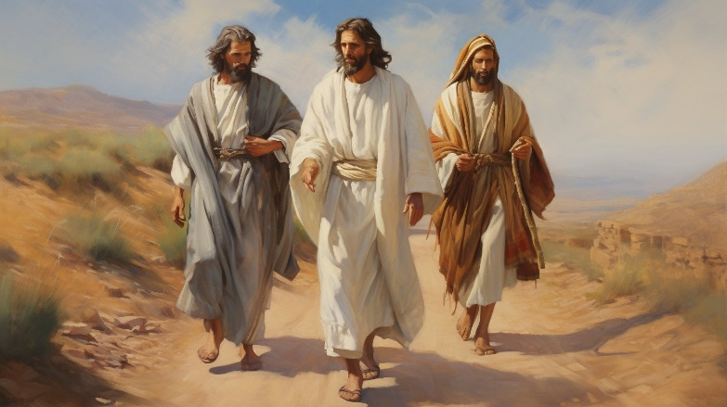

Today’s gospel begins with two disciples walking to Emmaus, overcome with sadness, loss, and disappointment. They had hoped Jesus, who was crucified, would be the one to redeem Israel! Yet the risen Christ walks with them and then opens their eyes in the breaking of the bread. Each Sunday our hearts burn within us as the scriptures are proclaimed and Christ appears to us as bread is broken and wine is poured. The story of Emmaus becomes the pattern of our worship each Lord’s day.

Preservice Music: Look Who Gathers at Christ’s Table ACS 977
Welcome!
Prelude
P – Preparing our hearts for Worship

Thanksgiving for Baptism
All may make the sign of the cross, the sign that is marked at baptism, as the presiding minister begins.
Alleluia! Christ is risen.
Christ is risen indeed. Alleluia!
Salvation belongs to our God who is seated on the throne
and to the Lamb!
Amen.
Let us give thanks for the gifts of baptism.
P - Merciful God,
you are the one who was, who is, and who is to come.
You lead us beside still waters.
We thank you for the waters of creation:
morning dew, gentle rain, roaring waves.
We thank you for the waters that nourish us.
Blessed are you.
You guide us to springs of the water of life.
Jesus Christ, you are the faithful witness
who accompanies us on our journeys.
We give you thanks for your life-giving death and resurrection.
We praise you for joining us in joy and sorrow.
Blessed are you.
You guide us to springs of the water of life.
Holy Spirit, you anoint our head with oil and our cup overflows.
Break down barriers that divide us.
Fill us with the breath of peace.
Blessed are you.
You guide us to springs of the water of life.
Holy One, we thank you for the gifts and grace of baptism,
and for making us a new creation.
We join with saints and angels, giving you honor and praise,
now and forever.
Amen.

Gathering Hymn: Now the Green Blade Rises ELW 379
1 Now the green blade rises from the buried grain,
wheat that in dark earth many days has lain;
love lives again, that with the dead has been;
love is come again like wheat arising green.
2 In the grave they laid him, love by hatred slain,
thinking that he would never wake again;
laid in the earth like grain that sleeps unseen;
love is come again like wheat arising green.
3 Forth he came at Easter, like the risen grain,
he that for three days in the grave had lain;
raised from the dead, my living Lord is seen;
love is come again like wheat arising green.
4 When our hearts are wintry, grieving, or in pain,
your touch can call us back to life again,
fields of our hearts that dead and bare have been;
love is come again like wheat arising green.
Text: John MacLeod Campbell Crum, 1872-1958
Text from Oxford Book of Carols © Oxford University Press 1928. All rights reserved
Duplication in any form prohibited without permission or valid license from copyright administrator.

P - The grace of our Lord Jesus Christ, the love of God and the communion of the Holy Spirit be with you all.
C - And also with you.

Prayer of the Day
O God, your Son makes himself known to all his disciples in the breaking of bread. Open the eyes of our faith, that we may see him in his redeeming work, who lives and reigns with you and the Holy Spirit, one God, now and forever.
Amen.

Volunteer Recognition and Appreciation
The body of Christ is made up of many members.
Not all have the same function.

We are blessed with many members who care for the functioning of the body of Christ at St. Timothy Lutheran Church.
We thank God for them.

They give of their time and talents.
Without their efforts and gifts, we could not be all God calls us to be.

Paul writes of the Macedonian Christians who wanted to share in ministry: “They gave themselves first to the Lord and, by the will of God, to us.” (2 Cor. 8:5)
Ministry flows from a commitment to serve the Lord.

By the will of God our volunteers are committed to the Lord and to us. God has worked mightily through them to bless us.
We thank God for them.

Our volunteers put flesh and bone on our call to be the body of Christ in the world.
They add muscle to our calling to be Christ to one another.

Sunday school and vacation Bible school teachers, confirmation and youth leaders, mentors and nursery helpers.
musicians, readers, assisting ministers, ushers, leaders of prayer, communion assistants, acolytes.
mission-project organizers, stewardship coordinators, offering counters, special event planners.
quilters, gardeners, artists, bakers, cooks.
prayer chain participants, visitors to the hospitalized and homebound, those who prepare funeral lunches.
ministers of hospitality of every kind. cleaners, bulletin assemblers, envelope stuffers, office helpers, and so many more:

We thank God for you!
We thank you for your time and talent
All for the Glory of God

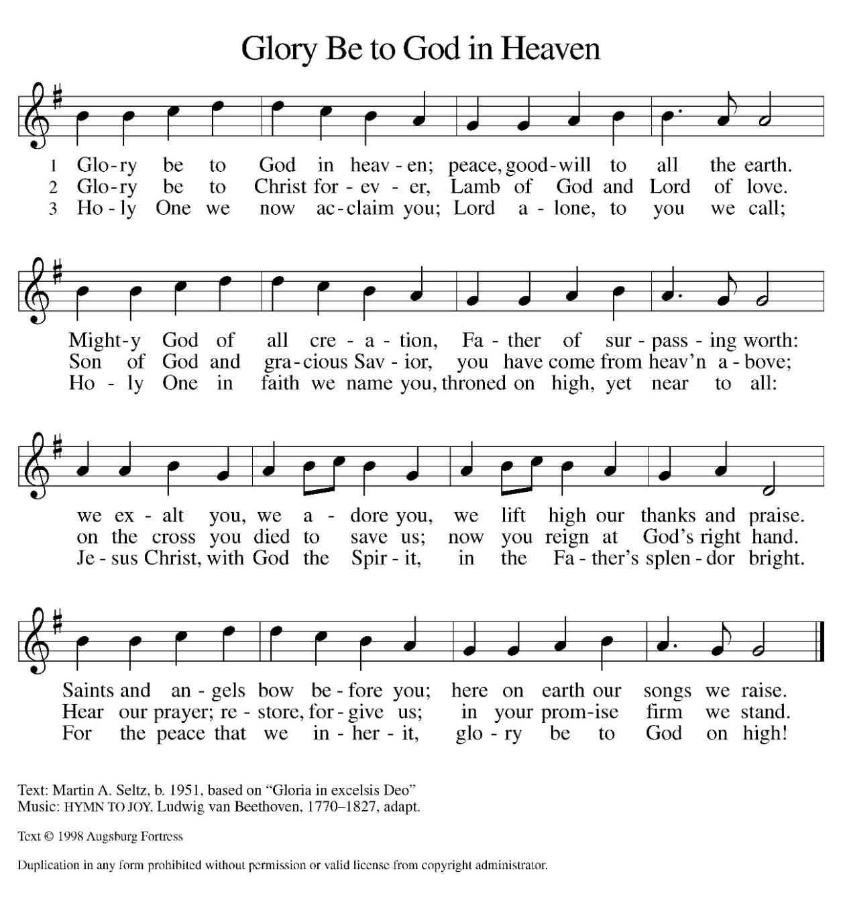
Hymn of Praise:

Please sit for our first reading.

First Reading: Acts 2:14a, 36-41
Today’s reading is the conclusion of Peter’s sermon preached following the giving of the Holy Spirit to the apostles on the day of Pentecost. The center of his preaching is the bold declaration that God has made the crucified Jesus both Lord and Christ.
^{14a} Peter, standing with the eleven, raised his voice and addressed [the crowd]: ³⁶ “Therefore let the entire house of Israel know with certainty that God has made him both Lord and Messiah, this Jesus whom you crucified.”
³⁷ Now when they heard this, they were cut to the heart and said to Peter and to the other apostles, “Brothers, what should we do?” ³⁸ Peter said to them, “Repent and be baptized every one of you in the name of Jesus Christ so that your sins may be forgiven, and you will receive the gift of the Holy Spirit. ³⁹ For the promise is for you, for your children, and for all who are far away, everyone whom the Lord our God calls to him.” ⁴⁰ And he testified with many other arguments and exhorted them, saying, “Save yourselves from this corrupt generation.” ⁴¹ So those who welcomed his message were baptized, and that day about three thousand persons were added.

A – Here ends the first reading!

C – Thanks be to God!

Psalm 116:1-4, 12-19
¹ I love the Lord, who has heard my voice,
and listened to my supplication,
² for the Lord has given ear to me
whenever I called.
³ The cords of death entangled me; the anguish of the grave came upon me;
I came to grief and sorrow.
⁴ Then I called upon the name of the Lord:
“O Lord, I pray you, save my life.”
¹² How shall I repay the Lord
for all the good things God has done for me?
¹³ I will lift the cup of salvation
and call on the name of the Lord.
¹⁴ I will fulfill my vows to the Lord
in the presence of all God’s people.
¹⁵ Precious in your sight, O Lord,
is the death of your servants.
¹⁶ O Lord, truly I am your servant;
I am your servant, the child of your handmaid; you have freed me from my bonds.
¹⁷ I will offer you the sacrifice of thanksgiving
and call upon the name of the Lord.
¹⁸ I will fulfill my vows to the Lord
in the presence of all God’s people,
¹⁹ in the courts of the Lord’s house,
in the midst of you, O Jerusalem. Hallelujah!

Second Reading: 1 Peter 1:17-23
The imagery of exile is used to help the readers of this letter understand that they are strangers in a strange land. Christians no longer belong to this age. Through the death of Christ we belong to God, so that our focus, faith, and hope are no longer on such things as silver or gold.
¹⁷ If you invoke as Father the one who judges impartially according to each person’s work, live in fear during the time of your exile. ¹⁸ You know that you were ransomed from the futile conduct inherited from your ancestors, not with perishable things like silver or gold ¹⁹ but with the precious blood of Christ, like that of a lamb without defect or blemish. ²⁰ He was destined before the foundation of the world but was revealed at the end of the ages for your sake. ²¹ Through him you have come to trust in God, who raised him from the dead and gave him glory, so that your trust and hope are in God.
²² Now that you have purified your souls by your obedience to the truth so that you have genuine mutual affection, love one another deeply from the heart. ²³ You have been born anew, not of perishable but of imperishable seed, through the living and enduring word of God.
A – Here ends the second reading!
C – Thanks be to God!

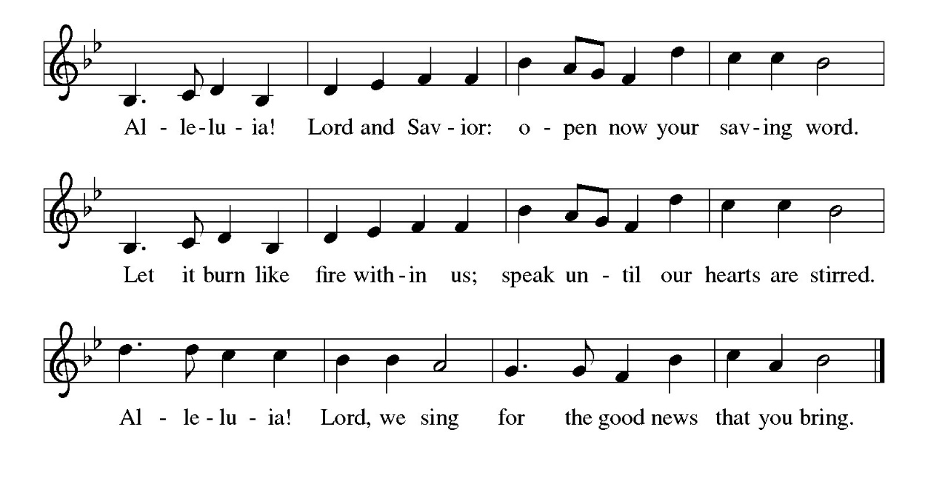
Gospel Acclamation

P - The Holy Gospel according to Luke, the 24th Chapter
C - Glory to You O Lord!

Gospel: Luke 24:13-35
The colorful story of Jesus’ appearance to two disciples on the road to Emmaus answers the question of how Jesus is to be recognized among us. Here, he is revealed through the scriptures and in the breaking of bread.
¹³ Now on that same day two [disciples] were going to a village called Emmaus, about seven miles from Jerusalem, ¹⁴ and talking with each other about all these things that had happened. ¹⁵ While they were talking and discussing, Jesus himself came near and went with them, ¹⁶ but their eyes were kept from recognizing him. ¹⁷ And he said to them, “What are you discussing with each other while you walk along?” They stood still, looking sad. ¹⁸ Then one of them, whose name was Cleopas, answered him, “Are you the only stranger in Jerusalem who does not know the things that have taken place there in these days?” ¹⁹ He asked them, “What things?” They replied, “The things about Jesus of Nazareth, who was a prophet mighty in deed and word before God and all the people, ²⁰ and how our chief priests and leaders handed him over to be condemned to death and crucified him. ²¹ But we had hoped that he was the one to redeem Israel. Yes, and besides all this, it is now the third day since these things took place. ²² Moreover, some women of our group astounded us. They were at the tomb early this morning, ²³ and when they did not find his body there they came back and told us that they had indeed seen a vision of angels who said that he was alive. ²⁴ Some of those who were with us went to the tomb and found it just as the women had said, but they did not see him.” ²⁵ Then he said to them, “Oh, how foolish you are and how slow of heart to believe all that the prophets have declared! ²⁶ Was it not necessary that the Messiah should suffer these things and then enter into his glory?” ²⁷ Then beginning with Moses and all the prophets, he interpreted to them the things about himself in all the scriptures.
²⁸ As they came near the village to which they were going, he walked ahead as if he were going on. ²⁹ But they urged him strongly, saying, “Stay with us, because it is almost evening and the day is now nearly over.” So he went in to stay with them. ³⁰ When he was at the table with them, he took bread, blessed and broke it, and gave it to them. ³¹ Then their eyes were opened, and they recognized him, and he vanished from their sight. ³² They said to each other, “Were not our hearts burning within us while he was talking to us on the road, while he was opening the scriptures to us?” ³³ That same hour they got up and returned to Jerusalem, and they found the eleven and their companions gathered together. ³⁴ They were saying, “The Lord has risen indeed, and he has appeared to Simon!” ³⁵ Then they told what had happened on the road and how he had been made known to them in the breaking of the bread.

P - The Gospel of the Lord.
C – Praise to you, O Christ!

Sermon

Hymn of the Day: With High Delight Let Us Unite ELW 368
1 With high delight let us unite
in songs of sweet jubilation.
You pure in heart, all bear your part,
sing Jesus Christ, our salvation.
To set us free forever, he
is ris’n and sends to all earth’s ends
good news to save ev’ry nation.

2 True God, he first from death has burst
forth into life, all subduing.
His enemy now vanquished see;
his death has been death’s undoing.
“And yours shall be like victory
o’er death and grave,” says he, who gave
his life for us, life renewing.

3 Let praises ring; give thanks, and bring
to Christ our Lord adoration.
His honor speed by word and deed
to ev’ry land, ev’ry nation.
So shall his love give us above,
from misery and death set free,
all joy and full consolation.

Text: Georg Vetter, 1536-1599; tr. Martin H. Franzmann, 1907-1976, alt.
Text © 1969 Concordia Publishing House
Duplication in any form prohibited without permission or valid license from copyright administrator.

The Apostle’s Creed
I believe in God, the Father almighty,
creator of heaven and earth.
I believe in Jesus Christ, God’s only Son, our Lord,
who was conceived by the Holy Spirit,
born of the virgin Mary,
suffered under Pontius Pilate,
was crucified, died, and was buried;
he descended to the dead.*
On the third day he rose again;
he ascended into heaven,
he is seated at the right hand of the Father,
and he will come to judge the living and the dead.
I believe in the Holy Spirit,
the holy catholic church,
the communion of saints,
the forgiveness of sins,
the resurrection of the body,
and the life everlasting. Amen.
From sundaysandseasons.com.
Copyright © 2026 Augsburg Fortress. All rights reserved.

Prayers of the People
Trusting in the power of Christ’s resurrection to heal and redeem our broken world, let us pray for the needs of all creation.
A brief silence.
Living Savior, just as you journeyed with the disciples to Emmaus, accompany us on our journey of faith. Gather us at your table, that we recognize you in the breaking of the bread. Merciful God,
receive our prayer.
Almighty God, you provide for the needs of all creation. Bless the fields that are being prepared for planting, and send favorable weather so that the soil may yield an abundant harvest. Merciful God,
receive our prayer.
God of justice, where leaders abuse power, confront them and call them to repentance. Where there is corruption, bring integrity; where there is violence, sow peace. Merciful God,
receive our prayer.
Healing Savior, your resurrection brings hope to a hurting world. Heal those who are sick (especially). Strengthen the weary, give courage to the despairing, and comfort the dying. Merciful God,
receive our prayer.
Gracious One, you have made us your own through the gift of baptism. Unite us in genuine love for one another and uphold this community in your name. Merciful God,
receive our prayer.
Eternal Light, we give thanks for all who have nurtured your church’s life in ages past. Bring us at last with them to the brightness of your glorious presence. Merciful God,
receive our prayer.
God of resurrection power, use us and these prayers to proclaim the good news of new life to all the world, through Jesus Christ, our risen Savior.
Amen.

P – The Peace of the Lord be with you always.
C – And also with you.

The Offering is Brought to the Altar
Offertory Prayer
Merciful God,
accept the fruits of our labor, gathered to give you glory.
You have set a table before us, a glimpse of that great day
when we will hunger and thirst no more.
Nourish us with the body and blood of Jesus,
that goodness and mercy may follow us
and bless the world you love.
In the name of Jesus,
Amen.

P – The Lord be with You
C – And also with you.
P – Lift up your hearts
C – We lift them to the Lord.
P – Let us give thanks to the Lord, our God
C – It is right to give Him our thanks and praise.

Preface
And so, with Mary Magdalene and Peter and all the witnesses of the resurrection, with earth and sea and all their creatures, and with angels and archangels, cherubim and seraphim, we praise your name and join their unending hymn:
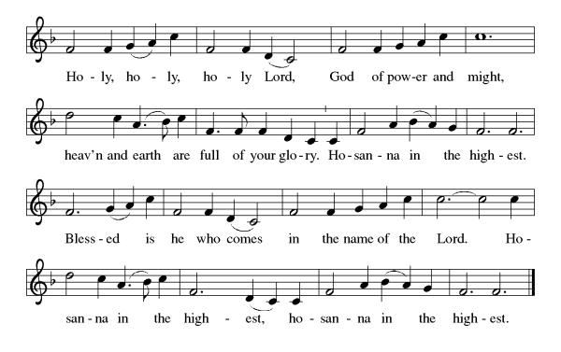

Eucharistic Prayer
(Words of Institution)

For as often as we eat of this bread and drink from this cup we proclaim the Lord’s death until He comes.
Christ has died
Christ is risen.
Christ will come again.
Remembering, therefore, his salutary command,
his life-giving passion and death, his glorious resurrection and ascension,
and the promise of his coming again,
we give thanks to you, O Lord God Almighty,
not as we ought but as we are able;
we ask you mercifully to accept our praise and thanksgiving and with your Word and Holy Spirit to bless us, your servants, and these your own gifts of bread and wine, so that we and all who share in the body and blood of Christ may be filled with heavenly blessing and grace,
and, receiving the forgiveness of sin,
may be formed to live as your holy people
and be given our inheritance with all your saints.
To you, O God, Father, Son, and Holy Spirit,
be all honor and glory in your holy church, now and forever. Amen.

Gathered into one, by the Holy Spirit let us listen to the words that Jesus taught us.

The Lord’s Prayer
Our Father, who art in heaven, hallowed be thy name, thy kingdom come, thy will be done, on earth as it is in heaven. Give us this day our daily bread; and forgive us our trespasses, as we forgive those who trespass against us; and lead us not into temptation but deliver us from evil. For thine is the kingdom, and the power, and the glory, forever and ever. Amen.
P: God feeds those who hunger, Come! Be fed and be healed!
C: Thanks be to God.

Invitation to Communion
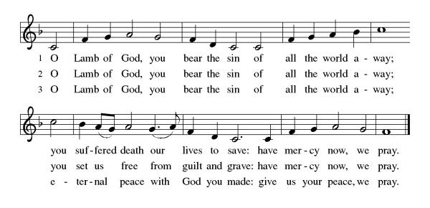

Distribution of Communion – Come Forward to Receive
Communion Hymn: Come, Let Us Eat ELW 491

P – Now may the body and blood of our Lord and Savior Jesus Christ strengthen you and keep you in His grace!
C – Thank You Jesus!

Prayer after Communion
Holy One,
through this meal you have made your home among us
and are making all things new.
Send us now to speak peace to anxious hearts,
to love our enemies,
and to bring your healing to the nations.
In the name of Jesus,
Amen.

Blessing
God Almighty, who is the beginning and the end,
Jesus Christ, the firstborn of the dead,
and the Spirit, our advocate and peace,
☩ bless you now and forever.
Amen.

Sending Hymn: This Joyful Eastertide ELW 391
1 This joyful Eastertide,
away with sin and sorrow!
My love, the Crucified,
has sprung to life this morrow.
Refrain
Had Christ, who once was slain,
not burst his three-day prison,
our faith had been in vain.
But now has Christ arisen,
arisen, arisen, arisen.
2 My flesh in hope shall rest
and for a season slumber
till trump from east to west
shall wake the dead in number. Refrain
3 Death's flood has lost its chill
since Jesus crossed the river.
Lover of souls, from ill
my passing soul deliver. Refrain
Text: George R. Woodward, 1848-1934

Dismissal
P – Look and listen to S.A.M. Bob
C- Thanks be to God. Alleluia!

Postlude:
Unless otherwise noted, service materials used in this bulletin are:
"Reprinted from the 1995 Moravian Book of Worship with permission of the Interprovincial Board of Communication, Moravian Church in North America."
Music is reprinted under OneLicense.Net #A712074 and/or Augsburg Fortress #SBL12176H. Scripture, unless otherwise noted, is from the New Revised Standard Version Bible, Copyright © 1989, Division of Christian Education of the National Council of the Churches of Christ in the United States of America. Used by permission. All rights reserved.
St Timothy’s is served by S.A.M. Robert Bonomo
Lay Minister Frank Hofstetter
Director of Music Sally Hennessey
Saturday Pianist Bill Robinson

Announcements for April 18th and 19th

ATTENDANCE
Saturday, April 11, 4pm 17
Sunday, April 12, 8am 53
Drive-Up Communion 2
72

The altar flowers are given, this week, by Greg & Judi Schutrum, in honor of their granddaughter Ashley’s birthday.

Serving our Lord this weekend:
Saturday, April 18th

Sunday, April 19th
Assisting Minister: Sarah Brisson
Reader: Dick Kleinsmith

This Week at St. Timothy's
Monday, April 20th
Tuesday, April 21st 1pm WELCA
Wednesday, April 22nd
Thursday, April 23rd 11am Bible Study for Beginners, 11am – Miniatures, 4pm - Choir
Friday, April 24th
Saturday, April 25th 4pm Worship
Sunday, April 26th 9am Worship – New Member Installation, 10:30am – Adult SS, Coffee Fellowship, Council

