St Timothy Lutheran Church
Saturday, August 1, 2026

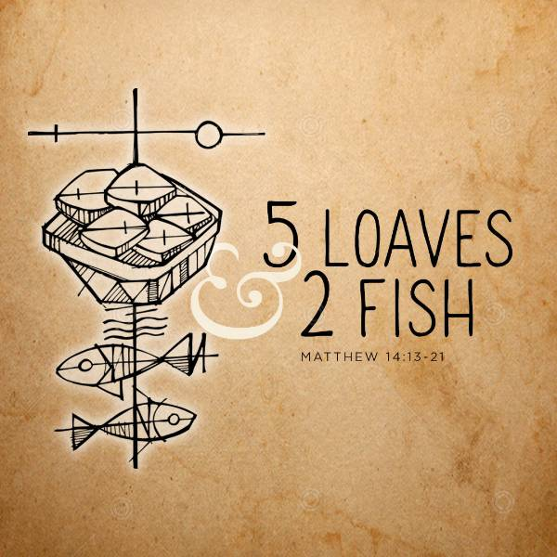

In today’s first reading God invites all who are hungry or thirsty to receive food and drink without cost. Jesus feeds the hungry multitude and reveals the abundance of God. At the eucharistic table we remember all who are hungry or poor in our world today. As we share the bread of life, we are sent forth to give ourselves away as bread for the hungry.
Preservice: Oh, Sing to God Above ELW 555
Welcome!
Prelude

Confession and Forgiveness
All may make the sign of the cross, the sign that is marked at baptism, as the presiding minister begins.
Blessed be the holy Trinity,☩ one God,
whose compassion endures forever.
Amen.
Let us confess our sin to God.
Silence is kept for reflection.
Compassionate God,
we confess to you all our sins.
Our burden is heavy, and we cannot free ourselves.
In your mercy, call us back to you.
Your yoke is easy and your burden is light.
Restore us to dwell in your peace.
In Christ’s name we pray,
Amen.
Jesus says, “Come to me,
all you who are weary
and are carrying heavy burdens,
and I will give you rest.”
In the name of God,
Father, ☩ Son, and Holy Spirit,
your sins are forgiven.
Rest in God’s love.
Amen.
Gathering Hymn: Gather Us in ELW 532

1 Here in this place the new light is streaming, now is the darkness vanished away; see in this space our fears and our dreamings
brought here to you in the light of this day.
Gather us in, the lost and forsaken, gather us in, the
blind and the lame; call to us now, and we shall awaken,
we shall arise at the sound of our name.

2 We are the young, our lives are a myst'ry, we are the old who yearn for your face; we have been sung throughout all of hist'ry,
called to be light to the whole human race.
Gather us in, the rich and the haughty, gather us in, the
proud and the strong; give us a heart, so meek and so lowly,
give us the courage to enter the song.

3 Here we will take the wine and the water, here we will take the bread of new birth, here you shall call your sons and your daughters, call us anew to be salt for the earth.
Give us to drink the wine of compassion, give us to eat the
bread that is you; nourish us well, and teach us to fashion
lives that are holy and hearts that are true.

4 Not in the dark of buildings confining, not in some heaven,
light years away—here in this place the new light is shining,
now is the kingdom, and now is the day.
Gather us in and hold us forever, gather us in and
make us your own; gather us in, all peoples together,
fire of love in our flesh and our bone.
Text: Marty Haugen, b. 1950
Text © 1982 GIA Publications, Inc. All rights reserved.
Duplication in any form prohibited without permission or valid license from copyright administrator.

P - The grace of our Lord Jesus Christ, the love of God and the communion of the Holy Spirit be with you all.
C - And also with you.
Prayer of the Day
Glorious God, your generosity waters the world with goodness, and you cover creation with abundance. Awaken in us a hunger for the food that satisfies both body and spirit, and with this food fill all the starving world; through your Son, Jesus Christ, our Savior and Lord. Amen.

Reading: Isaiah 55:1-5
God invites Israel to a great feast at which both food and drink are free. God also promises to make an everlasting covenant with all peoples, with promises that previously had been limited to Israel. As David was a witness to the nations, these nations shall now acknowledge the ways in which God has glorified Israel.
¹ Hear, everyone who thirsts;
come to the waters;
and you who have no money,
come, buy and eat!
Come, buy wine and milk
without money and without price.
² Why do you spend your money for that which is not bread
and your earnings for that which does not satisfy?
Listen carefully to me, and eat what is good,
and delight yourselves in rich food.
³ Incline your ear, and come to me;
listen, so that you may live.
I will make with you an everlasting covenant,
my steadfast, sure love for David.
⁴ See, I made him a witness to the peoples,
a leader and commander for the peoples.
⁵ Now you shall call nations that you do not know,
and nations that do not know you shall run to you,
because of the Lord your God, the Holy One of Israel,
for he has glorified you.

A – Here ends the reading!
C – Thanks be to God!
P - The Holy Gospel according to Matthew, the 14th Chapter
C - Glory to You O Lord!

Gospel: Matthew 14:13-21
After John the Baptist is murdered, Jesus desires a time of solitude. Still, his compassion for others will not allow him to dismiss those who need him, and he is moved to perform one of his greatest miracles.
¹³ Now when Jesus heard [about the beheading of John the Baptist,] he withdrew from there in a boat to a deserted place by himself. But when the crowds heard it, they followed him on foot from the towns. ¹⁴ When he went ashore, he saw a great crowd, and he had compassion for them and cured their sick. ¹⁵ When it was evening, the disciples came to him and said, “This is a deserted place, and the hour is now late; send the crowds away so that they may go into the villages and buy food for themselves.” ¹⁶ Jesus said to them, “They need not go away; you give them something to eat.” ¹⁷ They replied, “We have nothing here but five loaves and two fish.” ¹⁸ And he said, “Bring them here to me.” ¹⁹ Then he ordered the crowds to sit down on the grass. Taking the five loaves and the two fish, he looked up to heaven and blessed and broke the loaves and gave them to the disciples, and the disciples gave them to the crowds. ²⁰ And all ate and were filled, and they took up what was left over of the broken pieces, twelve baskets full. ²¹ And those who ate were about five thousand men, besides women and children.
P - The Gospel of the Lord.
C – Praise to you, O Christ!
Sermon by S.A.M. Robert Bonomo

Hymn of the Day: Lord, Whose Love in Humble Service ELW 712
1 Lord, whose love in humble service bore the weight of human need,
who upon the cross, forsaken, worked your mercy's perfect deed:
we, your servants, bring the worship not of voice alone, but heart;
consecrating to your purpose ev'ry gift which you impart.
2 Still your children wander homeless; still the hungry cry for bread;
still the captives long for freedom; still in grief we mourn our dead.
As you, Lord, in deep compassion healed the sick and freed the soul,
by your Spirit send your power to our world to make it whole.
3 As we worship, grant us vision, till your love's revealing light
in its height and depth and greatness dawns upon our quickened sight,
making known the needs and burdens your compassion bids us bear,
stirring us to ardent service, your abundant life to share.
4 Called by worship to your service, forth in your dear name we go,
to the child, the youth, the aged, love in living deeds to show;
hope and health, good will and comfort, counsel, aid and peace we give,
that your servants, Lord, in freedom may your mercy know and live.
Text: Albert F. Bayly, 1901-1984
Text © 1961 Oxford University Press.
Duplication in any form prohibited without permission or valid license from copyright administrator.

The Apostle’s Creed
I believe in God, the Father almighty,
creator of heaven and earth.
I believe in Jesus Christ, God’s only Son, our Lord,
who was conceived by the Holy Spirit,
born of the virgin Mary,
suffered under Pontius Pilate,
was crucified, died, and was buried;
he descended to the dead.*
On the third day he rose again;
he ascended into heaven,
he is seated at the right hand of the Father,
and he will come to judge the living and the dead.
I believe in the Holy Spirit,
the holy catholic church,
the communion of saints,
the forgiveness of sins,
the resurrection of the body,
and the life everlasting. Amen.
From sundaysandseasons.com.
Copyright © 2026 Augsburg Fortress. All rights reserved.

Prayers of the People
Loving God,
You are our Creator and Sustainer. When You open Your hand, You satisfy the hunger and thirst of every living thing. And so, we look to You in prayer for we are in need, trusting in Your love and Your abundant goodness.
Brief Silence
As You once fed the hungry crowds with five loaves and two small fish, we ask that You would again fill those who are empty this day. Pour out Your Spirit on all who hunger and thirst.
We pray,
Feed us Lord

We pray for those who are physically hungry: whose stomachs are empty. We think especially of those in countries who are facing critical food shortages; who are suffering the effects of malnutrition and starvation; and watching helplessly as loved ones die. Open Your hand, and pour out Your Spirit, so that they may be filled.
We pray,
Feed us Lord

We pray for those who are empty and emotionally lonely and long for companionship and love, caught in the grip of depression, discernment or overwhelmed with grief. Open Your hand, and pour out Your Spirit, so that they may be filled.
We pray,
Feed us Lord

We pray for those who are spiritually empty. They are troubled but don’t know where to turn; who long for purpose and meaning but just don’t know where to look. They need You, but they do not know You. Open Your hand. Pour out Your Spirit, so that they may be filled.
We pray,
Feed us Lord

For this congregation, that it bears faithful witness to the abundance and joy of life in You. Bless all your faithful people gathered here, that they may become blessings for this community.
We pray,
Feed us Lord

We pray for those dedicated members of St. Timothy’s Call Committee. Fill those on the committee with Your compassion and love as they discern what the Holy Spirit has planned, as they seek a Pastor of Word and Sacrament. Open Your hand and pour out Your Spirit, so that they may be filled.
We pray,
Feed us Lord
We pray for those who have gone before us to your home for eternity. May we joyfully live as they did, loving only You.
We pray
Feed us Lord

We pray in your Son’s name Jesus Christ, so that all of humanity might come to know the abundant life that comes from You.

Amen

P – The Peace of the Lord be with you always.
C – And also with you.

The Offering is Brought to the Altar
Offering Prayer

We lift our voices, we lift our hands, we lift our lives up to you; we are an Offering. Lord, use our voices, Lord, use our hands, Lord, use our lives, they are yours: we are an offering. All that we have, all that we are, all that we hope to be, we give to you, we give to you. We lift our voices, we lift our hands, we lift our lives up to you; we are an offering, we are an offering.

Preface
And so, with all the choirs of angels, with the church on earth and the hosts of heaven, we praise your name and join their unending hymn:

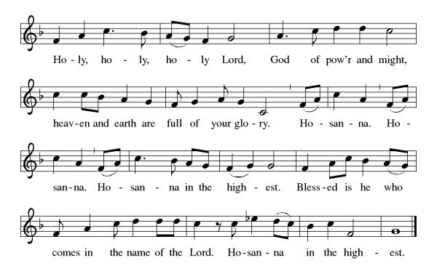

Eucharistic Prayer
(Words of Institution)
For as often as we eat of this bread and drink from this cup we proclaim the Lord’s death until He comes.
Christ has died
Christ is risen.
Christ will come again.
Remembering, therefore, his salutary command,
his life-giving passion and death, his glorious resurrection and ascension, and the promise of his coming again,
we give thanks to you, O Lord God Almighty,
not as we ought but as we are able;
we ask you mercifully to accept our praise and thanksgiving and with your Word and Holy Spirit to bless us, your servants, and these your own gifts of bread and wine, so that we and all who share in the body and blood of Christ may be filled with heavenly blessing and grace, and, receiving the forgiveness of sin,
may be formed to live as your holy people
and be given our inheritance with all your saints.
To you, O God, Father, Son, and Holy Spirit,
be all honor and glory in your holy church, now and forever. Amen.
The Lord’s Prayer
Our Father, who art in heaven, hallowed be thy name, thy kingdom come, thy will be done, on earth as it is in heaven. Give us this day our daily bread; and forgive us our trespasses, as we forgive those who trespass against us; and lead us not into temptation but deliver us from evil. For thine is the kingdom, and the power, and the glory, forever and ever. Amen.
P: Taste and see that the Lord is good.
C: Thanks be to God.
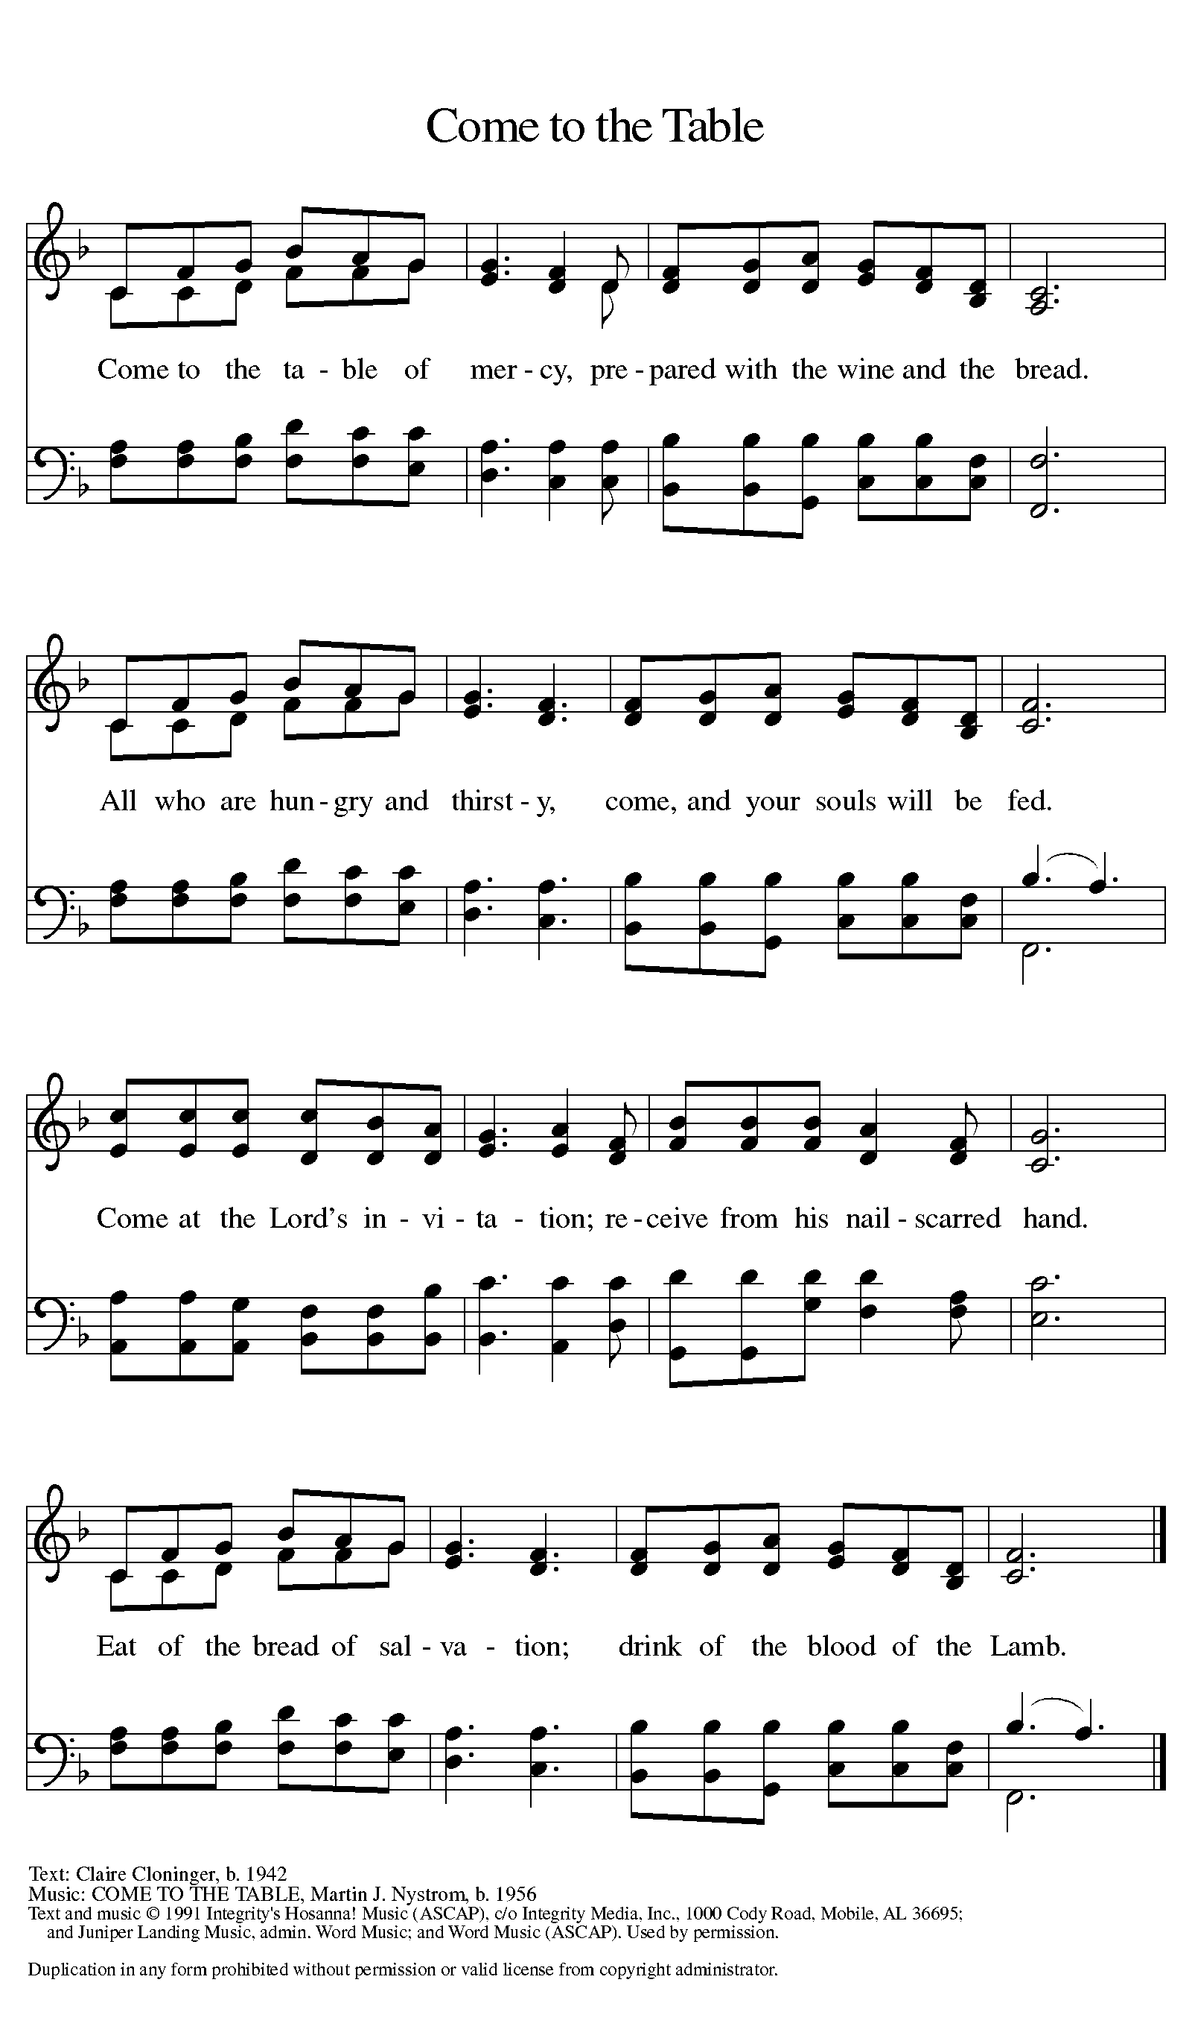
Invitation to Communion

Distribution of Communion – Come Forward to Receive
Communion Hymn: We Come to the Hungry Feast ELW 479, Eat This Bread ELW 472

P- Now may the body and blood of our Lord and Savior Jesus Christ strengthen you and keep you in His grace!
C - Thank You Jesus!

Prayer after Communion
Compassionate God,
Through the gifts of bread and wine
our hearts are filled with the abundance of your love.
Strengthen us that we, through this Holy meal,
may share your love freely, as you have shared with us.
We ask this in the name of Jesus,
through the Spirit nourishing us now and forever.
Amen.

Words of dismissal and benediction
Know that the ever-present mystery we name God
is in your past forgiving you,
in your present loving you,
and in your future meeting you.
And may the blessing of the Source of life, love and hope,
the Word of life, compassion and wisdom
and Breath of life, grace and truth,
Father, ☩ Son, and Holy Spirit,
surround, sustain and surprise you,
this day and all your days. Amen.

Sending Hymn: Go, My Children, with My Blessing ELW 543

1 “Go, my children, with my blessing, never alone.
Waking, sleeping, I am with you, you are my own.
In my love’s baptismal river
I have made you mine forever.
Go, my children, with my blessing, you are my own.”

2 “Go, my children, sins forgiven, at peace and pure.
Here you learned how much I love you, what I can cure.
Here you heard my dear Son’s story,
here you touched him, saw his glory.
Go, my children, sins forgiven, at peace and pure.”

3 “Go, my children, fed and nourished, closer to me.
Grow in love and love by serving, joyful and free.
Here my Spirit’s power filled you,
here my tender comfort stilled you.
Go, my children, fed and nourished, joyful and free.”

Text: Jaroslav J. Vajda, b. 1919, alt.
Text © 1983 Concordia Publishing House
Duplication in any form prohibited without permission or valid license from copyright administrator.

Dismissal
P – Look, and listen to S.A.M. Bob.
C- Thanks be to God.

Postlude:
Unless otherwise noted, service materials used in this bulletin are:
Music is reprinted under OneLicense.Net #A712074 and/or Augsburg Fortress #SBL12176H. Scripture, unless otherwise noted, is from the New Revised Standard Version Bible, Copyright © 1989, Division of Christian Education of the National Council of the Churches of Christ in the United States of America. Used by permission. All rights reserved.
St. Timothy’s is served by S.A.M. Robert “Bob” Bonomo
Lay Minister Frank Hofstetter
Director of Music Sally Hennessey
Saturday Pianist Bill Robinson

Announcements for August 1st and 2nd
ATTENDANCE
Saturday, July 25th, 4pm 26
Sunday, July 26th, 9am 45
Drive-Up Communion 2
73

The altar flowers are given this week by Ed and Carolyn Fialkowski, in honor of their 26th Wedding Anniversary!
Serving our Lord this weekend:
Saturday, August 1st
Reader – Jean Fowler

Sunday, August 2nd
Reader – Sarah Brisson
Altar Guild – John & Jodie Gudorf

This Week at St. Timothy's
Monday, August 3rd 10:30am PB&J, 11am – Healthy Start
Tuesday, August 4th
Wednesday, August 5th 1pm Card Makers
Thursday, August 6th 11-12 Bible Study, 11am – Miniatures, 4:30 - Choir
Friday, August 7th
Saturday, August 8th 4pm Worship, No Fellowship
Sunday, August 9th 9am Worship, 10:30 – Adult SS, Coffee Fellowship

PRAYER LIST
Marcia Treber
Family & Friends of Nick Nichols
Baby Atticus
Teresa York
Debbie Lawrence
Carole Albert
Linda C.
Ashlee
Frani Barnes
Mark Duffy
Wyatt Toney
Jim & Rosa Neth
Melanie
Trish Bradley
Fowler Family
Marcus

Our prayer list has been purged. If you want to put a name back on, please let us know.

