A Service of Worship, Praise and Hope
Welcome to St. Timothy Saturday Evening Worship!
April 27, 2024, Fifth Week of Easter
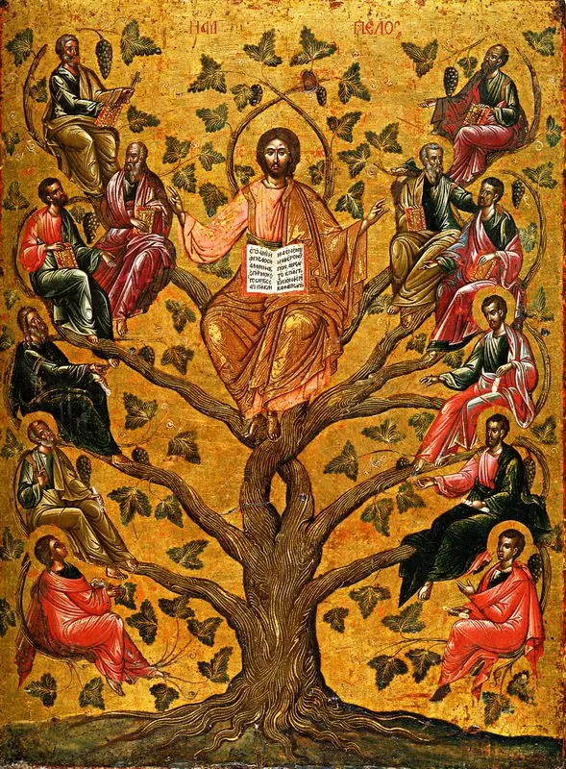

"Equip people to grow as Disciples faithfully serving our community"

We are glad to have you worship with us. All are welcome at communion. If you need gluten-free – please tell Pastor Joanie when you go up for communion. If you have any questions – just ask the Welcomer at the back of the sanctuary.

Please note** if you use a pew envelope for your offering – please write your name on the envelope so that the financial secretaries can post it as a gift from you. Thank You!
St Timothy Worship Planning Team
The Reverend Joan E. Holden 850-774-7730
Eric Mortensen – Director of Music
Frank Hofstetter, Parish Deacon

The Altar Flowers are given in honor of Kathy Burkett’s birthday!

This Week at St. Timothy's
Monday, April 29th PJ OFF
Tuesday, April 30th
Wednesday, May 1st 10am – Citrus Blessings, 10am – OT BS, 11:30am – Card Makers
Thursday, May 2nd 9:30am – Prayer Group, 11:00 am – Miniatures , 4:30pm - Choir
Friday, May 3rd 10am – NT BS
Saturday, May 4th NO MOST, 8-1:30pm WELCA SPRING GATHERING (HERE) 4 pm – Worship
Sunday, May 5th 9 am – Worship – Childrens SS, 10:30 am – Adult Sunday School, 11-11:30 am – Drive Up Communion

Rooted in the past and growing into the future, the church must always be reformed in order to live out the love of Christ in an ever-changing world. We celebrate the good news of God’s grace, that Jesus Christ sets us free every day to do this life-transforming work. Trusting in the freedom given to us in baptism, we pray for the church, that Christians will unite more fully in worship and mission.
(from Sundays and Seasons for Reformation Weekend)

“Shout to the Lord” is the last pre-service hymn the choir sings, it is Hymn #821 and everyone is welcome to sing with the choir.
Welcome and Sharing of Congregational News

Preparation Anthem: For God So Loved W&P 39

Gathering Hymn: Let All Things Now Living ELW 881
- Let all things now living a song of thanksgiving to
God the creator triumphantly raise,
who fashioned and made us, protected and stayed us, who
still guides us on to the end of our days.
God's banners are o'er us, God's light goes before
us, a pillar of fire shining forth in the night,
till shadows have vanished and darkness is banished, as
forward we travel from light into light.

- God rules all the forces: the stars in their courses and
sun in its orbit obediently shine;
the hills and the mountains, the rivers and fountains, the
deeps of the ocean proclaim God divine.
We too should be voicing our love and rejoicing;
with glad adoration a song let us raise
till all things now living unite in thanksgiving: "To
God in the highest, hosanna and praise!"

P - The grace of our Lord Jesus Christ, the love of God and the communion of the Holy Spirit be with you all.
C - And also with you.

Confession and Forgiveness
P - Blessed be the Holy Trinity, + one God, whose name is majestic in all the earth, who rescues and heals in every time of trouble, who does all things well.
C – Amen
P - Let us come before God, seeking forgiveness and life.
(Silence is kept for reflection and self-examination)
P - Steadfast and saving God,
C - Have mercy on us. We confess to you all our sins and that in these continuing times of uncertainty and fear, we have trouble trusting you and feeling your presence. Forgive us our sins, our doubts, our fears and lack of patience with others. Strengthen our faith and help us to let your hope and light shine through us in these dark times. We ask for mercy, wisdom and guidance, through Jesus Christ, our Savior and Lord. Amen.
P - In the name of + Jesus, the Son of God, receive mercy and find grace in your time of need. Your sins are forgiven; God's love is healing balm for your wounds. Rejoice, for God raises you up to new life in Christ.
C - Amen
Greeting
P - The joy of our Lord Jesus Christ, the compassion of God, and the creative power of the Holy Spirit be with you all.
C - And also with you.

Prayer of the Day
O God, you give us your Son as the vine apart from whom we cannot live. Nourish our life in his resurrection, that we will bear the fruit of love and know the fullness of your joy, through Jesus Christ, our Savior and Lord, who lives and reigns with you and the Holy Spirit, one God, now and forever. Amen.
Word

First Lesson: 1 John 4:7-21
We love God and others because God first loved us. We cannot say we love God, whom we have not seen, while hating fellow Christians, whom we regularly see. Love toward God is to be matched by love toward others because the essence of God is love.
⁷Beloved, let us love one another, because love is from God; everyone who loves is born of God and knows God. ⁸Whoever does not love does not know God, for God is love. ⁹God’s love was revealed among us in this way: God sent his only Son into the world so that we might live through him. ¹⁰In this is love, not that we loved God but that he loved us and sent his Son to be the atoning sacrifice for our sins. ¹¹Beloved, since God loved us so much, we also ought to love one another. ¹²No one has ever seen God; if we love one another, God lives in us, and his love is perfected in us.
¹³By this we know that we abide in him and he in us, because he has given us of his Spirit. ¹⁴And we have seen and do testify that the Father has sent his Son as the Savior of the world. ¹⁵God abides in those who confess that Jesus is the Son of God, and they abide in God. ¹⁶So we have known and believe the love that God has for us.
God is love, and those who abide in love abide in God, and God abides in them. ¹⁷Love has been perfected among us in this: that we may have boldness on the day of judgment, because as he is, so are we in this world. ¹⁸There is no fear in love, but perfect love casts out fear; for fear has to do with punishment, and whoever fears has not reached perfection in love. ¹⁹We love because he first loved us. ²⁰Those who say, “I love God,” and hate their brothers or sisters, are liars; for those who do not love a brother or sister whom they have seen, cannot love God whom they have not seen. ²¹The commandment we have from him is this: those who love God must love their brothers and sisters also.

P – The Holy Gospel according to John, Chapter 15

C – Glory to you O Lord.

Gospel: John 15:1-8
On the night of his arrest, Jesus taught his disciples about the relationship they would have with him. Those who abide in his word and love bear fruit, for apart from him, they can do nothing.
[Jesus said:] ¹“I am the true vine, and my Father is the vinegrower. ²He removes every branch in me that bears no fruit. Every branch that bears fruit he prunes to make it bear more fruit. ³You have already been cleansed by the word that I have spoken to you. ⁴Abide in me as I abide in you. Just as the branch cannot bear fruit by itself unless it abides in the vine, neither can you unless you abide in me. ⁵I am the vine, you are the branches. Those who abide in me and I in them bear much fruit, because apart from me you can do nothing. ⁶Whoever does not abide in me is thrown away like a branch and withers; such branches are gathered, thrown into the fire, and burned. ⁷If you abide in me, and my words abide in you, ask for whatever you wish, and it will be done for you. ⁸My Father is glorified by this, that you bear much fruit and become my disciples.”

P - The Gospel of Our Lord!
C - Praise to You O Christ!

Message:

Hymn of the Day: Alleluia! Jesus is Risen! ELW 377
1 Alleluia! Jesus is risen!
Trumpets resounding in glorious light!
Splendor, the Lamb, heaven forever!
Oh, what a miracle God has in sight!
Refrain
Jesus is risen and we shall arise.
Give God the glory! Alleluia!
2 Walking the way, Christ in the center
telling the story to open our eyes;
breaking our bread, giving us glory:
Jesus our blessing, our constant surprise. Refrain
3 Jesus the vine, we are the branches;
life in the Spirit the fruit of the tree;
heaven to earth, Christ to the people,
gift of the future now flowing to me. Refrain
4 Weeping, be gone; sorrow, be silent:
death put asunder, and Easter is bright.
Cherubim sing: O grave, be open!
Clothe us in wonder, adorn us in light. Refrain
5 City of God, Easter forever,
golden Jerusalem, Jesus the Lamb,
river of life, saints and archangels,
sing with creation to God the I AM! Refrain

Apostles’ Creed
I believe in God, the Father almighty,
creator of heaven and earth.
I believe in Jesus Christ, God’s only Son, our Lord,
who was conceived by the Holy Spirit,
born of the virgin Mary,
suffered under Pontius Pilate,
was crucified, died, and was buried;
he descended to the dead.
On the third day he rose again;
he ascended into heaven,
he is seated at the right hand of the Father,
and he will come to judge the living and the dead.
I believe in the Holy Spirit,
the holy catholic church,
the communion of saints,
the forgiveness of sins,
the resurrection of the body,
and the life everlasting. Amen.

Lord, listen to your children praying,
Lord, send your Spirit in this place;
Lord, listen to your children praying,
send us love, send us pow'r, send us grace.

Prayers of the People
Rejoicing that Jesus is risen and love has triumphed over fear, let us pray for the church, the world, and all those in need of good news. A brief silence.
We pray for the church around the world, for all ministers, and for the mission of the gospel. Keep all the newly baptized and confirmed in your care. Cleanse our hearts with your word and help us to abide in you always. God of grace, hear our prayer.
For the well-being of the earth and of all created things: for rivers and lakes, streams and estuaries, melting glaciers and polluted waters. Renew the face of the earth and shower us with your goodness. God of grace, hear our prayer.
For the nations and all those in authority: for local, state, and national leaders, for elected representatives at every level, and for international organizations, that justice and peace may reign. God of grace, hear our prayer.
For all those in need: for any experiencing homelessness or unemployment, for those fleeing from oppression or seeking asylum, and for all who are ill or suffering, especially everyone on our prayer list and everyone we name out loud or silently in our heart…... God of grace, hear our prayer.
For this congregation: for the caring ministries of this faith community, for all who visit and minister to one another, for all who take communion to homes or care centers, and for all who seek to share your love with the world. God of grace, hear our prayer.
At this time anyone can lift up prayers.
God of grace, hear our prayer.
With thanksgiving for the saints who rest from their labors. Help us, like them, to bear much fruit and to become your disciples, and at the last, bring us to that heavenly banquet where all will feast together at your table. God of grace, hear our prayer.
Into your hands, most merciful God, we commend all for whom we pray, trusting in your abiding love; through Jesus Christ, our resurrected and living Lord. Amen.

Peace

P- The Peace of the Lord be with you always.
C – And also with you.
We Share Christ’s Peace

Offering is Brought to the Altar

Offering Prayer

We lift our voices, we lift our hands, we lift our lives up to you; we are an Offering. Lord, use our voices, Lord, use our hands, Lord, use our lives, they are yours: we are an offering. All that we have, all that we are, all that we hope to be, we give to you, we give to you. We lift our voices, we lift our hands, we lift our lives up to you; we are an offering, we are an offering.

Jesus’ Words of Promise and Gift of Life
Dear Lord, Jesus Christ:
in the night in which you were betrayed,
You took bread, broke it and gave thanks,
then you gave it to your disciples saying:
take and eat, this is my body I am giving for you.
Do this in remembrance of me.
Again, after supper, Dear Lord Jesus,
You took the cup, gave thanks
and gave it for everyone to drink saying:
this cup is the new covenant in my blood,
I am shedding for you and for all people for the forgiveness of sin.
Do this for the remembrance of me. Amen.

Our Lord's Prayer
Our Father in heaven, hallowed be your name, your kingdom come, your will be done, on earth as in heaven. Give us today our daily bread. Forgive us our sins as we forgive those who sin against us. Save us from the time of trial and deliver us from evil. For the kingdom, the power, and the glory are yours, now and forever. Amen.

Invitation to Communion
P: Come to this Table where God really does come to us!
C: Thank You Jesus!
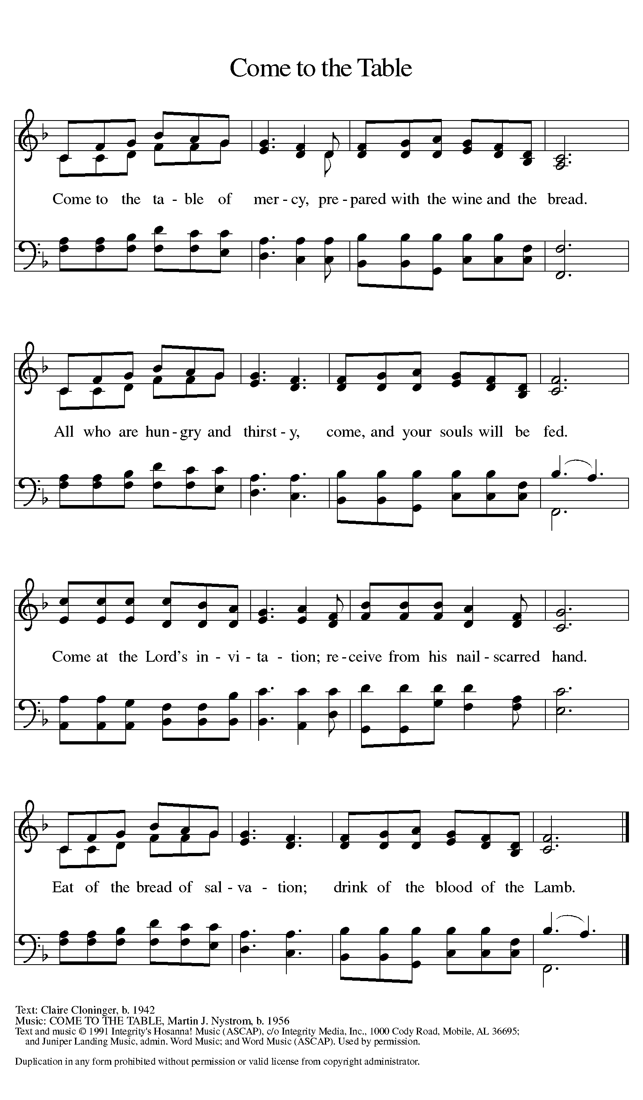

Distribution - Please come forward to receive

Communion Anthem: Lead Me, Guide Me W&P 84

You Satisfy the Hungry Heart ELW 484

P - Now may the body and blood of our Lord Jesus Christ strengthen you and keep you in his grace…. Jesus Loves You!
C – Thank You Jesus!

Prayer after Communion
Shepherding God, you have prepared a table before us and nourished us with your love. Send us forth from this banquet to proclaim your goodness and share the abundant mercy of Jesus, our redeemer and friend. Amen.

Sending

Blessing
P - God Almighty send you light and truth to keep you all the days of your lives. The hand of God protect you; the holy angels accompany you; and the blessing of almighty God, the Father, the ☩ Son, and the Holy Spirit, be with you now and forever.
C -Amen.

Sending Hymn: Word of God, Come Down on Earth ELW 510
- Word of God, come down on earth, living rain from
heav'n descending; touch our hearts and bring to birth
faith and hope and love unending. Word almighty,
we revere you; Word made flesh, we long to hear you.

- Word eternal, throned on high, Word that brought to
life creation, Word that came from heav'n to die,
crucified for our salvation, saving Word, the
world restoring, speak to us, your love outpouring.

3 Word that speaks God's tender love, one with God beyond
all telling, Word that sends us from above
God the Spirit, with us dwelling, Word of truth, to
all truth lead us; Word of life, with one bread feed us.

Dismissal
A: Alleluia! Go in peace. Rejoice and be glad.
C: Thanks be to God. Alleluia!

Postlude Anthem: Lord, I Lift Your Name on High W&P 90
Unless otherwise noted, materials used in this bulletin are:
From Sundays and Seasons.com. Copyright 2015 Augsburg Fortress. All rights reserved. Reprinted by permission under Augsburg Fortress Liturgies Annual License #SAS028635. Music is reprinted under OneLicense.Net #A712074 and/or Augsburg Fortress #SBL12176H. Scripture, unless otherwise noted, is from the New Revised Standard Version Bible, Copyright © 1989, Division of Christian Education of the National Council of the Churches of Christ in the United States of America. Used by permission. All rights reserved.

REMEMBRANCE
Catherine of Siena, theologian, died 1380
This theologian was the first woman among Roman Catholics to receive the title "Doctor [teacher] of the Church." Catherine was a Dominican sister known for her mystical visions as well as her work on behalf of people who were poor and imprisoned.

Announcements for April 27th and 28th
ATTENDANCE
Saturday, April 20th 4pm 27
Sunday, April 21st, 9am 49
Drive-Up Communion 3
79

WELCA SPRING GATHERING.
PEACE, BE NOT ANXIOUS
St. Timothy will be hosting the Pine Lands Conference Spring Gathering on May 4th . ALL WOMEN ARE INVITED ! This event will include women from the churches in our conference . We will start with a Breakfast and Registration at 9am . There is a $10 fee for the offering to the Florida-Bahama Women's Organization (SWO) and expenses. We will have a short meeting, a devotional SWO representative Leone Goding talk about WELCA and the changes to Lutheran World Relief. There will be a lunch provided with Gluten Free available. We will end the day with a Communion Service led by Pastor Joanie.
Please join us for this wonderful day of fellowship with our Sisters from the Pine Lands Conference. RSVP BY APRIL 26 ON THE WELCA BOARD SO THAT WE CAN BE ASSURED TO HAVE PLENTY OF SUPPLIES IF YOU ARE GLUTEN FREE PLEASE INDICATE THAT ON SIGN IN SHEET. ANY QUESTIONS SEE SALLIE HALEY.
