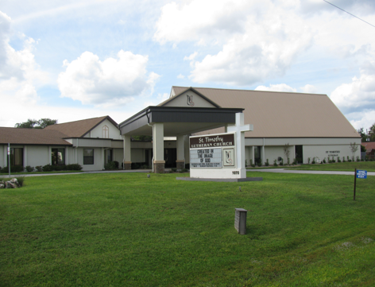

ST. TIMOTHY EVANGELICAL
LUTHERAN CHURCH
Vineyard Views
September 2026

Bob’s Corner
August 28,2026

What is God calling us to do. Do we know? Do we just give it a thought and move on? Do we say I’ll help out at the church next month and again you are a no show?
Do you know Jesus? Are you pleased with what He has done for us in our lives or are you still questioning Him. Would we go through what He went through for us? Our level of gratitude should be off the charts, because what He wants us to do is: Serve those in need, share the Good News, pray boldly everyday and love your neighbor.
That does not sound like a full plate. And yet we fall short, I fall short for at times in my gratitude for Jesus.
We should all remember this when we hear the word Stewardship, and when we hear the words time and talent.
Please do not shut down. Please open your life to serve Jesus as best as you can. There are many hands in the pot we call St. Timothy and there is always room for more hands.
It’s time to make time. It’s not time to make excuses. Jesus gave us a talent; we need to figure it out and use what talent He gave us. Jesus has given us the time to do His work.
If you love our Lord and if you love St. Timothy’s church sent me a big AMEN.
May the love of God, bless all of you and give you His peace.
S.A.M. Robert (Bob)
Deaconbob73@gmail.com



Call Committee Corner
UPDATE AS OF 8/24/2026
Dear Church Family,
When we last updated you on the progress of the Call Committee, we talked about our next steps per our Zoom call with Pastor Nicole Eastwood in June. We are feeling like the congregation may think that we are no longer active as a call committee. Nothing could be further from the truth. As the members of this committee listen to your questions, and comments, we must balance these concerns with what God is leading us to do in the mission set before us. As you may or may not be aware, many of the eight (8) members of this Call Committee, not only serve God in this capacity, but also in several other committees, on council, in worship, and other church group activities. We sure could use your help in prayer.
- On July 5, 2026, we held our practice interview with an approved Retired Pastor. It went very well and with the information that we discussed during that interview, and the notes that Pastor Eastwood had us take on corrections needed to the Ministry Site Profile, we proceeded to provide our Committee Tech Expert with a word document detailing the changes needed on the MSP. Most of the corrections and responses to the questions on the Ministry Site Profile were needed to provide a more specific picture of our Congregation as well as to provide a clearer picture of our area demographics pertaining to the lifestyles and economics of our area.
As Pastor Nicole asked us on the call, " Who are we at St. Timothy?" This may seem like an easy question, but it did take some time and discussion to clearly define the answers. Our prior Call Committees wrestled with the very same question during their searches for our prior pastors. And our church is not the only congregation in Citrus County that is searching for their new Shepherd.
- Once gave our Tech expert everything he needed to re-enter the national ELCA portal for Ministry Site Profiles. He emailed all of us and asked when it was okay to resubmit. We printed it for our committee to review once more, because eight (8) sets of eyes and brains are better than one. Then our committee met again, reviewed it, suggested any additional changes or corrections, and our Tech expert resubmitted the edited version on July 19, 2026 to the National ELCA Portal for the Ministry Site Profiles.
After that was completed, he filed the Seven Reflections of Ministry and Context form online. The response that our Tech expert received after filing was: The resubmitted MSP was being forwarded to the office of the Bishop for the Florida Bahamas Synod.
- On August 11, 2026, I emailed Pastor Nicole Eastwood to inform her that the MSP had been resubmitted and the Seven Reflections Form was filed. We also informed her that we held our practice interview with the approved retired Pastor. In addition, I added the MSP as an attachment. We requested a response from her to confirm that she was aware of the resubmission, etc. and that could she let us know if there was any movement on a decision by the Bishop in sending us a
potential candidate's information, so that we would be able to review it and contemplate an interview.
- As of August 23, 2026, we have not received a response to our email of August 11, 2026, therefore, we are sending an additional email letter with attachments again requesting an update from Pastor Nicole Eastwood and we are copying this information to her assistant.

We will update you again as soon as we have received a response from the Synod office. Until God, our Bishop, and Synod select prospective candidates to send to us, we must be wise, but also patient in waiting. Even though we are in a waiting period, this does not mean that God is not working on the new Shepherd for our St. Timothy flock.
- The only promise that we can make, as the Call Committee of St. Timothy Lutheran in Crystal River, is that we continue in our commitment to the mission that God has called us to and to prayerfully seek God's Guidance and Blessing on the choice of our future Pastor.
Respectfully Submitted,
Mary Schlumberger, for the Call Committee

Barbara Johnson Diane Mason
Ginny Owen Jackie Gregg
Richard Kleinsmith Judi Schutrum
John Gudorf

WELCA ANNOUNCEMENT FOR SEPTEMBER VINEYARD VIEWS
"Sisters in Christ, are sisters for life!"

Dear Sisters In Christ,
Are you a woman who attends St. Timothy Lutheran? If you recently joined our congregation and did not receive your welcome to our group from WELCA, then please call me, Mary Schlumberger at 352-212-7962 so that I may do that. It is that easy to become a member of WELCA (Women of the ELCA). We either have a membership meeting at 1:00 P.M. in the Bradford Fellowship Hall, or a luncheon at 12:00 P.M. either in the Bradford Fellowship Hall or a local restaurant, each month on the third Tuesday. Twice a year, we get to see our other sisters in Christ at the Pinelands Conference Spring Gathering at one of our sister churches in March on a Saturday, and Florida Bahamas Synod WELCA Fall Gathering from a Friday -Sunday usually around the second weekend in November at Warren Willis Retreat Center in Fruitland Park, FL. At many of our luncheons, we invite the men of St. Timothy. Check the WELCA Bulletin Board for any sign-up sheets and information.

We hope that you all had a great summer. And now we come back together for some fellowship with the ladies of St. Timothy. Our next meeting is Tuesday, September 15, 2026 at 1:00 p.m. in the Bradford Fellowship Hall. We have many items to cover, plan for, and get suggestions for our new WELCA year, and we would love to have all of our ladies participating.

Our WELCA Board was installed at our June 16, 2026 luncheon at the Three Sisters Restaurant. All members of our 2025-2026 Board agreed to stay on for another year. So the Board for 2026-2027 is:

President - Mary Schlumberger
Vice President - Barbara Carson
Treasurer - Barbara Johnson
Secretary - Sally Hennessey

We are so blessed to have a great group of ladies working together to keep our WELCA group lively and vibrant. See you in September.

Blessings,
Mary C. Schlumberger - President

THE POWER OF PRAYER IN ACTION
AND INSPIRATION

“TAKING A RISK”
By Barbara Carson

One of my favorite bible verses is Psalm 119:105 which is “Your Word is like a lamp for my feet and a light for my path.” Does that sound like risky business? We can divide that into two parts. One is your word is like a lamp. What happens when it is dark and dreary. We can lose our way and maybe become disoriented and fearful. We can miss out on opportunities. So, what is the answer to that? God, of course! His Word is his presence in our life. The risk is, do we take it and miss out on a great opportunity? That is why we need direction.

The second part is a light for my path. Stepping into a situation which could be unknown and also be scary. We need courage and through the power of prayer, God lights our path and when it could be negative or positive, he lights the way and helps us take the right path.

Remember the saying “when a door closes, God opens a window” to guide our path. He is opening our mind and heart to all possibilities and opportunities, but we have to take that risk. Our relationship with God will open and that smallest step of faith can activate the mightiest of miracles. God will reclaim us and the risk, well, taking a risk will be our lamp to guide us and his light will shine on our path toward him.
Yes, life can be a risky business, but God restores us and reclaims us no matter if we get sidetracked, he leads us towards him. Thank you, God, for being my perfect guide and navigator. AMEN

Benevolence for September - Nature Coast Ministries – Medical and Dental
Local program which offers free or drastically reduced priced dental care.

A thank you note from Judi Schutrum
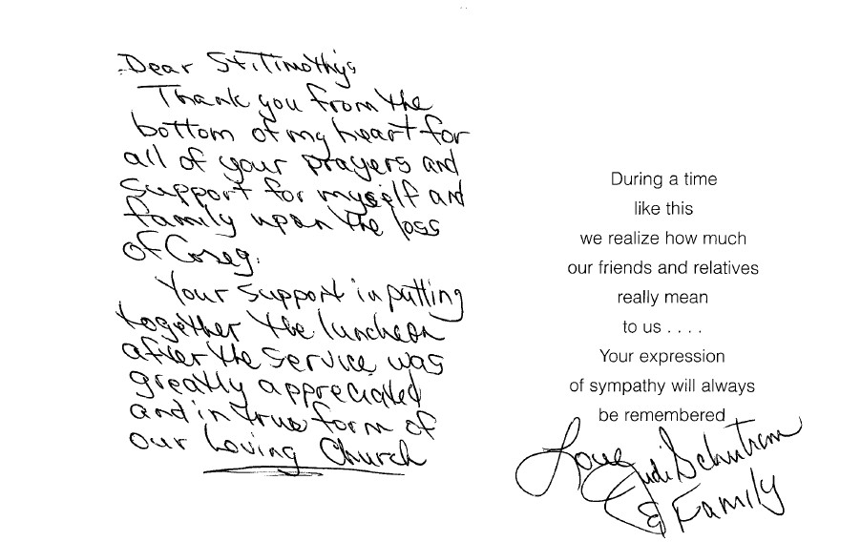


IRRIGATION SYSTEM
PLEASE DO NOT DRIVE OR PARK ON ANY OF THE GRASSY AREAS ON THE CHURCH PROPERTY. ALL THE SPRINKLER HEADS AND PIPES HAVE BEEN FIXED AND ARE IN WORKING ORDER. WE DON’T WANT TO HAVE TO KEEP REPLACING THEM.

CHILD SAFETY TRAINING
Child Safety Training will be given on Wednesday, September 16, 2026 at 9:30 am and on Sunday, September 20, 2026 at 10:30 am in our Fellowship Hall. This class is required every three years for keyholders, Council members, and anyone working with our children. Everyone is welcome and encouraged to take this training to help safeguard our children from sexual abuse. The class will last approximately 1 hour and 15 minutes. If you have any questions, please contact Lynn Dively at 352-382-0435.

C.A.S.A.
CITRUS COUNTY ABUSE SHELTER ASSOCIATION
Patti Cyr will now lead St. Timothy Lutheran Church as the representative for C.A.S.A. Outreach Ministry, for woman who are abused.
Starting in September we will begin to collect Care items:
Body wash Laundry detergent and softener
Shampoo and conditioner Trash bags
Body lotion Disinfectant wipes
Deodorant Lysol spray
Multi-purpose cleaner

At our next WELCA meeting in October, your donations will be presented to our guest speaker from C.A.S.A.
All women in the ELCA are WELCA representatives.
Come and welcome this month’s guest speaker and stay for a meeting. WELCA is a wonderful outreach ministry for those who might be looking to give their time and talent.
Please place your donated items in the designated bin in the Fellowship Hall.
For more information, please call Patti Cyr #352-422-7313.

Respectfully submitted,
Patti Cyr

From the desk of Minister Robert
If the holy spirit has touched you to even thinking about becoming a council member, feel free to call me or come and see me.
Having a discussion does not mean in any way that you must say yes.

Blessings

DEADLINES
Announcements
Please be aware that if you have entries for the weekend worship announcements you need to have them in on Tuesday prior, as we are preparing and printing them no later than Thursday.

Vineyard Views
If you have submissions for the October Vineyard Views, please have them in the office no later than the end of day on Tuesday, September 22nd.
Pinelands Fall Gathering 2026
Registration now open – sign-up sheet on board
Carpooling available
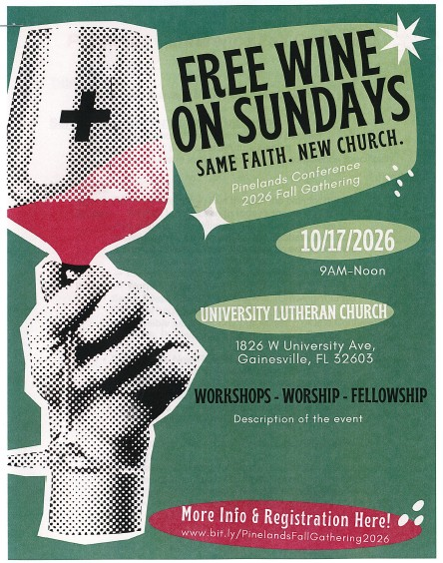
Please check for the following sign-up sheets
Pinelands Conference Fall Gathering – bulletin board by kitchen
Serving Our Lord (Worship Helpers) – bulletin board by kitchen
Flower chart – WELCA board
Healthy Start –bulletin board by kitchen
PB&J Ministry – bulletin board by kitchen
Serving Hands - bulletin board by kitchen
Coffee Hour – in kitchen

UPDATED 7/16 - ZOOM LINK FOR ADULT SUNDAY SCHOOL
Sundays at 10:30am
Join Zoom Meeting
https://us06web.zoom.us/j/88640128252?pwd=asNJ6OiNGFFTNzwNA5yhkvPpmt6VCT.1
Meeting chat link
https://us06web.zoom.us/launch/jc/88640128252
Meeting ID: 886 4012 8252
Passcode: 898938



THRIVENT FINANCIAL NEWS FOR SEPTEMBER 2026
$$$THRIVENT CHOICE DOLLARS®$$$
Thanks so much to our Thrivent Financial members and friends who direct their Thrivent Choice Dollars® to available for activities and projects for our mission and ministry here at St. Timothy. If you are an eligible Thrivent Financial member and have Choice Dollars® available, please call Thrivent (800-847-4836) and say “Thrivent Choice®” or go online to www.thrivent.com/thriventchoice and direct your dollars…hopefully to St. Timothy Lutheran Church in Crystal River. To date for 2026 our church has received $2,219.00 through
this program. Thanks to the following family members who recently directed their $$ to St. Timothy:

Patti Cyr Duwayne Fowler Barbara Johnson

THRIVENT ACTION TEAMS
Thrivent Action Teams make it easy for you to bring people together to make a positive change in your community! When you see a need, apply to lead a volunteer team. Once your idea is approved, a Thrivent Action Kit is delivered to your door. It’s packed with everything you need to help make your project a success. It even includes $250.00 in seed money to help get your project started. After you finish the project, you report the results on-line to Thrivent. This program is brought to you by Thrivent Financial because they believe that being wise with money and living generously go hand in hand. All your questions and requests for this funding program will be answered by going to Thrivent.com/actionteam.***Please note that Thrivent Financial funds accessed for all programs and activities involving St. Timothy Lutheran Church need to be approved by a Committee and the Congregational Council. 2026Thrivent Action Teams that have been approved: Easter Food Boxes, Bump2Baby Expo, PB&J Ministry, Food Pantry, God’s Work Our Hands, Thanksgiving Food Boxes, Christmas Elves and supplies for CASA.

THE $250 IN SEED MONEY IS A GIFT FROM THRIVENT THAT WE CAN USE TO HELP WITH COMMUNITY OUTREACH AND PROJECTS INVOLVING OUR CONGREGATION. THESE FUNDS ARE IN ADDITION TO OUR BUDGETED AMOUNTS AND OFFERINGS AND DONATIONS MADE BY OUR MEMBERS AND FRIENDS.

Financial Representatives for answering questions and offering advice on Thrivent investments and products are:

Katherine Gross Kevin Braunschweiger
in Gainesville, FL in Ocala, FL
352-505-8905 352-440-6784
Katherine.gross@thrivent.com
Virtual Advice Team – 855-303-7402

Submitted by Lynn Dively

Food Pantry – updated 9/17
The food pantry could use our help with food and/or money. If you want to donate, you can write a check out to LifeTree Church an write “food pantry” on the memo line. Please put the check in an envelope and place it in my mailbox, #210. The current food needs are : any canned vegetables, fruits, chili or peanut butter.
The food pantry continues to be open on the 2nd and 4th Tuesdays of the month, from 9-12. The next food pantry will be on September 22nd.

Healthy Start – updated 9/8
Needs for October: 6 baby lotion, 5 baby shampoo, 7 toys/teething rings, 7 Vaseline.
Carolyn Fialkowski

PB&J MINISTRY UPDATE
Our peanut butter lunch packing for DayStar is the first Monday of the month at 10:30. There is a sign-up sheet on the bulletin board in the hallway by the kitchen. We need about 6 people each time or let me know if you are interested. Thank you - Barbara Carson


MESSAGE FROM REGINA
Please, if you are at a church function, think about snapping a few photos for everyone to enjoy. Thank you in advance.

SERVING HANDS
Serving Hands is a program created to help members of our own congregation. Serving Hands is there for you if you need some help in the following areas: a meal brought to you, driving you to an appointment, a friendly visit, doing a household chore, communion brought to you, walking your dog, or picking up food for your pet, etc. These are one-time opportunities, not forever experiences. Please contact Carolyn Fialkowski at 814-392-4281, or Jean Fowler at 586-322-8337 if you need help.
Please don’t hesitate to call. We want to serve you! Also, if you are willing to help with any of these services, there is a sign-up chart on the kiosk in the entrance way of the church or call one of these ladies.

AED /Medical response :
We have a poster that is behind the kiosk across from our AED in the narthex. An emergency incident can happen at any time, and it is good to be prepared. The poster explains a “hands only “ CPR protocol as the first line of an emergency of that kind and is very easy for anyone. Please take a look and refresh yourself on the protocol. Our AED is valuable for saving lives but initiating CPR is essential. We do have several people in our congregation that have more detailed experience to assist as needed. For any questions, please ask Barbara Carson.
Instructional video on how to use the Philips AED.
https://youtu.be/t6GV9PAbgM4?si=dZuGq8aLjfvpFiM-
(ctrl + click to follow link)

ST TIMOTHY’S WEBSITE
Here is the St. Timothy website address: https://www.sttimlutherancrystalriver.com/
(ctrl + click to follow link)

LIVESTREAMING WILL BE UNAVAILABLE UNTIL FURTHER NOTICE, WHILE WE RESOLVE SOME TECHNICAL ISSUES. We apologize for any inconvenience.

Facebook
See our Facebook page for information about upcoming events and Please feel free to message us with suggestions about content. - Regina

St. Timothy Evangelical Lutheran Church | Facebook
(ctrl + click to follow link)


The Sunshine Card Makers
The Card Makers meet the first Wednesday of the month at 1pm, in the Fellowship Hall.
-Kathy G

We have the October, November, December 2026 Christ in Our Home booklets. There are some on the table by the mailboxes or you may request one to be put in your box.
HERE AND THERE WITH THE FOLKS OF ST TIMOTHY

Wednesday, September 2nd, 2026
Citrus Blessings
We had 7 volunteers, packed 185 bags and delivered 232

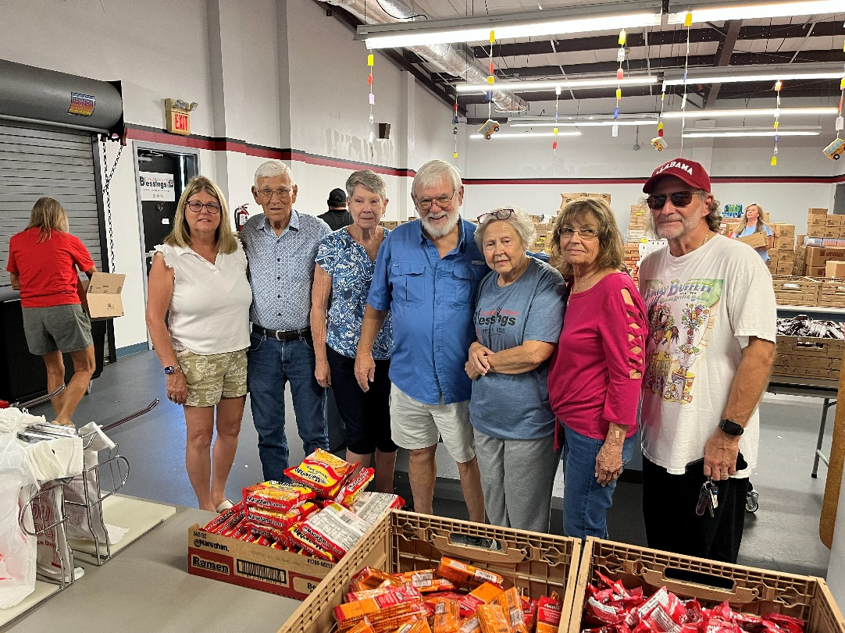



JoAnne Ollenborger 9/01
JoEllen Sigmund 9/01
Tyler Bobb 9/06
Eileen Hofstetter 9/11
George Wright 9/23
Michael Smorol 9/25
Robert Schlumberger 9/25

Birthday Blessings!

September 2026
SUNDAY | MONDAY | TUESDAY | WEDNESDAY | THURSDAY | FRIDAY | SATURDAY
 |  | 1 | 2  1pm Card Makers | 3 | 4 | 5  4pm Worship  No Fellowship
6  9am Worship  10:30 Adult SS, Coffee Fellowship | 7  LABOR DAY  10:30am PB&J  11am – Healthy Start | 8  9-12 Food Pantry | 9  10am Executive Council | 10  11-12 Bible Study for Beginners  11am Miniatures  1-2pm Dirty Dozen  3-4pm Worship & Music  3:30 - Chimes  4:30 Choir | 11 | 12  4pm Worship  No Fellowship
13  9am Worship (Special liturgy for GWOH)  10:30 Adult SS, Coffee Fellowship  12pm GWOH packing | 14  10:30 Ruth Circle resumes @ Barbara Carson’s house  1pm Garden Club | 15  1pm WELCA | 16  9:30 Child Safety Class  11am Council | 17  11-12 Bible Study for beginners  11am – Miniatures  3:30 - Chimes  4:30 Choir | 18 | 19  4pm Worship  No Fellowship
20  9am Worship  10:30 Adult SS, Coffee Fellowship  10:30 Child Safety Class | 21 | 22  9-12 Food Pantry  1pm Royal Dalton  Vineyard Views deadline | 23 | 24  11-12 Bible Study for beginners  11am – Miniatures,  3:30 – Chimes  4:30 Choir | 25 | 26  4pm Worship  No Fellowship
27  9am Worship -  10:30 Adult SS, Coffee Fellowship | 28 | 29  Bob @ Joy for Pastor’s Conference | 30 | 31  11-12 Bible Study for beginners  11am – Miniatures,  3:30 – Chimes  4:30 Choir

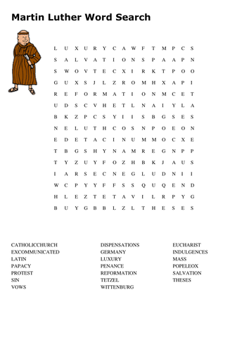

St. Timothy Lutheran Church
S.A.M. Robert “Bob” Bonomo
1070 N. Suncoast Blvd.
Crystal River, FL 34429
Phone: 352-795-5325

Church email: crsttimothy@tampabay.rr.com
Website: www.sttimlutherancrystalriver.com
(ctrl + click to follow link)

Lay Minister: Frank Hofstetter
Director of Music: Sally Hennessey
Saturday Pianist: Bill Robinson
Church Secretary: Regina Mendicino
Sexton: William “Bill” Dexter

2026 Congregational Council Members
President: Barbara Carson
Vice-President: Barbara Johnson
Secretary: Carolyn Fialkowski
Treasurer: Lynn Dively
Council Members: Patti Cyr, Jodie Gudorf, Bob Bonomo

Weekly Worship
Saturdays 4pm
Sundays 9am
Holy Communion available at both services
Adult Sunday School - 10:30am
Sunday Services -YouTube links on website

