Welcome to St. Timothy Evangelical Lutheran Church
Saturday, January 31st and Sunday, February 1st
Fourth Sunday After Epiphany

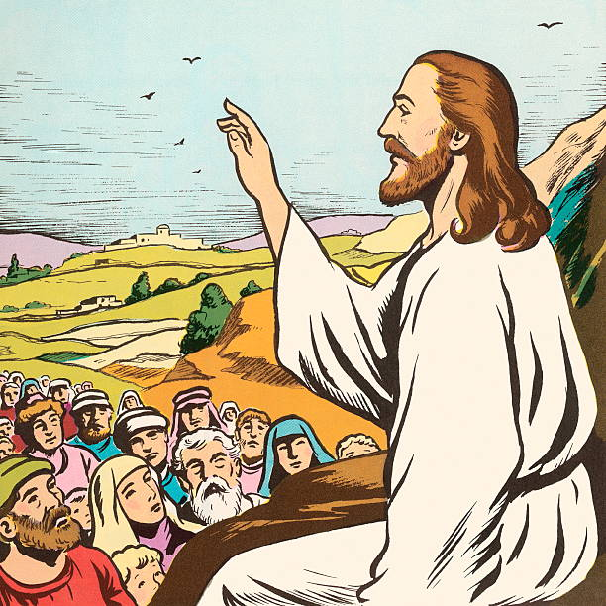

Who are the blessed ones of God? For Micah, they are those who do justice, love kindness, and walk humbly with God. For Paul, they are the ones who find wisdom in the weakness of the cross. For Jesus, they are the poor, the meek, the merciful, the pure in heart, the peacemakers, those who mourn, and those who hunger for righteousness. In baptism we find our blessed identity and calling in this countercultural way of living and serving.

Preservice: Let Justice Roll Like a River W&P 85
Welcome and Sharing of Congregational News
Prelude

Confession and Forgiveness
All may make the sign of the cross, the sign that is marked at baptism, as the presiding minister begins.
Blessed be the holy Trinity, ☩ one God,
the Creator of heaven and earth,
the Word who spoke life into being,
the Wind stirring the waters.
Amen.
Let us turn in confession to the one who knows us completely.
Silence is kept for reflection.
Mighty God, lover of justice,
you call us to life in community,
but we have served our own interests
at the expense of our neighbors.
We have sown deceit where honesty was needed.
We say the right words,
but our hearts are far from you.
Turn us to seek your face.
Knit us together and give us the mind of Christ,
that we may do justice, love mercy,
and walk humbly with you, our God.
Amen.

Forgiveness
The former things have passed away,
and new things God now declares:
Like a spring of water that never fails,
God covers you in the righteousness of Christ,
and forgives your sin in ☩ Jesus’ name.
May the Spirit give you strength to live for others,
and bless you with the gift of peace.
Amen.
Greeting
P: The joy of our Lord Jesus Christ, the compassion of God, and the creative power of the Holy Spirit be with you all.
C: And also with you.

Gathering Hymn: ACS 977
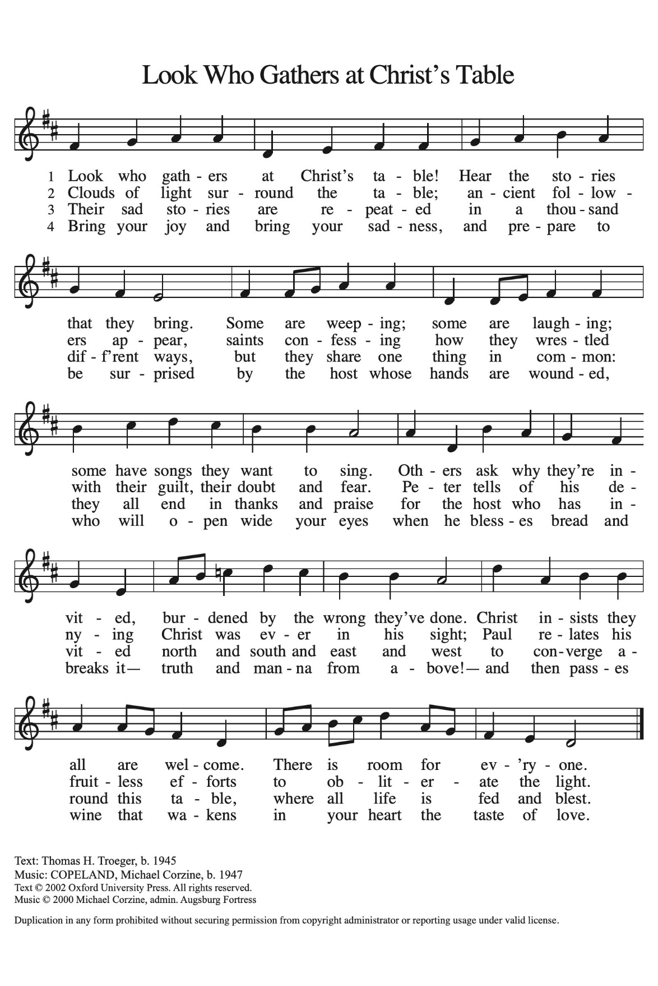

Prayer of the Day
Holy God, you confound the world’s wisdom in giving your kingdom to the lowly and the pure in heart. Give us such a hunger and thirst for justice, and perseverance in striving for peace, that in our words and deeds the world may see the life of your Son, Jesus Christ, our Savior and Lord. Amen.
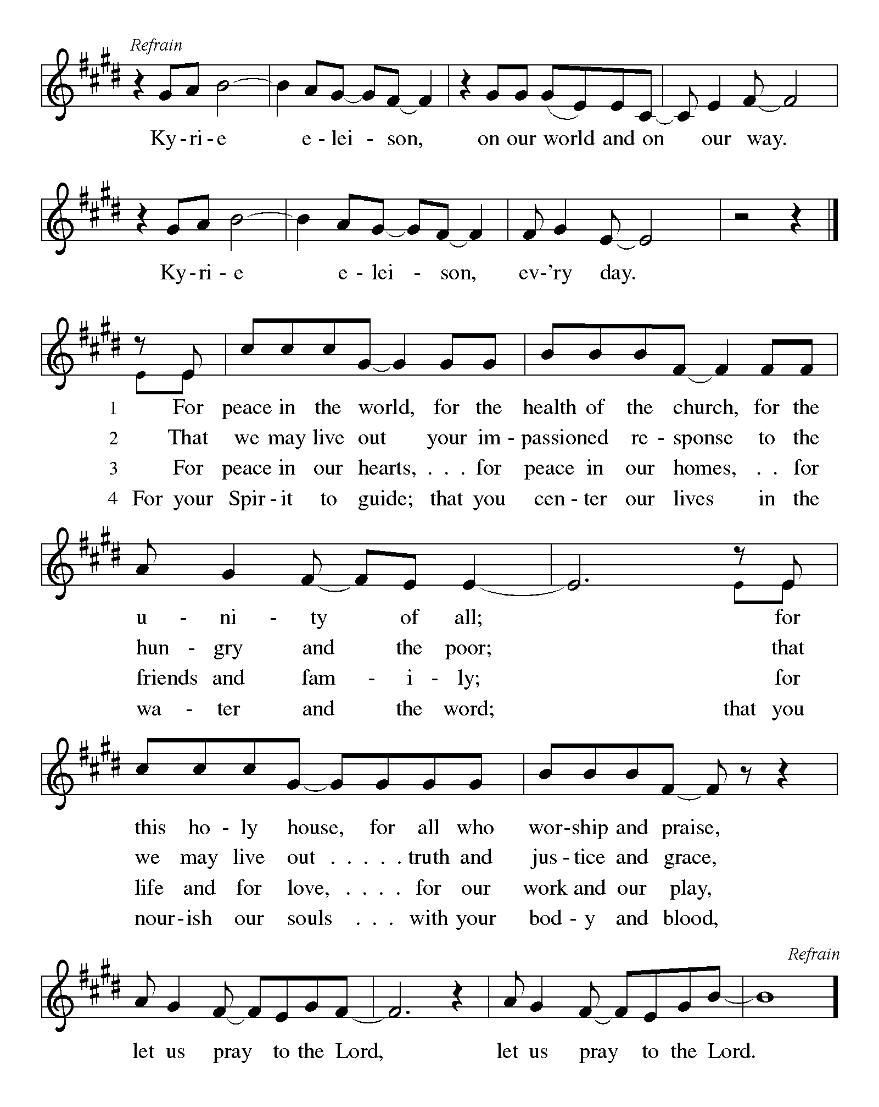

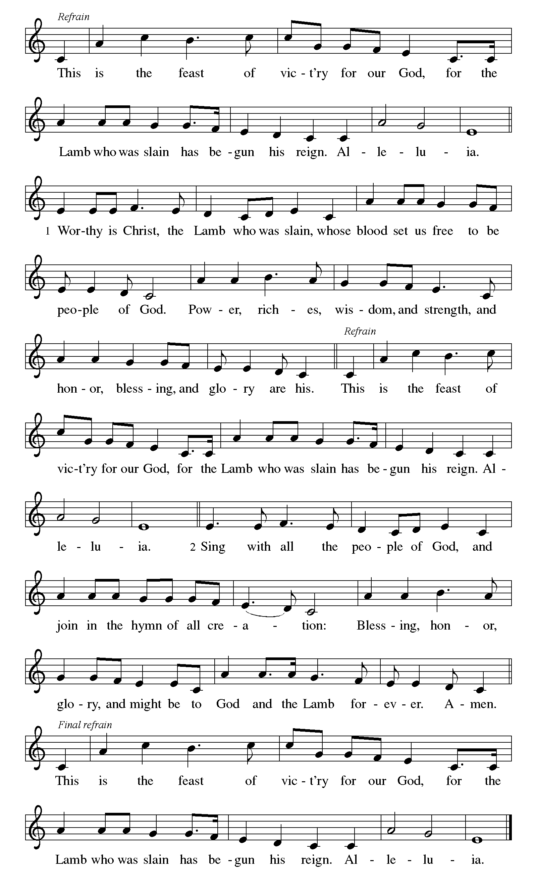

First Reading: Micah 6:1-8
With the mountains and the foundations of the earth as the jury, God brings a lawsuit against Israel. God has “wearied” Israel with a long history of saving acts. God does not want or expect lavish sacrifices to attempt to earn divine favor. Rather God empowers the people to do justice, to love loyalty to God, and to walk shrewdly in God’s service.
¹ Hear what the Lord says:
Rise, plead your case before the mountains,
and let the hills hear your voice.
² Hear, you mountains, the case of the Lord,
and you enduring foundations of the earth,
for the Lord has a case against his people,
and he will contend with Israel.
³ “O my people, what have I done to you?
In what have I wearied you? Answer me!
⁴ For I brought you up from the land of Egypt
and redeemed you from the house of slavery,
and I sent before you Moses,
Aaron, and Miriam.
⁵ O my people, remember now what King Balak of Moab devised,
what Balaam son of Beor answered him,
and what happened from Shittim to Gilgal,
that you may know the saving acts of the Lord.”
⁶ “With what shall I come before the Lord
and bow myself before God on high?
Shall I come before him with burnt offerings,
with calves a year old?
⁷ Will the Lord be pleased with thousands of rams,
with ten thousands of rivers of oil?
Shall I give my firstborn for my transgression,
the fruit of my body for the sin of my soul?”
⁸ He has told you, O mortal, what is good,
and what does the Lord require of you
but to do justice and to love kindness
and to walk humbly with your God?

P: Here ends our first reading.
C: Thanks be to God!

Psalm 15
¹ Lord, who may dwell in your tabernacle?
Who may abide upon your holy hill?
² Those who lead a blameless life and do what is right,
who speak the truth from their heart;
³ they do not slander with the tongue, they do no evil to their friends;
they do not cast discredit upon a neighbor.
⁴ In their sight the wicked are rejected, but they honor those who fear the Lord.
They have sworn upon their health and do not take back their word.
⁵ They do not give their money in hope of gain, nor do they take bribes against the innocent.
Those who do these things shall never be overthrown.

Second Reading: 1 Corinthians 1:18-31
According to the world’s standards of power and might, the message of the cross seems stupid and offensive. Yet this word reveals the paradoxical way God has chosen to work power and salvation through weakness, rejection, and suffering. Hence the message of the cross becomes true wisdom and power for believers.
¹⁸ The message about the cross is foolishness to those who are perishing, but to us who are being saved it is the power of God. ¹⁹ For it is written,
“I will destroy the wisdom of the wise,
and the discernment of the discerning I will thwart.”
²⁰ Where is the one who is wise? Where is the scholar? Where is the debater of this age? Has not God made foolish the wisdom of the world? ²¹ For since, in the wisdom of God, the world did not know God through wisdom, God decided, through the foolishness of the proclamation, to save those who believe. ²² For Jews ask for signs and Greeks desire wisdom, ²³ but we proclaim Christ crucified, a stumbling block to Jews and foolishness to gentiles, ²⁴ but to those who are the called, both Jews and Greeks, Christ the power of God and the wisdom of God. ²⁵ For God’s foolishness is wiser than human wisdom, and God’s weakness is stronger than human strength.
²⁶ Consider your own call, brothers and sisters: not many of you were wise by human standards, not many were powerful, not many were of noble birth. ²⁷ But God chose what is foolish in the world to shame the wise; God chose what is weak in the world to shame the strong; ²⁸ God chose what is low and despised in the world, things that are not, to abolish things that are, ²⁹ so that no one might boast in the presence of God. ³⁰ In contrast, God is why you are in Christ Jesus, who became for us wisdom from God, and righteousness and sanctification and redemption, ³¹ in order that, as it is written, “Let the one who boasts, boast in the Lord.”
P: Here ends our second reading.
C: Thanks be to God!
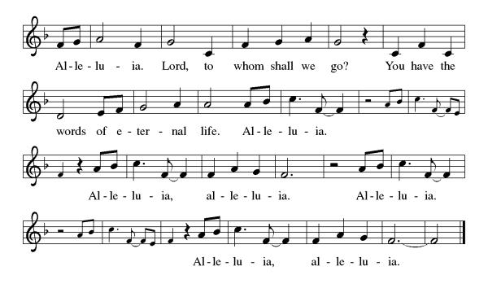
Gospel Acclamation

P: The Holy Gospel according to Matthew 5:1-12
C: Glory to you O Lord.

Gospel: Matthew 5:1-12
Jesus opens the Sermon on the Mount by naming those who are blessed in the reign of God.
¹ When Jesus saw the crowds, he went up the mountain, and after he sat down, his disciples came to him. ² And he began to speak and taught them, saying:
³ “Blessed are the poor in spirit, for theirs is the kingdom of heaven.
⁴ “Blessed are those who mourn, for they will be comforted.
⁵ “Blessed are the meek, for they will inherit the earth.
⁶ “Blessed are those who hunger and thirst for righteousness, for they will be filled.
⁷ “Blessed are the merciful, for they will receive mercy.
⁸ “Blessed are the pure in heart, for they will see God.
⁹ “Blessed are the peacemakers, for they will be called children of God.
¹⁰ “Blessed are those who are persecuted for the sake of righteousness, for theirs is the kingdom of heaven.
¹¹ “Blessed are you when people revile you and persecute you and utter all kinds of evil against you falsely on my account. ¹² Rejoice and be glad, for your reward is great in heaven, for in the same way they persecuted the prophets who were before you.”

P: The Gospel of Our Lord!
C: Praise to You O Christ!
Sermon by Bob

Hymn of the Day: ACS 1062
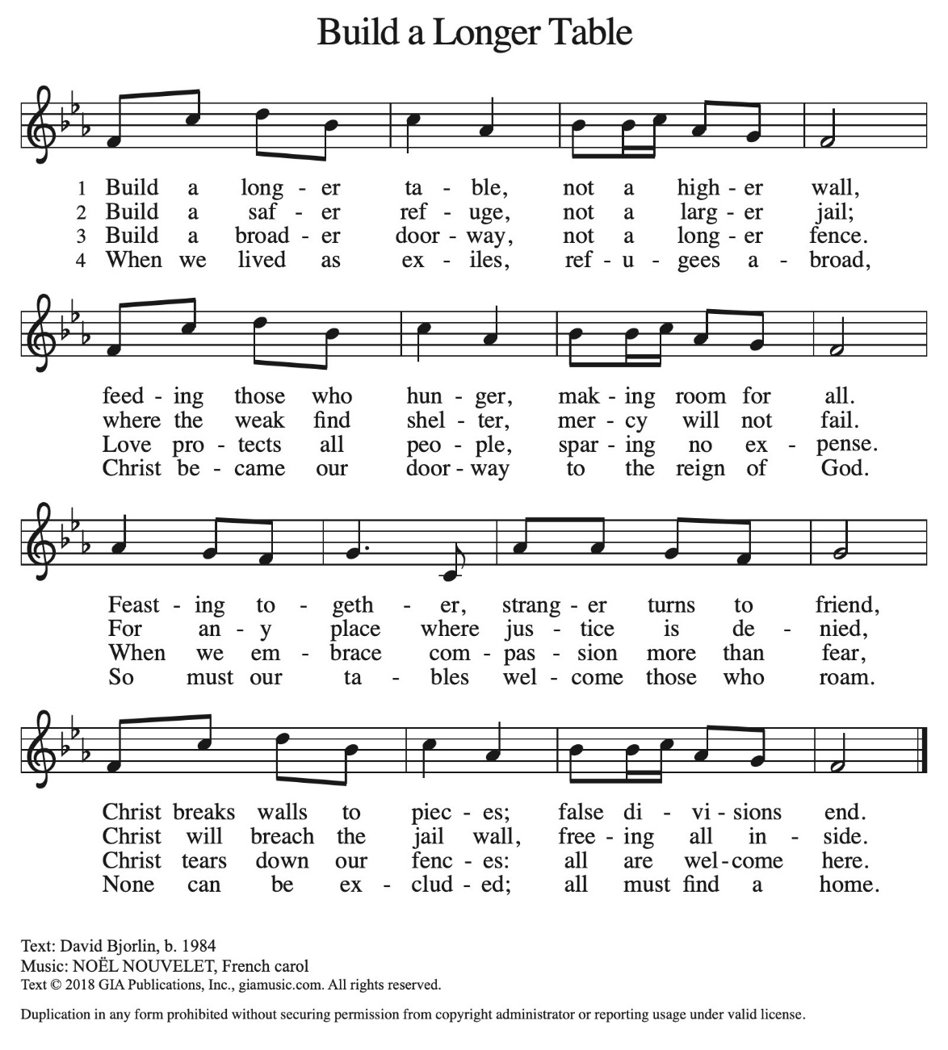

Apostles’ Creed
I believe in God, the Father almighty,
creator of heaven and earth.
I believe in Jesus Christ, God’s only Son, our Lord,
who was conceived by the Holy Spirit,
born of the virgin Mary,
suffered under Pontius Pilate,
was crucified, died, and was buried;
he descended to the dead.
On the third day he rose again;
he ascended into heaven,
he is seated at the right hand of the Father,
and he will come to judge the living and the dead.
I believe in the Holy Spirit,
the holy catholic church,
the communion of saints,
the forgiveness of sins,
the resurrection of the body,
and the life everlasting. Amen.

Lord, listen to your children praying,
Lord, send your Spirit in this place;
Lord, listen to your children praying,
send us love, send us pow'r, send us grace.

Prayers of the People

Response (after “Merciful God.”): “Have mercy on us.”

Confident that the Holy Spirit receives our prayers and answers us, we commend all for whom we pray to God’s loving-kindness made known to us in Christ Jesus our Savior.
Amen.

P: May the peace of our Lord Jesus Christ be with you all.
C: And also with you.
P: Let us now share this peace.
Offering is Brought to the Altar

Offertory Prayer
God of majesty,
no eye has seen, no ear has heard
what you have prepared for those who love you,
yet in this meal you reveal the wideness of your mercy.
Use what we have gathered
to feed us with the reign of God come near,
Jesus Christ, our Savior and Lord.
Amen.
P: The Lord be with you.
C: And also with you.

P: Lift up your hearts.
C: Lift them to the Lord.

P: Let us give thanks to the Lord our God.
C: It is right to give our thanks and praise.

Preface
(Words spoken by Bob)

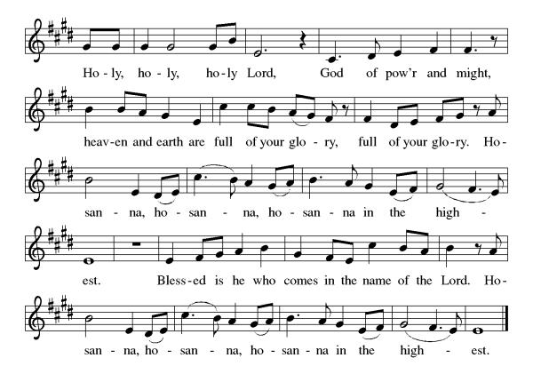
Eucharistic Prayer
(Words of Institution)

For as often as we eat of this bread and drink from this cup we proclaim the Lord’s death until He comes.
Christ has died
Christ is risen.
Christ will come again.
Gathered into one, by the Holy Spirit let us listen to the words that Jesus taught us.
The Lord’s Prayer
Our Father, who art in heaven, hallowed be thy name, thy kingdom come, thy will be done, on earth as it is in heaven. Give us this day our daily bread; and forgive us our trespasses, as we forgive those who trespass against us; and lead us not into temptation but deliver us from evil. For thine is the kingdom, and the power, and the glory, forever and ever. Amen.

Invitation to Communion
P: Here is the Lamb of God who takes away the sins of the world! Come to His table and taste on your lips a Love we cannot comprehend.
C: Amen
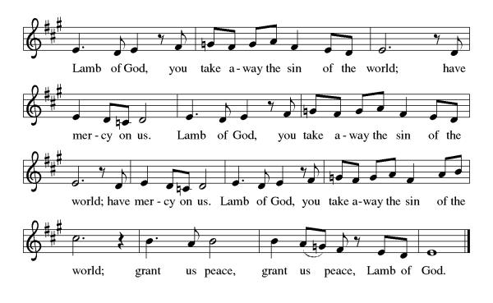
All may come.

Communion Anthem: O God of Mercy, God of Light ELW 714
P: We are now a tabernacle with Christ inside of us. Let us rejoice and be glad at the Lord’s table.
C: Amen

Prayer after Communion
Radiant God,
we have seen your glory in the face of Jesus Christ.
In the sacrament of his body and blood
you have drawn us to your heart.
Send us from this table with delight,
that our lives may reflect the beauty of your love,
and bear witness to all we have seen and heard,
through Jesus Christ, our Savior and Lord.
Amen.

Blessing
May the triune God,
Who has put a new song in your mouth
And tuned your heart for praise
☩ bless you now and forever
Amen.

Sending Hymn: To Be Your Presence ELW 546
1 To be your presence is our mission here,
to show compassion's face and list'ning ear,
to be your heart of mercy ever near,
alleluia!
2 To be your presence is our mission bold,
to feed the poor and shelter homeless cold,
to be your hands of justice, right uphold,
alleluia!
3 To be your presence is our mission blest,
to speak for all the broken and oppressed,
to be your voice of hope, your love expressed,
alleluia!
4 We are your heart, O Christ, your hands and voice,
to serve your people is our call and choice,
and in this mission we, the church, rejoice,
alleluia!

Text: Delores Dufner, OSB, b. 1939

Text © 2000 GIA Publications, Inc., 7404 S. Mason Ave., Chicago, IL 60638. www.giamusic.com. 800.442.3358. All rights reserved. Used by permission.
Dismissal
P: Go in peace. Do justice. Love mercy.
C: Thanks be to God.
Postlude
Unless otherwise noted, materials used in this bulletin are:
From Sundays and Seasons.com. Copyright 2015 Augsburg Fortress. All rights reserved. Reprinted by permission under Augsburg Fortress Liturgies Annual License #SAS028635. Music is reprinted under OneLicense.Net #A712074 and/or Augsburg Fortress #SBL12176H. Scripture, unless otherwise noted, is from the New Revised Standard Version Bible, Copyright © 1989, Division of Christian Education of the National Council of the Churches of Christ in the United States of America. Used by permission. All rights reserved.

St. Timothy Evangelical Lutheran Church
1070 N. Suncoast Blvd.
Crystal River, FL 34429
Telephone number (Office): 352-795-5325
Office email address: crsttimothy@tampabay.rr.com

St Timothy Worship Team
S.A.M. Robert F. Bonomo
Lay Minister, Frank Hofstetter
Director of Music, Sally Hennessey
Saturday Pianist, Bill Robinson
Announcements for January 31st & February 1st

ATTENDANCE
Saturday, January 24th, 4pm 24
Sunday, January 25th , 9am 51
Drive-Up Communion 0
75

The Altar Flowers are given this week by Bob Bonomo, in memory of his late wife, Maryann’s 75th birthday!

This Week at St. Timothy's
Monday, February 2nd 10am PB&J packing, 11am Healthy Start
Tuesday, February 3rd
Wednesday, February 4th 11am Citrus Blessings, 1pm Card Makers
Thursday, February 5th 11am Bible Study for Beginners (bring bible) 11am – Miniatures, 4:30pm - Choir
Friday, February 6th
Saturday, February 7th 4pm - Worship
Sunday, February 8th 9am – Worship, 10:15-10:45 – Drive Up Communion, 10:30am Adult SS, Coffee Fellowship

From the desk of Minister Robert
If the holy spirit has touched you to even thinking about becoming a council member, feel free to call me or come and see me.
Having a discussion does not mean, in any way that you must say yes.

Blessings
