A Service of Worship, Praise and Hope
Welcome to St. Timothy Saturday Evening Worship!
December 2nd, 2023, First Weekend in Advent



"Equip people to grow as Disciples faithfully serving our community"

We are glad to have you worship with us. All are welcome at communion. If you need gluten-free – please tell Pastor Joanie when you go up for communion. If you have any questions – just ask the Welcomer at the back of the sanctuary.
Please note** if you use a pew envelope for your offering – please write your name on the envelope so that the financial secretaries can post it as a gift from you. Thank You!
St Timothy Worship Planning Team
The Reverend Joan E. Holden 850-774-7730
Eric Mortensen – Director of Music
Deacon Frank Hofstetter

The Altar flowers are given, this week, by Sue Gable, in Leo’s memory!

This Week at St. Timothy's
Monday – December 4th PJ OFF, 11am – Healthy Start
Tuesday – December 5th
Wednesday – December 6th 10am – Blessings, 10 am – OT Bible Study, 11:30am – Card Makers, 4 pm – Advent Service, 5 pm – Soup Supper
Thursday – December 7th 11:30am – Miniatures, 4:30 pm – Choir Practice, 5:15 pm - Chimes
Friday – December 8th 10 am – NT Bible Study
Saturday – December 9th 4 pm – Worship
Sunday – December 10th 9 am – Worship, 10:30 am – Classes and Coffee Fellowship, 11-11:30 am – Drive Up Communion

Rooted in the past and growing into the future, the church must always be reformed in order to live out the love of Christ in an ever-changing world. We celebrate the good news of God’s grace, that Jesus Christ sets us free every day to do this life-transforming work. Trusting in the freedom given to us in baptism, we pray for the church, that Christians will unite more fully in worship and mission.
(from Sundays and Seasons for Reformation Weekend)

Welcome and Sharing of Congregational News

Preparation Hymn: Glorify Thy Name W&P 42
Confession and Forgiveness
P: Blessed be the Holy Trinity, + one God, the Lord of Israel who comes to set us free, the mighty Savior who comes to show mercy, the Dawn from on high who guides us into peace.
C: Amen
P: Let us come before God in confession.
P: To you, O God,
C: We lift up our souls. You know us through and through; we confess our sins to you. Remember not our sins; remember us with your steadfast love. Show us your ways; teach us your paths; and lead us in justice and truth, for the sake of your goodness in Jesus Christ our Savior. Amen.
P: Sisters and brothers, come with joy and draw water from the well of salvation. Remember the gift of baptism: your sin is washed away in the name of + Jesus; you belong to Christ; you are anointed to serve. Stand up and raise your heads! The reign of God is near.
C: Amen.
Greeting
P: Now is the time to prepare for the coming of the Lord! We begin in the name of the Father, and of the Son, and of the Holy Spirit.
C: Amen. Come Emmanuel!
Gathering Hymn: Blessed Be the God of Israel ELW 250
1 Blessed be the God of Israel who comes to set us free
and raises up new hope for us: a Branch from David’s tree.
So have the prophets long declared that with a mighty arm
God would turn back our enemies and all who wish us harm.

2 With promised mercy will God still the covenant recall,
the oath once sworn to Abraham, from foes to save us all;
that we might worship without fear and offer lives of praise,
in holiness and righteousness to serve God all our days.

3 My child, as prophet of the Lord you will prepare the way,
to tell God’s people they are saved from sin’s eternal sway.
Then shall God’s mercy from on high shine forth and never cease
to drive away the gloom of death and lead us into peace.

An Advent Litany
P: Blessed be the Lord, the God of Israel,
C: For the promise of a redeemer has come.
P: By the tender mercy of God,
C: the dawn from on high will break upon us,
P: And those who sit in darkness will see a great light!
C: Blessed be the Lord, the God of Israel.

Light Advent Wreath Light One Candle, Christ is Coming
(Vs 1)

Prayer of the Day
Stir up your power, Lord Christ, and come. By your merciful protection awaken us to the threatening dangers of our sins and keep us blameless until the coming of your new day, for you live and reign with the Father and the Holy Spirit, one God, now and forever. Amen.

Word

1 Corinthians 1:3-9
As the Christians in Corinth await the advent of Jesus, Paul reminds them how the Lord has already enriched them through spiritual gifts and will continue to strengthen them until the coming day of the Lord.
³Grace to you and peace from God our Father and the Lord Jesus Christ.
⁴I give thanks to my God always for you because of the grace of God that has been given you in Christ Jesus, ⁵for in every way you have been enriched in him, in speech and knowledge of every kind—⁶just as the testimony of Christ has been strengthened among you—⁷so that you are not lacking in any spiritual gift as you wait for the revealing of our Lord Jesus Christ. ⁸He will also strengthen you to the end, so that you may be blameless on the day of our Lord Jesus Christ. ⁹God is faithful; by him you were called into the fellowship of his Son, Jesus Christ our Lord.
A: Words of God!
C: Words of Life!
P: The Holy Gospel according to Mark, Chapter 13
C: Glory to you O Lord.

Gospel: Mark 13:24-37
[Jesus said:] ²⁴“In those days, after that suffering,
the sun will be darkened,
and the moon will not give its light,
²⁵and the stars will be falling from heaven,
and the powers in the heavens will be shaken.
²⁶Then they will see ‘the Son of Man coming in clouds’ with great power and glory. ²⁷Then he will send out the angels, and gather his elect from the four winds, from the ends of the earth to the ends of heaven.
²⁸“From the fig tree learn its lesson: as soon as its branch becomes tender and puts forth its leaves, you know that summer is near. ²⁹So also, when you see these things taking place, you know that he is near, at the very gates. ³⁰Truly I tell you, this generation will not pass away until all these things have taken place. ³¹Heaven and earth will pass away, but my words will not pass away.
³²“But about that day or hour no one knows, neither the angels in heaven, nor the Son, but only the Father. ³³Beware, keep alert; for you do not know when the time will come. ³⁴It is like a man going on a journey, when he leaves home and puts his slaves in charge, each with his work, and commands the doorkeeper to be on the watch. ³⁵Therefore, keep awake—for you do not know when the master of the house will come, in the evening, or at midnight, or at cockcrow, or at dawn, ³⁶or else he may find you asleep when he comes suddenly. ³⁷And what I say to you I say to all: Keep awake.”
P: The Gospel of Our Lord!
C: Praise to You O Christ!

Message:

Hymn of the Day: Jesus, the Light of the World ACS 914
1 Hark! the herald angels sing, Jesus, the Light of the world;
"Glory to the newborn king," Jesus, the Light of the world.

Refrain
We'll walk in the light, beautiful light,
come where the dewdrops of mercy are bright.
Shine all around us by day and by night,
Jesus, the Light of the world.

2 Joyful, all you nations, rise; Jesus, the Light of the world;
join the triumph of the skies; Jesus, the Light of the world. Refrain

3 Christ, by highest heav'n adored, Jesus, the Light of the world;
Christ, the everlasting Lord! Jesus, the Light of the world. Refrain

4 Hail the heav'n-born Prince of peace! Jesus, the Light of the world;
Hail the Sun of righteousness! Jesus, the Light of the world. Refrain

The Apostles’ Creed
I believe in God, the Father almighty,
creator of heaven and earth.
I believe in Jesus Christ, God’s only Son, our Lord,
who was conceived by the Holy Spirit,
born of the virgin Mary,
suffered under Pontius Pilate,
was crucified, died, and was buried;
he descended to the dead.
On the third day he rose again;
he ascended into heaven,
he is seated at the right hand of the Father,
and he will come to judge the living and the dead.
I believe in the Holy Spirit,

the holy catholic church,
the communion of saints,
the forgiveness of sins,
the resurrection of the body,
and the life everlasting. Amen.

Lord, listen to your children praying,
Lord, send your Spirit in this place;
Lord, listen to your children praying,
send us love, send us pow'r, send us grace.

Prayers of the People please stand, sit or kneel as you are able
With hope and expectation, we offer our prayers for the church, the world, and everyone who awaits God’s day of restoration. A brief silence.
Call your church into holy fellowship as we await the restoration of all things. Reenergize your faithful people to live with hope and compassion, especially those who serve as missionaries near and far. Center us on your promise to come among us and make all things new. Merciful God, receive our prayer.
All creation signals your presence, O God: the vastness of the cosmos, the turn of the seasons, and living things that both rest and flourish. Rekindle our commitment to care for the earth. Merciful God, receive our prayer.
Let the nations tremble at your holy presence, that justice and liberation prevail in all corners of the earth. Restore peace to nations in conflict, teach righteousness to corrupt leaders and systems, and bring stability to areas facing uncertain futures. Merciful God, receive our prayer.
Enrich the spirits of all who feel hopeless, fearful, or despairing. Stay close to those who await healing or relief, especially everyone on our prayer list and everyone we name out loud or silently in our hearts at this time…... Deliver all in any need. Merciful God, receive our prayer.
Be with those who keep awake at night: nurses working overnight shifts, caregivers of newborns and aging adults, stargazers, those who are anxious, or those who are traveling. Reveal to all that the dark can be a place of calm and comfort filled with your presence. Merciful God, receive our prayer.
At this time anyone can lift up prayers
Merciful God, receive our prayer.
You have sent out your angels and gathered your faithful people from every time and place, calling them into one fellowship of saints. Bless the witness of those who dwell in your eternal presence. Merciful God, receive our prayer.
Listen to these and all our prayers, O God of hosts, and restore us with your great and everlasting mercy. Amen.

We Share the Peace
Offering is Brought to Altar
Offering Prayer

We lift our voices, we lift our hands, we lift our lives up to you; we are an Offering. Lord, use our voices, Lord, use our hands, Lord, use our lives, they are yours: we are an offering. All that we have, all that we are, all that we hope to be, we give to you, we give to you. We lift our voices, we lift our hands, we lift our lives up to you; we are an offering, we are an offering.
Jesus’ Words of Promise and Gift of Life
Dear Lord, Jesus Christ:
in the night in which you were betrayed,
You took bread, broke it and gave thanks,
then you gave it to your disciples saying:
take and eat, this is my body I am giving for you.
Do this in remembrance of me.
Again, after supper, Dear Lord Jesus Christ,
You took the cup, gave thanks
and gave it for everyone to drink saying:
this cup is the new covenant in my blood,
I am shedding for you and for all people for the forgiveness of sin.
Do this for the remembrance of me.
Amen.

Our Lord’s Prayer
C: Our Father in heaven, hallowed be your name, your kingdom come, your will be done, on earth as in heaven. Give us today our daily bread. Forgive us our sins as we forgive those who sin against us. Save us from the time of trial and deliver us from evil. For the kingdom, the power, and the glory are yours, now and forever. Amen.
P: Come to this table where God really does come to us!
C: Thank You Jesus!
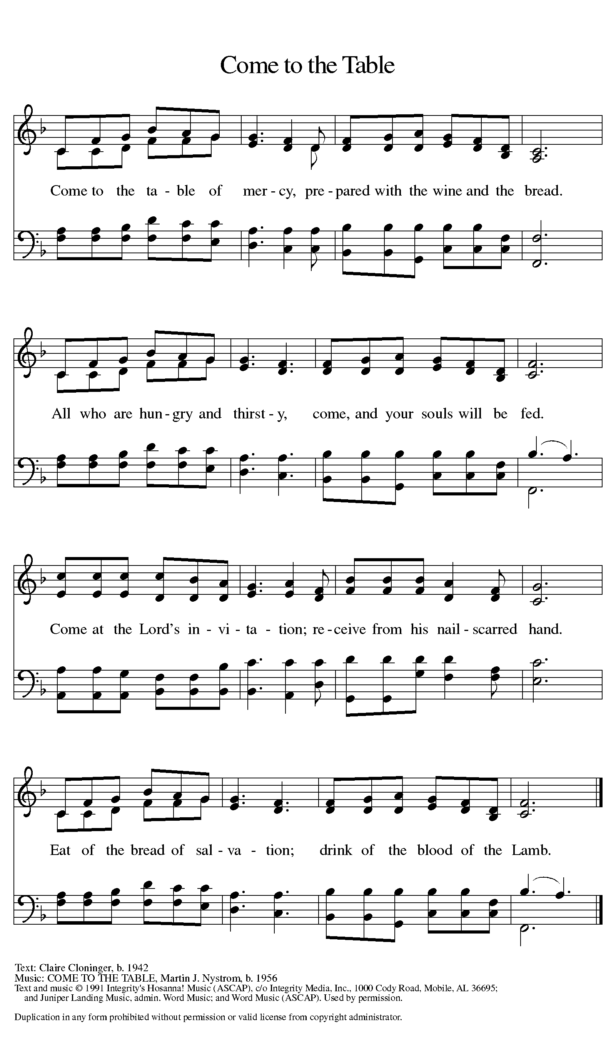

DISTRIBUTION - Please come forward to receive

Communion Hymn: Glory and Praise to Our God W&P 43
P: Now may the body and blood of our Lord Jesus Christ strengthen you and keep you in his grace…. Jesus Loves You!
C: Thank You Jesus!

Prayer after Communion
C: God for whom we wait, you come to us in the broken bread and the cup we share. Make us ready always to welcome Christ into our hearts and send us forth to be your people in the world, announcing your coming among us in Jesus Christ our Lord. Amen.

Sending

Blessing
P: ²³May the God of peace himself sanctify you entirely; and may your spirit and soul and body be kept sound and blameless at the coming of our Lord Jesus Christ. ²⁴The one who calls you is faithful, and he will do this.
C: Amen.

Sending Hymn: Joy to the World ELW 267
- Joy to the world, the Lord is come! Let earth receive
her king; let ev'ry heart prepare him
room and heav'n and nature sing, and heav'n and nature
sing, and heav'n, and heav'n and nature sing.

- Joy to the earth, the Savior reigns! Let all their
songs employ, while fields and floods, rocks, hills, and
plains repeat the sounding joy, repeat the sounding
joy, repeat, repeat the sounding joy.

- No more let sin and sorrow grow nor thorns infest
the ground; he comes to make his blessings
flow far as the curse is found, far as the curse is
found, far as, far as the curse is found.

- He rules the world with truth and grace and makes the
nations prove the glories of his righteousness
and wonders of his love, and wonders of his
love, and wonders, wonders of his love.

Dismissal

P: Go in peace. Prepare the way of the Lord!
C: By the Grace of God we will – Alleluia!
Postlude: Go Ye Therefore W&P 49
Unless otherwise noted, materials used in this bulletin are:
From Sundays and Seasons.com. Copyright 2015 Augsburg Fortress. All rights reserved. Reprinted by permission under Augsburg Fortress Liturgies Annual License #SAS028635. Music is reprinted under OneLicense.Net #A712074 and/or Augsburg Fortress #SBL12176H. Scripture, unless otherwise noted, is from the New Revised Standard Version Bible, Copyright © 1989, Division of Christian Education of the National Council of the Churches of Christ in the United States of America. Used by permission. All rights reserved.

REMEMBRANCE
Nicholas, Bishop of Myra, died around 342
Little is known about Nicholas, except that he was a bishop in present-day Turkey. According to legend, he was famous for his giving to the poor, and so has become a symbol of anonymous gift-giving.

Brief Announcements for December 2nd and 3rd
Attendance
Saturday, November 25th, 4pm 33
Sunday, November 26th, 9am 41
Drive-Up Communion 2
76

WELCA’S CHRISTMAS PARTY AND SECRET PRAYER SISTER LUNCHEON
Tuesday, December 19, 2023
12:00 Noon
St. Timothy’s Fellowship Hall
All ladies are invited to this special event.
There are 2 sign-up sheets (providing food and attendance) posted on the WELCA bulletin board.
Please join our sisters in Christ as we share in the joy and light of Jesus this special season and throughout the year.

Children’s Global Barnyard Project
Again, this year, our children are trying to collect enough money to purchase all the animals of a global barnyard. They will be collecting money after church every Sunday.
POINSETTIA PLANTS
We will have poinsettia plants available again this year for $10. If you will be writing a check, please be sure to note that it’s for the purchase of a poinsettia in order to ensure that the funds are distributed correctly.
We have 30 plants ordered so please sign up now so as not to miss out on getting a plant for yourself. IF YOU PLAN TO ORDER MORE THAN ONE PLANT, PLEASE WRITE THEM ON SEPARATE LINES WITH YOUR COMMEMORATION, TO AVOID ANY CONFUSION. Plants can be picked up after the 9 a.m. service on December 25th.
SPECIAL PRE- CHRISTMAS EVE SERVICE MUSIC
On the bulletin board outside the old music room - you can sign up to participate in the special music preceding the Christmas Eve services at 3 and 7 pm - put your name and the piece of music you wish to offer (you will need to arrange time to practice with Eric) - this is always special to all of us and we look forward to hearing your offerings (special music begins at 2:30 pm and 6:30 pm on Christmas Eve - you only sign up for the service you wish to offer special music for)

***Check the Kiosk for These Sign-Up Sheets***
Advent Soup Supper
Poinsettias
Healthy Start Packing
Worship Volunteers – November, December
Coffee Hour Hosts
Serving Hands
