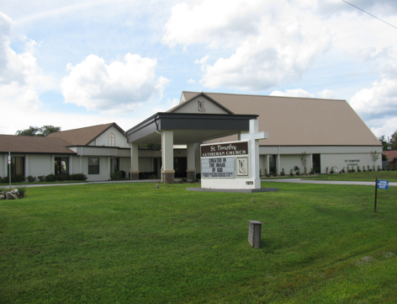

ST. TIMOTHY EVANGELICAL
LUTHERAN CHURCH
Vineyard Views
May 2026

Sam’s Corner
S.A.M. BOB BONOMO

May 2026

Greetings from Our Lord and Savior Jesus Christ,

Dear St. Timothy Family,

We are almost into six months of 2026. What have we accomplished as a church family from my first Worship service with all of you on 4/26/25 to this 4/26/26?
Let’s look at the improvements made in and out of our Sanctuary.
We have been so very blessed to have lighting updated in the Sanctuary. It is so joyful that the light of God shines on us every service.
We are also blessed because there were some who generously donated to this cause, only costing the church about $3,500.00. It’s not too late to contribute!
We have new banners that fit the season we are in. I pray that you read the banners, because what they say is uplifting.
Paraments have been made for Our Lord’s table and pulpit.
Generously donated by an individual purchasing fabric and using expert sewing skills.
A member has graciously donated time and talent to decorate the back of the church above the doors for the season of the liturgy, we share. Have you taken notice?
Our sound booth is active during worship to ensure those at home are able to be a part of this family, enjoying worship.
The tree in our parking lot was finally put to rest and another generous donor paid for this service.
The property committee has grown in volunteers, and that time and talent has been used to uncover irrigation issues and all the other challenges that come with it. The boarded window that has been open on the top outside of the building was corrected by two volunteers. The lights in the parking lot have been updated by the county at no cost to us, which now makes our parking lot a bit safer in the evening. Also adding to the safety of this church are the new security cameras purchased by the church to cover front, back, left side and right side of this building all visible by a cell phone for viewing.
The lights on our front sign have been updated. It is beautiful to see when you drive by on 19. Total cost was $2,950.00 that was paid by the church. Not too late to donate!

There are so many folks that purchase what is needed without submitting a bill. (Many members as well as salaried members are proactive to support any and all ministries that make up St. Tim’s, all for the glory of God.
Yet, there re folks who love their Lord, and attend worship regularly, and for that I am blessed to serve, but add nothing for the care and needs of this church.
We need more volunteers to use their talents and give of their time.
Prayerfully consider and rethink how you can help in any ministry we are blessed with here at St. Timothy.

Quilting Group: Anyone interested in starting one?
WELCA: all women are automatically members, but you need to come to meetings, and luncheons. Ask how you can help.
M.O.S.T. has been dissolved for lack of membership
Church council: Be a voice in making business decisions
Altar Guild: setting our Lord’s table and clean up after worship
Readers: Saturday and Sunday
Worship Assistants: Be a part of worship, reading and leading the congregation in prayer assisting the Pastor at God’s table.
Holy Communion assistants: Share in the giving:” This is the blood of Christ, shed for you.”
Choir and Chimes: We have a professional who will guide you.
Finance: Find out how this team keeps St. Tim’s above water.
Worship and Music: Choir and chime director meet with your interim s.a.m. to discuss different ways to celebrate worship so that the liturgy and music are in sync. Special occasions are also discussed.
Ask about our annual cleanup, which has already begun.

What would worship look like if the same people using their God gifted talents, who over and over give what they can, just stopped?

Why have I gone into detail?
- When you are asked to give the church an idea of your giving for the following year, during the Stewardship Campaign it is because we have a budget to cover for all the expenses we incur as a church.
- If you ignore it, you are contributing to the Holy closure of this church.
- If you are not a member, prayerfully consider making the change this year.

Note: If I left out any ministries in this memo, please let me know and I will rectify. Also know it was not intentional on my part

Blessings always and may His peace always be with you.
Bob

THE POWER OF PRAYER IN ACTION AND INSPIRATION

“MOVE YOUR STONE”
By Barbara Carson

Now that Easter is over Spring has sprung! We look forward to warmer weather, especially after our cold winter. The grass gets greener and the flowers are blooming. As we celebrate the resurrection of Christ, what message does that bring us personally. We can celebrate renewal. How do we do that? Well, the most important thing you can do is “Move Your Stone”. Going back to the story of Lazarus and his sisters who were mourning his death, we find that Jesus came, and He told them to move the stone from the front of his tomb. They were puzzled but did as He said. We know what happened, a new life appeared.

As we think of that stone being rolled away, we can think of this as a renewal for us. This can be our doorway to restoration. By removing a stone that maybe hindering us from following God’s path, we can step forward out of the tomb of darkness in our life that hinders us from using our full potential of God’s gifts for us. Our stone is rolled away so we can do great work. If we live in the darkness of life, we might not see the signs that Jesus has for us.

By rolling that stone away we can focus on renewing our mind and transforming our spirit with a fresh start and a new beginning. It gives us a revival in dealing with life’s challenges. Isaish 40:31 says “But those that hope in the Lord will renew their strength. They will soar on wings like eagles: they will run and not grow weary; they will walk and not be faint.” Also 2 Corinthians 5:17 “Therefore, if anyone is in Christ, the new creation has come. The old has gone, the new is here.” Don’t check God off your list, enter into the light from that tomb through that doorway to restoration and renewal. In a sermon that Bob gave he pointed out that moving that stone that is in our way is another first step in our faith. God never lets us down remembering that He is the light of our World! Amen

Benevolence for May - Lifetree Food Pantry
The Food Pantry is a joint venture between St. Timothy and Lifetree Church (formerly First Presbyterian of Crystal River). We partner to provide food, clothing, household and personal care items, and even pet food to an average of 120 qualified recipients.

Call Committee Corner

Dear Church Family,
The Call Committee has completed the Ministry Site Profile (MSP). We met with Church Council to review the MSP, and they approved it to be sent to our Assistant to the Bishop, Reverend Nicole Eastwood. She appreciated that we worked very hard on this form and its challenges. Our next step was entering it into the Synodical Site, and we worked on that step on Sunday, April 19, 2026. When it is finally approved by Synod, then we will post a printed copy of it on our Call Committee Corner Bulletin Board as well as in the Vineyard Views. Thank you for your continuing prayers and patience as we work through the many steps of study, prayer, discernment, and preparation. We trust God to keep us on the right path of where He is leading us as we wait for our new shepherd.
Respectfuly Submitted,
Mary Schlumberger & The Call Committee
WELCA ANNOUNCEMENT FOR MAY VINEYARD VIEWS
"Sisters in Christ, are sisters for life!"

Dear Sisters In Christ,
Did you know that if you are a woman, and you attend St. Timothy Lutheran, you are a member of WELCA (Women of the ELCA). We either have a membership meeting at 1:00 P.M. in the Bradford Fellowship Hall, or a luncheon at 12:00 P.M. either in the Bradford Fellowship Hall or a local restaurant, each month on the third Tuesday. Twice a year, we get to see our other sisters in Christ at the Pinelands Conference Spring Gathering at one of our sister churches in March on a Saturday, and Florida Bahamas Synod WELCA Fall Gathering from a Friday -Sunday usually around the second weekend in November at Warren Willis Retreat Center in Fruitland Park, FL.
Saturday, May 9, 2026 & Sunday, May 10, 2026 is Mother's Day weekend. WELCA led services are yet to be determined.
On Tuesday, May 19, 2026, at 12:00 pm in Bradford Hall, we will have an indoor picnic. The men & women are invited to this luncheon. Please see the sign up list on the WELCA bulletin board.
On Tuesday, June 16, 2026 at 12:00 pm, we are inviting the men of the church once again to have a hello summer luncheon at a local restaurant, yet to be determined.
We ask that you keep all of our WELCA sisters who have had injuries, and have undergone surgeries in your prayers for recovery.
Blessings,
Mary C. Schlumberger – WELCA President

From the desk of Minister Robert
If the holy spirit has touched you to even thinking about becoming a council member, feel free to call me or come and see me.
Having a discussion does not mean in any way that you must say yes.

Blessings

DEADLINES
Announcements
Please be aware that if you have entries for the weekend worship announcements you need to have them in on Tuesday prior, as we are preparing and printing them no later than Thursday.

Vineyard Views
If you have submissions for the June Vineyard Views, please have them in the office no later than the end of day on Thursday, May 21st.

Please check for the following sign-up sheets – updated 4/30
Serving Our Lord (Worship Helpers) – bulletin board by kitchen
Flower chart – WELCA board
Healthy Start –bulletin board by kitchen
PB&J Ministry – bulletin board by kitchen
Serving Hands - bulletin board by kitchen
WELCA “Hello Summer Luncheon” (@ Cedar River Seafood on 6/16 12pm) – WELCA board
Indoor Picnic/Potluck (Tuesday, 5/19 @12pm) – WELCA board
Clean up Volunteers – table in hallway
Coffee Hour – in kitchen

NEW ZOOM LINK FOR ADULT SUNDAY SCHOOL – 9/18
Topic: Adult Sunday School Class
Time: Sep 21, 2025 10:30 AM Eastern Time (US and Canada)
Every week on Sun, 97 occurrence(s)
Please download and import the following iCalendar (.ics) files to your calendar system.
Weekly: https://us02web.zoom.us/meeting/tZwrc-mprDMoH9YRklu1WcmVIop862c72xVO/ics?icsToken=DBOIHJoC7iVwo_7kCQAALAAAABAB_uGypwq2ymkMO9EqrhDMoZY3vO7cudxQ3PHNM4LxWE7vm8v6Hf2LmVyJEkPyvcQ1Vmg_NR4W6BglNTAwMDAwMQ&meetingMasterEventId=3pLv0et_SMuCQYJkMknIyQ
Join Zoom Meeting
https://us02web.zoom.us/j/88640128252?pwd=asNJ6OiNGFFTNzwNA5yhkvPpmt6VCT.1
Meeting ID: 886 4012 8252
Passcode: 898938


INFORMATION FROM THE FINANCE COMMITTEE
AND YOUR TREASURERS
In the hope of getting ahead of our property, liability and flood insurance costs for next year, we have been trying to save toward those expenses. (Property and liability premiums are due by June 1st of each year, and flood is due November 1st.) We would appreciate any additional donation you could make. Please include that amount with your regular offering and designate it as “Insurance” on the offering envelope.
A security camera system to monitor the outside areas of our campus has been installed. The cost is $3,852.00. If you would like to donate to this purchase for the welfare of our safety and security, please designate “Security Expense” on your offering.
Duke Energy has replaced and updated the lighting in the parking lot. There will be no additional charge for this service.
A weekly offering update is given with the email announcements. We are most grateful to all of you who support our programs through your prayers, offerings, time and talents.

Lynn Dively, Treasurer



THRIVENT FINANCIAL NEWS FOR MAY 2026

$$$THRIVENT CHOICE DOLLARS®$$$
Thanks so much to our Thrivent Financial members and friends who direct their Thrivent Choice Dollars® to
available for activities and projects for our mission and ministry here at St. Timothy. If you are an eligible Thrivent Financial member and have Choice Dollars® available, please call Thrivent (800-847-4836) and say “Thrivent Choice®” or go online to www.thrivent.com/thriventchoice and direct your dollars…hopefully to St. Timothy Lutheran Church in Crystal River. To date for 2026 our church has received $1035.00 through this program. Thanks to the following members and friend who recently directed their $$ to St. Timothy:

Robert Burkett Frank Hofstetter Sue Nawrocki

THRIVENT ACTION TEAMS
Thrivent Action Teams make it easy for you to bring people together to make a positive change in your community! When you see a need, apply to lead a volunteer team. Once your idea is approved, a Thrivent Action Kit is delivered to your door. It’s packed with everything you need to help make your project a success. It even includes $250.00 in seed money to help get your project started. After you finish the project, you report the results on-line to Thrivent. This program is brought to you by Thrivent Financial because they believe that being wise with money and living generously go hand in hand. All your questions and requests for this funding program will be answered by going to Thrivent.com/actionteam.***Please note that Thrivent Financial funds accessed for all programs and activities involving St. Timothy Lutheran Church need to be approved by a Committee and the Congregational Council. 2026Thrivent Action Teams that have been approved: Easter Food Boxes, Bump2Baby Expo

THE $250 IN SEED MONEY IS A GIFT FROM THRIVENT THAT WE CAN USE TO HELP WITH COMMUNITY OUTREACH AND PROJECTS INVOLVING OUR CONGREGATION. THESE FUNDS ARE IN ADDITION TO OUR BUDGETED AMOUNTS AND OFFERINGS AND DONATIONS MADE BY OUR MEMBERS AND FRIENDS.

Financial Representatives for answering questions and offering advice on Thrivent investments and products are:

Katherine Gross Kevin Braunschweiger
in Gainesville, FL in Ocala, FL
352-505-8905 352-440-6784
Katherine.gross@thrivent.com
Virtual Advice Team – 855-303-7402

Submitted by Lynn Dively

Food Pantry
The food pantry continues to operate on the 2nd and 4th week of every month from 9AM- noon. We continue to inform the congregation as to the needs of the pantry via the weekly announcements. The current needs are fruit, spaghetti- 16oz., peanut butter, chili which serves 2 people and laundry detergent (dollar store is fine), saltines. Thanks to all who contribute food. You can also contribute monetarily by writing out a check made out to Life Tree Church with Food Pantry in the memo line or writing out a check to St. Timothy Lutheran and putting food pantry in the memo line, and placing it in my mailbox, #210. We will also accept cash donations. Please put it in an envelope in mailbox, #210 and put your name on it so I know who you are. If you would like a receipt, please let me know.
The next food pantry will be on May 12th from 9-12.
Thank you. - Barbara J
Healthy Start – updated 5/5
Needs for May: 2 baby bibs, 4 baby lotion, 6 baby oil, 3 baby shampoo, 8 baby wipes, 7 Vaseline.
Carolyn Fialkowski

PB&J MINISTRY UPDATE – updated 4/22
Our peanut butter lunch packing for DayStar is the first Monday of the month at 10:30. There is a sign-up sheet on the bulletin board in the hallway by the kitchen. We need about 6 people each time or let me know if you are interested. Thank you - Barbara Carson


MESSAGE FROM REGINA
Please, if you are at a church function, think about snapping a few photos for everyone to enjoy. Thank you in advance.

SERVING HANDS
Serving Hands is a program created to help members of our own congregation. Serving Hands is there for you if you need some help in the following areas: a meal brought to you, driving you to an appointment, a friendly visit, doing a household chore, communion brought to you, walking your dog, or picking up food for your pet, etc. These are one-time opportunities, not forever experiences. Please contact Carolyn Fialkowski at 814-392-4281, or Jean Fowler at 586-322-8337 if you need help.
Please don’t hesitate to call. We want to serve you! Also, if you are willing to help with any of these services, there is a sign-up chart on the kiosk in the entrance way of the church or call one of these ladies.

AED /Medical response :
We have a poster that is behind the kiosk across from our AED in the narthex. An emergency incident can happen at any time, and it is good to be prepared. The poster explains a “hands only “ CPR protocol as the first line of an emergency of that kind and is very easy for anyone. Please take a look and refresh yourself on the protocol. Our AED is valuable for saving lives but initiating CPR is essential. We do have several people in our congregation that have more detailed experience to assist as needed. For any questions, please ask Barbara Carson.
Instructional video on how to use the Philips AED.
https://youtu.be/t6GV9PAbgM4?si=dZuGq8aLjfvpFiM-
(ctrl + click to follow link)

ST TIMOTHY’S WEBSITE
Here is the St. Timothy website address: https://www.sttimlutherancrystalriver.com/
(ctrl + click to follow link)

There are links for the weekend’s services on the homepage. Please note that the links will change every week, since this is a YouTube file address; every service has its own link. Watch for an email with the updated links when they are ready. The video links for previous weekends will still be available at the bottom of the webpage, as the links are updated each week. Please contact us if you would like a CD of any of the services to listen to. Be sure to check out our children’s artwork at the bottom of the home page. We hope to add more as they send it to us.

Here is a link to St Timothy's YouTube:
https://www.youtube.com/channel/UC5xrMj8-8_6iyR_KxjFAwRQ/videos
(ctrl + click to follow link)

Facebook
See our Facebook page for information about upcoming events and Please feel free to message us with suggestions about content. - Regina

St. Timothy Evangelical Lutheran Church | Facebook
(ctrl + click to follow link)


The Sunshine Card Makers
The Card Makers meet the first Wednesday of the month at 1pm, in the Fellowship Hall.
-Kathy G

We have the April, May and June 2026 Christ in Our Home booklets. There are some on the table by the mailboxes or you may request one to be put in your box.

HERE AND THERE WITH THE FOLKS OF ST TIMOTHY
More Easter Food Box Packing/Pizza Party
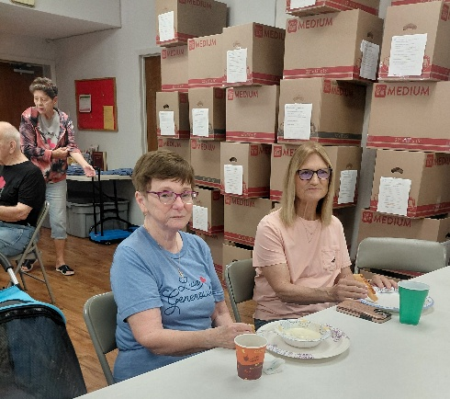
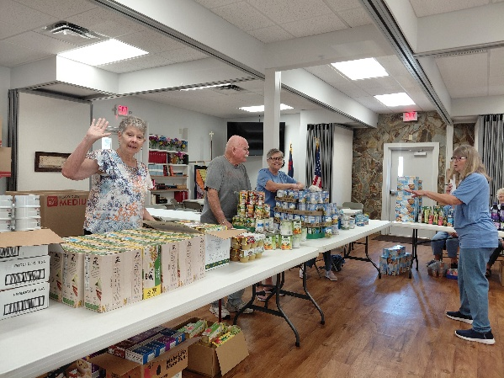

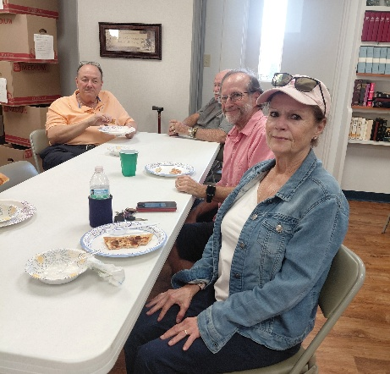


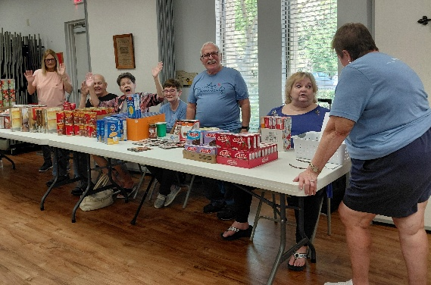
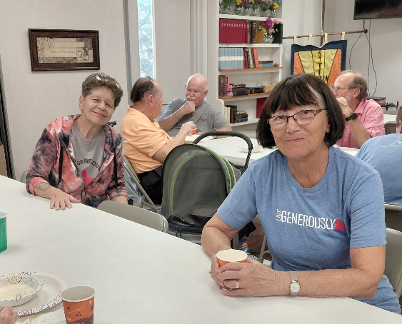
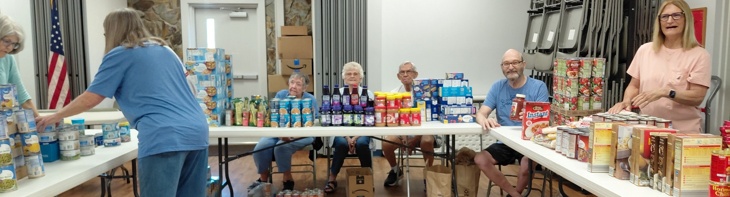
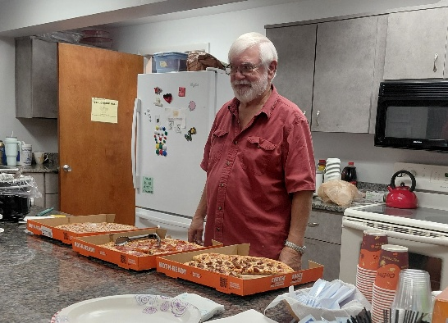

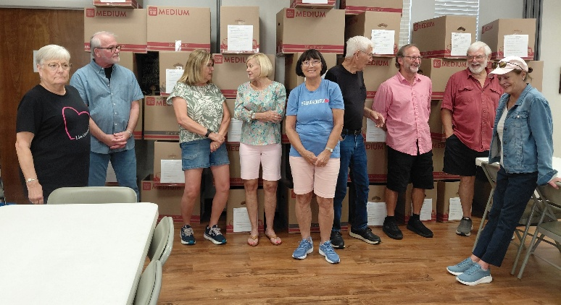
April Citrus Blessings
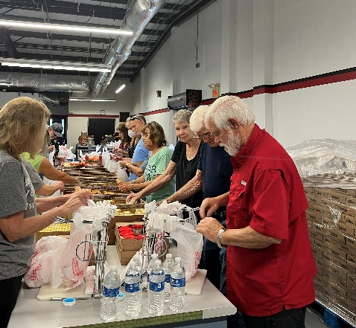


Installation of New Members
4/26/26
Debbie Colón, Becca Tatun, Frank Santana, and Ray Headrick

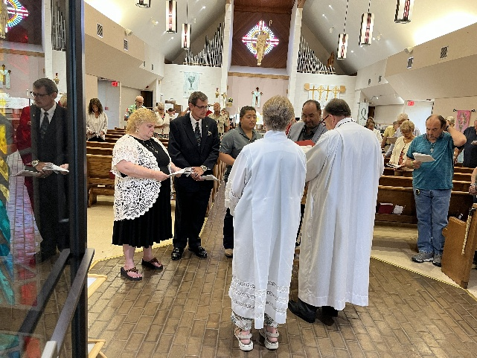
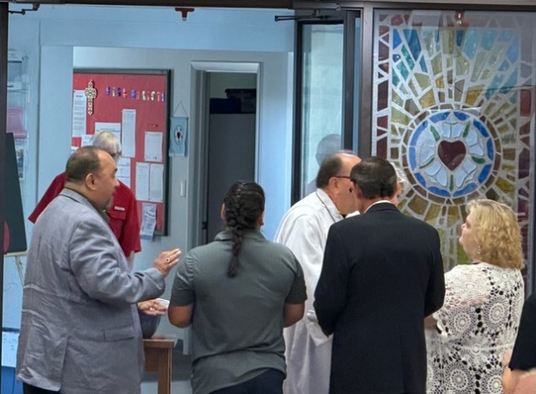
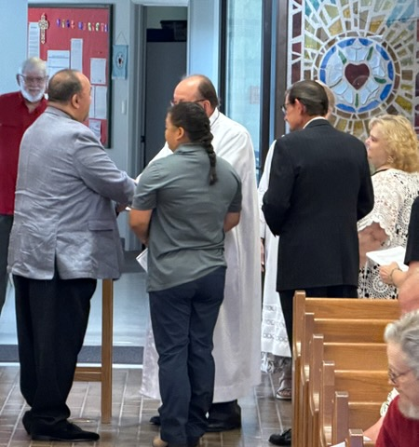
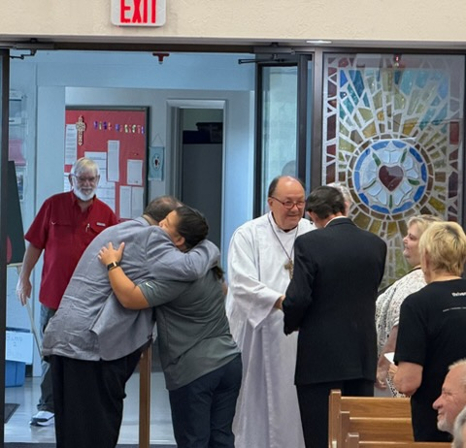
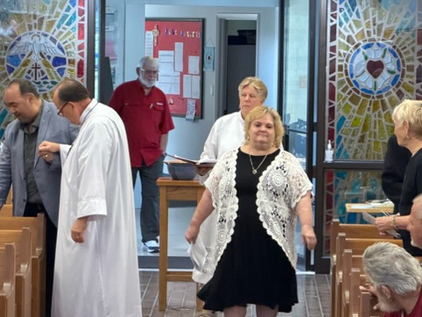


Kathy Geer 5/05
Nancy Brooks 5/13
Laura Withrock 5/14
Barbara Ward 5/23
John Gudorf 5/24
Walt Haussmann 5/27
Wendy Mayger 5/27
Sharon Beligotti 5/28
John Rulfs 5/28
Chase Messier 5/29

Birthday Blessings!
Directory Updates
Pule, Patricia “Patie” #36 M
10454 S. Walden Forest Circle
Homosassa, FL 34446

SUNDAY | MONDAY | TUESDAY | WEDNESDAY | THURSDAY | FRIDAY | SATURDAY
 |  |  |  |  | 1 | 2 Pinelands Conference Spring Gathering 9-12  4pm Worship  No Fellowship
3  9am Worship  10:30 Adult SS, Coffee Fellowship | 4  10:30am PB&J  11am Healthy Start | 5 | 6  11am Citrus Blessings  1pm Card Makers | 7  11-12 Bible Study for Beginners  11am Miniatures  3:30 Chimes  4:30 Choir | 8 | 9  4pm Worship  No Fellowship
10  9am Worship  10:30 Adult SS, Coffee Fellowship | 11  10:30 Ruth Circle @ Barb C’s house | 12  9-12 Food Pantry  1pm Royal Dalton  7pm ZOOM Pre-Assembly Bible Study | 13  1pm Worship & Music | 14  11-12 Bible Study for Beginners  11am Miniatures  3:30 Chimes  4:30 Choir | 15 | 16  4pm Worship  No Fellowship
17  9am Worship  10:30 Adult SS, Coffee Fellowship  Council | 18 | 19  12pm Indoor Picnic/potluck  7pm ZOOM Pre-Assembly Bible Study | 20 | 21  11-12 Bible Study for Beginners  11am Miniatures  3:30 Chimes  4:30 Choir | 22 | 23  4pm Worship  No Fellowship
24  9am Worship -  10:30 Adult SS, Coffee Fellowship | 25 | 26  9-12 Food Pantry  7pm ZOOM Pre-Assembly Bible Study | 27 | 28  11-12 Bible Study for Beginners  11am Miniatures  3:30 Chimes  4:30 Choir | 29 | 30
31
9am Worship -
10:30 Adult SS, Coffee Fellowship
May 2026

FOR FUN
Jesus and Satan were having an ongoing argument about who was better on his computer. They had been going at it for days, and God was tired of hearing all the bickering. Finally, God said, "Cool it. I am going to set up a test that will run two hours, and I will judge who does the better job." So, Satan and Jesus sat down at the keyboards and typed away.
They moused. They did spreadsheets. They wrote reports. They sent faxes. They sent e-mails. They sent e-mails with attachments. They downloaded files. They did some genealogy reports. They created labels and cards. They did every known job.
Jesus worked with heavenly efficiency, and Satan was faster than hell. But ten minutes before their time was up, lightning suddenly flashed across the sky, thunder rolled, rain poured, and-of course-the electricity went off. Satan stared at his blank screen and screamed every curse word known in the Underworld. Jesus just sighed.
The electricity finally came back on, and each of them restarted their computers. Satan started searching frantically, screaming "It's gone! It's all GONE! I lost everything when the power went out!" Meanwhile, Jesus quietly started printing out all of his files from the past two hours. Satan observed this and became irate. "Wait! He cheated! How did he do it?"
God shrugged and said, "Jesus saves."


St. Timothy Lutheran Church
S.A.M. Robert “Bob” Bonomo
1070 N. Suncoast Blvd.
Crystal River, FL 34429
Phone: 352-795-5325

Church email: crsttimothy@tampabay.rr.com
Website: www.sttimlutherancrystalriver.com
(ctrl + click to follow link)

Lay Minister: Frank Hofstetter
Director of Music: Sally Hennessey
Saturday Pianist: Bill Robinson
Church Secretary: Regina Mendicino
Sexton: William “Bill” Dexter

2026 Congregational Council Members
President: Barbara Carson
Vice-President: Barbara Johnson
Secretary: Carolyn Fialkowski
Treasurer: Lynn Dively
Council Members: Marsha Gibson, Bob Bonomo

Weekly Worship
Saturdays 4pm
Sundays 9am
Holy Communion available at both services
Adult Sunday School - 10:30am
Sunday Services -YouTube links on website

