Welcome to St. Timothy Evangelical Lutheran Church
Sunday, January 11th
Baptism of Our Lord, 1st Sunday After Epiphany



In the waters of the Jordan, Jesus is revealed as the beloved Son of God. Through this great epiphany, Jesus fulfills all righteousness and becomes the servant of God who will bring forth justice and be a light to the nations. In the waters of baptism we too are washed by the Word, anointed by the Spirit, and named God’s beloved children. Our baptismal mission is to proclaim good news to all who are oppressed or in need of God’s healing.

Welcome and Sharing of Congregational News
Preservice: Down Galilee’s Slow Roadways ACS 916

Confession and Forgiveness
All may make the sign of the cross, the sign that is marked at baptism, as the presiding minister begins.
Blessed be the holy Trinity, ☩ one God,
the Creator of heaven and earth,
the Word who spoke life into being,
the Wind stirring the waters.
Amen.
Let us turn in confession to the one who knows us completely.
Silence is kept for reflection.
Mighty God, lover of justice,
you call us to life in community,
but we have served our own interests
at the expense of our neighbors.
We have sown deceit where honesty was needed.
We say the right words,
but our hearts are far from you.
Turn us to seek your face.
Knit us together and give us the mind of Christ,
that we may do justice, love mercy,
and walk humbly with you, our God.
Amen.
The former things have passed away,
and new things God now declares:
Like a spring of water that never fails,
God covers you in the righteousness of Christ,
and forgives your sin in ☩ Jesus’ name.
May the Spirit give you strength to live for others,
and bless you with the gift of peace.
Amen.
Greeting
P: The joy of our Lord Jesus Christ, the compassion of God, and the creative power of the Holy Spirit be with you all.
C: And also with you.

Gathering Hymn: When Jesus Came to Jordan ELW 305
1 When Jesus came to Jordan to be baptized by John,
he did not come for pardon but as the Sinless One.
He came to share repentance with all who mourn their sins,
to speak the vital sentence with which good news begins.

2 He came to share temptation, our utmost woe and loss,
for us and our salvation to die upon the cross.
So when the dove descended on him, the Son of Man,
the hidden years had ended, the age of grace began.

3 Come, Holy Spirit, aid us to keep the vows we make;
this very day invade us, and ev'ry bondage break.
Come, give our lives direction, the gift we covet most:
to share the resurrection that leads to Pentecost.
Text: Fred Pratt Green, 1903-2000 Text © 1980 Hope Publishing Company, Carol Stream, IL 60188. All rights reserved.
Prayer of the Day
O God our Father, at the baptism of Jesus you proclaimed him your beloved Son and anointed him with the Holy Spirit. Make all who are baptized into Christ faithful to their calling to be your daughters and sons, and empower us all with your Spirit, through Jesus Christ, our Savior and Lord, who lives and reigns with you and the Holy Spirit, one God, now and forever. Amen.
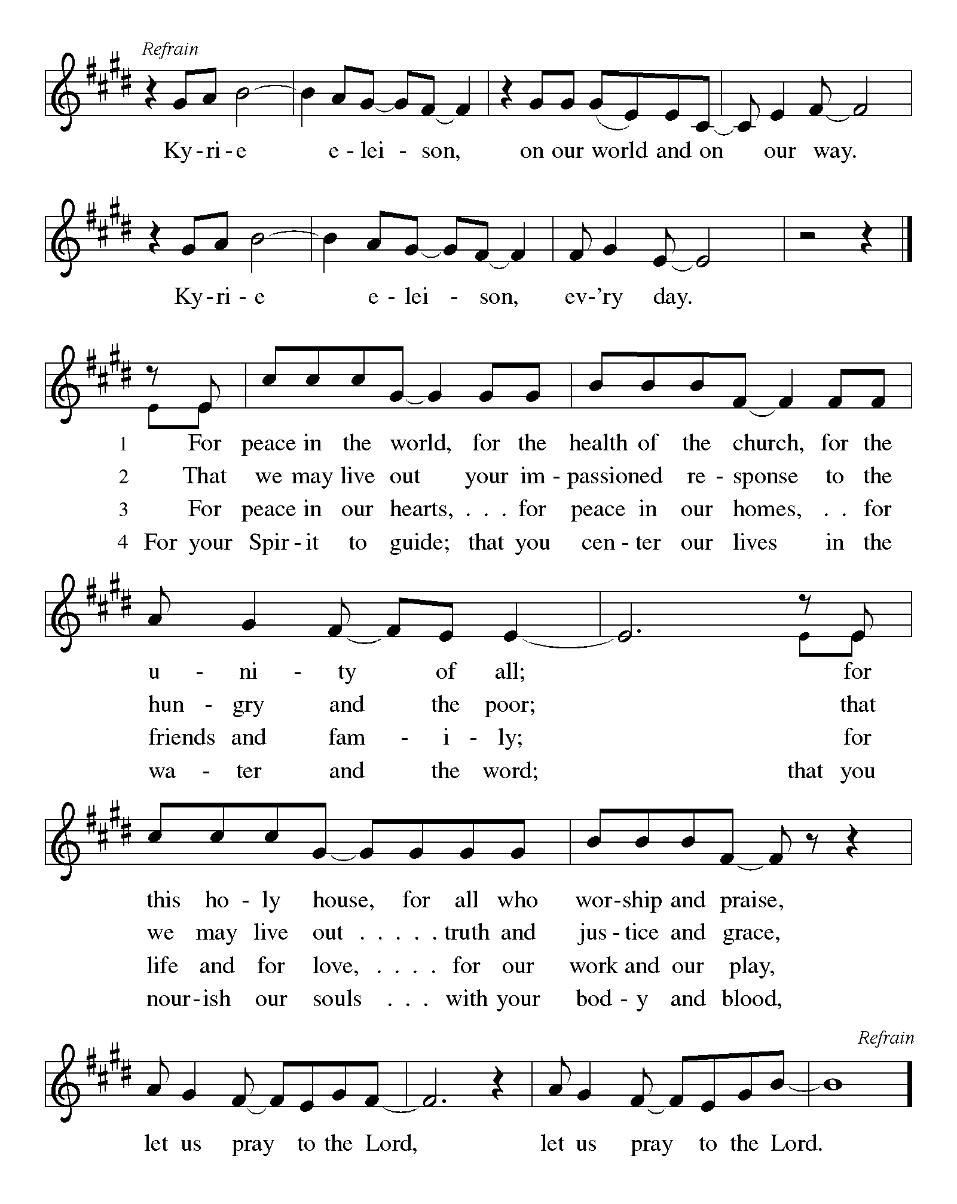
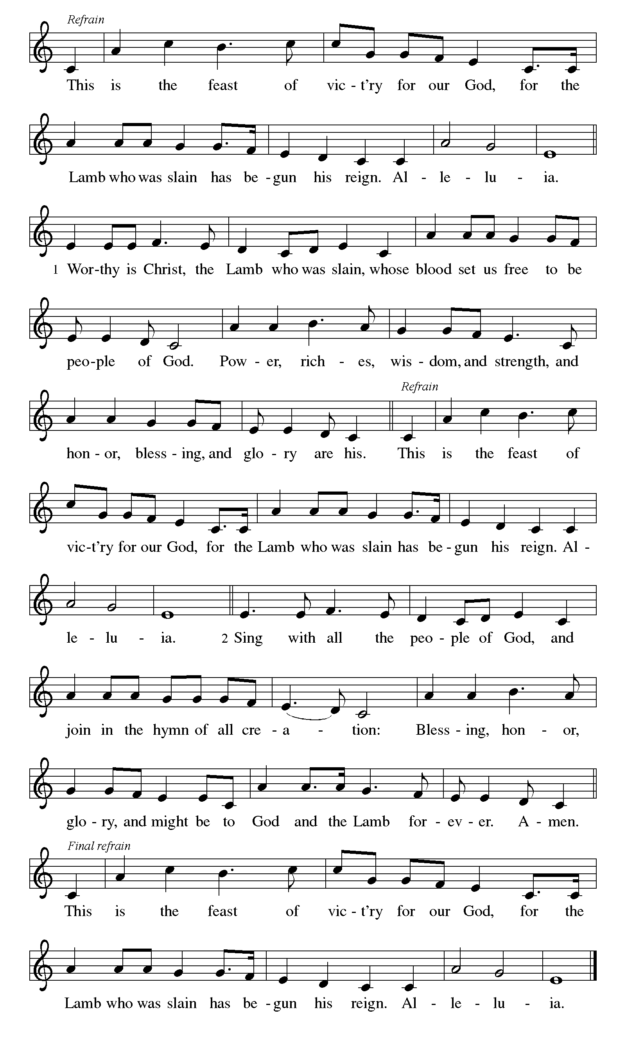

First Reading: Isaiah 42:1-9
God’s servant is endowed with God’s spirit in order to bring justice to the nations. The servant will not exercise authority boisterously or with violence, nor will weariness ever prevent the fulfilling of the servant’s task. God’s old promises have been fulfilled; the servant’s new assignment is to bring light to the nations.
¹ Here is my servant, whom I uphold,
my chosen, in whom my soul delights;
I have put my spirit upon him;
he will bring forth justice to the nations.
² He will not cry out or lift up his voice
or make it heard in the street;
³ a bruised reed he will not break,
and a dimly burning wick he will not quench;
he will faithfully bring forth justice.
⁴ He will not grow faint or be crushed
until he has established justice in the earth,
and the coastlands wait for his teaching.
⁵ Thus says God, the Lord,
who created the heavens and stretched them out,
who spread out the earth and what comes from it,
who gives breath to the people upon it
and spirit to those who walk in it:
⁶ I am the Lord; I have called you in righteousness;
I have taken you by the hand and kept you;
I have given you as a covenant to the people,
a light to the nations,
⁷ to open the eyes that are blind,
to bring out the prisoners from the dungeon,
from the prison those who sit in darkness.
⁸ I am the Lord; that is my name;
my glory I give to no other,
nor my praise to idols.
⁹ See, the former things have come to pass,
and new things I now declare;
before they spring forth,
I tell you of them.

P: Here ends our first reading.
C: Thanks be to God!

Psalm 29
¹ Ascribe to the Lord, you gods,
ascribe to the Lord glory and strength.
² Ascribe to the Lord the glory due God’s name;
worship the Lord in the beauty of holiness.
³ The voice of the Lord is upon the waters; the God of glory thunders;
the Lord is upon the mighty waters.
⁴ The voice of the Lord is a powerful voice;
the voice of the Lord is a voice of splendor.
⁵ The voice of the Lord breaks the cedar trees;
the Lord breaks the cedars of Lebanon;
⁶ the Lord makes Lebanon skip like a calf,
and Mount Hermon like a young wild ox.
⁷ The voice of the Lord
bursts forth in lightning flashes.
⁸ The voice of the Lord shakes the wilderness;
the Lord shakes the wilderness of Kadesh.
⁹ The voice of the Lord makes the oak trees writhe and strips the forests bare.
And in the temple of the Lord all are crying, “Glory!”
¹⁰ The Lord sits enthroned above the flood;
the Lord sits enthroned as king forevermore.
¹¹ O Lord, give strength to your people;
give them, O Lord, the blessings of peace.

Second Reading: Acts 10:34-43
Peter crosses the sharp religious boundary separating Jews from Gentiles and proclaims the good news of God’s inclusive forgiveness in Jesus’ name to Cornelius, a Roman centurion. As a result of Peter’s preaching, Cornelius and his family become the first Gentiles to be baptized in the name of Jesus Christ.
³⁴ Peter began to speak to [Cornelius and his household]: “I truly understand that God shows no partiality, ³⁵ but in every people anyone who fears him and practices righteousness is acceptable to him. ³⁶ You know the message he sent to the people of Israel, preaching peace by Jesus Christ—he is Lord of all. ³⁷ That message spread throughout Judea, beginning in Galilee after the baptism that John announced: ³⁸ how God anointed Jesus of Nazareth with the Holy Spirit and with power; how he went about doing good and healing all who were oppressed by the devil, for God was with him. ³⁹ We are witnesses to all that he did both in Judea and in Jerusalem. They put him to death by hanging him on a tree, ⁴⁰ but God raised him on the third day and allowed him to appear, ⁴¹ not to all the people but to us who were chosen by God as witnesses and who ate and drank with him after he rose from the dead. ⁴² He commanded us to preach to the people and to testify that he is the one ordained by God as judge of the living and the dead. ⁴³ All the prophets testify about him that everyone who believes in him receives forgiveness of sins through his name.”
P: Here ends our second reading.
C: Thanks be to God!
Gospel Acclamation
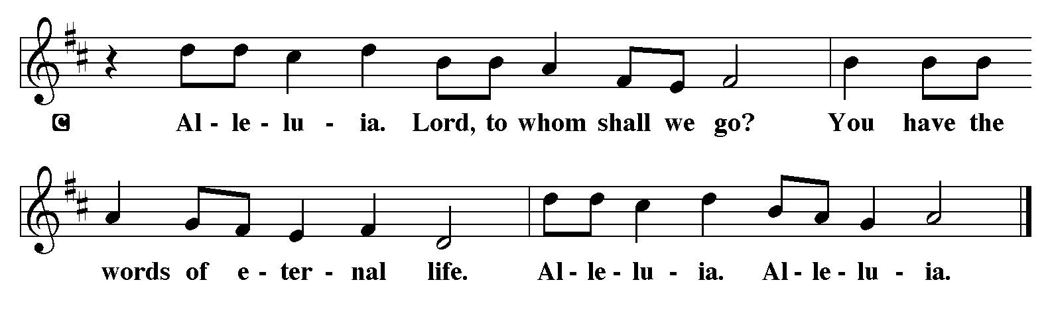
P: The Holy Gospel according to Matthew 3:13-17
C: Glory to you O Lord.

Gospel: Matthew 3:13-17
Before Jesus begins his ministry, he is baptized by John, touched by the Spirit, and identified publicly as God’s child.
¹³ Jesus came from Galilee to John at the Jordan, to be baptized by him. ¹⁴ John would have prevented him, saying, “I need to be baptized by you, and do you come to me?” ¹⁵ But Jesus answered him, “Let it be so now, for it is proper for us in this way to fulfill all righteousness.” Then he consented. ¹⁶ And when Jesus had been baptized, just as he came up from the water, suddenly the heavens were opened to him and he saw God’s Spirit descending like a dove and alighting on him. ¹⁷ And a voice from the heavens said, “This is my Son, the Beloved, with whom I am well pleased.”

P: The Gospel of Our Lord!
C: Praise to You O Christ!
Sermon by S.A.M. Bob

Hymn of the Day: Christ, When for Us You Were Baptized ELW 304
- Christ, when for us you were baptized, God's Spirit on you
came, as peaceful as a dove, and yet as
urgent as a flame, as urgent as a flame.

- God called you, "My beloved Son"; you are God's servant
true, sent to proclaim the reign of heav'n, God's
holy will to do, God's holy will to do.

- Straightway and steadfast until death you then obeyed the
call to serve with free and willing heart, to
give your life for all, to give your life for all.

- Baptize us with your Spirit, Lord; your cross on us be
signed, that likewise in God's service we may
perfect freedom find, may perfect freedom find.
Text: F. Bland Tucker, 1895-1984, alt.
Text © 1985 Church Pension Fund, admin. Church Publishing Incorporated. All rights reserved.

Apostles’ Creed
I believe in God, the Father almighty,
creator of heaven and earth.
I believe in Jesus Christ, God’s only Son, our Lord,
who was conceived by the Holy Spirit,
born of the virgin Mary,
suffered under Pontius Pilate,
was crucified, died, and was buried;
he descended to the dead.
On the third day he rose again;
he ascended into heaven,
he is seated at the right hand of the Father,
and he will come to judge the living and the dead.
I believe in the Holy Spirit,
the holy catholic church,
the communion of saints,
the forgiveness of sins,
the resurrection of the body,
and the life everlasting. Amen.

Lord, listen to your children praying,
Lord, send your Spirit in this place;
Lord, listen to your children praying,
send us love, send us pow'r, send us grace.

Prayers of the People

Response (after “Merciful God.”): “We thank you.”

P: May the peace of our Lord Jesus Christ be with you all.
C: And also with you.
P: Let us now share this peace.
Offering is Brought to the Altar

Offertory Prayer
God of majesty,
no eye has seen, no ear has heard
what you have prepared for those who love you,
yet in this meal you reveal the wideness of your mercy.
Use what we have gathered
to feed us with the reign of God come near,
Jesus Christ, our Savior and Lord.
Amen.
P: The Lord be with you.
C: And also with you.

P: Lift up your hearts.
C: Lift them to the Lord.

P: Let us give thanks to the Lord our God.
C: It is right to give our thanks and praise.

Preface
(Words spoken by S.A.M. Bob)
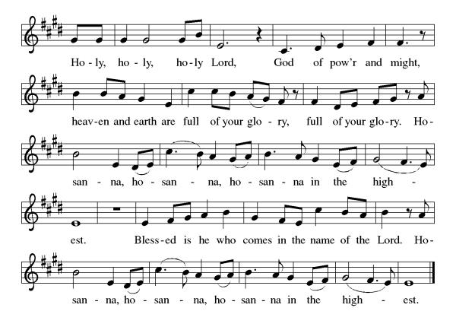
Eucharistic Prayer
(Words spoken by S.A.M. Bob)
Christ has died
Christ is risen.
Christ will come again.
Gathered into one, by the Holy Spirit let us listen to the words that Jesus taught us.

The Lord’s Prayer
Our Father, who art in heaven, hallowed be thy name, thy kingdom come, thy will be done, on earth as it is in heaven. Give us this day our daily bread; and forgive us our trespasses, as we forgive those who trespass against us; and lead us not into temptation but deliver us from evil. For thine is the kingdom, and the power, and the glory, forever and ever. Amen.

Invitation to Communion
P: This is the Lamb of God who takes away the sins of the world, happy are those who are called to His table. Taste on your lips a Love we cannot comprehend.
C: Amen
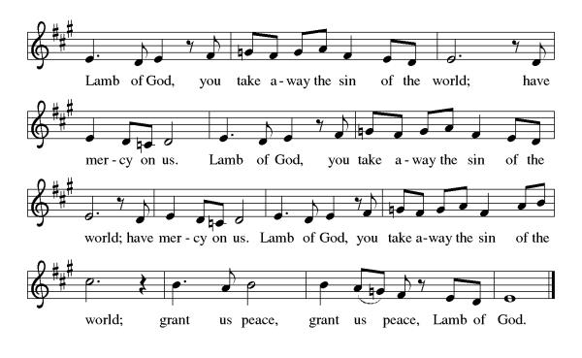
Please come forward to receive

Communion Anthem: Come to the Water of Life ACS 955
P: We are now a tabernacle with Christ inside of us. Let us rejoice and be glad at the Lord’s table.
C: Amen

Prayer after Communion
Radiant God,
we have seen your glory in the face of Jesus Christ.
In the sacrament of his body and blood
you have drawn us to your heart.
Send us from this table with delight,
that our lives may reflect the beauty of your love,
and bear witness to all we have seen and heard,
through Jesus Christ, our Savior and Lord.
Amen.

Blessing
May God the Father, God the Son and God the Holy Spirit ☩ bless you now and forever.
Amen.

Sending Hymn: Founded on Faith ACS 1048
1 Founded on faith, the church—alive by grace—
proclaims the gospel here and ev'ry place.
The word of God resounds through time and space: Alleluia!

2 Your cross, O Christ, renews our life each day.
Baptized in you, we learn and teach and pray.
Fed by your love, with thankful hearts, we say: Alleluia!

3 Equipped by prayer, we live the Spirit's call.
Empow'red to serve with gifts, both great and small,
we bring the living hope of God to all. Alleluia!

4 Growing in grace for God's created earth,
we yearn for justice, peace, and human worth;
a world restored; a faithful, caring church. Alleluia!

5 Founded on faith, called forth, empow'red to serve,
we share God's endless love without reserve.
Then let us shout aloud the living Word! Alleluia!

Text: Paul D. Weber, b. 1949
Text © 2017 Paul D. Weber, admin. Augsburg Fortress

Dismissal
P: Bring the peace He can only give us and share it with those outside these walls.
C: Thanks be to God.
Postlude:
Unless otherwise noted, materials used in this bulletin are:
From Sundays and Seasons.com. Copyright 2015 Augsburg Fortress. All rights reserved. Reprinted by permission under Augsburg Fortress Liturgies Annual License #SAS028635. Music is reprinted under OneLicense.Net #A712074 and/or Augsburg Fortress #SBL12176H. Scripture, unless otherwise noted, is from the New Revised Standard Version Bible, Copyright © 1989, Division of Christian Education of the National Council of the Churches of Christ in the United States of America. Used by permission. All rights reserved.

St. Timothy Evangelical Lutheran Church
1070 N. Suncoast Blvd.
Crystal River, FL 34429
Telephone number (Office): 352-795-5325
Office email address: crsttimothy@tampabay.rr.com

St Timothy Worship Team
S.A.M. Robert F. Bonomo
Lay Minister, Frank Hofstetter
Director of Music, Sally Hennessey
Saturday Pianist, Bill Robinson

Announcements for January 3rd and 4th

ATTENDANCE
Saturday, January 3rd, 4pm 23
Sunday, January 4th , 9am 42
Drive-Up Communion 3
68

The Altar Flowers are given this week to the glory of God!

This Week at St. Timothy's
Monday, January 12th 10:30am Ruth Circle @ Barb C’s house.
Tuesday, January 13^{h} 9-12 Food Pantry
Wednesday, January 14th
Thursday, January 15th 9:30am Prayer Group, 11am – Miniatures, 4:30pm - Choir
Friday, January 16th 1pm Royal Dalton Memory Care
Saturday, January 17th 4pm - Worship
Sunday, January 18th 9am – Worship, 10:15-10:45 – Drive Up Communion, Annual Congregational Meeting

