St Timothy Lutheran Church
Sunday, June 21, 2026
4th Sunday after Pentecost

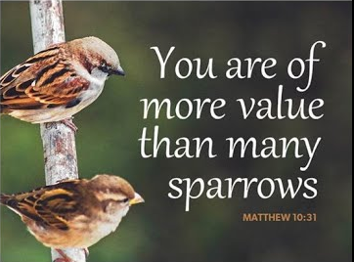

God does not promise that the path of the disciple will be easy. Jeremiah feels the pain of rejection from those who do not want to hear what he has to say. Jesus declares that his words may bring stark division. Even so, we need not be afraid for God accounts for each hair on our heads. Though we may experience rejection, frustration, division, and death, God’s grace and love make us a new creation each day. Marked with the cross and filled with holy food, we are sent from worship to witness to Christ in the world.

Preservice: We Know that Christ is Raised ELW 449
Welcome!
Prelude
P – Preparing our hearts for Worship

Confession and Forgiveness
All may make the sign of the cross, the sign that is marked at baptism, as the presiding minister begins.
Blessed be the holy Trinity,☩ one God,
whose compassion endures forever.
Amen.
Let us confess our sin to God.
Silence is kept for reflection.
Compassionate God,
we confess to you all our sins.
Our burden is heavy, and we cannot free ourselves.
In your mercy, call us back to you.
Your yoke is easy and your burden is light.
Restore us to dwell in your peace.
In Christ’s name we pray,
Amen.
Jesus says, “Come to me,
all you who are weary
and are carrying heavy burdens,
and I will give you rest.”
In the name of God,
Father, ☩ Son, and Holy Spirit,
your sins are forgiven.
Rest in God’s love.
Amen.

Gathering Hymn: Let the Whole Creation Cry ELW 876
1 Let the whole creation cry, "Glory to the Lord on high!"
Heav'n and earth, awake and sing, "Praise to our almighty king!"
Praise God, angel hosts above, ever bright and fair in love;
sun and moon, lift up your voice; night and stars, in God rejoice.

2 Servants striving for the Lord, prophets burning with the word,
those to whom the arts belong add their voices to the song.
Pow'rs of knowledge and of law, to the glorious circle draw;
all who work and all who wait, sing, "The Lord is good and great!"

3 Men and women, young and old, raise the anthem loud and bold,
and let children's happy hearts in this worship take their parts;
from the north to southern pole let the mighty chorus roll:
"Holy, Holy, Holy One; glory be to God alone!"

Text: Stopford A. Brooke, 1832-1916, alt.

P - The grace of our Lord Jesus Christ, the love of God and the communion of the Holy Spirit be with you all.
C - And also with you.

Prayer of the Day
Teach us, good Lord God, to serve you as you deserve, to give and not to count the cost, to fight and not to heed the wounds, to toil and not to seek for rest, to labor and not to ask for reward, except that of knowing that we do your will, through Jesus Christ, our Savior and Lord.
Amen.

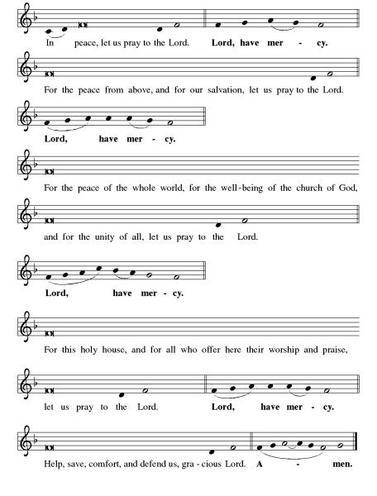
Kyrie ELW pg 138

Hymn of Praise: This is the Feast ELW pg 140-141

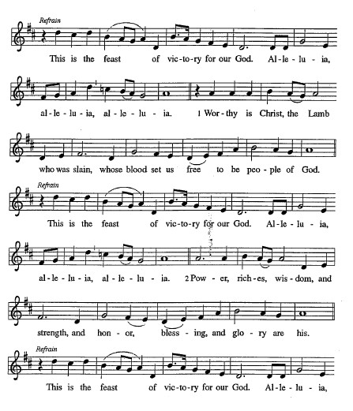

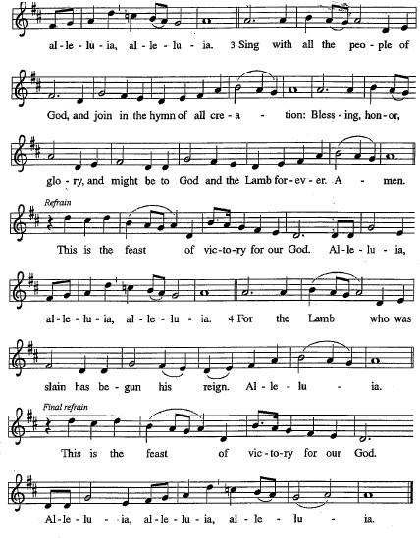
Please be seated.

First Reading: Jeremiah 20:7-13
Jeremiah accuses God of forcing him into a ministry that brings him only contempt and persecution. Yet Jeremiah is confident that God will be a strong protector against his enemies and commits his life into God’s hands.
⁷ O Lord, you have enticed me,
and I was enticed;
you have overpowered me,
and you have prevailed.
I have become a laughingstock all day long;
everyone mocks me.
⁸ For whenever I speak, I must cry out;
I must shout, “Violence and destruction!”
For the word of the Lord has become for me
a reproach and derision all day long.
⁹ If I say, “I will not mention him
or speak any more in his name,”
then within me there is something like a burning fire
shut up in my bones;
I am weary with holding it in,
and I cannot.
¹⁰ For I hear many whispering:
“Terror is all around!
Denounce him! Let us denounce him!”
All my close friends
are watching for me to stumble.
“Perhaps he can be enticed,
and we can prevail against him
and take our revenge on him.”
¹¹ But the Lord is with me like a terrifying warrior;
therefore my persecutors will stumble,
and they will not prevail.
They will be greatly shamed,
for they will not succeed.
Their eternal dishonor
will never be forgotten.
¹² O Lord of hosts, you test the righteous;
you see the heart and the mind;
let me see your retribution upon them,
for to you I have committed my cause.
¹³ Sing to the Lord;
praise the Lord!
For he has delivered the life of the needy
from the hands of evildoers.

A – Here ends the first reading!

C – Thanks be to God!

Psalm 69:7-10 [11-15] 16-18
⁷ Surely, for your sake I have suffered reproach,
and shame has covered my face.
⁸ I have become a stranger to my own kindred,
an alien to my mother’s children.
⁹ Zeal for your house has eaten me up;
the scorn of those who scorn you has fallen upon me.
¹⁰ I humbled myself with fasting,
but that was turned to my reproach.
[ ¹¹ I put on sackcloth also,
and became a byword among them.
¹² Those who sit at the gate murmur against me,
and the drunkards make songs about me.
¹³ But as for me, this is my prayer to you, at the time you have set, O Lord:
“In your great mercy, O God, answer me with your unfailing help.
¹⁴ Save me from the mire; do not let me sink;
let me be rescued from those who hate me and out of the deep waters.
¹⁵ Let not the torrent of waters wash over me, neither let the deep swallow me up;
do not let the pit shut its mouth upon me.
] ¹⁶ Answer me, O Lord, for your love is kind;
in your great compassion, turn to me.
¹⁷ Hide not your face from your servant;
be swift and answer me, for I am in distress.
¹⁸ Draw near to me and redeem me;
because of my enemies deliver me.

Second Reading: Romans 6:1b-11
In baptism we were incorporated into the reality of Christ’s death and resurrection. We have been made new in Christ through his death and resurrection to live freed from sin.
^{1b} Should we continue in sin in order that grace may increase? ² By no means! How can we who died to sin go on living in it? ³ Do you not know that all of us who were baptized into Christ Jesus were baptized into his death? ⁴ Therefore we were buried with him by baptism into death, so that, just as Christ was raised from the dead by the glory of the Father, so we also might walk in newness of life.
⁵ For if we have been united with him in a death like his, we will certainly be united with him in a resurrection like his. ⁶ We know that our old self was crucified with him so that the body of sin might be destroyed, so we might no longer be enslaved to sin. ⁷ For whoever has died is freed from sin. ⁸ But if we died with Christ, we believe that we will also live with him. ⁹ We know that Christ, being raised from the dead, will never die again; death no longer has dominion over him. ¹⁰ The death he died, he died to sin once for all, but the life he lives, he lives to God. ¹¹ So you also must consider yourselves dead to sin and alive to God in Christ Jesus.

A – Here ends the second reading!
C – Thanks be to God!
Gospel Acclamation
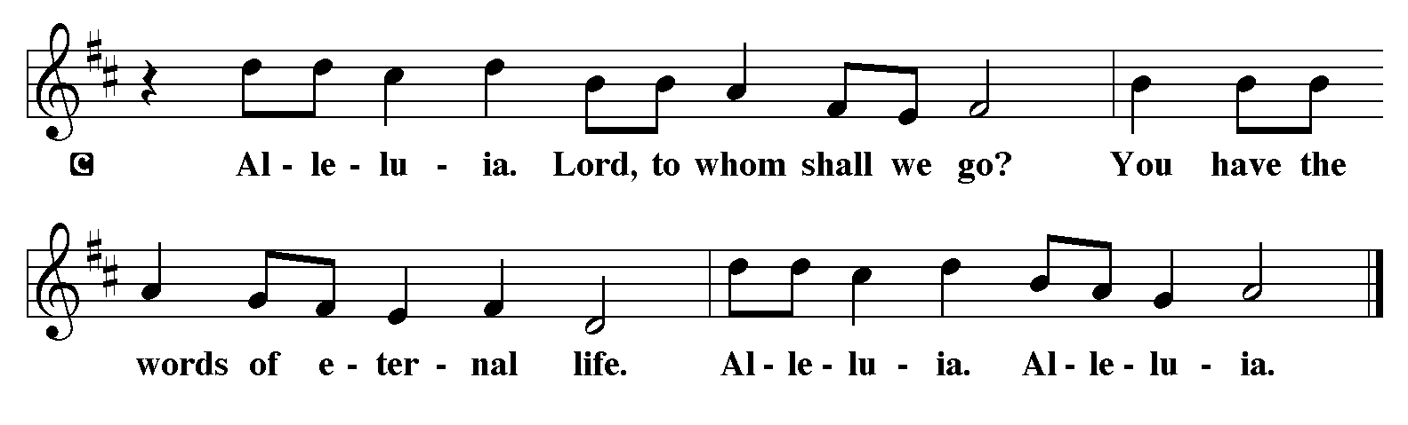
P - The Holy Gospel according to Matthew, the 10th Chapter
C - Glory to You O Lord!

Gospel: Matthew 10:24-39
Jesus warns his disciples that their ministry in his name will meet with opposition. However, he assures them that they need not fear for the truth will come to light. Life is found in Christ.
[Jesus said to the twelve:] ²⁴ “A disciple is not above the teacher nor a slave above the master; ²⁵ it is enough for the disciple to be like the teacher and the slave like the master. If they have called the master of the house Beelzebul, how much more will they malign those of his household!
²⁶ “So have no fear of them, for nothing is covered up that will not be uncovered and nothing secret that will not become known. ²⁷ What I say to you in the dark, tell in the light, and what you hear whispered, proclaim from the housetops. ²⁸ Do not fear those who kill the body but cannot kill the soul; rather, fear the one who can destroy both soul and body in hell. ²⁹ Are not two sparrows sold for a penny? Yet not one of them will fall to the ground apart from your Father. ³⁰ And even the hairs of your head are all counted. ³¹ So do not be afraid; you are of more value than many sparrows.
³² “Everyone, therefore, who acknowledges me before others, I also will acknowledge before my Father in heaven, ³³ but whoever denies me before others, I also will deny before my Father in heaven.
³⁴ “Do not think that I have come to bring peace to the earth; I have not come to bring peace but a sword.
³⁵ For I have come to set a man against his father,
and a daughter against her mother,
and a daughter-in-law against her mother-in-law,
³⁶ and one’s foes will be members of one’s own household.
³⁷ “Whoever loves father or mother more than me is not worthy of me, and whoever loves son or daughter more than me is not worthy of me, ³⁸ and whoever does not take up the cross and follow me is not worthy of me. ³⁹ Those who find their life will lose it, and those who lose their life for my sake will find it.”
P - The Gospel of the Lord.
C – Praise to you, O Christ!
Sermon

Hymn of the Day: How Firm a Foundation ELW 796
1 How firm a foundation, O saints of the Lord,
is laid for your faith in Christ Jesus, the Word!
What more can he say than to you he has said
who unto the Savior for refuge have fled?
2 "Fear not, I am with you, oh, be not dismayed,
for I am your God and will still give you aid;
I'll strengthen you, help you, and cause you to stand,
upheld by my righteous, omnipotent hand."
3 "When through fiery trials your pathway shall lie,
my grace, all-sufficient, shall be your supply.
The flames shall not hurt you; I only design
your dross to consume and your gold to refine."
4 "Throughout all their lifetime my people shall prove
my sov'reign, eternal, unchangeable love;
and then, when gray hairs shall their temples adorn,
like lambs they shall still in my bosom be borne."
Text: J. Rippon, A Selection of Hymns, 1787, alt.

The Apostle’s Creed
I believe in God, the Father almighty,
creator of heaven and earth.
I believe in Jesus Christ, God’s only Son, our Lord,
who was conceived by the Holy Spirit,
born of the virgin Mary,
suffered under Pontius Pilate,
was crucified, died, and was buried;
he descended to the dead.*
On the third day he rose again;
he ascended into heaven,
he is seated at the right hand of the Father,
and he will come to judge the living and the dead.
I believe in the Holy Spirit,
the holy catholic church,
the communion of saints,
the forgiveness of sins,
the resurrection of the body,
and the life everlasting. Amen.
From sundaysandseasons.com.
Copyright © 2026 Augsburg Fortress. All rights reserved.

Prayers of the People
Lord, all glory and praise and honor are offered to You, for You are our Redeemer, our Savior and Friend. We prayerfully ask for Your mercy as we pray for those in need, our community, and the world.

For the Whole People of God
Merciful Lord, Your grace is sufficient for all our needs, and You have promised to be the strength of the weary, the hope of those who fear, the healing of the ill, and the peace of all who are distressed. Hear us on behalf of all in need, that they may be well supplied by Your grace in every time of trouble.
Lord Jesus.
Come and save us

For Discipleship and Perseverance
Lord, in the words of Your Word, “Do not be afraid, little flock, for it is your Father’s good pleasure to give you the kingdom.” Strengthen every believer who is called to follow You, that they may stand firm in faith, endure trials with courage, and live as faithful witnesses to Your truth. May they accept and carry their cross daily and love others above self.
Lord Jesus,
Come and save us

For the Church
Bless the body of Christ, that it may be united in love, guided by the Holy Spirit, and equipped to proclaim the Gospel boldly. May the whole church be a light in the world, reflecting Your mercy and justice.
Lord Jesus
Come and save us

For Leaders and Servants
Empower Bishops, Pastors, Lay Ministers, Deacons, the laity of the church, Parish council members, Call committee members, and all who serve in Your name, that they may lead with wisdom, compassion, and courage, and that their ministry may draw others into a saving relationship with You.
Lord Jesus,
Come and save us

For the Sick, the Troubled
Heal the sick, comfort the grieving, and restore the broken. May Your peace dwell in every heart, and Your presence be felt in every place of need, Please to remember those aloud or in silence that are close in your hearts.
Lord Jesus,
Come and save us
Into Your hands, O Lord, we commend all for whom we pray, trusting in Your mercy, through Jesus Christ, our Lord.
Amen

P – The Peace of the Lord be with you always.
C – And also with you.

The Offering is Brought to the Altar
Offertory Prayer
Loving God,
we offer at your table the gifts of our hearts.
Help us take heart in you and share freely of your love,
so that all creation can taste your abundance.
We ask this in the name of Jesus,
through the Spirit abiding with us now and forever.
Amen.
The Great Thanksgiving

P – The Lord be with You
C – And also with you.
P – Lift up your hearts
C – We lift them to the Lord.
P – Let us give thanks to the Lord, our God
C – It is right to give Him our thanks and praise.

Preface
And so, with all the choirs of angels, with the church on earth and the hosts of heaven, we praise your name and join their unending hymn:

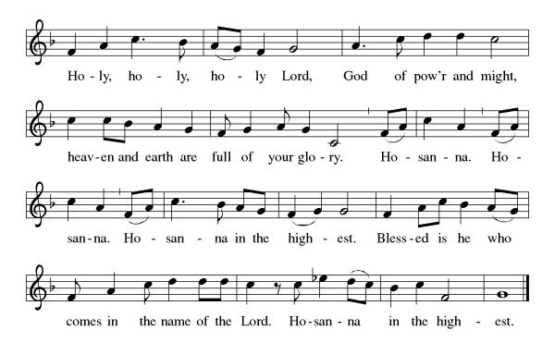

Eucharistic Prayer
(Words of Institution)

For as often as we eat of this bread and drink from this cup we proclaim the Lord’s death until He comes.
Christ has died
Christ is risen.
Christ will come again.
Remembering, therefore, his salutary command,
his life-giving passion and death, his glorious resurrection and ascension,
and the promise of his coming again,
we give thanks to you, O Lord God Almighty,
not as we ought but as we are able;
we ask you mercifully to accept our praise and thanksgiving and with your Word and Holy Spirit to bless us, your servants, and these your own gifts of bread and wine, so that we and all who share in the body and blood of Christ may be filled with heavenly blessing and grace,
and, receiving the forgiveness of sin,
may be formed to live as your holy people
and be given our inheritance with all your saints.
To you, O God, Father, Son, and Holy Spirit,
be all honor and glory in your holy church, now and forever. Amen.
Gathered into one, by the Holy Spirit let us listen to the words that Jesus taught us.

The Lord’s Prayer
Our Father, who art in heaven, hallowed be thy name, thy kingdom come, thy will be done, on earth as it is in heaven. Give us this day our daily bread; and forgive us our trespasses, as we forgive those who trespass against us; and lead us not into temptation but deliver us from evil. For thine is the kingdom, and the power, and the glory, forever and ever. Amen.
P: Taste and see that the Lord is good.
C: Thanks be to God.

Invitation to Communion
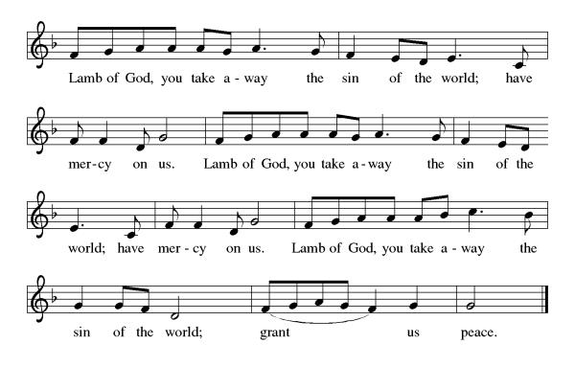
P – Come, feast at His table. He is waiting for you.
C – Amen.

Distribution of Communion – Come Forward to Receive
Communion Hymn: Loaves Were Broken ACS 966, Come to the Table (x3) ACS 961

P – Now may the body and blood of our Lord and Savior Jesus Christ strengthen you and keep you in His grace!
C – Thank You Jesus!

Prayer after Communion
Compassionate God,
Through the gifts of bread and wine
our hearts are filled with the abundance of your love.
Strengthen us that we, through this Holy meal,
may share your love freely, as you have shared with us.
We ask this in the name of Jesus,
through the Spirit nourishing us now and forever.
Amen.

Words of dismissal and benediction
Know that the ever-present mystery we name God
is in your past forgiving you,
in your present loving you,
and in your future meeting you.
And may the blessing of the Source of life, love and hope,
the Word of life, compassion and wisdom
and Breath of life, grace and truth
surround, sustain and surprise you,
this day and all your days. Amen.

Sending Hymn: O Jesus, I Have Promised ELW 810
1 O Jesus, I have promised to serve you to the end;
remain forever near me, my master and my friend.
I shall not fear the battle if you are by my side,
nor wander from the pathway if you will be my guide.

2 Oh, let me feel you near me; the world is ever near.
I see the sights that dazzle, the tempting sounds I hear.
My foes are ever near me, around me and within;
but, Jesus, then draw nearer to shield my soul from sin.

3 Oh, let me hear you speaking in accents clear and still
above the storms of passion, the murmurs of self-will.
Now speak to reassure me, to hasten or control;
now speak and make me listen, O Guardian of my soul.

4 O Jesus, you have promised to all who follow you
that where you are in glory your servant shall be too.
And Jesus, I have promised to serve you to the end;
oh, give me grace to follow, my master and my friend.
Text: John E. Bode, 1816-1874, alt.
Dismissal
P – Look and listen to S.A.M. Bob
C- Thanks be to God. Alleluia!

Postlude:
Unless otherwise noted, service materials used in this bulletin are:
Music is reprinted under OneLicense.Net #A712074 and/or Augsburg Fortress #SBL12176H. Scripture, unless otherwise noted, is from the New Revised Standard Version Bible, Copyright © 1989, Division of Christian Education of the National Council of the Churches of Christ in the United States of America. Used by permission. All rights reserved.

St Timothy’s is served by S.A.M. Robert Bonomo
Lay Minister Frank Hofstetter
Director of Music Sally Hennessey
Saturday Pianist Bill Robinson

Announcements for June 20th and 21st
ATTENDANCE
Saturday, June 13th, 4pm 26
Sunday, June 14th, 9am 56
Drive-Up Communion 2
84

The altar flowers are given this week by Sallie Haley, in honor of all the fathers and father figures on Father’s Day!

Happy Father’s Day!
In honor of all our St. Timothy men, a donation has been given by the church to God’s Work Our Hands!

Serving our Lord this weekend:
Saturday, June 20th

Sunday, June 21st
Assisting Minister – Sallie Haley
Reader – Sarah Brisson
Altar Guild – Steve & Sarah Brisson
Greeters – John & Jodie Gudorf

This Week at St. Timothy's
Monday, June 22nd
Tuesday, June 23rd 9-12 Food Pantry
Wednesday, June 24th 12pm Ice Cream Social
Thursday, June 25th 11-12 – Bible Study, NO MINIATURES, 4:30 - Choir
Friday, June 26th
Saturday, June 27th 4pm Worship, No Fellowship
Sunday, June 28th 9am Worship, Emergency Congregational Meeting

PRAYER LIST
Greg Schutrum
Debbie Lawrence
Carole Albert
Linda C.
Ashlee
Frani Barnes
Mark Duffy
Wyatt Toney
Jim & Rosa Neth
Melanie
Trish Bradley
Fowler Family
Nancy Brooks, Mike

FAVORITE HYMN SURVEY

In July and August, we will be using favorite hymns in both Saturday and Sunday services. Please list below your two favorite hymns, and where that hymn can be found (if you know). Hymns should be from the ELW, All Creation Sings, Worship & Praise, With One Voice, This Far by Faith, or the LBW if possible. Other hymns may be used depending on accessibility and copyright status. Please try to avoid seasonal hymns.

Hymns selected for use in July and August will be those with the most ‘votes’.

Please place completed surveys in the Music Director mailbox, or mailbox #190 if that is easier to reach.

